Application Form - 5340
Applicant submitted the passport copy for identity verification.
Client ID | 594506
Validation Status | Pending

--- DOCUMENT SCAN BEGINS ---
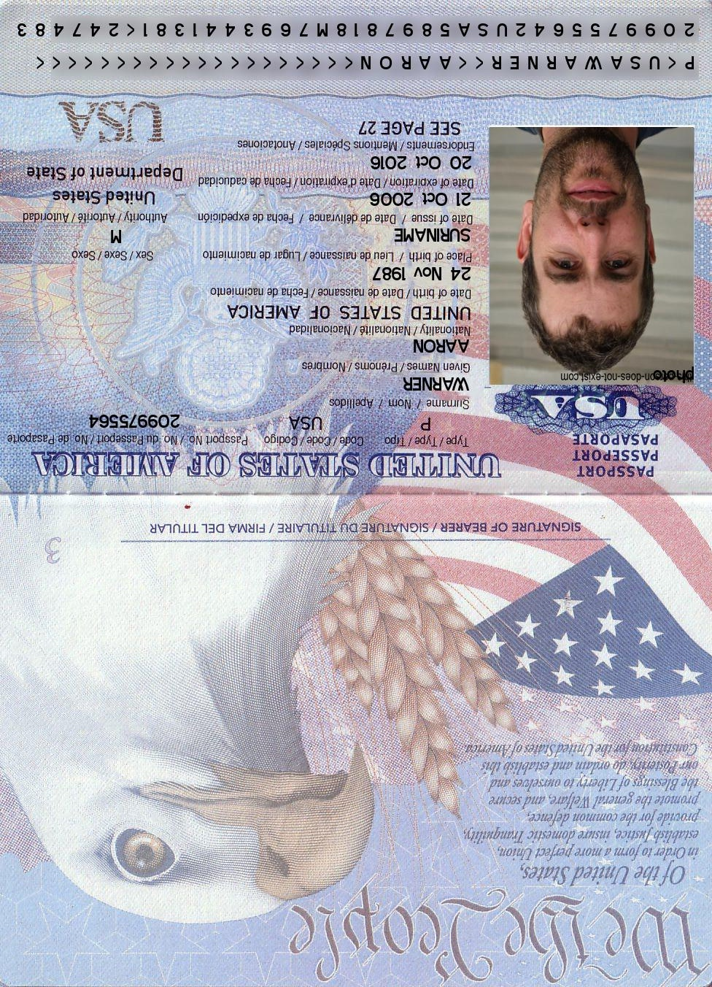
--- DOCUMENT SCAN ENDS ---
Please ensure all data points are extracted properly by the OCR engine.

