Application Form - 5689
Confidential document. Do not share without authorized permission.
Client ID | 387027
Validation Status | Pending

--- DOCUMENT SCAN BEGINS ---
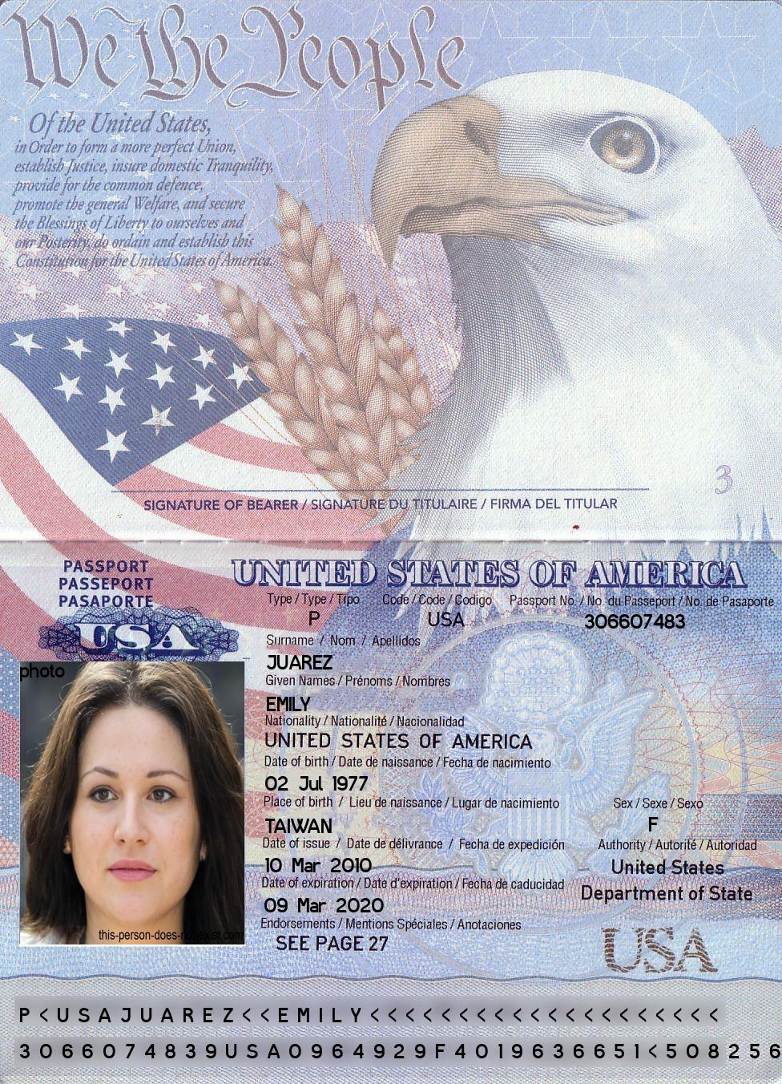
--- DOCUMENT SCAN ENDS ---
Please ensure all data points are extracted properly by the OCR engine.

