An Analysis of How Digital Behaviours Affect Quality of Life Using Big Data Concepts

Module Number: SWE5204
Module Name: Advanced Database & Big Data
Year/Semester: 2025 / April 25
Module Tutor/s: Juhel Uddin, Somdip Dey, Md Sadeque Imam Shaikh

HE27721

Module Number: SWE5204
Module Name: Advanced Database & Big Data
Year/Semester: 2025 / April 25
Module Tutor/s: Juhel Uddin, Somdip Dey, Md Sadeque Imam Shaikh

HE27721

Module Number: SWE5204
Module Name: Advanced Database & Big Data
Year/Semester: 2025 / April 25
Module Tutor/s: Juhel Uddin, Somdip Dey, Md Sadeque Imam Shaikh

HE27721

Module Number: SWE5204
Module Name: Advanced Database & Big Data
Year/Semester: 2025 / April 25
Module Tutor/s: Juhel Uddin, Somdip Dey, Md Sadeque Imam Shaikh

HE27721

Module Number: SWE5204
Module Name: Advanced Database & Big Data
Year/Semester: 2025 / April 25
Module Tutor/s: Juhel Uddin, Somdip Dey, Md Sadeque Imam Shaikh

HE27721

Module Number: SWE5204
Module Name: Advanced Database & Big Data
Year/Semester: 2025 / April 25
Module Tutor/s: Juhel Uddin, Somdip Dey, Md Sadeque Imam Shaikh

HE27721

Module Number: SWE5204
Module Name: Advanced Database & Big Data
Year/Semester: 2025 / April 25
Module Tutor/s: Juhel Uddin, Somdip Dey, Md Sadeque Imam Shaikh

HE27721

Module Number: SWE5204
Module Name: Advanced Database & Big Data
Year/Semester: 2025 / April 25
Module Tutor/s: Juhel Uddin, Somdip Dey, Md Sadeque Imam Shaikh

HE27721

Module Number: SWE5204
Module Name: Advanced Database & Big Data
Year/Semester: 2025 / April 25
Module Tutor/s: Juhel Uddin, Somdip Dey, Md Sadeque Imam Shaikh

HE27721

Module Number: SWE5204
Module Name: Advanced Database & Big Data
Year/Semester: 2025 / April 25
Module Tutor/s: Juhel Uddin, Somdip Dey, Md Sadeque Imam Shaikh

HE27721

Module Number: SWE5204
Module Name: Advanced Database & Big Data
Year/Semester: 2025 / April 25
Module Tutor/s: Juhel Uddin, Somdip Dey, Md Sadeque Imam Shaikh

HE27721

Module Number: SWE5204
Module Name: Advanced Database & Big Data
Year/Semester: 2025 / April 25
Module Tutor/s: Juhel Uddin, Somdip Dey, Md Sadeque Imam Shaikh

HE27721

Module Number: SWE5204
Module Name: Advanced Database & Big Data
Year/Semester: 2025 / April 25
Module Tutor/s: Juhel Uddin, Somdip Dey, Md Sadeque Imam Shaikh

HE27721

Module Number: SWE5204
Module Name: Advanced Database & Big Data
Year/Semester: 2025 / April 25
Module Tutor/s: Juhel Uddin, Somdip Dey, Md Sadeque Imam Shaikh

HE27721

Module Number: SWE5204
Module Name: Advanced Database & Big Data
Year/Semester: 2025 / April 25
Module Tutor/s: Juhel Uddin, Somdip Dey, Md Sadeque Imam Shaikh

HE27721

Module Number: SWE5204
Module Name: Advanced Database & Big Data
Year/Semester: 2025 / April 25
Module Tutor/s: Juhel Uddin, Somdip Dey, Md Sadeque Imam Shaikh

HE27721
2025

2025

2025

2025

2025

2025

2025

2025

2025

2025

2025

2025

2025

2025

2025

2025

Contents
Table of Figures 3
Introduction 4
Task 1 4
Task 2 6
Task 3 7
Acquisition 7
Storage 7
Analysis 8
Data wrangling 8
Descriptive analysis 14
Diagnostic analysis 17
Action 21
Task 4 22
Self-reflection 22
References 22

Table of Figures
Figure 1 7
Figure 2 7
Figure 3 7
Figure 4 8
Figure 5 8
Figure 6 8
Figure 7 9
Figure 8 9
Figure 9 9
Figure 10 10
Figure 11 10
Figure 12 10
Figure 13 11
Figure 14 11
Figure 15 11
Figure 16 11
Figure 17 12
Figure 18 12
Figure 19 13
Figure 20 13
Figure 21 13
Figure 22 14
Figure 23 14
Figure 24 15
Figure 25 15
Figure 26 15
Figure 27 16
Figure 28 16
Figure 29 17
Figure 30 17
Figure 31 18
Figure 32 18
Figure 33 18
Figure 34 19
Figure 35 19
Figure 36 20

Introduction
This report examines how social media behaviours impact mental health, and how that influences overall well-being, also referred to as quality of life.
By using Big Data principles, the patterns and relationships that were identified between different factors, such as screen time, notifications, focus, or mood, clearly and simply illustrate how people are impacted by their digital life.
“Social media usage has become a pervasive part of individuals’ interaction. Intensive handling and interaction affect the physical, mental, and spiritual health of the people and as such the quality of life.” (Marzo, 2024)
“Quality of life should be considered as a rich interplay and balance between how people see their internal state and how people see their relationships with other people.” (Cai, 2021)

Task 1
“Managing large-scale enterprise databases presents several challenges, including data consistency, security, and scalability”. (Oloruntoba, 2025)
Databases are systems created to store, organise and manage data in the most efficient way. Nowadays, due to billions of users, huge amounts of information, and fast applications that have to work globally in real time, including threats such as hackers and data breaches, the database technology to improve from simple and small to large-scale, secure and scalable.
To meet all these changes and new requirements, new ways to store data have been created including: cloud databases, serverless databases, AI-powered databases, multi-model databases, and blockchain-based databases. These upgrades required new security systems to protect sensitive data.
Some examples of widely known cloud databases are: Amazon Cloud, Google Cloud, Microsoft Azure. These platforms provide scalable, flexible and efficient solutions to every business needs. “[..]the aim of the cloud is to provide users and businesses with scalable and tailored services.” (Connolly, 2015) Cloud databases are also faster, safer, and cheaper, with practical features including automatic server scaling and global accessibility.
“Serverless databases are a relatively new trend in database technology, providing a solution where businesses do not need to manage server infrastructure for their database. Instead, the database automatically scales according to demand, and users are billed only for actual usage. This model is particularly attractive for applications with unpredictable or variable workloads.” (Miryala, 2024)
Serverless databases use the cloud to manage everything. That takes the pressure off the user regarding managing servers, hiring staff as well as billing. They also automatically optimize themselves.
AI-powered databases are an improvement because AI helps optimize the database automatically by making queries run faster, detecting hackers and saving money by using less hardware. This is managed without human intervention.
“Modern databases, such as Oracle, Microsoft Azure SQL, Amazon Redshift, and Google BigQuery, support in-database AI analytics, and allow AI tasks to be performed directly through user-friendly SQL interfaces. For better performance, these databases enable AI-driven knob tuning to autonomously refine database configurations.” (Zhao, 2025)
With blockchain databases, data is traceable and permanent, which helps with audits. This is very useful for finance, legal, and supply chains.
“The advancement in digitization has gradually shifted society's emphasis on the value of national security, particularly in protecting government databases. It should be noted that blockchain, in its turn, starting as fake money, started becoming popular as a way of improving the database and making it more reliable and transparent with the help of decentralization.” (Yapar, 2021)
“BlockchainDB implements a shared (and sharded) database on top of a classic blockchain. The database interface provides a simple key-value store API to the user, similar to Veritas and BigchainDB. The blockchain layer is flexible, being able to interact with different blockchains, such as Ethereum and Hyperledger Fabric.” (Ge, 2022)
As for new security features, databases have now encryption- data unreadable to hackers- ”Encryption can be used to protect data stored in databases or data that are in transit over a network from a database to a computer.” (Dennis, 2015); access control- only certain users can see data; and zero-trust- treats every access as suspicious and verifies everything. MongoDB Atlas is a very secure cloud database used by many apps.
Cloud, serverless, AI-powered, and blockchain-based databases are transforming the way organisations manage, store, and protect their data. They each have strengths that cover the present demands for scalability, optimization and security. Cloud platforms are flexible and auto-scalable; serverless ones reduce management and costs; AI-powered systems have better performance and security, and blockchains are transparent, traceable and trustworthy. Together, these advancements improve and cover all future database systems, helping businesses face the needs of an ever-evolving world.

Task 2
“At its essence, a database is a structured collection of data organized to facilitate efficient retrieval and manipulation.” (Cochran, 2024)
The key components of a database are: tables, rows, columns and keys.
There are a few types of databases, but this a comparison between two of them: relational databases and NoSQL databases.
Relational databases organise data into tables, with predefined associations. Some examples are: MySQL, PostgreSQL, and Oracle Database. They have been the scaffold of data management for decades.
Due to the evolution of technology, the expansion of the Internet and the vast amount of data coming with this, NoSQL databases appeared as a solution. Their flexibility and scalability help deal with huge volumes of unstructured or semi-structured data.
“An organization can utilize an SQL database if it places a priority on data standardization and consistency. NoSQL should be utilized when a business has a large quantity of unstructured data and data availability is a high requirement” (Khan, 2023)
NoSQL databases switch from the structure of relational databases to make space for various data models, comprising document-oriented, key-value, graph, and column-family stores. Some examples are: MongoDB and Cassandra.
A popular document-oriented database is MongoDb. It stores data in flexible, JSON-type documents. Each document can have a various structure, allowing space for dynamic design. It’s perfect to use when handling data that doesn’t fit neatly into tables. They are perfect for e-commerce websites, like Amazon, Etsy, e-Bay.
When storage and simple data retrieval is a priority, key-value stores are the best solution. They store data as key-value pairs. Some examples are: Redis and Amazon DynamoDB. They’re good with user session in web apps, like Instagram.
When fast write and retrieval of large amount of data is needed, column-family databases are used. They organise data into column rather than rows. Example: Apache Cassandra. They’re perfect for messaging apps, like WhatsApp.
When there is data with intricate associations, graph databases come in the picture. They use graph structures to navigate the relationships between the data efficiently. Example: Neo4j. These are used for social networks, like Facebook, TikTok (e.g. ‘People you may know’)
All these new types of databases came as a solution to the vast amount of data coming with the evolution of the internet and people’s needs. Depending on the demands of each organization, they can choose whatever is most fit for them.

Task 3

Acquisition
I chose to use the Kaggle.com site because it provides datasets that are legal, complete and free from sensitive or personally identifiable information. The datasets are open-source and suitable for academic use, making them accessible globally.
I decided on the “Mental Health and Digital Behaviour (2020-2024)” dataset because it shows how daily screen time can influence general well-being and impact quality of life, especially our stress and anxiety levels.

Storage
When deciding on what type of storage to use- cloud-based or local- cloud-based systems are more often than not more secure, scalable and accessible. This type of storage is easily accessible from anywhere, it protects data from damage and loss, and also it complies with General Data Protection Regulations (GDPR).
For this project, local storage was used- the dataset was downloaded and stored on a laptop for academic purposes.
For further protection and security, Google Cloud or AWS should be used in the future. It would make it easier to share with other researchers, allow updates in real-time, ensure scalability and faster processing, and add extra protection with encryption. The only downside would be monthly costs and that it’ll depend on the internet.

Analysis
This dataset includes two types of indicators- for digital behaviour- daily screen time- in minutes, number of app switches, social media usage time- in minutes, notification count, and focus and concentration scores- and mental health indicators- mood score, anxiety levels and sleep duration.

Data wrangling
Pandas was used to load the data set file in a data frame (Figure 1) and see the data in it (Figures 2 and 3).

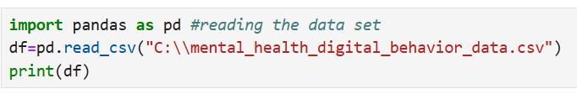
Figure 1

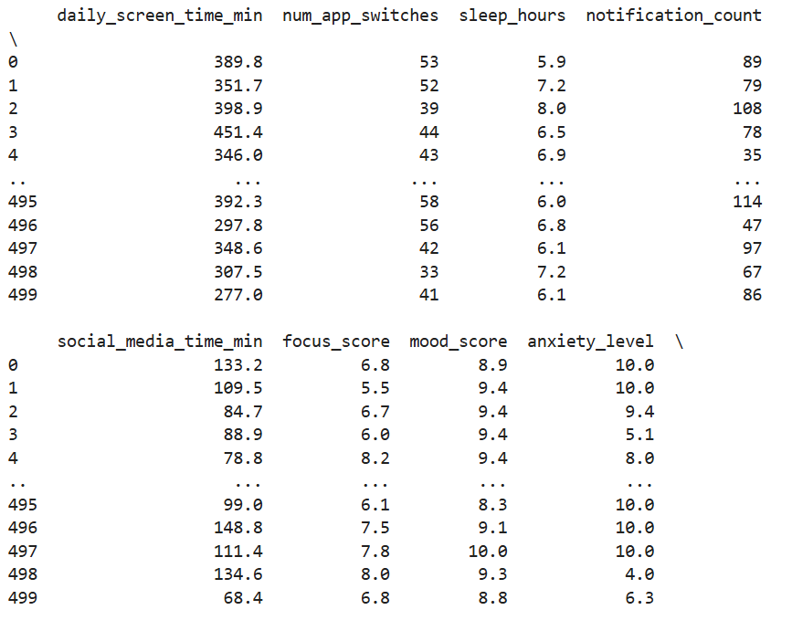
Figure 2

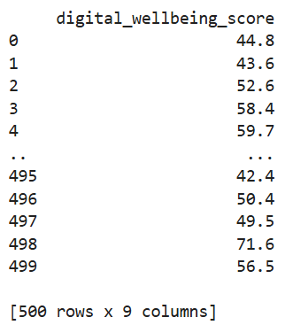
Figure 3
To do a quick overview of the data, we use the head- to view the first 10 rows (Figures 4,5 and 6), tail- to view the last 10 rows(Figures 7 and 8)- and info-it shows more information about the dataset- functions (Figure 9).
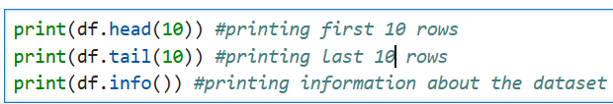
Figure 4
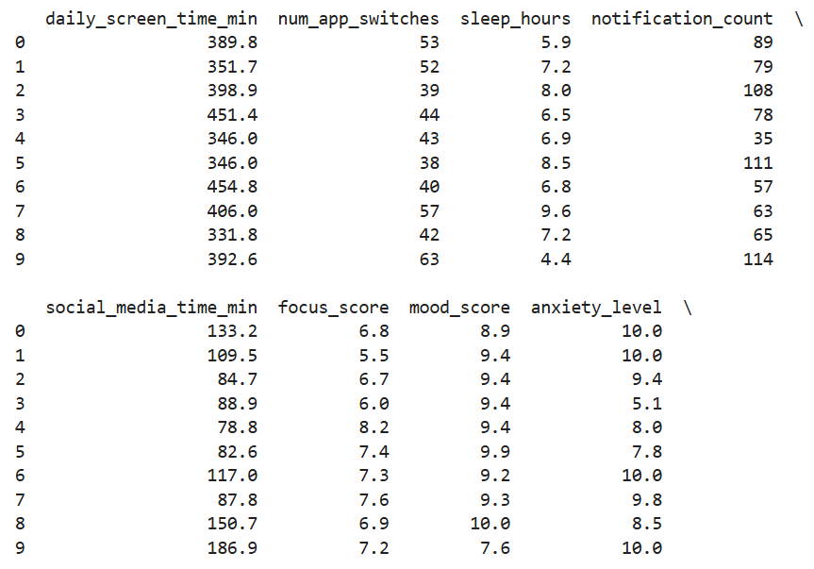
Figure 5

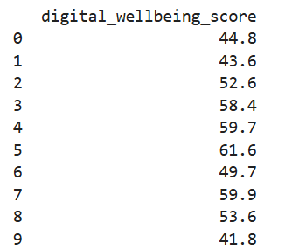
Figure 6

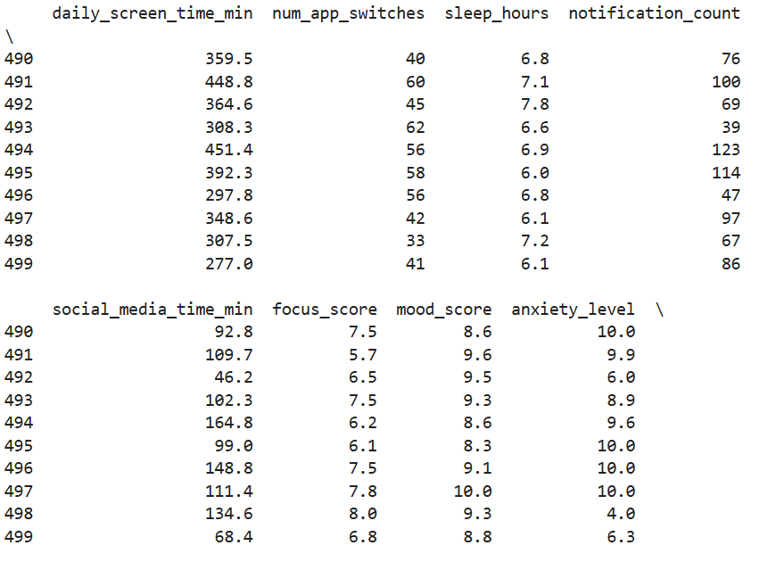
Figure 7

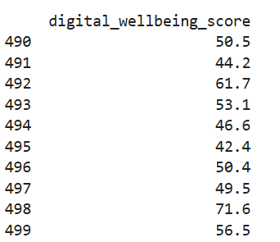
Figure 8
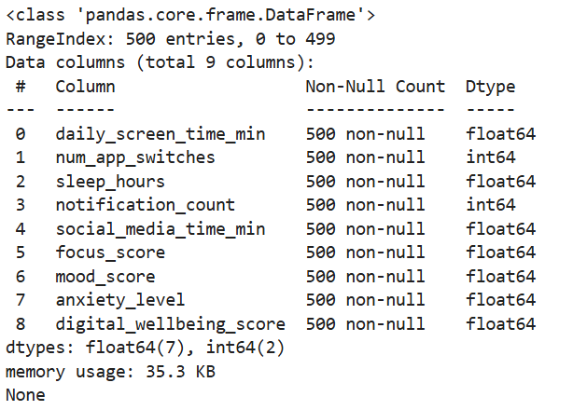
Figure 9
The info function shows that the data in this set has only non-null values. That means it can be analyzed as is.
To be able to analyze the data properly, it is important to do some “data cleaning” beforehand. Data cleaning involves fixing the “bad” data in the set, like: empty cells, data in wrong format, wrong data or duplicates.
One way to remove empty cells is to remove the row that contain the empty cells using the dropna method (Figures 10, 11 and 12).
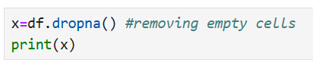
Figure 10
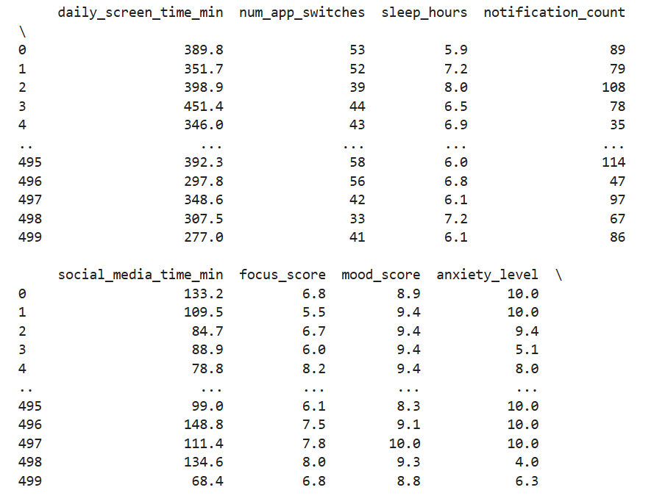
Figure 11
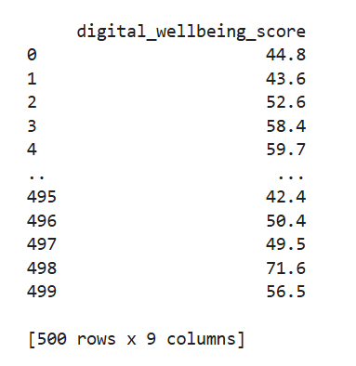
Figure 12

To drop duplicate data, the drop_duplicates method is applied (Figures 13, 14 and 15).
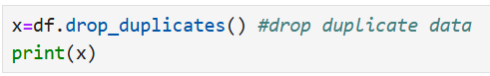
Figure 13
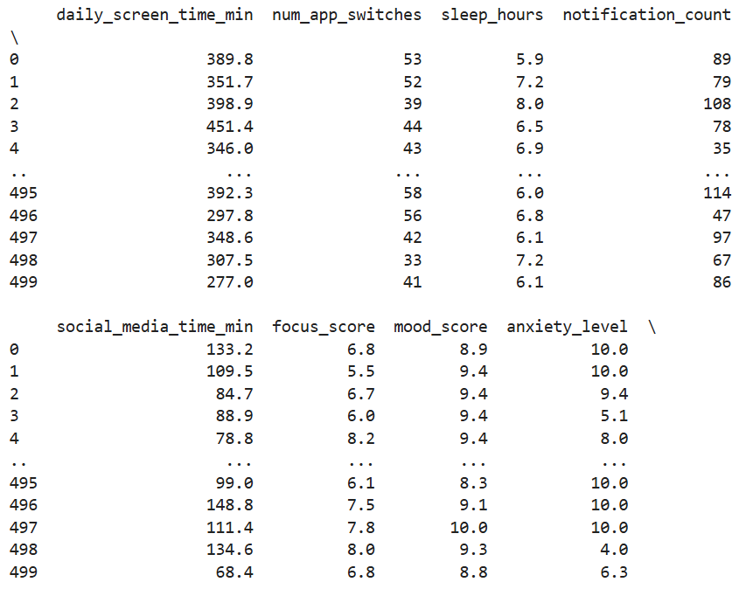
Figure 14
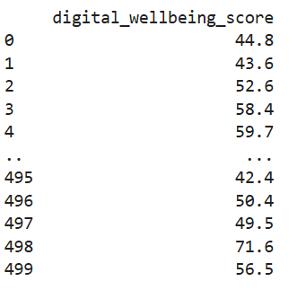
Figure 15

To see a specific value, the loc method is used (Figure 16).
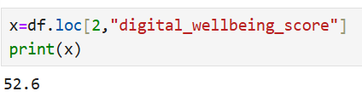
Figure 16
A common way to replace empty cells is to calculate the mean- the average of a column (Figure 17), median- the middle value of the column (Figure 18) or mode value- the value that appears most frequently in the data (Figures 19)- of the column and use the fillna( ) method to put them in the empty cell instead.
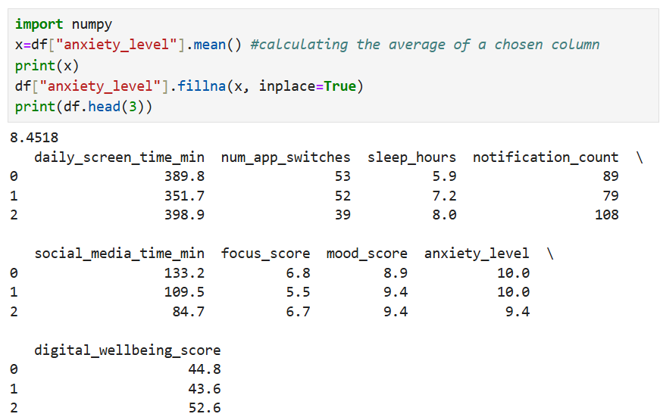
Figure 17

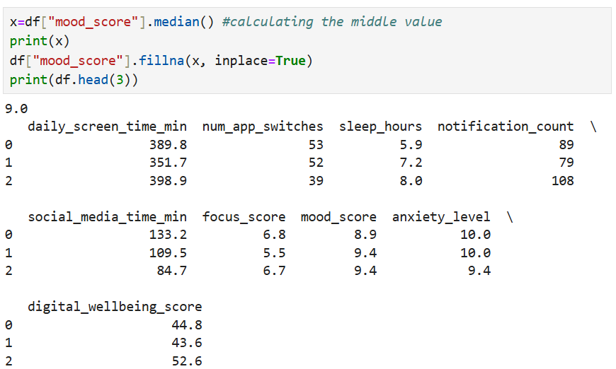
Figure 18
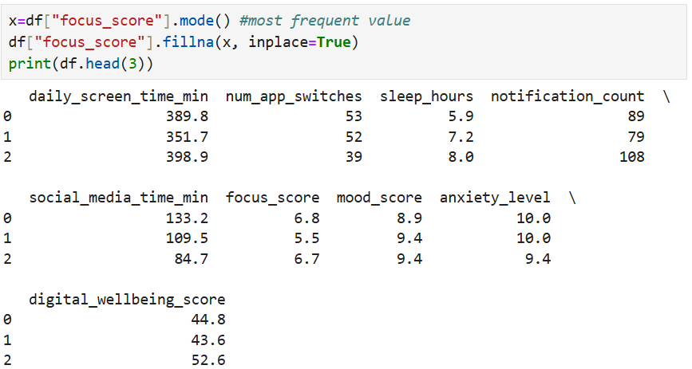
Figure 19
If there is wrong/error data in a specific row, we can change it using the loc method (Figure 20).
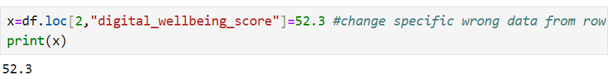
Figure 20

Descriptive analysis
Descriptive analysis describes data without deep investigation. It summarises the dataset and shows the current situation.
To create a diagram to visualize the data set, pyplot is used, a submodule of matplotlib library (Figures 21 and 22).
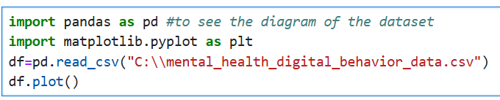
Figure 21
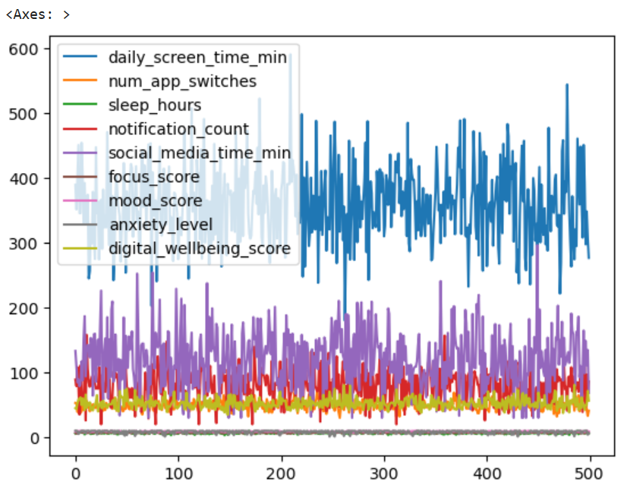
Figure 22

For a specific diagram, using the kind method, there has to be specified an x and a y axis (Figures 23 and 24).
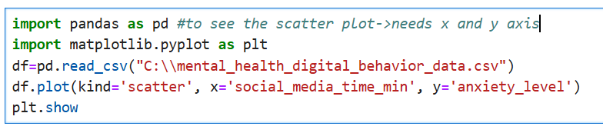
Figure 23
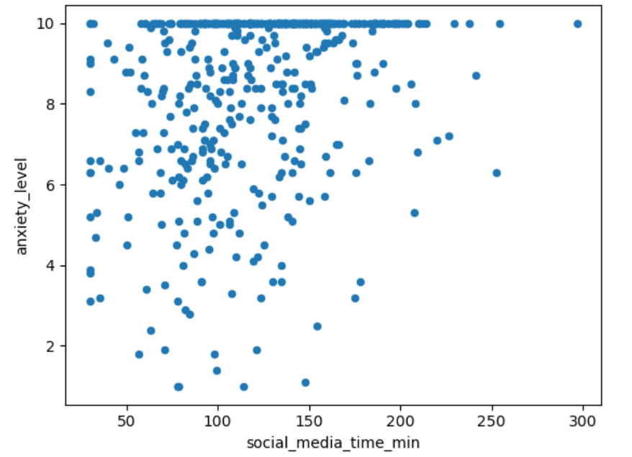
Figure 24
A histogram is a graph the shows only one column (Figures 25 and 26).
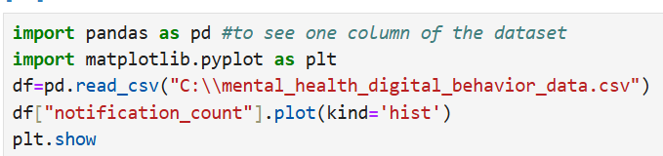
Figure 25
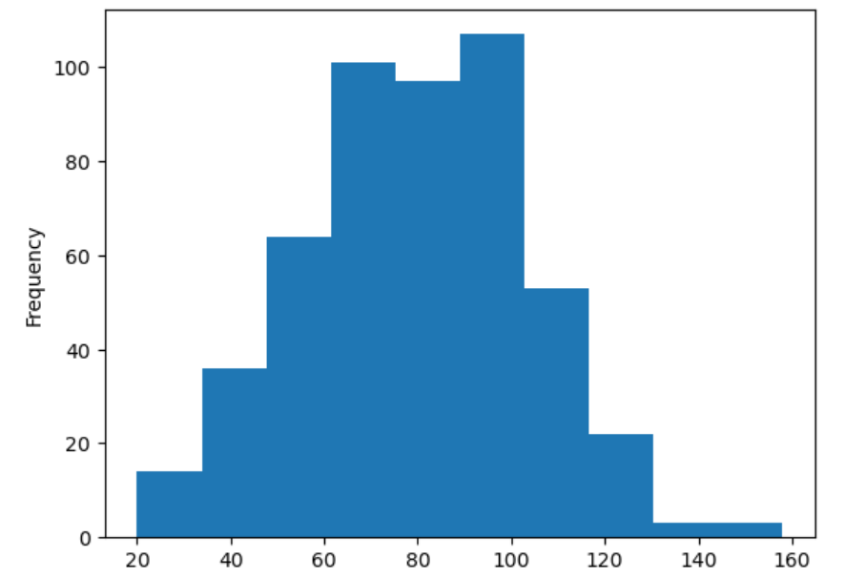
Figure 26

Diagnostic analysis
Diagnostic analysis investigates relationships in the dataset to figure out causes or correlations.
A regression line is a straight line that shows how 2 things relate.
“Structural relationships in relational schemas can be effectively captured by graph-based representations” (Sassi, 2025)
Bellow are some connections made from the data set.
Spending a long time on social media and receiving a high number of notifications increase anxiety (Figures 27- 30).
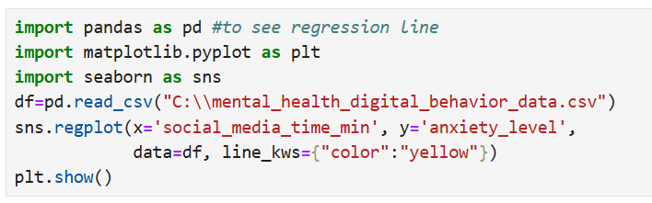
Figure 27
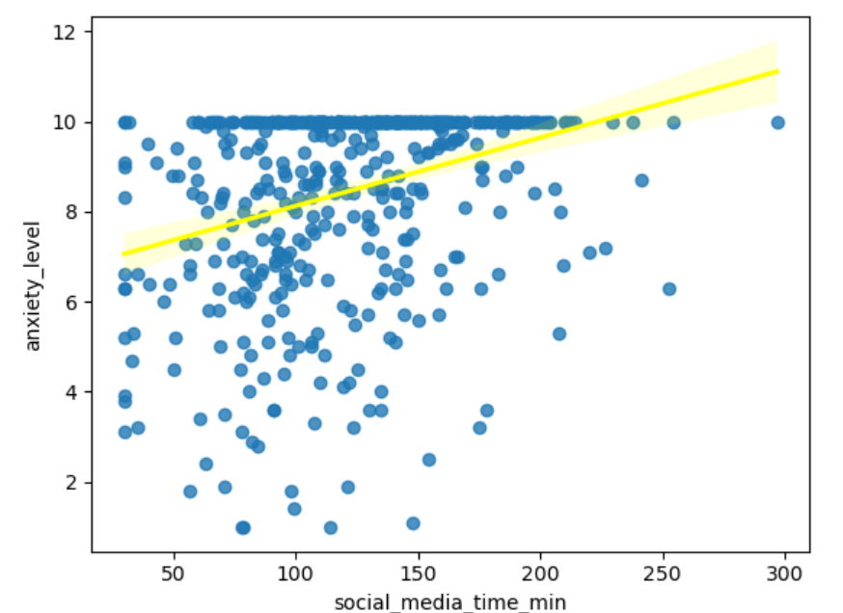
Figure 28
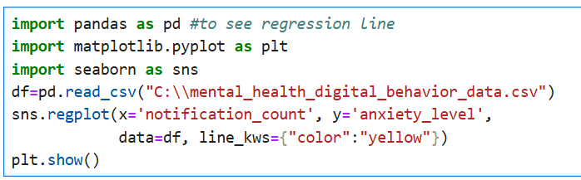
Figure 29
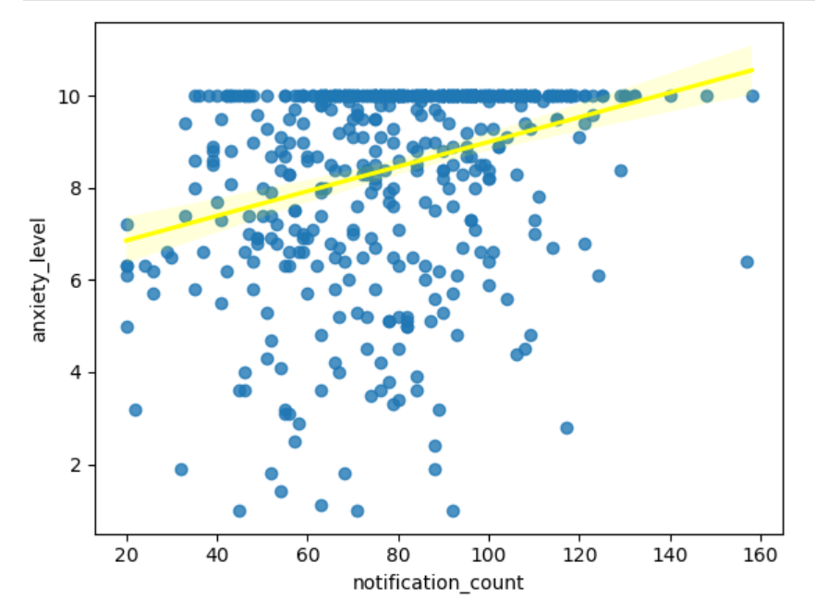
Figure 30
“Anxiety and depression have been associated with adverse societal and individual correlates, including higher health care costs and an increased risk for physical comorbidities, such as cardiovascular illnesses.” (Hohls, 2021)
Excessive anxiety can lead to a range of physical and mental health issues. Physical symptoms may include headaches, stomachaches, muscle pain, fatigue, and sleep problems. Mentally, it can manifest as difficulty concentrating, making decisions, or feeling restless and irritable. Anxiety can also trigger panic attacks, characterized by intense fear, rapid heartbeat, and shortness of breath. Furthermore, persistent anxiety can contribute to the development of other mental health conditions like depression or Obsessive Compulsive Disorder.
Too many notifications and spending too much time on a screen decrease focus (Figures 31- 34)

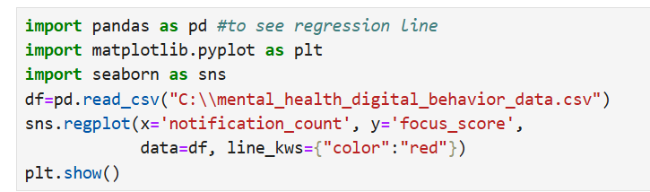
Figure 31
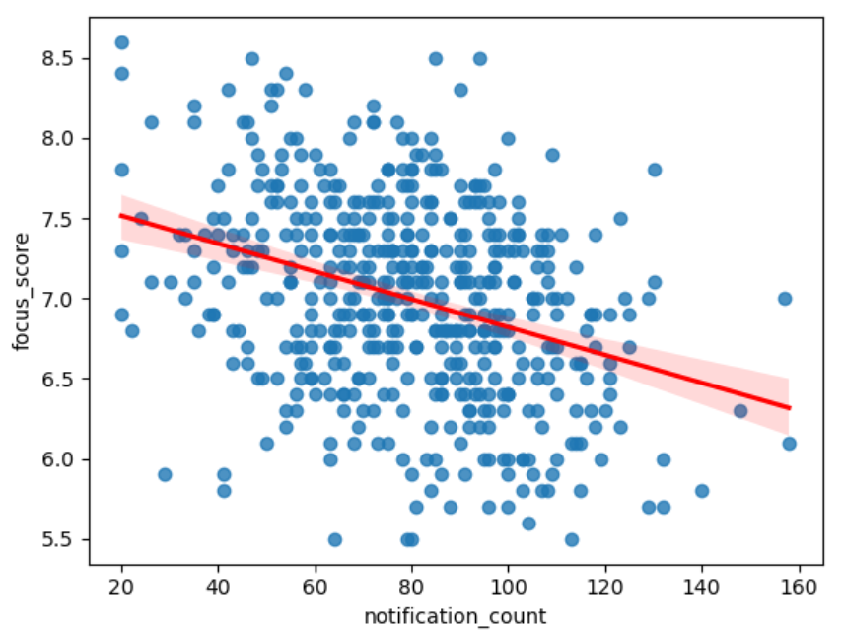
Figure 32
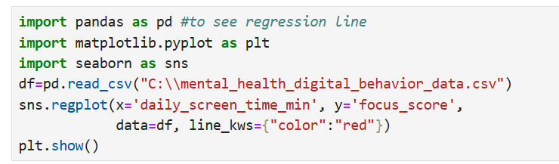
Figure 33
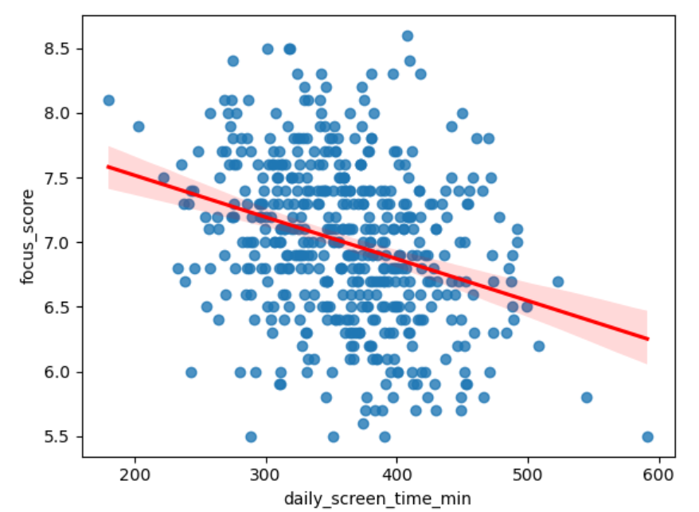
Figure 34

Insufficient focus can lead to a variety of issues including decreased productivity, increased errors, difficulty completing tasks, and strained relationships. It can also contribute to feelings of frustration, stress, and even depression. Furthermore, it can hinder academic and professional performance, leading to missed deadlines and a decline in the quality of work.
Using social media does increase mood, but an excess time spent on it decreases it (Figures 35 and 36).
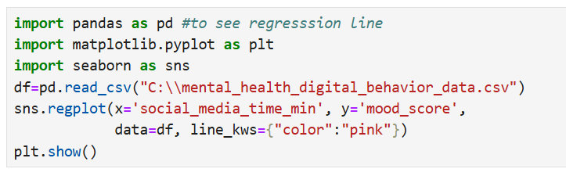
Figure 35
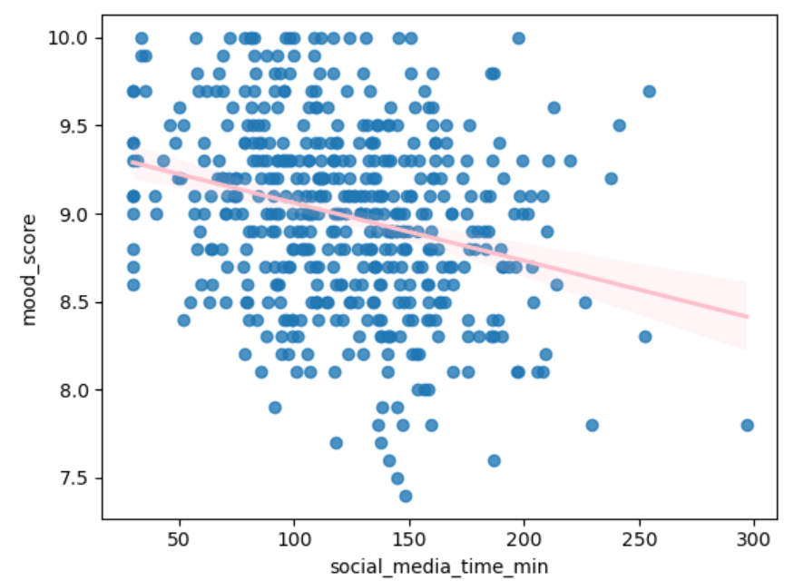
Figure 36
“Social media use can negatively affect mental health and it can also lead to addiction.” (von Lieres, 2022)

Action
Based on the findings from the diagnosis analysis, it’s safe to say that it is necessary for people to have more control over their screen habits.
Some basic indications to reduce the negative aspects of unhealthy digital behaviours are:
-reducing social media time drastically
-muting irrelevant notifications, or keeping them to a minimum
-implementing better sleep habits
-reducing general screen time
These changes should help people have a better quality of life in the long run.

Task 4

Self-reflection
At first, it was hard to decide on which dataset to get and build the whole report on, but when I found one related to mental health, something I am passionate about, it was easy to move forward with creating the whole document around it.
The second struggle was finding the appropriate resources and references relevant to my presentation and conclusions. What helped was me putting myself in the place of the reader and trying to figure out what would I want to know more of, maybe some definitions from books or academic articles. After I applied that, finding references went smoother.
Another issue I had was at diagnostic analysis, I couldn’t decide which graphs are important to show, which are the most obvious relationships and patterns. What helped was looking at the dataset, at minimum values and maximum values and relate them to other ones to reach some conclusions. Then I created the relevant graphs and regression lines to have a better perspective. After I looked over everything, I kept the most important and obvious findings and scrapped the rest. It really helped get a better view on the whole picture and I created the entire document based on them. From my point of view, the regression lines are the most important part. Data wrangling is important as well, but the dataset was “clean”.

References
Cai, T. V. (2021). The Quality of Life Definition: Where Are We Going? Uro, 1-2.
Cochran, A. P. (2024). Python Programming and SQL. London: Amazon KPD.
Connolly, T. B. (2015). Database Systems- A Practical Approach to Design, Implementation, and Management. Harlow: Pearson Education Limited.
Dennis, A. W. (2015). Systems Analysis and Design. Hoboken: Wiley.
Ge, Z. L. (2022). Hybrid Blockchain Database Systems: Design and Performance. Proceedings of the VLDB Endowment, 1-2.
Hohls, J. K.-H. (2021). Anxiety, Depression and Quality of Life- A Systematic Review of Evidence from Longitudinal Observational Studies. International Journal of Environmental Research and Public Health, 1-2.
Khan, W. K. (2023). SQL and NoSQL Database Software Architecture Performance Analysis and Assessments—A Systematic Literature Review. Big Data and Cognitive Computing, 10-11.
Marzo, R. R. (2024). The evolving role of social media in enhancing quality of life: a global perspective across 10 countries. Archives of Public Health, 11-12.
Miryala, N. K. (2024). Emerging Trends and Challenges in Modern Database Technologies: A Comprehensive Analysis. International Journal of Science and Research, 4-5.
Oloruntoba, O. (2025). AI-Driven Autonomous Database Management: Self-tuning, Predictive Query Optimization, and Intelligent Indexing in Enterprise IT Environments. World Journal of Advanced Research and Reviews, 3-4.
Sassi, N. J. (2025). Efficient AI-Driven Query Optimization in Large-Scale Databases: A Reinforcement Learning and Graph-Based Approach. Mathematics, 2-3.
von Lieres, S. J. (2022). The Impact of Social Media Use on Young Adults’ Quality of Life During the COVID-19 Pandemic in South India. IEEE, 1-2.
Yapar, O. (2021). Blockchain-Based Database Management for National Security: Ensuring Data Integrity and Privacy. International Journal of Emerging Technologies and Innovative Research, 15-16.
Zhao, Z. A. (2025). NeurDB: On the Design and Implementation of an AI-powered Autonomous Database. Conference on Innovative Data Systems Research (pp. 4-5). Amsterdam: Cornell University.

