Portfolio Report: Implementing Data Structures and Algorithms in Java

Module Tutor/s: Adeline Chanseau, Laith Al Saeed, Mona Zarbaf

HE27721
Data Structures and Algorithms
Table of Contents
Introduction 2
Task 1 2
A. Time and Space Complexity 2
B. Exercise 3
C. Exercise 4
Task 2 4
A. Implementing a stack data structure 4
B. Providing the code for the stack 6
C. Testing 8
Task 3 9
A. Implementing a singly and doubly linked list using Java 9
B. Implementing a Binary Search Tree using Java 14
C. Implementing a Java program for finding Adjacency matrix using a given graph 17
Task 4 18
A. Hash Map 18
B. Implementing an Array List using Java 20
C. Time Complexity of put( ), get( ), and remove( ) in a List based Map 21
References 22

Introduction
This report aims to demonstrate how Java can be applied to solve problems and tasks.
It will cover time and space complexity, stacks, linked lists, binary trees, hash maps and arrays, showing appropriate knowledge and understanding of concepts.
“Java is a whole platform, with a huge library, containing lots of reusable code, and an execution environment that provides services such as security, portability across operating systems, and automatic garbage collection.” (Horstmann, 2024)

Task 1

Time and Space Complexity
“Time complexity describes the amount of time taken by the computer to run a code by counting the number of operations performed in an algorithm.” (Phalke, 2024)
“The number of times the algorithm must execute, relative to the length of the input,
is known as time complexity. [..] one of the tools to describe the algorithm time complexity is the Big O notation that applies mathematical equations. These equations include constant time O(1), divide and conquer O(log(n)), polynomials O(n), exponentials O(2ⁿ), factorials O(n!).” (Karim, 2025)
Time and Space complexity is needed to show how efficient a program is and to predict how programs behave when the input is immense. The Big-O notation comes from “order of growth” and it used to measure the algorithm. Depending on how complex a program is, there is a different notation:
- O(1)-> constant time- action takes the same amount of time
- O(n)-> linear time- action takes longer, as the problem grows
- O(n²)-> quadratic time- actions take more time ex: when comparing items with every other
- O(log n)-> logarithmic time- action is faster because the problem is cut in half each time
- O(n log n)-> linearithmic time- action takes step-by-step time, with halving work ex: when sorting
- O(2ⁿ)-> exponential time- action doubles in work every time when adding one more item
- O(n!)-> factorial time- action explodes because it goes through every possible order of the items
Time complexity analysis is very important to consider because it shows how scalable and efficient an algorithm is. As an example, O(n) can be very practical for small data sets, but may become slow when n is large. As a difference, O(log n) grows slower and is favoured in voluminous applications, like databases.

Exercise
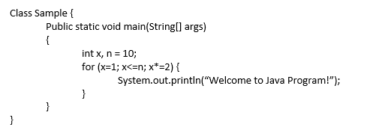
For this exercise, we have to explain the time complexity of the code above.
The program involves a loop. It starts from x=1, then each time we go through it- on each iteration, x changes: x=x*2, so x becomes 2, then 4, then 8 and it stops there, because 8*2=16, and that is bigger than 10.
Because the loop doesn’t run 10 times- the n number- because x grows too fast, I decided on O(log n) as answer.

Exercise
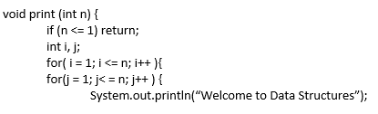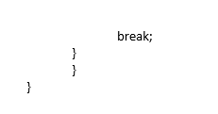
For this exercise we had to do the same as the previous one, determine the Big O notation for the code above.
This code involves 2 nested loops. The first loop compares i to n for n times, then the loop inside that one compares j to n, again for n times. Because this results in n*n iterations, I decided on O(n²).
But then, I noticed the ‘break’. That means the inner loop does only iteration each time, because the ‘break’ stops it there. For the outer loop, that means 1, not n. Because of that, the final answer is O(n).

Task 2

Implementing a stack data structure
A stack is a generic data structure that represents a LIFO- last in first out- collection of objects allowing for pushing/popping elements in constant time.
Stacks are used often in computing, like text editors, even in videogames for backtracking, managing some functions in programming languages. Their LIFO characteristic makes them very easy to use, predictable and efficient too.
For this part, we had to create a stack in Java that supports these operations:
- push( )- to add an item on top of the stack;

This is the code:

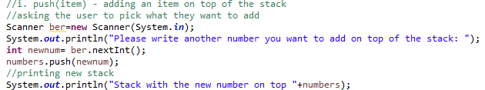

This is the output:

- pop( )- to remove an item from the top of the stack;

This is the code:

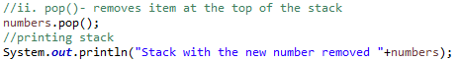

This is the output:
- peek( )- to show the item on top of the stack without removing it;

This is the code:

This is the output:

- isEmpty( )- to return true/ false if the stack is empty/ not empty;

This is the code:

This is the output:

- get_min( )- to return the minimum item in the stack without removing it.

This is the code:

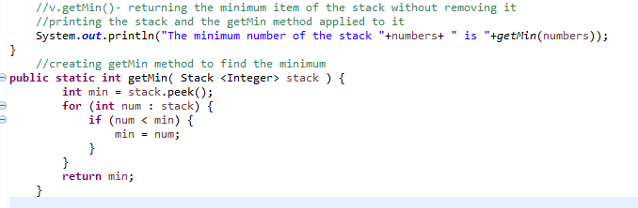

This is the output:

Providing the code for the stack
This is the whole code for the task:
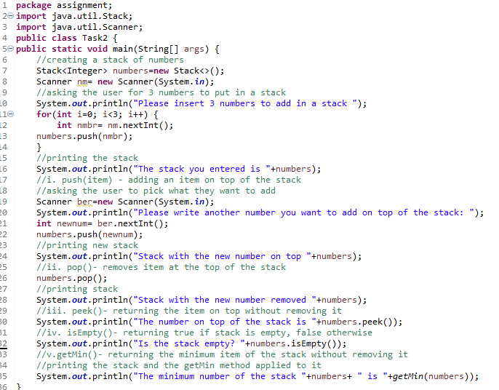
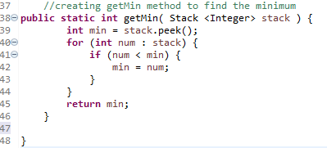

This is the output:
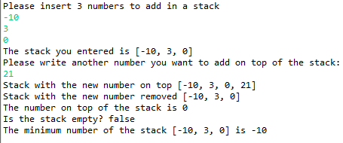
As can be seen from the images, the code is working, and it demonstrates how it pushes and pops items. In this case, it pushed the number 21 given by the user, and it popped it out. It shows the top of the stack- in this case, the number 0. It checked it the stack was empty, and it returned “false”, the stack is not empty; and it showed the minimum value of the stack by using a method.

Testing
I used multiple values to make sure the code is working correctly.
As seen above, the first stack contained the numbers: -10, 3, and 0.
Below, I’m giving different examples to ensure everything Is correct and efficient:
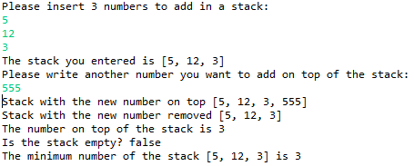
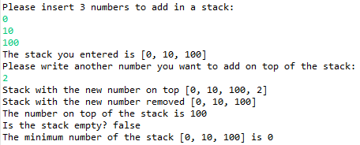
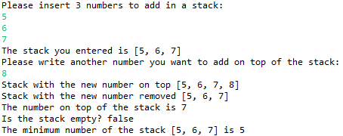

Task 3

Implementing a singly and doubly linked list using Java
“The LinkedList class[..] provides a linked-list data structure.” (Schildt, 2024)
For this part of the task, we had to implement a singly linked list and a doubly linked list, and for each list we had to create classes for the following operations:
1. insert_front(value)- to insert a new value at the front of the list
2. insert_end(value)- to insert a new value at the end of the list
3. delete(value)- to delete a value
4. display( )- to display the list
I created five classes, two for the Singly list, two for the Doubly and one main to show the operations.
The first one is the “Node” for the Singly Linked list:
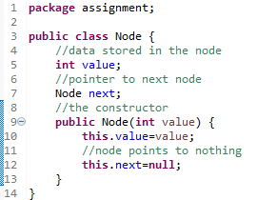

The second one is the “SinglyLinkedList”, which has all the operations and important code in:
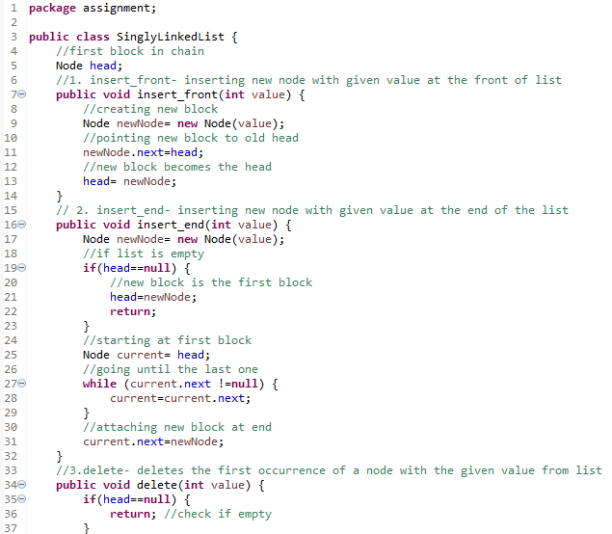
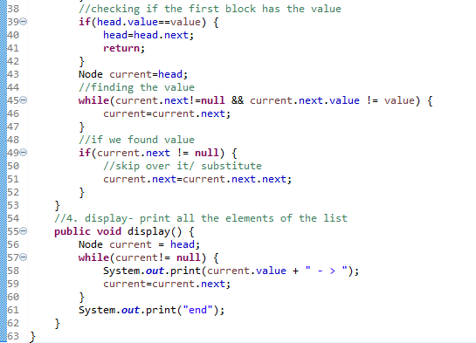
After, I created “Task3”, as a main program, where I put the values in the list. It is in 2 parts, one for the Singly list, and bellow is for the Doubly list.
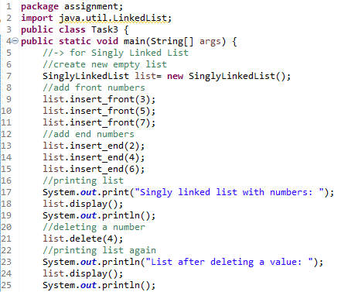

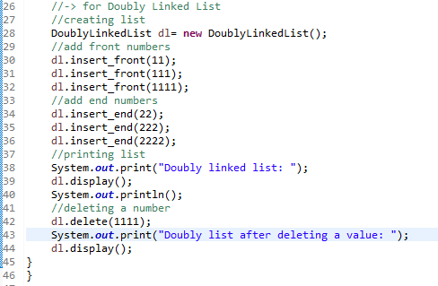

I also created a “DNode” class, for the Doubly linked list nodes.

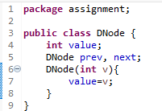

And a “DoublyLinkedList” one, that has all the important coding:
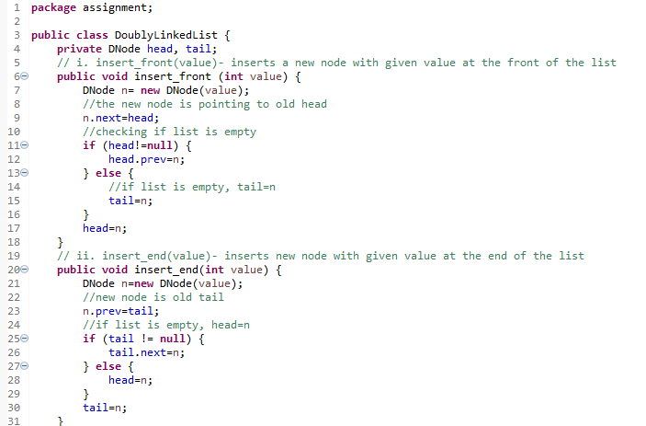
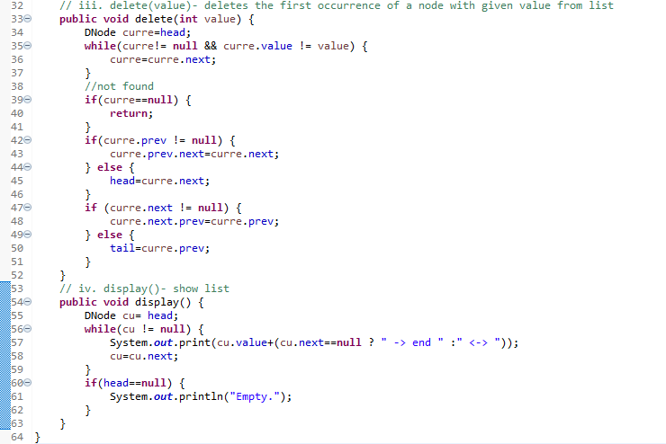

The final output was this:
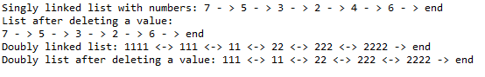
Every operation is working and the program does what is requested to do.

Implementing a Binary Search Tree using Java
For this part of the task, we had to implement a Binary Search Tree and go through these following operations:
1. insert(value)- inserting a new node with the given value
2. search(value)- searching for a node with the given value
3. delete(value)- deleting a node with the given value
4. in_order_traversal( )- performing an in-order traversal and returning a list of values in ascending order.
First, I created a “TreeNode” class in Java. I decided it was easier to put it separately then in the main program.
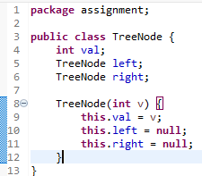
Then, I created a “BST” class, which contained all the main code for the tree.
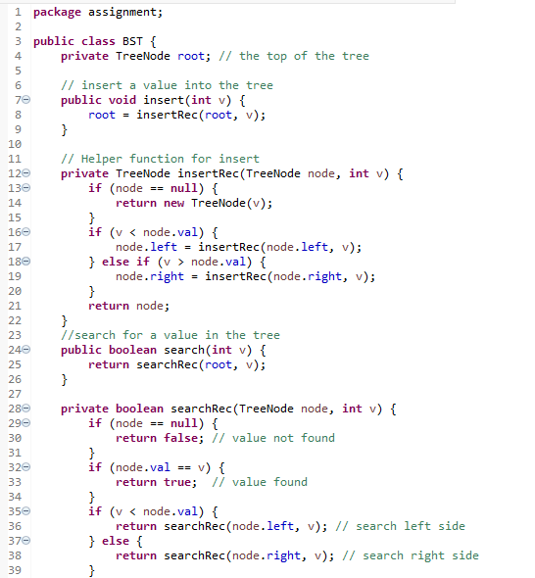
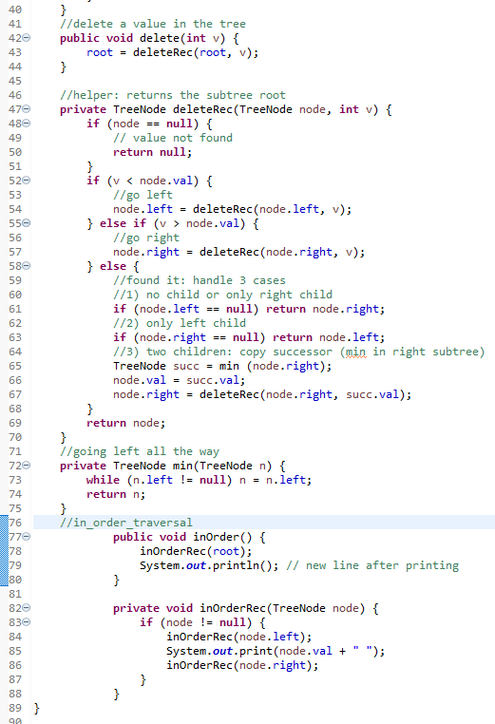

After I did this, I added in the class “Task3” the values of the tree itself and applied the code.
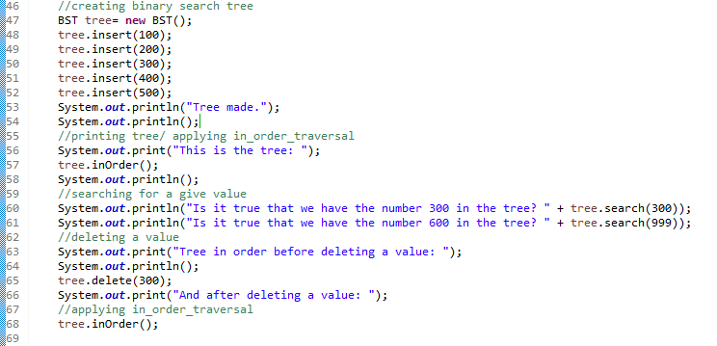
The out was the following:
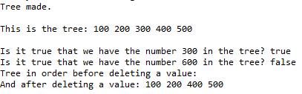
The code is correct, efficient and does what it is supposed to do.

Implementing a Java program for finding Adjacency matrix using a given graph
We were given the graph below to use for finding an adjacency matrix:
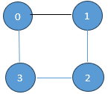
This is the code for it:
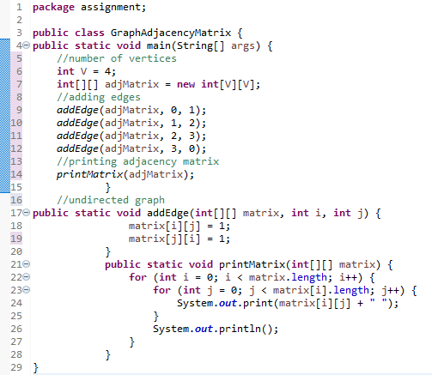
And this is the output:
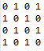

Task 4

Hash Map
For this part of the task, we have to implement a given code in Java of a simple Hash Map and answer the following:
i. explaining the use of “MapExample” class and its methods
ii. describing the process of inserting key-value into Hash Map
iii. demonstrating how to retrieve the value associated with “kumar”
iv. explaining the role of the “remove(key)” and how it can be useful
v. explaining the role of “containsKey” and how it can be useful
vi. provide a code snippet to print all keys and corresponding values
This is the code given:
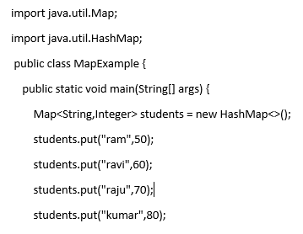
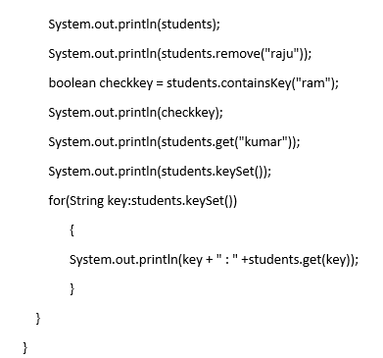
These are the answers for this part of the task:
i. The MapExample is a demo program that creates a HashMap called “students”. It shows how to add students and their marks using ‘put’; it deletes a student with ’remove’; it checks if a student exists through ‘containsKey’; it retrieves a student’s mark with ‘get’ and it prints all students with ‘keySet’ and a loop function.
ii. To be able to insert values into the HashMap, we use the function ‘put(key, value)’.
The ‘key’ is the student’s name, and the values are the student’s marks.
An example would be ”students.put(“ravi”, 60)”.
iii. To retrieve the value associated with the key “kumar”, we use the function ‘get’.
For example: students.get(“kumar”). After applying this, the output window should show the value “80”.
iv. The role of the ‘remove(key)’ in this Hash Map is to delete a student and their marks. For example: students.remove(“raju”) should erase “raju” from the map.
This is very useful for when we want to delete information from a map.
v. The role of ‘containsKey’ here is to check if the map has a student name, which is the key here. For example: if we write “students.containsKey(“ram”)”, the output shows ‘true’ if he exists, and ‘false’ if he is not there. This is very useful to apply before using the function ‘get’, because ‘get’ will return ‘null’ if the student doesn’t exist in the map.
vi. If we want to print all keys and corresponding values from the Hash Map, we can use a loop. The code would be this: for (String key: students.keySet()){ System.out.println(“Student ”key+” has the mark ”+students.get(key)+”. ”);}

Implementing an Array List using Java
This part of the task involved implementing anArray List with integer values and display the element under 50 using Iterator.
This is the code part:
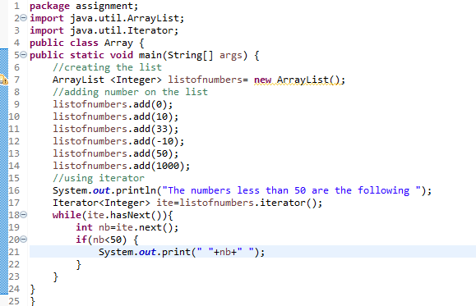

And this is the output:
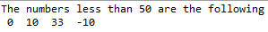

Time Complexity of put( ), get( ), and remove( ) in a List based Map
For this part of the task, we need to explain the time complexity for some functions in a list.
For the function ’put(item)’, because we have to go through the whole list to check if the key exists before inserting it, the time complexity is O(n). We go once through everything, so it’s linear.
For the function ‘get(item)’, we have to go through the list one by one until we find the matching key. That means linear complexity, so O(n).
For the ‘remove(item)’ function, we have to go through the list to find the item before you can remove it. That means the complexity is O(n), linear time.

References
Horstmann, C. S. (2024). Core Java, Volume 1. Boston: Pearson Education.
Karim, A. A. (2025). Stealing some Notation from Big O Notation to Develop a new Multithreading Priority Formula . Journal of Engineering and Technology for Industrial Applications, 236-242.
Phalke, S. V. (2024). Big-O Time Complexity Analysis of Algorithm. IEEE, 1-2.
Schildt, H. C. (2024). Java- The Complete Reference. New York: McGraw Hill Publishing.

