Software development and object-oriented programming applications
module: introduction to software development
student: he27721
Module tutor: Kawther rekabi
date: 3 November 2024
institution: regent college london
2024

Table of Contents

Introduction 2
Python programming 2
Student Registration System 2
Displaying specific designs 21
Java programming 27
Student record system 27
Conclusion 39
Self-reflection 39
References 39

Introduction

The purpose of this report is to showcase the understanding of object-oriented programming and some of the technical parts of software development.
The report will cover solutions to three programming tasks, two in Python and one in Java, which will be explained and discussed in the following chapters.
Firstly, a program design will be created using Python, that contains functions to create a student registration system.
Secondly, while still using the same language, another program will be created for the user to pick a design and show the chosen design on the screen.
Thirdly, in Java a program will be created for a student record system that contains student names, addresses, courses etc. that will be able to add new students and return and amend personal information.
Lastly, at the end of this report, there’s a ‘Self-reflection’ section that tackles the different issues that appeared during coding and a ‘Reference’ part which contains the resources that helped create this report.

Python programming

Student Registration System

This is the first programming task, designed using Python and it represents a student registration system that can add a student, save and retrieve the registered student’s details and it also implements error handling techniques.

Flow chart

The flow chart below shows in a simple way the logic behind the code.
When the user starts the program, a straightforward menu appears on the screen, with 4 choices: register a new student, view registered student details, modify registered student details and exit.
The user may pick any choice they want, according to their needs and when they are done, they can exit the program using the ‘Exit’ option.
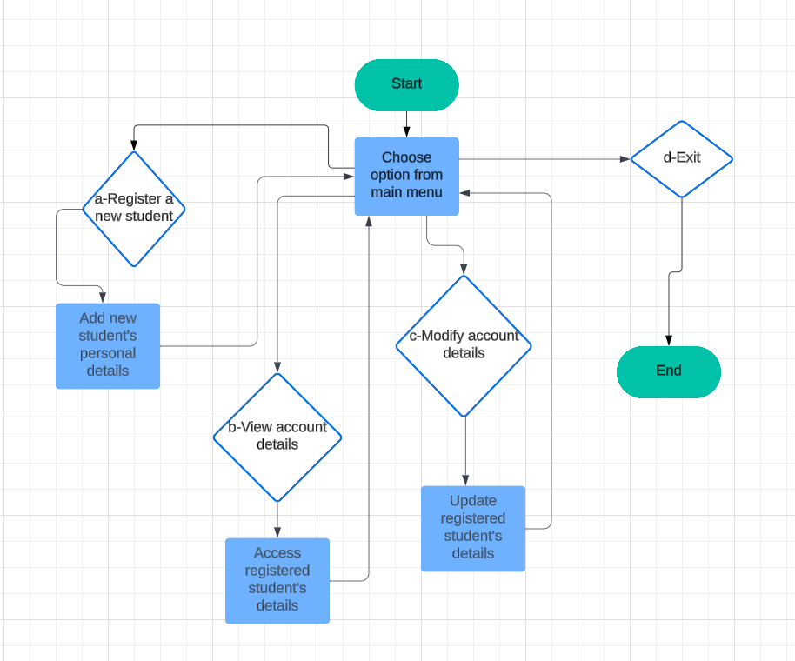

Design and code explanation and error handling techniques

The program has a simple and straightforward menu, very user friendly, for the user to choose what they want to do. It contains 4 options: ‘a-Register a new student’, ‘b-View account details for a registered student’, ‘c-Modify account details for a registered student’, and ‘d-Exit current program’.
The ‘Exit’ choice is present in case the user wants to choose different options without having to start the program again. The program will stop whenever the user wants to.

The output looks like this: 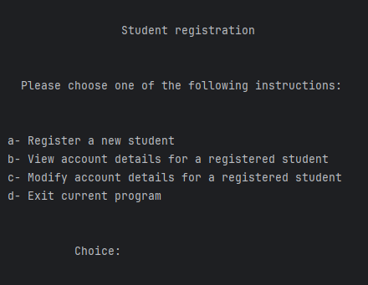
This is the code for the menu: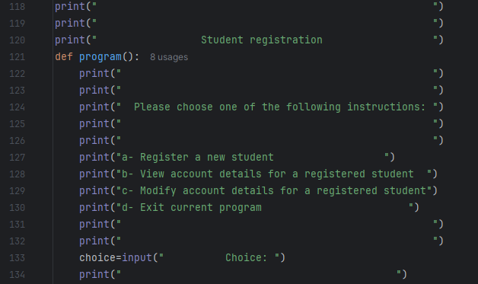
For each menu option, there is a function that does what the option says, and then a series of nested ‘if’s that verify the choice the user decided upon. Excluding option ‘d’, that if chosen it only shows on the screen a message, then exits the program. The functions are named: studentregistration, view_student_details_ and modify_student_details. Each of them are presented bellow. There are also error handling messages, in case the user choses an irrelevant option.
This is the code for the nested ifs, the ‘d- Exit’ option and the error message: 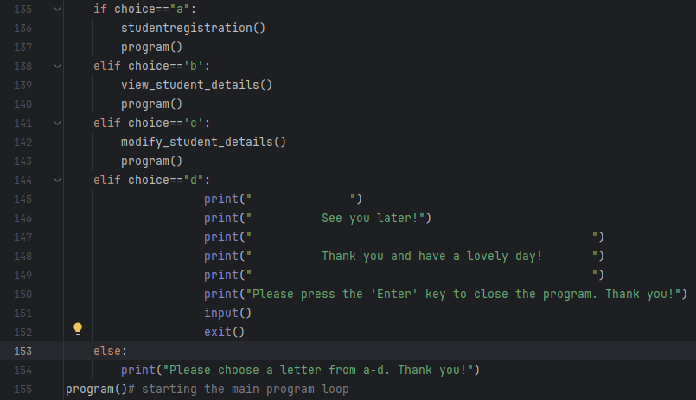This is the output for option ‘d’: 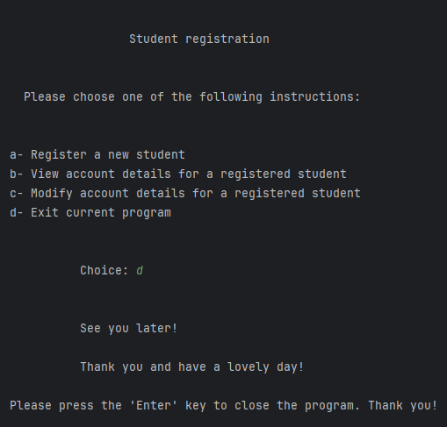
This is output in case the user puts in something else than the options available (it also brings the user back to the main menu): 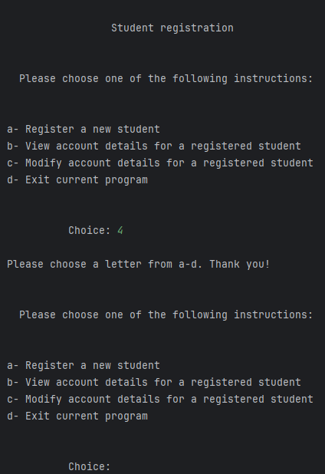
At the beginning of the code, there is a dictionary.” Dictionaries, often referred to as dicts, are an essential data structure in Python for organizing and storing data as key-value pairs. [..] Values in a dictionary are accessed using their corresponding keys.” (Cochran, 2024)
I used this to store the student data in it.
It contains the last name, first name, course and student ID of a registered student:
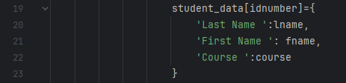
For option ‘a- Register a new student’, there is the function ‘studentregistration’, that helps the user to add a new student by name, course and id.
After some nested ‘if’s, we are allowed to store the data in the dictionary created.
There are 4 steps, 4 ‘if’s to pass to store the student data: last name, first name, course and ID number.
If the user puts the correct type of data in, they are allowed to move to the next step, if not, they will receive a message that tells them that what they put it is invalid, and they are taken back to the beginning. This is one of the error handling techniques present.
This is the code for the ‘studentregistration’ function. It starts with a message for the user: 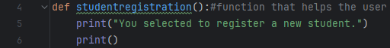
It continues with the ‘last name’ if: 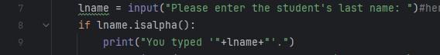
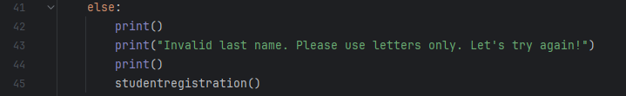
Followed by the ‘first name’ if: 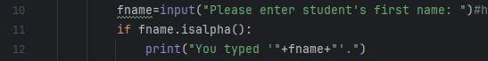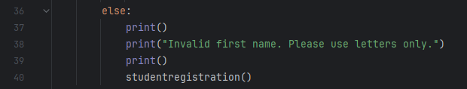
Next step being the ‘course’ if: 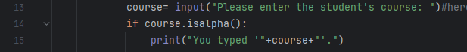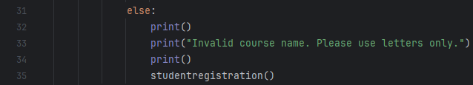
And, lastly, the ‘id’ if, which allows the data to be put in the dictionary and shows a message to the user with what they put in: 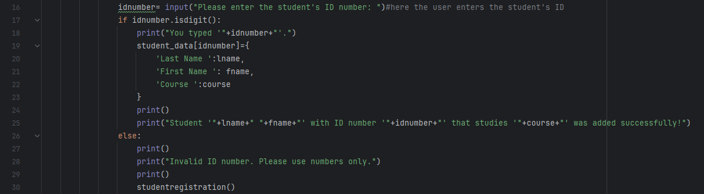
If everything is put in correctly, the output looks like this (it also takes the user back to the main menu in case they want to pick a different choice): 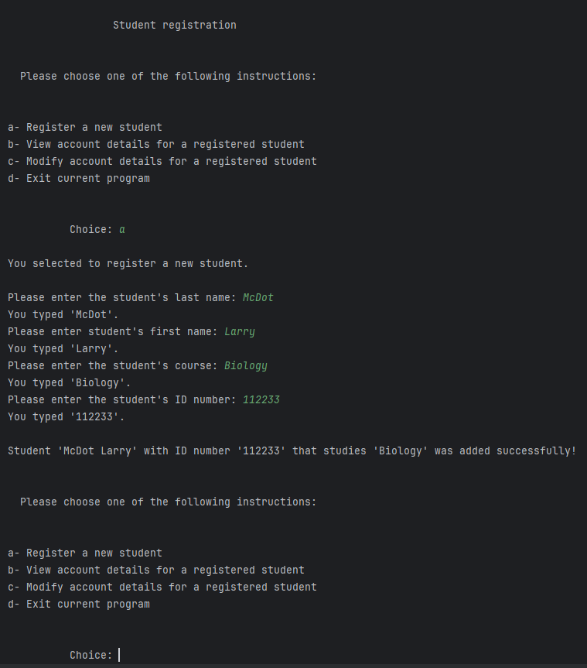
If the user makes miskes, depending on the mistake, the output will be one of these: 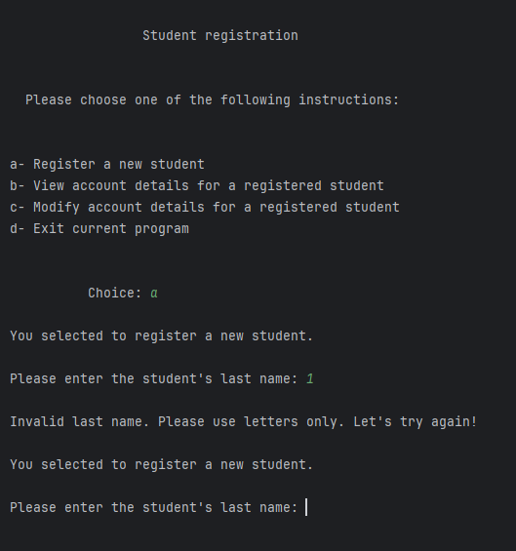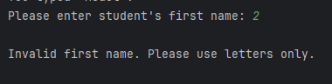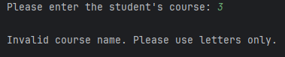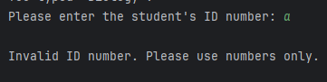
The second function is ‘view_student_details’. It allows the user to see a registered student’s data by accessing the dictionary ‘student_data’ where everything is saved. There is also an ‘if’ function, for error handling: 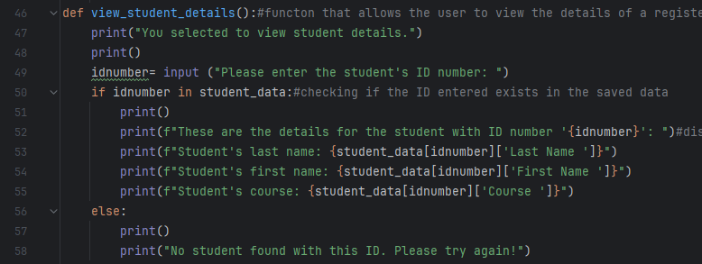
This covers option ‘b-View student account details for a registered student’.
I first added a student, then I wanted to view what I added. This is the output for ‘b’: 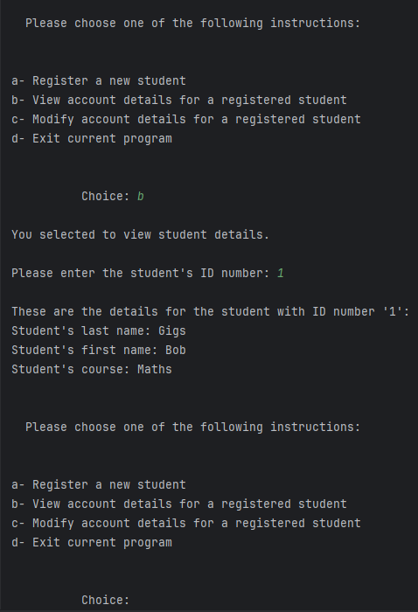
This is what appears on the screen if the user makes a mistake: 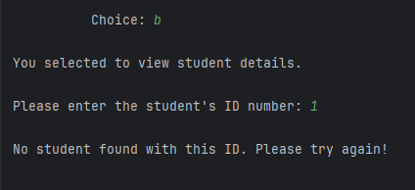
For option ‘c- Modify account details for a registered student’, there is a function ‘modify_student_details’. It allows the user to modify a registered student details using the student’s ID number. This is the code for that: 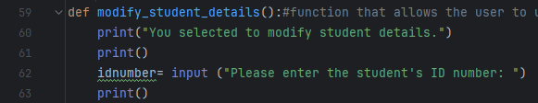
This is the output:
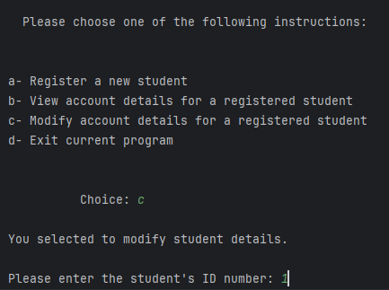
The user then gets to choose from a menu what detail they want to change: 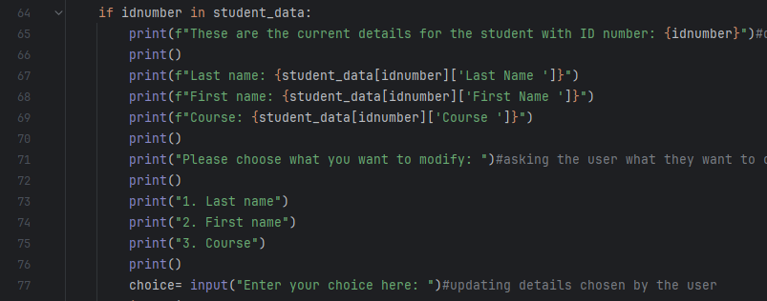
This is the output: 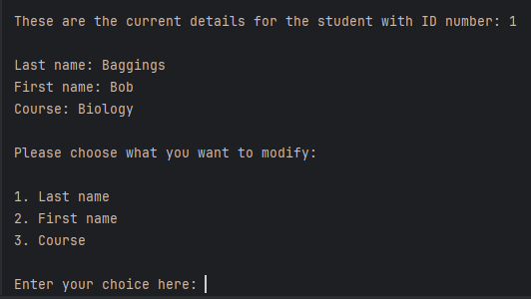
This is the output in case the user wants to change the last name: 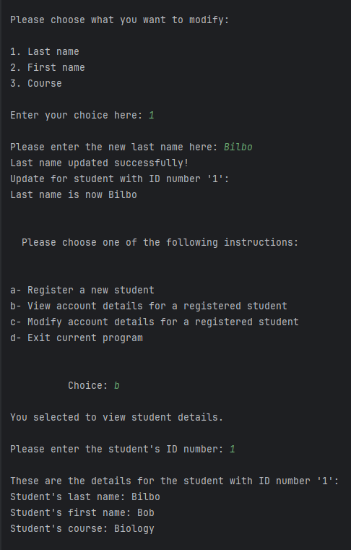
This is the output in case the user wants to change the first name: 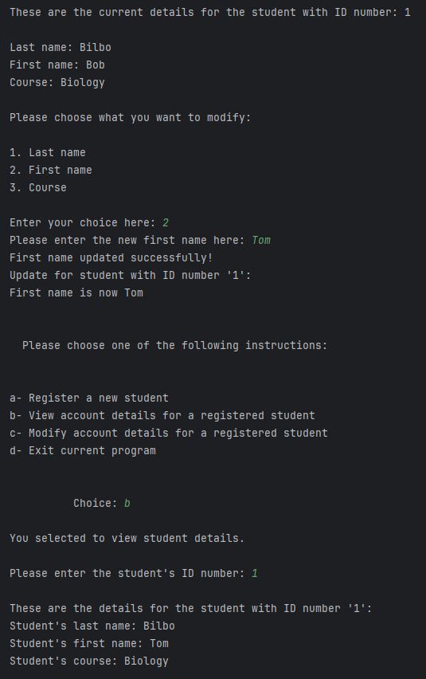
This is the output in case the user wants to change the student’s course: 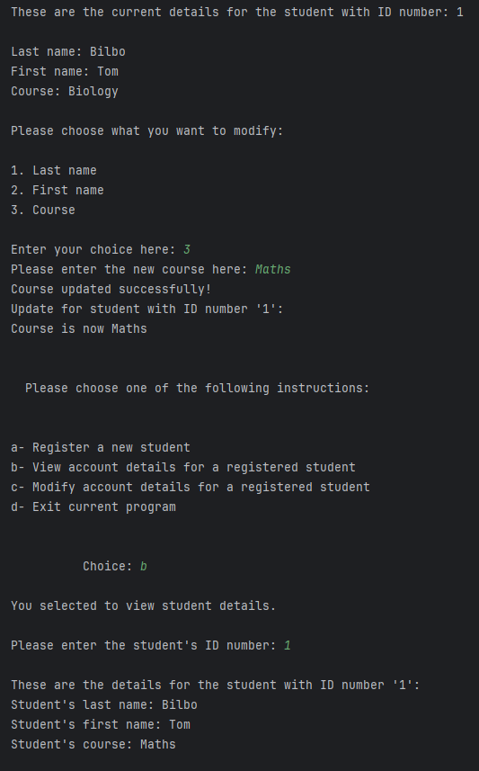
This is what happens when the user put’s an invalid choice: 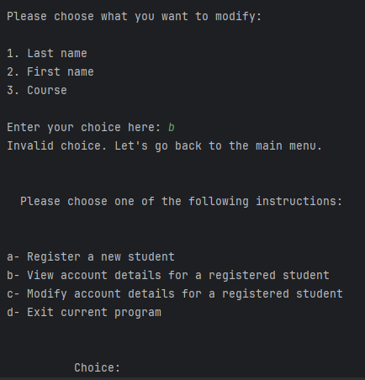

Displaying specific designs

Design and code explanation, including error handling techniques
This program displays on the screen 3 designs for the user to choose from.
It starts with a clear menu of choices. This is the code for it: 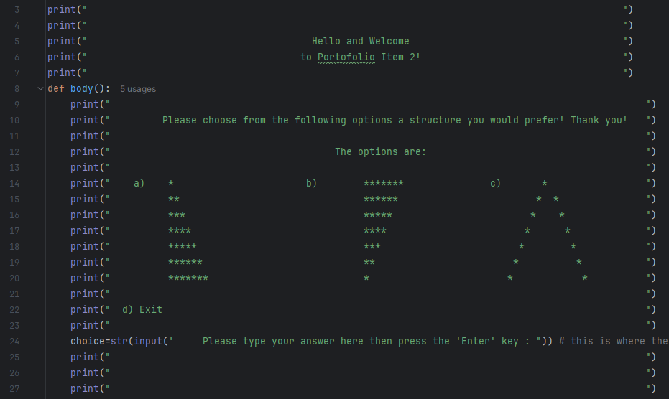
It’s simple, straightforword, clear and user friendly. It also includes an ‘Exit’ option because this menu will appear on the screen until the user decides to stop the program.
This option was added in case the user wants to see other designs, not just stop at one, if they choose to.
The number of rows the pattern has is 8, to not overwhelm the user with other choices than the design they prefer.
The output of the menu is this: 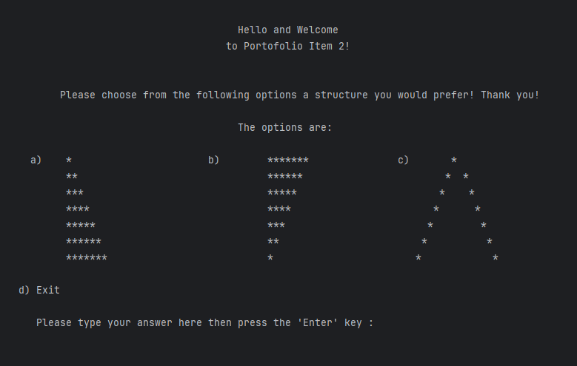
The code for option ‘a’ is this: 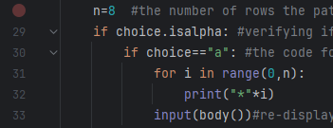
It starts with a nested ‘if’ and contains a ‘for’ function. “The most common type of flow control statement is the if statement.” (Sweigart, 2020)
The program checks if the user added a letter, if the letter is option ‘a’, and if it is, it uses the ‘for’ to print stars, for every row, the same number of stars.
The output for option ‘a’ is this: 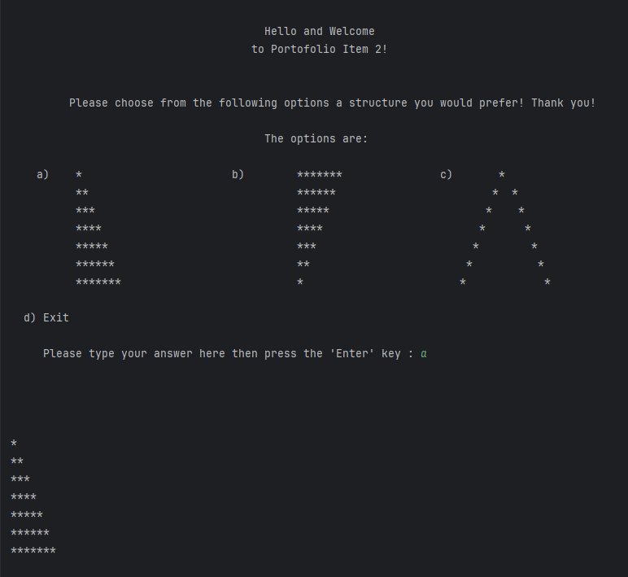
The code option ‘b’ continues the nested ‘if’ and also contains a ‘for’ function: 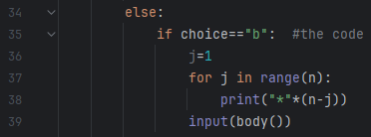
The code here checks using an ‘if’ that the option is ‘b’, and with a ‘for’ function, it displays stars as so: the number of stars on the first line is equal to the maximum number of rows and it decreases as it moves to a different line until it’s finished.
And this is the output: 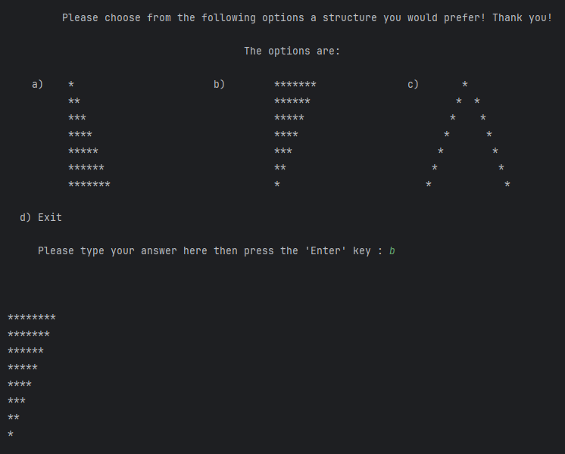
The code for option ‘c’ is: 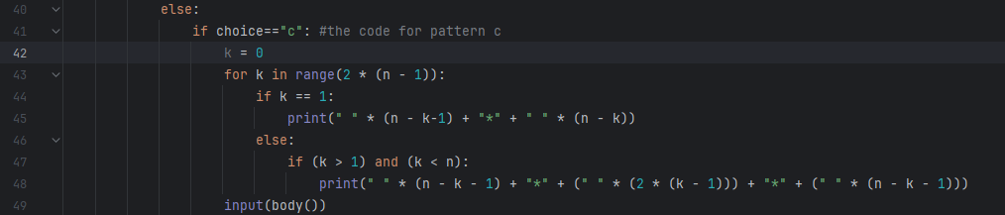
Here, the code verifies if the choice is ‘c’ through an ‘if’.
Within a ‘for’ function, the triangle was split in 2: the first line and the rest of the triangle body. The principle behind it is simple: print space, then stars, then space again, from top to bottom. The first line is the top of the design.
And this is the output: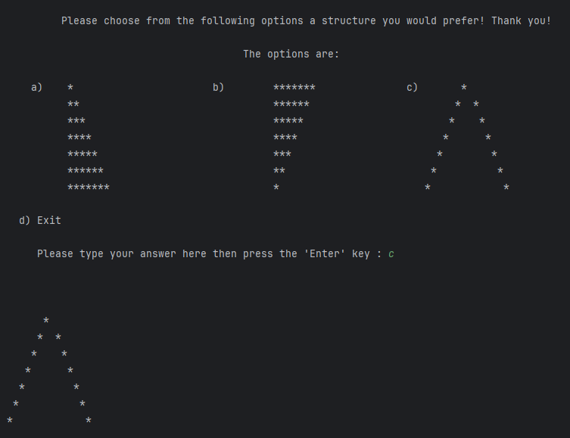
As for error handling, there is a messsage in case the user doesn’t put in a valid option. The code for it is:
The output looks like this: 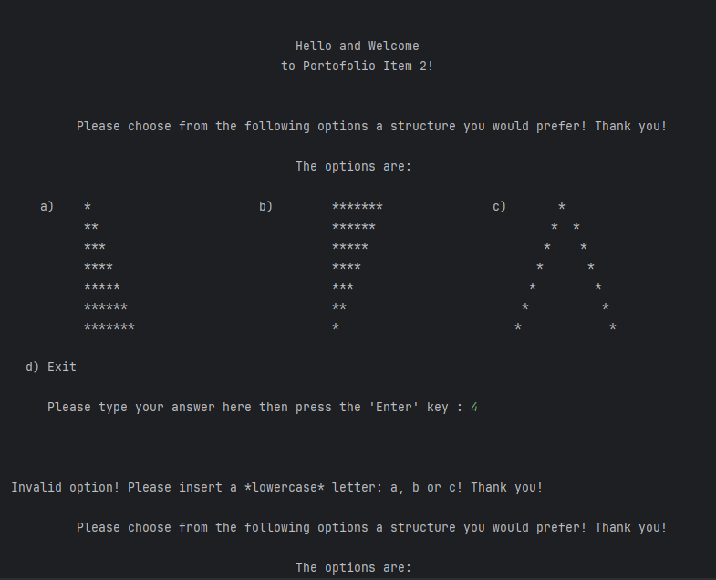

Java programming

Student record system
This program is a simulation of a student record system, using the Java programming language, that allows the user to add a new student, retrieve a registered student’s information, amend a registered student’s information and show the details of all students. “It is important to state at the outset that Java is a strongly typed language.” (Schildt, 2024)

Class diagram
“Classes and interfaces lie at the heart of the Java programming language.” (Joshua, 2018)
I made a simple class diagram that represents the idea of the program designed: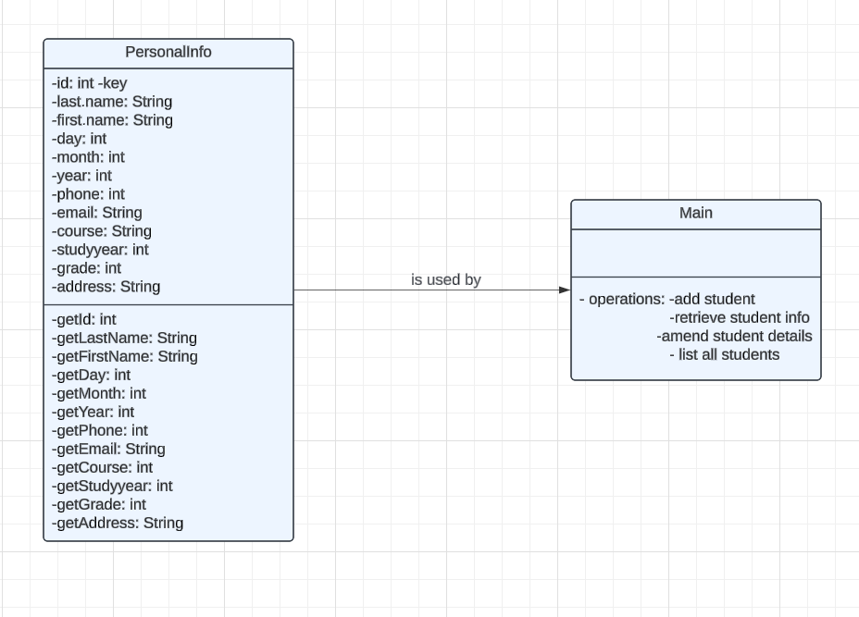

Design and code explanation

The design is simple, there is a menu that includes what the brief asks for: to add a new student, retrieve student information, amend student details, show all student details and exit.
It’s basic, very user-friendly to not exhaust the person using the program, and to offer the possibility of choosing whatever option they want until they are done, then exit the program.

This is the code for the menu: 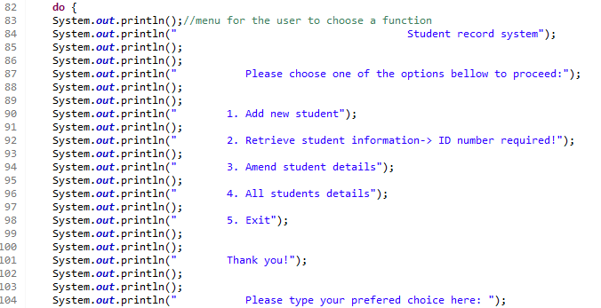
And this is the output: 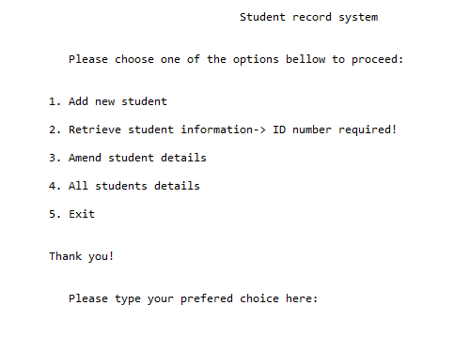
For option ‘1- Add new student’, I created another class to hold the student information the user is required to put in. It saves and returns the data, and this is the code for it: 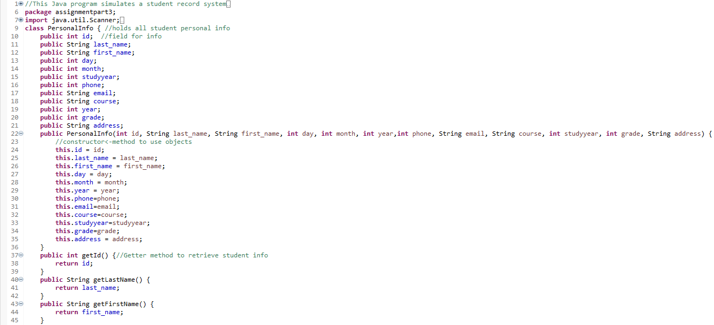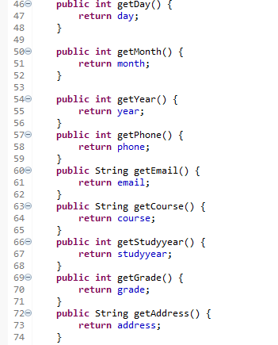
There is an if for the user’s choices, and for the first option, the code is: 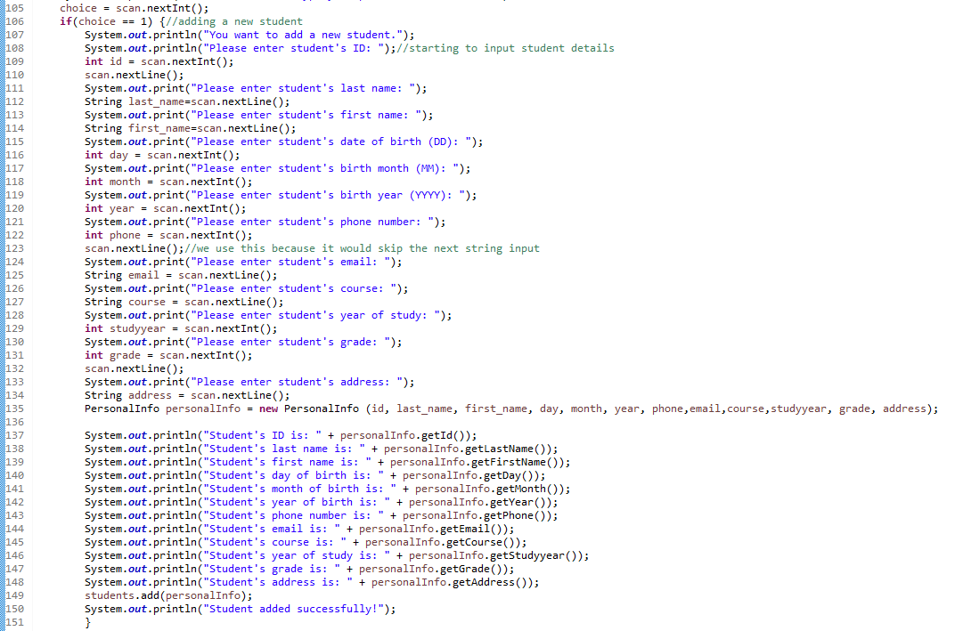
And the output is: 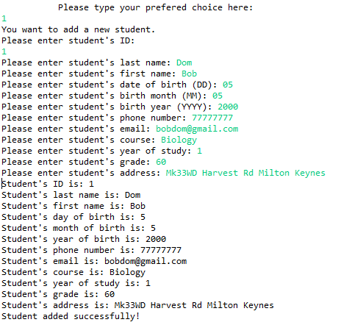
For option ‘2-Retrieve student information’, the user has to have the student’s ID to look for the information, and this is the code: 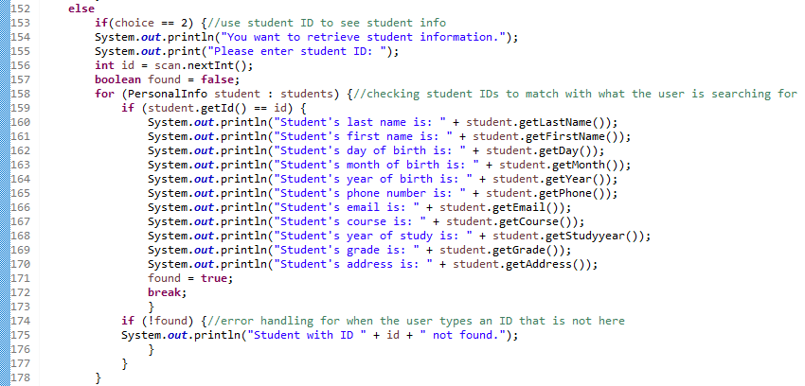
This is the output: 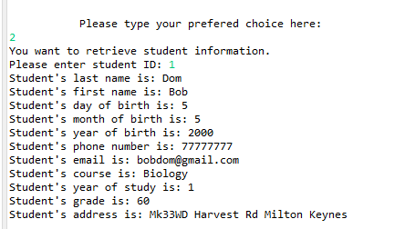
For option ‘3-Amend student details’, the user has to know the student ID to be able to change anything they would like about the student. There is another menu for the user to choose what they want to change. The code for all of this is the following: 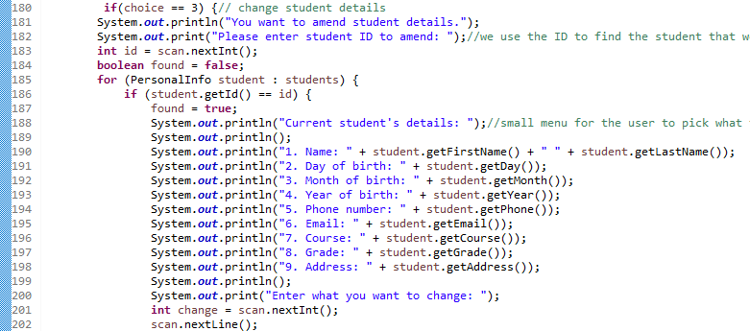
There is a switch function to implement the user’s choice: 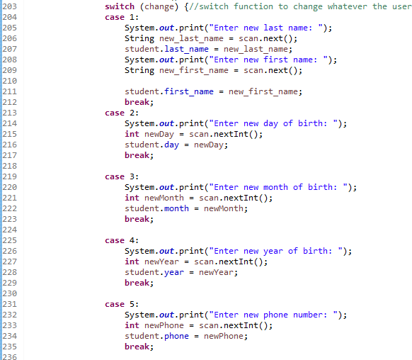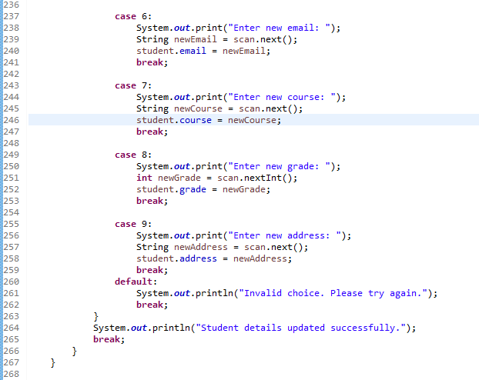
It also includes a message as an error handling technique: 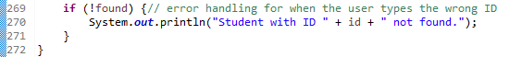
The output is: 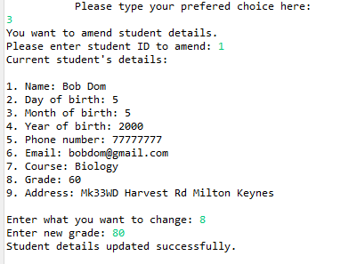
And here is the proof the data changed: 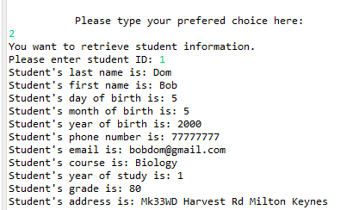
For option ‘4-All students details’, there is an array to put in student details, then a for function to access all of them. There is also a message in case there are no students in the system, as an error handling technique. This is the code: 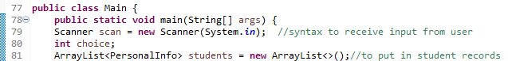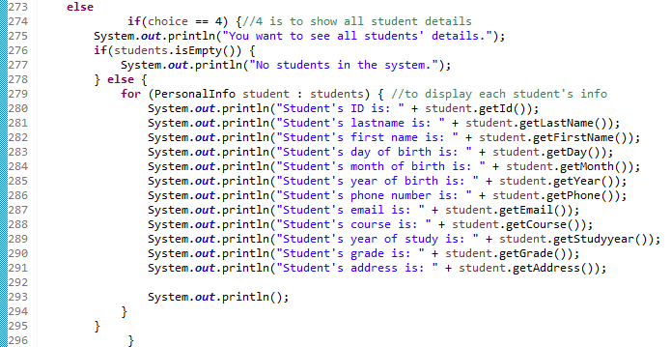
There was another student added to show that the function is working properly. This is the output: 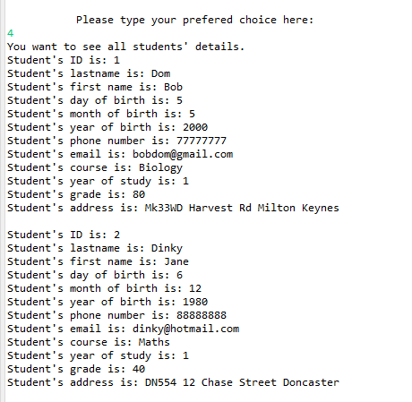
The last option, ‘5-Exit’, is for the user to exit and close the program. This is the code for it: 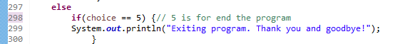
And this is the output: 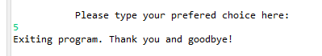
And a last error handling technique, with code and output, after which we close the rerun of the menu: 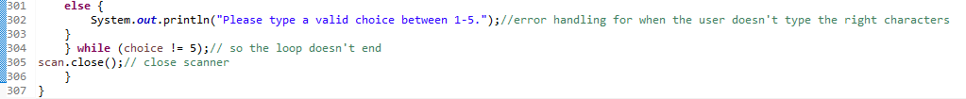
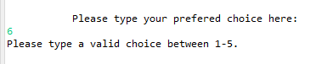

Conclusion
All the programs designed, created and presented here are fulfilling their requirements as per the assessment brief.
The program created in Python for the student registration system saves, retrieves and modifies student details.
The one created with the same language, that displays triangular shapes is also working properly and does what it is asked to do.
The Java program that simulates a student record system allows the user to add a new student, retrieve and amend the details of a registered student and shows the details of all the students registered. It also uses multiple classes, and contains inheritance and encapsulation principles, as per request.
All the programs have error handling techniques implemented.

Self-reflection
The issues encountered were with the design pattern program in Python, more specifically, the last one of the triangle designs.
Firstly, I didn’t know how to create an empty triangle. I researched the internet, I looked up tutorials, already made coding and even Chatgpt. While I did find some solutions, when I copied the code and applied it, it wouldn’t show the pattern needed and I couldn’t understand the logic behind it.
Because of that, I decided to come up with my own solution. What I did was add 3 parts for the function to print: the space, the stars and then space again. I used another variable, k, for that.
But then, another problem appeared: the first line would print 2 stars instead of one, so I created a separate line for that, and it sorted out all the issues.

References

Cochran, A. P., 2024. Python programming and SQL. 1st ed. Great Britain: Amazon.
Joshua, B., 2018. Effective Java. 3rd ed. USA: Pearson Addison-Wesley.
Schildt, H. D. C. D., 2024. Java: The Complete Reference. 13 ed. USA: McGraw Hill.
Sweigart, A., 2020. Automate the boring stuff with Python. 2nd ed. San Francisco: no starch press.

