Pre-flight Experiments for Biorack.

Our first studies showed that the osteoblast was sensitive to gravity (1), with growth inhibition and changes in cytoskeleton and nuclear morphology.
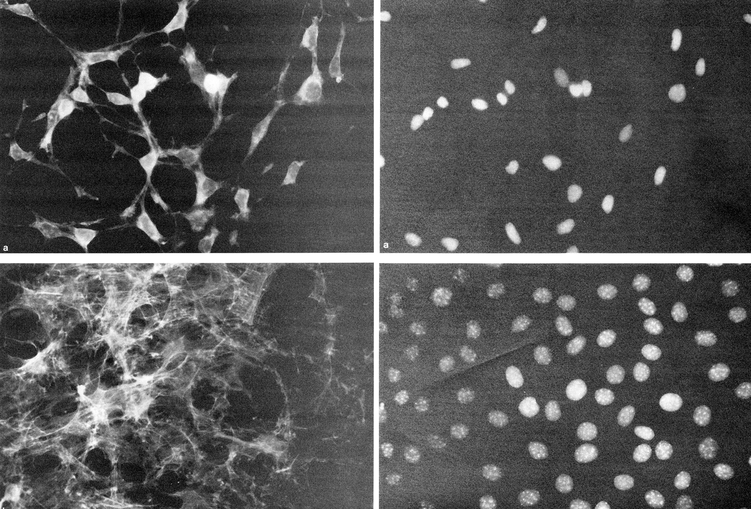
μG

Gr
Actin cytoskeleton Nuclei
Figure 1. Osteoblasts were grown for 4 days either in microgravity (μG) on in normal Earth gravity (Gr). Osteoblasts were stained with Rhodamine-Phalloidin (for actin cytoskeleton) or with Hoechst (for nuclear DNA). Images are reproduced from one of our publications (1). Glucose utilization per cell was the same for both environments.

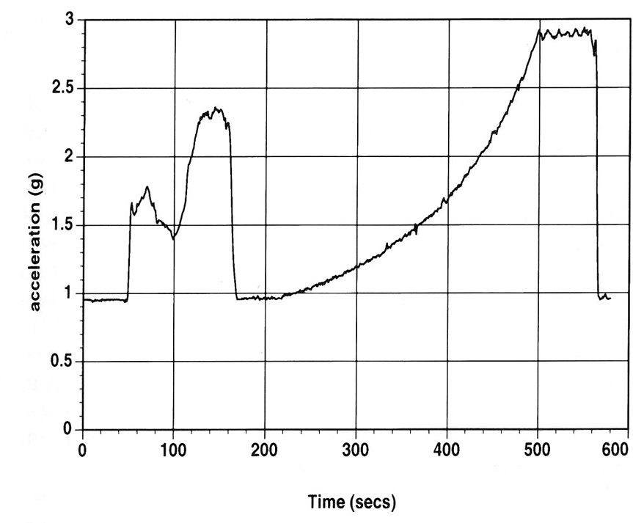
In the next set of pre-flight experiments, we asked the question “ will the gravitational forces of launch affect our osteoblasts?” Using our Biorack hardware, we subjected the osteoblasts to a launch force profile for the 10-minute period simulating the Shuttle reaching orbit. The gravity profile is shown in Figure 2 to the left.

Within 30 minutes of the gravity forces, we saw changes in the gene expression of the osteoblasts. There were significant upregulation of the immediate early gene,
c-fos and also, we saw a change in the expression of the osteocalcin gene as seen in Figures 3 and 4 below.

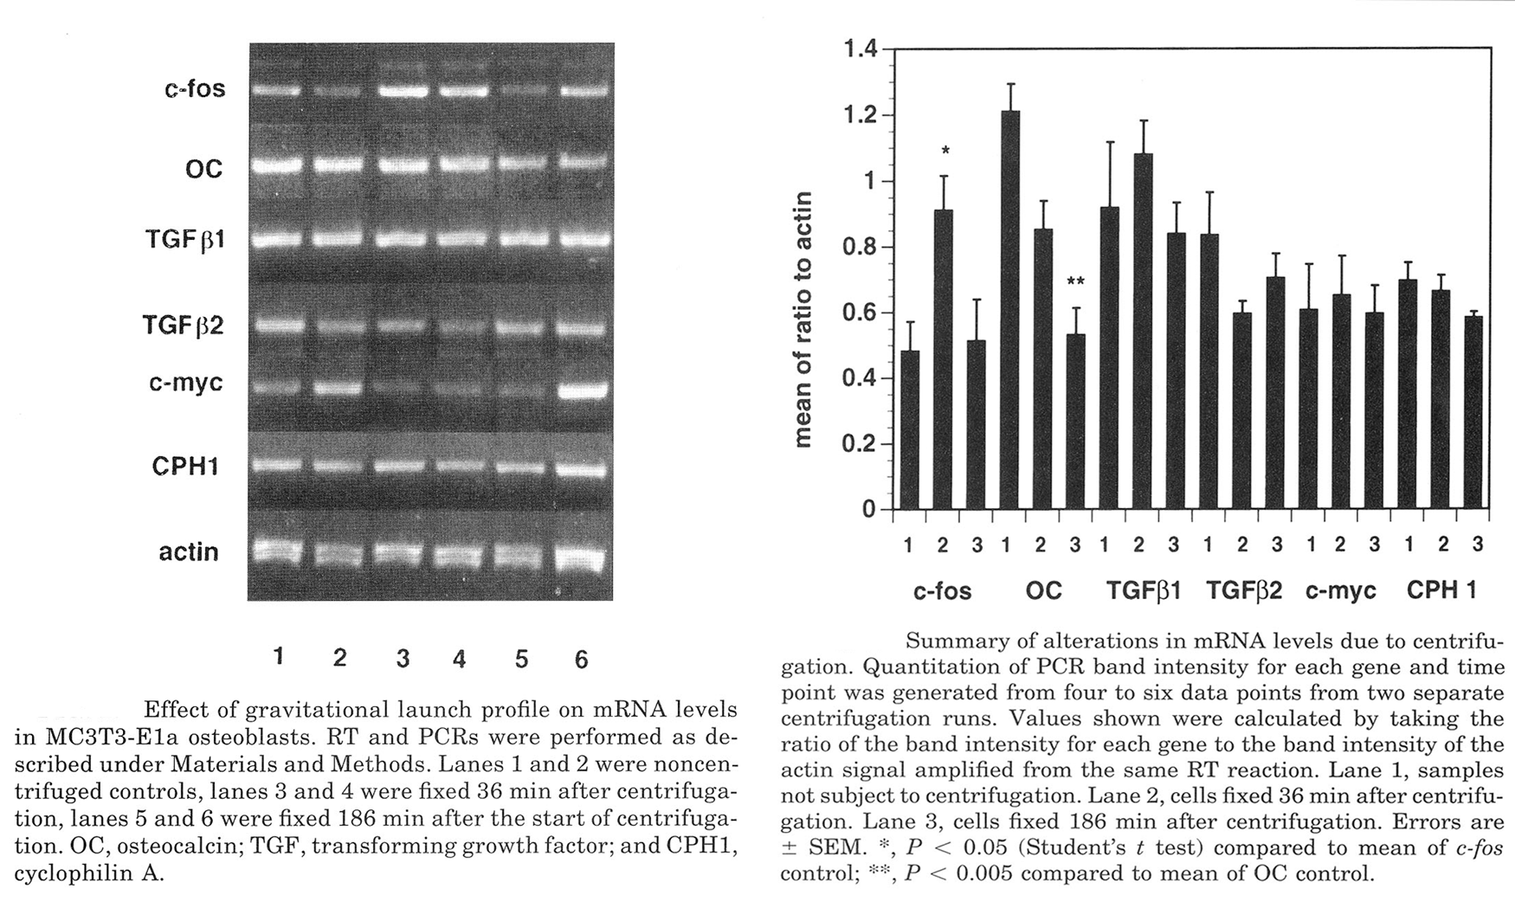
Figure 3 Figure 4

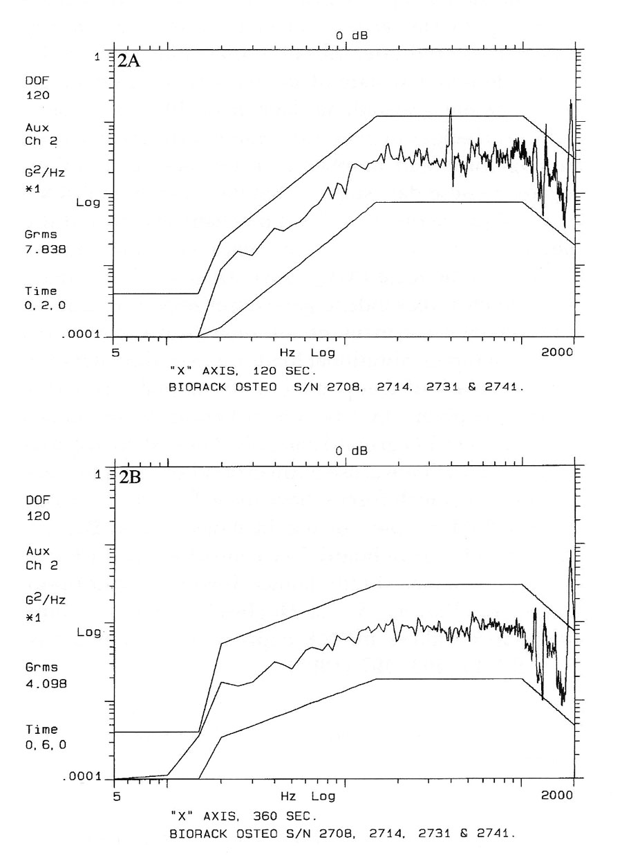
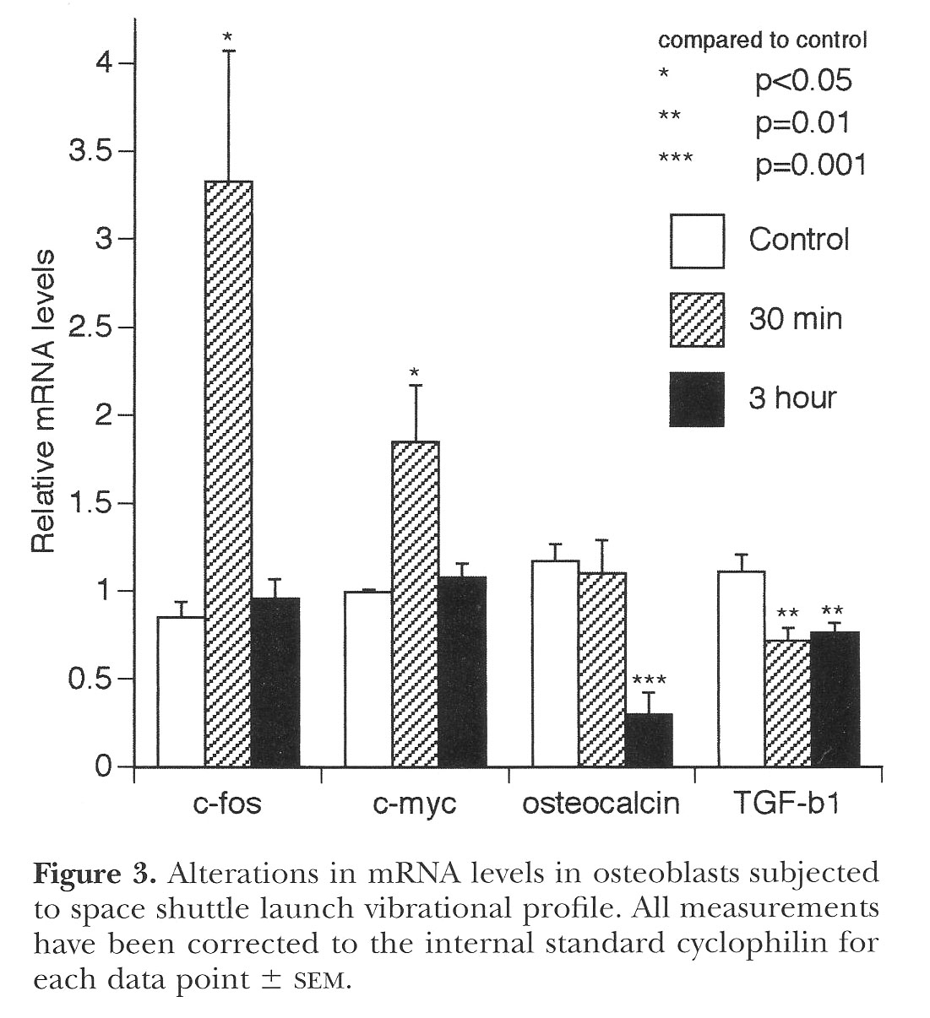
We also found that the vibration of launch can also induce the early immediate genes, specifically c-fos, and c-myc. Osteocalcin and TGFb messages were downregulated with vibration (2). Details of this experiment can be found in the publication (2).
Figure 5: Vibrational launch profiles Figure 6: Changes in gene expression with vibration

From these preflight data, we found that the effects of launch both vibrational and gravitational forces can cause changes in the osteoblast and we therefore sent our experiment up with quiescent cells to minimize these effects. The experimental protocol for the Biorack was as follows:
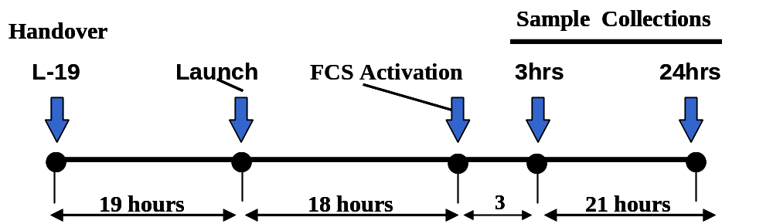

Of course, because spaceflight is not always a predictable laboratory, there were sometimes changes in collection times, some were collected as earl as 30 minutes early (e.g. 2.5 hrs instead of 3 hrs) and some were collected late (e.g. 27.5 hours after FCS activation), but all were collected at acceptable times for analysis.

Microgravity Data:
Some cellular responses are not altered in microgravity The OSTEO experiments were conducted in the ESA BioRack equipment. BioRack is a multi-user facility consisting of incubators with variable gravity centrifuges, a cooler, a freezer and a sealed glovebox. Two identical BioRack modules were used: one Ground Model remained on Earth, the other was flown in SpaceHab on the Shuttle. BioRack has an important advantage over other microgravity facilities in that it provides a small radius (78 mm) slow rotating (107.0 =/- 0.5rpm) centrifuge. This allows a 1-G on board control. Because of proximity, both the 0-G and 1-G samples experience identical launch vibrations, accelerations, cosmic radiation and other unknown conditions in the flight. The only difference between the flight groups is the gravity parameter,
n = 4 for all samples.
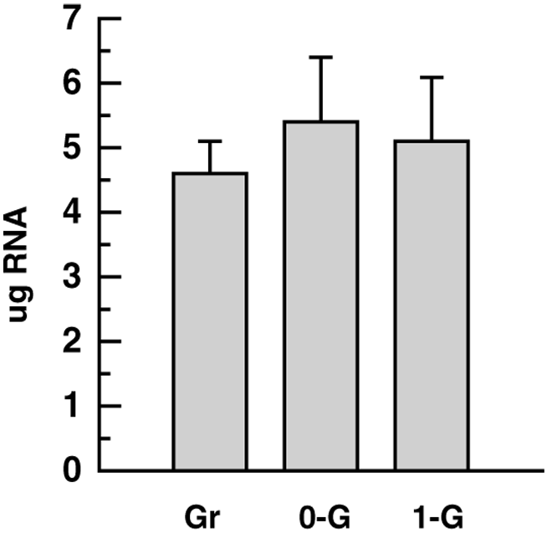
Figure 7: No change in total RNA synthesis in spaceflight: Overall mRNA synthesis is not altered but specific transcriptional genes expression are altered: The mechanisms by which mammalian cells respond to gravitational signals are unknown. Several reports have described gravity-specific changes in mRNA levels following exposure of cultured cells and whole animals to varying periods of microgravity in experiments performed in spaceflight, sounding rockets and clinostats. We examined sera activation of quiescent cells for gravity-dependent changes in mRNA levels for several genes involved in bone cell growth and maturation On the left is a graph of the relative micrograms of total RNA recovered from flight samples. There were no significant differences between the samples. Gr = ground; 0-G=microgravity and 1-G is the onboard 1G control (3). In fact, it is significant that even though there are known changes in convection and diffusion in a 0-gravity environment, that was not reflected by this biological process.

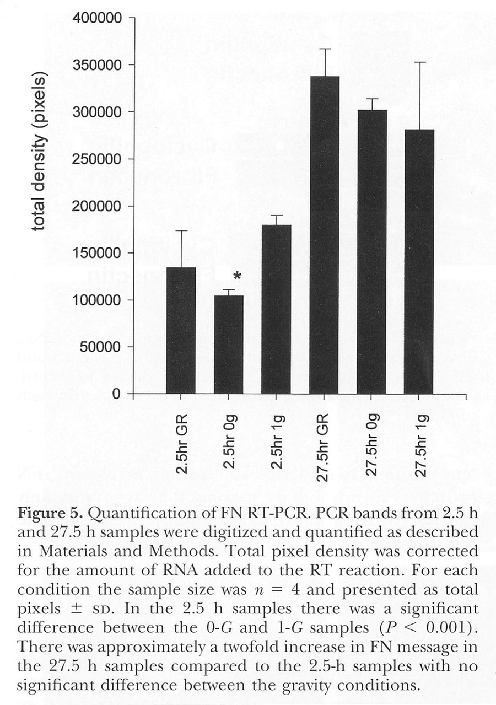
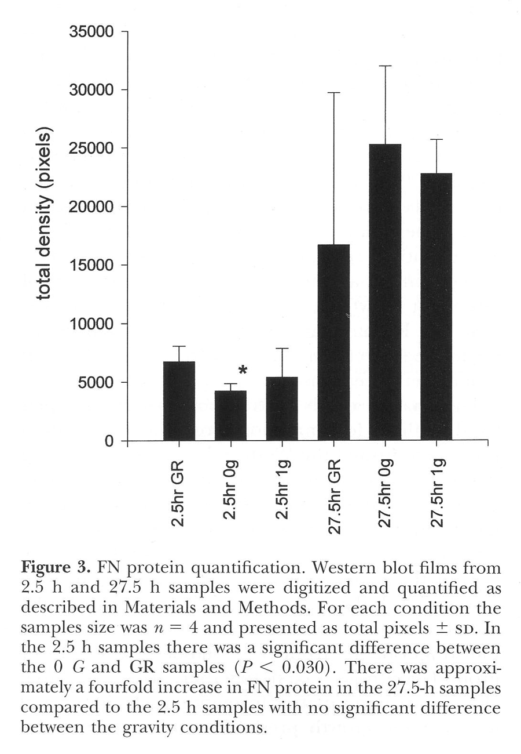
In our Biorack experiments another surprising finding was that the cell shape change seen in our original 1996 spaceflight experiment was most likely not due to changes in fibronectin matrix. Samples from STS 76, 81 and 84 showed no difference in the fibronectin mRNA after activation (4).
Figure 8: FN mRNA expression in osteoblasts Figure 9: FN Protein synthesis in osteoblasts
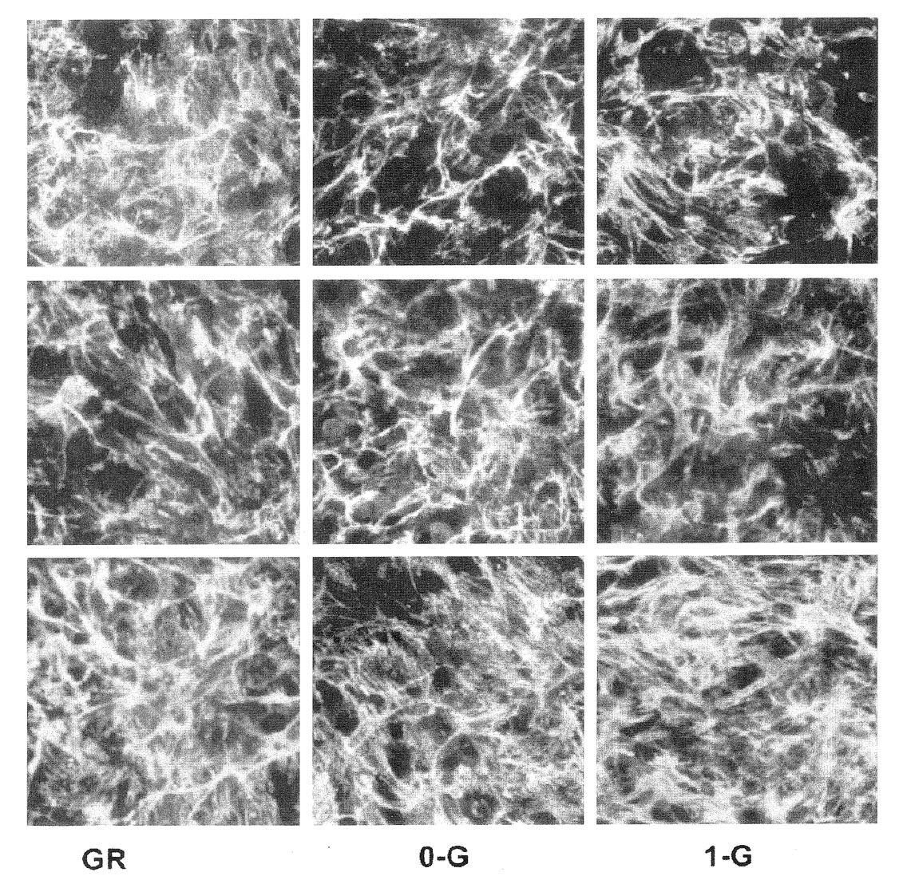
In addition to the lack of significant changes in fibronectin mRNA and protein synthesis, as seen in Figure 10, the matrix formation was also not altered by the microgravity condition (4).

Figure 10: Immunofluorscence localization of FN in MC3T3-E1 osteoblast cultures grown on Earth (GR), in microgravity (0-G) or in an on board 1-gravity centrifuge (1-G). Cells were seeded on non-treated glass coverslips and grown in 10% FCS over night. Cells were sera deprived before launch and sera activated in microgravity 19 hours after launch. 27.5 hours after activation, while still in microgravity, cells were fixed with formaldehyde. Cells were stained with an anti-FN primary antibody and then with anti-rabbit secondary labeled with Texas Red. Photographic exposure times and conditions were identical using 100x objective.

Systems that are affected by microgravity: Fetal Calf Sera stimulates production of PGE₂, and osteoblast growth, surprisingly, in spaceflight, there was a stimulation with FCS, however, there is no growth stimulation accompanying the rise in PGE₂ content.

Time | Ground | ug | 1-G flight
0 hr | 417 ± 163 | 532 ± 189 | 451 ± 197
3 hr | 4180 ± 380 | 6447 ± 1760* | 6157 ± 668*
29 hr | 3904 ± 1693 | 6959 ± 1132** | 6065 ± 870**
Media alone | 41 ± 6 |  | *P < 0.05  ** P < 0.001

We have previously shown that our early passage MC3T3-E1 cells are directly sensitive to gravity mechanical loading (1) or vibrational stress (5). Studies from this laboratory published this spring (6) demonstrate that the mechanical transduction of c-fos in osteoblasts can be inhibited by specific inhibition of PKA. Using deletion mutants of the c-fos promoter region, our recent studies (7) show that the effect of PGE₂ on the osteoblast is also mediated by cAMP, presumably through the EP4 receptor. Therefore the central point of signal transduction for both mechanical transduction (either by G-protein activation, cytoskeleton or SSRE) or by eicosanoids is going through c-AMP mediated pathway(7, 8). Results reported in the 2000 Endocrinology paper suggest that the CRE element is a key player in the mechanical stress induced immediate early gene expression of the osteoblast.

Surprisingly, cox-2 gene expression is also affected by microgravity, however normal feed forward induction of the message is lost in microgravity (e.g. PGE₂ does is not able to increase cox-2 expression) .

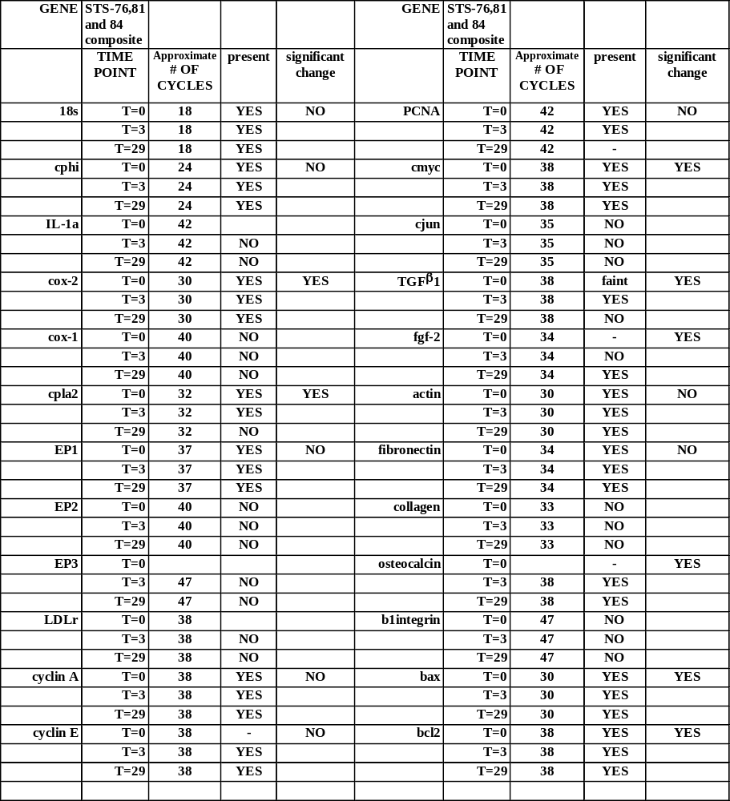
Table II: Altered Gene expression in microgravity Osteoblast gene expression in microgravity. Osteoblasts were flown on the Shuttle in a quiescent state, after insertion into orbit, the cultures were activated with FCS. Semi-quantative RT-PCR analysis was measured at cycle number noted. . Many of the genes that had significantly changed expression in microgravity are early pleotipic genes that normally are increased by growth factors found in FCS. Significant changes at the collection timepoints are noted (n=4).

Changes occur in osteoblast growth activation in microgravity. As was noted inTable1, the osteoblast responds to gravity stress by releasing the membrane bound arachidonic acid (AA). This essential fatty acid is converted to eicosanoids, either prostaglandin by the enzyme cox-2 or PGI2 by prostacyclin synthase. The eicosanoids are then released from the cell and stimulates eicosanoids receptors like EP, which turns on the PKC pathway and/or the PKA pathway signals. Blocking either of these signals can block new bone growth. MC3T3-E1 osteoblasts were used to study bone cell growth in spaceflight. Osteoblasts were launched on the Shuttle in a quiescent state and were activated by adding fresh medium with 10% FCS in microgravity (10⁻⁶ to 10 ^{–9}g). The cox-2 should have been induced in microgravity, however it was not.

Figure 11: Confirmation of changes in morphology in osteoblasts exposed to microgravity on the Shuttle in Biorack experiments:

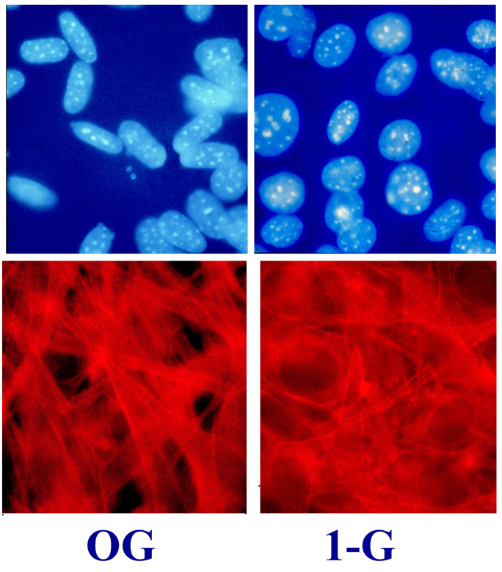
The cytoskeleton of the flight osteoblasts have a reduced number of stress fibers and a unique abnormal morphology. Nuclei in the ground controls were large and round with punctate Flight samples were elongated. Hoechst staining of the DNA nucleosomes show that the cells are viable, however the shape changes in microgravity. Studies on glucose utilization provide further evidence that the cells have same energy utilization.

Growth is reduced: Flown osteoblasts grow slowly in microgravity with total cell number significantly reduced in the microgravity samples;
55 ± 6 in 0-G vs. 141 ± 8 cells (1).

Overall, the prostaglandin pathway in the osteoblast does not respond normally to FCS stimulation in microgravity, having lost it’s feed forward mechanism of action. The cause underlying the loss of feedforward regulation is currently unknown and is under investigation.

1. Fitzgerald, J., and Hughes-Fulford, M. (1996) Gravitational loading of a simulated launch alters mRNA expression in osteoblasts. Exp Cell Res 228, 168-171.
2. Tjandrawinata, R. R., Vincent, V. L., and Hughes-Fulford, M. (1997) Vibrational force alters mRNA expression in osteoblasts. Faseb J 11, 493-497.
3. Hughes-Fulford, M., Tjandrawinata, R., Fitgerald, J., Gasuad, K., and V, G. (1999) Effect of microgravity on osteoblast growth activation: Analysis of transcription, translation and morphology. In Biorack on Spacehab: biological experiments on three Shuttle-to-Mir missions. (Perry, M., ed) Vol. ESA Publ. Div. pp. p. 25-32., European Space Agency SP ; 1222, Noordwijk, The Netherlands
4. Hughes-Fulford, M., and Gilbertson, V. (1999) Osteoblast fibronectin mRNA, protein synthesis, and matrix are unchanged after exposure to microgravity. Faseb J 13, S121-127.
5. Tjandrawinata, R. R., Dahiya, R., and Hughes-Fulford, M. (1997) Induction of cyclo-oxygenase-2 mRNA by prostaglandin E2 in human prostatic carcinoma cells. Br J Cancer 75, 1111-1118
6. Barry, O. P., Kazanietz, M. G., Pratico, D., and FitzGerald, G. A. (1999) Arachidonic acid in platelet microparticles up-regulates cyclooxygenase- 2-dependent prostaglandin formation via a protein kinase C/mitogen- activated protein kinase-dependent pathway. J Biol Chem 274, 7545-7556.
7. Fitzgerald, J., Dietz, T. J., and Hughes-Fulford, M. (2000) Prostaglandin E2-induced up-regulation of c-fos messenger ribonucleic acid is primarily mediated by 3',5'-cyclic adenosine monophosphate in MC3T3-E1 osteoblasts. Endocrinology 141, 291-298.
8. Fitzgerald, J., and Hughes-Fulford, M. (1999) Mechanically induced c-fos expression is mediated by cAMP in MC3T3-E1 osteoblasts. Faseb J 13, 553-557.

