Question 1

public void PrintAllNum()

{

int num1;

Console.WriteLine("Give a number : ");

num1 = Convert.ToInt32(Console.ReadLine());

Console.WriteLine("Result: ");

for (int i = 0; i <= num1; i++)

{

Console.WriteLine(i);

}

}

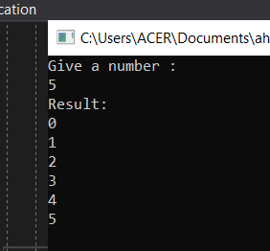

Question 2

public void DetermineOddOrEven()

{

int num1;

Console.WriteLine("Give a number : ");

num1 = Convert.ToInt32(Console.ReadLine());

Console.WriteLine("Result: ");

if(num1 % 2 == 0)

{

Console.WriteLine(num1 + " is an even number");

}

else

Console.WriteLine(num1 + " is an odd number");

}

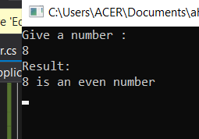

Question 3

public void FindGreaterNum()

{

int num1, num2;

Console.WriteLine("Please enter the first number : ");

num1 = Convert.ToInt32(Console.ReadLine());

Console.WriteLine("Please enter the second number : ");

num2 = Convert.ToInt32(Console.ReadLine());

Console.WriteLine("Result: ");

if(num1 > num2)

Console.WriteLine("The greater number is " + num1);

else

Console.WriteLine("The greater number is " + num2);

}

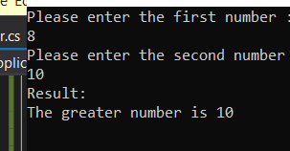

Question 4

public void FindGreatestNum()

{

int num1, num2, num3, greatest;

Console.WriteLine("Please enter the first number : ");

num1 = Convert.ToInt32(Console.ReadLine());

Console.WriteLine("Please enter the second number : ");

num2 = Convert.ToInt32(Console.ReadLine());

Console.WriteLine("Please enter the third number : ");

num3 = Convert.ToInt32(Console.ReadLine());

greatest = num1;

if (greatest < num2 && num2 > num3)

greatest = num2;

else if (greatest < num3 && num3 > num2)

greatest = num3;

Console.WriteLine("Result: ");

Console.WriteLine("The greatest number is " + greatest);

}

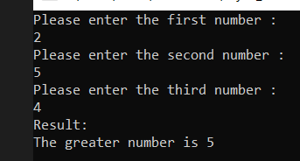

Question 5

public void FindInBetweenNum()

{

int num1, num2;

Console.WriteLine("Please enter the first number : ");

num1 = Convert.ToInt32(Console.ReadLine());

Console.WriteLine("Please enter the second number : ");

num2 = Convert.ToInt32(Console.ReadLine());

Console.WriteLine("Result: ");

for (int i = num1 + 1; i < num2; i++)

{

Console.WriteLine(i);

}

}

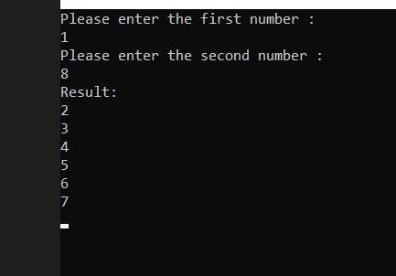

Question 6

public void FindIsPrime()

{

int num1;

bool isPrime = true;

Console.WriteLine("Please enter a number : ");

num1 = Convert.ToInt32(Console.ReadLine());

if (num1 <=1)

{

isPrime = false;

}

for (int i = 2; i < num1; i++)

{

if (num1 % i == 0)

{

isPrime = false;

break;

}

}

Console.WriteLine("Result: ");

if(isPrime)

Console.WriteLine(num1 + " is a prime number");

else

Console.WriteLine(num1 + " is not a prime number");

}

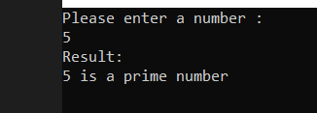

Question 7

public void FindAllPrime()

{

int num1, num2, count = 0;

bool isPrime = true;

Console.WriteLine("Please enter the first number : ");

num1 = Convert.ToInt32(Console.ReadLine());

Console.WriteLine("Please enter the second number : ");

num2 = Convert.ToInt32(Console.ReadLine());

int[] numbers = new int[num2 - num1];

for (int i = num1 + 1; i < num2; i++)

{

numbers[count] = i;

count++;

}

for (int i = 0; i < count; i++)

{

if (numbers[i] <= 1)

{

isPrime = false;

}

for (int x = 2; x < numbers[i]; x++)

{

isPrime = true;

if (numbers[i] % x == 0)

{

isPrime = false;

break;

}

}

Console.WriteLine("Result: ");

if (isPrime)

Console.WriteLine(numbers[i] + " is a prime number");

else

Console.WriteLine(numbers[i] + " is not a prime number");

}

}

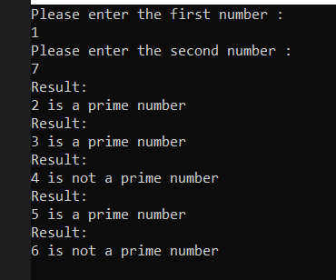

Question 8

public void FindSumDivisibleNum()

{

List<int> numbers = new List<int>();

int num, sum = 0;

do

{

Console.WriteLine("Please enter a number : ");

num = Convert.ToInt32(Console.ReadLine());

if (num >= 0)

numbers.Add(num);

} while (num >= 0);

foreach (int x in numbers)

{

if (x % 7 == 0)

{

sum += x;

}

}

Console.WriteLine("Result: ");

Console.WriteLine("Total of numbers divisible by 7 is :" + sum);

}

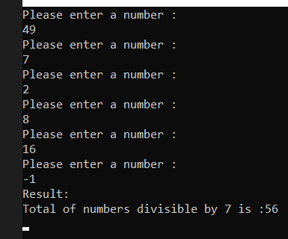

Question 9

public void FindSumOfAllDigit()

{

string nums;

int sum = 0;

Console.WriteLine("Please enter a number with 4 digits: ");

nums = Console.ReadLine();

int[] numbers = new int[nums.Length];

for (int i = 0; i < nums.Length; i++)

{

numbers[i] = int.Parse(nums[i].ToString());

sum += numbers[i];

}

Console.WriteLine("Result: ");

Console.WriteLine("Total of all digits are :" + sum);

}

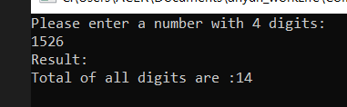

Question 10

public void FindIsPalindrome()

{

Console.WriteLine("Please enter a number with 4 digits: ");

string oriString = Console.ReadLine();

char[] charArray = oriString.ToArray();

Array.Reverse(charArray);

string newString = new string(charArray);

Console.WriteLine("Reverse String : " + newString);

if (oriString.Equals(newString))

{

Console.WriteLine(oriString + " is Palindrome.");

}

else

Console.WriteLine(oriString + " is not Palindrome.");

}

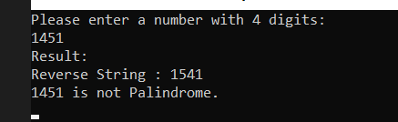

Question 11

public class Solution {

public double MyPow(double x, int n) {

return Math.Pow(x,n);

}

void main(string[] args)

{

Console.WriteLine("Please enter a digit : ");

double number1 = double.Parse(Console.ReadLine());

Console.WriteLine("Please enter the exponential power : ");

int number2 =Convert.ToInt32(Console.ReadLine());

Console.WriteLine(MyPow(number1, number2));

}

}

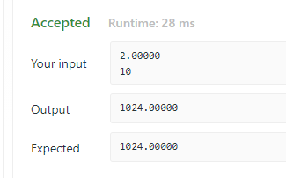

Question 12

using System;

{

public class Program

{

public bool IsHappy(double n) {

if(n == 1)

return true;

else

return false;

}

public static void Main()

{

Console.WriteLine("Input : n = ");

var number1 = Console.ReadLine();

double m = Double.Parse(number1);

Program ma = new Program();

if(number1.Length == 1)

{

ma.IsHappy(m);

}

else

{

do

{

m = 0.00;

for (int i = 0; i < number1.Length; i++)

{

double[] numArray = new double[number1.Length];

numArray[i] = Double.Parse(number1[i].ToString());

m += Math.Pow(numArray[i], 2);

}

number1 = m.ToString();

} while (number1.Length != 1);

m = Double.Parse(number1);

ma.IsHappy(m);

}

}

}

