Question 1

class Question1

{

public bool Solution()

{

int[] digits = new int[16];

string input;

int sum = 0;

Console.WriteLine("Plese enter 16 digit number : ");

input = Console.ReadLine();

while (input.Length != 16)

{

Console.WriteLine("Invalid. Please enter 16 digit number : ");

input = Console.ReadLine();

}

for (int i = 0; i < 16; i++)

{

digits[i] = Convert.ToInt32(input[i].ToString());

}

int[] newArray = Enumerable.Reverse(digits).ToArray();

for (int i = 0; i < 16; i++)

{

int num = 0;

if (i % 2 != 0)

{

num = newArray[i] \* 2;

if (num.ToString().Length > 1)

{

int addNum = num / 10 + num % 10;

num = addNum;

}

}

else

num = newArray[i];

sum += num;

}

if (sum % 10 == 0)

return true;

else

return false;

}

}

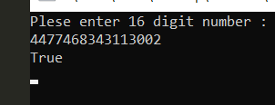

Question 2:

class Question

{

public int GetNotRepeatNum()

{

int[] digits = new int[11];

Console.WriteLine("Plese enter 11 digit number : ");

for (int i = 0; i < 11; i ++)

{

digits[i] = Convert.ToInt32(Console.ReadLine());

}

for (int i = 0; i < 11; i++)

{

int j;

for( j = 0; j < 11; j++)

{

if (i != j && digits[i] == digits[j])

break;

}

if (j == 11)

return digits[i];

}

return -1;

}

static void Main(string[] args)

{

Question2 q2 = new Question2();

int value = q2.GetNotRepeatNum();

if(value < 0)

{

Console.WriteLine("All number are repeating.");

}

else

Console.WriteLine("Answer : " + value);

}

}

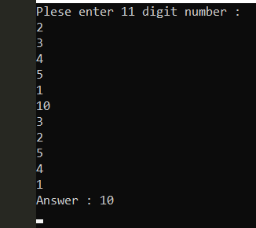

Question 3:

class Question3

{

public List<int> GetInput()

{

int input;

List<int> inputList = new List<int>();

do

{

Console.WriteLine("Key in a digit : ");

input = Convert.ToInt32(Console.ReadLine());

if (input > 0)

{

inputList.Add(input);

}

} while (input > 0);

inputList.Sort();

foreach (int n in inputList)

{

Console.WriteLine(n);

}

return inputList;

}

public void GetMedian(List<int> input)

{

int count = input.Count;

if(count % 2 == 0)

{

int a = input[count / 2 - 1];

int b = input[count / 2];

Console.WriteLine("The median is : " + (a + b) / 2);

}

else

Console.WriteLine("The median is : " + input[count / 2]);

}

public void GetMode(List <int> input)

{

int highestCount = 0, mode = 0;

for(int i = 0; i < input.Count; i++)

{

for(int j = 0; j < input.Count; j++)

{

int countMode = 0;

if (input[i] == input[j])

{

countMode++;

if(countMode > highestCount)

{

highestCount = countMode;

mode = input[i];

}

}

}

}

if(highestCount > 0)

Console.WriteLine("The mode is : " + mode);

else

Console.WriteLine("There is no mode.");

}

}

static void main[string [] args]

{

Question3 q3 = new Question3();

var inputList = q3.GetInput();

q3.GetMedian(inputList);

q3.GetMode(inputList);

}

}

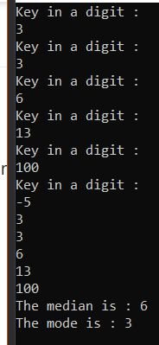

Question 4:

public class Solution {

public int FindNumbers(int[] nums) {

int countEven = 0;

Console.WriteLine(nums.Length);

for(int i = 0; i < nums.Length; i++)

{

if(nums[i].ToString().Length %2 == 0)

{

countEven++;

}

}

return countEven;

}

}

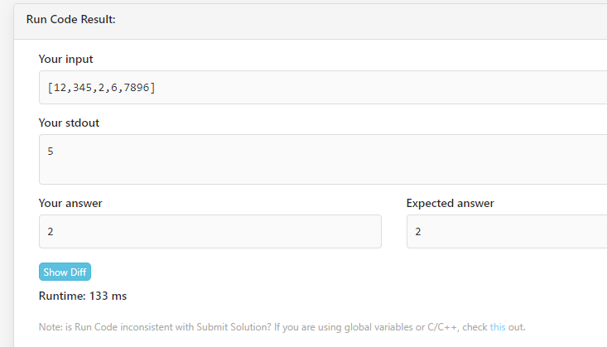

Question 5:

public class Solution {

public int RemoveDuplicates(int[] nums) {

if (nums.Length == 0) return 0;

int numRemoved = 0;

for (int i = 1; i < nums.Length;i++){

if (nums[i] == nums[i-1]) numRemoved++;

nums[i - numRemoved] = nums[i];

}

return nums.Length - numRemoved;

}

}

