Beaver's Choice Paper Company
Multi-Agent Inventory, Quote, and Sales System
Design report, implementation review, and evaluation summary

1. System summary
The submitted system uses five agents: an Orchestrator Agent, Inventory Agent, Quote Agent, Sales Agent, and Business Advisor Agent. The Orchestrator Agent receives each text request, extracts the request date, delivery deadline, quantities, and catalog items, then delegates the stock, pricing, and transaction work to the worker agents. The final response is a customer-facing message that states whether the order was fulfilled, gives the quote when applicable, explains the main rationale, and avoids internal cash, margin, database, or error details.
The implementation uses smolagents tool definitions for database and business-operation tools. The script also reads UDACITY_OPENAI_API_KEY, or OPENAI_API_KEY as a fallback, and points the OpenAI-compatible configuration to the Vocareum endpoint. The evaluation path uses deterministic business rules after the tools are bound, which keeps the sample run repeatable and keeps database updates consistent across runs.

2. Workflow diagram explanation
The submitted diagram file is beavers_choice_workflow_diagram.png. It shows the same five agents used in the code and their tool connections.
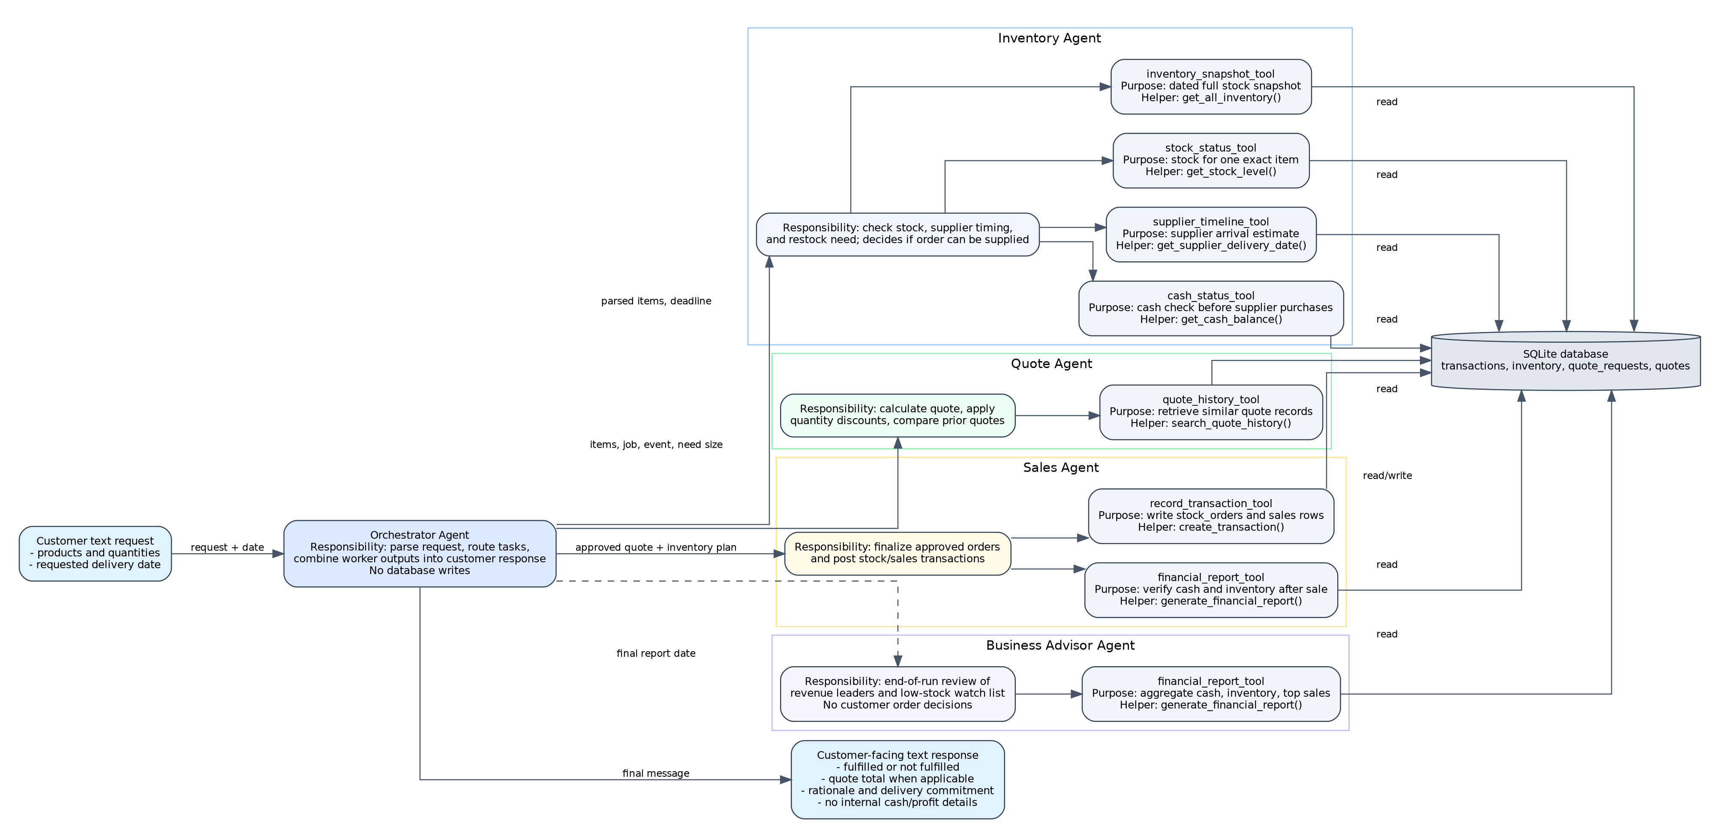
Agent | Distinct responsibility | Tools and helper functions
Orchestrator Agent | Parses request text, coordinates worker agents, and formats the final customer response. | No database tools; delegates to worker agents.
Inventory Agent | Checks current stock, decides whether supplier replenishment is needed, checks delivery feasibility, and checks cash before supplier purchases. | inventory_snapshot_tool -> get_all_inventory; stock_status_tool -> get_stock_level; supplier_timeline_tool -> get_supplier_delivery_date; cash_status_tool -> get_cash_balance.
Quote Agent | Calculates quote lines, applies quantity discounts, and consults prior quote history for small and medium orders. | quote_history_tool -> search_quote_history.
Sales Agent | Finalizes approved orders by posting stock order and sales transactions, then verifies updated financial state. | record_transaction_tool -> create_transaction; financial_report_tool -> generate_financial_report.
Business Advisor Agent | Reviews end-of-run sales leaders and low-stock items without changing customer order decisions. | financial_report_tool -> generate_financial_report.

3. Starter helper function review
These functions from the starter file were reviewed and then mapped to tools in the implementation.
Starter function | Purpose in this project
generate_sample_inventory | Builds a reproducible starting inventory subset from the paper supply catalog with stock quantities and minimum stock levels.
init_database | Creates the SQLite tables, loads quote request and quote history CSV files, seeds inventory, and posts initial cash and stock transactions.
create_transaction | Posts one stock order or sales transaction to the transactions table and returns the inserted transaction id.
get_all_inventory | Returns a dated inventory snapshot by adding stock orders and subtracting sales for each item.
get_stock_level | Returns the dated stock level for one exact item name.
get_supplier_delivery_date | Estimates supplier arrival based on order quantity and request date.
get_cash_balance | Calculates cash as sales revenue minus stock purchase cost through the requested date.
generate_financial_report | Combines cash, inventory value, total assets, item-level inventory, and top-selling products for a date.
search_quote_history | Searches previous quote requests and quote explanations for matching terms and returns comparable quote records.

4. Implementation details
The final Python file is beavers_choice_multi_agent.py. It contains the starter database functions, the smolagents tool definitions, request parsing, the five agent classes, and the evaluation runner in one file. This satisfies the one-file source code requirement while keeping the system modular through classes and tool functions.
Inventory decisions are conservative. If existing stock covers the order, the Inventory Agent approves that line. If stock is short, it checks whether supplier replenishment can arrive by the customer's delivery deadline and whether cash is sufficient for the supplier purchase. If the item is outside the sellable catalog or the arrival date misses the deadline, the order is not posted. This prevents hidden partial sales and gives the customer a clear reason.
Quote decisions use catalog value, a service factor for handling and sourcing, and a tiered quantity discount. The Quote Agent also searches prior quote history using the provided helper. For smaller requests, comparable history can cap the quote so prices stay competitive. The response states the discount tier and the number of comparable requests checked, without exposing internal margin or cash details.
Sales decisions are only made after the Inventory Agent and Quote Agent both provide an approved plan. The Sales Agent records any required stock order transactions first, then records the sales transactions, and finally reads the financial report to confirm the updated database state. Unfulfilled requests do not write transactions.

5. Evaluation results
Metric | Result | Rubric connection
Requests evaluated | 20 | The full quote_requests_sample.csv file was processed.
Fulfilled requests | 9 | Meets the requirement for at least three fulfilled quote requests.
Requests changing cash balance | 9 | Meets the requirement for at least three cash balance changes.
Unfulfilled requests | 11 | Meets the requirement that not all requests are fulfilled.
Final cash balance | $45,884.21 | Shows the cumulative effect of posted stock and sales transactions.
Final inventory value | $4,471.75 | Shows inventory value after completed transactions.
Request | Date | Status | Quote | Cash change | Outcome rationale
1 | 2025-04-01 | fulfilled | $83.36 | $83.36 | Completed order; quote and delivery commitment provided.
2 | 2025-04-03 | not_fulfilled | $646.58 | $0.00 | Unsupported catalog item.
3 | 2025-04-04 | not_fulfilled | $12,048.75 | $0.00 | Unsupported catalog item.
4 | 2025-04-05 | fulfilled | $106.71 | $69.76 | Completed order; quote and delivery commitment provided.
5 | 2025-04-05 | fulfilled | $110.31 | $5.31 | Completed order; quote and delivery commitment provided.
6 | 2025-04-06 | fulfilled | $93.55 | $9.55 | Completed order; quote and delivery commitment provided.
7 | 2025-04-07 | fulfilled | $741.15 | $461.15 | Completed order; quote and delivery commitment provided.
8 | 2025-04-07 | fulfilled | $583.20 | $107.70 | Completed order; quote and delivery commitment provided.
9 | 2025-04-07 | not_fulfilled | $39.12 | $0.00 | Supplier timing misses requested deadline.
10 | 2025-04-08 | fulfilled | $182.05 | $37.05 | Completed order; quote and delivery commitment provided.
11 | 2025-04-08 | fulfilled | $193.35 | $39.35 | Completed order; quote and delivery commitment provided.
12 | 2025-04-08 | fulfilled | $65.28 | $11.28 | Completed order; quote and delivery commitment provided.
13 | 2025-04-08 | not_fulfilled | $62.77 | $0.00 | Supplier timing misses requested deadline.
14 | 2025-04-09 | not_fulfilled | $2,762.10 | $0.00 | Supplier timing misses requested deadline.
15 | 2025-04-12 | not_fulfilled | $144,585.00 | $0.00 | Supplier timing misses requested deadline.
16 | 2025-04-13 | not_fulfilled | $168.24 | $0.00 | Supplier timing misses requested deadline.
17 | 2025-04-14 | not_fulfilled | $308.88 | $0.00 | Supplier timing misses requested deadline.
18 | 2025-04-14 | not_fulfilled | $164.02 | $0.00 | Supplier timing misses requested deadline.
19 | 2025-04-15 | not_fulfilled | $996.30 | $0.00 | Supplier timing misses requested deadline.
20 | 2025-04-17 | not_fulfilled | $3,267.00 | $0.00 | Unsupported catalog item.
The strongest behavior in the evaluation is that completed orders are posted only when the full request can be supplied by the customer's deadline. The system also distinguishes between unsupported catalog items, supplier timing conflicts, and cash policy limits. Each unfulfilled response includes a specific reason and does not alter the database. Completed responses include the quote total, line items, delivery commitment, discount rationale, and confirmation date.

6. Rubric coverage checklist
Rubric item | Coverage
Workflow diagram shows all agents and responsibilities | Covered by beavers_choice_workflow_diagram.png and Section 2.
Diagram shows tools and helper functions | Each tool box names the helper function it wraps.
Maximum of five agents | Exactly five agents are used.
Orchestrator plus worker roles | Orchestrator delegates to Inventory, Quote, Sales, and Advisor agents.
Recommended framework used | smolagents tool definitions and worker shells are included.
All required starter helpers used in tool definitions | create_transaction, get_all_inventory, get_stock_level, get_supplier_delivery_date, get_cash_balance, generate_financial_report, and search_quote_history are wrapped as tools.
Evaluation file generated | test_results.csv was produced by run_test_scenarios().
At least three cash changes and fulfilled requests | 9 cash changes and 9 fulfilled requests.
Not all requests fulfilled | 11 requests were not fulfilled, with reasons.
Explainable customer outputs | Responses include status, quote, delivery, discount rationale, and fulfillment rationale without internal cash or margin details.

7. Further improvements
- Add a supplier catalog expansion workflow for products currently treated as unsupported, such as balloons, tickets, and plain A3 paper. This would reduce lost sales while still requiring supplier timing and cash checks before accepting orders.
- Add backorder and partial-fulfillment options. The current policy avoids partial sales for clarity, but a future version could offer accepted substitutions, split shipments, or a follow-up quote for the available portion of a request.
- Add a customer negotiation agent that can propose alternate delivery dates or substitute products when the original request misses the supplier deadline.
- Add a restock planning dashboard that reviews low-stock items after every run and recommends reorder quantities before customer demand arrives.

