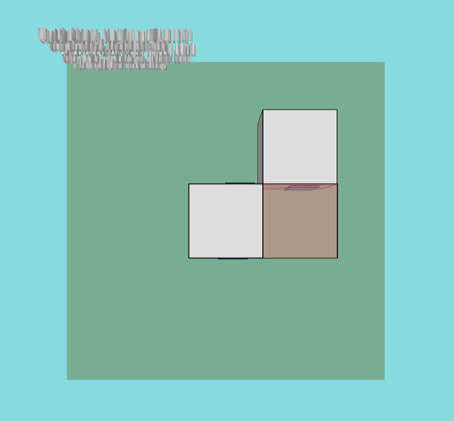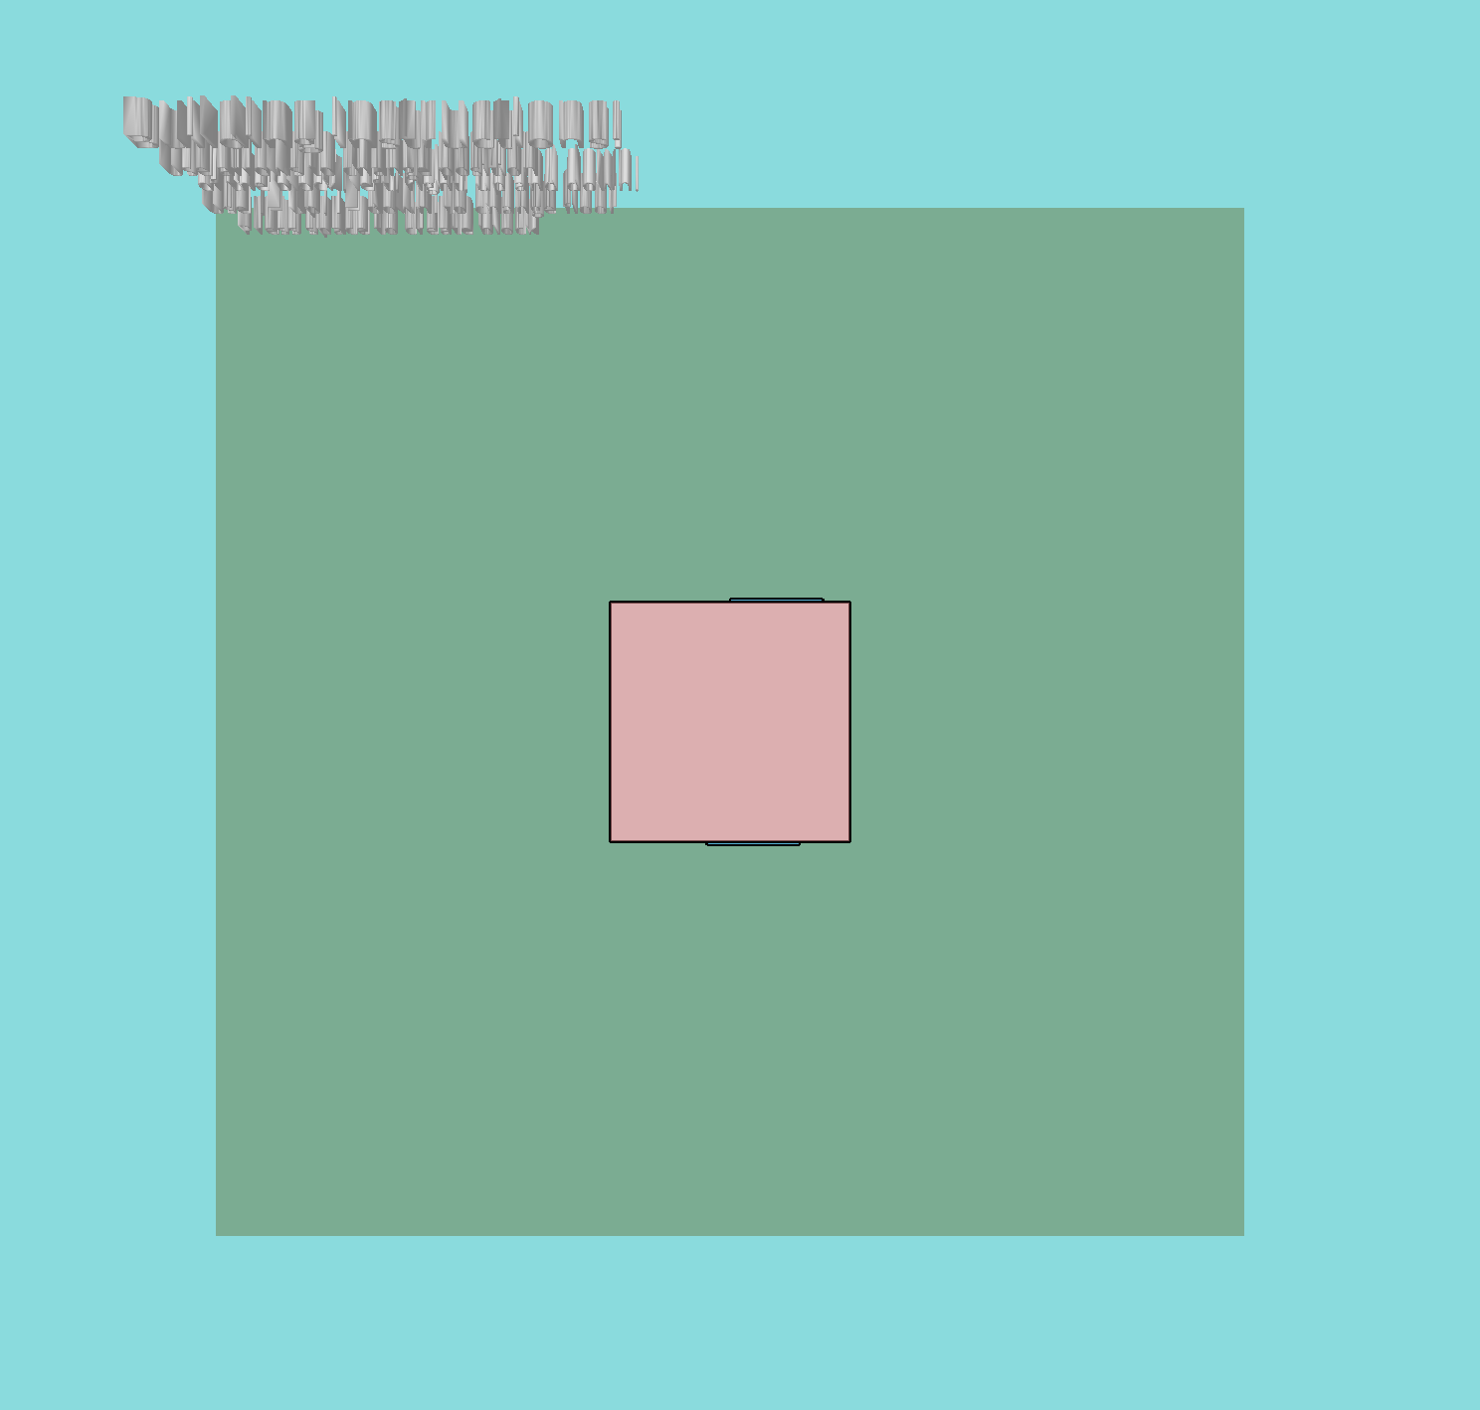

CONCEPT: To build your own house. Some modern house are made from the quadratic box idea, where all elements are boxes. This program makes it possible to get a quick impression of different combination of boxes.

FEATURE GROUP: Could be either people who are planning to build a house for inspiration. Or everyone, like people play mindcraft.

Ester Marie Aagaard,

Github:

Link for project:

HOUSE BUILDER