CSCI 1480
University of Central Arkansas
Lab 4 Out-class Assignment

Topic: String Library/Character Testing/Character Conversion
Reading: Ch. 10

*Note: Include the following set of comments at the top of your source code for all assignments.
//Your Name
//Assignment # (Example: Lab4out)
//Brief description of the purpose of the program (Example: //Calculates the area of a square.)

Overview
(Save this file as lab4out.cpp)
Write a C++ program that implements a postage addressing system for letters mailed via the United States Postal system. Your program will first prompt the user for the mailing information of where the letter is to be sent. Only residential data will be utilized by your program. This mailing information consists of the following data:

1. First name
2. Last name
3. Street Address
4. City
5. State
6. Zip Code

The user will also be prompted for the weight (in ounces) of the letter to be mailed. Examples of prompting the user for the above fields are shown below:
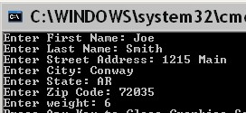
Each field must be validated on the following rules:

1. First Name must consist only of alphas.
2. Last Name must consist only of alphas
3. The Street Address must consist only of alpha, numerics, and white space
4. The City can contain only alphas and its first letter must be uppercase.
5. The State must have a length of 2 characters and consist only of alphas. Your program will need to convert this field to all uppercase.
6. The Zip Code must have a length of 5 characters and consist only of digits (numerics).
7. The weight must be an integer and be between 1 and 6 inclusively.

The field must be re-entered in the event that it fails its validation rule as given above. The mailing envelope will be displayed as shown below once all fields have been correctly entered:
(525,20)
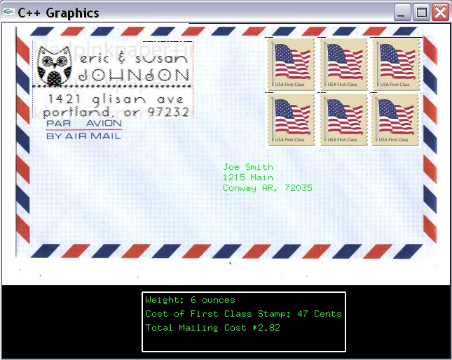
(43,26)
(315,210)
(200,385)

Width = 290
Height = 85

The first stamp should be displayed at (525,20). Each subsequent stamp is displayed with offset of 75pixels in the horizontal and 79 pixels in the vertical. A maximum of 3 stamps should be displayed in a single row.

Note: The city, state, and zip code must be combined into one line. A comma should separate the
The above display consists of the following images:

1. The envelope.bmp provides the background for the graphics window. It is shown below:
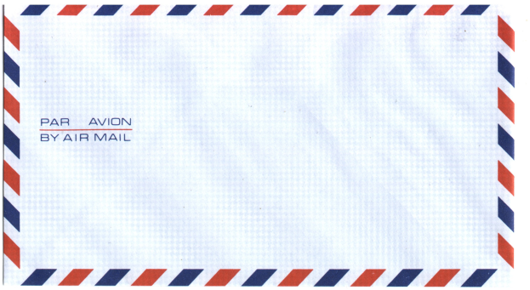
envelope.bmp

2. The return address is always for the residence shown:
Eric & Susan Johnson
1421 Glisan Ave
Portland, OR 97232

The following image contains the return address as shown above:
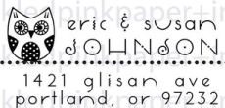
returnAddress.bmp

3. A stamp is displayed for each ounce entered for the weight. The first class stamp is given as stamp.bmp illustrated below:

stamp.bmp
In the example, 6 ounces was entered for the weight. This results in 6 stamps being displayed as shown.

The cost for a single first class stamp is 47 cents.

A summary box is shown near the bottom of the Graphics Window. This box should display the weight, the cost of a first class stamp, and the total mailing costs.

The total mailing costs is the #ounces multiplied by 47 cents.

The weight field is used for computing the mailing cost. The mailing cost is

47 cents/1 ounce

The cost for a single first class stamp is 47 cents. Your program will display a single first class stamp for each ounce. Use stamp.bmp for displaying the stamp.

The user is next prompted to run the program again as shown below:
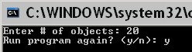

Examples for 1, 2, 3, 4, and 5 ounces for the weight are shown below:

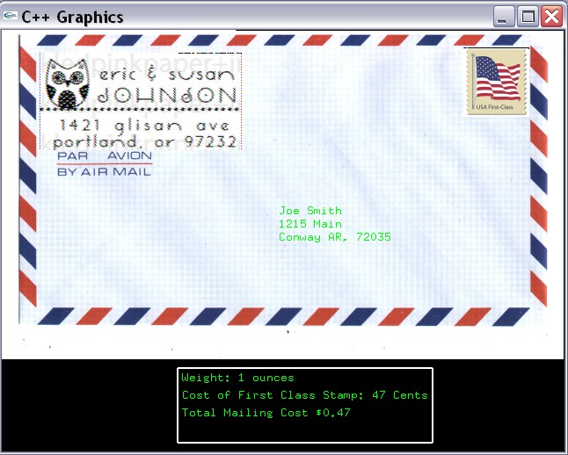

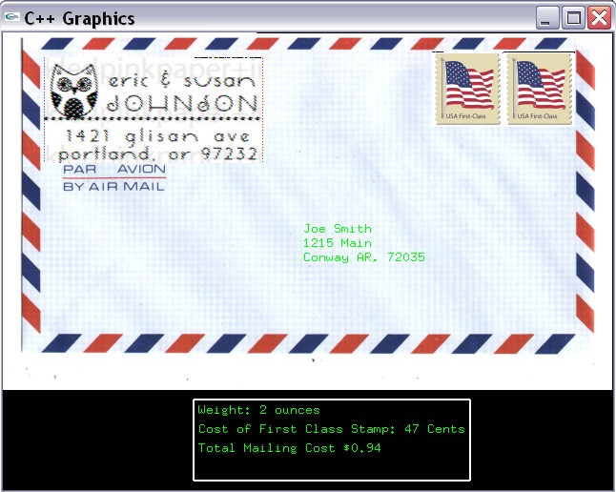

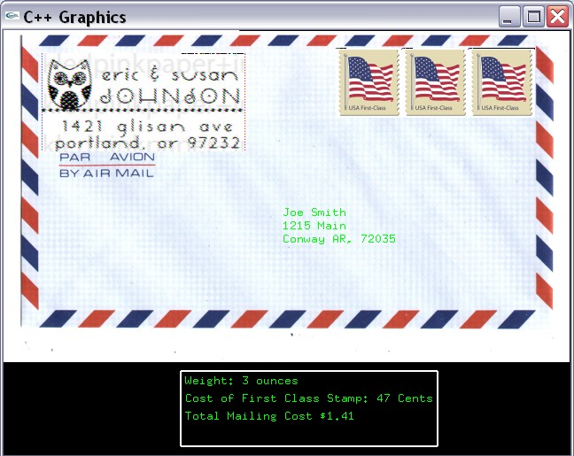

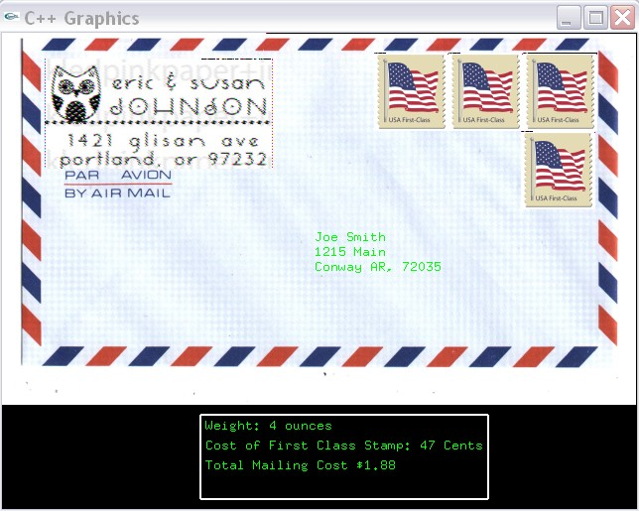

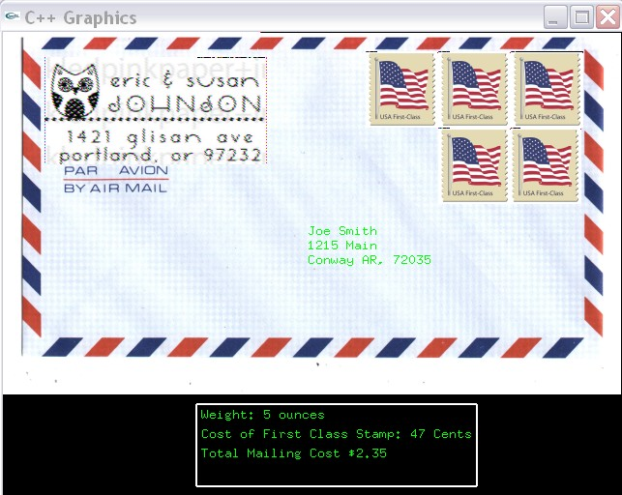

Required Functions

The following functions are required when implementing this program. You are free to add any extra functions that you like.

string getString(string prompt);
Prompts the user for a string based on the input parameter prompt. The user-entered string is returned as s string data type.

Input: string prompt - string informing user what type of data they should enter. Examples for this prompt are:

Enter First Name:
Enter Last Name:
Enter Street Address:
Enter City:
Enter State:
Enter Zip Code
Enter Phone:

Return Value: string containing the data entered by the user.

bool validateName(string name);
Validates either the first name or last name (both have the same rule - can contain only alphas).

Input: string name - string containing a name - either first name or last name. Only residential names are considered.

Return Value: true if name is valid, false otherwise.

bool validateAddress(string address);
Validates the street address based on its rule - can contain only alpha, numerics or spaces.

Input: string address - string containing the street address - the street address consists of a street number and street name only.

Return Value: true if address is valid, false otherwise.

bool validateCity(string city);
Validates the city based on its rule - can contain only alphas and the first letter must be uppercase.

Input: string city - string containing the city’s name.

Return Value: true if city is valid, false otherwise.
bool validateState(string state);
Validates the state abbreviation based on its rule - can contain only alphas and has length of exactly 2 letters.

Input: string state - string containing the state’s abbreviation.

Return Value: true if state is valid, false otherwise.

bool validateZip(string zip);
Validates the zip code based on its rule - can contain only digits and has length of exactly 5 letters.

Input: string zip - string containing the zip code.

Return Value: true if zip code is valid, false otherwise.

string convertToUpper(string input);
Converts characters stored in input to all uppercase. The converted characters are then returned by this function.

Input: string string - array of characters.

Return value - string - a string containing the uppercase converted characters.

Note: This function should be called in main with input parameter contain the 2-character state’s abbreviation. The output of this function is all upper case string.

void displayLetter(string fn, string ln, string addr, string city, string state, string zip, int weight);
Displays the postage letter as shown on page 2. The images and fields should be displayed as shown.

Input: string fn - First Name of recipient.

Input: string ln - Last Name of recipient.

Input: string address- Street Address of recipient.

Input: string city - City name of recepient.

Input: string state - State abbreviation of recepient.

Input: string zip - Zip code of recepient.

Input: int weight: Weight of postage letter.

This function should perform the following steps:

1. Display envelope.bmp at (0,0).

2. Display returnAddress.bmp.

3. Combine the first name and last name and display on one line as shown on page 2.

4. Display the street address beneath the name as shown on page 2.

5. Combine the city, state, and zip code and display on one line as shown on page 2.

6. Display the appropriate number of stamps based on the weight. Add one stamp for each ounce of weight.

7. Display a summary box containing the weight, cost of a first class stamp, and the total postage costs. A first class stamp is always 47 cents for this program. The postage cost is computed as:

cost = weight*0.47;

Where weight is an integer value measured in ounces.

Special Note

The example screen capture is provided only as an example of what the results should look like. You will not be deducted points if your results are not identical to the one shown (your results should be neatly done and readable though).

What you Submit

Submit lab4out.cpp via Blackboard..

