Estevan DeVargas - Combined Lab Image Portfolio
All uploaded lab images organized by the code/project they correspond to

Sections
1. Lab 0 - Gates
2. Lab 1 - Comparator and 7-Segment Display
3. Lab 2 - Full Adder and 4-bit Ripple-Carry Adder
4. Lab 3 - Structural Design / Multiplexers / Decoder

Lab 0 - Design and Simulate Gates
Basic VHDL gate design, simulation, and schematic views
Lab 0 - Design and Simulate Gates - Page 1
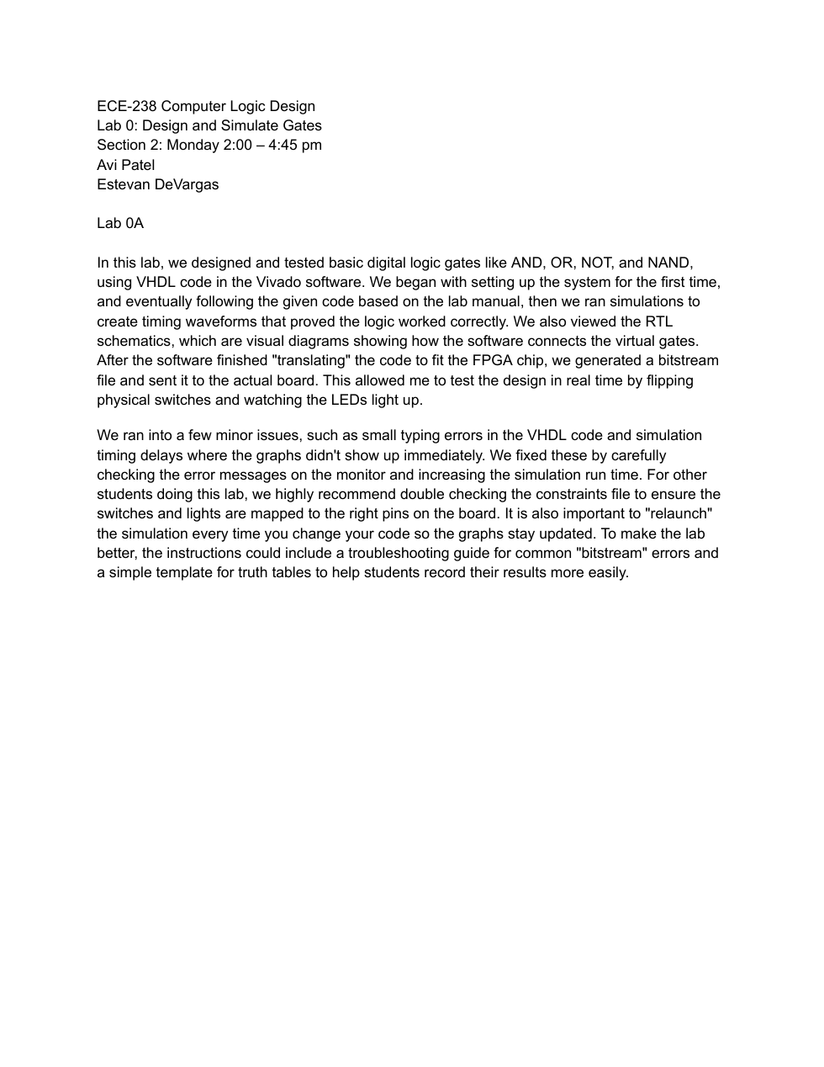

Lab 0 - Design and Simulate Gates - Page 2
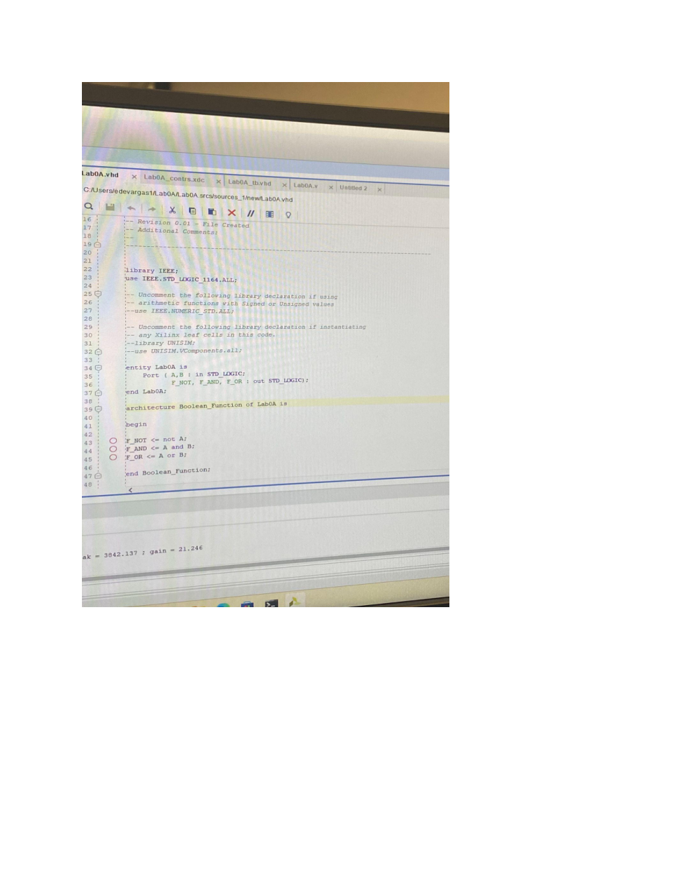

Lab 0 - Design and Simulate Gates - Page 3
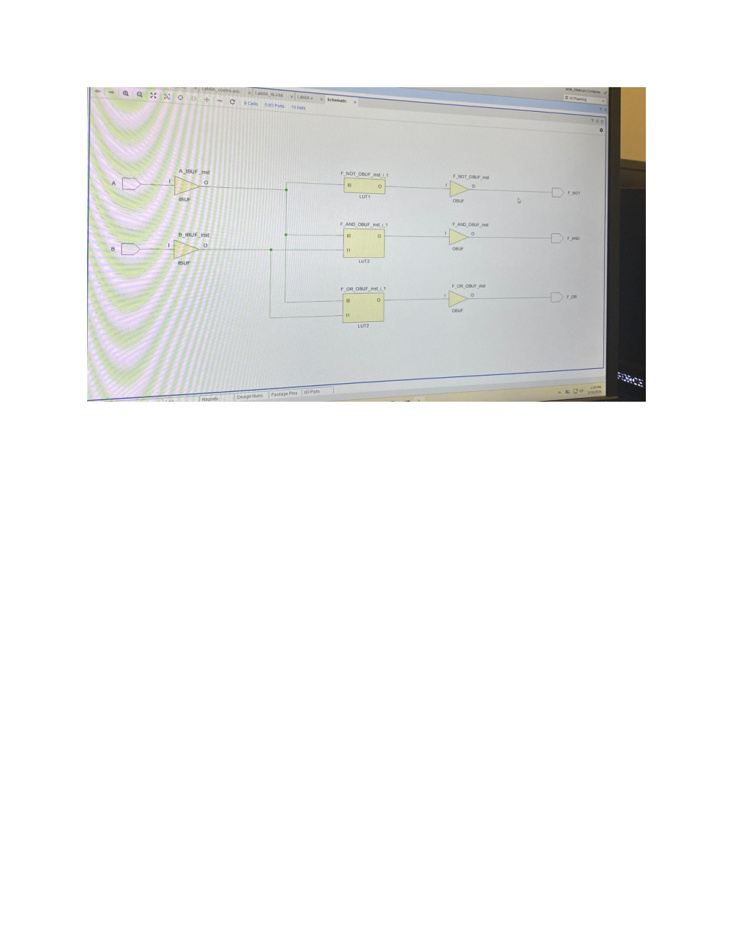

Lab 0 - Design and Simulate Gates - Page 4
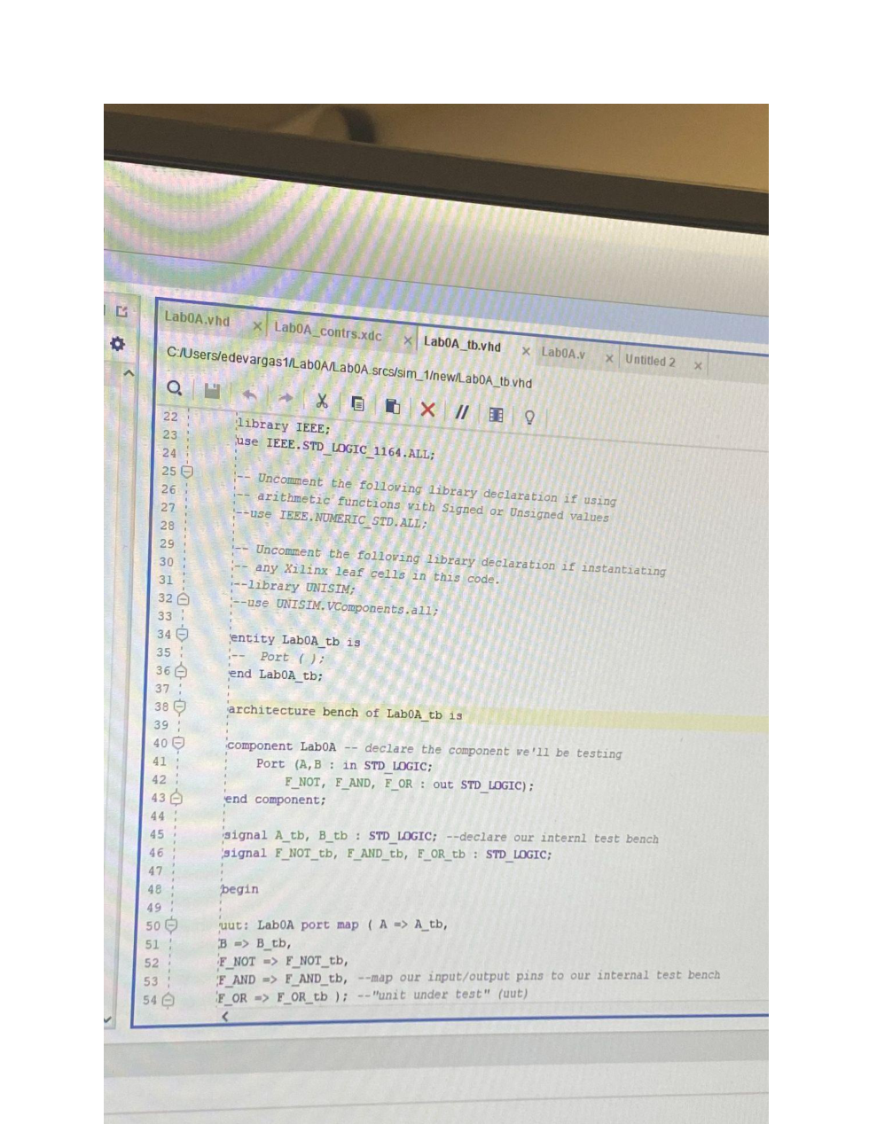

Lab 0 - Design and Simulate Gates - Page 5
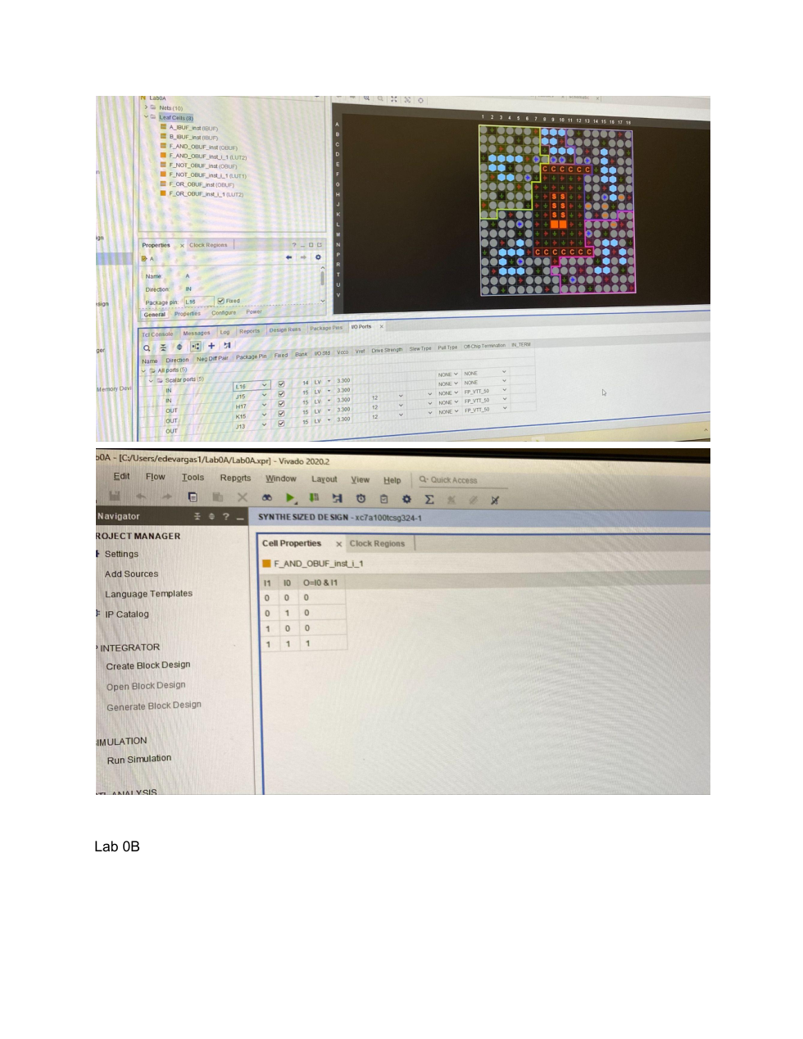

Lab 0 - Design and Simulate Gates - Page 6
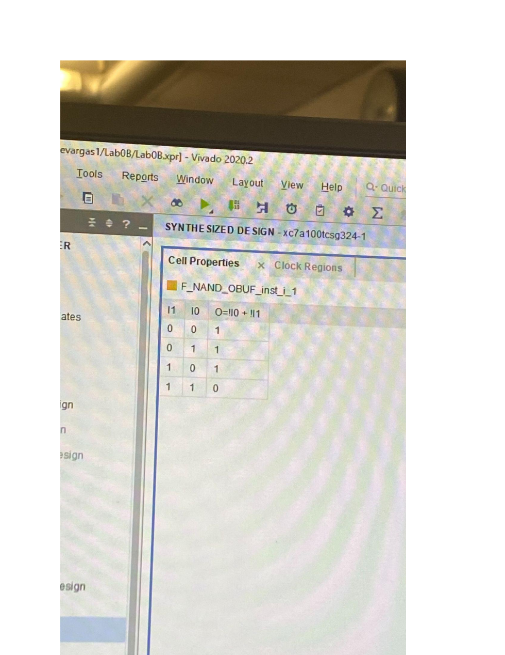

Lab 0 - Design and Simulate Gates - Page 7
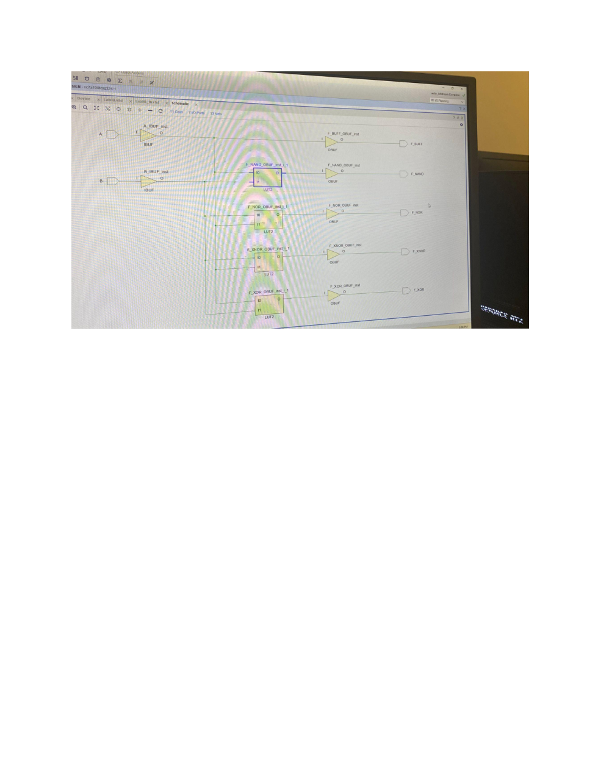

Lab 0 - Design and Simulate Gates - Page 8
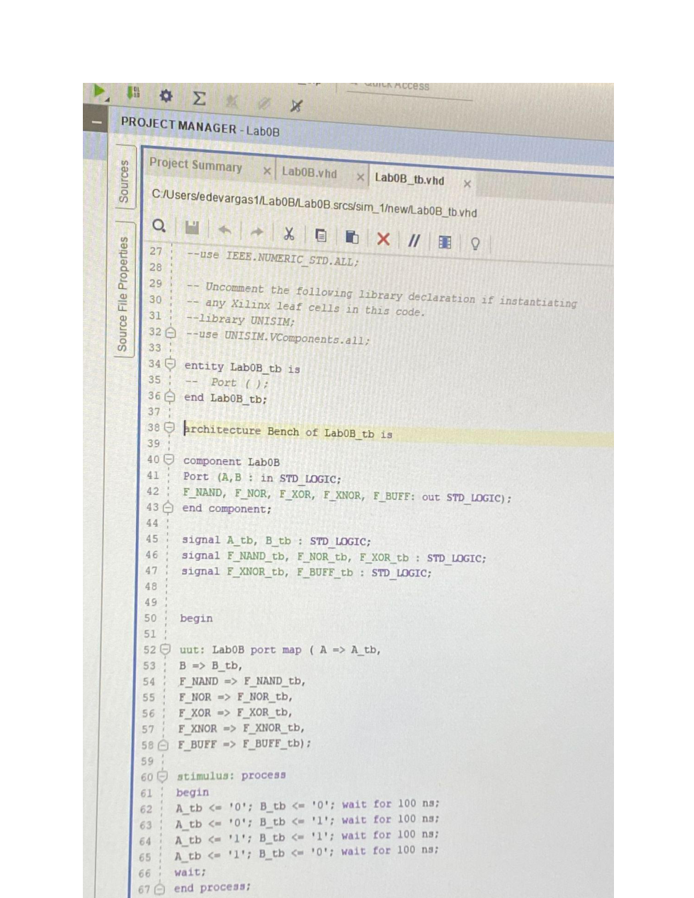

Lab 0 - Design and Simulate Gates - Page 9
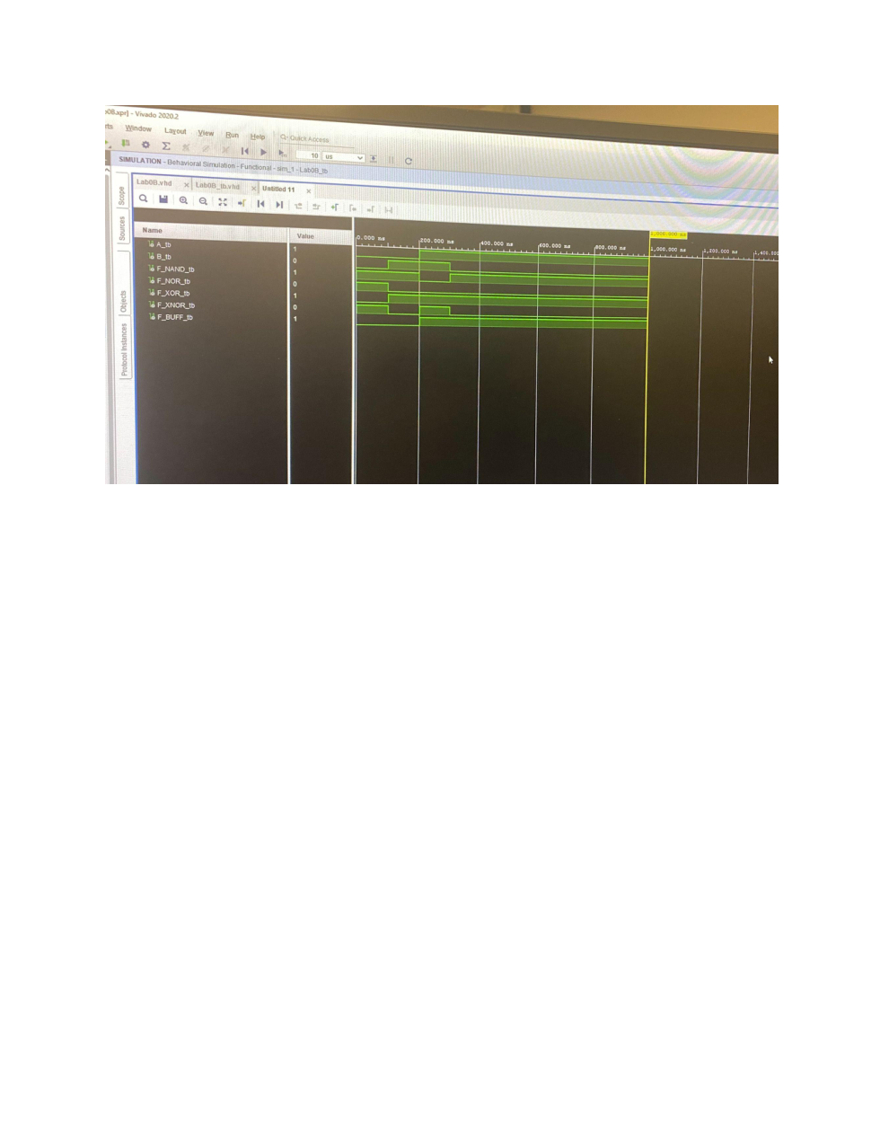

Lab 0 - Design and Simulate Gates - Page 10
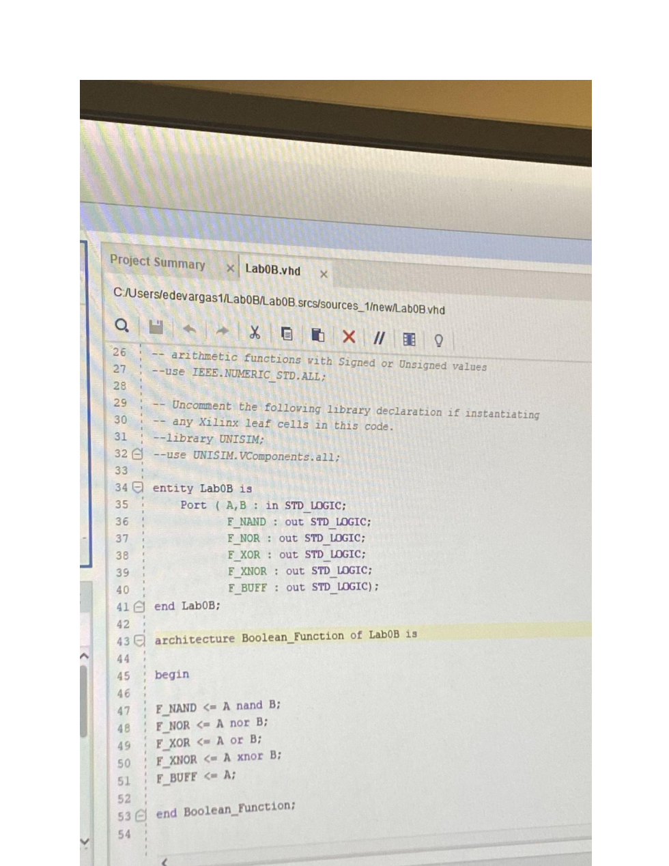

Lab 0 - Design and Simulate Gates - Page 11


Lab 0 - Design and Simulate Gates - Page 12
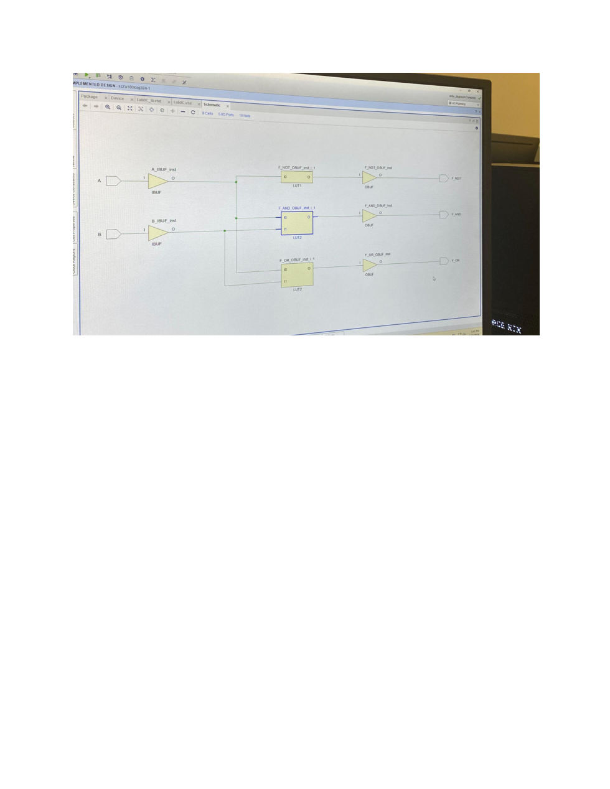

Lab 0 - Design and Simulate Gates - Page 13
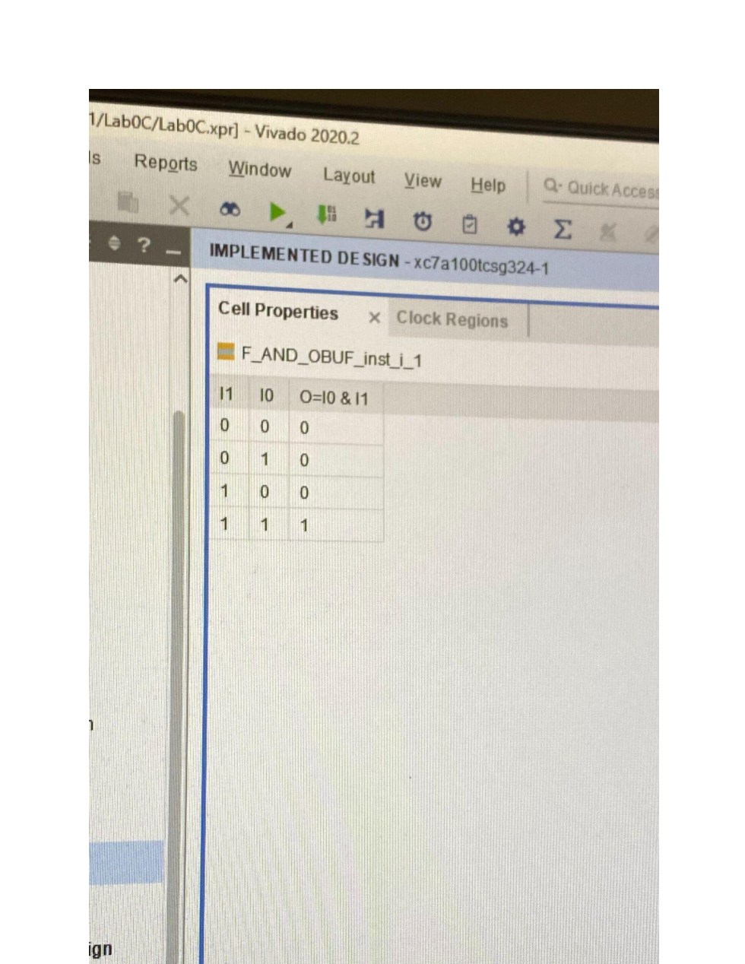

Lab 0 - Design and Simulate Gates - Page 14
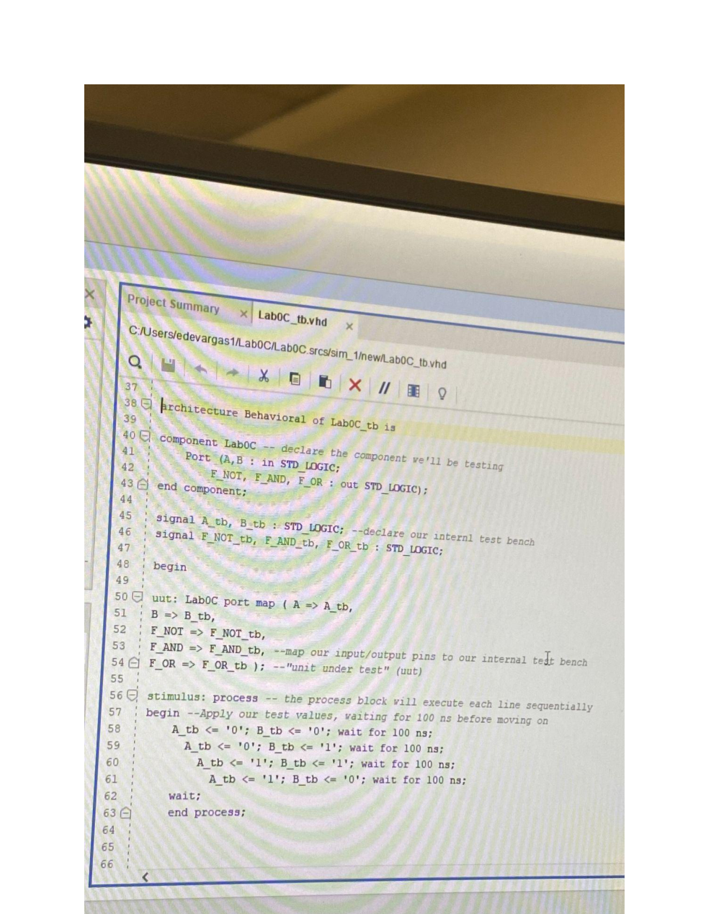

Lab 0 - Design and Simulate Gates - Page 15
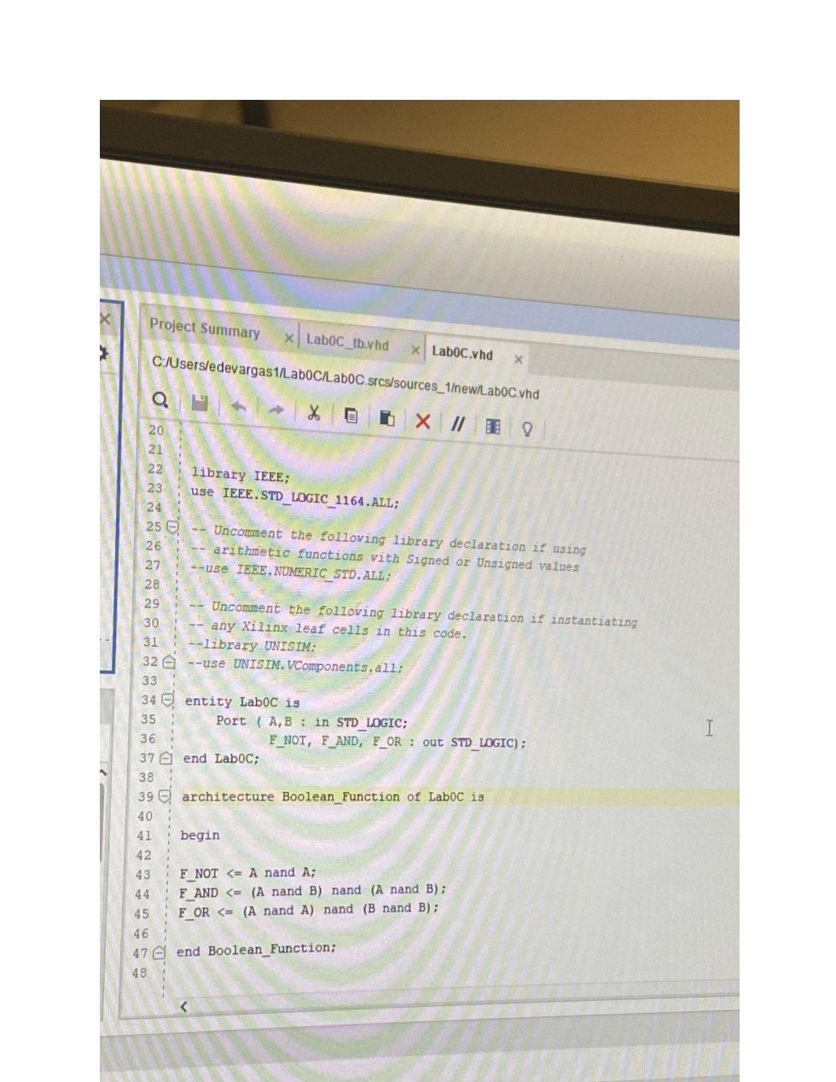

Lab 1 - Comparator and 7-Segment Display
Comparator logic and 7-segment display output in VHDL
Lab 1 - Comparator and 7-Segment Display - Page 1
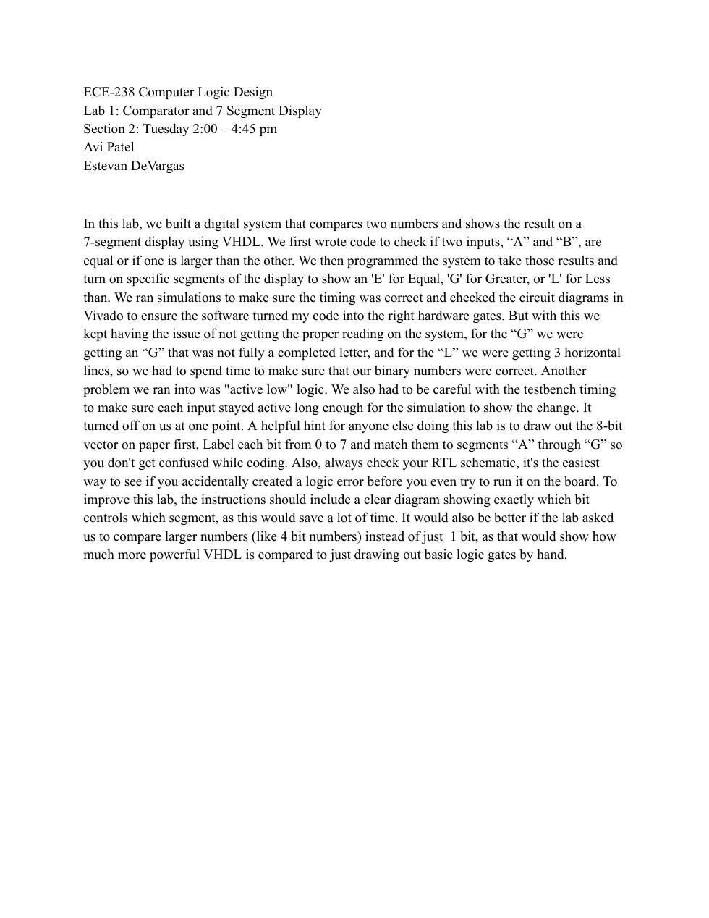

Lab 1 - Comparator and 7-Segment Display - Page 2
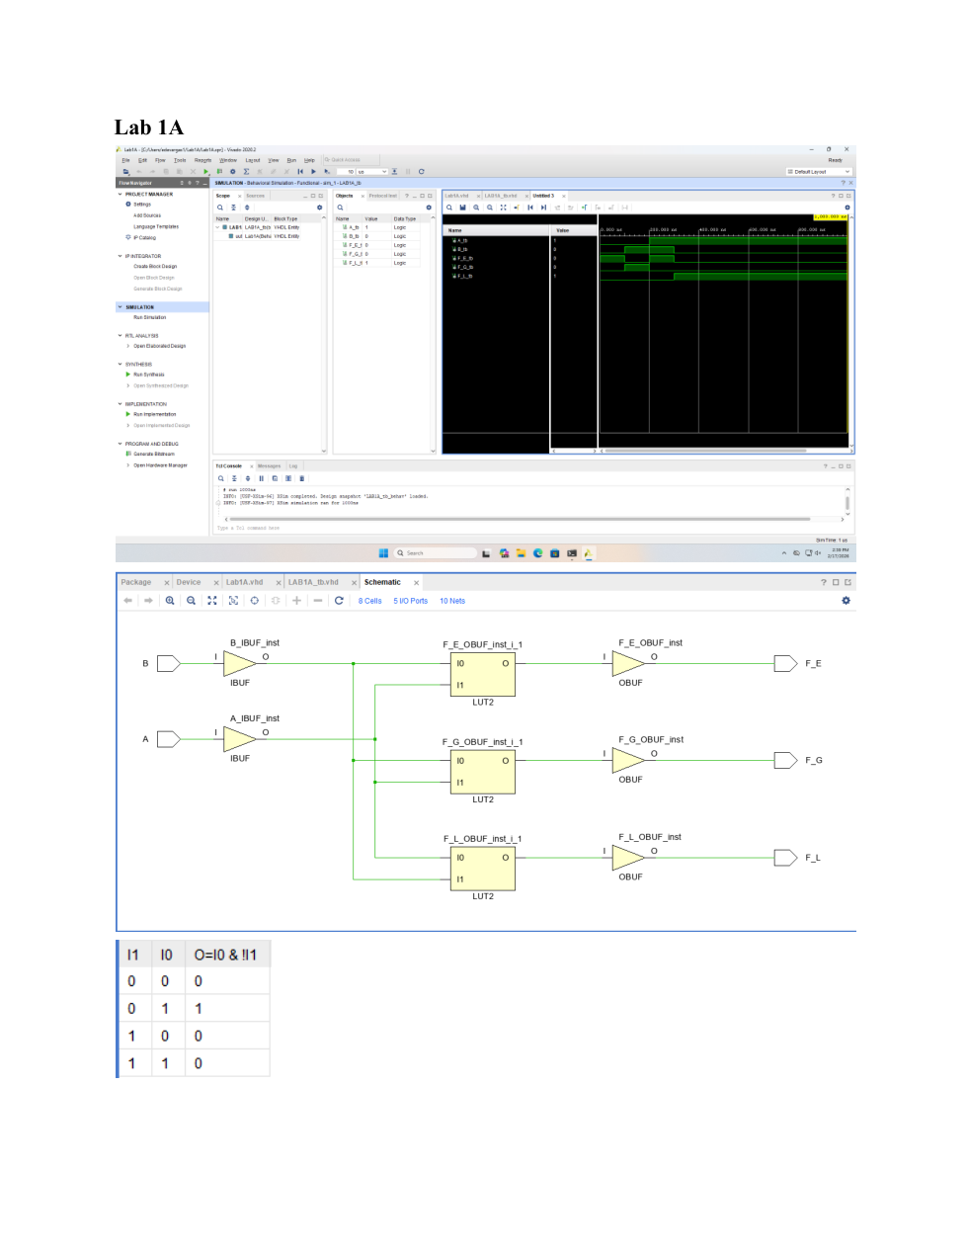

Lab 1 - Comparator and 7-Segment Display - Page 3
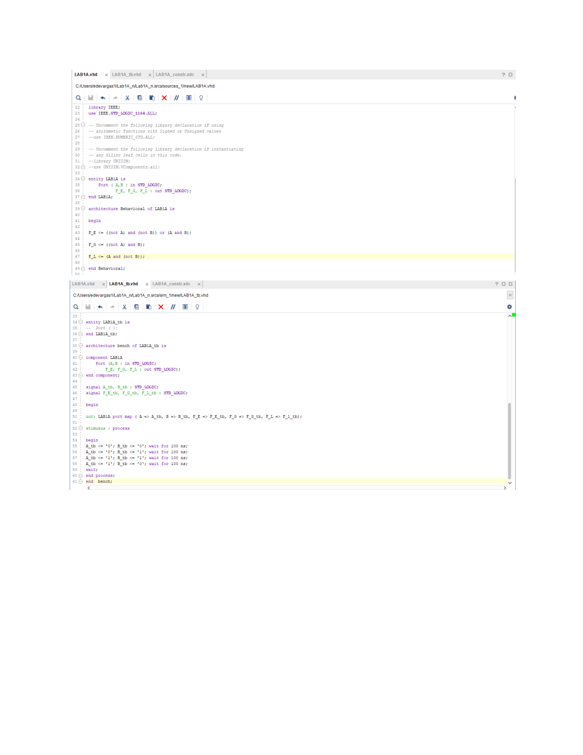

Lab 1 - Comparator and 7-Segment Display - Page 4
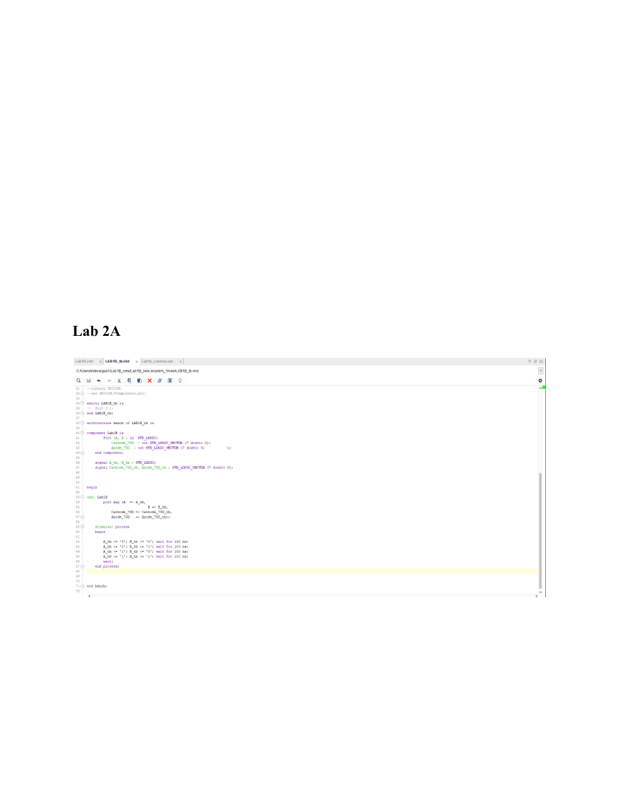

Lab 1 - Comparator and 7-Segment Display - Page 5
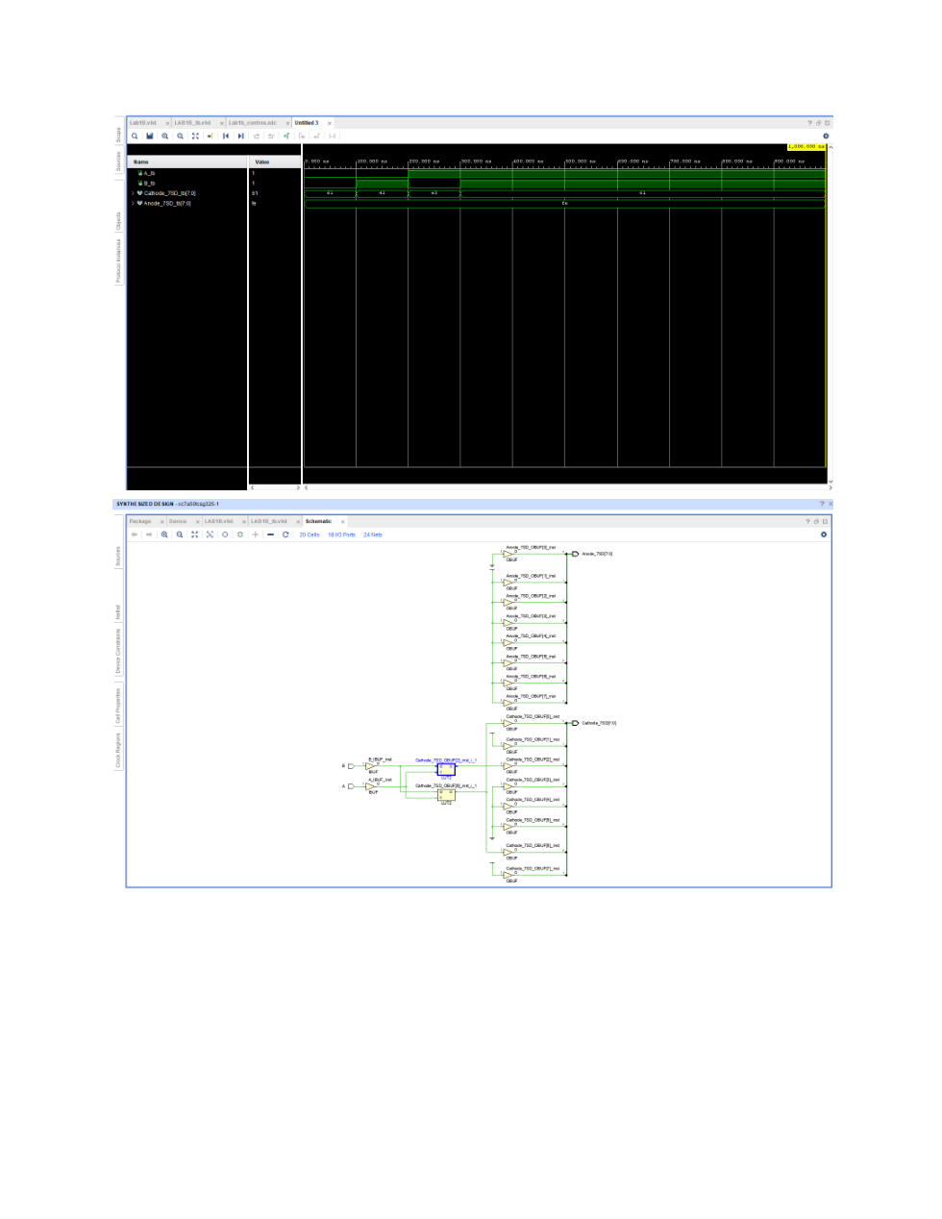

Lab 1 - Comparator and 7-Segment Display - Page 6
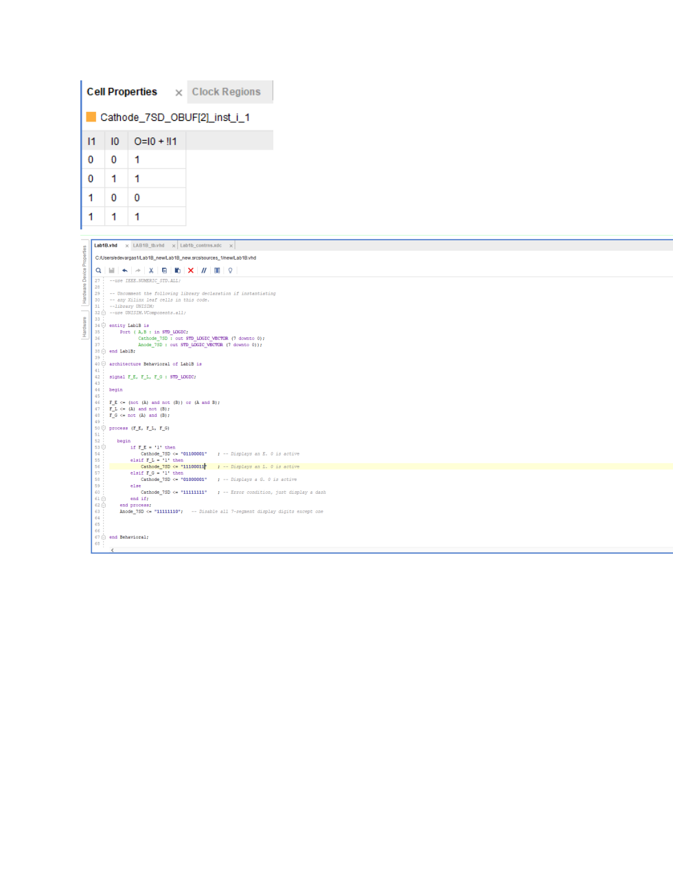

Lab 2 - Full Adder and 4-bit Ripple-Carry Adder
Adder design, simulation, and hardware verification
Lab 2 - Full Adder and 4-bit Ripple-Carry Adder - Page 1
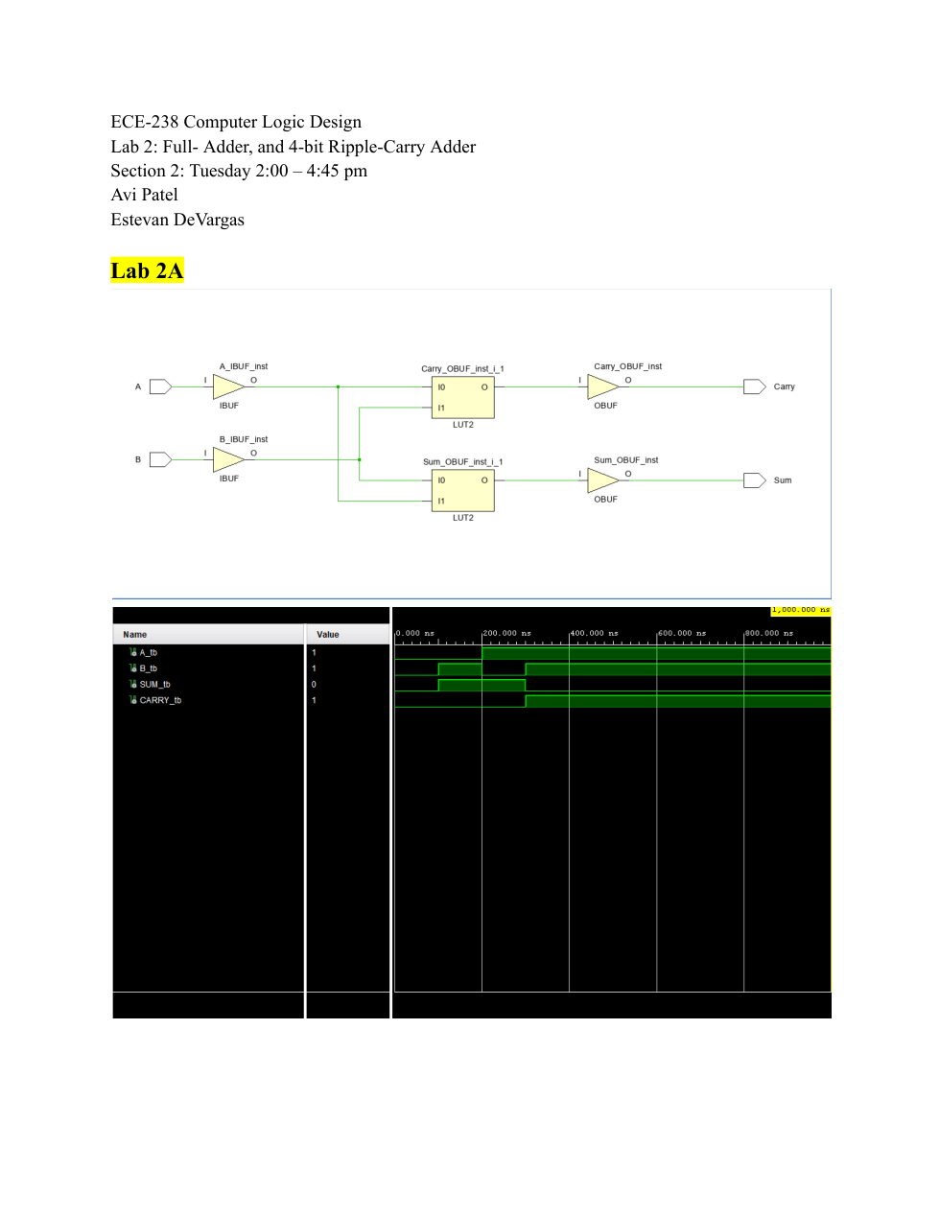

Lab 2 - Full Adder and 4-bit Ripple-Carry Adder - Page 2
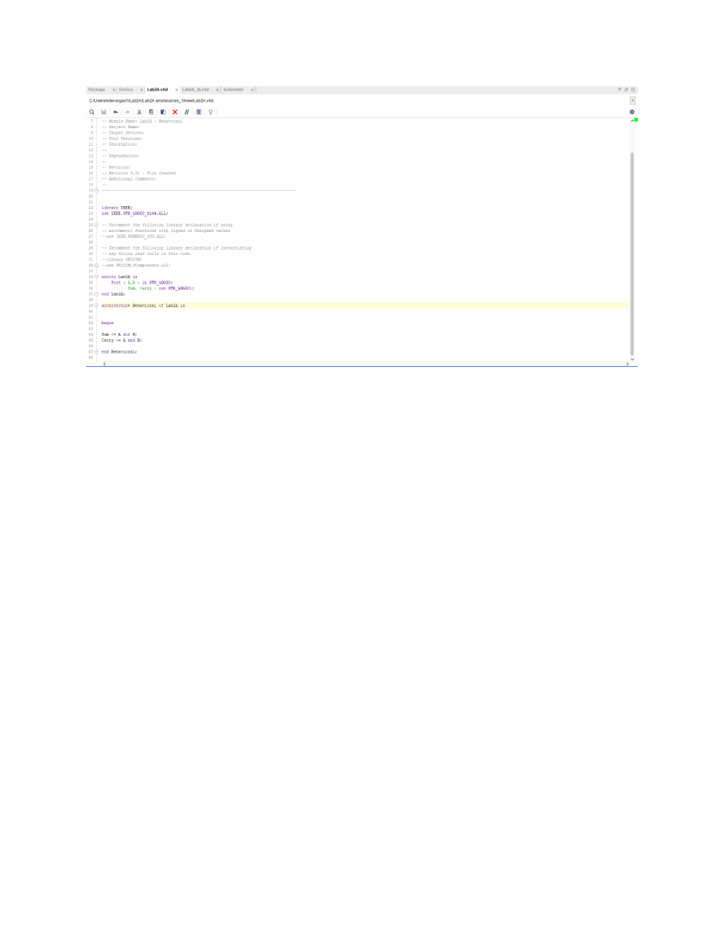

Lab 2 - Full Adder and 4-bit Ripple-Carry Adder - Page 3
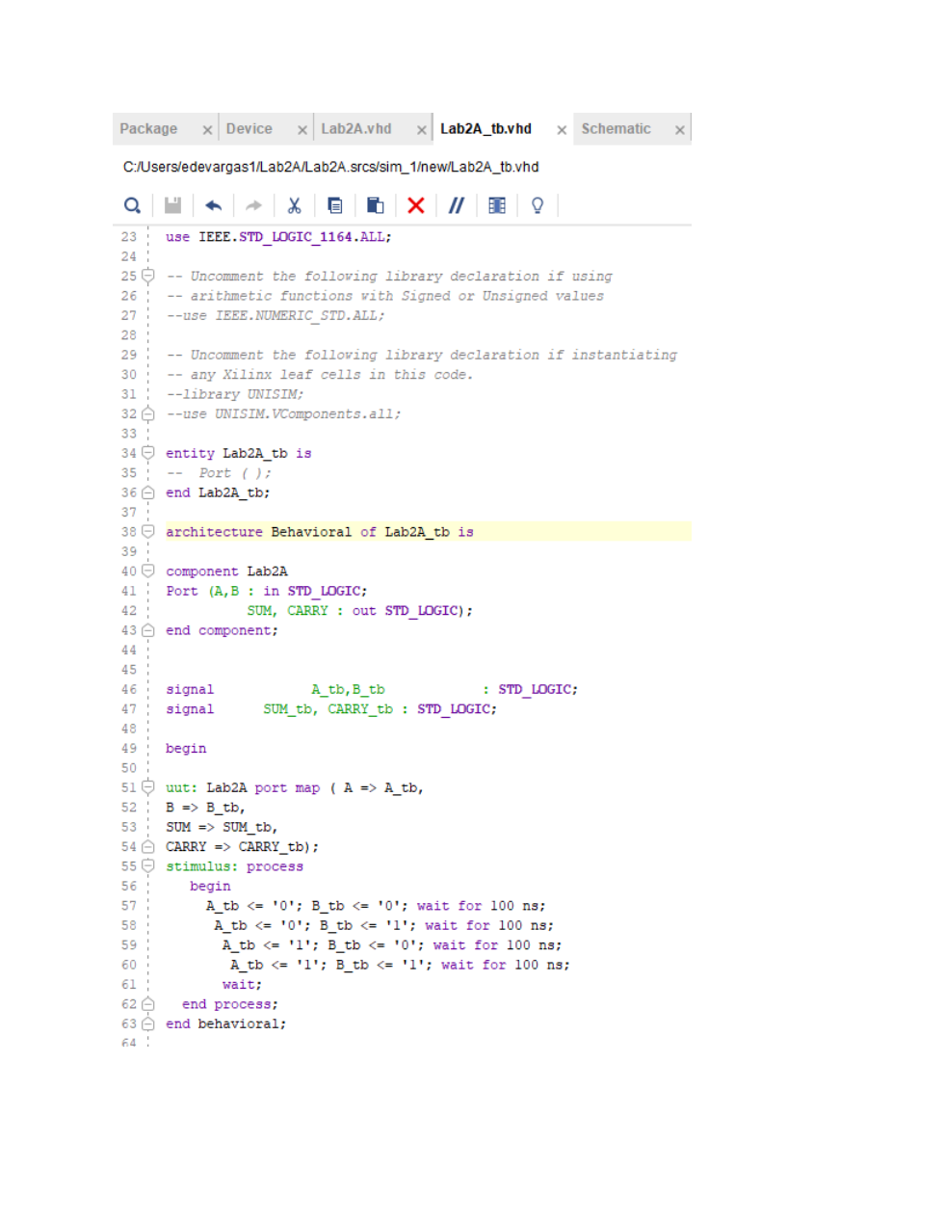

Lab 2 - Full Adder and 4-bit Ripple-Carry Adder - Page 4
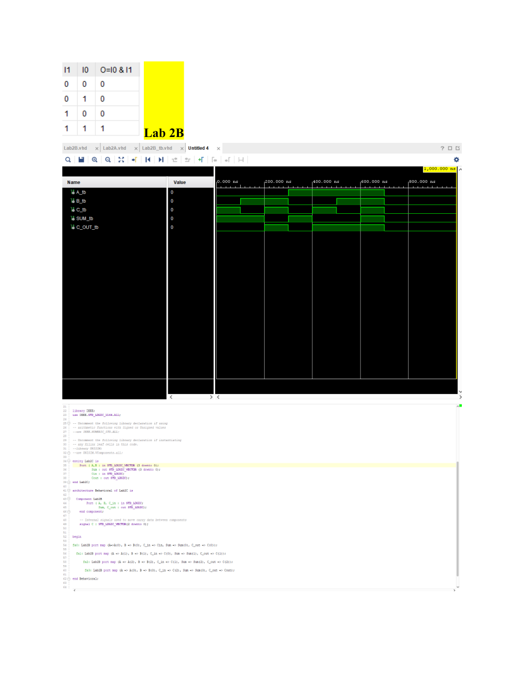

Lab 2 - Full Adder and 4-bit Ripple-Carry Adder - Page 5
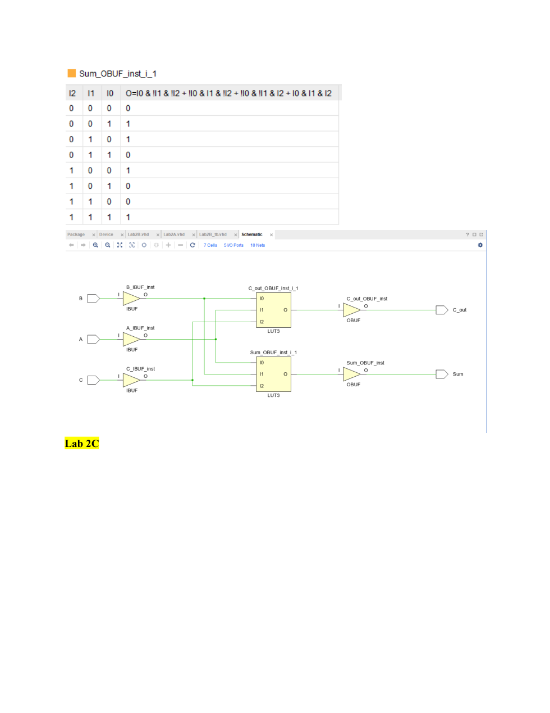

Lab 2 - Full Adder and 4-bit Ripple-Carry Adder - Page 6
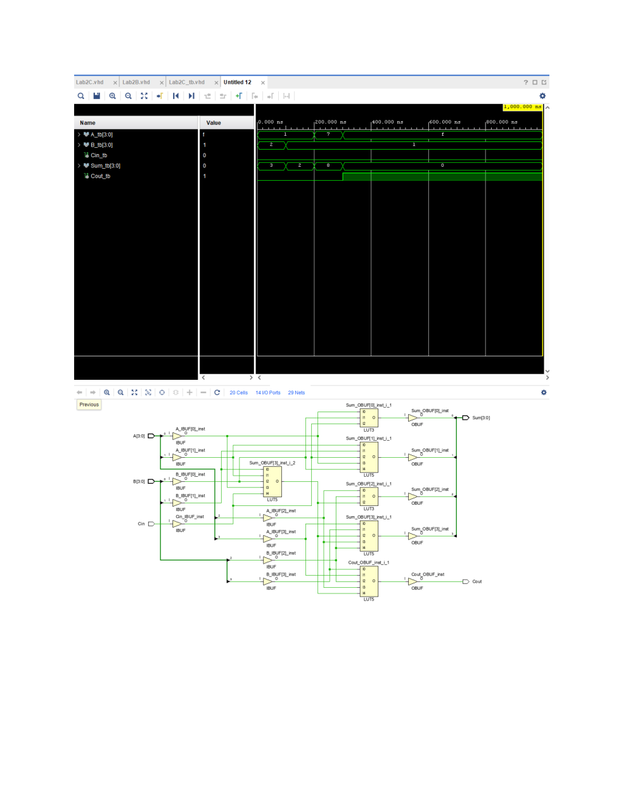

Lab 2 - Full Adder and 4-bit Ripple-Carry Adder - Page 7
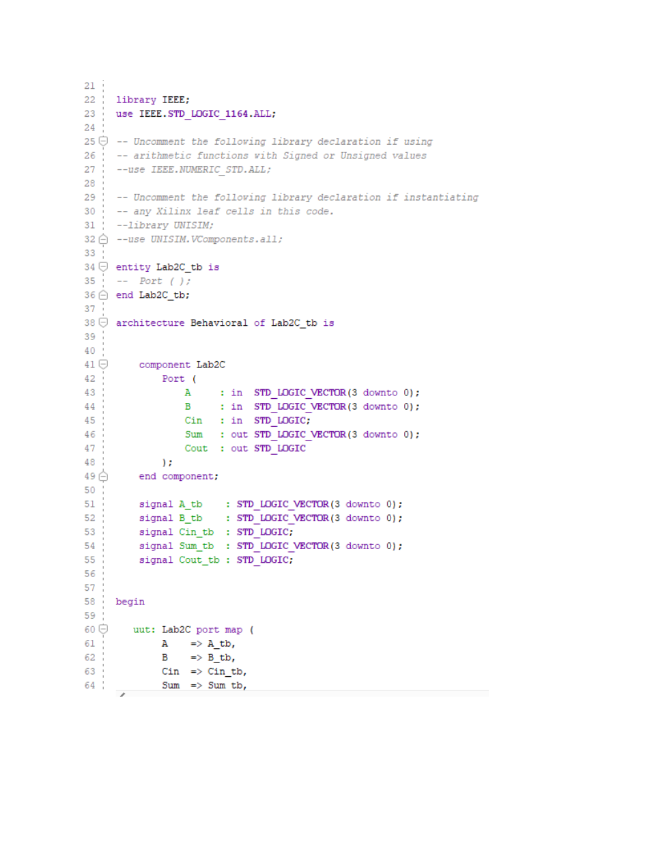

Lab 2 - Full Adder and 4-bit Ripple-Carry Adder - Page 8
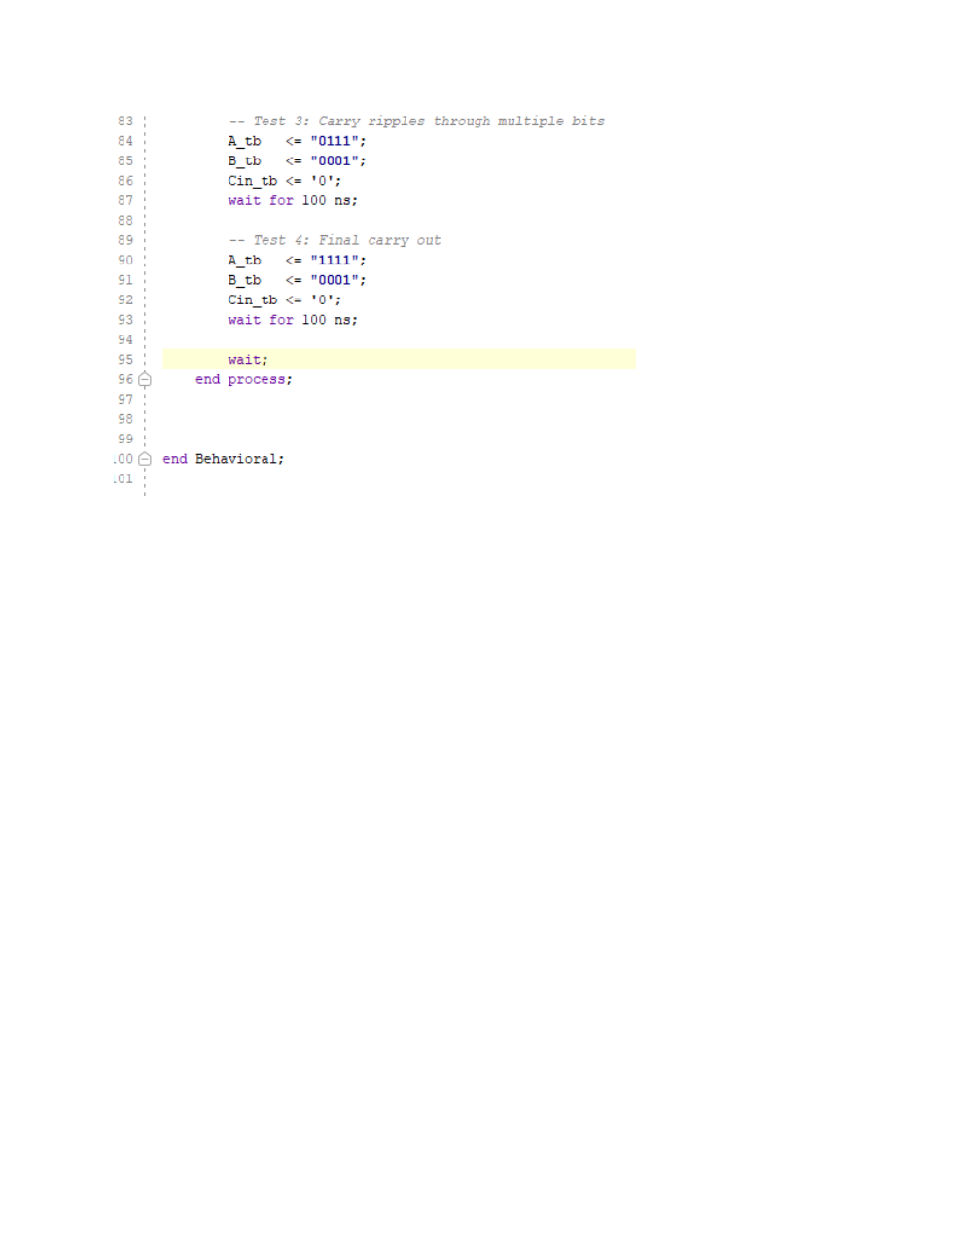

Lab 2 - Full Adder and 4-bit Ripple-Carry Adder - Page 9
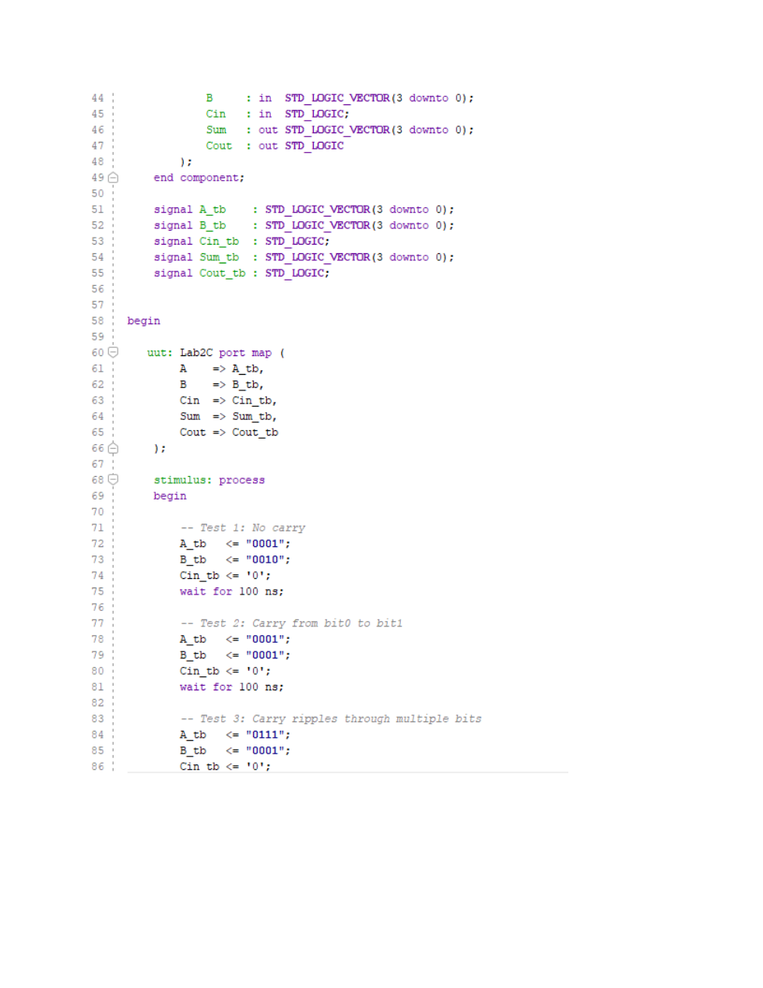

Lab 2 - Full Adder and 4-bit Ripple-Carry Adder - Page 10
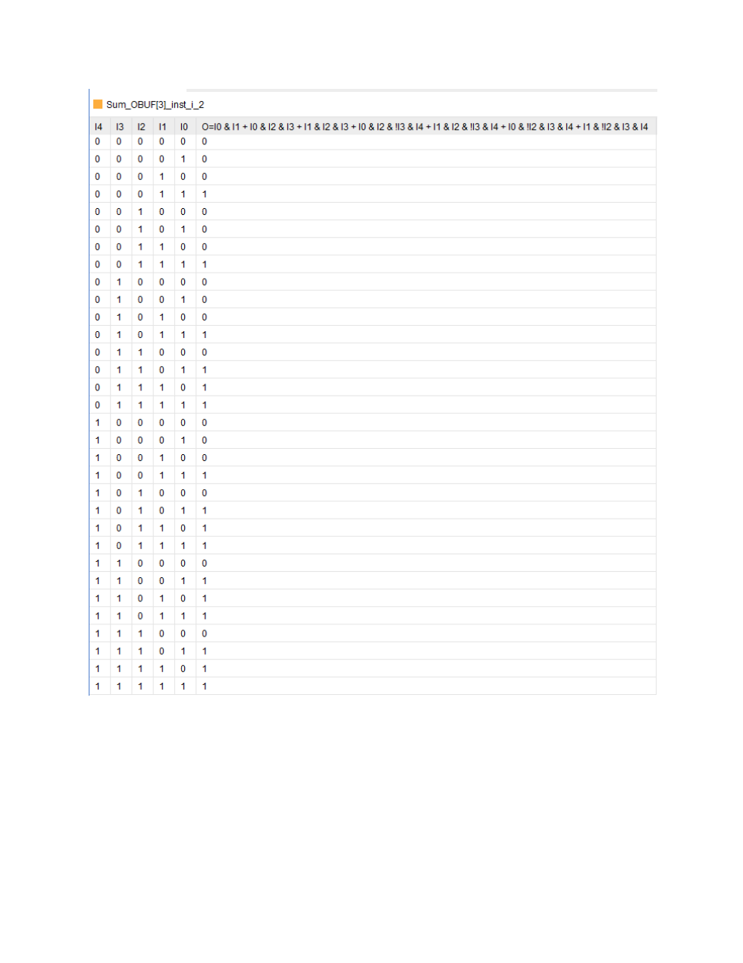

Lab 2 - Full Adder and 4-bit Ripple-Carry Adder - Page 11
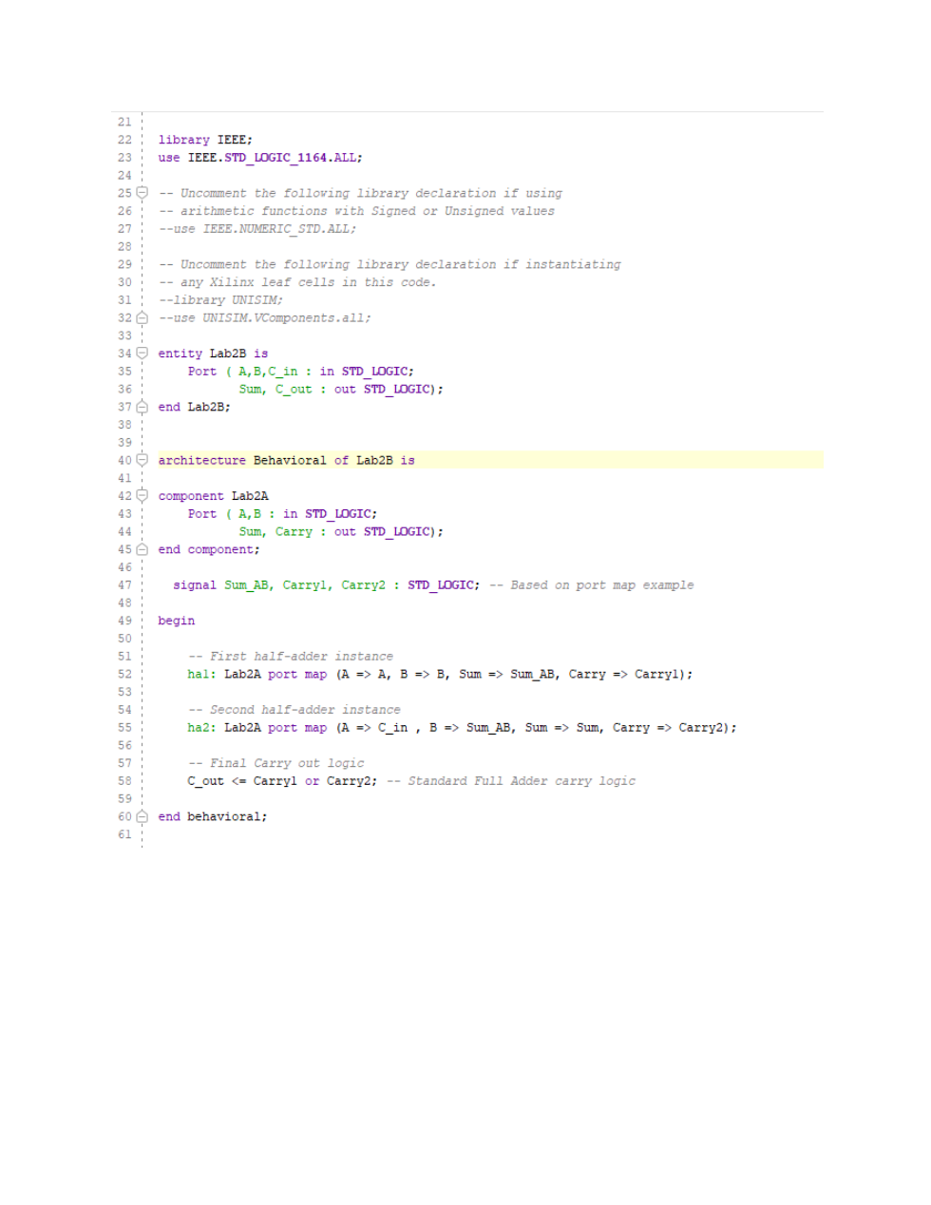

Lab 2 - Full Adder and 4-bit Ripple-Carry Adder - Page 12
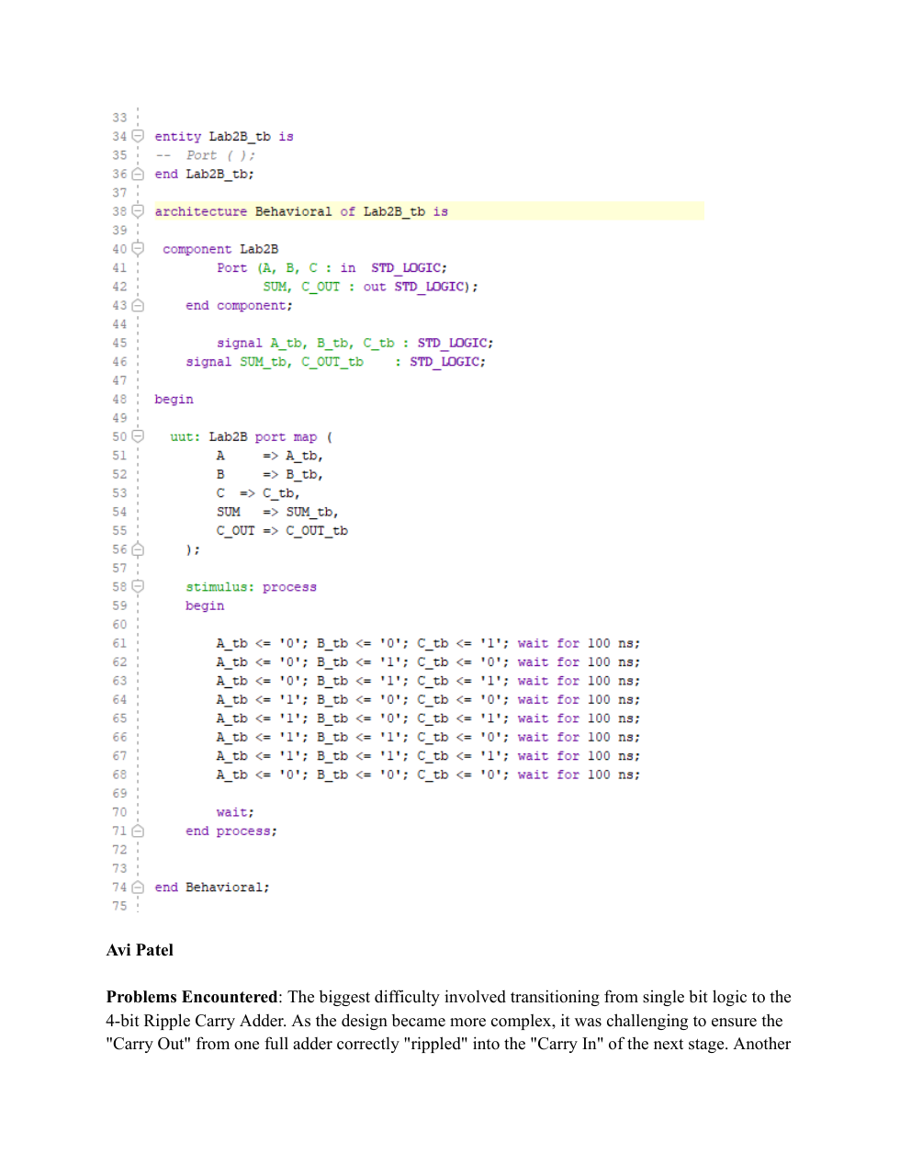

Lab 2 - Full Adder and 4-bit Ripple-Carry Adder - Page 13
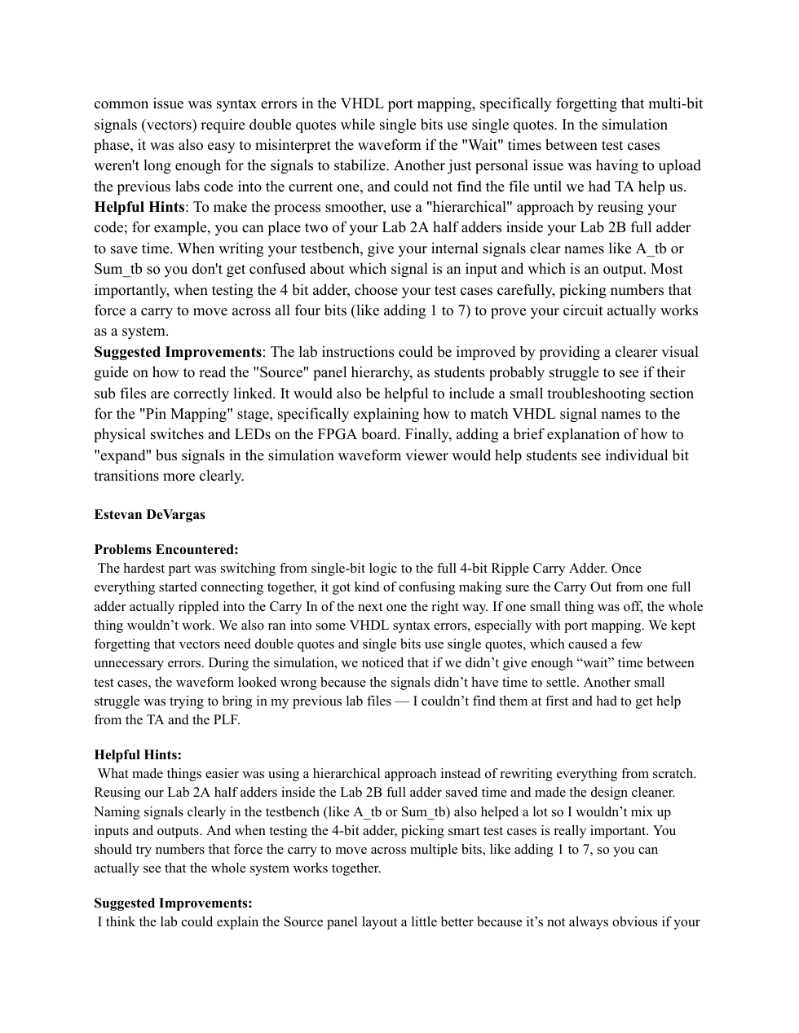

Lab 2 - Full Adder and 4-bit Ripple-Carry Adder - Page 14


Lab 3 - Structural Design, Multiplexers and Decoder
Structural VHDL design, multiplexers, decoder, and integrated logic
Lab 3 - Structural Design, Multiplexers and Decoder - Page 1
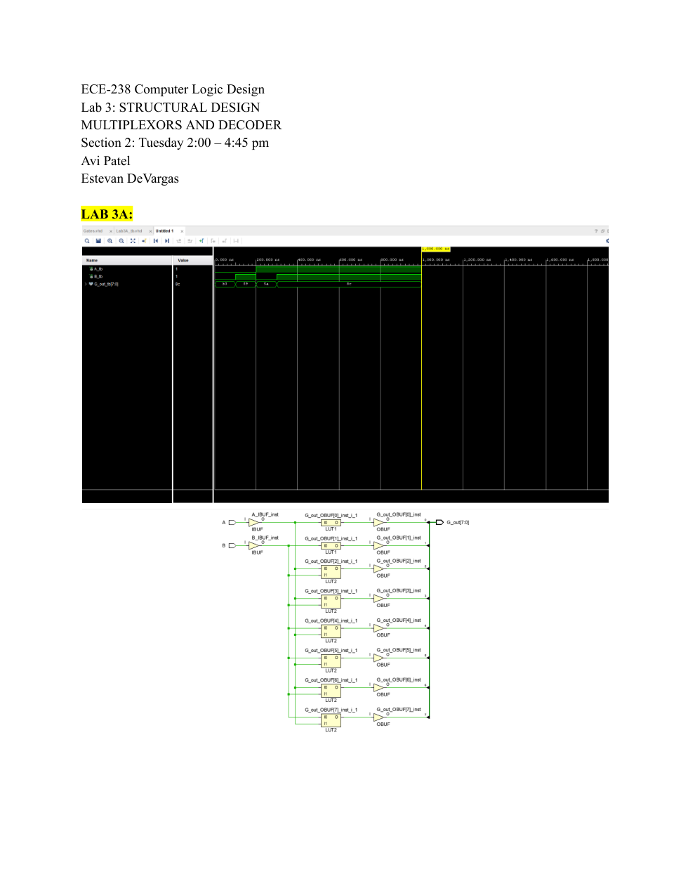

Lab 3 - Structural Design, Multiplexers and Decoder - Page 2
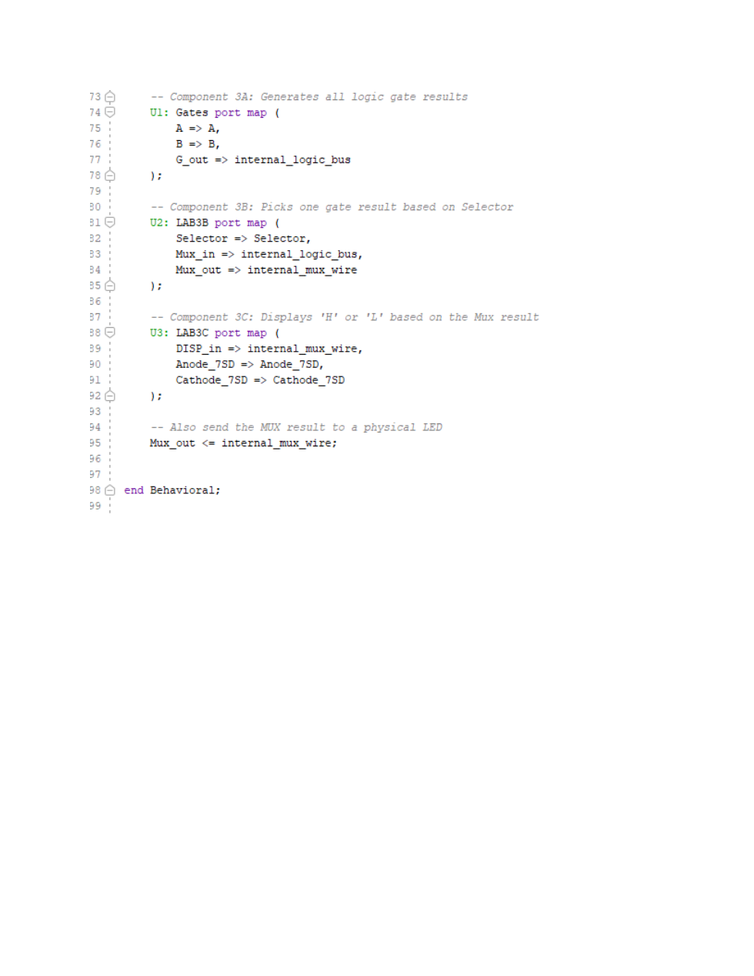

Lab 3 - Structural Design, Multiplexers and Decoder - Page 3
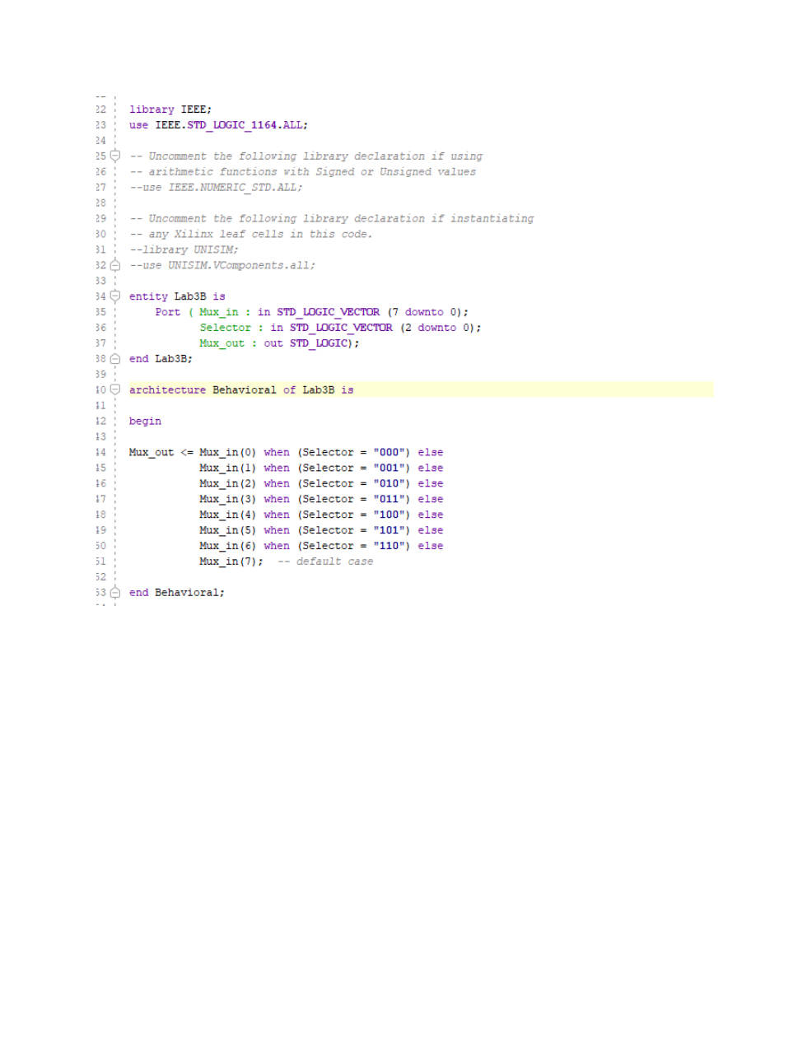

Lab 3 - Structural Design, Multiplexers and Decoder - Page 4
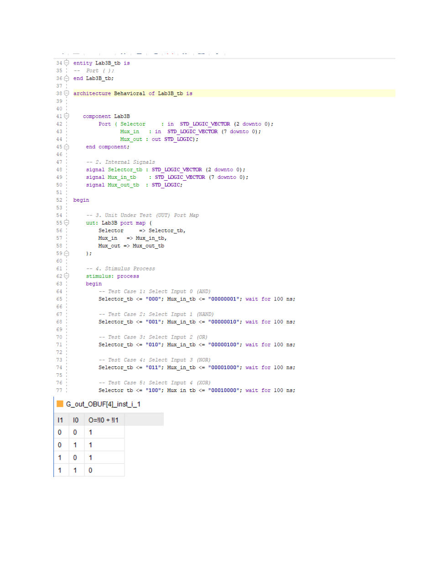

Lab 3 - Structural Design, Multiplexers and Decoder - Page 5
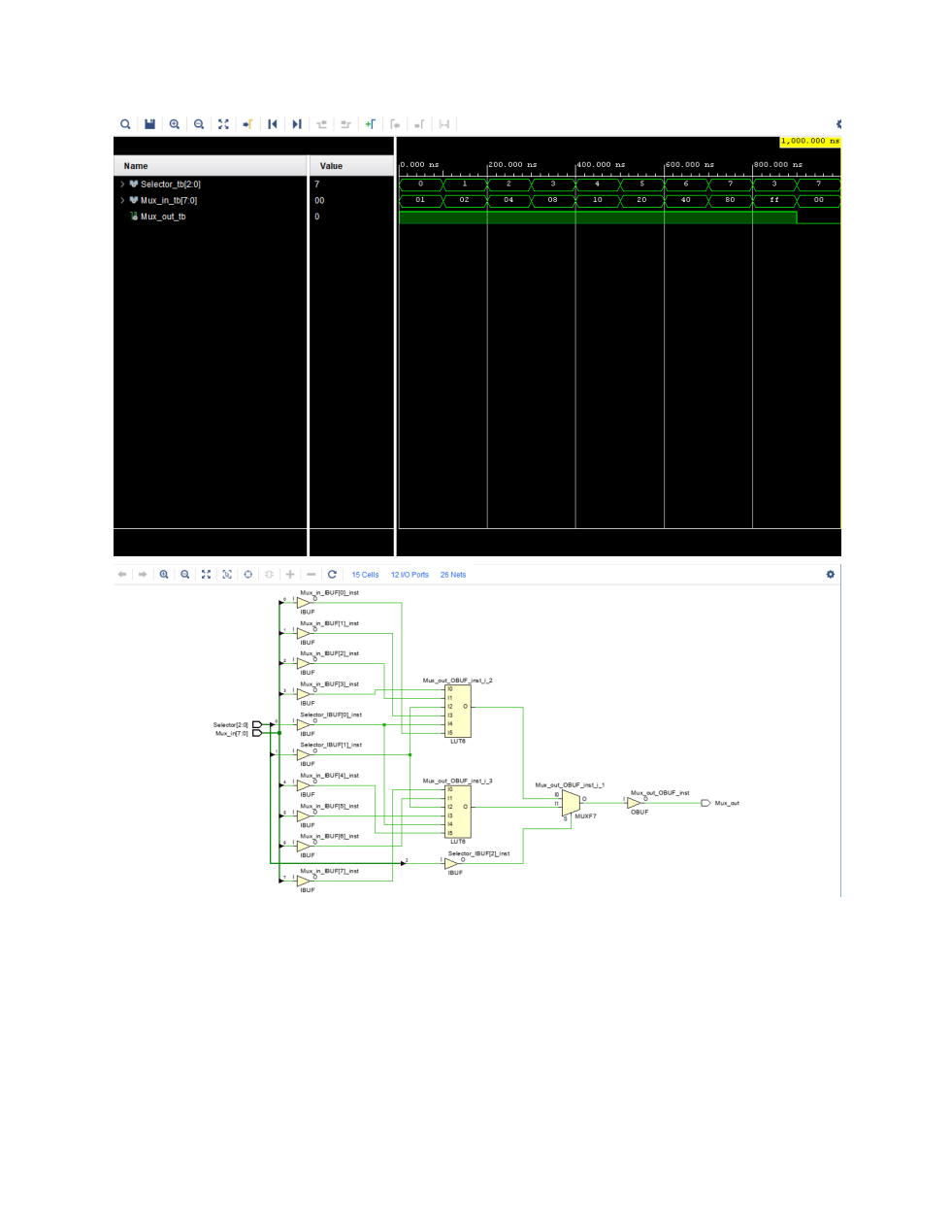

Lab 3 - Structural Design, Multiplexers and Decoder - Page 6
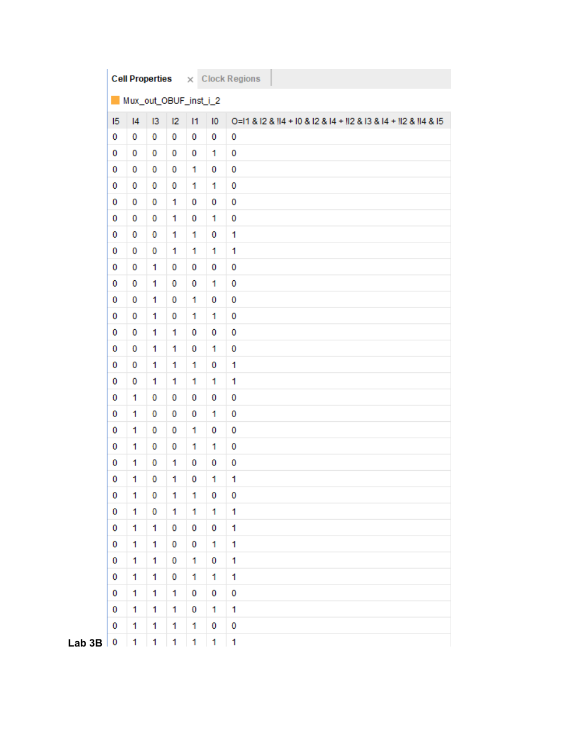

Lab 3 - Structural Design, Multiplexers and Decoder - Page 7
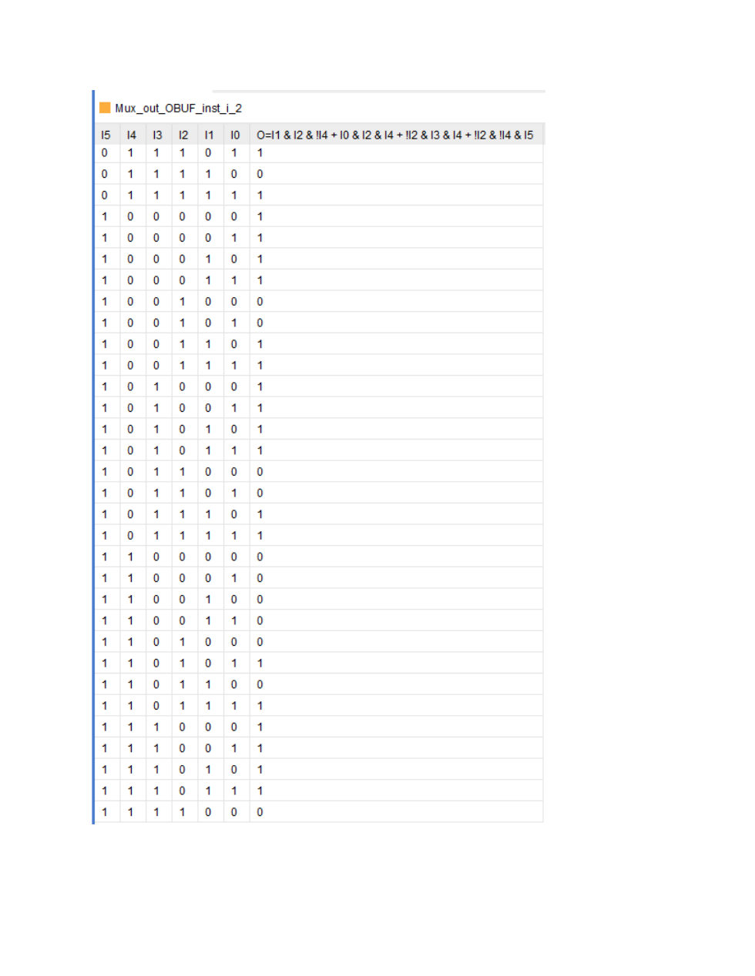

Lab 3 - Structural Design, Multiplexers and Decoder - Page 8
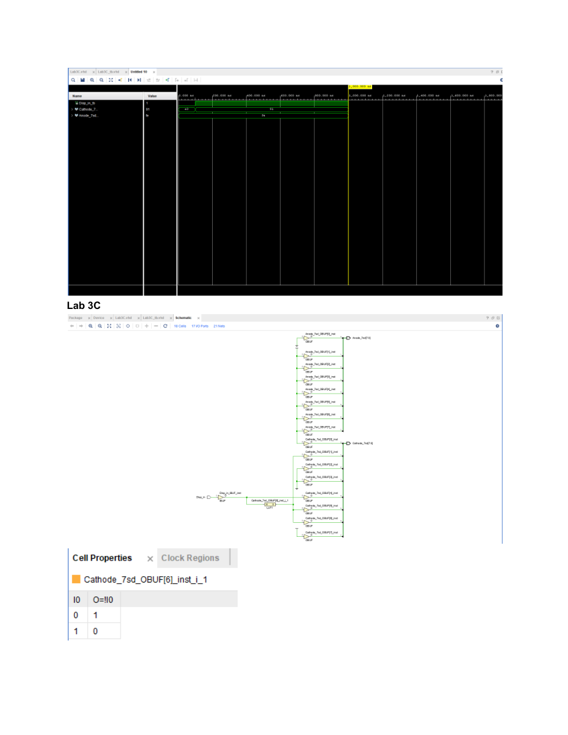

Lab 3 - Structural Design, Multiplexers and Decoder - Page 9
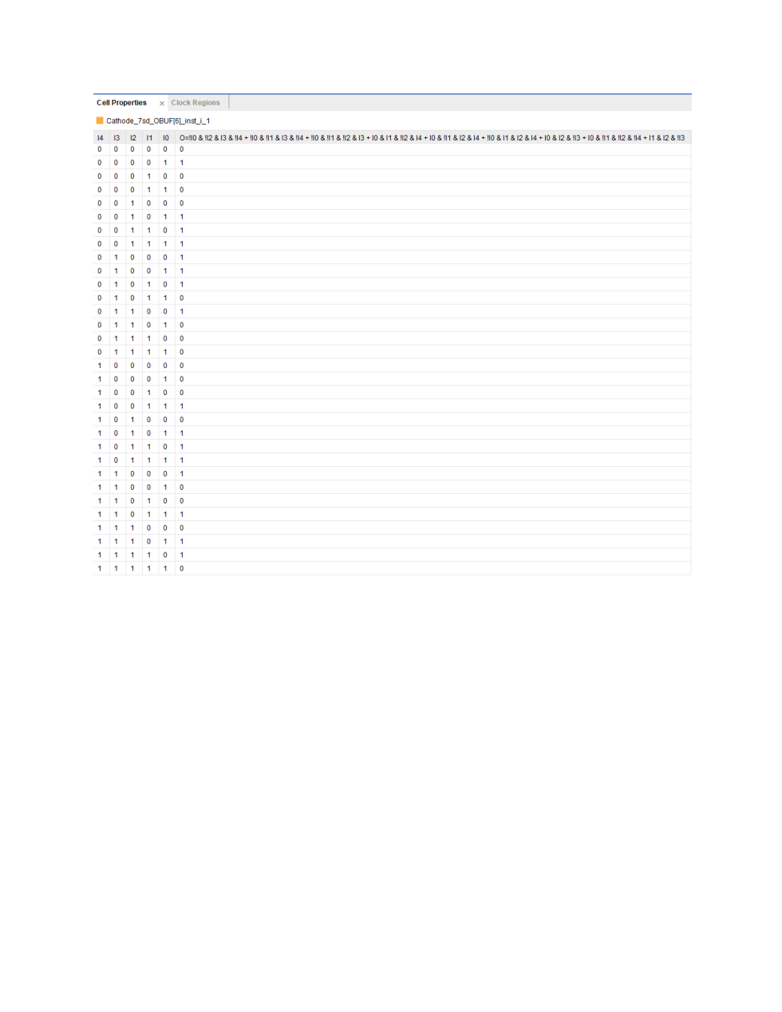

Lab 3 - Structural Design, Multiplexers and Decoder - Page 10
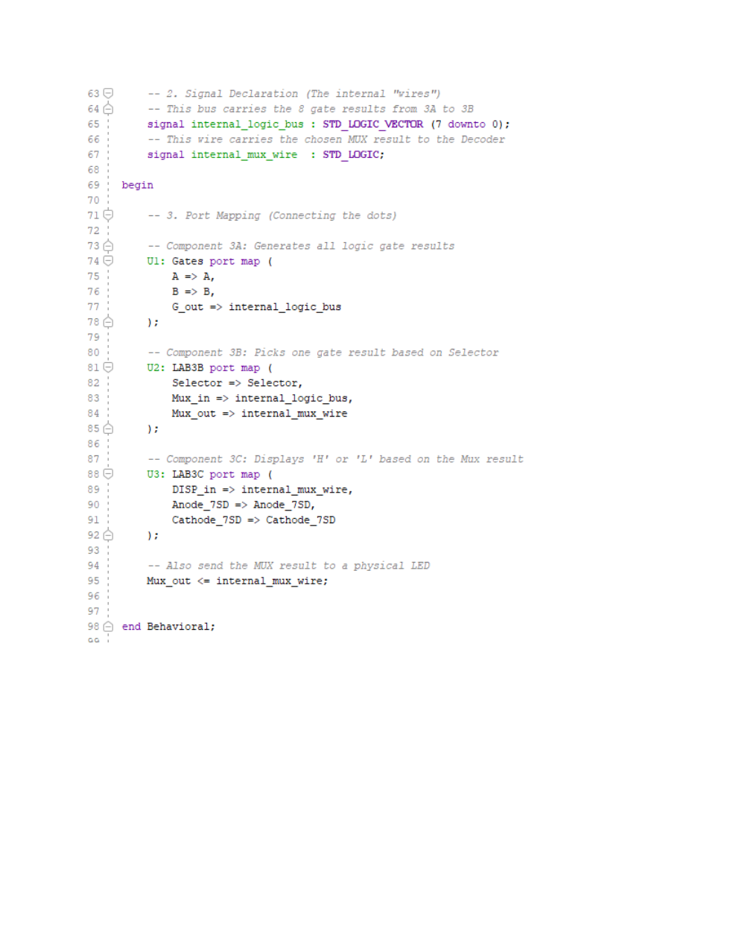

Lab 3 - Structural Design, Multiplexers and Decoder - Page 11
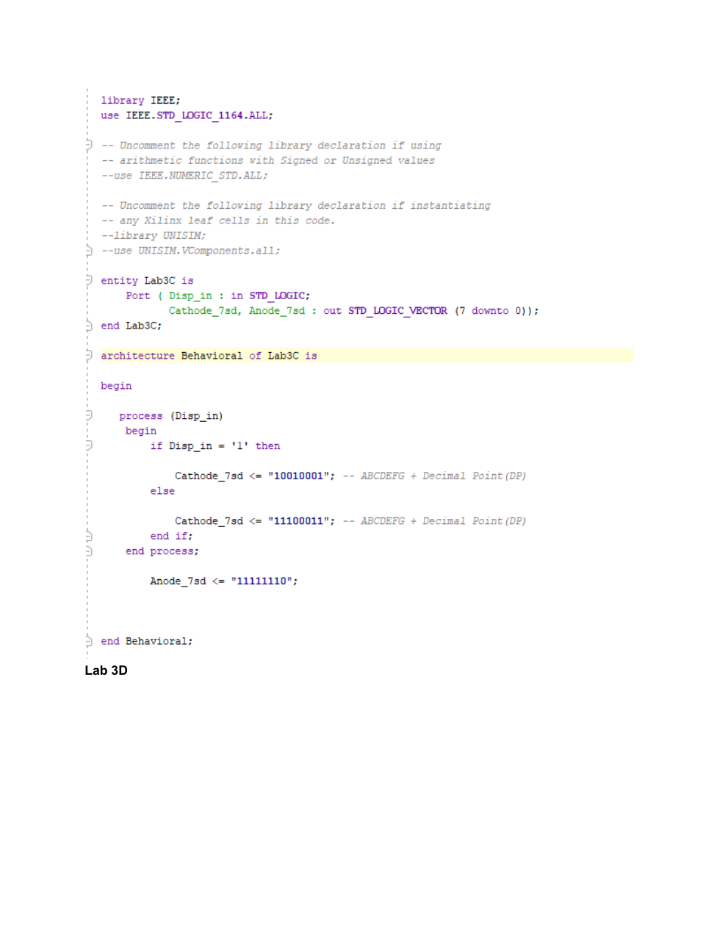

Lab 3 - Structural Design, Multiplexers and Decoder - Page 12
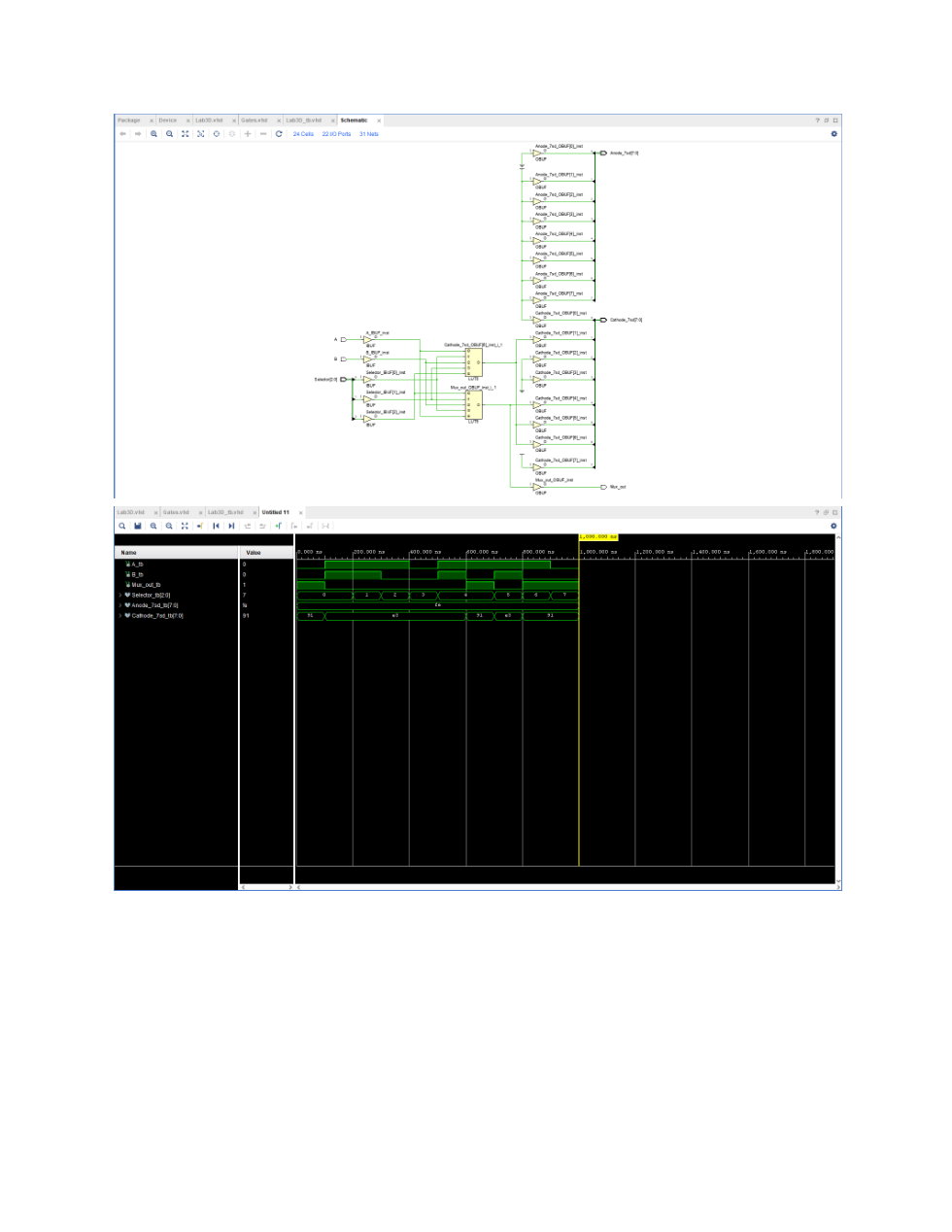

Lab 3 - Structural Design, Multiplexers and Decoder - Page 13
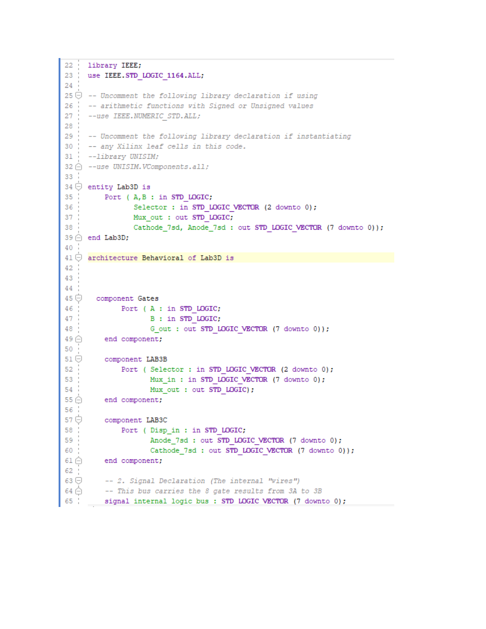

Lab 3 - Structural Design, Multiplexers and Decoder - Page 14
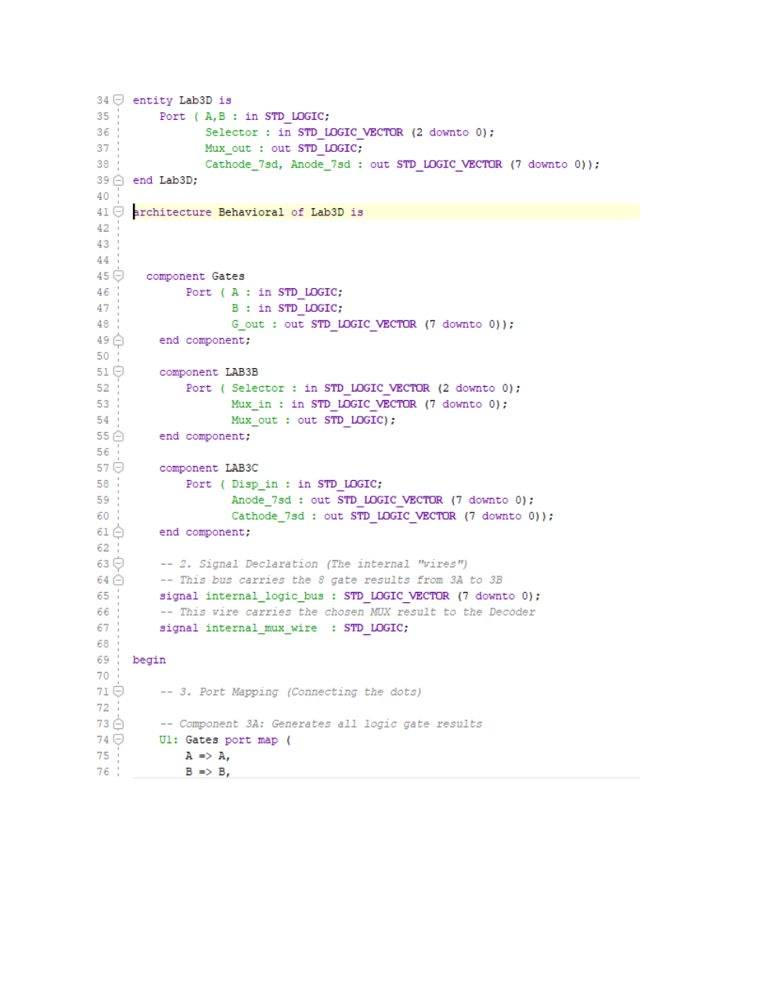

Lab 3 - Structural Design, Multiplexers and Decoder - Page 15


Lab 3 - Structural Design, Multiplexers and Decoder - Page 16
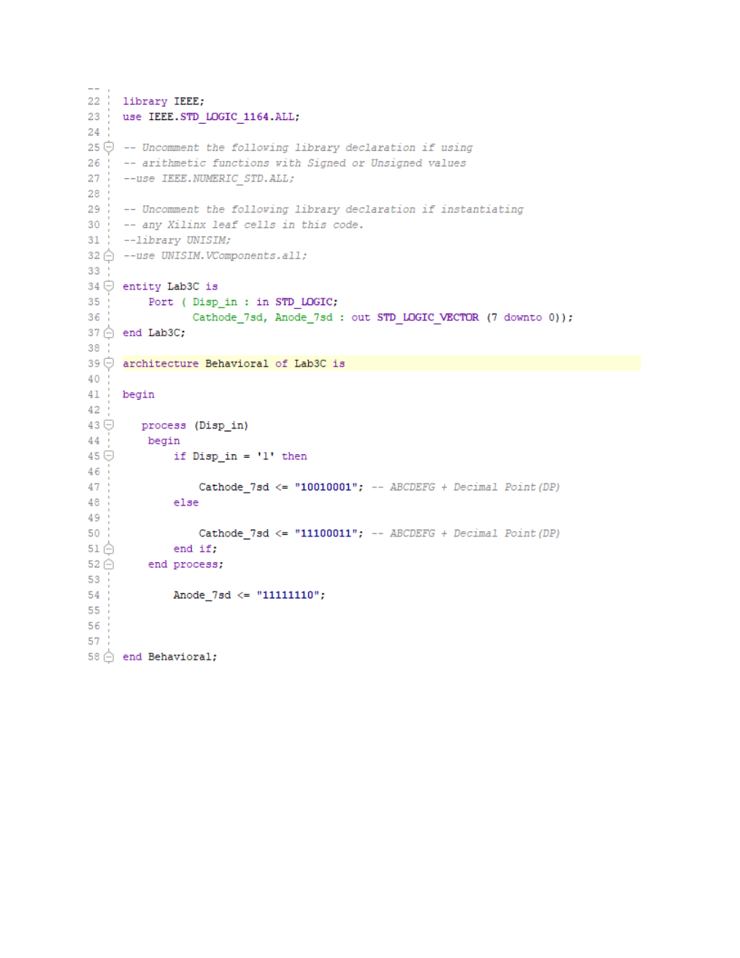

Lab 3 - Structural Design, Multiplexers and Decoder - Page 17
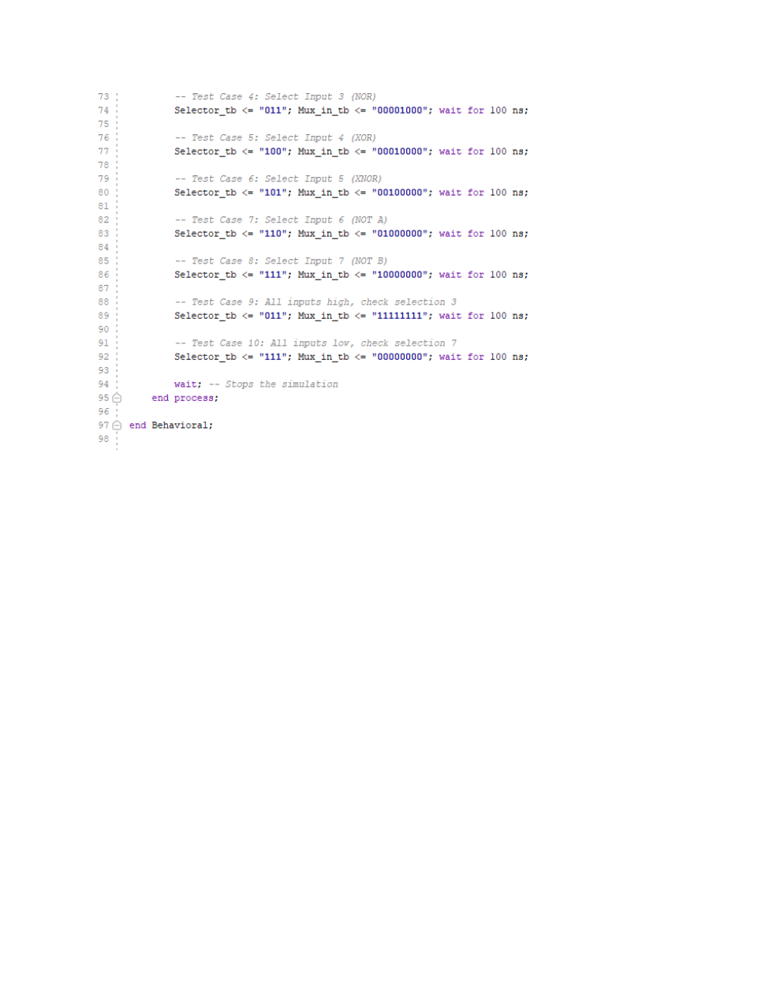

Lab 3 - Structural Design, Multiplexers and Decoder - Page 18
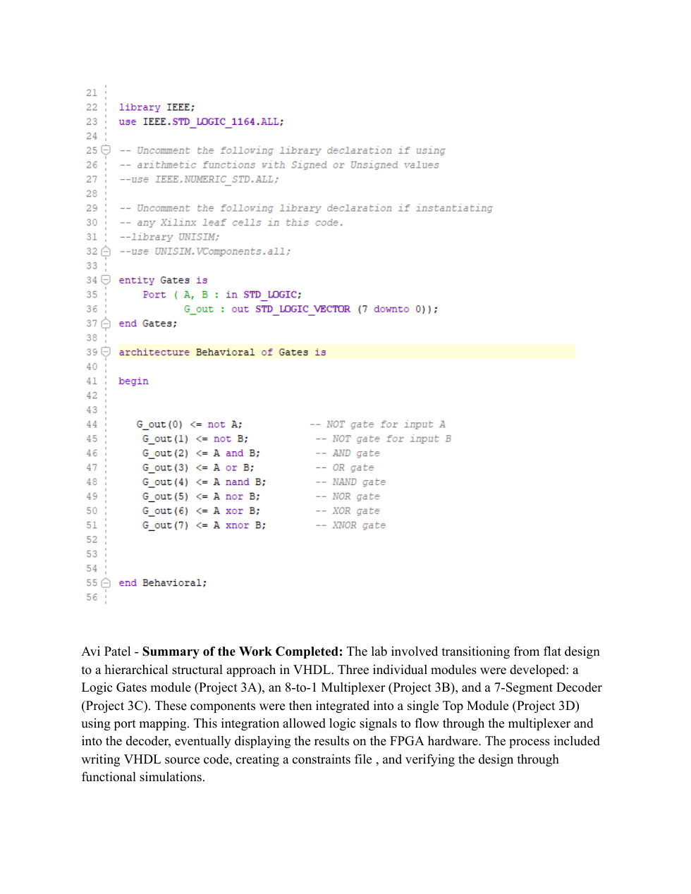

Lab 3 - Structural Design, Multiplexers and Decoder - Page 19
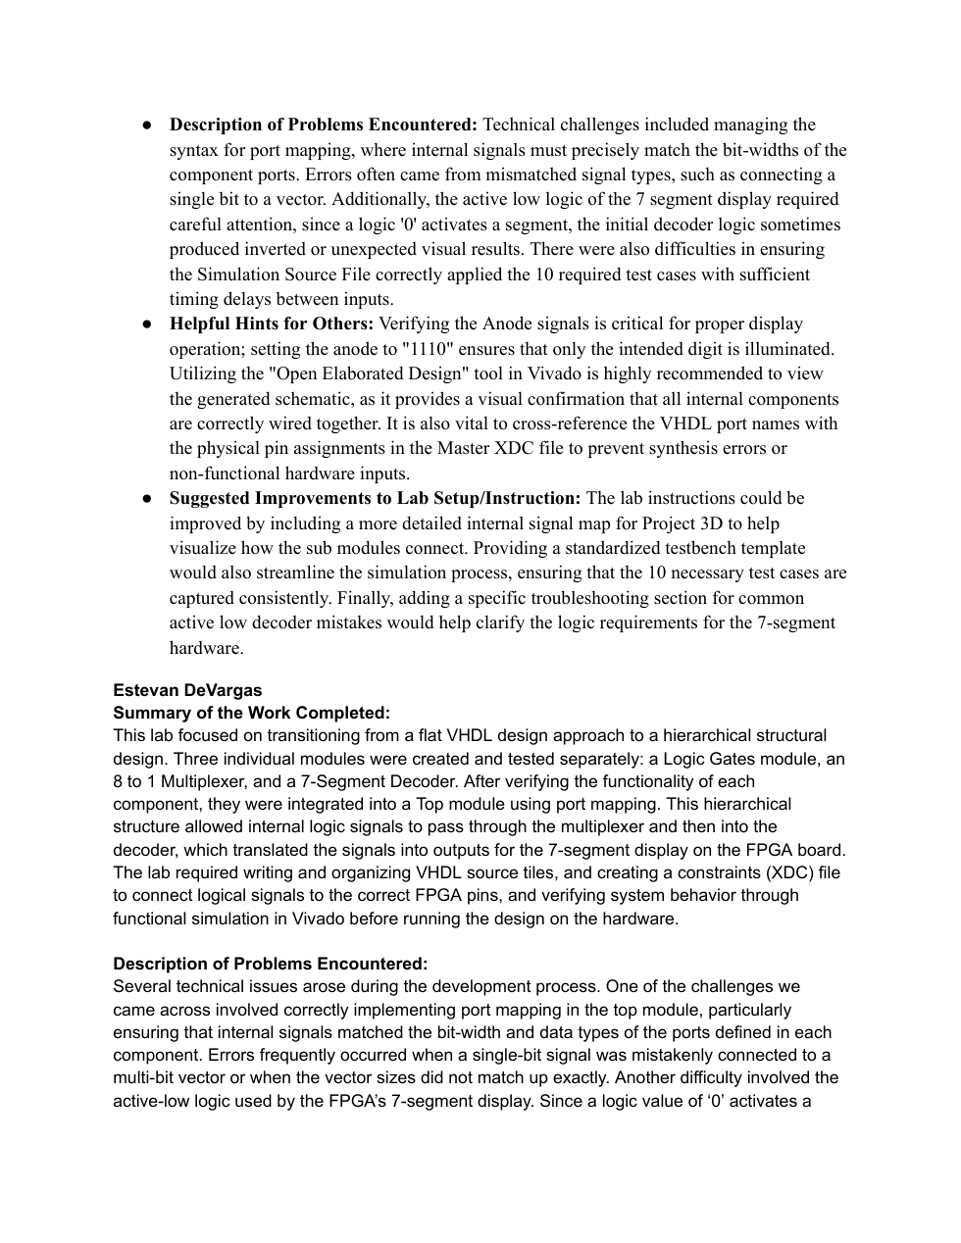

Lab 3 - Structural Design, Multiplexers and Decoder - Page 20
