|  |
| --- |
| ECSE 428 |
| Assignment B |
| TDD development |

|  |
| --- |
| Chaoyi Liu: 260678101  Bill Zhang:  2018-3-4 |

目录

Test 1 1

Test 2 3

Test 3 4

Test 4 6

Test 5 7

Test 6 8

Test 7 10

Test 8 11

Test 9 13

Test 10 15

Test 11 16

Test 12 18

Test 13 18

Test 14 18

Test 15 18

Test 16 18

Test 17 19

Test 18 19

### Test 1

1. Test name: too_few_args
2. Call Setup: PostalCalculation 150 100
3. Expected Result: arguments too few
4. Purpose: check if the input is not enough

#### Failing

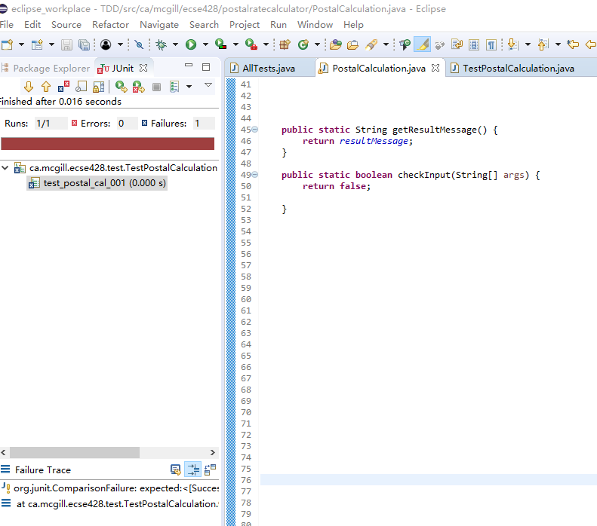

#### Successful

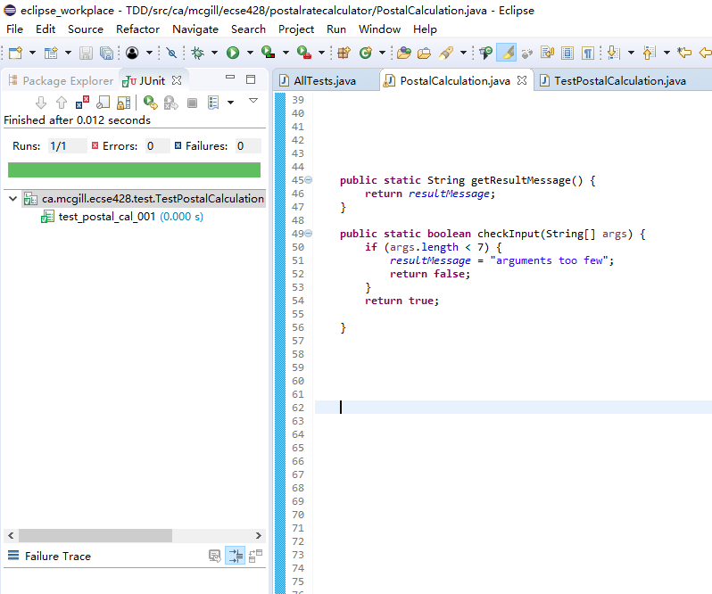

### Test 2

1. Test name: too_many_args
2. Call Setup: PostalCalculation 150 100 H2H2H2 H2X3F4 150 100 100 100 Regular
3. Expected Result: arguments too few
4. Purpose: check if the input exceeds what we need

#### Failing

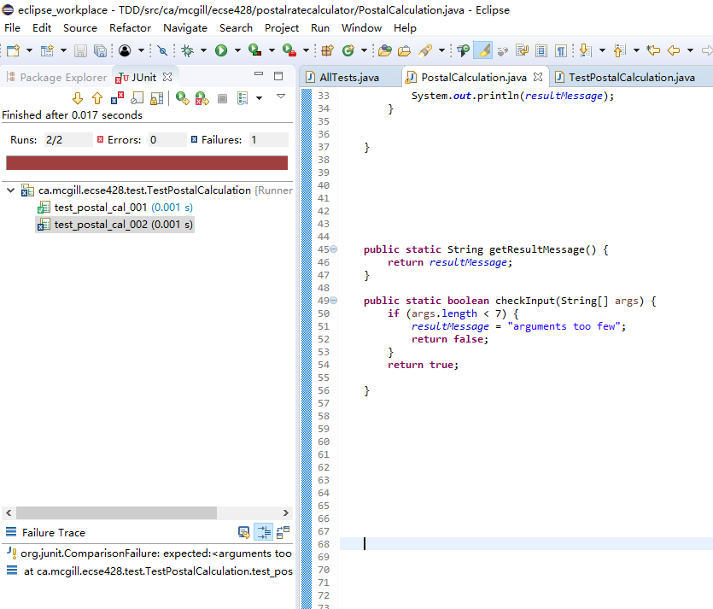

#### Successful

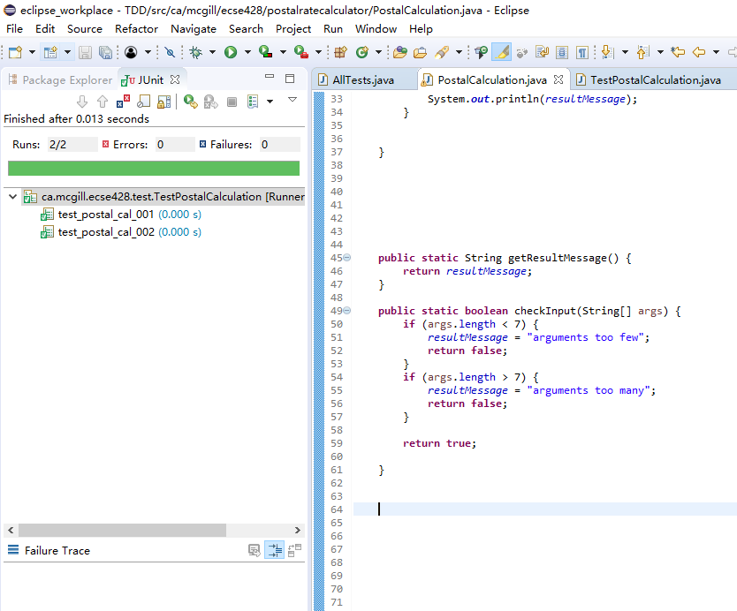

### Test 3

1. Test name: too_small_length
2. Call Setup: PostalCalculation H2H2H2 H2X3F4 10 100 100 100 Regular
3. Expected Result: length too small
4. Purpose: check if length is smaller than 140

#### Failing

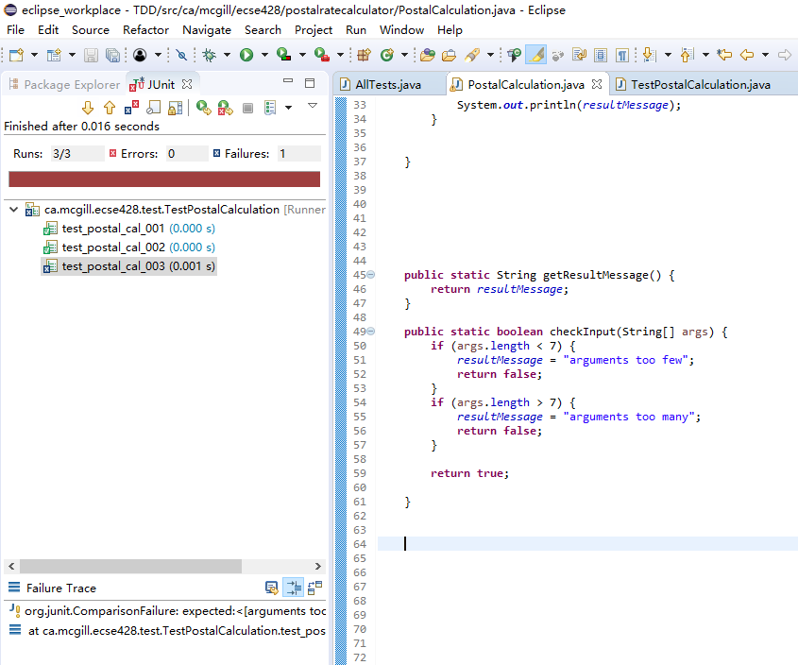

#### Successful

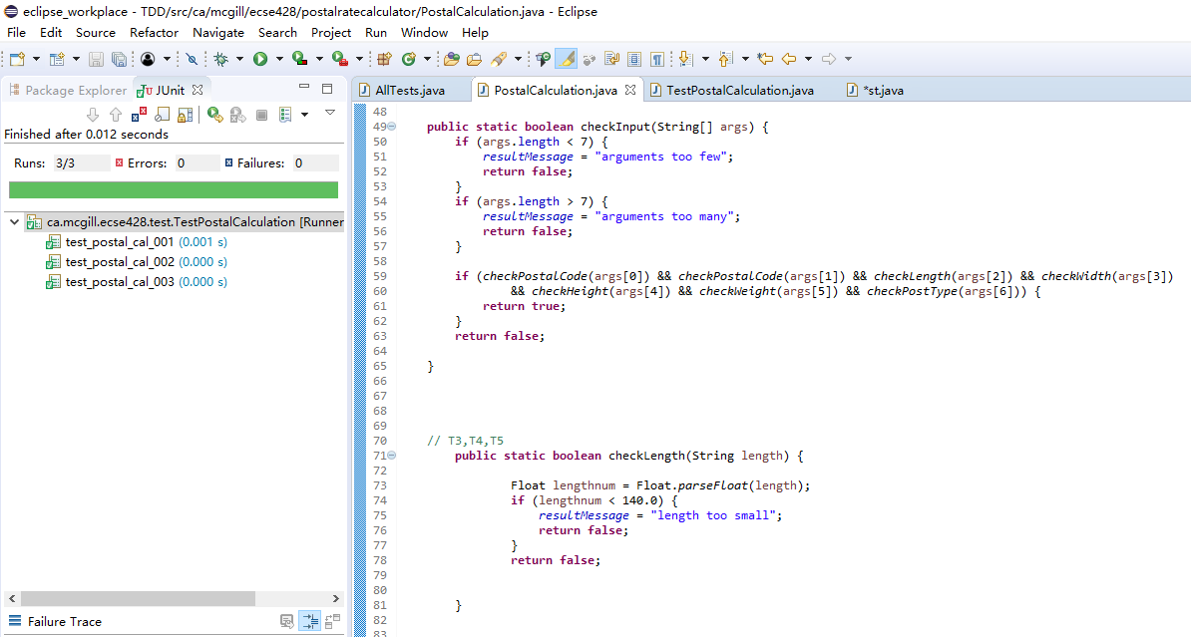

### Test 4

1. Test name: too_big_length
2. Call Setup: PostalCalculation H2H2H2 H2X3F4 500 100 100 100 Regular
3. Expected Result: length too big
4. Purpose: check if length is bigger than 380

#### Failing

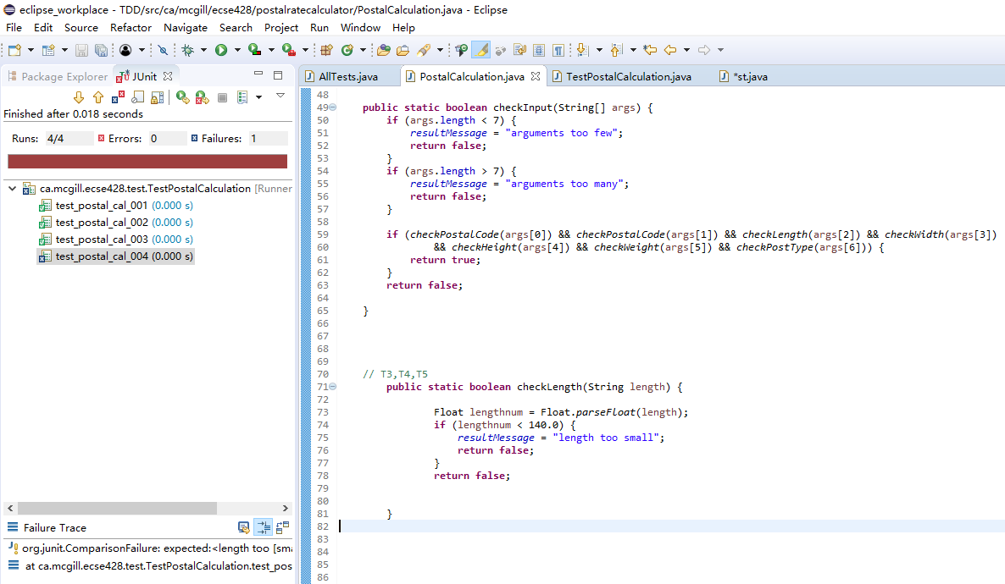

#### Successful

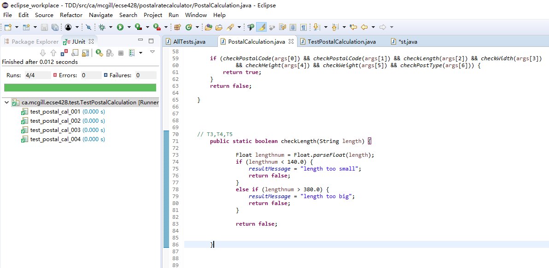

### Test 5

1. Test name: length_not_num
2. Call Setup: PostalCalculation H2H2H2 H2X3F4 length 100 100 100 Regular
3. Expected Result: invalid length
4. Purpose: check if the length input is a number

#### Failing

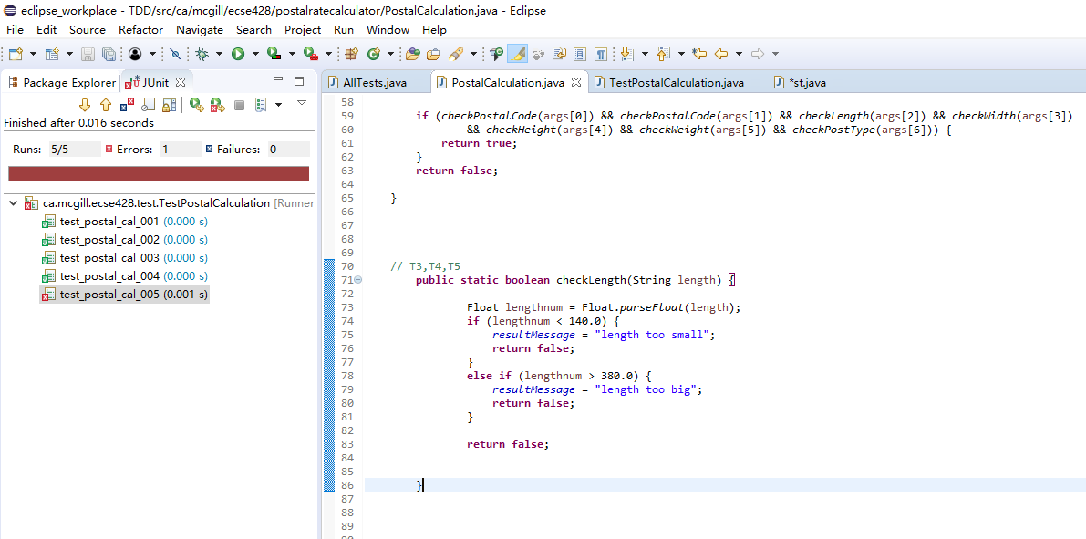

#### Successful

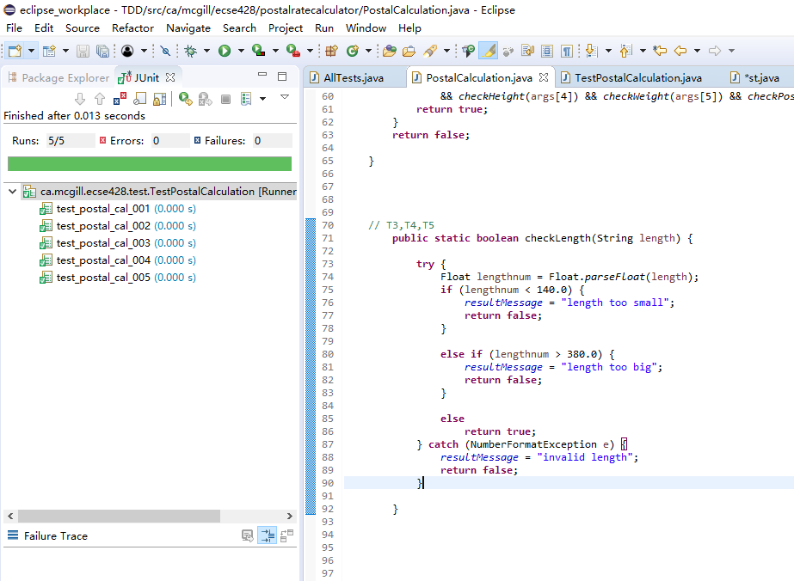

### Test 6

1. Test name: too_small_width
2. Call Setup: PostalCalculation H2H2H2 H2X3F4 150 10 100 100 Regular
3. Expected Result: width too small
4. Purpose: check if width is smaller than 90

#### Failing

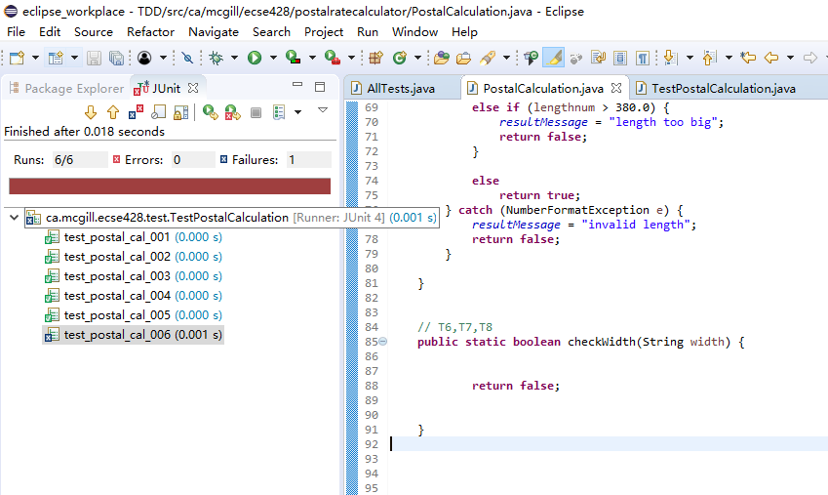

#### Successful

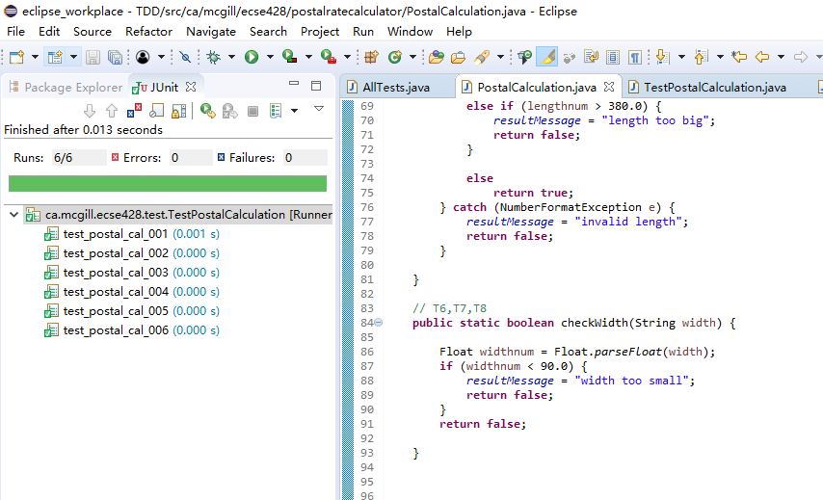

### Test 7

1. Test name: too_big_width
2. Call Setup: PostalCalculation H2H2H2 H2X3F4 150 500 100 100 Regular
3. Expected Result: width too big
4. Purpose: check if width is bigger than 270

#### Failing

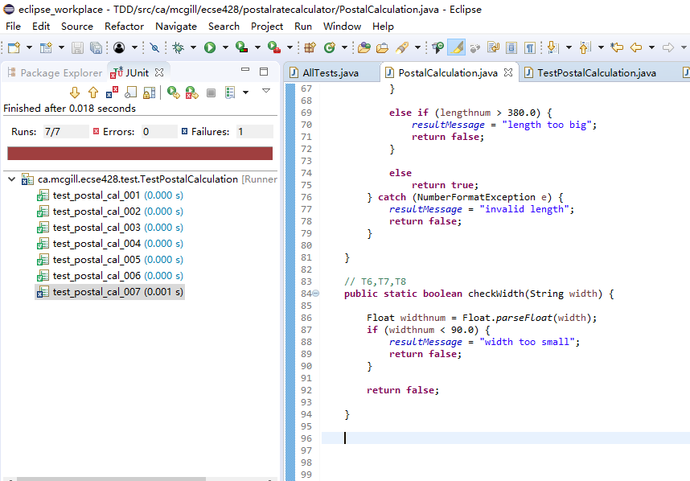

#### Successful

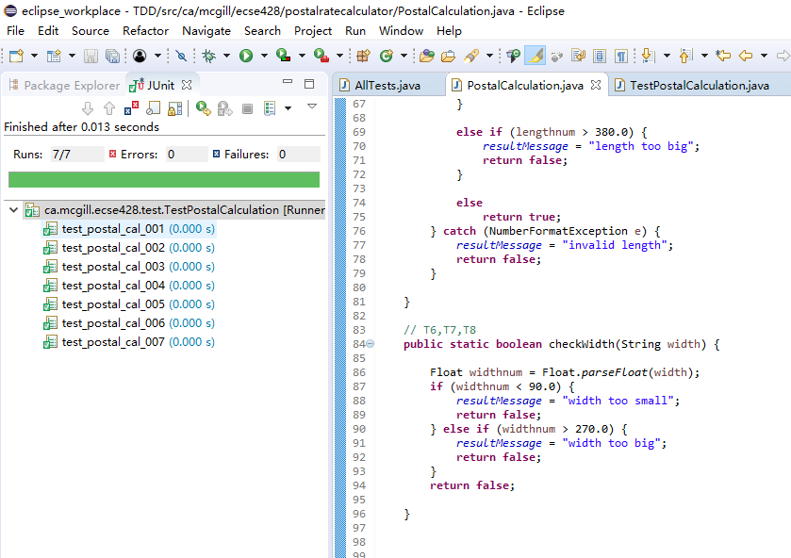

### Test 8

1. Test name: width_not_num
2. Call Setup: PostalCalculation H2H2H2 H2X3F4 150 width 100 100 Regular
3. Expected Result: invalid width
4. Purpose: check if the width input is a number

#### Failing

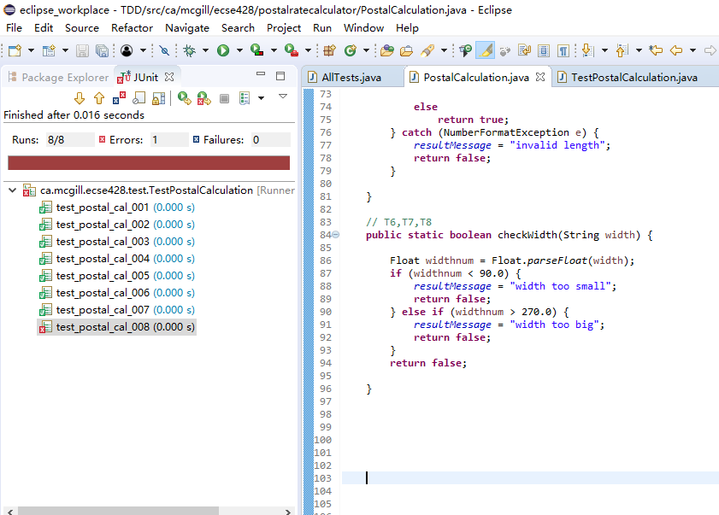

#### Successful

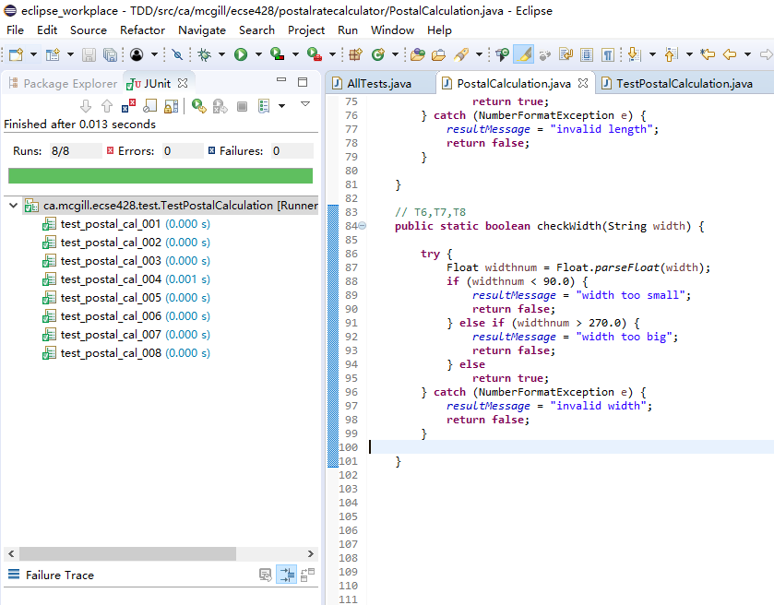

### Test 9

1. Test name: too_small_weight
2. Call Setup: PostalCalculation H2H2H2 H2X3F4 150 100 100 1 Regular
3. Expected Result: weight too small
4. Purpose: check if weight is smaller than 3

#### Failing

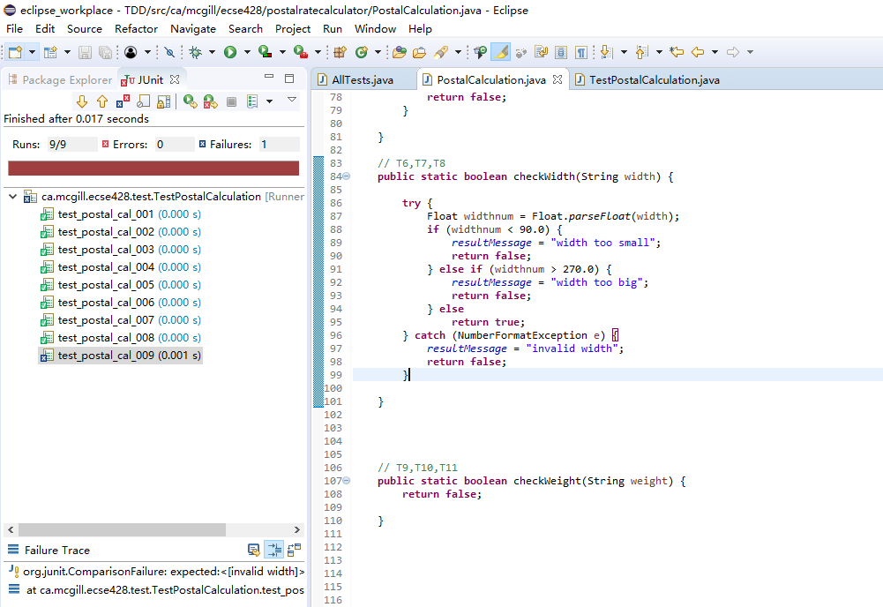

#### Successful

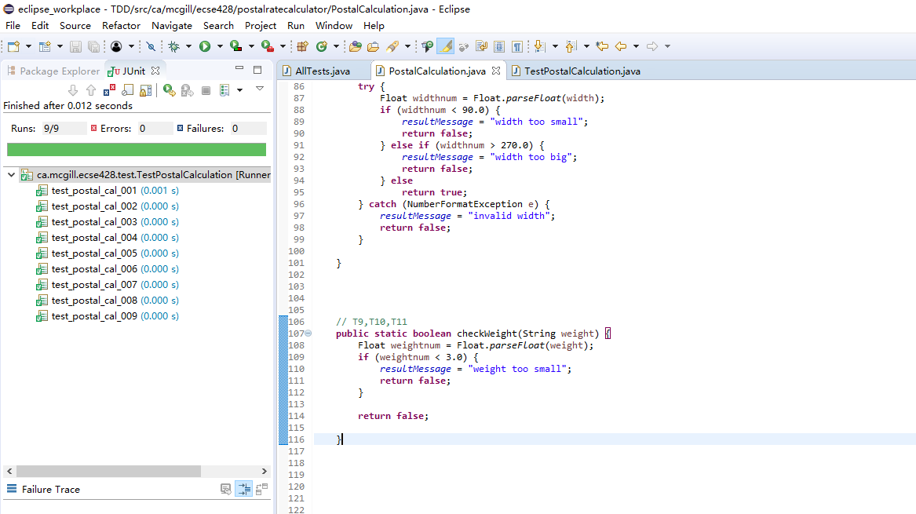

### Test 10

1. Test name: too_big_weight
2. Call Setup: PostalCalculation H2H2H2 H2X3F4 150 100 100 800 Regular
3. Expected Result: weight too big
4. Purpose: check if weight is bigger than 500

#### Failing

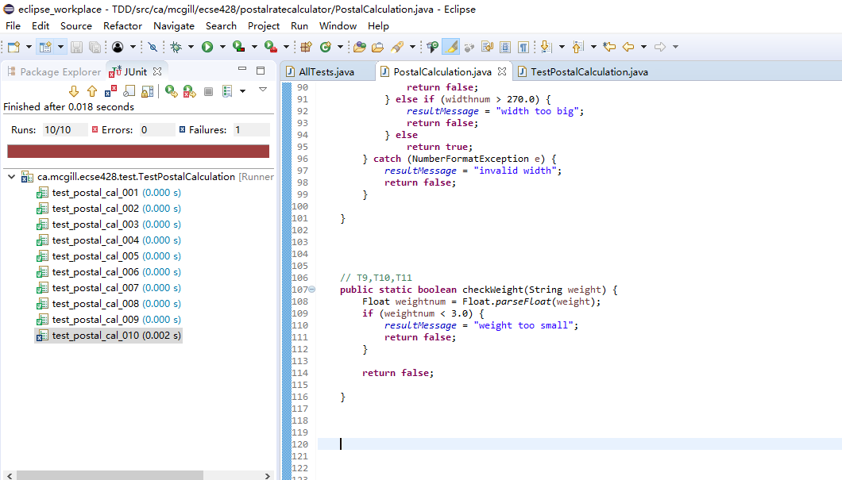

#### Successful

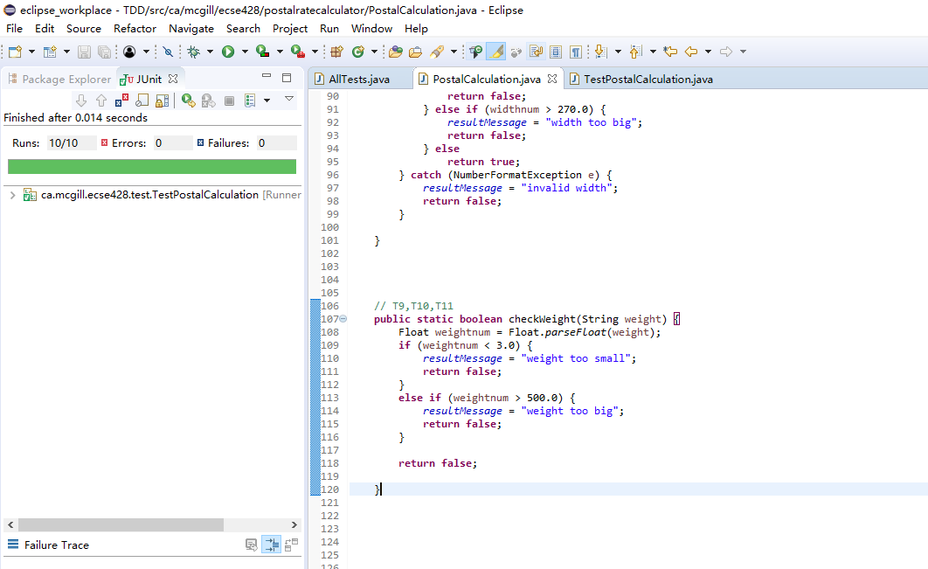

### Test 11

1. Test name: weight_not_num
2. Call Setup: PostalCalculation H2H2H2 H2X3F4 150 100 100 weight Regular
3. Expected Result: invalid weight
4. Purpose: check if the weight input is a number

#### Failing

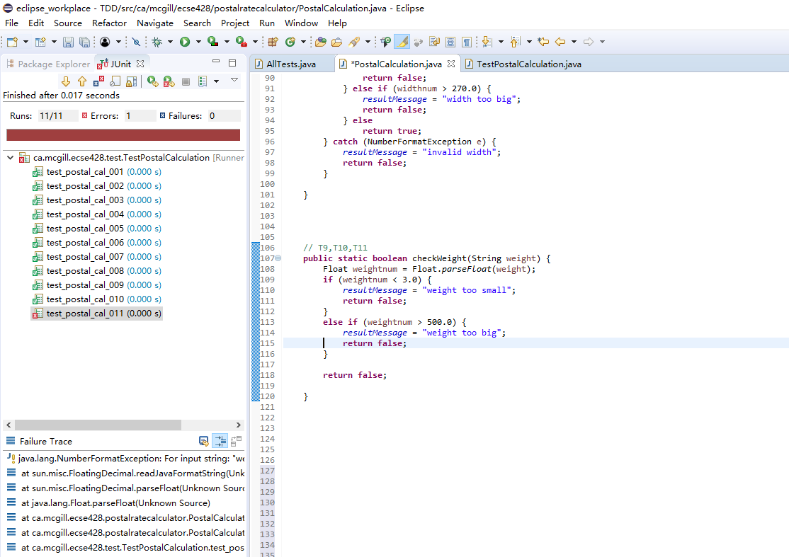

#### Successful

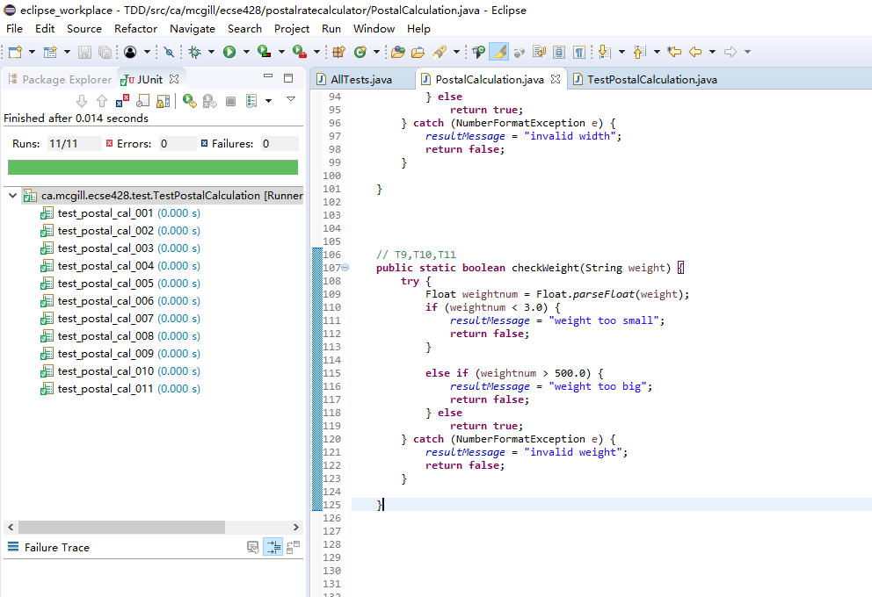

### Test 12

1. Test name: too_small_height
2. Call Setup:
3. Expected Result:
4. Purpose:

### Test 13

1. Test name: too_big_height
2. Call Setup:
3. Expected Result:
4. Purpose:

### Test 14

1. Test name: height_not_num
2. Call Setup:
3. Expected Result:
4. Purpose:

### Test 15

1. Test name: postal_code_from_valid
2. Call Setup:
3. Expected Result:
4. Purpose:

### Test 16

1. Test name: postal_code_to_valid
2. Call Setup:
3. Expected Result:
4. Purpose:

### Test 17

1. Test name: postal_type_check
2. Call Setup:
3. Expected Result:
4. Purpose:

### Test 18

1. Test name: rate_calculation
2. Call Setup:
3. Expected Result:
4. Purpose: