ANALYSTLAB AFRICA
Experience Lab Internship Programme
WEEK 5 ANALYTICS REPORT
HealthConnect Clinic
Improving Patient Appointment Attendance and Healthcare Support Using Data and AI
Track: Data Analytics
Focus: Exploratory Analysis, KPI Development & Business Insights
Week 5

1. Executive Summary
In Week 5, I moved the HealthConnect Data Analytics work from the planning stage established in Week 4 into practical analysis and initial implementation. I used the HealthConnect Appointment Dataset and Data Dictionary to validate the dataset, examine appointment attendance and no-show patterns, develop key performance indicators (KPIs), and build an initial Power BI analytical dashboard.
The analysis shows that missed appointments are a major operational issue in the dataset. Out of 5,000 appointment records, 2,423 were No-Show, 2,314 were Attended, and 263 were Cancelled. This corresponds to a 48.46% No-Show Rate, 46.28% Attendance Rate and 5.26% Cancellation Rate.
The strongest patterns observed were associated with booking lead time and previous no-show history. No-show rates increased substantially as the number of days between booking and appointment increased, and patients with more previous no-shows also showed higher future no-show rates. Reminder-sent appointments had a higher attendance rate than appointments without a reminder, although this analysis is observational and does not establish that reminders caused the improvement.
The Week 5 output provides HealthConnect with an evidence-based view of the attendance problem and a starting point for more targeted interventions and future predictive or AI-supported work.

2. Week 4 → Week 5 Transition
Week 4 established the HealthConnect problem, reviewed the available resources, assessed the data at an initial level, identified business questions and proposed KPIs. Week 5 required the Data Analytics track to move from planning into actual analysis, KPI development, visualisation and business insights.
Week 4 Foundation | Week 5 Implementation
Problem | Understand and reduce appointment no-shows while improving attendance and support.
Proposed approach | Validate data, explore attendance/no-show patterns, calculate KPIs and develop visual analysis.
Resources | HealthConnect_Appointment_Data.csv; HealthConnect_Data_Dictionary.xlsx; Clinic Knowledge Base where applicable.
Key assumptions | Appointment outcomes are accurate; relationships observed are associations, not proof of causation.
Week 5 objective | Complete data preparation, EDA, KPI calculations, initial dashboard and business insights.

3. Business Problem and Analytical Objective
The overall HealthConnect project question is:
“How can HealthConnect Clinic use data and AI to reduce missed appointments and improve the patient support experience?”
My Data Analytics responsibility in Week 5 was to provide evidence about appointment attendance and no-show patterns that can support operational decision-making and provide a useful analytical foundation for the other HealthConnect workstreams.
The analysis focused on the following business questions:
- What proportion of scheduled appointments are attended, missed, or cancelled?
- Which patient age groups have the highest missed appointment rates?
- Does the number of days between booking and appointment relate to no-show likelihood?
- Does sending reminders relate to attendance and no-show outcomes?
- Does distance to the clinic relate to attendance?
- Do previous missed appointments relate to future no-show behaviour?
- Do appointment type and time period relate to attendance?
- Are there differences in no-show rates across days or other appointment characteristics?

4. Data Preparation and Quality Assessment
I used the original HealthConnect appointment dataset as the source for the analysis and did not overwrite the original project resource. The Power BI work was saved separately as HealthConnect_Week5_Data_Analytics.pbix.
Data Quality Item | Result | Action / Interpretation
Rows | 5,000 | All records retained for analysis.
Columns | 18 | Relevant appointment, patient, booking, reminder and outcome variables retained.
Duplicate rows | None identified | No duplicate rows removed.
Unique appointment IDs | 5,000 | Appointment ID is unique across the dataset.
Missing reminder_channel | 1,366 | Retained. 'None' is a valid category and was not treated as null.
Missing distance_to_clinic_km | 90 | Null values retained; no rows deleted.
Missing waiting_time_minutes | 60 | Null values retained; no rows deleted.
Core ID/outcome fields | No missing values identified | Suitable for KPI and outcome analysis.
Inconsistent values | No material inconsistencies identified | Categories and logical relationships checked.
Original dataset | Preserved | No overwrite of source file.

4.1 Dataset Columns and Structure
Column | Type | Description / Use
appointment_id | Text/ID | Unique appointment identifier
patient_id | Text/ID | Patient identifier
gender | Text | Patient gender category
age | Whole Number | Patient age
age_group | Text | Age category
appointment_type | Text | Type of appointment
booking_date | Date | Date appointment was booked
appointment_date | Date | Scheduled appointment date
appointment_day | Text | Day of week of appointment
appointment_time | Time/Category | Appointment time / time period
booking_lead_days | Whole Number | Days between booking and appointment
previous_appointments | Whole Number | Number of previous appointments
previous_no_shows | Whole Number | Number of previous missed appointments
reminder_sent | Text | Whether a reminder was sent
reminder_channel | Text | Email, SMS, WhatsApp or None
distance_to_clinic_km | Decimal Number | Distance from patient to clinic
waiting_time_minutes | Whole Number | Waiting time in minutes
appointment_outcome | Text | Attended, No-Show or Cancelled

4.2 Data Validation Checks
- Age values were within the observed range of 18–80 years.
- Booking lead time values were within 0–60 days.
- Previous no-shows did not exceed previous appointments.
- Appointment day was consistent with appointment date.
- Age group was consistent with age.
- Booking and appointment dates were consistent with booking lead days.
- Appointment outcomes were consistently recorded as Attended, No-Show or Cancelled.
- Reminder channels included Email, SMS, WhatsApp and None.
- Distance and waiting-time fields were numeric where recorded.
Missing distance and waiting-time values were not removed because deleting those rows could unnecessarily reduce the dataset and bias the analysis. The missing values were retained and treated as unavailable observations for analyses requiring those fields.

5. Analytical Method and Tools
I used Microsoft Power BI for data preparation, KPI development, exploratory analysis and dashboard visualisation. Power Query was used to inspect and validate the dataset structure and data types. DAX measures were used to calculate the main KPIs and no-show rates used in the analysis.
Stage | Activity | Tool / Output
1. Data preparation | Inspect fields, types, missing values, duplicates and category consistency. | Power Query / Power BI
2. KPI development | Create five measures from the Week 4 KPI candidates. | DAX / Power BI
3. EDA | Compare no-show rates across appointment, patient, reminder and history variables. | Power BI visuals
4. Dashboard | Present KPIs and key analytical visuals on a dedicated dashboard page. | Power BI
5. Interpretation | Translate observed patterns into business implications and recommendations. | Analytics report

6. KPI Development
I selected five KPIs from the candidates identified in Week 4. These KPIs were selected because they directly describe the scale of the attendance problem and provide operational measures that HealthConnect can monitor.
KPI | Definition | Result | Why it matters | Interpretation
No-Show Rate | Percentage of scheduled appointments that resulted in No-Show. | 48.46% | Shows the scale of missed appointments. | High no-show level indicates a significant operational opportunity.
Attendance Rate | Percentage of scheduled appointments that were attended. | 46.28% | Measures successful appointment utilisation. | Less than half of scheduled appointments were attended.
Cancellation Rate | Percentage of scheduled appointments that were cancelled. | 5.26% | Separates cancellations from missed appointments. | Cancellations are much smaller than no-shows.
Average Booking Lead Time | Average number of days between booking and appointment. | 29.64 days | Provides context for scheduling behaviour. | Longer lead times were associated with higher no-show rates.
Reminder Effectiveness | Attendance rate among appointments where a reminder was sent. | 47.63% | Provides a monitoring measure for reminder-supported attendance. | Higher observed attendance, but not proof of causation.

6.1 DAX Measures Used

No-Show Rate
No-Show Rate =
DIVIDE(
CALCULATE(
COUNTROWS('HealthConnect_Appointment_Data'),
'HealthConnect_Appointment_Data'[appointment_outcome] = "No-Show"
),
COUNTROWS('HealthConnect_Appointment_Data')
)

Attendance Rate
Attendance Rate =
DIVIDE(
CALCULATE(
COUNTROWS('HealthConnect_Appointment_Data'),
'HealthConnect_Appointment_Data'[appointment_outcome] = "Attended"
),
COUNTROWS('HealthConnect_Appointment_Data')
)

Cancellation Rate
Cancellation Rate =
DIVIDE(
CALCULATE(
COUNTROWS('HealthConnect_Appointment_Data'),
'HealthConnect_Appointment_Data'[appointment_outcome] = "Cancelled"
),
COUNTROWS('HealthConnect_Appointment_Data')
)

Average Booking Lead Time
Average Booking Lead Time =
AVERAGE('HealthConnect_Appointment_Data'[booking_lead_days])

Reminder Effectiveness
Reminder Effectiveness =
DIVIDE(
CALCULATE(
COUNTROWS('HealthConnect_Appointment_Data'),
'HealthConnect_Appointment_Data'[reminder_sent] = "Yes",
'HealthConnect_Appointment_Data'[appointment_outcome] = "Attended"
),
CALCULATE(
COUNTROWS('HealthConnect_Appointment_Data'),
'HealthConnect_Appointment_Data'[reminder_sent] = "Yes"
)
)

7. Exploratory Data Analysis
The EDA focused on appointment characteristics, patient characteristics, previous appointment history, reminders, waiting time, distance, cancellations and no-show outcomes.

7.1 Appointment Outcome Distribution
Outcome | Count | Share
No-Show | 2,423 | 48.46%
Attended | 2,314 | 46.28%
Cancelled | 263 | 5.26%
Total | 5,000 | 100.00%

No-Show was the largest outcome category, with 2,423 appointments. The no-show rate was slightly higher than the attendance rate, showing that missed appointments are a major operational issue in the dataset.

7.2 Reminder Sent vs Appointment Outcome
Reminder Sent | Attended | No-Show | Cancelled | Attendance Rate | No-Show Rate
Yes | 1,731 | 1,721 | 182 | 47.63% | 47.33%
No | 583 | 702 | 81 | 42.68% | 51.39%

Appointments where reminders were sent had an observed attendance rate of 47.63%, compared with 42.68% for appointments without a reminder. This is approximately a 4.95 percentage-point difference. The corresponding no-show rates were approximately 47.33% and 51.39%. This is an association, not proof that reminders caused the difference.

7.3 Booking Lead Time and No-Show Rate
Booking Lead Group | No-Show Rate
0–7 days | 27.81%
8–14 days | 33.55%
15–30 days | 43.21%
31–45 days | 53.82%
46–60 days | 67.69%

A strong upward pattern was observed. No-show rate increased from 27.81% for appointments booked 0–7 days before the appointment to 67.69% for appointments booked 46–60 days in advance. This is a 39.88 percentage-point difference.

7.4 Previous No-Shows and Future No-Show Rate
Previous No-Show Group | No-Show Rate
0 previous no-shows | 48.51%
1 previous no-show | 53.49%
2 previous no-shows | 59.36%
3+ previous no-shows | 68.82%

No-show rate increased as previous no-show history increased. The rate rose from 48.51% among appointments with no previous no-shows to 68.82% among appointments with three or more previous no-shows, a 20.31 percentage-point difference.

7.5 Age Group and No-Show Rate
Age Group | No-Show Rate
55–64 | 50.75%
25–34 | 50.70%
18–24 | 50.18%
35–44 | 48.35%
45–54 | 48.05%
65+ | 45.12%

The 55–64 age group recorded the highest no-show rate at 50.75%, while the 65+ group recorded the lowest at 45.12%. The range is relatively narrow compared with the stronger patterns for booking lead time and previous no-show history.

7.6 Appointment Type and No-Show Rate
Appointment Type | No-Show Rate
Follow-up | 51.23%
Diagnostic Test | 49.75%
Specialist Consultation | 47.44%
General Consultation | 46.64%

Follow-up appointments had the highest no-show rate at 51.23%, while General Consultation had the lowest at 46.64%. The difference is modest.

7.7 Appointment Time Period and No-Show Rate
Time Period | No-Show Rate
Evening | 49.78%
Afternoon | 48.38%
Morning | 48.14%

Evening appointments had the highest no-show rate at 49.78%, while morning appointments had the lowest at 48.14%. The small difference suggests a modest relationship.

7.8 Gender and No-Show Rate
Gender | No-Show Rate
Male | 48.71%
Female | 48.43%
Prefer not to say | 43.52%

Male and female no-show rates were almost identical. Gender therefore does not appear to be a major differentiator in this dataset.

7.9 Distance to Clinic and Waiting Time
Distance to clinic was included in the exploratory analysis using grouped distance bands, and waiting time was included as a relevant analytical variable. The dashboard contains the distance-group visual. Because distance and waiting time contain missing observations, these variables should be interpreted with care and should not be used to make causal conclusions from this initial analysis.

8. Key Findings
Finding | Evidence | Business Implication
1. No-shows are the main appointment outcome. | 48.46% of appointments were No-Show. | Missed appointments should be treated as a major operational priority.
2. Longer booking lead time is strongly associated with no-shows. | 27.81% at 0–7 days versus 67.69% at 46–60 days. | Long-lead appointments may require stronger confirmation/engagement.
3. Previous no-show history is a strong indicator. | 48.51% with 0 previous no-shows versus 68.82% with 3+. | Past attendance behaviour can support targeted follow-up and future risk analysis.
4. Reminder-sent appointments show better attendance. | 47.63% attendance with reminders versus 42.68% without. | Reminder processes are worth monitoring and testing.
5. Age differences are modest. | 45.12% to 50.75% across age groups. | Age can support segmentation but is not the primary driver.
6. Appointment type has a moderate difference. | 51.23% Follow-up versus 46.64% General Consultation. | Appointment type may help identify groups for investigation.
7. Time period shows a small difference. | 49.78% Evening versus 48.14% Morning. | Time period alone is unlikely to explain most no-shows.
8. Gender is not a major differentiator. | 48.71% Male versus 48.43% Female. | Gender should not be prioritised as a major intervention variable alone.

9. Business Recommendations
Recommendation | Action | Priority | Reason
Prioritise high-risk segments | Use previous no-show history and long booking lead time for targeted attendance-support actions. | High | These variables show the strongest observed patterns.
Strengthen confirmation for long-lead appointments | Consider additional confirmation or engagement steps for appointments booked far in advance, subject to approved procedures. | High | 46–60 day group had a 67.69% no-show rate.
Review reminder coverage | Investigate why some appointments do not receive reminders and assess whether coverage can be improved. | High | Reminder-sent appointments had higher observed attendance.
Maintain a no-show monitoring dashboard | Monitor No-Show Rate, Attendance Rate, Cancellation Rate and key segments. | Medium | Creates a repeatable management view.
Use prior behaviour in future predictive work | Share the previous-no-show finding with Data Science for candidate feature review. | High | Provides an evidence-based input for later prediction.
Avoid over-targeting weak differentiators | Do not base major interventions on gender or time period alone. | Medium | Observed differences were small.

10. Initial Analytical Dashboard
I created a dedicated Power BI page titled “Week 5 Dashboard”. It presents the five KPI cards together with the main exploratory visuals developed during the Week 5 analysis. The detailed EDA page was retained, while the dedicated dashboard provides a consolidated view for decision-making.
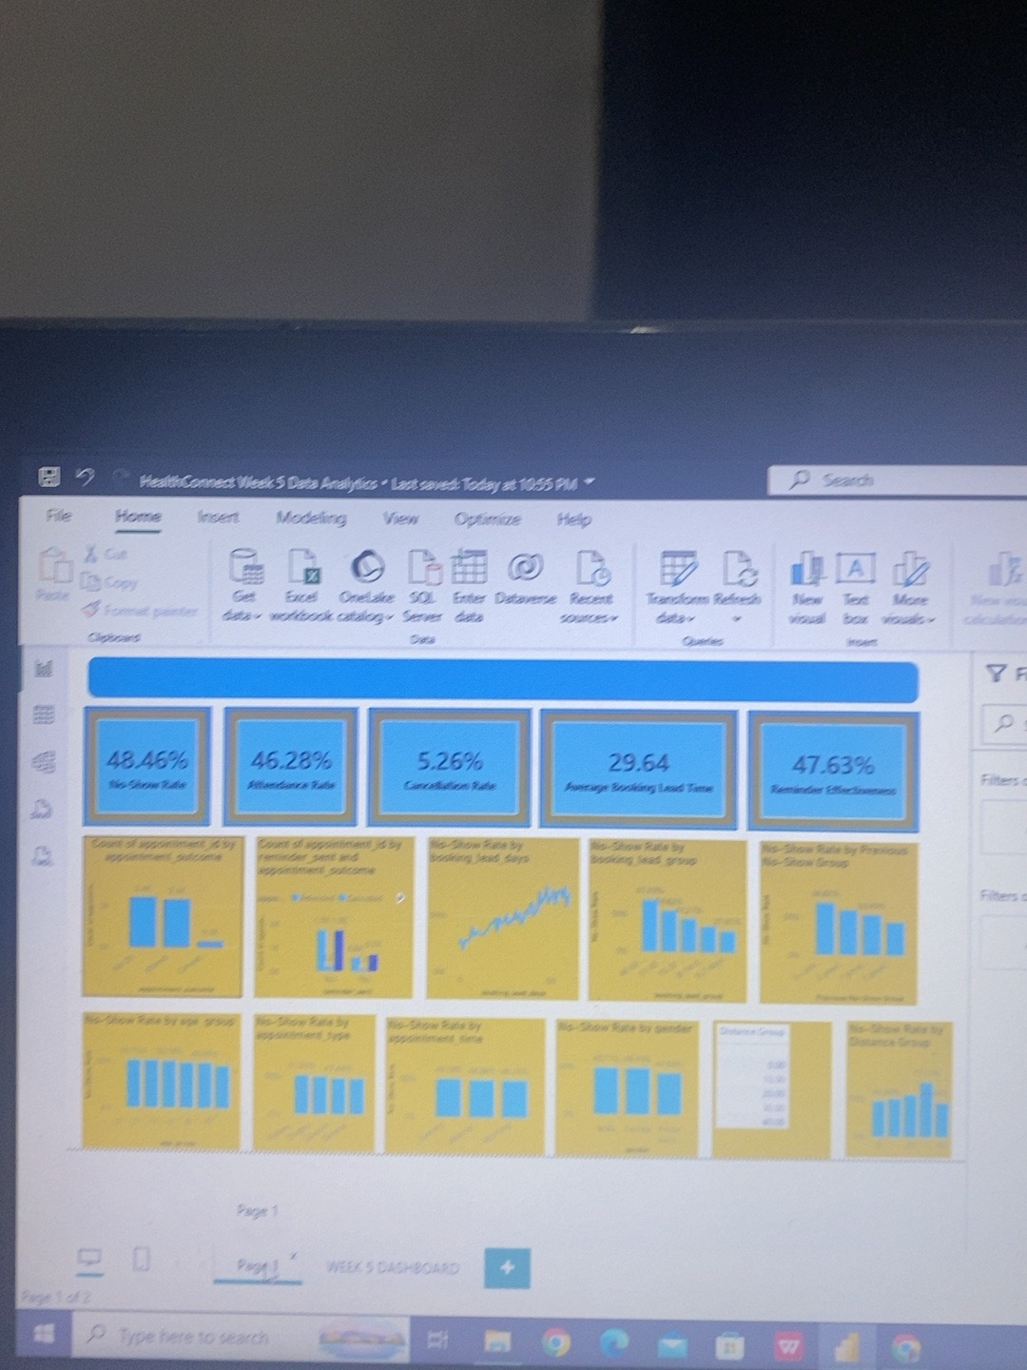
Figure 1: HealthConnect Week 5 Data Analytics Dashboard in Power BI.

11. Cross-Track Collaboration
The Data Analytics work provides information that can be used by the other HealthConnect technical tracks. In particular, the analysis identifies previous no-shows and booking lead time as important variables associated with appointment no-shows. These findings are relevant to the Data Science track because they can inform the selection and review of candidate features for future no-show prediction.
The analytical output to be shared across the tracks is the Week 5 KPI/EDA summary and the identified high-risk patterns. This creates a direct dependency between descriptive analysis and later predictive modelling. The findings should be treated as evidence for further investigation rather than proof of causal relationships.
Note: this section describes the analytical dependency. Any formal collaboration evidence, such as a message or acknowledgement from another track, should be attached separately if required by the submission process.

12. Challenges, Decisions and Changes from Week 4
Area | Challenge / Decision | Outcome
Data preparation | Missing values in reminder channel, distance and waiting time. | Retained appropriate missing values; no rows deleted.
Reminder channel | The category 'None' appeared in reminder_channel. | Retained as a valid category.
Duplicate checking | Temporary duplicate-check queries were created during validation. | Temporary queries were removed; clean original query retained.
EDA scope | Many variables could be explored. | Focused on Week 5 requirements and stopped after required EDA coverage.
Dashboard | Detailed EDA page became crowded. | Created a separate Week 5 Dashboard page.
Interpretation | Observed relationships could be mistaken for causal effects. | Used association language and avoided causal claims.

13. Limitations
- The dataset is fictional and anonymized, so findings are specific to the provided project data.
- The analysis is observational and identifies associations rather than causation.
- Distance to clinic and waiting time contain missing values, limiting complete interpretation.
- The dataset may not contain every factor affecting attendance.
- Reminder Effectiveness measures attendance among reminder-sent appointments; it does not prove a causal improvement.
- Some subgroup differences are relatively small and should not be over-interpreted.
- Further analysis may be required before implementing major interventions.

14. Remaining Work and Week 6 Focus
Week 5 was intentionally focused on analysis, KPI development and initial dashboard implementation. It does not represent the complete HealthConnect solution.
- Use the Week 5 findings as an evidence base for the next project stage.
- Further investigate the strongest no-show patterns, especially previous no-shows and booking lead time.
- Support cross-track work by providing validated analytical findings and relevant variables.
- Refine the analytical dashboard if additional requirements are introduced.
- Continue monitoring data quality and document any changes to definitions or assumptions.
- Support later predictive or AI-related work without assuming that Week 5 associations are causal.

15. Conclusion
Week 5 successfully moved the HealthConnect Data Analytics work from planning into practical implementation. The dataset was validated, five KPIs were calculated, exploratory analysis was completed across relevant appointment and patient variables, and an initial Power BI dashboard was developed.
The clearest analytical signals were the relationship between longer booking lead time and higher no-show rates, and the relationship between previous no-show history and future no-show rates. Reminder-sent appointments also showed better observed attendance than appointments without reminders. These findings provide HealthConnect with specific areas to investigate further while maintaining appropriate caution about causality.
The Week 5 output therefore provides a practical analytical foundation for the next stage of the HealthConnect project without treating the current analysis as the final solution.

Appendix A – Power BI Analytical Fields Created
Field | Type | Purpose
booking_lead_group | Calculated Column | Groups booking lead time into 0–7, 8–14, 15–30, 31–45 and 46–60 days.
Previous No-Show Group | Calculated Column | Groups previous no-shows into 0, 1, 2 and 3+.
Distance Group | Group/Bin | Groups distance to clinic for comparative analysis.
No-Show Rate | DAX Measure | Calculates overall/contextual no-show rate.
Attendance Rate | DAX Measure | Calculates overall/contextual attendance rate.
Cancellation Rate | DAX Measure | Calculates overall/contextual cancellation rate.
Average Booking Lead Time | DAX Measure | Calculates average booking lead time.
Reminder Effectiveness | DAX Measure | Calculates attendance rate among appointments with reminders sent.

Appendix B – Week 5 Completion Checklist
Week 5 Requirement | Status
Review Week 4 foundation | Completed
Data preparation and quality checks | Completed
Exploratory data analysis | Completed
KPI development: 3–5 KPIs | Completed – 5 KPIs
Initial dashboard / visual report | Completed
At least 5 business insights | Completed – 8 findings
Business recommendations | Completed
Limitations | Completed
Challenges and decisions documented | Completed
Week 6 focus identified | Completed

