**A PROPOSED OFFERING OF** **BUS TICKETING AND BOOKING SYSTEM**

**FOR VICTORY LINER INC.**

Project Proposal Presented to the

Faculty of Datamex College of Saint Adeline, Inc.

In Partial Fulfillment of the Requirements for the

Degree of Bachelor of Science in Information Technology

By:

Arellano, Romeo C.

Estigoy, Ron Kyrie

Flores, Joserey G.

Gadi, Susana

August 2025

**PROJECT PROPOSAL**

**INTRODUCTION**

The purpose of this document is to define the requirements and specifications for the development of an Offline Bus Ticketing System for Victory Liner. This document outlines the system’s objectives, core functionalities, scope, and operational requirements. It serves as a reference for all stakeholders including project sponsors, developers, testers, and end users to ensure a clear and mutual understanding of the system’s intended design and behavior

**Background Information**

Victory Liner is one of the leading transportation companies in the Philippines, serving thousands of passengers daily. Currently, their semi-manual ticketing system and limited online booking options are outdated and inefficient. Problems like overbooking, delayed confirmations, manual errors, and lack of real-time updates affect both passengers and staff. With increasing demand for faster and more convenient travel services, there is a need to upgrade to a fully digital, bus ticketing booking system.

**Project Objectives And Goals**

To develop offline an bus ticketing and booking system.

To allow passengers to choose routes, seats, and bus types with ease.

To simplify the passenger booking process.

To help staff with trip scheduling, seat tracking.

To enchance staff efficiency.

To ensure secure organized data management.

**Client Information**

Company Name: Victory Liner, Inc.

Business Type: Transportation / Bus Line Services

Contact Person: Mr. Ramon C. Villareal (IT Systems Supervisor)

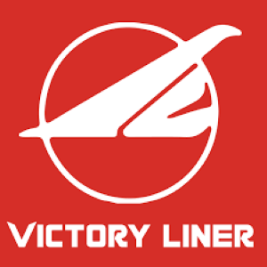 Contact Number: 0917 284 5593

erson to have a diffent rol

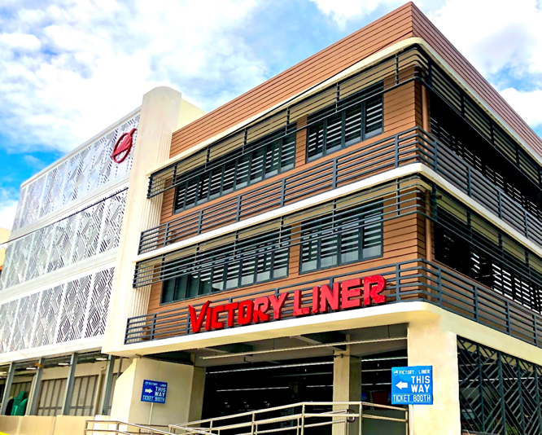Victory Liner, Inc. is among the biggest and most reliable transport companies in the Philippines with bus traveling services catering to millions of passengers within Luzon. With the ongoing growth in the number of passengers and increasing routes, there is a growing need for a better and ticketing and reservation system. To serve the needs of contemporary commuters and optimize internal processes, Victory Liner needs a powerful system that can process online ticket reservations, trip planning, and secure data storage for passengers and operation staff.

**Project Scope**

**Specific Deliverables and Outcomes expected from the project**

This project will create a Bus ticketing and Booking system that works offline, to be used only in Victory Liner terminals. Passengers can go to the terminal, book a ticket, choose their seat, select the type of bus, and get a printed ticket.

**Inclusions and Exclusions**

The system will include features like booking tickets at the terminal, choosing seats, selecting bus types (like Regular or Deluxe), printing tickets, and admin tools for scheduling and reports.

However, it will not include online booking, mobile apps, online payments, or SMS/email notifications. It will also not have GPS tracking or any feature that needs internet connection. The system will only be used in terminals and will not work online.

**Assumptions and Constraints**

This project assumes that each terminal will have computers and printers ready to use. It also assumes that staff will be trained to use the system, and the company will give the correct information for bus routes, prices, and schedules.

There are also some limits. Since the system is offline, it cannot be used from other locations or branches. It won’t update automatically, and all changes or backups need to be done manually. Also, each terminal will handle its own data, and there won’t be any real-time connection between branches.

**Project Approach**

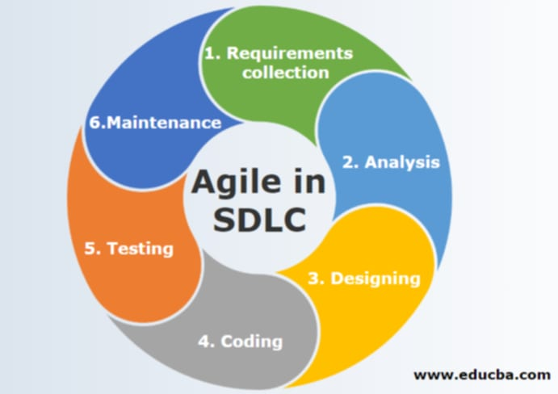

This project will follow a step-by-step approach to develop an offline Ticketing and Reservation System for Victory Liner. The goal is to create a system that is easy to use, fast, and reliable for both terminal staff and passengers. The system will be designed to work in terminals without needing an internet connection, focusing on smooth ticket booking, seat selection, and trip scheduling.

**Methodologies And Framework Used**

This project will use the Agile Methodology, which allows the system to be developed in small parts and improved continuously. Agile is chosen because it is flexible and makes it easier to adjust the system based on feedback while it is being built.

The system will use a local database such as MySQL or SQLite for offline data storage. The interface will be created using Visual Basic, and the design will, meaning the system will be divided into separate parts like booking, reporting, routes, and scheduling.

**Key Activities And Milestones**

• Project Planning - Understanding the needs of Victory Liner..

• System Design - Creating layouts for how the system will look.

• System Development - Writing the actual code to build the system features.

• Testing Phase - Checking if the system works correctly and fixing any issues

• Deployment - Installing the system on computers in the terminals.

• Training and Handover - Teaching the staff how to use the system and handing.

**Project Team**

|  |  |  |
| --- | --- | --- |
| **Project Leader** | Arellano, Romeo C.- He is responsible for assigning tasks to each member or role. He will also give deadlines for the tasks, at the right time or date, and must not exceed them because the process of the tasks will take longerand she is also task for the documentation. |  |
| **Programmer** | Estigoy, Ron Kyrie - He is one of the most important roles, because he is the one who codes the system to be created and do an database. |  |
| **System Designer** | Gadi, Susana - This is the most necessary role of all, because this shows how creative the system is, and it is also the way to impress the panelists or anyone who looks at the System. |  |
| **System Analyst** | Flores, Jose Rey - This role is important, because he is the one who checks for bugs or errors in coding. He needs to be quick in checking for errors or bugs so that it can be submitted on the due date. |  |

**Project Timeline**

The creation of the Victory Liner Bus Ticketing and Booking System adhered to a systematic 2 Months and 1 week schedule so each phase in the project was finished effectively and accurately. Here is the timeline of the development schedule:

Week 1: Requirements Gathering - Gathered system requirements and operational knowledge from ticketing officers, terminal personnel, and dispatchers.

Week 2-3: System Design - Developed database schema and authored user interface designs for ticket reservation, seat allocation, and trip planning.

Week 4-7: System Development - Created the central system modules such as ticket booking, seat allocation, fare calculation, schedule configuration, and ticket printing.

Week 8: Testing - Performed unit and system testing to detect and correct bugs, ensure correct data, and provide seamless running of all modules.

Week 9: Deployment and Training - Implemented the system at chosen Victory Liner terminals and instructed ticketing and dispatch personnel in operating the system efficient.

**PROJECT RESOURCES**

Both hardware and software resources were needed to create the Victory Liner Bus Ticketing and Booking System, such as coding platforms, testing environments, and basic development tools. The resources were structured accordingly:

Software Resources

Microsoft Visual Basic 2010 (VB10) - Utilized for creating the desktop-based interface for the bus ticketing and booking transactions, such as modules for seat selection, fare calculation, and trip scheduling.

SQL Server Management Studio (SSMS) - Used to develop, maintain, and secure the backend database for holding booking records, schedules, routes, fares, and passenger information.

Microsoft Office Word - Used for project documentation, user guides, and system reports.

**Hardware Resources:**

Development PC - A desktop running an Intel Core i5 processor, with capability to execute the system's development, testing, and deployment processes using VB.NET and SSMS.

Printing ticket – to be use for scanning the ticket for the passengers ticket boarding.

**External Storage Drive**

Utilized to preserve copies of project files and database while in development, for data retrieval in event of a hardware or software problem.

**Human Resources**

Term Code Crafters Development Team - Accountable for system analysis, design, programming, testing, documentation, and deployment.

Terminal Staff and Ticketing Officers (Victory Liner) - Contributed real-world perspective during requirements gathering, assisted in testing activities, and tested the system's usability and accuracy in a working environment

**Risk Management**

To make sure the Victory Liner ticketing system worked well and was finished on time, the team looked at possible problems early and planned how to avoid them. One big problem that could happen was losing the system data because of power loss or someone deleting it by accident. To stop this from happening, the team saved backup copies of the system in different places so they could bring it back if something went wrong. Another risk was system errors or bugs, especially in important parts like booking, seat choosing, or calculating the fare. To fix this, the team tested each part of the system carefully to make sure everything worked correctly.

The team also had to manage time problems, like school deadlines or slow progress. They made a schedule with extra time in case of delays and focused first on the most important features, like booking and sheduling. Because the group was small, there was a risk of people getting too much work or missing tasks. To solve this, they shared the work evenly and had weekly check-ups to make sure everything was going as planned. Lastly, the team knew that some terminal workers might not know how to use a computer system. So they made the system simple and easy to use, and they also gave training to help the staff understand how to use it.

**Communication Plan**

Communication played a very important role in the successful creation of the Victory Liner Bus Ticketing and Booking System. Since the system was built by the Code Crafters team, in partnership with Victory Liner’s terminal and operations staff, it was important that both sides stayed connected and updated throughout the project.

The main goals of the communication plan were:

•To make sure everyone clearly understood the system’s goals and features

• To give regular updates on progress

• To get feedback and approval on time, so there would be fewer delays.

There were two main groups involved:

1. Code Crafters Team - They worked on analyzing, designing, building, testing, and installing the system

2. Victory Liner Staff - They helped by giving system requirements, giving feedback during testing, and approving the final version of the system

To keep communication smooth, the team used different tools:

Messenger - was used for formal messages like progress reports, sharing requirements, and sending approvals

Microsoft Word - was used to write reports, design mockups, and system documents

Google Meet - was used for virtual meetings, to discuss system modules, solve problems, and explain features

This communication setup helped make sure that everyone was working toward the same goal, stayed updated, and shared ideas clearly. Because of this, the project was finished on time and the final system met the needs of Victory Liner

**Project Governance**

The project governance for the Victory Liner Bus Ticketing and Booking The project governance for the Victory Liner Bus Ticketing and Booking System helped keep the project well-organized, on track, and focused on what was really needed. It clearly showed who was responsible for what, how decisions were made, and how the team and the client worked together from the start to the end of the project. The system design and main features were based on the real needs of Victory Liner’s terminal staff and operations. Their feedback helped shape important parts of the system like ticket booking, fare calculation, seat selection, and trip scheduling. As the system was being built, the team continued to get feedback through testing and demo sessions. This helped improve the system and make sure it would work well in actual bus terminals.

**In Terms Of Roles:**

The Code Crafters Development Team was in charge of all the technical work like designing the system, writing the code, building the database, testing the features, and installing the final system.

Victory Liner’s operations and dispatch staff acted as the main users and decisionmakers. They checked the features, gave suggestions, and helped make sure the system matched the real way things are done at the terminals.

To make sure everyone stayed updated and worked well together, regular meetings were held. These meetings helped with tracking progress, fixing issues, getting approval, and making sure every phase of the project.

**Appendix**

Elmasri, R., & Navathe, S. B. (2016). *Fundamentals of database systems* (7th ed.). Pearson.

GeeksforGeeks. (2021, July 20). *Database management system (DBMS) tutorial*. GeeksforGeeks. https://www.geeksforgeeks.org/dbms/

Joyanes Aguilar, L. (2011). *Programming with Visual Basic .NET*. McGraw-Hill.

Microsoft. (n.d.). *ADO.NET overview*. Microsoft Learn. https://learn.microsoft.com/en-us/dotnet/framework/data/adonet/

Microsoft. (n.d.). *Visual Basic documentation*. Microsoft Learn. https://learn.microsoft.com/en-us/dotnet/visual-basic/

Pressman, R. S. (2014). *Software engineering: A practitioner’s approach* (8th ed.). McGraw-Hill Education.

Stack Overflow. (n.d.). *VB.NET and SQL Server integration examples*. Stack Overflow. https://stackoverflow.com/

Tutorials Point. (n.d.). *VB.Net tutorial*. Tutorials Point. https://www.tutorialspoint.com/vb.net/

W3Schools. (n.d.). *SQL tutorial*. W3Schools. https://www.w3schools.com/sql