**Aztec Manufacturing Corp.**

**Sub-Supplier Label Specifications and Packaging Guidelines**

Effective August, 2019, Aztec Manufacturing Corp. has begun implementation of Electronic Data Interchange with their suppliers. As part of this initiative, Aztec will also be requiring suppliers to use the label specification developed to identify all incoming products to any of the Aztec Manufacturing Corp. facilities.

Included in this document are specifications and samples for container and master labels.

As to make the transition easier for all parties involved in this initiative, notes have been added for each specification as it pertains to Packaging Guidelines. Suppliers must adhere to these standards in order to avoid costly returns to our suppliers, expedited moves for damaged freight, and extra material handling charges.

**Container Label Sample**

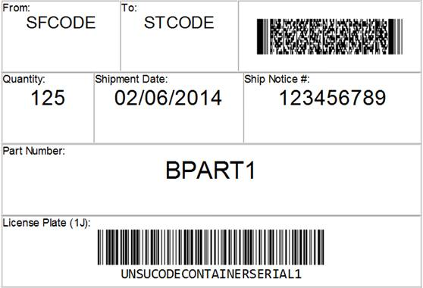

**Specifications for the Container Label**

Each container must have three container labels. Each container label should use Arial Font. The number below corresponds with the areas of the label from top to bottom, left to right:

1. Ship From Code
2. Ship To Code
3. 2D Symbol PDF417 bar code including these data fields:

|  |  |  |  |
| --- | --- | --- | --- |
| Data Indentifier | Definition | Ex | Requirement |
| P | Aztec Part Number |  | Mandatory |
| Q | Quantity |  | Mandatory |
| 1J | License Plate |  | Mandatory |
| K | Purchase Order |  | Mandatory |
| B | Container Type |  | Optional |
|  |  |  |  |

The following characters are used in 2D barcodes to help determine the beginning and ending of data streams and data fields.

|  |  |  |  |
| --- | --- | --- | --- |
| Description | ASCII/ISO 646 Character | Decimal Value | Hex Value |
| Right bracket | [ | 91 | 5B |
| Left parenthesis | ) | 41 | 29 |
| Greater than sign | > | 62 | 3E |
| Group separator | GS (non-printable) | 29 | 1D |
| Record separator | RS (non-printable) | 30 | 1E |
| End of Transmission | EOT (non-printable) | 04 | 04 |

Each 2D label must start with the following header (Note – the “06” is a static number):

[)>RS06

Each field must start with the group separator:

GSQ1000

Each 2D label must end with the record separator and message trailer:

RS EOT

The following sample is for part “TEST1” with quantity 100, license plate SUP001/00000123, purchase order 01001, container type BIN01:

[)>RS06 GSPTEST1GSQ100GS1J SUP001/00000123GSK01001 GSBBIN01RS EOT

1. Quantity
2. Shipment Date
3. Ship Notice # (SID)
4. Part Number
5. License Plate bar code must be Code 128. The value is comprised of the Aztec-assigned supplier code [identical to 856 N103 for ‘SU’], a “/” [ascii 0047] separator, and a serial number [identical to 856 MAN02] which must not repeat within the 12 month rolling year. The license plate text must be below the barcode itself and may, but is not required, to display the “/” separator.

**Special Packaging Guidelines pertaining to the Container Label**

Label size should be 4” x 6”.

3 labels per package are required. Placement should be front, back and one side of container.

Every container shipped to Aztec Manufacturing Corp. must have a container label for quality tracking purposes.

The serial number should not be repeated within a 12-month period.

Master Label Samples

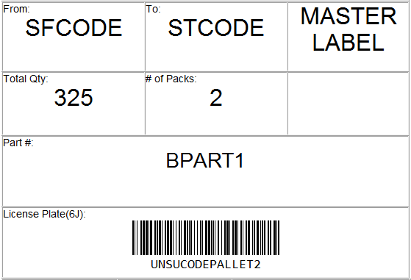

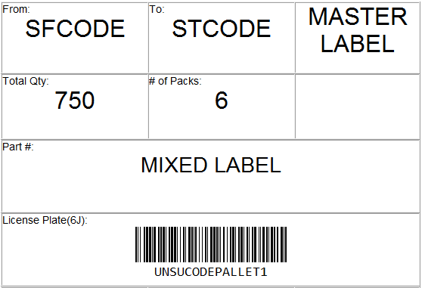

**Specifications for Master Label**

The items below correspond with the areas of the label from top to bottom, left to right:

1. Ship From Code
2. Ship to Code
3. Master Label Indication
4. Quantity
5. Number of Packs
6. Not used
7. Part Number, if only one part number is present on the pallet. If multiple part numbers are in the shipment, indicate ‘Mixed Label’
8. License Plate (The bar code must be Code 128 and the text must be below the barcode itself)

**Special Packaging Guidelines pertaining to the Master Label**

Label size should be 4” x 6” (See Additional Packaging Guidelines for more information).

Labels should be placed on the **outside** of any stretch film, banding or cardboard that may otherwise block the ability to scan and view of the label.

2 labels minimum are required and should be placed as close to center on front and backside of unit.

**Master labels are only required if more than one smaller package is contained in a larger package or unit.**

**Additional Packaging Guidelines**

Please use caution when choosing a label. Certain colors have a reflecting characteristic that make it hard for the scanners to read. Aztec Manufacturing Corp. is not dictating the label type, but requires that a sample label be e-mailed to [rjohnson@aztecmfgcorp.com](mailto:rjohnson@aztecmfgcorp.com) to verify ability to scan. An approval must be received before using labels on packages.

Use caution when packaging products to make sure the label is in an area visible to Aztec Manufacturing Corp. receiving personnel. Master Labels must be used in any instance where a smaller package is packed or contained within a larger unit such as pallets, baskets, and plastic totes.

Please direct any questions to [support@iconnect-corp.com](mailto:support@iconnect-corp.com) (877-275-7417).