**TSM Corporation**

**Sub-Supplier Label Specifications and Packaging Guidelines**

Effective March 2014, TSM Corporation has begun implementation of Electronic Data Interchange with their suppliers. As part of this initiative, TSM will also be requiring suppliers to use the label specification developed to identify all incoming products to any of the TSM Corporation facilities.

Included in this document are specifications and samples for container and master labels.

As to make the transition easier for all parties involved in this initiative, notes have been added for each specification as it pertains to Packaging Guidelines. Suppliers must adhere to these standards in order to avoid costly returns to our suppliers, expedited moves for damaged freight, and extra material handling charges.

**Container Label Sample**

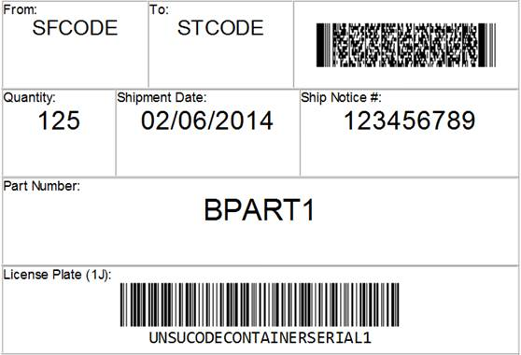

**Specifications for the Container Label**

Each container must have three container labels. Each container label should use Arial Font. The number below corresponds with the areas of the label from top to bottom, left to right:

1. Ship From Code
2. Ship To Code
3. 2D bar code including these data fields:

|  |  |  |  |
| --- | --- | --- | --- |
| Data Indentifier | Definition |  | Requirement |
| P | TSM Part Number |  | Mandatory |
| Q | Quantity |  | Mandatory |
| 1J | Container Serial |  | Mandatory |
| K | Purchase Order |  | Mandatory |
| B | Container Type |  | Optional |
|  |  |  |  |

1. Quantity
2. Shipment Date
3. Ship Notice # (SID)
4. Part Number
5. The bar code must be Code 128 and cannot be a repeating serial within the 12 month rolling year. The serial text must be below the barcode itself.

**Special Packaging Guidelines pertaining to the Container Label**

Label size should be 4” x 6”.

3 labels per package are required. Placement should be front, back and one side of container.

Every container shipped to TSM Corporation must have a container label for quality tracking purposes.

The serial number should not be repeated within a 12-month period.

Master Label Samples

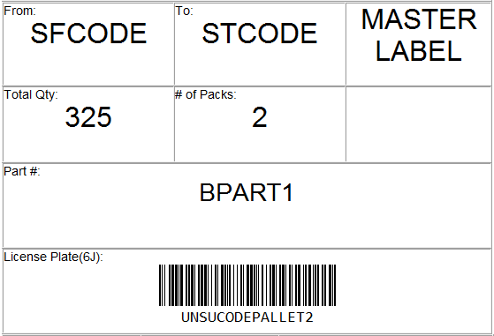

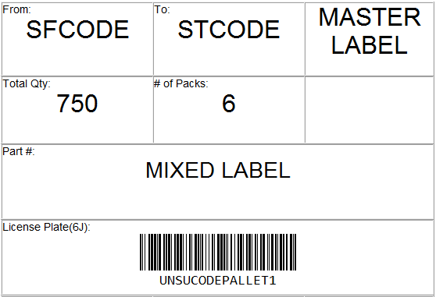

**Specifications for Master Label**

The items below correspond with the areas of the label from top to bottom, left to right:

1. Ship From Code
2. Ship to Code
3. Master Label Indication
4. Quantity
5. Number of Packs
6. Not used
7. Part Number, if only one part number is present on the pallet. If multiple part numbers are in the shipment, indicate ‘Mixed Label’
8. License Plate (The bar code must be Code 128 and the text must be below the barcode itself)

**Special Packaging Guidelines pertaining to the Master Label**

Label size should be 4” x 6” (See Additional Packaging Guidelines for more information).

Labels should be placed on the **outside** of any stretch film, banding or cardboard that may otherwise block the ability to scan and view of the label.

2 labels minimum are required and should be placed as close to center on front and backside of unit.

Master labels are required if more than one smaller package is contained in a larger package or unit**.**

**Additional Packaging Guidelines**

Please use caution when choosing a label. Certain colors have a reflecting characteristic that make it hard for the scanners to read. TSM Corporation is not dictating the label type, but requires that a sample label be e-mailed to [Jim.Gasparovich@TSMCorp.com](mailto:Jim.Gasparovich@TSMCorp.com) to verify ability to scan. An approval must be received before using labels on packages.

Use caution when packaging products to make sure the label is in an area visible to TSM Corporation receiving personnel. Master Labels must be used in any instance where a smaller package is packed or contained within a larger unit such as pallets, baskets, and plastic totes.

Please direct any questions to [support@iconnect-corp.com](mailto:support@iconnect-corp.com) (877-275-7417).