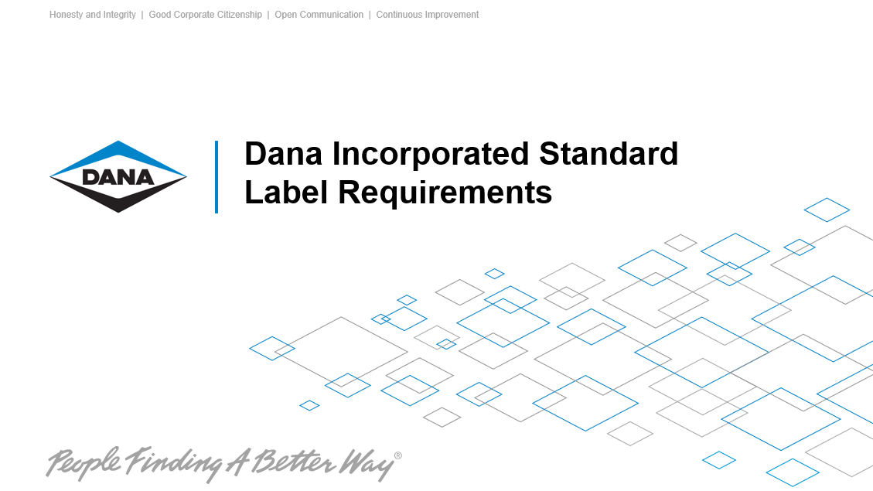

To assure container labels meet the need of our receiving and inventory system, incoming supplier labels must conform to both AIAG and Dana Incorporated Standard Label specifications.

- It is the responsibility of the suppliers to ensure all products are correctly identified with labels or tags affixed to each container. Both labels and tags are acceptable. The term “label” will be used to represent either tag or label in this document.
- Bar coding plays an extremely important part in our overall manufacturing systems. We pay our suppliers based on the bar code labels, update our inventories that drive our MRP system, and track material from receiving to in-process to finished stores. Labels shall meet requirements as specified in this document.
- These requirements are based on several AIAG Guidelines, including but not limited to AIAG B-1, AIAG B-3, AIAG B-8, and AIAG B-10.
- All bar codes shall be type 3 of 9 (Code 39) and will require a Start and Stop Code or
Code 128 Subset B.
- Barcodes shall be minimum .50” (13mm) in height and a have a preferred ratio of 3.1 and X-dim width of 15 mil. Where the preferred size is not possible, barcodes should have a ratio no less than 2.5:1 and an X-dim width no less than 9 mil.
- All bar code fields shall be valid and scan correctly. Equipment is available to verify that the bar codes meet the quality requirements as documented in the AIAG guidelines. Use of statistical process control (SPC) is recommended.
- Labels shall be white in color with black printing. Labels should be a minimum in size of 4.0 inches (100mm) high by 6.0 inches (150mm) wide.
- All data should be left justified and each field programmed as described below.
- Each bar code shall have the appropriate data identifier as identified below. The data identifier shall be shown in parentheses ( ), at the end of each title block.

- Part Number - Data Identifier: P
Light Axle Product Sites: A maximum of 18 characters can be used, but is not necessary to use all characters. The part number should match the part number as listed on the Purchase Order.
If there are dashes, periods or other special characters in the part number, they shall be replaced by spaces. A part # with the suffix of X must have a space between the part # and the suffix.
Example: | 73124 X

Driveshaft Product Sites: A maximum of 18 characters can be used but is not necessary to use all characters. The part number should match the part number as listed on the Purchase Order.
Dashes and periods are required.
All sites are listed in section 13.

- Quantity- Data Identifier: Q
A maximum of 7 numeric characters may be used in the quantity. Blank spaces are not numeric; therefore, if your program requires a specific number of characters be used, unused character spaces shall be left-filled with zeros.

- Supplier Number – Data Identifier: V
The supplier number is assigned by each Customer destination and may vary between Dana facilities.

- Serial Number – Data Identifier: S (3S is also acceptable)
Master labels: Both “M” and “4S” are acceptable
The serial number shall not exceed nine (9) characters. Serial numbers shall not be used more than once within a 12-month period.

- Supplier Name and Location – Human-readable characters only.
Supplier Company Name followed by the Supplier Address (City/State/Postal required).

- Part Description – Human-readable characters only.
Description of Part Number, should not exceed 30 characters

- Purchase Order Number – Data Identifier: K
Purchase Order Number for parts being shipped as ordered by Dana
Note: If a supplier is already supplying labels to Light Axle Sites without the PO Number, these labels are still acceptable. Any new labels designed should contain the Purchase Order Number.

- Heat Code/Cast Date – Data Identifier: 1T (DA is also acceptable)
Heat Code or Cast Date can be alpha and/or numeric depending on the Supplier’s methodology. Heat Code or Cast Date is to be used as noted below and shall not exceed seven (7) characters
If a date is used, use Julian Date methodology as follows:
Four (4) numbers – the first denotes the last digit of the year and the last three (3) denote the sequential day within the year.
Example: | December 31, 2003 is 3365

- Forging Suppliers: Record the particular heat of steel used to produce the particular production run.
- Permanent Mold Aluminum Castings: Record the unique “heat treat batch number” assigned to these parts by the supplier.
- Friction Welded Rear Light Axle Tube Suppliers: Record the Julian Date of Friction Welding.
- Casting Suppliers: Record the Julian Date when the castings were actually cast.
- Coiled Steel Suppliers: Record the heat code of the steel (if cast date exists, use the date field).
- Other Suppliers: If the part does not have a heat code, cast date, lot or batch number, this area may be left blank or used for any other purpose the supplier desires and agreed upon the Dana facility.

- Date – Data Identifier: 3D (DB is also acceptable)
This area shall be used for manufacturing date, pack date, shipping date, or any other Julian Date that suits the Dana Buyer and the supplier best. If heat code field has been used, the cast date may be recorded in the date field. Once the date code is established, it cannot be changed without prior customer approval.
Julian Date methodology is as follows: Four (4) numbers – the first denotes the last digit of the year and the last three (3) denote the sequential day within the year.
Example: | December 31 2003 is 3365

In addition to the Julian date, the date may also be displayed in International format.
Example: | 31Dec2003

- Revision Level – Data Identifier: 2P (DC is also acceptable)
Current Customer print level assigned by Dana Product Engineering is subject to the Production Part Approval Process (PPAP). The Revision Level shall be a minimum of one and a maximum of two characters and should match the Supplier Purchase Order. If the part is a standard part or if the Revision Level is REL (Release), it should be noted as two dashes (--). The Revision Level field should not be left blank.

Field Name | Title Block | Data  Identifier | Maximum  Characters | Text  Height
Part Number | PART NUMBER  (P) | P | 18 | .50”  12mm
Quantity | QUANTITY  (Q) | Q | 7 | .50”  12mm
Supplier Number | SUPPLIER  (V) | V | 9 | .25”  6mm
Serial Number | SERIAL (S)  SERIAL (3S) | S / 3S | 9 | .25”  6mm
Serial Number (Master Label) | SERIAL (M)  SERIAL (4S) | M / 4S | 9 | .25”  6mm
Serial Number  (Mixed Load) | SERIAL (G)  SERIAL (5S) | G / 5S | 9 | .25”  6mm
Supplier Name & Location |  |  | 60 | .10”  2.5mm
Part Description | DESC. |  | 30 | .16”  4mm
Purchase Order Number | PO NUMBER  (K) | K | 10 | .25”  6mm
Heat Code | HEAT CODE/  LOT (1T)  HEAT CODE/  LOT (DA) | 1T / DA | 7 | .25”  6mm
Date Code | DATE (3D)  DATE (DB) | 3D / DB | 4 | .25”  6mm
Date (International format) |  |  | 11 | .16”  4mm
Revision Level | REV. LEVEL (2P)  REV. LEVEL (DC) | 2P / DC | 2 | .25”  6mm
- Label Attachment:
- The most common shipping containers and their respective label locations are listed in the AIAG-B10 guidelines.
- Placement of the label shall be parallel to the base of the container and where possible should be a minimum of 18” from the bottom of the container.
- Specific label placement requirements are listed below:
- Tote Labels: Totes require two (2) identical bar code labels; they shall be attached to the sides/ends of the tote, in the framework provided.
- Small Cartons: Small, palletized cartons require two (2) identical bar code labels, attached on adjacent corners.
- Tubs/Baskets/Boxes: Large metal tubs, wires baskets, crates or pallet boxes require two (2) identical bar code labels, attached on adjacent corners.
- Master Labels: Master Labels shall be attached on either end of the pallet that has an opening for a forklift. Master labels shall never be placed on top of the pallet. If the pallet is film-wrapped, the Master Label should be attached to the film. If the material on the pallet extends to the full length of the pallet and the Master Labels are damaged, the facility may ask the supplier to take the necessary steps to protect the labels.
- Mixed Loads: A pallet with mixed part numbers shall have a Mixed Load Label attached to either end of the pallet. Additionally, a pallet with mixed part numbers shall have one Master Label per part number, per lot number.
- Banding: If the pallet consists of multiple containers banded together, the banding shall not cover the Master Labels; and should avoid covering tote or carton labels when possible.

- Non-Conformance
Penalties may be incurred for non-conformance of these requirements. Penalties will be charged at the facility’s discretion.

- Applicable Sites
Unless otherwise communicated from the Dana receiving plant, this label format must be used.

- Contact Information
For questions please use your Dana 1 Source account or contact the below contacts.
Bill Leedy |  | (419) 482-2346 | Bill.Leedy@dana.com
Jen Bihn | Sr. Business Analyst | (419) 482-2414 | Jen.Bihn@Dana.com

- Samples

Sample 1: Sample Container Label for Dana Holding Corporation (Driveshaft/Light Axle sites)
(P) Part Number | 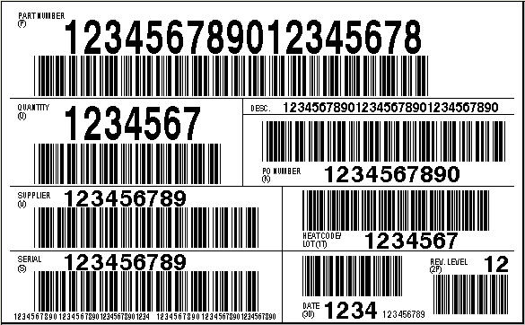 |  | Part Description
(Q) Quantity |  |  | (K) Purchase Order Number
(V)  Vendor Number |  |  | (1T) or (DA) Heat Code/Batch /Lot #
(S) or (3S)  Serial Number |  |  | (2P) or (DC) Revision Level
 | Supplier Name Followed by Address  (City/State/Postal Code) | (3D) or (DB)  Date Mfg/Shipped (Format: Julian Date)  and  Date Mfg/Shipped (Format: 22Nov2004)

Sample 2: Sample Master Label for Dana Holding Corporation (Driveshaft/Light Axle sites)
(P) Part Number | MASTER LABEL  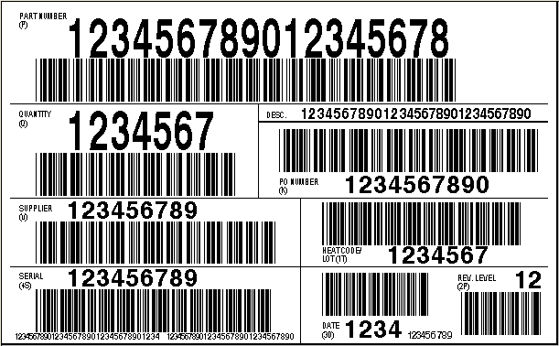 |  | Part Description
(Q) Total Pallet Quantity |  |  | (K) Purchase Order Number
(V)  Vendor Number |  |  | (1T) or (DA) Heat Code/Batch /Lot #
(M) or (4S)  Serial Number |  |  | (2P) or (DC) Revision Level
 | Supplier Name Followed by Address  (City/State/Postal Code) | (3D) or (DB)  Date Mfg/Shipped (Format: Julian Date)  and  Date Mfg/Shipped (Format: 22Nov2004)

