Steel Releases PO Import Application

User Instructions

# Main Screen:

The Main Screen shows the Finished Goods, Raw Parts, Suppliers and PO numbers that are available for import. Use the Add / Edit / Delete buttons to modify this data.

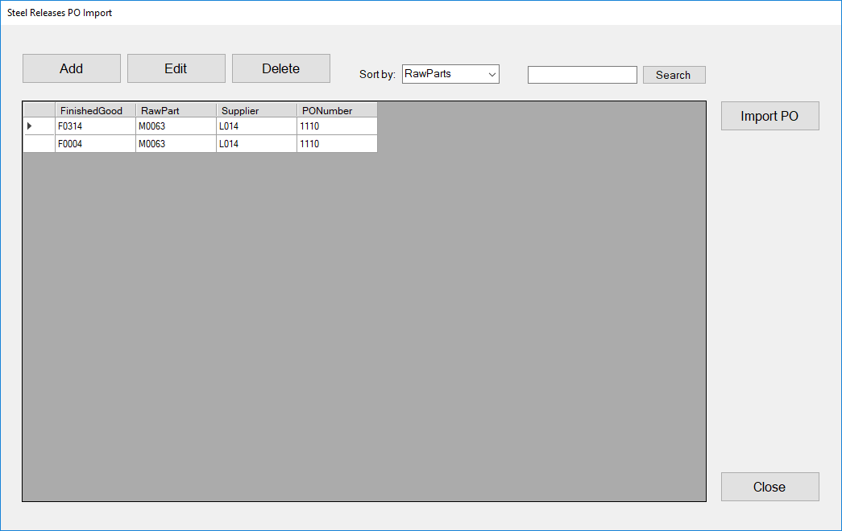

Important Notes:

* Releases can ONLY be imported if there is a row for that Raw Part with a valid PO Number.
* If you change suppliers for a Raw Part you must edit the row or delete it and re-add it with the correct supplier.
* If you change PO(s) but keep the same Supplier, you must edit the row or delete it and re-add it with the correct PO Number.

# Add / Edit Screen:

The Add / Edit screen allows you to specify the Raw Part and PO Number to use when importing releases. Choose the appropriate Finished Good, Raw Part, and PO Number / Supplier from the corresponding drop-downs and click “SAVE”.

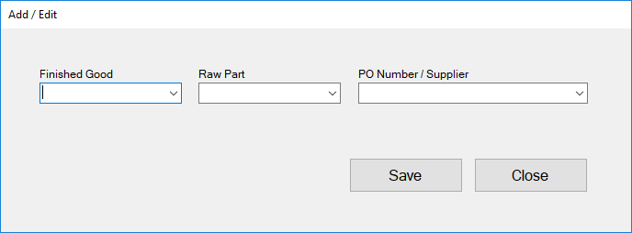

Important Notes:

* If a PO Number doesn’t show up in the list after you choose the Raw Part, it is because that PO Number is a “Normal PO” and there aren’t any releases with the selected Raw Part. You must create a dummy release on the normal PO for the desired part number or use a “Blanket PO”.

# Import PO Releases Screen:

The Import PO Releases screen let’s you copy and paste data from a spreadsheet to create releases in Monitor. Only releases for Raw Parts that are setup in the main screen with appropriate PO Numbers can be imported.

