Analysis of Violence Ratings and Bechdel Test Scores for Oscars Nominated Films from 2020 to 2026
Esther Lim, Ethan Sanders, Kamila Kwiatkowska
2026-04-19

Research Question

Among the Oscar Academy Award Best Picture shortlisted films from 2020 to 2026, is there a significant relationship between a film’s IMDb Violence and Gore rating and the number of Bechdel Test criteria it meets?

Hypotheses

Hypothesis 1 (H1)
There is a statistically detectable relationship between a film’s IMDb Violence and Gore rating and the number of Bechdel Test criteria it meets among Oscar Best Picture shortlisted films (2020-2026).

Hypothesis 2 (H2)
There is a relationship between a film being female-directed and non-female-directed and its odds of passing all three Bechdel Test criteria among Oscar Best Picture shortlisted films (2020-2026).

Hypothesis 3 (H3)
There is a relationship between a film’s worldwide box office revenue and the IMDb Violence and Gore rating among Oscar Best Picture shortlisted films (2020-2026).

Summarised Findings

Hypothesis 1 (H1)
No statistically significant relationship detected between violence rating and Bechdel score. Notable: cubic contrast in OLS was significant (p = .041), suggesting possible non-linear pattern worth investigating.

Hypothesis 2 (H2)
Female-directed films showed 5.5× higher odds of passing the Bechdel test, but the result was non-significant, almost certainly due to very small female-director cell count (n = 9).

Hypothesis 3 (H3)
Revenue distributions were broadly similar across all four violence rating groups. Descriptively, “Severe” films had the highest median revenue ($117M), but this difference was not significant.

H1 Analysis

Chi-square Test of Independence (H1)
violence_levels <- c('None', 'Mild', 'Moderate', 'Severe')
film_data <- film_data %>%
mutate(
violence = violence %>%
ordered(levels = violence_levels)
)
h1chisq_tbl <- table(film_data$violence, film_data$bechdel)
print("4x4 Contingency Table:")
## [1] "4x4 Contingency Table:"
print(h1chisq_tbl)
##
## 0 1 2 3
## None 0 1 0 10
## Mild 1 8 4 11
## Moderate 1 1 4 12
## Severe 2 3 0 9
h1chisq_results <- chisq.test(h1chisq_tbl)
## Warning in chisq.test(h1chisq_tbl): Chi-squared approximation may be incorrect
print("H1 Chi-square Test Results:")
## [1] "H1 Chi-square Test Results:"
print(h1chisq_results)
##
## Pearson's Chi-squared test
##
## data: h1chisq_tbl
## X-squared = 14.79, df = 9, p-value = 0.09687

Chi-square Test of Independence (H1) Results
A chi-square test of independence was conducted to examine the relationship between IMDb Violence and Gore rating (None, Mild, Moderate, Severe) and the number of Bechdel Test criteria met (0–3) among Oscar Best Picture shortlisted films from 2020 to 2026. As several expected cell counts fell below 5, the result should be interpreted with caution, as the chi-square approximation may be unreliable. The result was not statistically significant, $χ^{2}$ (df = 9, n = 67) = 14.79, p = .097. A Fisher’s exact test is therefore recommended as a more appropriate alternative given the sample size.

Fisher’s Exact Test (H1)
h1fsh_tbl <- table(film_data$violence, film_data$bechdel)
print("4x4 Contingency Table:")
## [1] "4x4 Contingency Table:"
print(h1fsh_tbl)
##
## 0 1 2 3
## None 0 1 0 10
## Mild 1 8 4 11
## Moderate 1 1 4 12
## Severe 2 3 0 9
h1fsh_results <- fisher.test(table(film_data$violence, film_data$bechdel))
print("H1 Fisher's Exact Test Results:")
## [1] "H1 Fisher's Exact Test Results:"
print(h1fsh_results)
##
## Fisher's Exact Test for Count Data
##
## data: table(film_data$violence, film_data$bechdel)
## p-value = 0.08647
## alternative hypothesis: two.sided

Fisher’s Exact Test (H1) Results
A Fisher’s exact test was conducted to examine the association between IMDb Violence and Gore rating and Bechdel Test score, as the small sample size rendered the chi-square approximation unreliable. The test was not statistically significant, p = .087. The null hypothesis is therefore retained, as the data provide no evidence of an association between a film’s violence rating and its Bechdel Test score among Oscar Best Picture shortlisted films (2020–2026).

OLS Linear Model (H1)
h1ols <- lm(film_data$bechdel ~ film_data$violence, film_data = ols_data)
## Warning: In lm.fit(x, y, offset = offset, singular.ok = singular.ok, ...) :
## extra argument 'film_data' will be disregarded
summary(h1ols)
##
## Call:
## lm(formula = film_data$bechdel ~ film_data$violence, film_data = ols_data)
##
## Residuals:
## Min 1Q Median 3Q Max
## -2.5000 -0.7708 0.1818 0.8571 0.9583
##
## Coefficients:
## Estimate Std. Error t value Pr(>|t|)
## (Intercept) 2.3757 0.1231 19.305 <0.0000000000000002 ***
## film_data$violence.L -0.3505 0.2697 -1.300 0.1984
## film_data$violence.Q 0.2097 0.2461 0.852 0.3975
## film_data$violence.C -0.4585 0.2200 -2.084 0.0413 *
## ---
## Signif. codes: 0 '***' 0.001 '**' 0.01 '*' 0.05 '.' 0.1 ' ' 1
##
## Residual standard error: 0.9662 on 63 degrees of freedom
## Multiple R-squared: 0.08707, Adjusted R-squared: 0.0436
## F-statistic: 2.003 on 3 and 63 DF, p-value: 0.1226

OLS (H1) Results
An ordinary least squares regression was conducted to examine whether IMDb Violence and Gore rating predicted the number of Bechdel Test criteria met. The overall model was not statistically significant, F(3, 63) = 2.00, p = .123, R2 = .087, adjusted R2 = .044. The null hypothesis is therefore retained. However, it is worth noting that the cubic polynomial contrast was statistically significant, b = −0.459, SE = 0.220, t(63) = −2.08, p = .041, which may suggest a non-linear component to the relationship that warrants further investigation with a larger sample.

Spearman Rho Test (H1)
h1corr_results <- cor.test(x = film_data$violence_coded, y = film_data$bechdel, method = "spearman")
## Warning in cor.test.default(x = film_data$violence_coded, y =
## film_data$bechdel, : Cannot compute exact p-value with ties
print(h1corr_results)
##
## Spearman's rank correlation rho
##
## data: film_data$violence_coded and film_data$bechdel
## S = 53861, p-value = 0.5478
## alternative hypothesis: true rho is not equal to 0
## sample estimates:
## rho
## -0.07473071

Spearman Rho Test Results (H1)
A Spearman’s rank correlation was conducted to examine the monotonic relationship between IMDb Violence and Gore rating and the number of Bechdel Test criteria met. The warning regarding ties is expected when an ordinal variable with few levels is used and does not invalidate the result. The correlation was negligible and not statistically significant, rs(65) = −.075, S = 53861, p = .548. The null hypothesis is therefore retained, as the data provide no evidence of a monotonic relationship between a film’s violence rating and its Bechdel Test score among Oscar Best Picture shortlisted films (2020–2026).

H1 Data Visualisation

Scatterplot (H1)
film_data %>%
ggplot(aes(x = violence, y = bechdel)) +
geom_jitter(width = 0.25, color = "#ED8B00FF") +
labs(
title = "Distribution of Bechdel Test Scores by \nViolence and Gore Rating",
x = "Violence and Gore Rating",
y = "Bechdel Test Score")
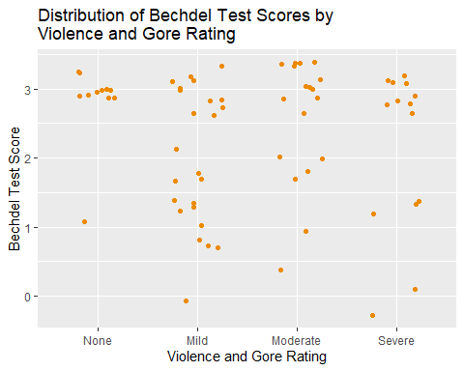

Scatterplot with Regression (H1)
violence_levels <- c('None','Mild','Moderate','Severe')
film_data <- film_data %>%
mutate(violence = factor(
violence,
levels = violence_levels,
ordered = TRUE
)
)
film_data %>%
ggplot(aes(x = violence, y = bechdel)) +
geom_jitter(width = 0.25, color = "#ED8B00FF") +
geom_smooth(
aes(group = 1),
method = "lm",
se = FALSE,
col = "#00496FFF"
) +
labs(
title = "Distribution of Bechdel Test Scores by \nViolence and Gore Rating",
x = "Violence and Gore Rating",
y = "Bechdel Test Score")
## `geom_smooth()` using formula = 'y ~ x'
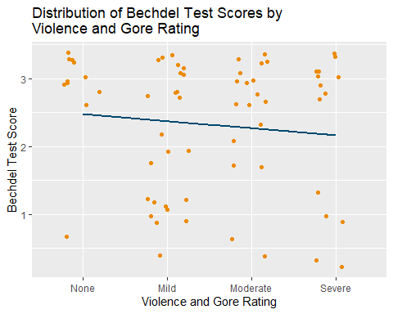

Violin (H1)
film_data %>%
ggplot(aes(x = violence, y = bechdel)) +
geom_violin(color = "#ED8B00FF", fill = "#EDD746FF")+
labs(
title = "Distribution of Bechdel Test Scores by \nViolence and Gore Rating",
x = "Violence and Gore Rating",
y = "Bechdel Test Score"
)
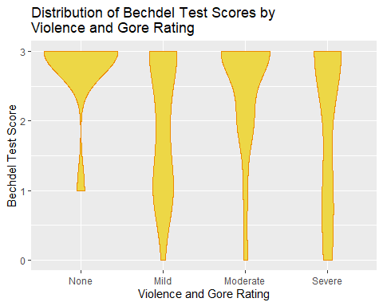

Boxplot (H1)
film_data %>%
ggplot(aes(x = violence, y = bechdel)) +
geom_boxplot(color = "#ED8B00FF", fill = "#EDD746FF") +
labs(
title = "Distribution of Bechdel Test Scores \nby Violence and Gore Rating",
x = "Violence and Gore Rating",
y = "Bechdel Test Score"
)

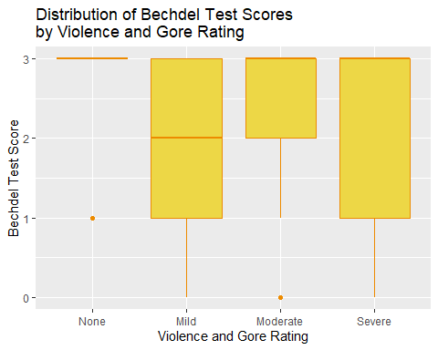

Hypothesis 2 (H2)
There is a relationship between a film being female-directed and non-female-directed and its odds of passing all three Bechdel Test criteria among Oscar Best Picture shortlisted films (2020-2026).

H2 Analysis

Fisher’s Exact Test (H2)
h2odds_test <- film_data %>%
mutate(director_binary = factor(
ifelse(gen_dir == "female", "Female", "Non-Female"),
levels = c("Non-Female", "Female")
),
bechdel_binary = factor(
ifelse(bechdel == 3, "Pass", "Fail"),
levels = c("Fail", "Pass")
)
)
h2odds_table <- table(h2odds_test$director_binary, h2odds_test$bechdel_binary)
print("2x2 Contingency Table:")
## [1] "2x2 Contingency Table:"
print(h2odds_table)
##
## Fail Pass
## Non-Female 24 34
## Female 1 8
h2odds_results <- fisher.test(h2odds_table)
print("Odds Ratio Test Results:")
## [1] "Odds Ratio Test Results:"
print(h2odds_results)
##
## Fisher's Exact Test for Count Data
##
## data: h2odds_table
## p-value = 0.1378
## alternative hypothesis: true odds ratio is not equal to 1
## 95 percent confidence interval:
## 0.6667075 260.4957885
## sample estimates:
## odds ratio
## 5.534587

Fisher’s Exact Test (H2) Results
A Fisher’s exact test was conducted to examine the relationship between director gender and passing the Bechdel test. While female-directed films had over five times higher odds of passing the test compared to non-female-directed films, this difference was not statistically significant, OR = 5.53, with a 95% confidence interval [0.67, 260.50], p = .138.

Chi-square Test (H2)
h2chisq_tbl <- table(film_data$gen_dir, film_data$bechdel)
print("Observed Frequencies:")
## [1] "Observed Frequencies:"
print(h2chisq_tbl)
##
## 0 1 2 3
## female 1 0 0 8
## male 3 13 8 34
h2chisq_results <- chisq.test(h2chisq_tbl)
## Warning in chisq.test(h2chisq_tbl): Chi-squared approximation may be incorrect
print("Expected Frequencies (Must mostly be ≥ 5):")
## [1] "Expected Frequencies (Must mostly be ≥ 5):"
print(h2chisq_results$expected)
##
## 0 1 2 3
## female 0.5373134 1.746269 1.074627 5.641791
## male 3.4626866 11.253731 6.925373 36.358209
print("Chi-Square Test Results:")
## [1] "Chi-Square Test Results:"
print(h2chisq_results)
##
## Pearson's Chi-squared test
##
## data: h2chisq_tbl
## X-squared = 4.8575, df = 3, p-value = 0.1825
ggplot(film_data, aes(x = bechdel)) +
geom_histogram(binwidth = 1, fill = "#0F85A0FF", color = "#89AAC6FF") +
facet_wrap(~ gen_dir) +
theme_minimal() +
labs(
title = "Distribution of Bechdel Test Scores \nby Director Gender",
x = "Bechdel Test Score",
y = "Count"
)
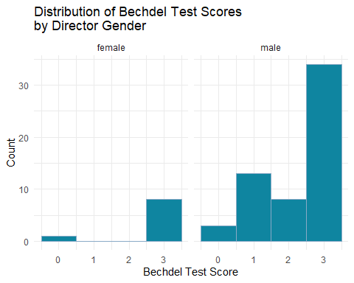

Chi-square Test (H2) Results
A chi-square test was conducted to examine if there is a relationship between director gender and Bechdel Test score. As the number of female directors in the dataset were too few, the calculated chi-square value was inaccurate. Furthermore, this relationship was not statistically significant, $χ^{2}$ = 4.8575, df = 3, p = .183.

Independent Samples t-test (H2)
h2tt_results <- t.test(bechdel ~ gen_dir, data = film_data)
print("Independent Samples t-test Results:")
## [1] "Independent Samples t-test Results:"
print(h2tt_results)
##
## Welch Two Sample t-test
##
## data: bechdel by gen_dir
## t = 1.1415, df = 10.548, p-value = 0.2789
## alternative hypothesis: true difference in means between group female and group male is not equal to 0
## 95 percent confidence interval:
## -0.3828737 1.1989657
## sample estimates:
## mean in group female mean in group male
## 2.666667 2.258621

Independent Samples t-test (H2) Results
A independent samples t-test was thus conducted to examine the difference between the mean average score on the Bechdel Test between genders of directors. This assumes that the variable for the Bechdel Test is continuous. The result showed that there was no statistically significant difference between the Bechdel Test scores of female-directed movies and non-female-directed movies, t = 1.1415, df = 10.548, p = .279.

Mann-Whitney U Test (H2)
film_data %>%
group_by(gen_dir) %>%
summarize(median_bechdel = median(bechdel, na.rm = TRUE))
## # A tibble: 2 × 2
## gen_dir median_bechdel
## <chr> <dbl>
## 1 female 3
## 2 male 3
h2mannwhit_results <- wilcox.test(bechdel ~ gen_dir, data = film_data)
print(h2mannwhit_results)
##
## Wilcoxon rank sum test with continuity correction
##
## data: bechdel by gen_dir
## W = 329.5, p-value = 0.1474
## alternative hypothesis: true location shift is not equal to 0

Mann-Whitney U Test (H2) Results
In order to account for few cell counts for female director variable, and to treat the Bechdel Test score as ordinal, a Mann-Whitney U Test was conducted to determine if there was a significant difference in Bechdel Test scores between female-directed and non-female-directed Oscar-nominated films from 2000 to 2026. The median Bechdel Test score for female-directed films (Mdn = 3) was not significantly different from non-female-directed films (Mdn = 3), U = 329.5, p = 0.147.

H2 Data Visualisation

Bar Plot (H2)
This bar plot shows the breakdown of Bechdel Test criteria met by each film grouped according to gender of film director (Female, Non-female).
ggplot(film_data, aes(x = gen_dir, fill = factor(bechdel))) +
geom_bar(position = "fill") +
scale_y_continuous(labels = scales::percent_format()) +
scale_fill_paletteer_d("PNWColors::Bay") +
theme_minimal() +
labs(
title = "Proportion of Bechdel Test Scores \nby Director Gender",
x = "Director Gender",
y = "Percentage of Films",
fill = "Bechdel Test Score"
)
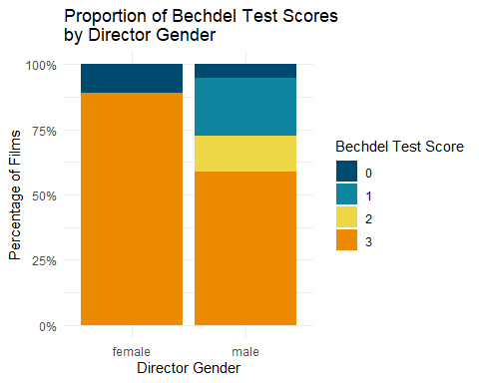 ### Time Trend (H2)
This time trend graph shows the proportion of films that meet all three criteria of the Bechdel Test by year, from 2020 to 2026, split by gender of film director.
yearly_trends <- film_data %>%
mutate(
Passed = ifelse(bechdel == 3, 1, 0),
director_binary = factor(ifelse(gen_dir == "female", "Female", "Non-Female"))
) %>%
group_by(year, director_binary) %>%
summarize(Pass_Rate = mean(Passed, na.rm = TRUE), .groups = "drop")
ggplot(yearly_trends, aes(x = year, y = Pass_Rate, color = director_binary)) +
geom_line(size = 1.2) +
geom_point(size = 3) +
scale_color_manual(values = c("Non-Female" = "#0F85A0FF", "Female" = "#DD4124FF")) +
scale_y_continuous(labels = scales::percent_format(), limits = c(0, 1)) +
theme_minimal() +
labs(
title = "Bechdel Test Pass Rates Over Time (2020-2026)",
x = "Year of Award",
y = "Percentage of Films that Pass the Bechdel Test (Score = 3)",
color = "Director Gender"
)
## Warning: Using `size` aesthetic for lines was deprecated in ggplot2 3.4.0.
## ℹ Please use `linewidth` instead.
## This warning is displayed once per session.
## Call `lifecycle::last_lifecycle_warnings()` to see where this warning was
## generated.
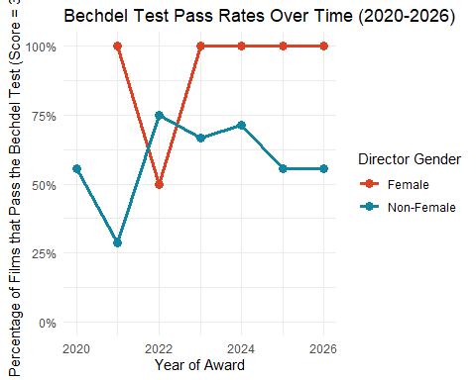

Cumulative Density Plot (H2)
This cumulative density plot visualises the proportion of films over the six years across the Bechdel Test Scores, split by gender of film director.
ggplot(film_data, aes(x = bechdel, color = gen_dir)) +
stat_ecdf(geom = "step", size = 1.2) +
scale_color_manual(values = c("#DD4124FF", "#0F85A0FF")) +
theme_minimal() +
labs(
title = "Cumulative Density of Bechdel Test Scores \nby Director Gender",
x = "Bechdel Test Score",
y = "Cumulative Proportion",
color = "Director Gender"
)
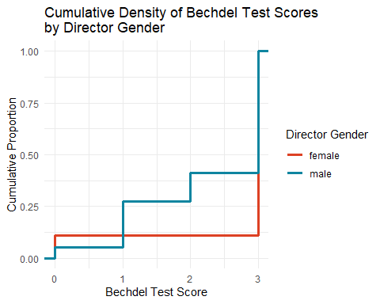

Mosaic Plot (H2)
This mosaic plot visualises distribution of Bechdel Test criteria met by the whole population-Oscars Academy Award Best Picture Shortlisted Films between 2020 and 2026-split by gender of film director and proportions of each number of Bechdel Test criteria met.
mosaic_table <- table(film_data$gen_dir, film_data$bechdel_coded)
mosaicplot(
mosaic_table,
main = "Proportional Breakdown of Bechdel Test Status \nby Director Gender",
color = c("#ED8B00FF", "#0F85A0FF"),
xlab = "Director Gender",
ylab = "Bechdel Test Status (Pass/Fail)",
border = "#00496FFF"
) +
theme(
plot.title = element_text(size = 12, hjust = 0.5)
)
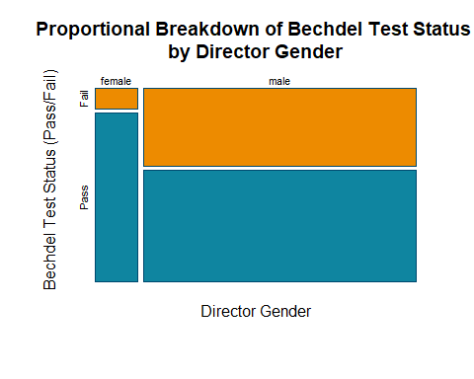
## NULL
mosaic_table_more <- table(film_data$gen_dir, film_data$bechdel)
mosaicplot(
mosaic_table_more,
main = "Proportional Breakdown of Bechdel Test Scores \nby Director Gender",
color = c("#ED8B00FF", "#89AAC6FF"),
xlab = "Director Gender",
ylab = "Bechdel Test Score",
border = "#00496FFF"
) +
theme(
plot.title = element_text(size = 12, hjust = 0.5)
)
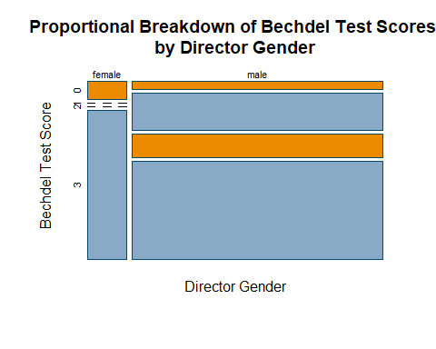
## NULL

Hypothesis 3 (H3)
There is a relationship between a film’s worldwide box office revenue and the IMDb Violence and Gore rating among Oscar Best Picture shortlisted films (2020-2026).

H3 Analysis
##Descriptive Statistics
violence_levels <- c('None','Mild','Moderate','Severe')
film_data <- film_data %>%
mutate(
box_office = box_office %>%
as.numeric(),
log_box_office = log10(box_office),
violence = factor(
violence,
levels = violence_levels,
ordered = TRUE
),
violence_coded = as.numeric(factor(
violence,
levels = violence_levels,
ordered = TRUE))
) %>%
filter(!is.na(box_office))
film_data %>%
group_by(violence) %>%
summarize(
n = n(),
Mdn = median(box_office, na.rm = TRUE),
M = mean(box_office, na.rm = TRUE),
SD = sd(box_office, na.rm = TRUE),
Mdn_log = median(log_box_office, na.rm = TRUE),
M_log = mean(log_box_office, na.rm = TRUE)
)%>%
mutate(
Mdn = scales::dollar(Mdn, accuracy = 1),
M = scales::dollar(M, accuracy = 1),
SD = scales::dollar(SD, accuracy = 1),
Mdn_log = round(Mdn_log, 2),
M_log = round(M_log, 2)
)
## # A tibble: 4 × 7
## violence n Mdn M SD Mdn_log M_log
## <ord> <int> <chr> <chr> <chr> <dbl> <dbl>
## 1 None 11 $39,458,207 $195,740,224 $425,661,509 7.6 7.51
## 2 Mild 22 $50,925,979 $224,787,992 $390,566,466 7.71 7.69
## 3 Moderate 17 $50,250,625 $252,864,412 $567,672,853 7.7 7.65
## 4 Severe 13 $117,625,455 $231,489,199 $299,548,572 8.07 7.78

Kruskal-Wallis Test (H3)
h3krus_results <- kruskal.test(
box_office ~ violence,
data = film_data
)
print(h3krus_results)
##
## Kruskal-Wallis rank sum test
##
## data: box_office by violence
## Kruskal-Wallis chi-squared = 1.5274, df = 3, p-value = 0.676

Kruskal-Wallis Test (H3) Results
A Kruskal-Wallis test was conducted to examine whether worldwide box office revenue differed across violence rating groups. The test was not statistically significant, H(3) = 1.53, p = .676. The null hypothesis is therefore retained, as the data provide no evidence of a relationship between a film’s violence rating and its worldwide box office revenue among Oscar Best Picture shortlisted films (2020–2026).

Dunn Post-Hoc Test (H3)
h3dunn_results <- dunn.test(
x = film_data$box_office,
g = film_data$violence,
method = 'bonferroni'
)
## Kruskal-Wallis rank sum test
##
## data: x and group
## Kruskal-Wallis chi-squared = 1.5274, df = 3, p-value = 0.68
##
##
## Dunn's Pairwise Comparison of x by group
## (Bonferroni)
## Col Mean-│
## Row Mean │ Mild Moderate None
## ─────────┼─────────────────────────────────
## Moderate │ 0.318457
## │ 1.0000
## │
## None │ 0.745386 0.445572
## │ 1.0000 1.0000
## │
## Severe │ -0.603616 -0.852237 -1.187317
## │ 1.0000 1.0000 0.7053
##
## α = 0.05
## Reject Ho if p ≤ α/2, where p = Pr(Z ≥ |z|)
print(h3dunn_results)
## $chi2
## [1] 1.527364
##
## $Z
## [1] 0.3184574 0.7453862 0.4455721 -0.6036163 -0.8522376 -1.1873176
##
## $P
## [1] 0.3750690 0.2280191 0.3279532 0.2730494 0.1970411 0.1175512
##
## $P.adjusted
## [1] 1.0000000 1.0000000 1.0000000 1.0000000 1.0000000 0.7053071
##
## $comparisons
## [1] "Mild - Moderate" "Mild - None" "Moderate - None"
## [4] "Mild - Severe" "Moderate - Severe" "None - Severe"

Dunn Post-Hoc Test (H3) Results
As the Kruskal-Wallis test was not statistically significant, Dunn’s pairwise post-hoc comparisons are reported for completeness only and should not be interpreted inferentially. All Bonferroni-corrected pairwise comparisons were non-significant, with p-values ranging from .705 to 1.000, confirming that no specific pair of violence rating groups differed significantly in box office revenue.

Spearman Correlation (H3)
h3sp_results <- cor.test(
~ as.integer(violence) + box_office,
data = film_data,
method = 'spearman'
)
## Warning in cor.test.default(x = mf[[1L]], y = mf[[2L]], ...): Cannot compute
## exact p-value with ties
print(h3sp_results)
##
## Spearman's rank correlation rho
##
## data: as.integer(violence) and box_office
## S = 36711, p-value = 0.3534
## alternative hypothesis: true rho is not equal to 0
## sample estimates:
## rho
## 0.1188849

Spearman Correlation (H3) Results
A Spearman correlation was conducted to examine the monotonic relationship between violence rating and worldwide box office revenue. The warning regarding ties is expected when an ordinal variable with few levels is used and does not invalidate the result. The correlation was weak and not statistically significant, rho = .119, S = 36711, p = .353, consistent with the Kruskal-Wallis finding. The null hypothesis is therefore retained.

Data Visualisation

Scatter Plot (H3)
film_data %>%
ggplot(aes(x = violence, y = log_box_office)) +
geom_jitter(width = 0.25, color = "#ED8B00FF") +
geom_smooth(aes(group = 1), method = "lm", se = FALSE, col = "#00496FFF") +
scale_y_continuous(
name = expression(paste("Worldwide Box Office ",log[10], " ($,",10^n,")")),
breaks = seq(5, 10, by = 1),
limits = c(5, 10)
) +
labs(
x = 'Violence and Gore Rating',
title = 'Distribution of Box Office Revenue by \nViolence and Gore Rating'
)
## `geom_smooth()` using formula = 'y ~ x'
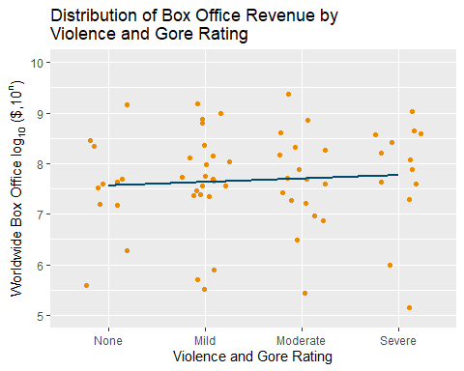

Violon Plot (H3)
film_data %>%
ggplot(aes(x = violence, y = log_box_office)) +
geom_violin(color = "#ED8B00FF", fill = "#EDD746FF") +
scale_y_continuous(
name = expression(paste("Worldwide Box Office ",log[10], " ($,",10^n,")")),
breaks = seq(5, 10, by = 1),
limits = c(5, 10)
) +
labs(x = 'Violence and Gore Rating',
title = 'Distribution of Box Office Revenue by \nViolence and Gore Rating'
)
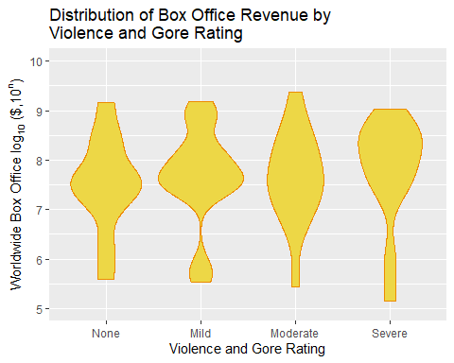

Box Plot (H3)
film_data %>%
ggplot(aes(x = violence, y = log_box_office)) +
geom_boxplot(color = "#ED8B00FF", fill = "#EDD746FF") +
scale_y_continuous(
name = expression(paste("Worldwide Box Office ",log[10], " ($,",10^n,")")),
breaks = seq(5, 10, by = 1),
limits = c(5, 10)
) +
labs(
x = 'Violence and Gore Rating',
title = 'Distribution of Box Office Revenue by \nViolence and Gore Rating'
)
