Activity Title: SME System Analyst Challenge: Analyze Before You Build

1. SME Profile
Category | Description
Name of SME | Romel Hair Salon
Type of Business | Hair and Beauty Salon
Main Customers | The business primarily serves the general public, including men, women, and students in the local community who avail of haircuts, hair coloring, hairstyling, and other beauty services.
Daily Operations | The salon operates Monday to Saturday, from 9:00 AM to 7:00 PM. Daily activities include attending to walk-in and appointed customers, providing hair and beauty services, processing service payments through the Point-of-Sale (POS) system, monitoring salon product inventory, generating sales reports, handling customer payments, scheduling appointments, and managing employee payroll.
Employees Involved | The business is managed by a Manager, who oversees daily operations and business decisions. Stylists and Beauticians perform haircuts, coloring, and other salon services, and a Receptionist / Cashier handles appointment bookings, greets customers, and processes payments.

2. Current Business Process
Process | Current Business Process
Customer Ordering | Customers personally visit the salon as walk-ins or call ahead to request an appointment. The receptionist writes down appointment schedules in a physical logbook, and the cashier processes service payments at the counter using the POS system.
Inventory Management | Salon supplies such as shampoo, hair color, and styling products are manually counted and recorded in a notebook by the stylists whenever new stock arrives or products are used up.
Sales Processing | Service transactions are recorded through a basic POS system, which calculates totals, processes payments, and issues receipts.
Report Generation | Daily sales are manually tallied by the cashier and reported to the manager at closing; there is no automatic weekly or monthly report generation.
Business Analytics | The salon has no analytics tools. The manager relies on personal observation to decide which services are most in demand and which products to reorder.
Payment Processing | Customers can pay using cash or e-wallet services. Card payments are not currently accepted.
Delivery | The salon does not offer delivery; all services are rendered on-site.
Payroll (Salary) | Employee salaries, including commissions from services rendered, are computed manually by the manager using a notebook and distributed in cash according to the salon's payroll schedule.

3. Identified Problems
Problem | Effect
Inventory is manually recorded in a notebook. | Salon product counts may become inaccurate, leading to unexpected shortages during peak service days.
Appointments are booked only through a physical logbook. | Customers must call or visit in person to check availability, and double-bookings sometimes occur.
No customer database or service history. | The business cannot track a customer's preferred stylist, past services, or offer loyalty promotions.
Limited business analytics. | Management cannot easily identify the most popular services or top-performing stylists.
Salary and commission processing is done manually. | Payroll computation may be delayed or contain errors.

4. Root Cause Analysis
Problem | Why does it happen? | Who is affected? | What happens if it continues?
Manual inventory recording | Salon product stock is counted and recorded by hand after use or restocking. | Manager, stylists, customers | Incorrect stock levels and unexpected shortages of salon products.
Logbook-based appointment booking | Appointment schedules are only tracked on paper. | Customers and stylists | Double-bookings and inconvenience for customers checking availability.
No customer database | Customer information and service history are not recorded. | Manager and customers | No loyalty programs or personalized service recommendations.
Limited analytics | Reports only show manually tallied daily totals. | Management | Poor decision-making on staffing and service offerings.
Manual payroll and commission tracking | Salary and commissions are computed and recorded by hand. | Employees and manager | Payroll errors and delays.

5-6. Functional Requirements and Non-Functional Requirements
Functional Requirements | Non-Functional Requirements
1. The system shall allow employees to log in securely using unique user accounts. | 1. The system shall provide a user-friendly and intuitive interface for all employees.
2. The system shall record and process customer service payments. | 2. The system shall be available during business operating hours with minimal downtime.
3. The system shall automatically update salon product inventory after every service transaction. | 3. The system shall protect business data through secure authentication and access control.
4. The system shall notify the manager when salon product stock reaches a predefined minimum level. | 4. The system shall generate reports and process transactions within a few seconds.
5. The system shall generate daily, weekly, and monthly sales reports. | 5. The system shall be scalable to accommodate future business growth and additional users.
6. The system shall maintain a customer database for service history and preferred stylist records.
7. The system shall support online booking for salon appointments.
8. The system shall process multiple payment methods, including cash, cards, and e-wallets.
9. The system shall manage employee payroll and commission records.
10. The system shall generate business analytics on service demand and stylist performance.

7. Recommended Technologies
Component | Recommended Technology | Why Are These Technologies Appropriate?
Front-end | Flutter | Builds a responsive and easy-to-use application across multiple platforms.
Back-end | Node.js with Express | Efficiently handles business logic and system operations.
Database | PostgreSQL | Securely stores and manages business data.
Reports | PDF Reports with Dashboard Charts | Generates clear reports and visual business insights.
Authentication | JSON Web Token (JWT) | Secures user accounts and controls system access.
Notifications | Email and SMS Notifications | Sends alerts for important business events and low salon product stock.
Hosting | Render | Provides reliable and scalable cloud hosting.

8. Proposed Integrated System
The proposed integrated system will combine inventory management, sales processing, customer record management, payroll, reporting, and online appointment booking into a single platform. Salon product inventory will update automatically after each transaction, sales reports will be generated in real time, and the manager will receive low-stock notifications for key products. Customers will also have the option to book appointments online, while employees can securely access only the features relevant to their roles.

9. Simple Context Diagram
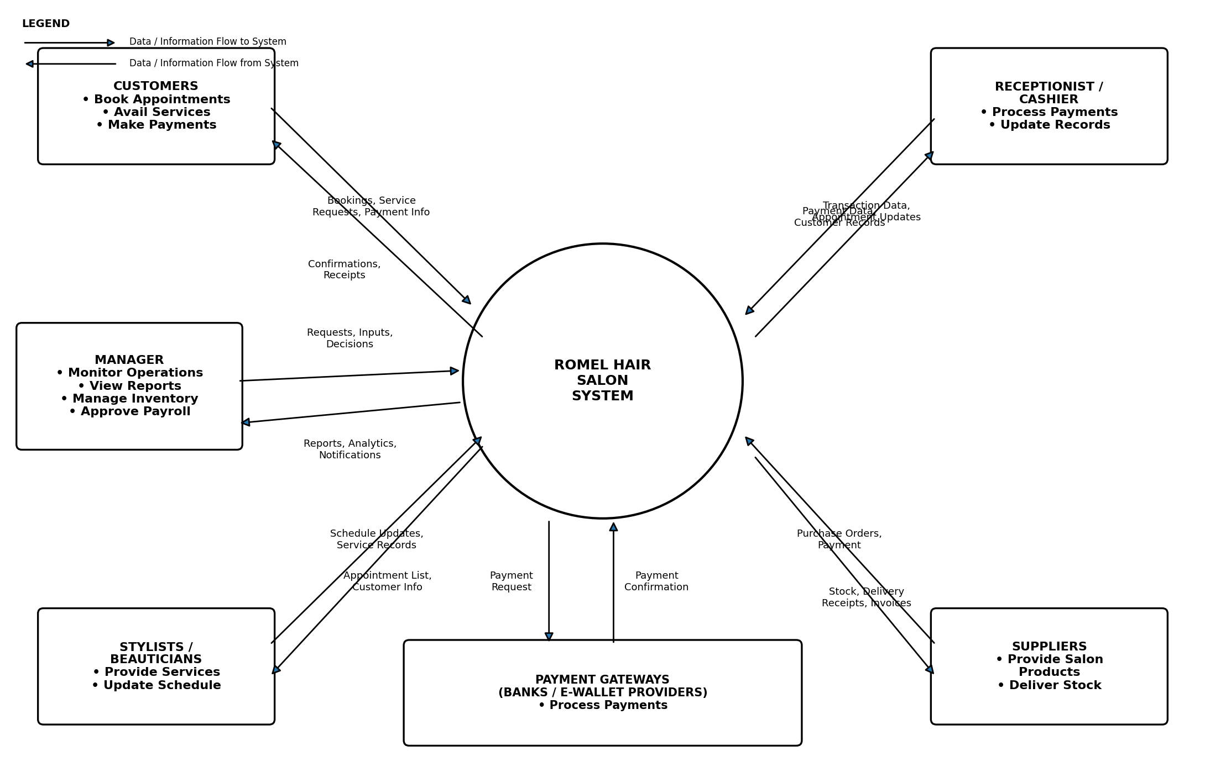

10. Reflection
As the system analyst, my biggest challenge would be understanding the actual workflow of the business and ensuring that the proposed system matches the daily operations of Romel Hair Salon. Since employees are already used to logging appointments and inventory by hand, introducing a new integrated system may require training and adjustment. Another challenge is balancing functionality with affordability, because SMEs often have limited budgets. The system should improve inventory tracking, appointment scheduling, payroll, and reporting while remaining simple, reliable, and easy to use. Proper planning and communication with the owner and employees are essential to ensure successful implementation and adoption.

