**The Battle of Neighborhoods Project - Eric S**.

**1. Introduction**

**1.1 Background**

Denver is a large city in Colorado, US and the central neighborhood accounts for around 100,000 people. For this project, I'll be looking at the neighborhoods of Baker, Capitol Hill, Cherry Creek, Cheesman Park, City Park, Congress Park, City Park West, Civic Center, Country Club, Lincoln Park, North Capitol Hill, Speer, and Union Station.

**1.2 Problem**

In this project, I will investigate if there is a good location in central Denver to open an Italian restaurant.

**2. Data acquisition**

**2.1 Description of the Data**

I got the neighborhood data from Wikipedia ([link](https://en.wikipedia.org/wiki/List_of_neighborhoods_in_Denver)). This information included names and population of the area. I then used the python geocoder library to get geographical coordinates of neighborhoods. From there, I used the Foursquare API venues explore method to get the venues of given neighborhoods.

**2.2 Locations of Neighborhoods**

I created a map with folium, shown below, that illustrates the general locations of the neighborhoods.

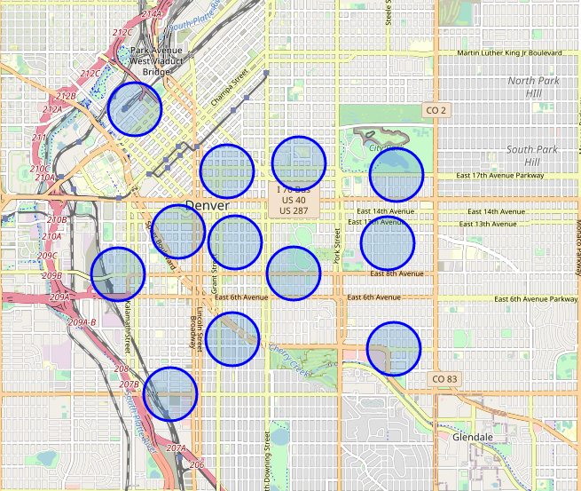

**2.3 Loading Other Venues in the Neighborhoods**

After loading the coordinates of my neighborhoods, I set up the Foursquare API to gather all the restaurants in the area. Foursquare is very nice as it not only tells us the name of the restaurant, but also places the venue into a category.

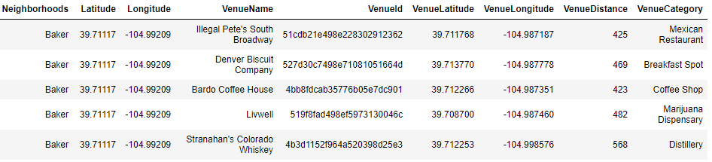

**3. Data Analysis**

**3.1 Grouping and Counting by Venue Category**

Now that I had all of the necessary data, I began my analysis. I started by grouping and counting the different venue categories to gather a picture of the restaurants in the area. The top three most popular venues were coffee shoes, American restaurants, and Mexican restaurants. After finding out that general information, I decided to count the total number of actual restaurants and compare that to the total number of Italian restaurants. Here are the results:

*Number of restaurants: 335*

*Number of Italian restaurants: 16*

*Percentage of Italian restaurants: 4.78%*

**3.2 Restaurant Counts by Neighborhoods**

While the previous section illustrates that Italian restaurants are in short supply, we can break it down further and look at how many restaurants are in each neighborhood. That graph is on the following page and shows there are a few neighborhoods that lack an Italian restaurant entirely.

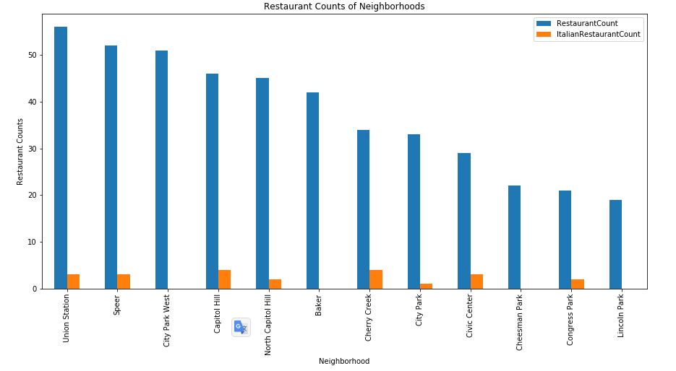

**3.3 Restaurant Counts by Neighborhoods with Population**

I then decided to look at the same graph as above, however, make all of the columns a percentage of their totals. Doing so shows a graph that is a little easier to understand. It also helps us to eliminate some of the worst neighborhoods. For example, Cherry Creek. It has about 7% of total restaurants, but accounts for over 17% of the total number of Italian restaurants. The Civic Center is another good example of this.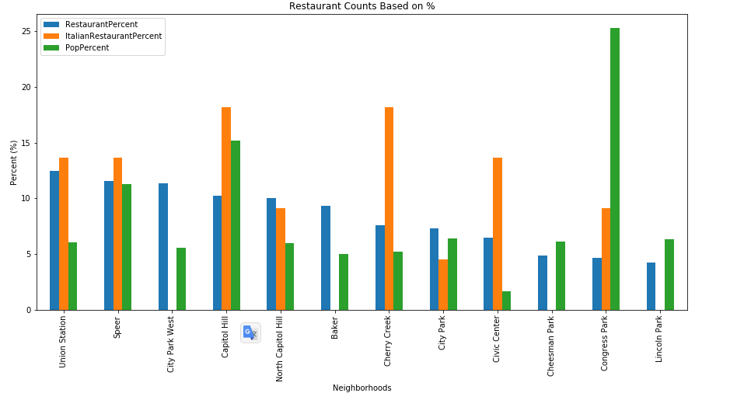

**4. Conclusions**

**4.1 Three Good Options**

After narrowing down a few more bad options, we are left with Congress Park, Cheesman Park, and Lincoln Park. Congress Park does have other Italian restaurants. However, it also has the largest population percentage of all of the neighborhoods. Cheesman Park and Lincoln Park are very similar. Both have no other Italian restaurants and almost identical population percentages (see below).

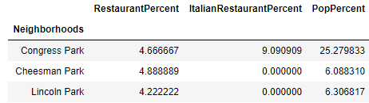

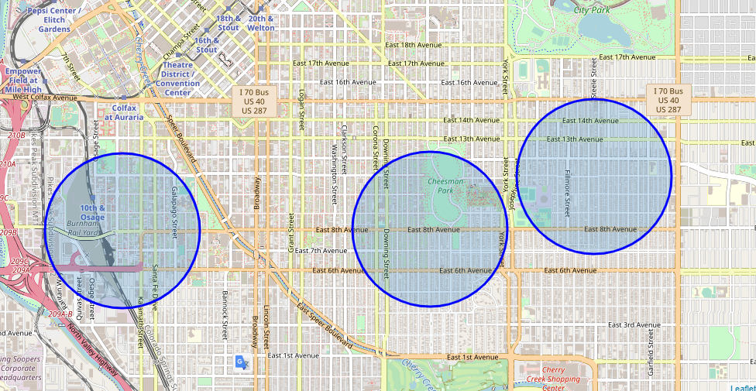

**4.2 Final Decision**

Since Congress Park and Cheesman Park neighbor each other on East 8th Ave, choosing a location between these two neighborhoods could allow the restaurant to pull people from both neighborhoods.