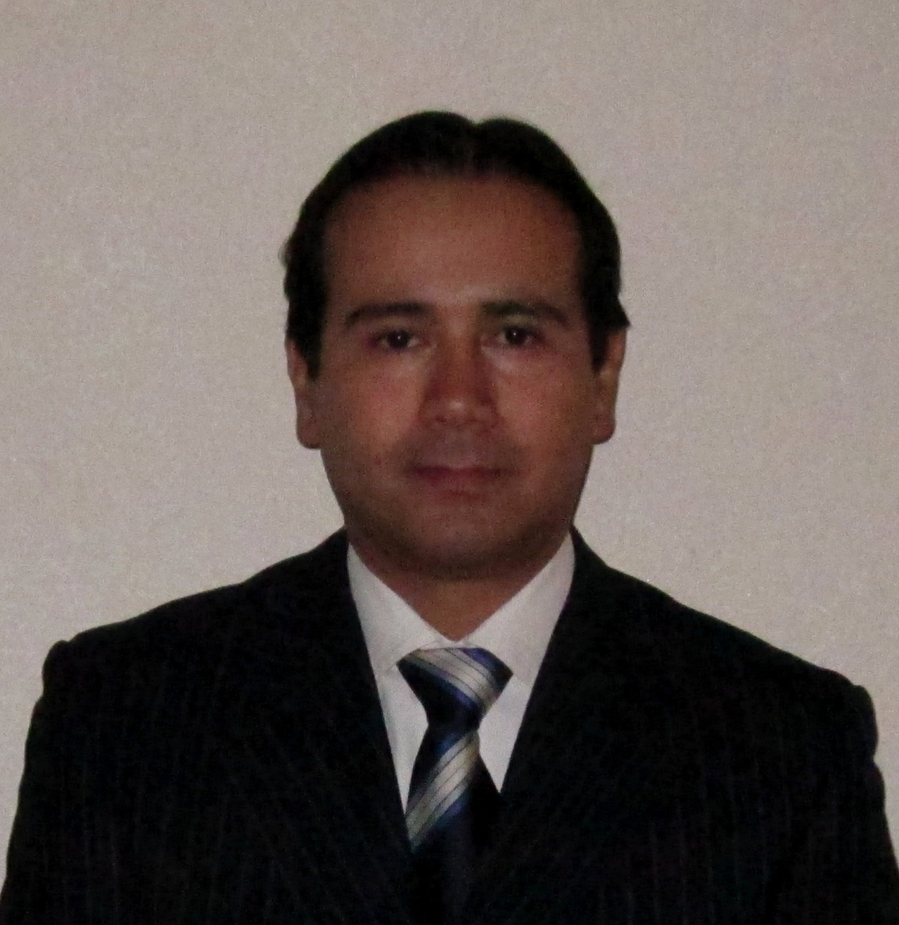
DAVID ROMERO LOPEZ
México/ Extremadura 112. Insurgentes Mixcoac. Mexico DF 02950
Tel. (+52) 55 47 51 96 34 email: davidromero40@hotmail.com.com
OBJECTIVE
Leadership Position
SUMMARY OF QUALIFICATIONS
ALCON LABORATORIES
- Clinical Applications Specialist (CAS) North LACAR, Alcon Labs, (2011-Current)
- Surgical Refractive Specialist (SRS), Mexico, Alcon Labs, (2007 – 2011)
- Surgical Sales Representative (SSR), Mexico, Alcon Labs, (2006)
- LADARVision® Refractive Surgery Specialist, Mexico, Alcon Labs, (May 2004-2005)
- Optometry Clinic Manager, Mexico, UNAM, (2003- May 2004)
- Associate Professor Level “A” Clinical and Optics Modules, Mexico, UNAM (1998-2002)
SKILLS AND ACCOMPLISHMENTS
- Clinical Applications Specialist Training and marketing of the LenSx and Wavelight products in North LACAR area. Targeting, Forecast and Product presentations, development of patient information materials. Launching of LenSx and surgeons training surgical “in service”. Development of KOL´s for the area market.
- Surgical Refractive Specialist working with High Potential Accounts in Mexico, enhancing ReSTOR® Multifocal IOL (intraocular lens for cataract surgery) market share and strategy; AcrySof® CACHETTM Launching and surgeon trainings “Surgical In Service”, Operating Rooms and Congresses; Acrysof® Toric IOL Launching and surgeon trainings in Operating Rooms and Congresses. SRS´s and SSR´s Technical Training. Successful Execution of APP in key accounts
- Surgical Sales Representative Introducing cataract Phacoemulsification and Vitrectomy surgeries technique & equipments; Premium Products in main accounts.
- Refractive Surgery Specialist working with users and potential accounts in Mexico enhancing LADARVision® System benefits and strategy, Surgeons and Staff trainings in Operating Rooms and Congresses
EDUCATION
- MARKETING AND COMMERCIAL STRATEGIES DIPLOMA, UNIVERSIDAD IBEROAMERICANA, Mexico. 2008
- OPTOMETRIST GRADE. México, UNIVERSIDAD NACIONAL AUTONOMA DE MEXICO 1993-1997
- ALCON COURSES. All surgical sales courses in several countries (USA, Mexico, Venezuela, Colombia and Argentina) GPS I, GPS II, GPS Advanced, SRS´s Trainings, Effective Presentations Workshop, Practice Development, APP, RPM.

