Automation Setup and Guideline Document

Table of Contents

1. Installation of JDK
2. Installation of Eclipse
3. Configuration of TestNG in Eclipse
4. Installation of Maven
5. Script Execution:
6. View Execution Report:
7. Automation Framework Architecture:

Installation of JDK

JDK (Java Development Kit): Download the JDK from https://www.oracle.com/java/technologies/javase-downloads.html link.
After finishing the download, install the executable file into your system.
Set Java home as Environmental variable into your system, see screen:

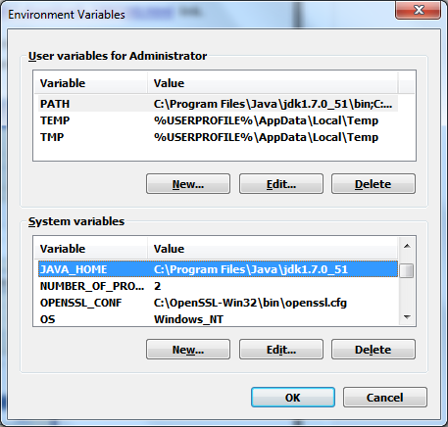

User can see the above screen if he follows the following steps:
- Right click on the My Computer icon from your desktop
- Click Properties
- Click Advanced tab
- Click Environment Variables button
- User would see Environment Variables interface
- Click New associated with System variables section
- You would see New System Variable interface
- Put JAVA_HOME into the variable name field
- Path of your JDK into the variable value field, as into the above screen my JAVA Home directory is installed into C:\Program Files\Java\jdk1.7.0_02
- Click Ok

User can check if java is successfully installed on the system or not, follow two screens which are below:
Run java –version command into the command prompt like:
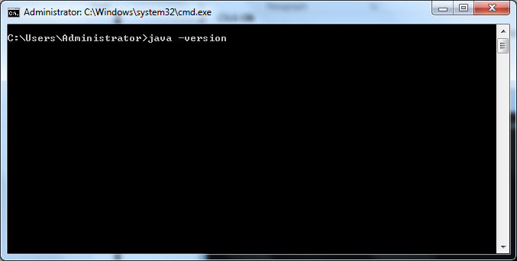

After execution of above command you would see the following screen:
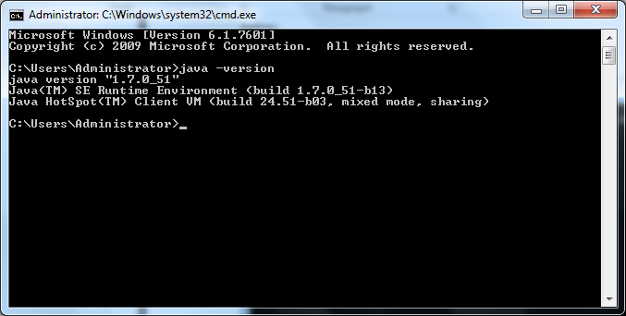

Installation of Eclispe

Downlaod Eclispe in Windows machine: Go to "https://www.eclipse.org/downloads/" and download according to your windowns machine. If you machine is 64 bit then you should install eclispe 64 bit otherwise you have to install 32 bit eclispe.

TestNG Configuration in Eclipse:

- Open the eclispe
- Move to Help>>Install New Software
- In Available Software popup provide the given link "http://dl.bintray.com/testng-team/testng-eclipse-release/" and follow the screenshot I have attached.

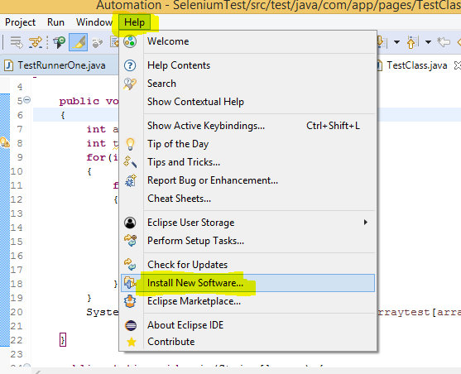

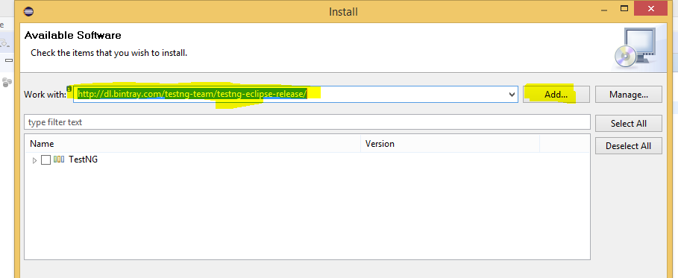

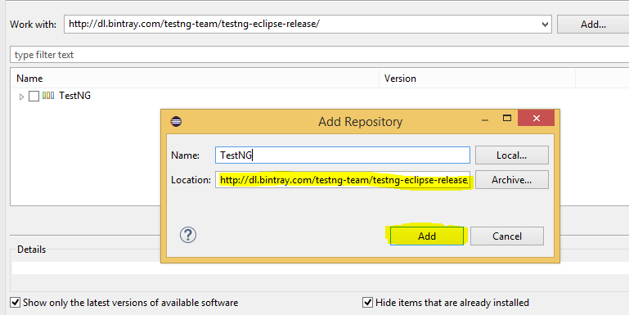

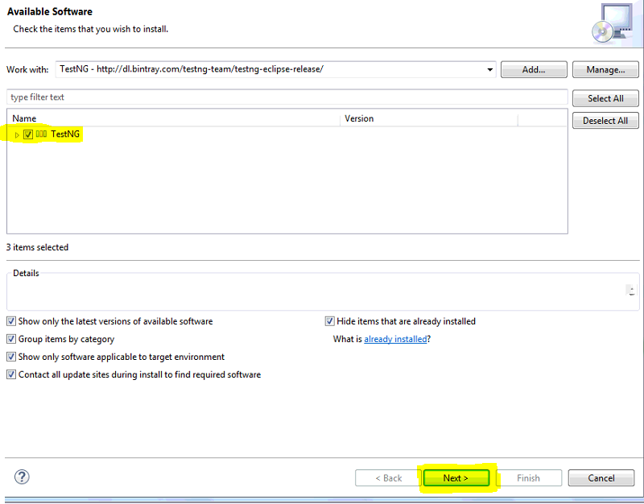

Installation of Maven

Maven as build tool: Download the binary distribution of Maven from https://maven.apache.org/download.cgi link.
After finishing with download, unzip the zipped file into any directly into your system. As you can see in the given screen

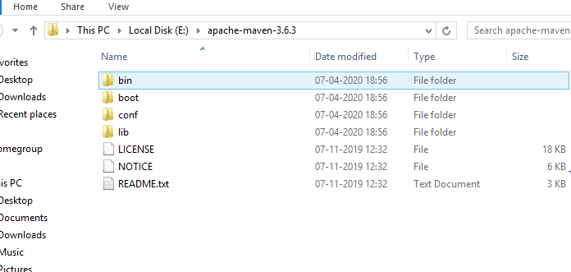

Set the Maven home as Environmental variable into your system, see screen:
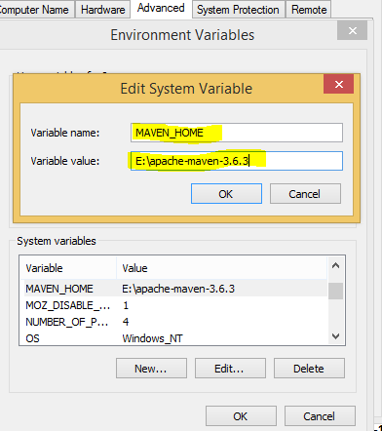

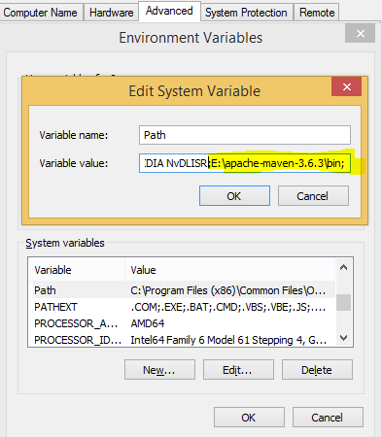

User can see the above screen if he follows the following steps:
- Right click on the My Computer icon from your desktop
- Click Properties
- Click Advanced tab
- Click Environment Variables button
- User would see Environment Variables interface
- Click New associated with System variables section
- You would see New System Variable interface
- Put Maven_home into the variable name field
- Path of your Maven into the variable value field, as into the above screen my ANT Home directory is installed into E:\apache-maven-3.6.3
- Click Ok
- In the System Variables you would see variable Path, select the row, click Edit and define two paths(E:\apache-maven-3.6.3\bin;) like into the following screen, in my case path of Maven bin folder is ;E:\apache-maven-3.6.3\bin;
- Click OK

User can check if Maven is successfully installed on the system or not, follow two screens which are below:

Run mvn –version command into the command prompt like:
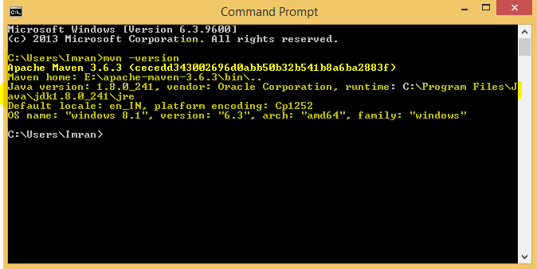

So ultimately if Maven is successfully installed on your system then you get “Maven version name with other information such jdk, OS.

Script Execution: We can run the script with three way

Individual Test Script
- Through TestNG.xml file
- From the command prompt

- Individual test Script execution:
- Open the automation project in your eclipse.
- Move to your Test scripts.
- Right clicking on your individual Test Script and select run as TestNG. See the below attached screenshot

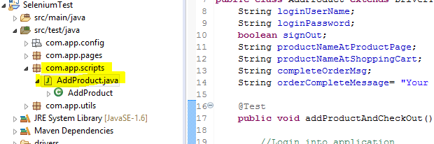

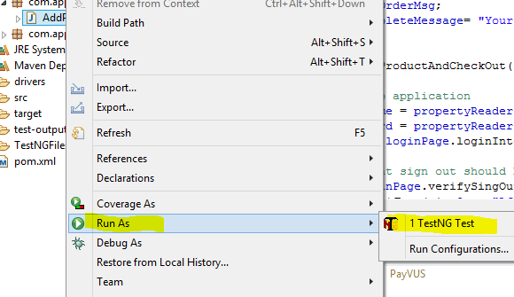
- Through testng.xml file execution:
- Open the automation project in your eclipse.
- Move to your testng.xml file.
- Right clicking on your individual Test Script and select run as TestNG. See the below attached screenshot
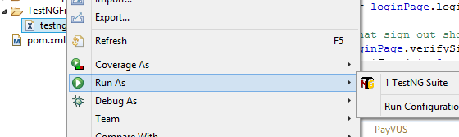

- Through testng.xml file execution:
- Move to your pom.xml file in your automation project root folder
- Run the command: mvn test

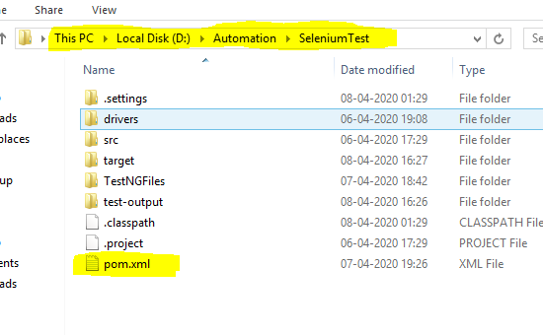

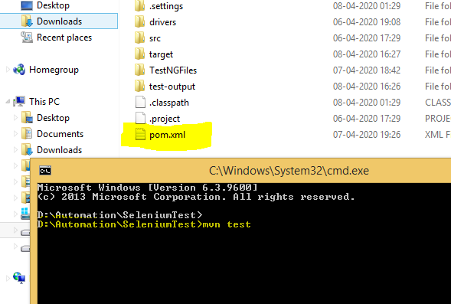

View Execution Report:
- Open your project eclipse
- Move to test-output folder
- Open emailable-report.html file
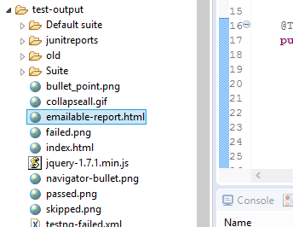

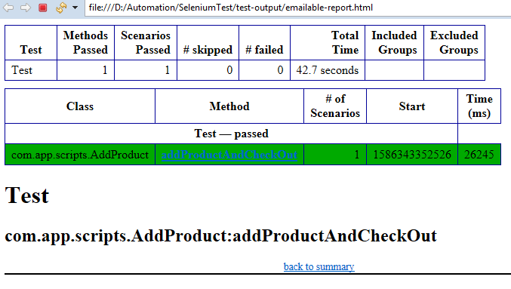
5 Automation Framework Architecture:
Automation framework consists below folders and files:
- src/test/java: Under src we have following packages:
- com. app.config: Here we keep all the static information i.e. url, user credentials, related to the application in ‘application.properties’ file.
- com. app.pages: Page helper folder has multiple helper file on for each page, containing various method related to that page.
For example: LoginHelper class have method like “enter username method”, “enter password” method and “click on submit”. Doing so, any modification is one page will not lead to modifying things at multiple places and other part of application do not know anything else about the rest of application and maintain a level of abstraction. Same piece of code can be reference from anywhere if required and reduce redundancy of code.
- com. app.TestScripts: This folder contains the actual test case files. In each of the file we extended DriverTest case file and used corresponding page helper file.
- com.app.util: Here we initialize the driver for browser like Firefox, also contains the common driver classes used by all the page helper classes and tests class. For example, ‘wait for element’, ‘clickOn, ‘findelement’, all these methods have been defined on the DriverHelper class and being referred from various page helper classes.
- TestNG-Files: Here we put the testing xml file here we mapped the java class and its test method to testNG.
- drivers: this folder has all the required jar file including chromedriver.exe.
- pom.xml: pom. xml file is heart of your project. it contain all the dependencies and plug-in of your project

