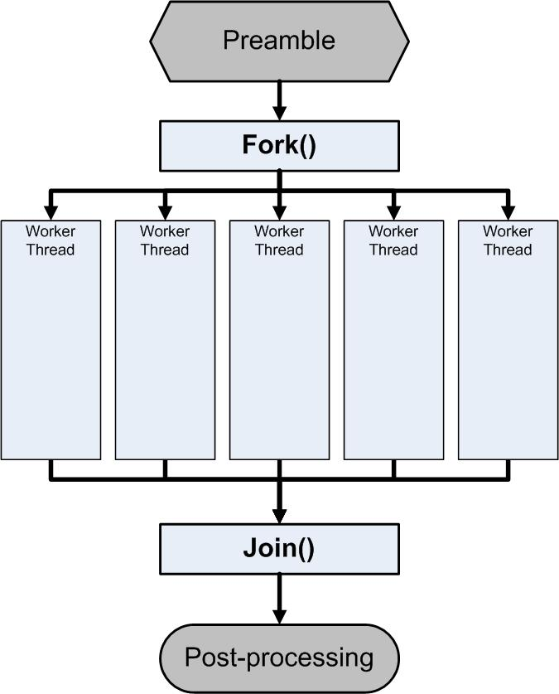Test: C

Represented by a double transverse line with any number of entry and exit arrows. These symbols are used whenever two or more control flows must operate simultaneously. The exit flows are activated concurrently, when all of the entry flows have reached the concurrency symbol. A concurrency symbol with a single entry flow is a fork; one with a single exit flow is a join.