Research Results: Single-Point Mutation Stability Prediction
This document summarizes the performance metrics of the three primary architectures tested for predicting the change in binding free energy (ΔΔG) upon mutation.

1. Visual Comparison
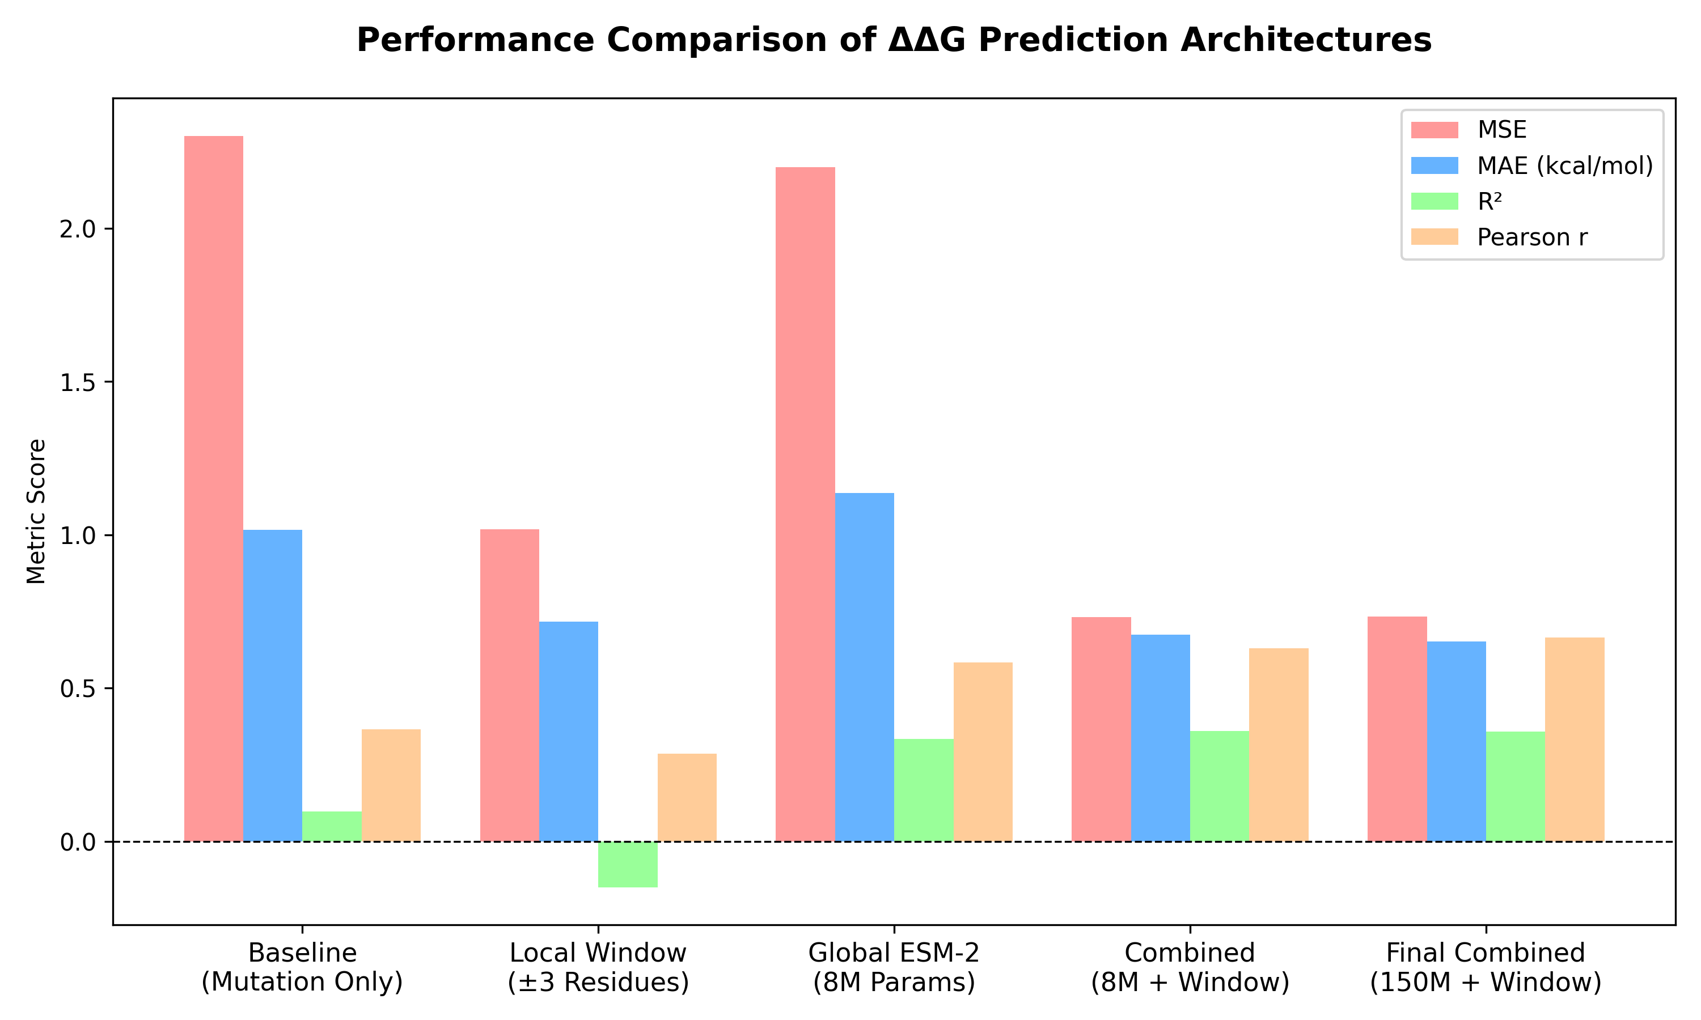
Analysis: While the local context window achieved the lowest absolute error (MAE), it failed to capture the underlying variance (negative R²). The transition to ESM-2 Self-Attention embeddings successfully solved this issue, dramatically improving the Pearson correlation from 0.285 to 0.584, indicating a much stronger ability to rank mutations by their true stabilizing or destabilizing effects.

2. Raw Data Metrics
Model Architecture | MSE | MAE (kcal/mol) | R² | Pearson r
Baseline  (Mutation Only) | 2.302 | 1.016 | 0.098 | 0.365
Local Window  (±3 Residues) | 1.018 | 0.717 | -0.150 | 0.285
Global ESM-2  (8M Params) | 2.199 | 1.136 | 0.334 | 0.584
Combined  (8M + Window) | 0.732 | 0.674 | 0.360 | 0.630
Final Combined  (150M + Window) | 0.734 | 0.651 | 0.358 | 0.664

