SeatTogether — Team Midterm Report
  - ISE4133 Software Engineering, Fall 2026, Inha University
Team ID | 15
Product | SeatTogether
Members | Esteve BASCUNANA (12264733), Adam LARKEM (12264692)
Submission date | 2026-10-25
Repository | https://github.com/estvv/software-engineering-project
Submitted version | Tag midterm-v1 (commit: to fill at submission)
Run instructions | Node.js 20.9 or later. npm install, then npm run dev (app on http://localhost:3000, API at /api/tables). Checks: npm test (automated tests), bash scripts/api_check.sh (manual API check). Details in the repository README.

1 Product and problem
Target user. An Inha University student who arrives at the student cafeteria during the lunch rush with a full tray and 30–60 minutes to eat. A secondary user is the same student eating alone, who might welcome company.
Problem. At peak time the room is crowded and free tables are scattered. From the entrance, nobody can see which tables are free.
Statement | Status | Source
The cafeteria is crowded at lunch peak and free tables are hard to spot from a distance. | Observed | Team members' own repeated experience as cafeteria users
Other students recognize the problem. | Observed | Reactions when the idea was pitched in the Week 2 class session; this does not show how many students are affected
The problem is frequent for a meaningful share of students. | Assumed | M1 assumption #3, confidence Medium
Students will check in and out reliably. | Assumed | M1 assumption #2, confidence Low; the riskiest assumption

Current alternatives. Students walk through the room with their tray and scan the rows until they spot a free table, sometimes doing a full lap (observed). We assume that some give up and eat standing, leave, or eat alone instead of joining a half-empty table (not observed yet).
Evidence status. No user test has been run yet. The M1 plan (clickable mockup, 8–10 students; support thresholds: 70% complete the check-in without help, 30% turn on "open to company" spontaneously) is still to be done. Claims above marked Assumed are not results.

2 Final demo scope
Main user task. Find a free table on a map of the cafeteria, go to it, and mark it occupied while seated so that other students do not walk to it for nothing.
Feature (final demo) | Story | State at the midterm
F1 Cafeteria map with each table's status, and a message when no table is free | S1 | Complete on a temporary layout (backend + map UI)
F2 Check-in / check-out of a table ("I'm sitting here" / "I'm leaving") | S2 | Complete (backend + buttons)
F3 "Open to company" status shown on the same map | S3 | Not started; depends on the user test (P1)

Excluded this semester, with the reason:
- In-app chat or messaging: harassment and moderation risk out of proportion to an MVP; students can walk over to a table.
- Table reservation and food ordering: outside the problem we are solving.
- User accounts and login: not needed to find a table; a check-in token protects check-out instead (section 6).
- Seat-by-seat tracking: tables are tracked as a whole (rule R1).
- Abuse prevention for statuses (e.g. one person occupying several tables): revisit only if the user test shows real interest.
- Community reporting of "has space" / "full" zones (S4): kept in the backlog, only if F1–F3 are done.

3 Requirements
Both stories serve the main task above. Criteria describe expected behavior; section 5 shows which have been checked and how.
ID | Requirement and observable result | Check
S1 | As a student arriving at the cafeteria with a tray, I want to see which tables are free on a map, so that I can go directly to a free table instead of walking around.
S1-AC1 | Given T1 is marked free and T2 occupied, when the student opens the map, then T1 is shown as free and T2 as occupied, each with a distinct color and a text label, without tapping a table. | Backend: automated test. UI: screenshot (A3)
S1-AC2 | Given every table is marked occupied, when the student opens the map, then "No free table reported right now" is shown above the map. | Backend: automated test. UI: screenshot (A3)
S2 | As a student who has just sat down, I want to mark my table occupied by selecting it and confirming once, and free it when I leave, so that other students do not walk to a table that is already taken.
S2-AC1 | Given T1 is shown as free, when the student selects T1 and confirms "I'm sitting here", then T1 is shown as occupied. | Backend: automated test + manual API check. UI: screenshot (A3)
S2-AC2 | Given the student is checked in at T1, when the student selects "I'm leaving", then T1 is shown as free. | Backend: automated test + manual API check. UI: screenshot (A3)

Rules decided since M2 (open questions in M2, decided on 2026-10-15 and recorded in the backlog):
ID | Rule | Reason
R1 | A check-in at a table that is already occupied is rejected ("Table already occupied"). The first check-in stays. | Tables are tracked as a whole, as in M1; simplest rule to explain and test.
R2 | A check-in expires after 60 minutes; the table is then shown as free. | Upper end of the 30–60 minute lunch break of our user. Not validated with users.

4 Design
The structure below is Architecture v1 (Week 5), now implemented as one Next.js application. Each box is a logical responsibility, not a separate server.
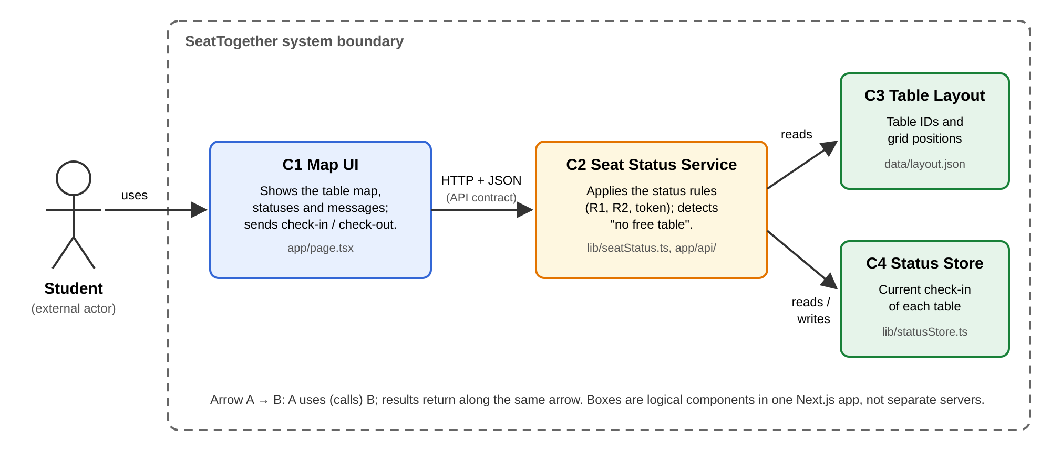
Figure 1. Structure diagram (logical view) with the file that implements each component.
Component | Responsibility | Implementation
C1 Map UI | Displays the map, statuses and messages; sends check-in / check-out. Contains no status rule. | app/page.tsx
C2 Seat Status Service | Combines layout and check-ins, applies R1, R2 and the token check, and decides "no free table". | lib/seatStatus.ts; HTTP layer in app/api/tables/…
C3 Table Layout | Table IDs and grid positions. | data/layout.json (temporary 3 × 4 grid)
C4 Status Store | Current check-in (token, time) of each table. | lib/statusStore.ts, in memory

C1 and C2 communicate only through a written API contract (API_contract.md): GET /api/tables returns every table with its status and a noFreeTable flag; POST /api/tables/{id}/checkin and …/checkout change a status and report errors with fixed codes (404, 400, 409, 403).

Decision D1: where the status rule is applied
Need | S1-AC1 and S1-AC2 require each table's status and the "no free table" case to be decided consistently; S2 writes the statuses. The rules (expiry, occupied-table check-in) were still open when we designed.
Option A (chosen) | A separate Seat Status Service (C2) applies the rules. The UI only requests statuses and displays them.
Option B | The UI reads the Status Store directly and applies the rules itself.
Reason | Quality attribute: maintainability. The rules were expected to change, and they did (R1, R2). With A, a rule change is made in one place, and the UI is unaffected as long as the C1–C2 interface stays the same ("implement once" and "stable interfaces", Sommerville, Ch. 4).
Cost | One more component, plus an interface we must specify and keep stable (the API contract and error codes). For the clickable mockup this was work with no visible benefit.
Reconsider if | The rules turn out to be trivial and stable after the user test, or the team drops the coded MVP.

What we have checked about D1 so far. R1 and R2 were decided after Architecture v1. Both are implemented only in lib/seatStatus.ts (C2). The API contract, written before the code, did not need to change when the rules were implemented, and the tests for S1-AC1 and S1-AC2 pass with the rules in place. Once C1 existed, we changed the R2 duration to 5 seconds in C2 only: the map showed the table free again after 5 seconds, with no change to app/page.tsx (A3).

5 Current implementation
Working core feature. S1 and S2 work end to end in the browser. A student's check-in makes the table occupied on the map, a second check-in is refused, only the token holder can free the table, and the map shows a message when no table is free.
Item | State | Evidence
C2, C3, C4 and GET /api/tables (S1) | Complete | Automated tests (A1)
Check-in / check-out, R1, R2, token check (S2) | Complete | Automated tests (A1); manual API check 6/6 (A2)
C1 map UI (S1-AC1, S1-AC2 on screen) | Complete (Adam) | Browser check (A3)
S2 buttons in the UI | Complete (Adam) | Browser check (A3)
Real cafeteria layout (backlog P2) | Not started | Temporary layout used, see below
User test of the mockup (backlog P1) | Not started | None; assumptions remain open
Persistent storage | Not started (not planned for the midterm) | —

Executed technical checks.
- Automated tests (Vitest), 28 passing. C2 unit tests and route tests cover S1-AC1, S1-AC2, S2-AC1, S2-AC2, R1, R2 (occupied at 59:59, free at 60:00 with a fixed clock), the wrong-token case, invalid bodies and unknown tables. Re-run by Esteve on 2026-10-15, commit d786cca: 28/28 (A1).
- Manual API check, 6/6. scripts/api_check.sh builds and starts the app and sends six real HTTP requests (check-in 201, map shows occupied, second check-in 409, wrong token 403, right token 200, unknown table 404). Run by Esteve on 2026-10-15: every status code and message matched the contract (A2).
- Browser check of the UI, 5/5. On the production build, five steps covering S1-AC1, S1-AC2, S2-AC1, S2-AC2, R1 and the wrong-token case each showed the expected statuses and messages. Run by Adam on 2026-10-17 (A3).
Temporary data and simulated parts.
- The table layout is a placeholder 3 × 4 grid (T1–T12), not the real cafeteria. It will be replaced from the team's sketch; only the IDs and positions change, not the API.
- Check-ins are kept in server memory. Restarting the server frees every table.
- No real students use the system yet. All statuses in the tests and screenshots were created by us.
Front-end part (Adam). C1 is implemented in app/page.tsx. It calls GET /api/tables, draws the grid from each table's row and column, and gives each table a colour and a text label (free / occupied), so the status does not rely on colour alone. When noFreeTable is true, it shows "No free table reported right now" above the map. Selecting a table enables "I'm sitting here", which calls check-in and keeps the checkinToken in the browser (localStorage), and "I'm leaving", which sends the token back. For 403 and 409 the UI shows the error.message returned by C2 unchanged, then reloads the map. C1 applies no status rule (D1).
Not done on the UI side. The map reloads when the page opens and after the student's own action; another student's change appears only after a reload (automatic refresh planned, section 7). The UI has no automated test: it is checked by hand in the browser (A3).

6 Security and privacy
Risk: anyone can free someone else's table. Check-out is a request that any browser can send for any table ID. Without a check, a student could free a table where someone is sitting, by mistake or on purpose, and the map would send other students to it. This is an integrity and authorization risk: a request acts on an object the caller does not own (Week 7, IDOR). It hits S1 and S2 directly, because the map can no longer be trusted.
Response. Check-in returns a random token (UUID v4) and check-out requires it. With another token the API answers 403 INVALID_TOKEN and the table stays occupied. The check lives in C2 only (lib/seatStatus.ts). We chose this over user accounts: there is no login, and the server stores only the table ID, the token and the check-in time, with no name, student ID or IP address (data minimization, Week 7). The token stays in the student's browser.
Executed check. Automated test security: check-out with another token returns 403 and the table stays occupied (A1); manual API check step 4, 403 with the expected message (A2); and on screen, with the stored token replaced by another student's: "Only the student who checked in can free this table.", T2 still occupied (A3).
Remaining limits. The token is a bearer secret: whoever holds it can check out, so a deployed version must use HTTPS (local runs use HTTP). Nothing stops one person from checking in at several tables or sending many check-ins (no rate limit, backlog X2). We accept this for the MVP and revisit it after the user test.
Privacy of "open to company" (F3, not built yet). It would show on a public map that a person is eating alone at a given table, which could help a stranger find and approach them. If we build F3, it must be opt-in and off by default, carry no name or photo, and end with the check-in.

7 Plan for the final demo
The midterm shows S1 and S2 working on a temporary layout. Remaining priorities, in order:
Priority | Owner, target | Done when
1. Real cafeteria layout (P2): sketch the room, replace data/layout.json | Esteve, Week 9 | Map matches the room; API unchanged
2. Mockup user test (P1) with 8–10 students | Both, Week 9 | Results reported against the M1 thresholds (70% check in without help, 30% turn on "open to company")
3. Automatic map refresh, so other students' check-ins appear without a reload | Adam, Week 9 | Two browsers open: a check-in in one shows in the other within 10 s
4. MVP demo (M4): S1 and S2 on the real layout | Both, Week 10 | S1-AC1 to S2-AC2 shown live
5. S3 "open to company" (F3), only if P1 supports it | Adam (UI), Esteve (C2, API), after M4 | Opt-in status on the map, with the privacy rules of section 6

Main risk. Students do not check in and out reliably (M1 assumption #2, our riskiest). The map would then show taken tables as free, and S1 loses its value. P1 measures it before we build F3: if fewer than 70% complete the check-in without help, we simplify the check-in flow first and keep F3 out of the final demo. R2 already limits how long a forgotten check-in stays on the map (60 minutes).

References
- Sommerville, I. (2020). Engineering Software Products: An Introduction to Modern Software Engineering, Global Edition. Pearson.
- ISE4133 course materials, Fall 2026: Week 4 (requirements, acceptance criteria), Week 5 (architecture), Week 6 (services and APIs), Week 7 (security and privacy).
- Team documents: M1_product_vision.md, M2_story_slice.md, BACKLOG.md, Architecture_v1.md, API_contract.md, AI_USAGE.md.

Evidence appendix

A1 Automated tests — supports S1-AC1, S1-AC2, S2-AC1, S2-AC2, R1, R2, token check
npm test, run by Esteve BASCUNANA on 2026-10-15 at 19:00 KST, commit d786cca.
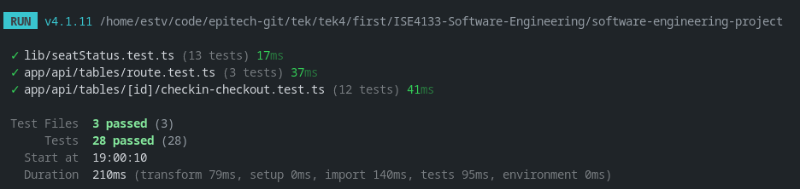
Figure A1. 3 test files, 28 tests passed.

A2 Manual API check — supports S2-AC1, S2-AC2, R1, token check
bash scripts/api_check.sh, run by Esteve BASCUNANA on 2026-10-15 at 19:00 KST, commit d786cca. Full table of expected and actual results: docs/evidence/2026-10-15_api_manual_check.md.
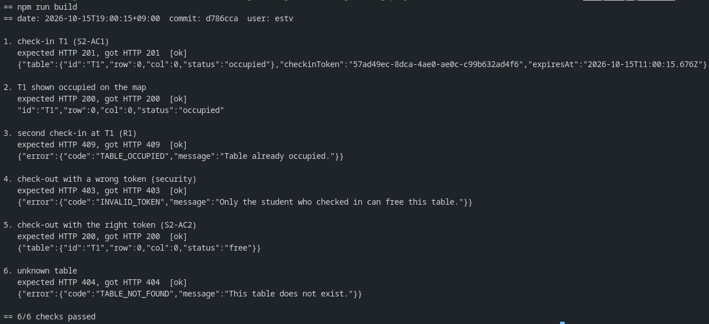
Figure A2. Six requests, expected vs actual HTTP status: 6/6 passed.

A3 UI screenshots — supports S1-AC1, S1-AC2, S2-AC1, S2-AC2, R1, token check
Production build in a browser, run by Adam LARKEM on 2026-10-17, branch feat/c1-map-ui. Steps and expected results: docs/evidence/2026-10-17_c1_ui_check.md.
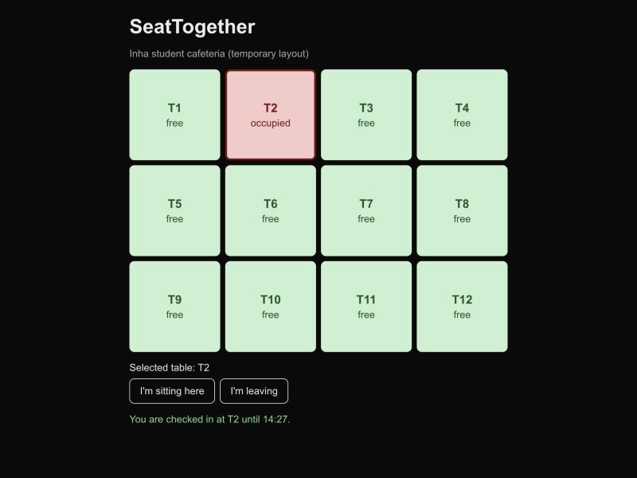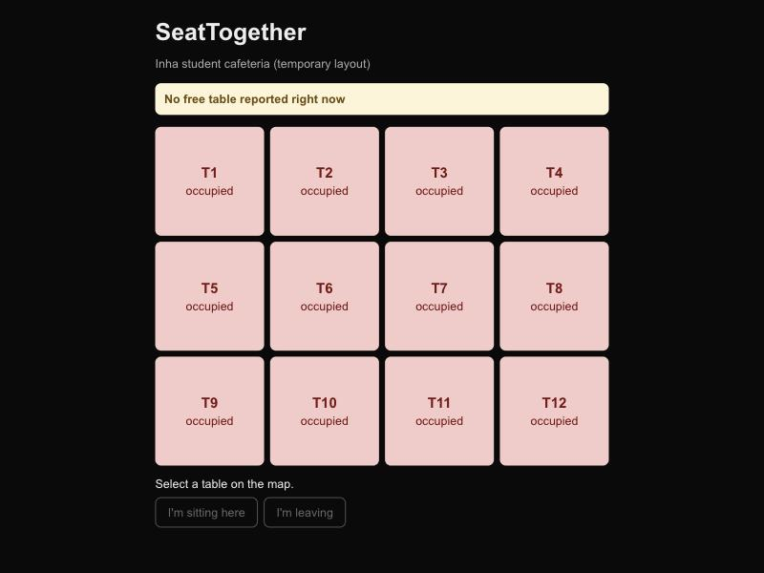
Figure A3a (left). S1-AC1, S2-AC1: after "I'm sitting here" on T2, T2 is occupied and T1 free. Figure A3b (right). S1-AC2: every table occupied, message above the map.
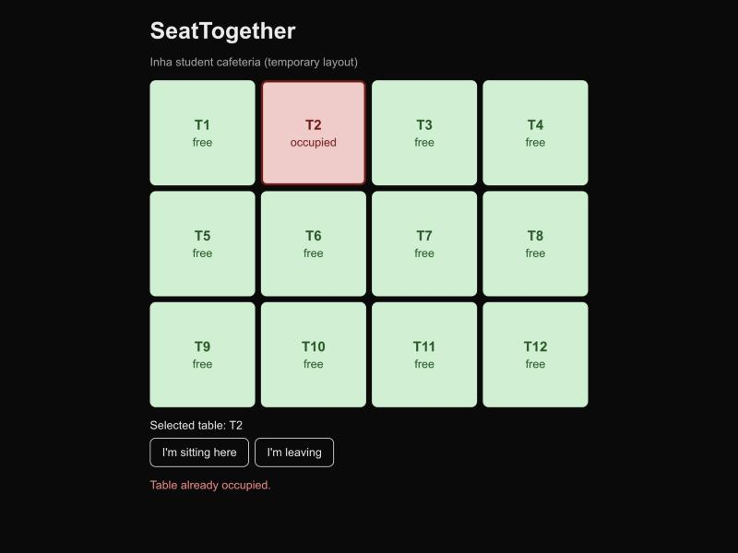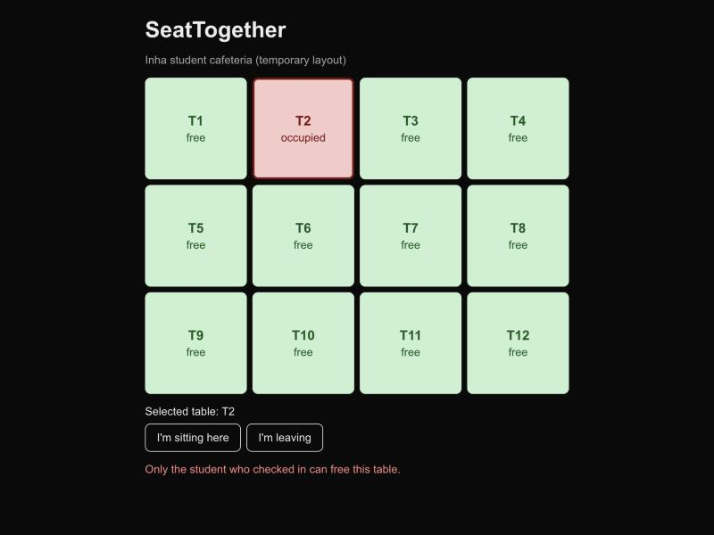
Figure A3c (left). R1: second check-in at T2 refused (409). Figure A3d (right). Check-out with another student's token refused (403); T2 stays occupied.
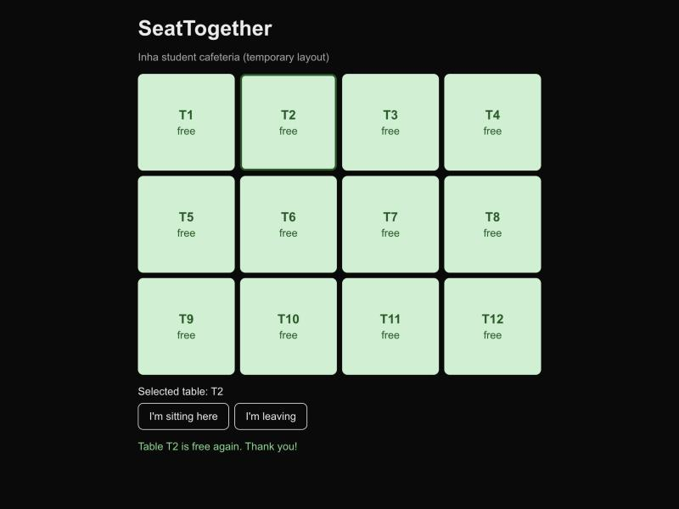
Figure A3e. S2-AC2: after "I'm leaving", T2 is free again.

A4 Links
- Pull requests with review: #5 plan and decisions, #6 API contract, #7 S1 backend, #8 S2 backend. Front-end: #26 C1 map UI and S2 buttons.
- Issues with owners and target dates: milestone "Midterm".

A5 AI use and how we verified it
We used Claude and Claude Code (Anthropic). Every use is logged in AI_USAGE.md (entries 1–9): the purpose, the input, the output, what the AI did not do, and the team's checks.
- What AI produced: drafts of the M2 story slice, Architecture v1, the API contract, the midterm plan and this report's sections 1–5; the backend code and tests; the API check script.
- What the team decided: the product, users and stories (M1), and every option recorded in AI_USAGE: R1, R2, Next.js, the token in the contract, the noFreeTable flag. Where the AI suggested an option we did not take, the log says so.
- How we verified it: Adam reviewed the documents on pull requests and asked for changes (AI_USAGE entries 2, 3, 5); Esteve re-ran the tests and the API check himself (A1, A2). AI output is never reported as user research or as a test result.

