As required in the directions, this contracts evenly splits deposits among three employees and any remaining Wei is returned to sender

Smart Contract: (successfully compiled)

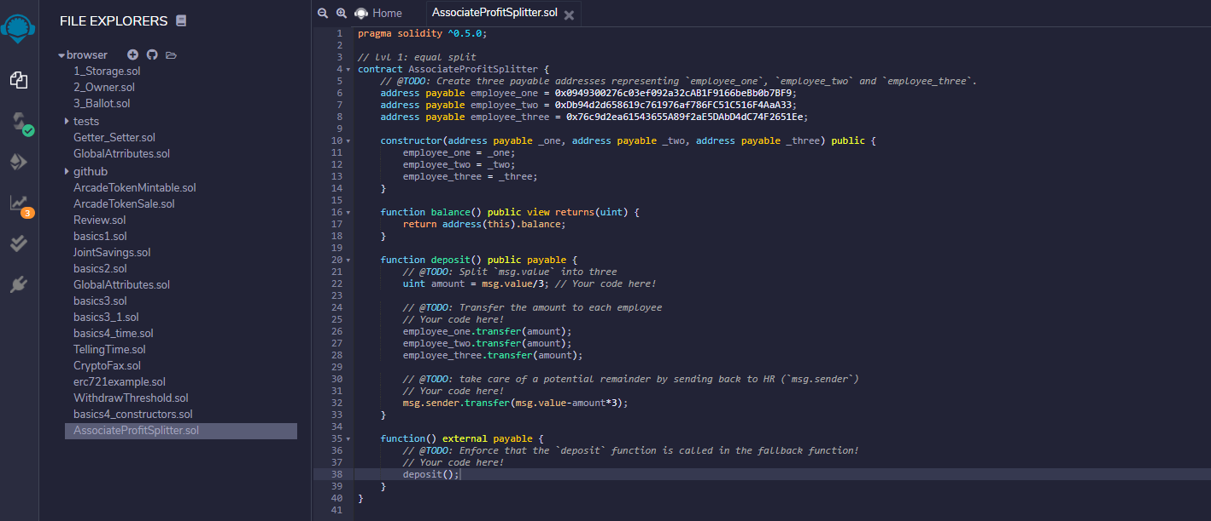

Ganache balances for payable addresses:

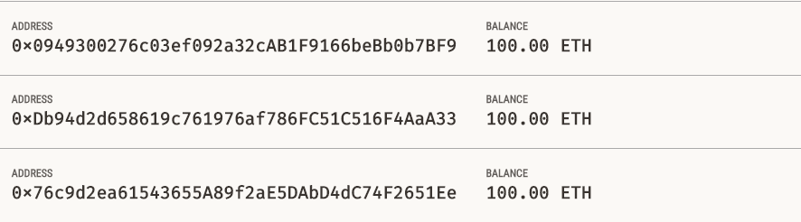

Deploying the contract (Injected Web3)

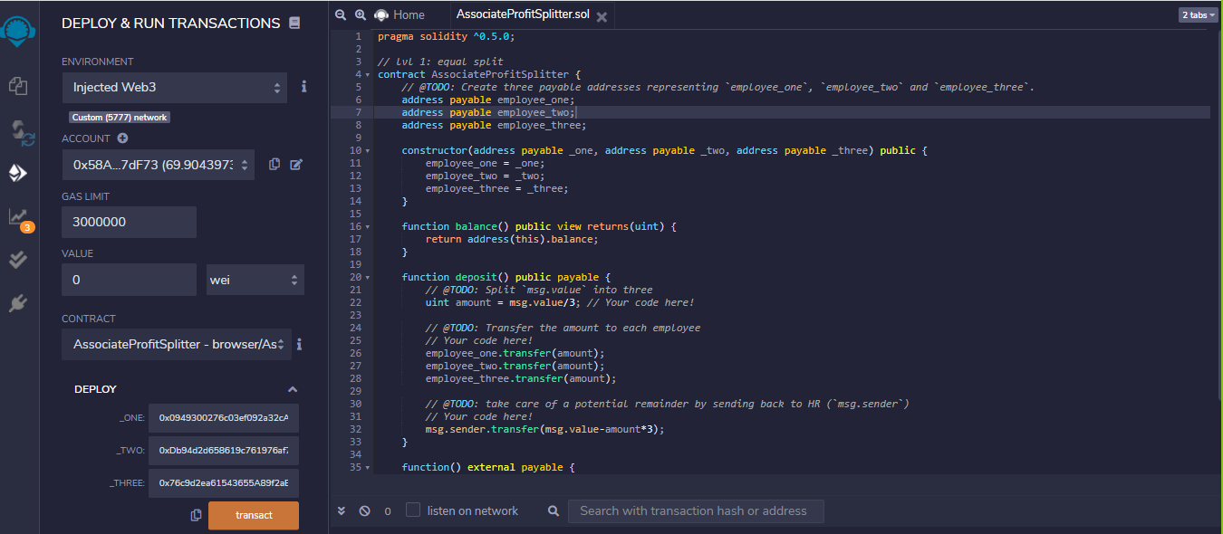

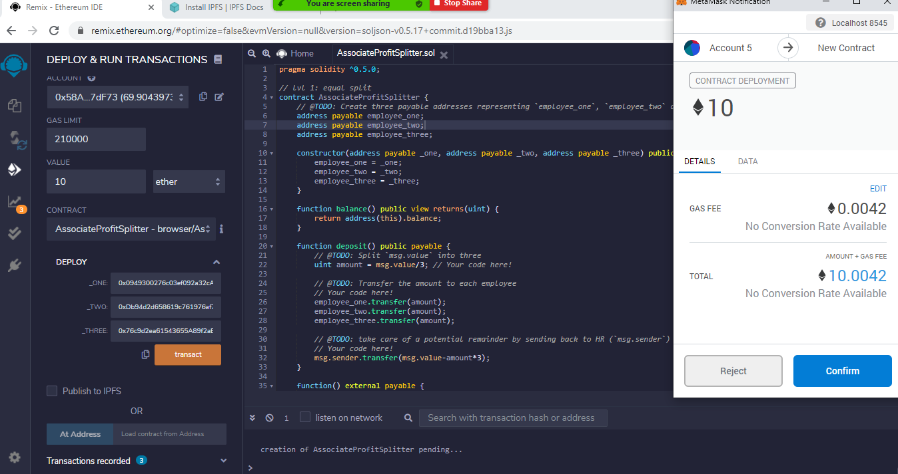

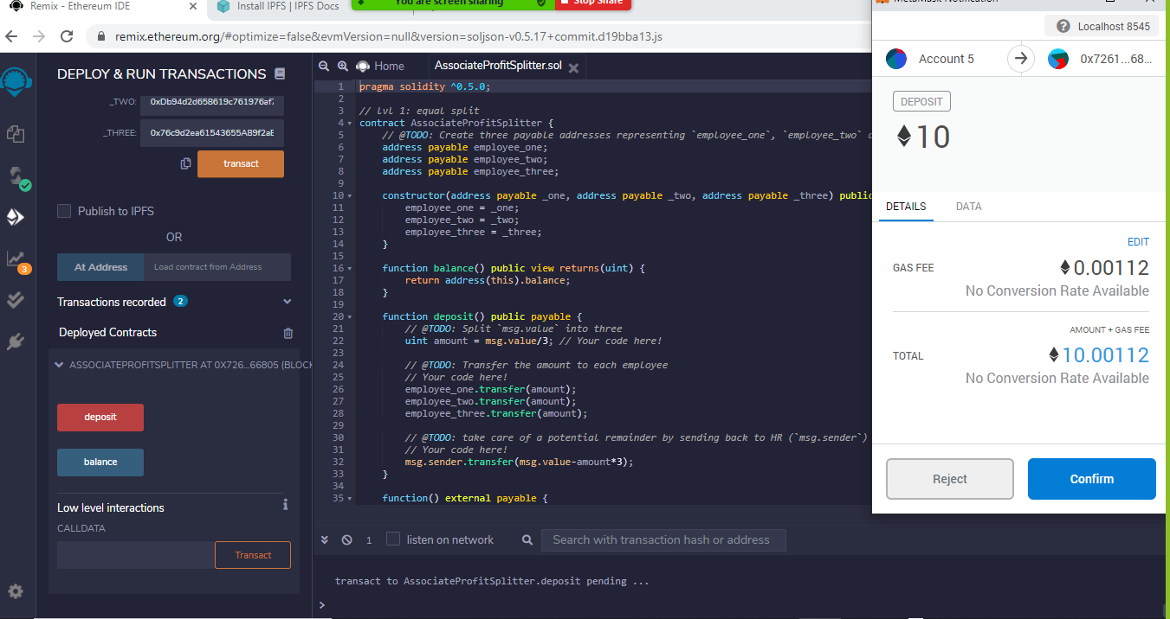

New Ganache Balances

