As required in the directions, this contract calculates the rudimentary percentages for different tiers of employees (CEO, CTO, BoB) and returns any remaining Wei is returned to the employee with the highest percentage

Smart Contract: (successfully compiled)

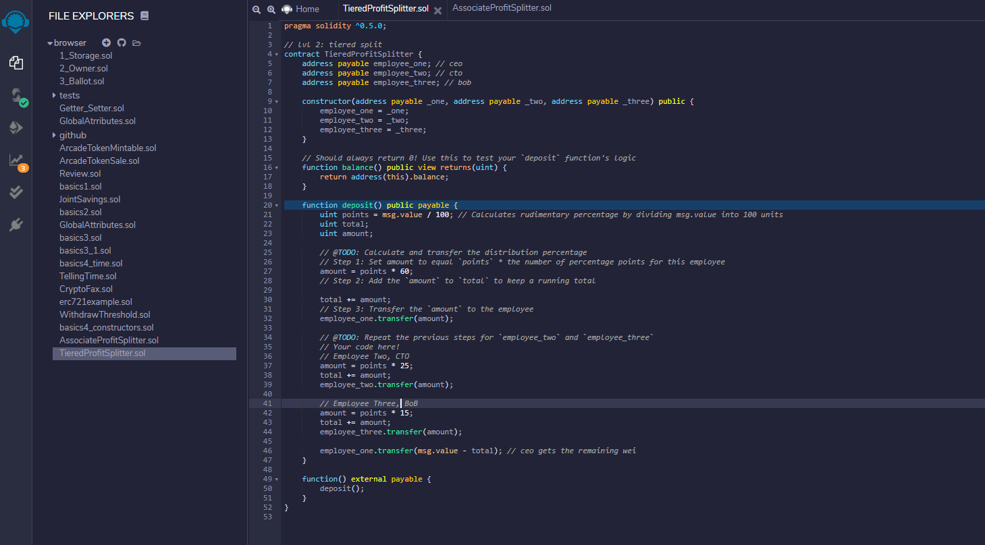

Ganache balances for payable addresses:

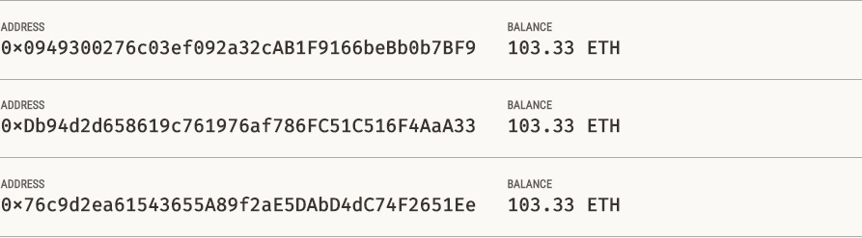

Deploying the contract (Injected Web3) msg.value = 14 ETH

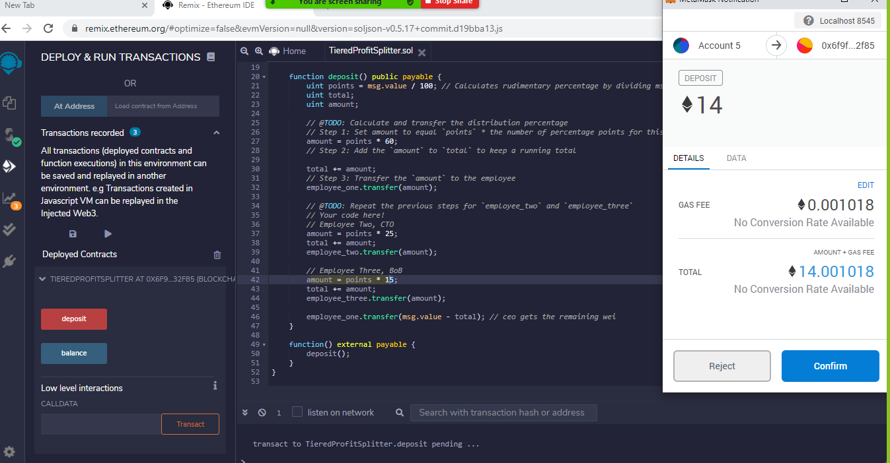

New Ganache

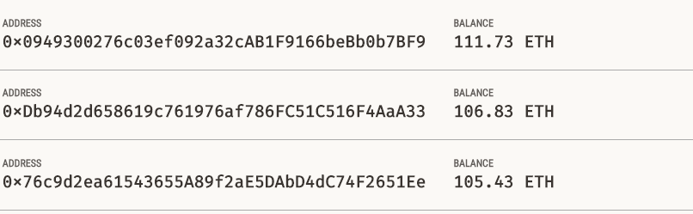

New Ganache Balances