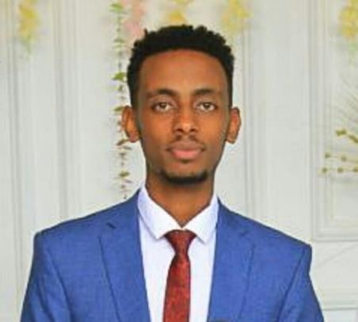Esubalew Bitew Abebe

# Summary

i am Senior Mobile App and Web Developer specializing in full stack development. Experienced with all stages of the development cycle for dynamic (Cross platform) App and web projects. Well-versed in numerous programming languages including HTML5,XML,PHP OOP, JavaScript, CSS, MySQL, Firebase, JAVA,React-Native,React.js,Node.js. I have developed Ethiopian social media **(www.paziyon.com)** and an E- commerce system(**Aseb Mobile Apllication**) and **Ezezu Food Delivery App** Available on Android and ios platforms .Strong background in project management and customer relations.

# Skill Highlights

Contact

* React.js
* React Native
* Angular.js
* Node.js
* Java,C++,
* Web servers :-Apache
* Database: Mysql,Mongo DB
* Android Studio
* Full stack web development
* Full stack Mobile App

development

# Experience

* Solid understanding of

software development

* Dedicated
* Fast learner
* Creative design
* Complex problem solving
* Innovative
* Effective Communication
* Service-focused

Ermias Fentaye

Software Developer [Email:Ermiyas812@gmail.com](mailto:Ermiyas812@gmail.com) Phone: 0939019494

**Mobile app & Web Developer** - 09/2020 to 05/2022

**Boost Software Development**, Bahir Dar



**Address:**

Addis Ababa, Ethiopia

**Phone:**

0943476984

**Email:**

[esubalewbitew13@gmail.com](mailto:esubalewbitew13@gmail.com)

**LinkedIn:**

linkedin.com/in/esubalew-bitew

Languages

Amharic – native English – Advanced

Hobbies

* Codding
* Creativity
* Photography
* Design
* Technology Movie

Reference

* + Cooperate with designers to create clean interfaces and simple, intuitive interactions and experiences.
  + Develop project concepts and maintain optimal workflow.
  + Complete detailed programming and development tasks for full stack public and internal websites as well as challenging back- end server code.

**Cross Platform Mobile Application Developer** - 09/2022 to current

**Ezezu Commerce,** Addis Ababa

* + - Developed and maintained React Native component, screens, and features for the mobile apps.

# Education

**Bahir Dar University**

**BSc**: **Electrical Engineering (Communication Stream)** | Aug, 2022

**CGPA: 3.55**

# Certifications

* + Mobile App Development(React Native):Bahir Dar university,ICT4D
  + Course Completion of Node.js : Simplilearn
  + Devops :ZergawISP
  + Course Completion React.js : Simplilearn
  + Cyberopps Association : Cisco Network Academy

•