Getting current main working.

This demo is how to get the current version of UniTrail functioning correctly on windows machines.

# Create and activate a student unity profile:

We want a unity profile with a student ID activated to get Unity pro or whatever they call the best version\

# Download and open Unity launcher:

Then activate your student license.

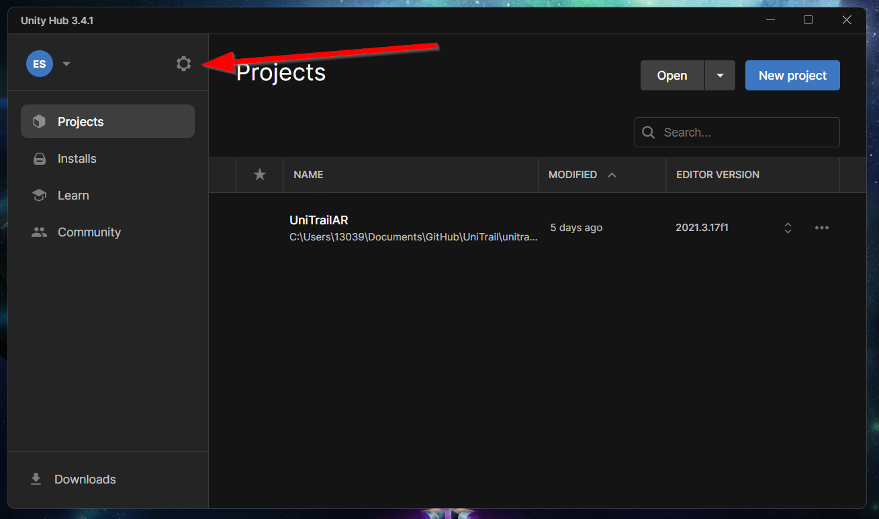

Select add license and add you license you got emailed to you

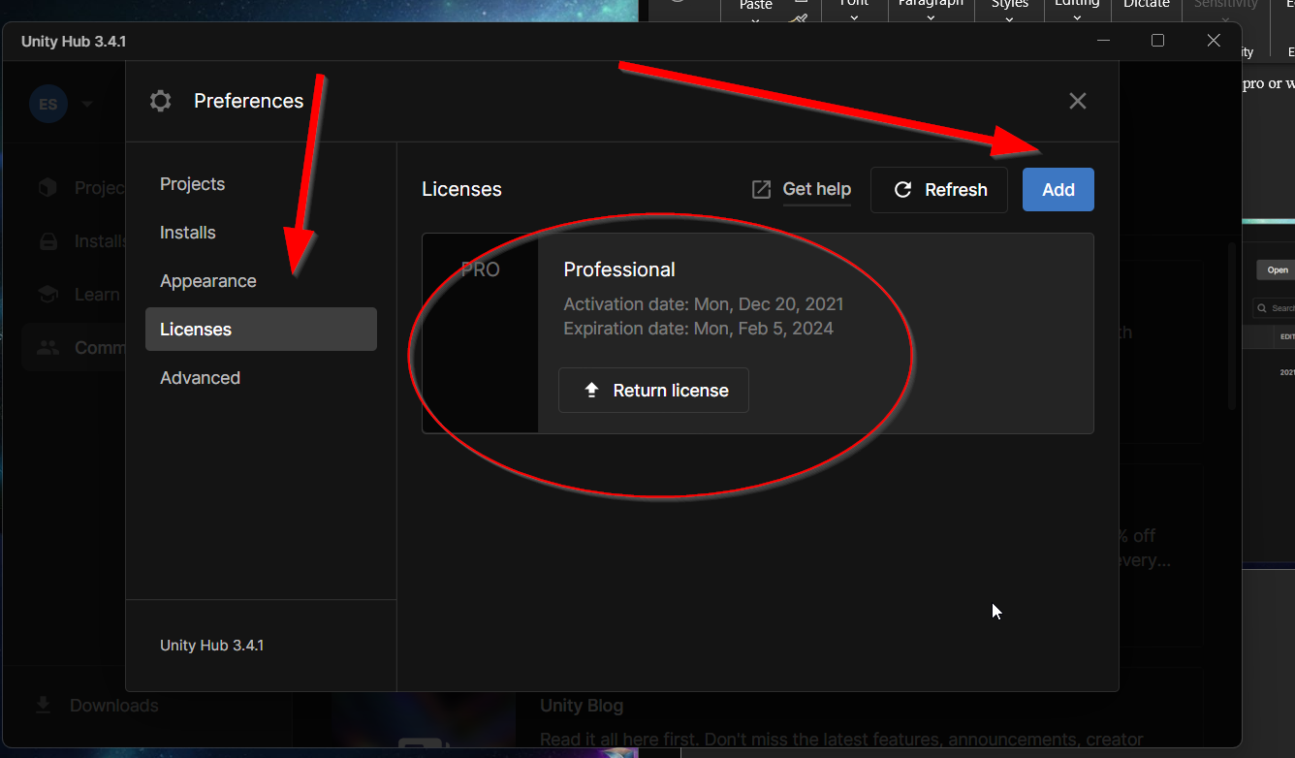

This should be the license you are working on

# Download unity editor version: 2021.3.17f1

You will need to select more as this version will not populate in unity hub automatically but it can be found unity website.

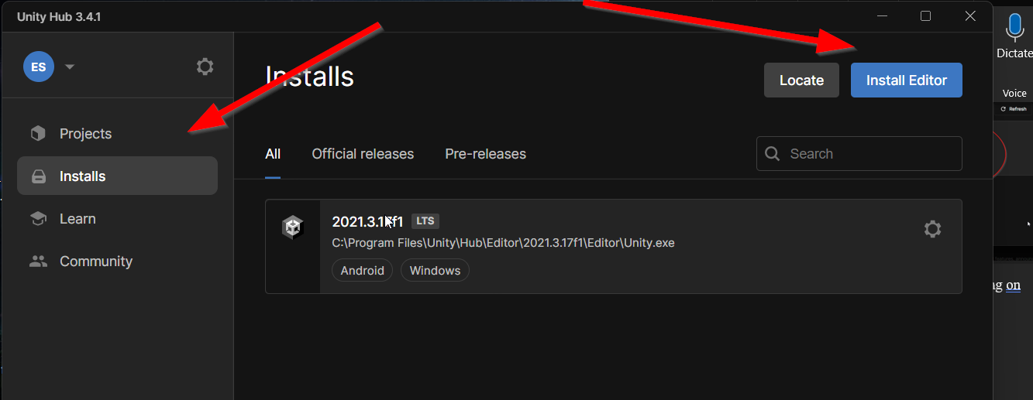

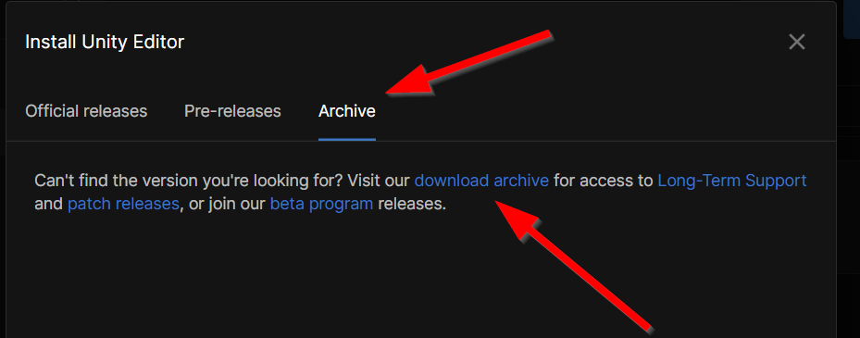

Allow this to install entirely including VisualStudio!

# VisualStudio add ins.

Inside visual studio we have some additional tools we need to interface with the windows kernel.

Make sure to add these tools, they are utilized by Unity.

# Open our project the unity version you just downloaded.

Make sure you have the current version of main on your local machine and through the unity hub open our project.

The unity file will be inside of the unitrail flutter project here:

open this folder.

# Set target machine to Android device:

Inside of the editor after opening the project we need to set the target device to an Android device:

When selected if any downloads are necessary complete those and switch to android platform (This is so we can utilize the android emulator)

# Flutter export from unity.

Next we will select the flutter top tab drop menu and export the project to flutter.

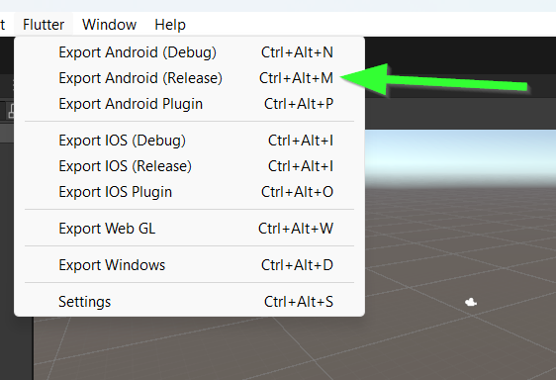

I recommend the release export, the debug is notorious for breaking builds on emulators.

# Modify Local Properties

Open the local.properties file this will be inside of the android folder inside the unitrail flutter project folder.

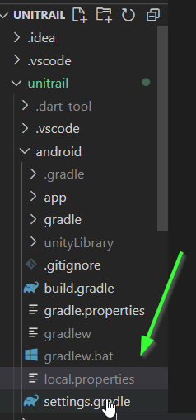

Make sure these paths are pointing to correct and working locations for unity to work

# Run and debug

At this point you should be ready to flutter run the project and successfully run in the emulator. (Remember the views will not work on emulator but we should be able to load the app)