GIT

Aliases git config --global alias.co checkout
git config --global alias.ci commit
git config --global alias.st status
git config --global alias.br branch
git config --global alias.up "pull --rebase"
git config --global alias.lol "log --graph --decorate --oneline"
git config --global alias.unadd "reset HEAD --"

git config --global user.name <user name> Set up user-name

git config --global user.email <email> Set up email-address

git config --global color.ui true Nice command line colours

git init Initialize local git repository
git status check current status
git add <filename> Start tracking changes made to a file

git add --all Adds all new or modified files

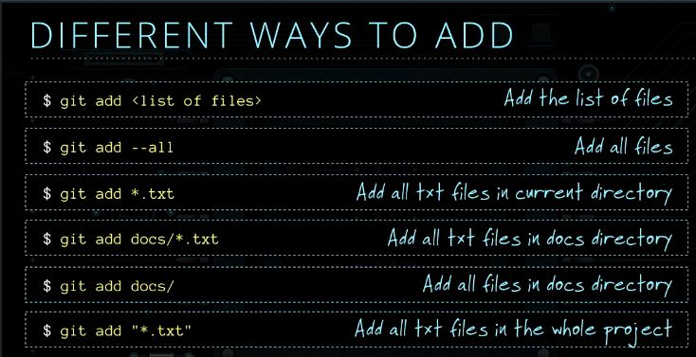
git commit Store staged changes in your local repository. Creates a new index on the timeline.
git commit -m <comment> Add a comment to your commit
git log Think of the log as a journal that remembers all the changes we've committed in the order we committed them.
git log --pretty=oneline Snyggare sätt att visa loggen
git remote add <name> <location> To push our local repo to the GitHub server we'll need to add a remote repository.
git push -u <origin> <master> The name of our remote is origin and the default local branch name is master. The -u tells Git to remember the parameters, so that next time we can simply run git push and Git will know what to do.
git push origin <br-name> Push a newly created branch to the remote repo origin.
git pull <origin> <master> To check for changes on our GitHub repository "origin" and pull down any new changes
git pull When you use pull, Git tries to automatically do your work for you. It is context sensitive, so Git will merge any pulled commits into the branch you are currently working in. pull automatically merges the commits without letting you review them first. If you don’t closely manage your branches you may run into frequent conflicts.
git fetch When you fetch, Git gathers any commits from the target branch that do not exist in your current branch and stores them in your local repository. However, it does not merge them with your current branch. This is particularly useful if you need to keep your repository up to date, but are working on something that might break if you update your files. To integrate the commits into your master branch, you use merge.

git push <origin> --delete <branch> Delete a remote branch
git remote prune <origin> After someone deletes a branch from a remote repository, git will not automatically delete the local repository branches when a user does a git pull or git fetch. However, if the user would like to have all tracking branches removed from their local repository that have been deleted in a remote repository they can use prune.
gitt diff HEAD Take a look at what is different from our last commit by using the git diff command.
In this case we want the diff of our most recent commit, which we can refer to using the HEAD pointer.
git diff --staged Run git diff with the --staged option to see the changes you just staged
git reset <file-name> You can unstage files by using the git reset command.

git checkout -- <target> you can change back to how files were at the last commit by using this command. Go ahead get rid of all the changes since the last commit for the file specified as target here.
git branch list which branch you've got.

git branch <branch name> Create a branch.
When developers are working on a feature or bug they'll often create a copy (aka. branch) of their code they can make separate commits to. Then when they're done they can merge this branch back into their main master branch.
git checkout -b <branch-name> Create and checkout a new branch
Short for:
$ git branch <br-name>
$ git checkout <br-name>

git checkout <branch name> Switch branches

git rm <filename> git rm command will not only remove the actual files from disk, but will also stage the removal of the files for us.

git merge <branch-name> Stand in the branch you want to merge to (master).
Change branch with "git checkout <br-name>" Merge your changes from the other branch into the master branch.

git branch -d <-D><branch name> Delete a branch.

git clone <repo> Copies an existing Git repository. It has its own history, manages its own files and is a completely isolated environment from the original repository.
As a convenience, cloning automatically creates a remote connection called origin pointing back to the original repository. This makes it very easy to interact with a central repository.

git clone <repo> <directory> Clone the repository located at <repo> into the folder called <directory> on the local machine.
git init --bare <project> Creates a bare repo. No working directory created. You should not work on the files at the repo site so the files are only located in .git/objects database.

git clone ssh://john@example.com/path_to_my-project.git
The first command initializes a new Git repository in the my-project folder on your local machine and populates it with the contents of the central repository. Then, you can cd into the project and start editing files, committing snapshots, and interacting with other repositories. Also note that the .git extension is omitted from the cloned repository. This reflects the non-bare status of the local copy.
git show Reports the changes introduced by the most recent commit. Shows both the commit and the difference between the commit and any parent commit.
git show <branch>:<filename> Display the file in the specified branch.
git ls-files -u Another way to see which files need merging
git show :1:<filename> Show the first version of the file
git show :2:<filename> Show the second version of the file
git stash 1) Saves your working directory and index to a safe place and
2) Restores your working directory and index to the most recent commit.
You can then work on other branches, make commits, etc. and when you’re ready to get back to where you were, you type git stash pop and you’re back, working at full speed.
--pretty[=<format>] Pretty-print the contents of the commit logs in a given format, where <format> can be one of oneline, short, medium, full, fuller, email, raw and format:<string>

--format=<format> See format concept below
git tag List tags
git tag -a <tag-name> Create an annotated tag with a comment
git tag <tag-name> Create a lightweight tag

git push origin <tagname> Share a tag to the remote repo
git push origin --tags Share all tags to remote repo
git show [options] <object> Shows one or more objects
(blobs, trees, tags and commits).
For commits it shows the log message and textual diff. It also presents the merge commit in a special format as produced by git diff-tree --cc.
For tags, it shows the tag message and the referenced objects.
For trees, it shows the names (equivalent to git ls-tree with --name-only).
For plain blobs, it shows the plain contents.
The command takes options applicable to the git diff-tree command to control how the changes the commit introduces are shown.

GIT Concepts

HEAD http://www.gitguys.com/topics/head-where-are-we-where-were-we/
Git uses the HEAD variable, which by default, is a reference to the current (most recent) commit.
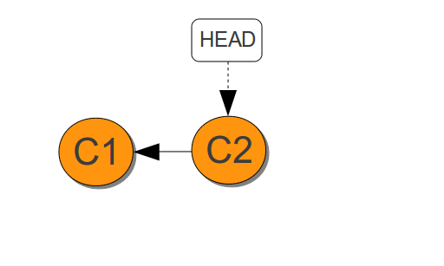
Adding commits changes HEAD
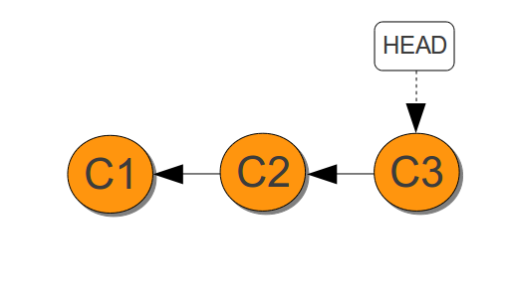
Many git commands, such as git log and git show use HEAD as the commit to report on. However, you can specify a different the parent commit for git show to report on by using the ~ character (“tilde”).
For example, to show the commit from the parent of HEAD (which is the parent of the most recent commit), you use HEAD~
Or to refer to the commit before HEAD~ (which is the very first commit made to the repository), you can use either HEAD~~ or HEAD~2
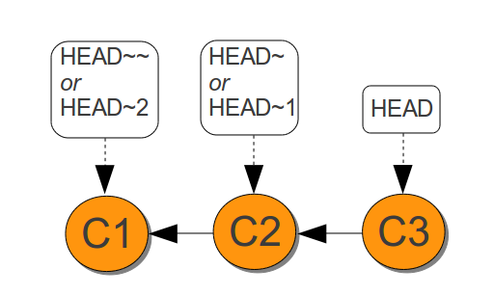
The contents of the git HEAD variable is stored in a text file in the .git/HEAD
# cat .git/HEAD
ref: refs/heads/master
TAGS Git uses two main types of tags: lightweight and annotated.
A lightweight tag is very much like a branch that doesn’t change — it’s just a pointer to a specific commit.
Annotated tags, however, are stored as full objects in the Git database. They’re checksummed; contain the tagger name, e-mail, and date; have a tagging message; and can be signed and verified with GNU Privacy Guard (GPG). It’s generally recommended that you create annotated tags so you can have all this information; but if you want a temporary tag or for some reason don’t want to keep the other information, lightweight tags are available too.
FORMATS Note: you can specify the default pretty format in the repository configuration (see git-config(1)).

--abbrev-commit Instead of showing the full 40-byte hexadecimal commit object name, show only a partial prefix. Non default number of digits can be specified with "--abbrev=<n>" (which also modifies diff output, if it is displayed).
This should make "--pretty=oneline" a whole lot more readable for people using 80-column terminals.

--no-abbrev-commit Show the full 40-byte hexadecimal commit object name. This negates --abbrev-commit and those options which imply it such as "--oneline". It also overrides the log.abbrevCommit variable.

--oneline This is a shorthand for "--pretty=oneline --abbrev-commit" used together.

--encoding=<encoding> The commit objects record the encoding used for the log message in their encoding header; this option can be used to tell the command to re-code the commit log message in the encoding preferred by the user. For non plumbing commands this defaults to UTF-8.

--notes[=<ref>] Show the notes (see git-notes(1)) that annotate the commit, when showing the commit log message. This is the default for git log, git show and git whatchanged commands when there is no --pretty, --format nor --oneline option given on the command line.

By default, the notes shown are from the notes refs listed in the core.notesRef and notes.displayRef variables (or corresponding environment overrides). See git-config(1) for more details.

With an optional <ref> argument, show this notes ref instead of the default notes ref(s). The ref is taken to be in refs/notes/ if it is not qualified.

Multiple --notes options can be combined to control which notes are being displayed. Examples: "--notes=foo" will show only notes from "refs/notes/foo"; "--notes=foo --notes" will show both notes from "refs/notes/foo" and from the default notes ref(s).

--no-notes Do not show notes. This negates the above --notes option, by resetting the list of notes refs from which notes are shown. Options are parsed in the order given on the command line, so e.g. "--notes --notes=foo --no-notes --notes=bar" will only show notes from "refs/notes/bar".

--show-notes[=<ref>]
--[no-]standard-notes These options are deprecated. Use the above --notes/--no-notes options instead.

--show-signature Check the validity of a signed commit object by passing the signature to gpg --verify and show the output.

LINKS
Bra Sida http://www.gitguys.com/
GIT Reference Manual http://git-scm.com/doc
Interaktiv Git kurs http://try.github.io/

