UAT: MultipleTables coloretal: OR

Jiajie Chen, Xiao Su

2022-12-29

# Enviroment setup

Load colorectal

rm(list = ls())  
knitr::opts_chunk$set(echo = TRUE)  
source_all_files <- function(path){  
 files <- list.files(path)  
 for(i in 1:length(files)){  
 full_path <- paste(path, files[i],sep="")  
 source(full_path)  
 }  
}  
### Load the new version  
library(ggplot2)

## Warning: package 'ggplot2' was built under R version 4.2.2

new_verrsion_path <- 'G:/My Drive/ShareFolder/mmeta_package/working/new_mmeta_dev/func_dev/'  
source_all_files(new_verrsion_path)  
load('G:/My Drive/ShareFolder/mmeta_package/working/mmeta/data/colorectal.rda')

# Test sampling method

## Create object

* load the data:
  + here use colorectal as example
  + input data is a data frame.
  + the input data frame should contain the following columns:
    - y1
    - n1
    - y2
    - n2
* specify model
* specify measure

colorectal['study_name'] <- colorectal['studynames']  
multiple_tables_obj_sampling <- MultipleTables.create(data=colorectal, measure='OR', model= 'Sarmanov')

### model fit

* estimate the hyper parameters via maximum likelihood
* draw posterior samples for each study
* calculate posterior density for each study
* likelihood ratio test for correlation

default:

multiple_tables_obj_sampling <- MultipleTables.modelFit(multiple_tables_obj_sampling, method = 'sampling')

control list can be specified to control the fitting process: * n_samples: number of posterior samples; Defualt is 5000. * mcmc_initial: initial values for (p1, p2) in MCMC; Default is c(0.5, 0.5) * upper_bound: upper bound for the measure. Default is 100. * lower_bound: lower bound for the measure. For RD, default is -1. For RR/OR, defualt is 0. * num_grids: number of grids to calculate density; The defualt is 20498. * optim_method: optimazation method. Default is “L-BFGS-B”. Please refer to ‘optim’ function. * maxit = maximum number of iterations for iteration. Default is 1000. Please refer to ‘optim’ function., * initial_values: initial value for optimization. The default approach is to fit overdispertion beta-bin model to generate initial value via aod package.

set number of posterior samples is 5000

multiple_tables_obj_sampling <- MultipleTables.modelFit(multiple_tables_obj_sampling, method = 'sampling',   
 control = list(n_samples = 3000))

set intial values correspoinding to c(a1, b1, a2, b2, rho) as c(1,1,1,1,0):

multiple_tables_obj_sampling <- MultipleTables.modelFit(multiple_tables_obj_sampling, method = 'sampling',   
 control = list(initial_values = c(1,1,1,1,0)))

maximum number of iterations for iteration is 100

multiple_tables_obj_sampling <- MultipleTables.modelFit(multiple_tables_obj_sampling, method = 'sampling',   
 control = list(maxit = 100))

maximum number of iterations for iteration is 100 and number of posterior samples as 3000

multiple_tables_obj_sampling <- MultipleTables.modelFit(multiple_tables_obj_sampling, method = 'sampling',   
 control = list(maxit = 100, nsamples = 3000))

## Summary

* Estimate overall measure (point and confidence interval)
* Estimate study-specific measure(point and confidence interval)

default

multiple_tables_obj_sampling <- MultipleTables.summary(multiple_tables_obj_sampling)

## Model: Sarmanov Beta-Binomial Model  
## THe overall Odds Ratio  
## Estimate: 1.099  
## 95% confident interval: [0.704,1.717]  
##   
## Maximum likelihood estimates of hyperparameters:  
## a1 =3.106, b1 =2.91, a2 =3.944, b2 =3.362, rho =0.125  
## Likelihood ratio test for within-group correlation (H0: rho=0):  
## chi2: 3.152; p-value: 0.076  
##   
## Study-SpecifcOdds Ratio:  
## Mean Lower Upper  
## Ilett 3.544 1.480 7.246  
## Ilett1 1.749 0.756 3.580  
## Wohlleb 2.458 0.983 5.246  
## Ladero 1.196 0.682 1.967  
## Rodriguez 1.080 0.404 2.294  
## Lang 0.984 0.462 1.859  
## Oda 1.140 0.256 3.237  
## Shibuta 1.091 0.766 1.499  
## Bell 1.160 0.707 1.799  
## Spurr 0.890 0.494 1.509  
## Hubbard 0.851 0.604 1.164  
## Welfare 1.018 0.657 1.506  
## Gil 1.272 0.750 1.976  
## Chen 0.830 0.560 1.204  
## Lee 1.047 0.660 1.580  
## Yoshika 0.892 0.277 2.113  
## Potter 0.987 0.707 1.347  
## Slattery 1.913 1.668 2.187  
## Agundez 1.193 0.766 1.785  
## Butler 1.055 0.656 1.628

alpha = 0.1

MultipleTables.summary(multiple_tables_obj_sampling, alpha = 0.1)

## Model: Sarmanov Beta-Binomial Model  
## THe overall Odds Ratio  
## Estimate: 1.099  
## 90% confident interval: [0.756,1.598]  
##   
## Maximum likelihood estimates of hyperparameters:  
## a1 =3.106, b1 =2.91, a2 =3.944, b2 =3.362, rho =0.125  
## Likelihood ratio test for within-group correlation (H0: rho=0):  
## chi2: 3.152; p-value: 0.076  
##   
## Study-SpecifcOdds Ratio:  
## Mean Lower Upper  
## Ilett 3.544 1.656 6.411  
## Ilett1 1.749 0.854 3.053  
## Wohlleb 2.458 1.112 4.567  
## Ladero 1.196 0.742 1.795  
## Rodriguez 1.080 0.473 2.001  
## Lang 0.984 0.510 1.643  
## Oda 1.140 0.321 2.605  
## Shibuta 1.091 0.812 1.427  
## Bell 1.160 0.762 1.671  
## Spurr 0.890 0.537 1.357  
## Hubbard 0.851 0.637 1.106  
## Welfare 1.018 0.707 1.408  
## Gil 1.272 0.815 1.835  
## Chen 0.830 0.597 1.129  
## Lee 1.047 0.714 1.472  
## Yoshika 0.892 0.334 1.814  
## Potter 0.987 0.739 1.283  
## Slattery 1.913 1.714 2.138  
## Agundez 1.193 0.824 1.658  
## Butler 1.055 0.704 1.523

set digit = 4

MultipleTables.summary(multiple_tables_obj_sampling, alpha = 0.05, digit = 4)

## Model: Sarmanov Beta-Binomial Model  
## THe overall Odds Ratio  
## Estimate: 1.0992  
## 95% confident interval: [0.7038,1.7168]  
##   
## Maximum likelihood estimates of hyperparameters:  
## a1 =3.1057, b1 =2.9104, a2 =3.9439, b2 =3.3623, rho =0.1249  
## Likelihood ratio test for within-group correlation (H0: rho=0):  
## chi2: 3.1522; p-value: 0.0758  
##   
## Study-SpecifcOdds Ratio:  
## Mean Lower Upper  
## Ilett 3.5441 1.4797 7.2461  
## Ilett1 1.7486 0.7562 3.5800  
## Wohlleb 2.4584 0.9831 5.2461  
## Ladero 1.1956 0.6824 1.9667  
## Rodriguez 1.0801 0.4039 2.2942  
## Lang 0.9838 0.4623 1.8590  
## Oda 1.1398 0.2561 3.2374  
## Shibuta 1.0913 0.7663 1.4990  
## Bell 1.1599 0.7072 1.7991  
## Spurr 0.8896 0.4942 1.5089  
## Hubbard 0.8514 0.6036 1.1640  
## Welfare 1.0181 0.6571 1.5061  
## Gil 1.2725 0.7496 1.9761  
## Chen 0.8296 0.5601 1.2041  
## Lee 1.0474 0.6596 1.5795  
## Yoshika 0.8923 0.2774 2.1129  
## Potter 0.9872 0.7072 1.3474  
## Slattery 1.9131 1.6685 2.1865  
## Agundez 1.1925 0.7661 1.7855  
## Butler 1.0553 0.6560 1.6278

not print out

MultipleTables.summary(multiple_tables_obj_sampling, alpha = 0.05, digit = 4,  
 verbose = FALSE)

## Strucutre of MultipleTables objects

str(multiple_tables_obj_sampling)

## List of 15  
## $ data :'data.frame': 20 obs. of 6 variables:  
## ..$ y1 : num [1:20] 10 19 13 40 13 92 33 151 50 34 ...  
## ..$ y2 : num [1:20] 27 27 23 49 20 14 33 112 96 32 ...  
## ..$ n1 : num [1:20] 41 45 41 96 28 205 36 329 112 96 ...  
## ..$ n2 : num [1:20] 49 49 43 109 44 34 36 234 202 103 ...  
## ..$ studynames: chr [1:20] "Ilett" "Ilett1" "Wohlleb" "Ladero" ...  
## ..$ study_name: chr [1:20] "Ilett" "Ilett1" "Wohlleb" "Ladero" ...  
## $ measure : chr "OR"  
## $ model : chr "Sarmanov"  
## $ alpha : num 0.05  
## $ chi2_value : num 3.15  
## $ p_value : num 0.0758  
## $ prior_mle : Named num [1:5] 3.106 2.91 3.944 3.362 0.125  
## ..- attr(*, "names")= chr [1:5] "a1" "b1" "a2" "b2" ...  
## $ hessian_log : num [1:5, 1:5] -3.61e+01 3.00e+01 3.49 -3.56 6.37e-06 ...  
## ..- attr(*, "dimnames")=List of 2  
## .. ..$ : chr [1:5] "loga1" "logb1" "loga2" "logb2" ...  
## .. ..$ : chr [1:5] "loga1" "logb1" "loga2" "logb2" ...  
## $ cov_matrix_log : num [1:5, 1:5] 0.113158 0.102589 0.000426 -0.00048 -0.001897 ...  
## $ overall_measure_estimation:List of 2  
## ..$ point : num 1.1  
## ..$ confindent_interval: Named num [1:2] 0.704 1.717  
## .. ..- attr(*, "names")= chr [1:2] "lower" "upper"  
## $ specific_summary :'data.frame': 20 obs. of 7 variables:  
## ..$ study_name: chr [1:20] "Ilett" "Ilett1" "Wohlleb" "Ladero" ...  
## ..$ mean : num [1:20] 3.54 1.75 2.46 1.2 1.08 ...  
## ..$ median : num [1:20] 3.21 1.62 2.25 1.15 0.98 ...  
## ..$ ET_lower : num [1:20] 1.48 0.756 0.983 0.682 0.404 0.462 0.256 0.766 0.707 0.494 ...  
## ..$ ET_upper : num [1:20] 7.25 3.58 5.25 1.97 2.29 ...  
## ..$ HRD_lower : num [1:20] 1.179 0.617 0.82 0.629 0.315 ...  
## ..$ HRD_upper : num [1:20] 6.51 3.13 4.72 1.86 2.04 ...  
## $ samples :List of 20  
## ..$ Ilett : Named num [1:5000] 1.63 1.23 1.32 1.05 1.04 ...  
## .. ..- attr(*, "names")= chr [1:5000] "" "" "" "" ...  
## ..$ Ilett1 : Named num [1:5000] 1.67 1.56 1.35 1.22 1.27 ...  
## .. ..- attr(*, "names")= chr [1:5000] "" "" "" "" ...  
## ..$ Wohlleb : Named num [1:5000] 0.978 1.797 1.935 1.619 2.009 ...  
## .. ..- attr(*, "names")= chr [1:5000] "" "" "" "" ...  
## ..$ Ladero : Named num [1:5000] 0.956 0.861 0.869 0.825 0.639 ...  
## .. ..- attr(*, "names")= chr [1:5000] "" "" "" "" ...  
## ..$ Rodriguez: Named num [1:5000] 1.657 0.652 0.474 1.011 1.614 ...  
## .. ..- attr(*, "names")= chr [1:5000] "" "" "" "" ...  
## ..$ Lang : Named num [1:5000] 0.699 0.833 0.763 0.804 0.829 ...  
## .. ..- attr(*, "names")= chr [1:5000] "" "" "" "" ...  
## ..$ Oda : Named num [1:5000] 2.699 2.068 0.608 0.617 0.646 ...  
## .. ..- attr(*, "names")= chr [1:5000] "" "" "" "" ...  
## ..$ Shibuta : Named num [1:5000] 0.981 0.925 0.916 1.417 1.385 ...  
## .. ..- attr(*, "names")= chr [1:5000] "" "" "" "" ...  
## ..$ Bell : Named num [1:5000] 1.115 0.936 0.915 1.33 0.905 ...  
## .. ..- attr(*, "names")= chr [1:5000] "" "" "" "" ...  
## ..$ Spurr : Named num [1:5000] 0.589 0.77 0.703 0.701 0.931 ...  
## .. ..- attr(*, "names")= chr [1:5000] "" "" "" "" ...  
## ..$ Hubbard : Named num [1:5000] 0.641 0.625 0.712 0.943 0.893 ...  
## .. ..- attr(*, "names")= chr [1:5000] "" "" "" "" ...  
## ..$ Welfare : Named num [1:5000] 1.101 0.731 1.471 1.088 1.125 ...  
## .. ..- attr(*, "names")= chr [1:5000] "" "" "" "" ...  
## ..$ Gil : Named num [1:5000] 2.333 2.001 0.881 1.013 1.314 ...  
## .. ..- attr(*, "names")= chr [1:5000] "" "" "" "" ...  
## ..$ Chen : Named num [1:5000] 0.631 0.839 0.774 0.913 0.713 ...  
## .. ..- attr(*, "names")= chr [1:5000] "" "" "" "" ...  
## ..$ Lee : Named num [1:5000] 0.324 0.244 1.206 1.165 1.056 ...  
## .. ..- attr(*, "names")= chr [1:5000] "" "" "" "" ...  
## ..$ Yoshika : Named num [1:5000] 0.0449 0.0364 0.1712 0.1165 0.0272 ...  
## .. ..- attr(*, "names")= chr [1:5000] "" "" "" "" ...  
## ..$ Potter : Named num [1:5000] 1.101 1.001 1.087 0.96 0.768 ...  
## .. ..- attr(*, "names")= chr [1:5000] "" "" "" "" ...  
## ..$ Slattery : Named num [1:5000] 1.06 1.52 1.41 1.41 1.62 ...  
## .. ..- attr(*, "names")= chr [1:5000] "" "" "" "" ...  
## ..$ Agundez : Named num [1:5000] 0.978 1.115 1.225 1.375 1.227 ...  
## .. ..- attr(*, "names")= chr [1:5000] "" "" "" "" ...  
## ..$ Butler : Named num [1:5000] 1.145 0.651 0.998 0.921 0.84 ...  
## .. ..- attr(*, "names")= chr [1:5000] "" "" "" "" ...  
## $ density :List of 20  
## ..$ Ilett :List of 2  
## .. ..$ x: num [1:2048] 0 0.0489 0.0977 0.1466 0.1954 ...  
## .. ..$ y: num [1:2048] 1.88e-07 4.87e-07 1.21e-06 2.86e-06 6.50e-06 ...  
## ..$ Ilett1 :List of 2  
## .. ..$ x: num [1:2048] 0 0.0489 0.0977 0.1466 0.1954 ...  
## .. ..$ y: num [1:2048] 1.38e-05 5.44e-05 1.80e-04 5.08e-04 1.23e-03 ...  
## ..$ Wohlleb :List of 2  
## .. ..$ x: num [1:2048] 0 0.0489 0.0977 0.1466 0.1954 ...  
## .. ..$ y: num [1:2048] 7.57e-06 2.06e-05 5.17e-05 1.21e-04 2.64e-04 ...  
## ..$ Ladero :List of 2  
## .. ..$ x: num [1:2048] 0 0.0489 0.0977 0.1466 0.1954 ...  
## .. ..$ y: num [1:2048] 4.51e-17 2.08e-14 8.79e-12 1.51e-09 1.08e-07 ...  
## ..$ Rodriguez:List of 2  
## .. ..$ x: num [1:2048] 0 0.0489 0.0977 0.1466 0.1954 ...  
## .. ..$ y: num [1:2048] 0.000105 0.000657 0.002992 0.010396 0.028619 ...  
## ..$ Lang :List of 2  
## .. ..$ x: num [1:2048] 0 0.0489 0.0977 0.1466 0.1954 ...  
## .. ..$ y: num [1:2048] 5.18e-08 2.42e-06 5.27e-05 5.79e-04 3.59e-03 ...  
## ..$ Oda :List of 2  
## .. ..$ x: num [1:2048] 0 0.0489 0.0977 0.1466 0.1954 ...  
## .. ..$ y: num [1:2048] 0.0191 0.042 0.0813 0.1395 0.2149 ...  
## ..$ Shibuta :List of 2  
## .. ..$ x: num [1:2048] 0 0.0489 0.0977 0.1466 0.1954 ...  
## .. ..$ y: num [1:2048] 1.39e-16 9.63e-17 6.34e-17 1.44e-16 2.06e-16 ...  
## ..$ Bell :List of 2  
## .. ..$ x: num [1:2048] 0 0.0489 0.0977 0.1466 0.1954 ...  
## .. ..$ y: num [1:2048] 9.03e-17 9.26e-17 3.65e-16 4.37e-13 2.69e-10 ...  
## ..$ Spurr :List of 2  
## .. ..$ x: num [1:2048] 0 0.0489 0.0977 0.1466 0.1954 ...  
## .. ..$ y: num [1:2048] 1.22e-12 8.95e-10 1.67e-07 9.63e-06 2.25e-04 ...  
## ..$ Hubbard :List of 2  
## .. ..$ x: num [1:2048] 0 0.0489 0.0977 0.1466 0.1954 ...  
## .. ..$ y: num [1:2048] 7.58e-17 5.58e-17 1.08e-16 8.04e-17 9.29e-17 ...  
## ..$ Welfare :List of 2  
## .. ..$ x: num [1:2048] 0 0.0489 0.0977 0.1466 0.1954 ...  
## .. ..$ y: num [1:2048] 1.66e-16 7.83e-17 1.05e-16 1.58e-16 1.08e-13 ...  
## ..$ Gil :List of 2  
## .. ..$ x: num [1:2048] 0 0.0489 0.0977 0.1466 0.1954 ...  
## .. ..$ y: num [1:2048] 2.58e-17 6.93e-17 1.34e-16 2.42e-14 2.26e-11 ...  
## ..$ Chen :List of 2  
## .. ..$ x: num [1:2048] 0 0.0489 0.0977 0.1466 0.1954 ...  
## .. ..$ y: num [1:2048] 5.73e-17 3.04e-17 1.03e-16 1.80e-16 3.72e-11 ...  
## ..$ Lee :List of 2  
## .. ..$ x: num [1:2048] 0 0.0489 0.0977 0.1466 0.1954 ...  
## .. ..$ y: num [1:2048] 5.70e-11 4.22e-08 5.01e-06 1.21e-04 9.43e-04 ...  
## ..$ Yoshika :List of 2  
## .. ..$ x: num [1:2048] 0 0.0489 0.0977 0.1466 0.1954 ...  
## .. ..$ y: num [1:2048] 0.006 0.0151 0.0376 0.0858 0.17 ...  
## ..$ Potter :List of 2  
## .. ..$ x: num [1:2048] 0 0.0489 0.0977 0.1466 0.1954 ...  
## .. ..$ y: num [1:2048] 1.38e-16 1.44e-16 1.06e-16 1.04e-16 1.47e-16 ...  
## ..$ Slattery :List of 2  
## .. ..$ x: num [1:2048] 0 0.0489 0.0977 0.1466 0.1954 ...  
## .. ..$ y: num [1:2048] 1.52e-16 1.96e-16 6.40e-17 4.10e-17 1.33e-16 ...  
## ..$ Agundez :List of 2  
## .. ..$ x: num [1:2048] 0 0.0489 0.0977 0.1466 0.1954 ...  
## .. ..$ y: num [1:2048] 1.35e-16 5.10e-17 1.19e-16 1.57e-16 7.38e-16 ...  
## ..$ Butler :List of 2  
## .. ..$ x: num [1:2048] 0 0.0489 0.0977 0.1466 0.1954 ...  
## .. ..$ y: num [1:2048] 1.37e-16 7.81e-17 3.24e-16 8.17e-13 7.63e-10 ...  
## $ method : chr "sampling"  
## $ digit : num 3  
## - attr(*, "class")= chr "MultipleTables"

## Plot

#### overlay density:

Density plot :overlay (default)

Note * There are no enough types of line.

MultipleTables.plot(multiple_tables_obj_sampling, plot_type = 'density',  
 layout_type = 'overlay')

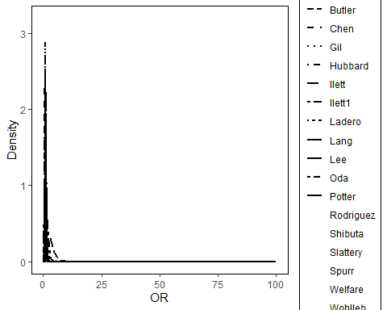

Set by = ‘color’

MultipleTables.plot(multiple_tables_obj_sampling, plot_type = 'density',  
 layout_type = 'overlay',  
 by = 'color'  
 )

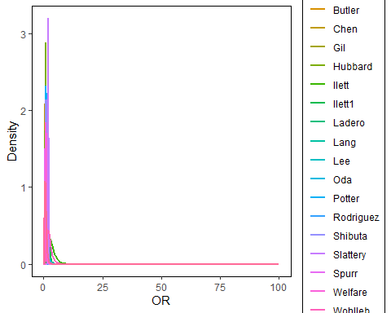

Set by = ‘color’ and specify xlim as 0 to 5.

MultipleTables.plot(multiple_tables_obj_sampling, plot_type = 'density',  
 layout_type = 'overlay',  
 by = 'color',  
 xlim = c(0,5)  
 )

## Warning: Removed 38900 rows containing missing values (`geom_line()`).

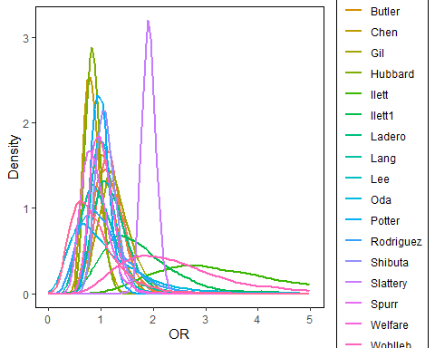

Set by = ‘color’ and specify xlim as 0 to 5 and add vertical line at OR = 1

MultipleTables.plot(multiple_tables_obj_sampling, plot_type = 'density',  
 layout_type = 'overlay',  
 by = 'color',  
 xlim = c(0,5),  
 add_vertical = 1  
 )

## Warning: Removed 38900 rows containing missing values (`geom_line()`).

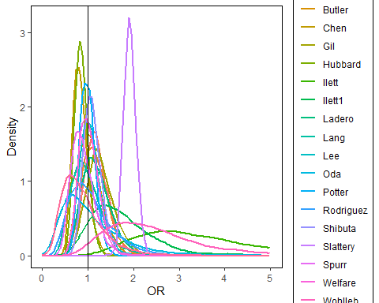

select three studies:

ggplot2_obj <- MultipleTables.plot(multiple_tables_obj_sampling, plot_type = 'density',  
 layout_type = 'overlay',  
 selected_study_names = c('Bell','Chen','Oda'),  
 xlim = c(0,5))   
  
  
ggplot2_obj

## Warning: Removed 5835 rows containing missing values (`geom_line()`).

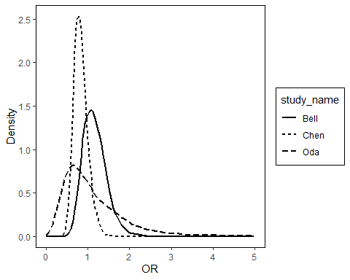

add external layouts for the return ggplot2 : * xlab as Odds ratio

ggplot2_obj <- MultipleTables.plot(multiple_tables_obj_sampling, plot_type = 'density',  
 layout_type = 'overlay',  
 by = 'color',  
 xlim = c(0,5))   
   
  
ggplot2_obj + xlab('Odds Ratio') + ggtitle('OR ration for XX cancer')

## Warning: Removed 38900 rows containing missing values (`geom_line()`).

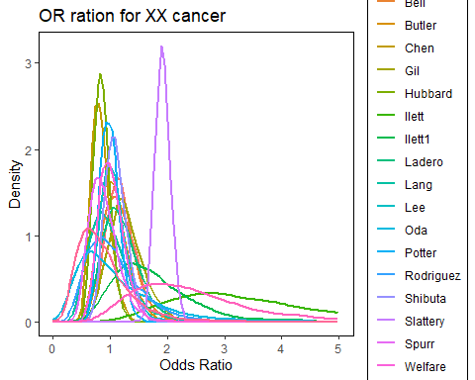

ggplot2_obj

## Warning: Removed 38900 rows containing missing values (`geom_line()`).



### side by side density:

density plot: side by side, default

MultipleTables.plot(multiple_tables_obj_sampling,   
 plot_type = 'density',  
 layout_type = 'side_by_side')

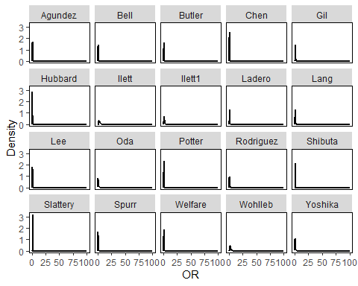 set xlim between 0 to 5; add vetical line at OR = 1

MultipleTables.plot(multiple_tables_obj_sampling,   
 plot_type = 'density',  
 layout_type = 'side_by_side',  
 add_vertical = 1,  
 xlim = c(0,5))

## Warning: Removed 38900 rows containing missing values (`geom_line()`).

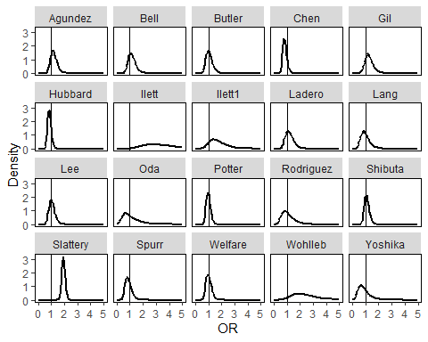

select 3 studies: study_name in c(‘Bell’,‘Chen’,‘Oda’)

MultipleTables.plot(multiple_tables_obj_sampling,   
 plot_type = 'density',  
 layout_type = 'side_by_side',  
 selected_study_names = c('Bell','Chen','Oda'),  
 xlim = c(0,5))

## Warning: Removed 5835 rows containing missing values (`geom_line()`).

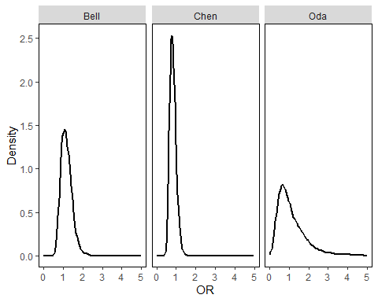

### Forest plot

forest plot: default

MultipleTables.plot(multiple_tables_obj_sampling, plot_type = 'forest')

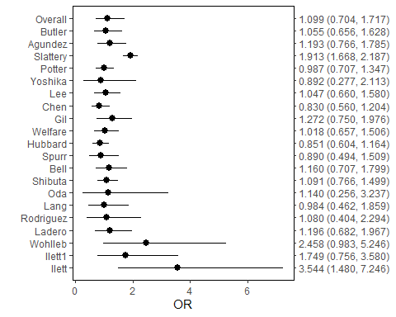 add vertical line at OR = 1

MultipleTables.plot(multiple_tables_obj_sampling, plot_type = 'forest', add_vertical = 1) +  
 xlab('Odds ratio')

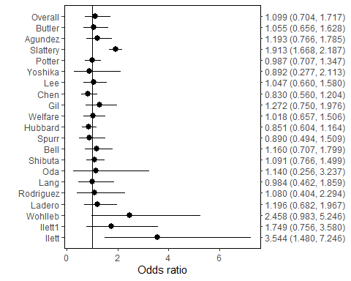

forest plot: add vertical line and set digit = 2 (need to re-run summary method)

multiple_tables_obj_sampling <- MultipleTables.summary(multiple_tables_obj_sampling, alpha = 0.05, digit = 2,  
 verbose = FALSE)  
MultipleTables.plot(multiple_tables_obj_sampling, plot_type = 'forest', add_vertical = 1) +  
 xlab('Odds ratio')

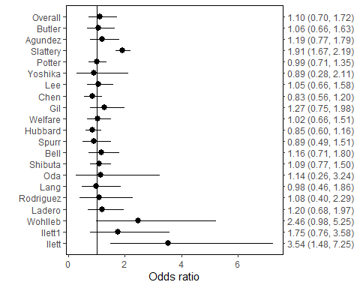 display OR in log scale

MultipleTables.plot(multiple_tables_obj_sampling, plot_type = 'forest', add_vertical = 1) +  
 xlab('Odds ratio') + scale_x_continuous(trans='log10')

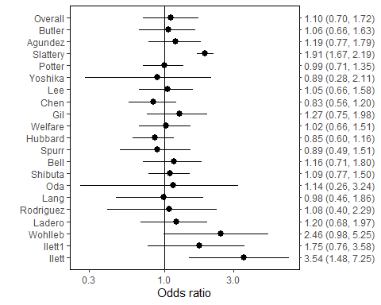

forest plot: not show the CIs

MultipleTables.plot(multiple_tables_obj_sampling, plot_type = 'forest', add_vertical = 1, show_CI = FALSE) +  
 xlab('Odds ratio')

## Scale for y is already present.  
## Adding another scale for y, which will replace the existing scale.

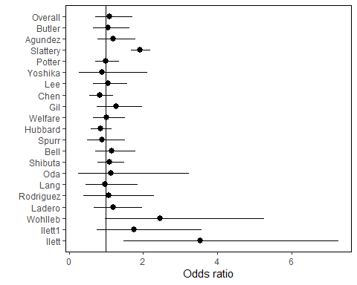

## Exact method

## Create object

* load the data:
  + here use colorectal as example
  + input data is a data frame.
  + the input data frame should contain the following columns:
    - y1
    - n1
    - y2
    - n2
* specify model
* specify measure

colorectal['study_name'] <- colorectal['studynames']  
multiple_tables_obj_exact <- MultipleTables.create(data=colorectal, measure='OR', model= 'Sarmanov')

### model fit

* estimate the hyper parameters via maximum likelihood
* draw posterior samples for each study
* calculate posterior density for each study
* likelihood ratio test for correlation

default:

multiple_tables_obj_exact <- MultipleTables.modelFit(multiple_tables_obj_exact, method = 'exact')

control list can be specified to control the fitting process: * n_samples: number of posterior samples; Defualt is 5000. * mcmc_initial: initial values for (p1, p2) in MCMC; Default is c(0.5, 0.5) * upper_bound: upper bound for the measure. Default is 100. * lower_bound: lower bound for the measure. For RD, default is -1. For RR/OR, defualt is 0. * num_grids: number of grids to calculate density; The defualt is 20498. * optim_method: optimazation method. Default is “L-BFGS-B”. Please refer to ‘optim’ function. * maxit = maximum number of iterations for iteration. Default is 1000. Please refer to ‘optim’ function., * initial_values: initial value for optimization. The default approach is to fit overdispertion beta-bin model to generate initial value via aod package.

set number of posterior samples is 5000

multiple_tables_obj_exact <- MultipleTables.modelFit(multiple_tables_obj_exact, method = 'exact',   
 control = list(n_samples = 3000))

set intial values correspoinding to c(a1, b1, a2, b2, rho) as c(1,1,1,1,0):

multiple_tables_obj_exact <- MultipleTables.modelFit(multiple_tables_obj_exact, method = 'exact',   
 control = list(initial_values = c(1,1,1,1,0)))

maximum number of iterations for iteration is 100

multiple_tables_obj_exact <- MultipleTables.modelFit(multiple_tables_obj_exact, method = 'exact',   
 control = list(maxit = 100))

maximum number of iterations for iteration is 100 and number of posterior samples as 3000

multiple_tables_obj_exact <- MultipleTables.modelFit(multiple_tables_obj_exact, method = 'exact',   
 control = list(maxit = 100, nsamples = 3000))

## Summary

* Estimate overall measure (point and confidence interval)
* Estimate study-specific measure(point and confidence interval)

default

multiple_tables_obj_exact <- MultipleTables.summary(multiple_tables_obj_exact)

## Model: Sarmanov Beta-Binomial Model  
## THe overall Odds Ratio  
## Estimate: 1.099  
## 95% confident interval: [0.704,1.717]  
##   
## Maximum likelihood estimates of hyperparameters:  
## a1 =3.106, b1 =2.91, a2 =3.944, b2 =3.362, rho =0.125  
## Likelihood ratio test for within-group correlation (H0: rho=0):  
## chi2: 3.152; p-value: 0.076  
##   
## Study-SpecifcOdds Ratio:  
## Mean Lower Upper  
## Ilett 3.492 1.414 7.433  
## Ilett1 1.726 0.774 3.570  
## Wohlleb 2.430 0.963 5.170  
## Ladero 1.188 0.669 1.968  
## Rodriguez 1.080 0.413 2.375  
## Lang 0.984 0.471 1.871  
## Oda 1.160 0.271 3.237  
## Shibuta 1.101 0.781 1.515  
## Bell 1.150 0.705 1.754  
## Spurr 0.883 0.473 1.465  
## Hubbard 0.850 0.606 1.145  
## Welfare 1.007 0.638 1.492  
## Gil 1.281 0.782 2.021  
## Chen 0.831 0.546 1.179  
## Lee 1.053 0.680 1.580  
## Yoshika 0.896 0.285 2.160  
## Potter 0.983 0.710 1.349  
## Slattery 1.925 1.669 2.207  
## Agundez 1.200 0.767 1.791  
## Butler 1.050 0.654 1.608

alpha = 0.1

MultipleTables.summary(multiple_tables_obj_exact, alpha = 0.1)

## Model: Sarmanov Beta-Binomial Model  
## THe overall Odds Ratio  
## Estimate: 1.099  
## 90% confident interval: [0.756,1.598]  
##   
## Maximum likelihood estimates of hyperparameters:  
## a1 =3.106, b1 =2.91, a2 =3.944, b2 =3.362, rho =0.125  
## Likelihood ratio test for within-group correlation (H0: rho=0):  
## chi2: 3.152; p-value: 0.076  
##   
## Study-SpecifcOdds Ratio:  
## Mean Lower Upper  
## Ilett 3.492 1.603 6.482  
## Ilett1 1.726 0.884 3.102  
## Wohlleb 2.430 1.108 4.528  
## Ladero 1.188 0.732 1.788  
## Rodriguez 1.080 0.488 2.030  
## Lang 0.984 0.528 1.638  
## Oda 1.160 0.330 2.565  
## Shibuta 1.101 0.821 1.442  
## Bell 1.150 0.761 1.633  
## Spurr 0.883 0.523 1.350  
## Hubbard 0.850 0.639 1.096  
## Welfare 1.007 0.686 1.393  
## Gil 1.281 0.842 1.861  
## Chen 0.831 0.589 1.116  
## Lee 1.053 0.722 1.455  
## Yoshika 0.896 0.343 1.801  
## Potter 0.983 0.745 1.265  
## Slattery 1.925 1.719 2.159  
## Agundez 1.200 0.821 1.675  
## Butler 1.050 0.702 1.500

set digit = 4

MultipleTables.summary(multiple_tables_obj_exact, alpha = 0.05, digit = 4)

## Model: Sarmanov Beta-Binomial Model  
## THe overall Odds Ratio  
## Estimate: 1.0992  
## 95% confident interval: [0.7038,1.7168]  
##   
## Maximum likelihood estimates of hyperparameters:  
## a1 =3.1057, b1 =2.9104, a2 =3.9439, b2 =3.3623, rho =0.1249  
## Likelihood ratio test for within-group correlation (H0: rho=0):  
## chi2: 3.1522; p-value: 0.0758  
##   
## Study-SpecifcOdds Ratio:  
## Mean Lower Upper  
## Ilett 3.4919 1.4135 7.4328  
## Ilett1 1.7264 0.7743 3.5695  
## Wohlleb 2.4299 0.9634 5.1702  
## Ladero 1.1875 0.6690 1.9680  
## Rodriguez 1.0799 0.4130 2.3750  
## Lang 0.9839 0.4706 1.8713  
## Oda 1.1597 0.2706 3.2367  
## Shibuta 1.1013 0.7813 1.5149  
## Bell 1.1497 0.7048 1.7537  
## Spurr 0.8827 0.4730 1.4649  
## Hubbard 0.8495 0.6062 1.1450  
## Welfare 1.0071 0.6384 1.4922  
## Gil 1.2810 0.7818 2.0210  
## Chen 0.8313 0.5457 1.1787  
## Lee 1.0533 0.6801 1.5803  
## Yoshika 0.8958 0.2850 2.1604  
## Potter 0.9829 0.7097 1.3489  
## Slattery 1.9252 1.6690 2.2068  
## Agundez 1.2001 0.7667 1.7914  
## Butler 1.0496 0.6542 1.6083

not print out

MultipleTables.summary(multiple_tables_obj_exact, alpha = 0.05, digit = 4,  
 verbose = FALSE)

## Strucutre of MultipleTables objects

str(multiple_tables_obj_exact)

## List of 15  
## $ data :'data.frame': 20 obs. of 6 variables:  
## ..$ y1 : num [1:20] 10 19 13 40 13 92 33 151 50 34 ...  
## ..$ y2 : num [1:20] 27 27 23 49 20 14 33 112 96 32 ...  
## ..$ n1 : num [1:20] 41 45 41 96 28 205 36 329 112 96 ...  
## ..$ n2 : num [1:20] 49 49 43 109 44 34 36 234 202 103 ...  
## ..$ studynames: chr [1:20] "Ilett" "Ilett1" "Wohlleb" "Ladero" ...  
## ..$ study_name: chr [1:20] "Ilett" "Ilett1" "Wohlleb" "Ladero" ...  
## $ measure : chr "OR"  
## $ model : chr "Sarmanov"  
## $ alpha : num 0.05  
## $ chi2_value : num 3.15  
## $ p_value : num 0.0758  
## $ prior_mle : Named num [1:5] 3.106 2.91 3.944 3.362 0.125  
## ..- attr(*, "names")= chr [1:5] "a1" "b1" "a2" "b2" ...  
## $ hessian_log : num [1:5, 1:5] -3.61e+01 3.00e+01 3.49 -3.56 6.37e-06 ...  
## ..- attr(*, "dimnames")=List of 2  
## .. ..$ : chr [1:5] "loga1" "logb1" "loga2" "logb2" ...  
## .. ..$ : chr [1:5] "loga1" "logb1" "loga2" "logb2" ...  
## $ cov_matrix_log : num [1:5, 1:5] 0.113158 0.102589 0.000426 -0.00048 -0.001897 ...  
## $ overall_measure_estimation:List of 2  
## ..$ point : num 1.1  
## ..$ confindent_interval: Named num [1:2] 0.704 1.717  
## .. ..- attr(*, "names")= chr [1:2] "lower" "upper"  
## $ specific_summary :'data.frame': 20 obs. of 7 variables:  
## ..$ study_name: chr [1:20] "Ilett" "Ilett1" "Wohlleb" "Ladero" ...  
## ..$ mean : num [1:20] 3.49 1.73 2.43 1.19 1.08 ...  
## ..$ median : num [1:20] 3.211 1.618 2.247 1.129 0.989 ...  
## ..$ ET_lower : num [1:20] 1.414 0.774 0.963 0.669 0.413 ...  
## ..$ ET_upper : num [1:20] 7.43 3.57 5.17 1.97 2.38 ...  
## ..$ HRD_lower : num [1:20] 1.114 0.567 0.707 0.605 0.302 ...  
## ..$ HRD_upper : num [1:20] 6.58 3.13 4.63 1.83 2.05 ...  
## $ samples :List of 20  
## ..$ Ilett : Named num [1:5000] 2.11 4.57 3.35 2.38 1.31 ...  
## .. ..- attr(*, "names")= chr [1:5000] "" "" "" "" ...  
## ..$ Ilett1 : Named num [1:5000] 1.511 1.443 0.996 1.821 1.821 ...  
## .. ..- attr(*, "names")= chr [1:5000] "" "" "" "" ...  
## ..$ Wohlleb : Named num [1:5000] 1.111 0.939 1.625 2.071 2.037 ...  
## .. ..- attr(*, "names")= chr [1:5000] "" "" "" "" ...  
## ..$ Ladero : Named num [1:5000] 0.9 0.838 1.121 1.149 1.161 ...  
## .. ..- attr(*, "names")= chr [1:5000] "" "" "" "" ...  
## ..$ Rodriguez: Named num [1:5000] 1.016 1.324 2.215 0.856 0.785 ...  
## .. ..- attr(*, "names")= chr [1:5000] "" "" "" "" ...  
## ..$ Lang : Named num [1:5000] 1.13 1.24 1.25 1.1 1.15 ...  
## .. ..- attr(*, "names")= chr [1:5000] "" "" "" "" ...  
## ..$ Oda : Named num [1:5000] 5.53 6.37 1.79 4.07 1.37 ...  
## .. ..- attr(*, "names")= chr [1:5000] "" "" "" "" ...  
## ..$ Shibuta : Named num [1:5000] 0.997 0.888 1.537 1.496 1.257 ...  
## .. ..- attr(*, "names")= chr [1:5000] "" "" "" "" ...  
## ..$ Bell : Named num [1:5000] 1.22 1.13 1.13 1.12 1.08 ...  
## .. ..- attr(*, "names")= chr [1:5000] "" "" "" "" ...  
## ..$ Spurr : Named num [1:5000] 0.8 0.54 1.03 1.31 1.38 ...  
## .. ..- attr(*, "names")= chr [1:5000] "" "" "" "" ...  
## ..$ Hubbard : Named num [1:5000] 1.38 1.069 0.541 0.772 0.904 ...  
## .. ..- attr(*, "names")= chr [1:5000] "" "" "" "" ...  
## ..$ Welfare : Named num [1:5000] 0.895 0.808 0.942 0.933 0.743 ...  
## .. ..- attr(*, "names")= chr [1:5000] "" "" "" "" ...  
## ..$ Gil : Named num [1:5000] 0.605 1.327 1.559 1.464 0.989 ...  
## .. ..- attr(*, "names")= chr [1:5000] "" "" "" "" ...  
## ..$ Chen : Named num [1:5000] 0.991 0.771 0.745 0.779 0.803 ...  
## .. ..- attr(*, "names")= chr [1:5000] "" "" "" "" ...  
## ..$ Lee : Named num [1:5000] 1.095 2.381 1.521 2.426 0.985 ...  
## .. ..- attr(*, "names")= chr [1:5000] "" "" "" "" ...  
## ..$ Yoshika : Named num [1:5000] 0.0671 0.1366 0.0716 0.1376 0.394 ...  
## .. ..- attr(*, "names")= chr [1:5000] "" "" "" "" ...  
## ..$ Potter : Named num [1:5000] 1.063 0.748 0.792 1.046 1.078 ...  
## .. ..- attr(*, "names")= chr [1:5000] "" "" "" "" ...  
## ..$ Slattery : Named num [1:5000] 1 1.19 1.49 1.49 1.38 ...  
## .. ..- attr(*, "names")= chr [1:5000] "" "" "" "" ...  
## ..$ Agundez : Named num [1:5000] 0.979 1.132 1.176 1.262 1.063 ...  
## .. ..- attr(*, "names")= chr [1:5000] "" "" "" "" ...  
## ..$ Butler : Named num [1:5000] 0.266 0.901 1.662 1.566 1.835 ...  
## .. ..- attr(*, "names")= chr [1:5000] "" "" "" "" ...  
## $ density :List of 20  
## ..$ Ilett :List of 2  
## .. ..$ y: num [1:2048] 0.00 6.36e-26 4.16e-19 1.51e-15 3.18e-13 ...  
## .. ..$ x: num [1:2048] 0 0.0326 0.0651 0.0977 0.1302 ...  
## ..$ Ilett1 :List of 2  
## .. ..$ y: num [1:2048] 0.00 1.17e-19 1.02e-13 1.08e-10 9.40e-09 ...  
## .. ..$ x: num [1:2048] 0 0.0326 0.0651 0.0977 0.1302 ...  
## ..$ Wohlleb :List of 2  
## .. ..$ y: num [1:2048] 0.00 6.63e-21 4.58e-15 4.94e-12 4.56e-10 ...  
## .. ..$ x: num [1:2048] 0 0.0326 0.0651 0.0977 0.1302 ...  
## ..$ Ladero :List of 2  
## .. ..$ y: num [1:2048] 0.00 1.10e-34 2.06e-22 1.61e-16 5.35e-13 ...  
## .. ..$ x: num [1:2048] 0 0.0326 0.0651 0.0977 0.1302 ...  
## ..$ Rodriguez:List of 2  
## .. ..$ y: num [1:2048] 0.00 1.92e-11 2.94e-07 2.14e-05 2.96e-04 ...  
## .. ..$ x: num [1:2048] 0 0.0326 0.0651 0.0977 0.1302 ...  
## ..$ Lang :List of 2  
## .. ..$ y: num [1:2048] 0.00 1.93e-14 5.92e-10 1.50e-07 5.50e-06 ...  
## .. ..$ x: num [1:2048] 0 0.0326 0.0651 0.0977 0.1302 ...  
## ..$ Oda :List of 2  
## .. ..$ y: num [1:2048] 0 0.000214 0.003925 0.018093 0.047966 ...  
## .. ..$ x: num [1:2048] 0 0.0326 0.0651 0.0977 0.1302 ...  
## ..$ Shibuta :List of 2  
## .. ..$ y: num [1:2048] 0.00 7.38e-92 6.96e-61 2.22e-44 7.35e-34 ...  
## .. ..$ x: num [1:2048] 0 0.0326 0.0651 0.0977 0.1302 ...  
## ..$ Bell :List of 2  
## .. ..$ y: num [1:2048] 0.00 1.78e-70 2.55e-44 1.22e-30 3.84e-22 ...  
## .. ..$ x: num [1:2048] 0 0.0326 0.0651 0.0977 0.1302 ...  
## ..$ Spurr :List of 2  
## .. ..$ y: num [1:2048] 0.00 4.54e-23 5.49e-15 6.65e-11 2.40e-08 ...  
## .. ..$ x: num [1:2048] 0 0.0326 0.0651 0.0977 0.1302 ...  
## ..$ Hubbard :List of 2  
## .. ..$ y: num [1:2048] 0.00 3.55e-77 8.35e-50 2.14e-35 2.43e-26 ...  
## .. ..$ x: num [1:2048] 0 0.0326 0.0651 0.0977 0.1302 ...  
## ..$ Welfare :List of 2  
## .. ..$ y: num [1:2048] 0.00 1.53e-53 3.13e-34 1.82e-24 1.38e-18 ...  
## .. ..$ x: num [1:2048] 0 0.0326 0.0651 0.0977 0.1302 ...  
## ..$ Gil :List of 2  
## .. ..$ y: num [1:2048] 0.00 1.31e-40 2.11e-28 6.95e-22 1.25e-17 ...  
## .. ..$ x: num [1:2048] 0 0.0326 0.0651 0.0977 0.1302 ...  
## ..$ Chen :List of 2  
## .. ..$ y: num [1:2048] 0.00 2.87e-58 1.37e-36 1.76e-25 1.01e-18 ...  
## .. ..$ x: num [1:2048] 0 0.0326 0.0651 0.0977 0.1302 ...  
## ..$ Lee :List of 2  
## .. ..$ y: num [1:2048] 0.00 9.03e-44 8.80e-30 2.07e-22 1.18e-17 ...  
## .. ..$ x: num [1:2048] 0 0.0326 0.0651 0.0977 0.1302 ...  
## ..$ Yoshika :List of 2  
## .. ..$ y: num [1:2048] 0.00 7.71e-06 4.98e-04 4.52e-03 1.87e-02 ...  
## .. ..$ x: num [1:2048] 0 0.0326 0.0651 0.0977 0.1302 ...  
## ..$ Potter :List of 2  
## .. ..$ y: num [1:1502] 0.00 3.17e-208 2.13e-142 1.49e-105 1.17e-80 ...  
## .. ..$ x: num [1:1502] 0 0.0326 0.0651 0.0977 0.1302 ...  
## ..$ Slattery :List of 2  
## .. ..$ y: num [1:2048] 0 0 0 0 0 ...  
## .. ..$ x: num [1:2048] 0 0.0326 0.0651 0.0977 0.1302 ...  
## ..$ Agundez :List of 2  
## .. ..$ y: num [1:2048] 0.00 2.68e-50 2.13e-34 4.12e-26 8.82e-21 ...  
## .. ..$ x: num [1:2048] 0 0.0326 0.0651 0.0977 0.1302 ...  
## ..$ Butler :List of 2  
## .. ..$ y: num [1:2048] 0.00 2.96e-127 5.19e-83 9.11e-59 8.49e-43 ...  
## .. ..$ x: num [1:2048] 0 0.0326 0.0651 0.0977 0.1302 ...  
## $ method : chr "exact"  
## $ digit : num 3  
## - attr(*, "class")= chr "MultipleTables"

## Plot

#### overlay density:

Density plot :overlay (default)

Note * There are no enough types of line.

MultipleTables.plot(multiple_tables_obj_exact, plot_type = 'density',  
 layout_type = 'overlay')

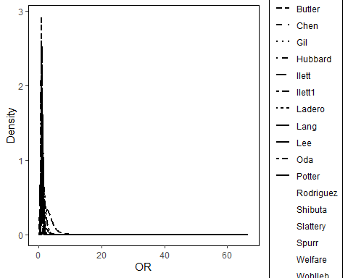

Set by = ‘color’

MultipleTables.plot(multiple_tables_obj_exact, plot_type = 'density',  
 layout_type = 'overlay',  
 by = 'color'  
 )

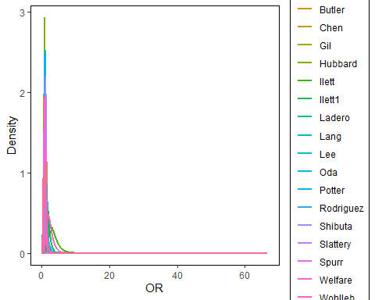

Set by = ‘color’ and specify xlim as 0 to 5.

MultipleTables.plot(multiple_tables_obj_exact, plot_type = 'density',  
 layout_type = 'overlay',  
 by = 'color',  
 xlim = c(0,5)  
 )

## Warning: Removed 37334 rows containing missing values (`geom_line()`).

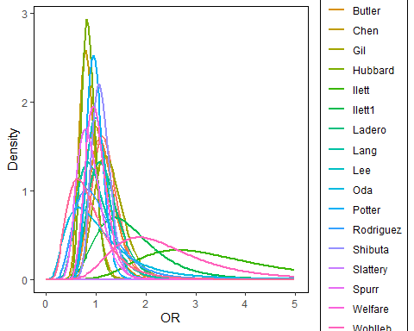

Set by = ‘color’ and specify xlim as 0 to 5 and add vertical line at OR = 1

MultipleTables.plot(multiple_tables_obj_exact, plot_type = 'density',  
 layout_type = 'overlay',  
 by = 'color',  
 xlim = c(0,5),  
 add_vertical = 1  
 )

## Warning: Removed 37334 rows containing missing values (`geom_line()`).

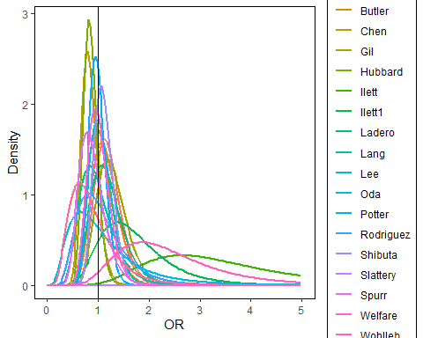

select three studies:

ggplot2_obj <- MultipleTables.plot(multiple_tables_obj_exact, plot_type = 'density',  
 layout_type = 'overlay',  
 selected_study_names = c('Bell','Chen','Oda'),  
 xlim = c(0,5))   
  
  
ggplot2_obj

## Warning: Removed 5682 rows containing missing values (`geom_line()`).

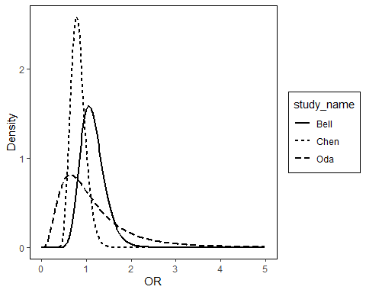

add external layouts for the return ggplot2 : * xlab as Odds ratio

ggplot2_obj <- MultipleTables.plot(multiple_tables_obj_exact, plot_type = 'density',  
 layout_type = 'overlay',  
 by = 'color',  
 xlim = c(0,5))   
   
  
ggplot2_obj + xlab('Odds Ratio') + ggtitle('OR ration for XX cancer')

## Warning: Removed 37334 rows containing missing values (`geom_line()`).

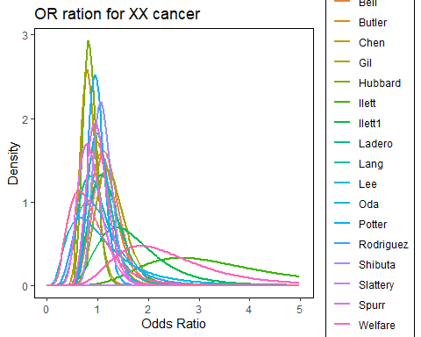

ggplot2_obj

## Warning: Removed 37334 rows containing missing values (`geom_line()`).



### side by side density:

density plot: side by side, default

MultipleTables.plot(multiple_tables_obj_exact,   
 plot_type = 'density',  
 layout_type = 'side_by_side')

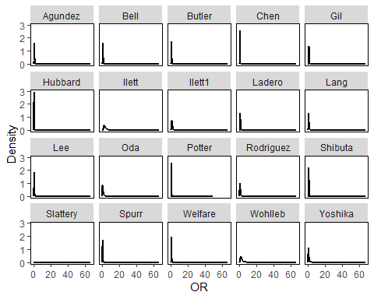 set xlim between 0 to 5; add vetical line at OR = 1

MultipleTables.plot(multiple_tables_obj_exact,   
 plot_type = 'density',  
 layout_type = 'side_by_side',  
 add_vertical = 1,  
 xlim = c(0,5))

## Warning: Removed 37334 rows containing missing values (`geom_line()`).

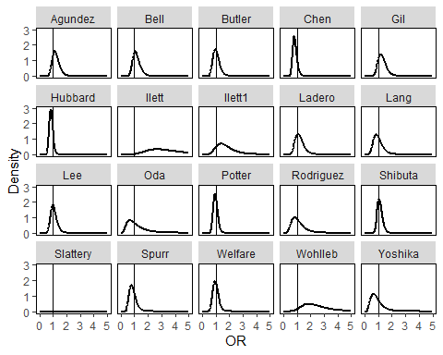

select 3 studies: study_name in c(‘Bell’,‘Chen’,‘Oda’)

MultipleTables.plot(multiple_tables_obj_exact,   
 plot_type = 'density',  
 layout_type = 'side_by_side',  
 selected_study_names = c('Bell','Chen','Oda'),  
 xlim = c(0,5))

## Warning: Removed 5682 rows containing missing values (`geom_line()`).

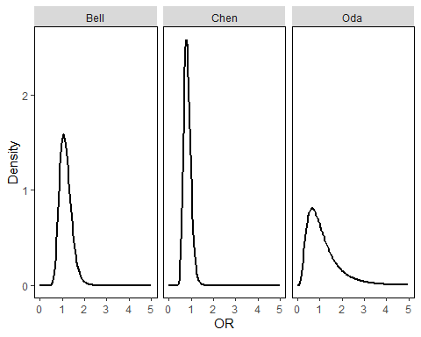

### Forest plot

forest plot: default

MultipleTables.plot(multiple_tables_obj_exact, plot_type = 'forest')

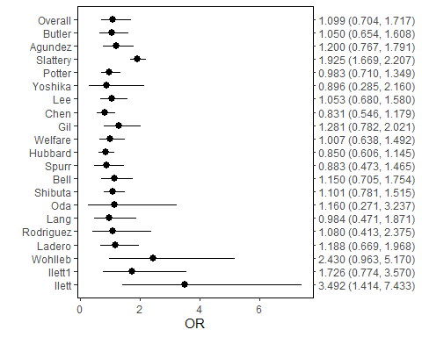 add vertical line at OR = 1

MultipleTables.plot(multiple_tables_obj_exact, plot_type = 'forest', add_vertical = 1) +  
 xlab('Odds ratio')

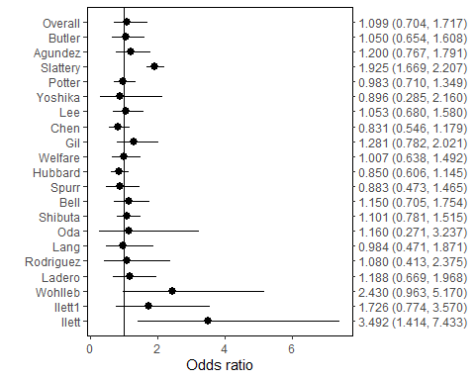

forest plot: add vertical line and set digit = 2 (need to re-run summary method)

multiple_tables_obj_exact <- MultipleTables.summary(multiple_tables_obj_exact, alpha = 0.05, digit = 2,  
 verbose = FALSE)  
MultipleTables.plot(multiple_tables_obj_exact, plot_type = 'forest', add_vertical = 1) +  
 xlab('Odds ratio')

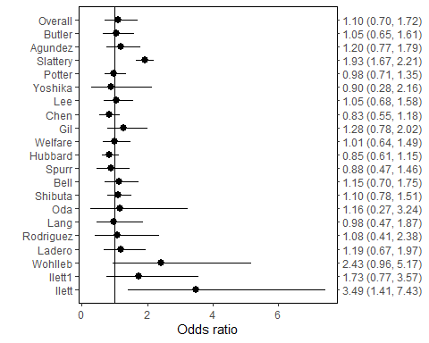 display OR in log scale

MultipleTables.plot(multiple_tables_obj_exact, plot_type = 'forest', add_vertical = 1) +  
 xlab('Odds ratio') + scale_x_continuous(trans='log10')

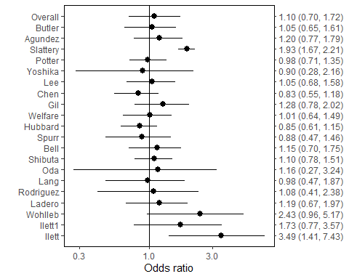

forest plot: not show the CIs

MultipleTables.plot(multiple_tables_obj_exact, plot_type = 'forest', add_vertical = 1, show_CI = FALSE) +  
 xlab('Odds ratio')

## Scale for y is already present.  
## Adding another scale for y, which will replace the existing scale.

