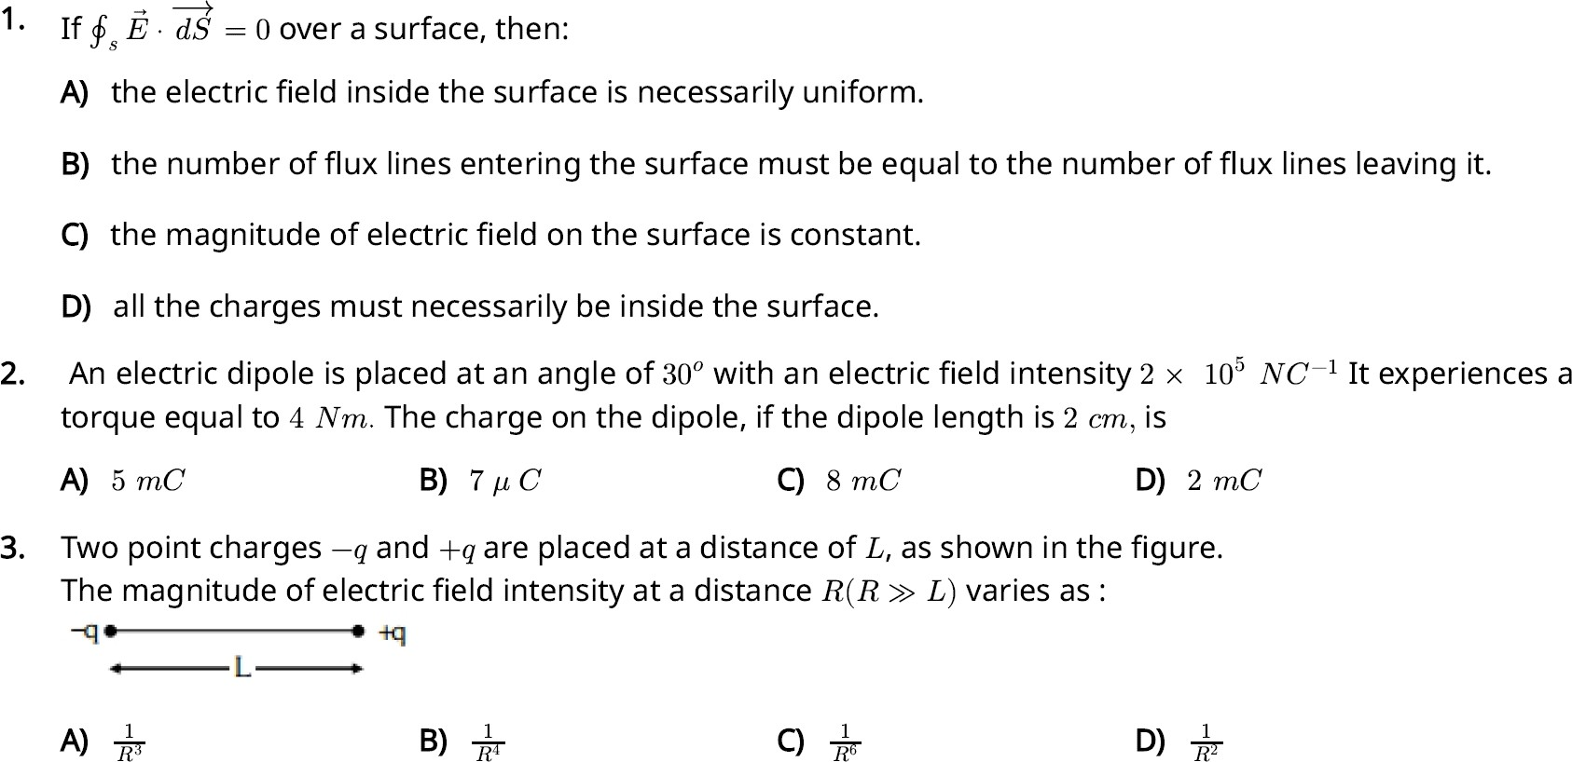
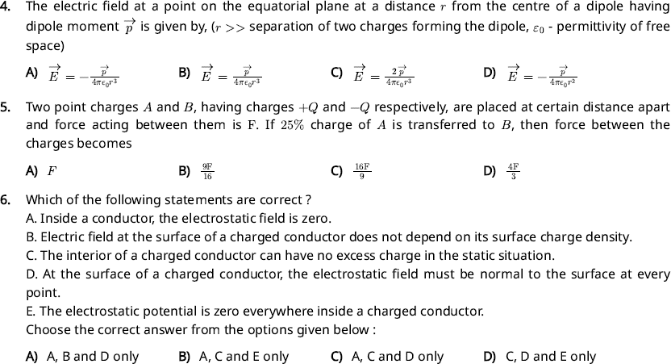

- Five capacitors of capacitances 01 = 02 = Q3 = Q4 = 10 µF and s = 2. µF are connected as shown, along with a battery of O V. Find the total equivalent capacitance of the network and the charge on each capacitor.
½ C3
[II 11

C4
Cl
--
C5
1--

50
  - 5µF, 125µ0 on 01 to Q4 and 2 µCon Cs
  - 5µF, 125µ0 on all capacitors
  - 5µF, 2 OµC on all capacitors
D} 4.µF, 250µ0 on 01 to 04 and 12 µG on Os
- An electric dipole with dipole moment 6 x lQ,6 m is aligned with the direction of a uniform electric field of magnitude 4 x 105N/0 The dipole is then rotated through an angle of 60' with respect to the electric field. The change in the potential energy of the dipole is:
  - 0.8 J B), 1.0J C) 1.2J D) 1.5 J
- If the plates of a parallel plate capacitor connected to a battery are moved close to each other; then
- the charge stored in it. increases.
- the energy stored in it, decreases.
- its capacitance increases.
- the ratio of charge to its potential remains the same.
- the product of charge and voltage increases.
Choose the most appropriate answer from the options given below:
- A, G and E only BJ, B, D and E only q A B and Conly [)) A, Band E only
- In the following circuit, the equivalent capacitance between terminal Aand terminal B is:

2µF • • 2 µF •

I'
I�

A +2� S

I I,
2 f.1-F 2 µF

  - lµF B) 0.5µF q 4µF D) 2µF
- An electric dipole is placed as shown in the figure.The electric potential (in 10² v ) at point P due to the
dipole is (1:o = permittivity offree space and ₄�, = K) :
0

San
- p
0
•
-q�(,--�)•◄(E,-- ....) +q
3cm 3cm

  - (-}) qI< q ({-) q.K D) ( {) ql<

- The equivalent capacitance of the system shown in the following circuit is 1.1.F

M-�µ�µJ--.B

3�1
  - 9 B) 2 q 3 D) 6
- Six charges +q, -q, +q, -q,+q and -q arefixed at the corners of a hexagon of sided as shown in the figure. The work done in bringing a charge q0 to the centre of the hexagon from infinity is :(c:₀- permittivity of free space)
+q -q


--q •C\i +q

�. ,
+q

  - 0
  - -q'
4ITCod
D) ---=L (6 1)
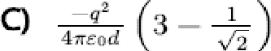
4,reod
f2

- The effective capacitances of two capacitors are 3 /.J.F and 16 /.J.F, when they are connected in series and parallel respectively. The capacitance of two capacitors are
  - 10µF,6µF B) SµF, 8 µF q 12µF,4µF D) l.2µF, l.SµF
- Two hollow conducting spheres of rad iii R₁ and R₂ (R₁ >> R₂) have equal charges. The potential would be:

  - more on smaller sphere

C) dependent on the material property of the sphere
- Polar molecules are the molecules:
  - having zero dipole moment.
  - equall on both the spheres

D) more on bigger sphere

- acquire a dipole moment only in the presence of electric field due to displacement of charges.

- acquire a dipole moment only when magnetic field is absent.

- having a permanent electric dipole moment.

- The electrostatic force between the metal plates of an isolated parallel plate capacitor C having a charge
Q and area A, is
  - Independent of the dista nee between the plates

  - Linearly proportional to the distance between the plates

  - Inversely proportional to the distance between the plates

  - Propo rtionall to the square root of the distance between the pIates
- A resistor is connected to a battery of 12 V emf and internal resistance 2 n. If the current in the circuit is
0.6 A, the terminal voltage of the battery is:
- 10V B) 1.2 V q 12V D) 10.8 V

- A room heater is rated 400 W, 220 V. If the supply voltage drops to 200 V, what will be the power consumed (approximately)?
  - 200 W B) 400 W q 331 W D) 121 W
- The terminal voltage of the battery, whose emf iis 10 V and internal resistance H1, when connected through an external resistance of 4S1 as shown in the figure is:
!2
. .·;;; ··:
t
' 11-1---#,/\'/,M1A-: ,
: 10V ,
·- a - • - a - • - - A• - A - • A - A.

  - 6 V B) 8 V 0 lOV D) 4 V
- 10 resistors, each of resistance Rare connected in series to a battery of emf E and negligible internal resistance. Then those are connected in parallel to the same battery, the current is increased n times. The valueofnis:
  - 1000 B) 10 0 100 D) 1

- The magnitude and direction of the current in the following circuit is:-

2n 10V SV lo
A-"'uum,_.� ,,UUVII. --.B

I' �-----.....1/VU'lr---------' C
7Q

  - l. A from B to A through E

C) 0.5 A from A to B through E
- The reciprocal of resistance is
- O.2 A from B to A through E
- , ,§,_ A from A to B through E

  - reactance B), mobility C) conductivity D), conductance
- A cell of em,f 4 V and internal resistance 0.5 n is connected to a 7. !1 external resistance. The terminal potential difference of the cell is V.
  - 3.75 B), 4.25 C) 4 D), 0.375
- A wheatstone bridge is used to determine the value of unknown resistance X by adjusting the variable resistance Y as shown in the figure. For the most: precise measurement of X, the resistances P and Q:

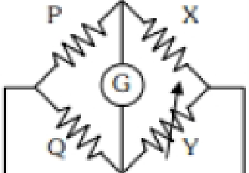

  - should be approximately equal and are small
q do not play any significant role

  - should be very large and unequal

D), should be approximately equal to 2 X

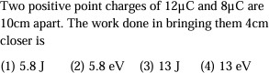
- ​

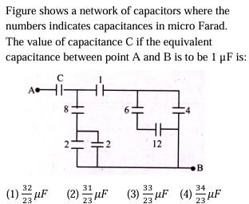
- ​

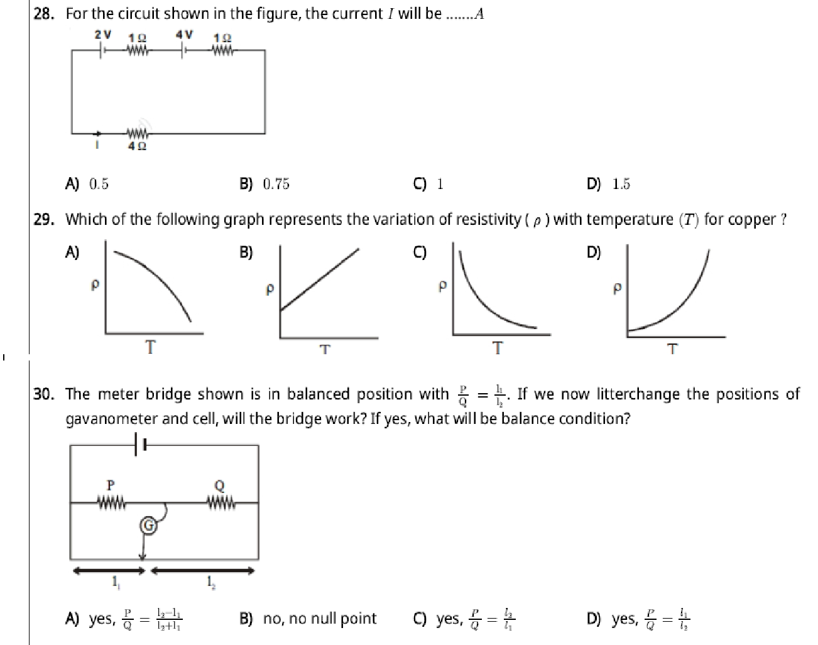

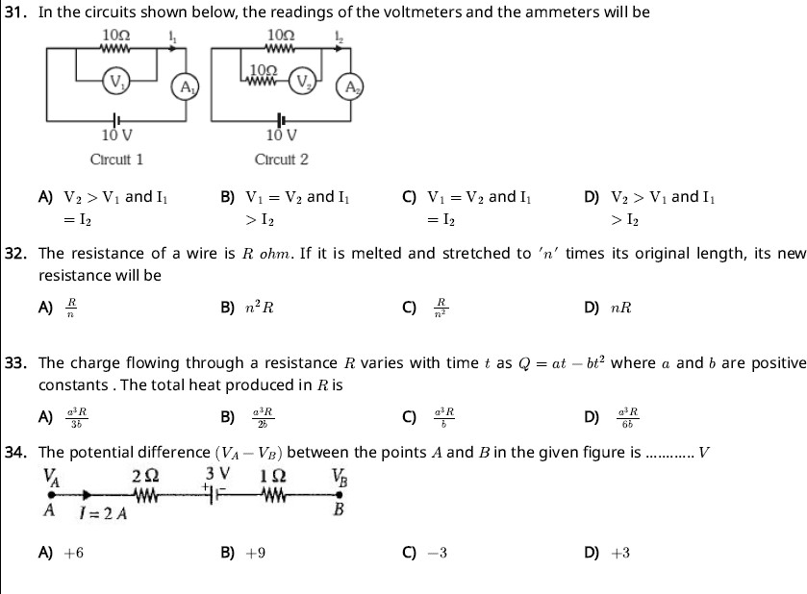

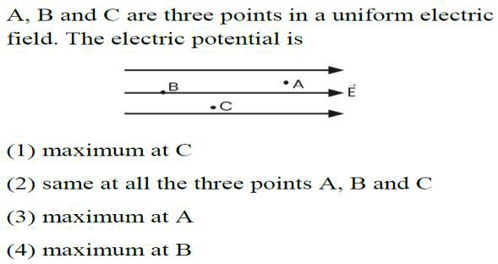
35.

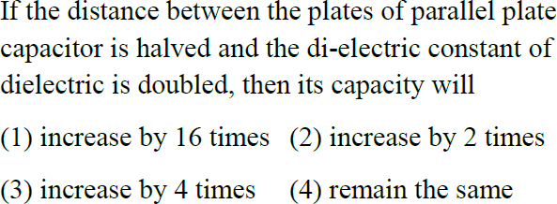
36.

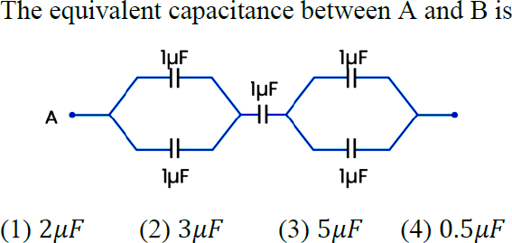
37.

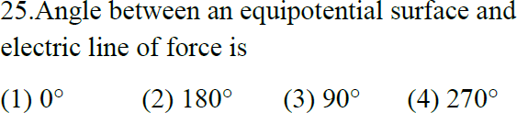
38.

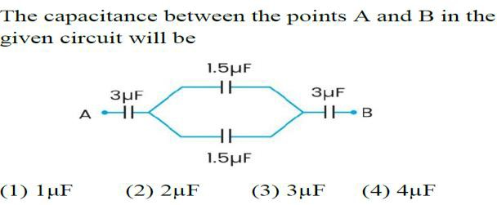
39.

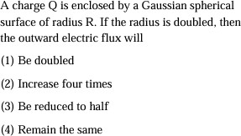
40.

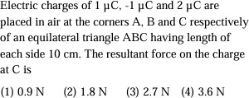
41.

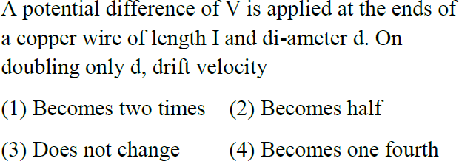
42.

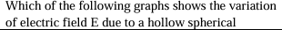
43.
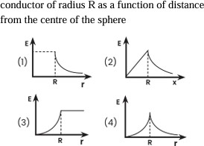

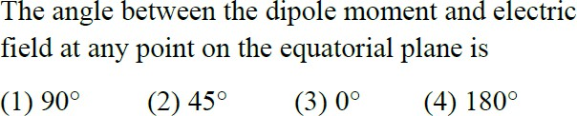
44.

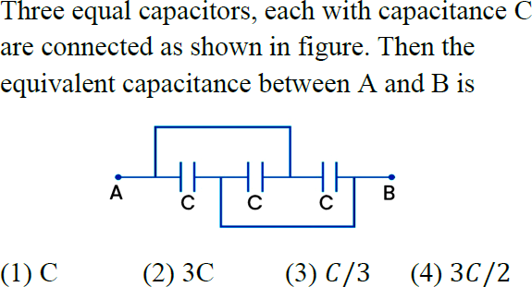
45.

