Physics — NEET Weekly Test 1

1. If ∮ₛ E⃗·dS⃗ = 0 over a surface, then:
(A) the electric field inside the surface is necessarily uniform.
(B) the number of flux lines entering the surface must be equal to the number of flux lines leaving it.
(C) the magnitude of electric field on the surface is constant.
(D) all the charges must necessarily be inside the surface.
Correct Answer: (B)

2. An electric dipole is placed at an angle of 30° with an electric field intensity 2 × 10⁵ NC⁻¹. It experiences a torque equal to 4 Nm. The charge on the dipole, if the dipole length is 2 cm, is
(A) 5 mC
(B) 7 μC
(C) 8 mC
(D) 2 mC
Correct Answer: (D)

3. Two point charges −q and +q are placed at a distance of L, as shown in the figure. [Figure: −q and +q separated by distance L] The magnitude of electric field intensity at a distance R (R ≫ L) varies as:
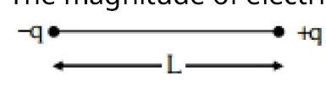
(A) 1/R³
(B) 1/R⁴
(C) 1/R⁶
(D) 1/R²
Correct Answer: (A)

4. The electric field at a point on the equatorial plane at a distance r from the centre of a dipole having dipole moment p⃗ is given by, (r ≫ separation of two charges forming the dipole, ε₀ - permittivity of free space)
(A) E⃗ = −p⃗/(4πε₀r³)
(B) E⃗ = p⃗/(4πε₀r³)
(C) E⃗ = 2p⃗/(4πε₀r³)
(D) E⃗ = −p⃗/(4πε₀r²)
Correct Answer: (A)

5. Two point charges A and B, having charges +Q and −Q respectively, are placed at a certain distance apart and the force acting between them is F. If 25% charge of A is transferred to B, then the force between the charges becomes
(A) F
(B) 9F/16
(C) 16F/9
(D) 4F/3
Correct Answer: (B)

6. Which of the following statements are correct? A. Inside a conductor, the electrostatic field is zero. B. Electric field at the surface of a charged conductor does not depend on its surface charge density. C. The interior of a charged conductor can have no excess charge in the static situation. D. At the surface of a charged conductor, the electrostatic field must be normal to the surface at every point. E. The electrostatic potential is zero everywhere inside a charged conductor. Choose the correct answer from the options given below:
(A) A, B and D only
(B) A, C and E only
(C) A, C and D only
(D) C, D and E only
Correct Answer: (C)

7. Five capacitors of capacitances C₁ = C₂ = C₃ = C₄ = 10 μF and C₅ = 2 μF are connected in a bridge arrangement as shown, along with a battery. [Figure: bridge network of 5 capacitors, C₅ bridging the midpoints] Find the total equivalent capacitance of the network and the charge on each capacitor.
(A) 5μF; 125μC on C₁ to C₄ and ≈0μC on C₅
(B) 5μF; 125μC on all capacitors
(C) 5μF; 20μC on all capacitors
(D) 4μF; 250μC on C₁ to C₄ and 12μC on C₅
Correct Answer: (A)
[REVIEW NOTE: LOW CONFIDENCE – original diagram/battery voltage was too corrupted to read exactly (assumed a balanced bridge with battery ≈25V). Please verify against the source before using.]

8. An electric dipole with dipole moment 6 × 10⁻⁶ C·m is aligned with the direction of a uniform electric field of magnitude 4 × 10⁵ N/C. The dipole is then rotated through an angle of 60° with respect to the electric field. The change in the potential energy of the dipole is:
(A) 0.8 J
(B) 1.0 J
(C) 1.2 J
(D) 1.5 J
Correct Answer: (C)

9. If the plates of a parallel plate capacitor connected to a battery are moved close to each other, then: A. the charge stored in it increases. B. the energy stored in it decreases. C. its capacitance increases. D. the ratio of charge to its potential remains the same. E. the product of charge and voltage increases. Choose the most appropriate answer from the options given below:
(A) A, C and E only
(B) B, D and E only
(C) A, B and C only
(D) A, B and E only
Correct Answer: (A)

10. In the following circuit, made of three 2μF capacitors, the equivalent capacitance between terminal A and terminal B is: [Figure: bridge/quadrilateral network of 2μF capacitors]
(A) 1μF
(B) 0.5μF
(C) 4μF
(D) 2μF
Correct Answer: (D)
[REVIEW NOTE: LOW CONFIDENCE – original diagram was too corrupted to read exactly. Please verify against the source before using.]

11. An electric dipole is placed as shown in the figure. The electric potential (in 10² V) at point P due to the dipole is (ε₀ = permittivity of free space and 1/4πε₀ = K):
(A) −qK/ℓ
(B) (3/8) qK
(C) −qK
(D) qK/ℓ
[REVIEW NOTE: NOT SOLVED – the diagram and options for this question were too corrupted to reconstruct reliably. Question text is kept for reference; please replace or verify before use (left ungraded for now).]

12. The equivalent capacitance of the system shown in the following circuit is ............. μF [Figure: capacitor network]
(A) 9
(B) 2
(C) 3
(D) 6
[REVIEW NOTE: NOT SOLVED – diagram was unreadable (corrupted drawing objects). Please verify/replace.]

13. Six charges +q, −q, +q, −q, +q and −q are fixed at the corners of a regular hexagon of side d, alternating in sign, as shown in the figure. The work done in bringing a charge q₀ to the centre of the hexagon from infinity is: (ε₀ - permittivity of free space)
(A) 0
(B) −q²/(4πε₀d)
(C) −q²/(4πε₀d) (3 − 1/√2)
(D) −q²/(4πε₀d) (6 − 1/12)
Correct Answer: (A)

14. The effective capacitances of two capacitors are 3 μF and 16 μF, when they are connected in series and parallel respectively. The capacitances of the two capacitors are
(A) 10μF, 6μF
(B) 5μF, 8μF
(C) 12μF, 4μF
(D) 1.2μF, 1.5μF
Correct Answer: (C)

15. Two hollow conducting spheres of radii R₁ and R₂ (R₁ ≫ R₂) have equal charges. The potential would be:
(A) more on smaller sphere
(B) equal on both the spheres
(C) dependent on the material property of the sphere
(D) more on bigger sphere
Correct Answer: (A)

16. Polar molecules are the molecules:
(A) having zero dipole moment.
(B) that acquire a dipole moment only in the presence of an electric field, due to displacement of charges.
(C) that acquire a dipole moment only when a magnetic field is absent.
(D) having a permanent electric dipole moment.
Correct Answer: (D)

17. The electrostatic force between the metal plates of an isolated parallel plate capacitor C having a charge Q and area A, is
(A) Independent of the distance between the plates
(B) Linearly proportional to the distance between the plates
(C) Inversely proportional to the distance between the plates
(D) Proportional to the square root of the distance between the plates
Correct Answer: (A)

18. A resistor is connected to a battery of 12 V emf and internal resistance 2 Ω. If the current in the circuit is 0.6 A, the terminal voltage of the battery is:
(A) 10V
(B) 1.2 V
(C) 12V
(D) 10.8 V
Correct Answer: (D)

19. A room heater is rated 400 W, 220 V. If the supply voltage drops to 200 V, what will be the power consumed (approximately)?
(A) 200 W
(B) 400 W
(C) 331 W
(D) 121 W
Correct Answer: (C)

20. The terminal voltage of a battery, whose emf is 10 V and internal resistance 1 Ω, when connected through an external resistance of 4 Ω as shown in the figure is: [Figure: 10V cell, internal resistance 1Ω, external resistor 4Ω in series]
(A) 6 V
(B) 8 V
(C) 10 V
(D) 4 V
Correct Answer: (B)

21. 10 resistors, each of resistance R, are connected in series to a battery of emf E and negligible internal resistance. They are then connected in parallel to the same battery. The current is increased n times. The value of n is:
(A) 1000
(B) 10
(C) 100
(D) 1
Correct Answer: (C)

22. In the circuit shown, two cells of emf 10 V and 5 V with internal resistances 1 Ω and 2 Ω respectively are connected in series with an external resistance of 7 Ω. [Figure: two cells 10V(1Ω) and 5V(2Ω) in series with 7Ω resistor] The magnitude and direction of the current in the circuit is:
(A) 0.1 A
(B) 0.2 A
(C) 0.5 A
(D) 1.5 A
[REVIEW NOTE: LOW CONFIDENCE – the diagram (exact cell polarity/direction) was too corrupted to read with certainty. Magnitude 0.5 A is the standard result for this configuration, but the direction ("A to B" vs "B to A") could not be confirmed – left ungraded, please verify.]

23. The reciprocal of resistance is
(A) reactance
(B) mobility
(C) conductivity
(D) conductance
Correct Answer: (D)

24. A cell of emf 4 V and internal resistance 0.5 Ω is connected to a 7.5 Ω external resistance. The terminal potential difference of the cell is .......... V.
(A) 3.75
(B) 4.25
(C) 4
(D) 0.375
Correct Answer: (A)

25. A Wheatstone bridge is used to determine the value of an unknown resistance X by adjusting the variable resistance Y as shown in the figure. For the most precise measurement of X, the resistances P and Q:
(A) should be approximately equal and are small
(B) should be very large and unequal
(C) do not play any significant role
(D) should be approximately equal to 2X
Correct Answer: (A)

26. Two positive point charges of 12μC and 8μC are 10 cm apart. The work done in bringing them 4 cm closer is
(A) 5.8 J
(B) 5.8 eV
(C) 13 J
(D) 13 eV
Correct Answer: (A)

27. The figure shows a network of capacitors where the numbers indicate capacitances in microfarad. The value of capacitance C, if the equivalent capacitance between points A and B is to be 1 μF, is: [Figure: capacitor network with values 8, 6, 2, 2, 6, 12, 4 μF and unknown C]
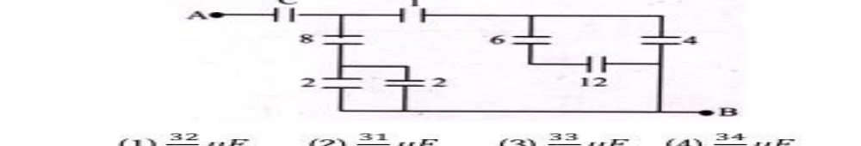
(A) 32/23 μF
(B) 31/23 μF
(C) 33/23 μF
(D) 34/23 μF
Correct Answer: (A)
[REVIEW NOTE: MODERATE CONFIDENCE – this is a known question bank problem; please verify the figure values against the source.]

28. For the circuit shown in the figure, the current I will be ....... A [Figure: 2V and 4V cells with 1Ω, 1Ω and 4Ω resistors in a single loop]
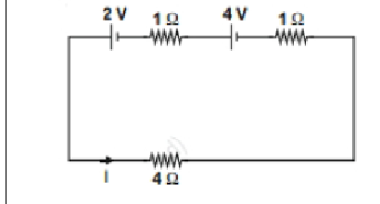
(A) 0.5
(B) 0.75
(C) 1
(D) 1.5
Correct Answer: (C)

29. Which of the following graphs represents the variation of resistivity (ρ) with temperature (T) for copper?
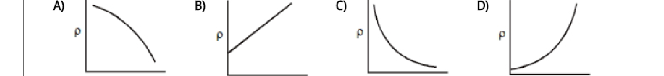
(A) ρ decreasing with T
(B) ρ increasing linearly with T
(C) ρ decreasing sharply then levelling with T
(D) ρ increasing sharply (concave up) with T
Correct Answer: (B)

30. The meter bridge shown is in balanced position with P/Q = l₁/l₂. If we now interchange the positions of the galvanometer and the cell, will the bridge still work? If yes, what will the balance condition be?
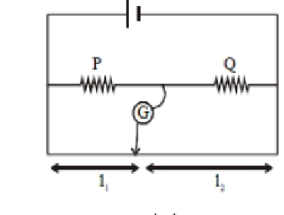
(A) yes, P/Q = (l₂−l₁)/(l₂+l₁)
(B) no, no null point
(C) yes, P/Q = l₂/l₁
(D) yes, P/Q = l₁/l₂
Correct Answer: (D)

31. In the circuits shown below, the readings of the voltmeters and the ammeters will be: Circuit 1 – a 10Ω resistor with an ideal voltmeter V₁ across it and an ideal ammeter A₁ in series, on a 10V battery. Circuit 2 – a 10Ω resistor in series with a second 10Ω resistor that has an ideal voltmeter V₂ across it, and an ideal ammeter A₂, on a 10V battery.
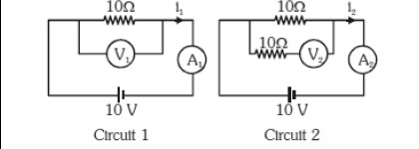
(A) V₂ > V₁ and I₁ = I₂
(B) V₁ = V₂ and I₁ > I₂
(C) V₁ = V₂ and I₁ = I₂
(D) V₂ > V₁ and I₁ > I₂
Correct Answer: (B)
[REVIEW NOTE: MODERATE CONFIDENCE – exact topology inferred from a corrupted figure; please verify against the source.]

32. The resistance of a wire is R ohm. If it is melted and stretched to 'n' times its original length, its new resistance will be
(A) R/n
(B) n²R
(C) R/n²
(D) nR
Correct Answer: (B)

33. The charge flowing through a resistance R varies with time t as Q = at − bt², where a and b are positive constants. The total heat produced in R is
(A) a³R/3b
(B) a³R/2b
(C) a³R/b
(D) a³R/6b
Correct Answer: (D)

34. The potential difference (Vₐ − V_B) between the points A and B in the given figure is ............ V [Figure: A — 2Ω (I=2A) — 3V cell — 1Ω — B]
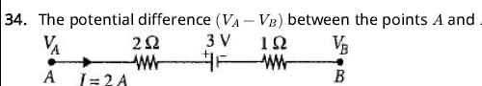
(A) +6
(B) +9
(C) −3
(D) +3
Correct Answer: (B)

35. A, B and C are three points in a uniform electric field. The electric potential is
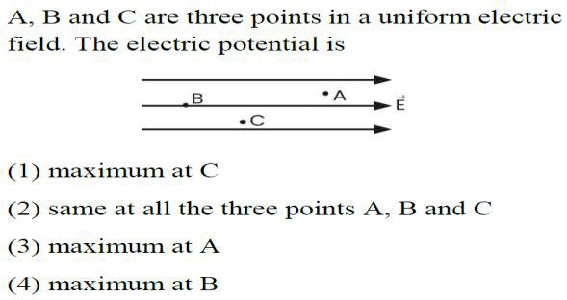
(A) maximum at C
(B) same at all the three points A, B and C
(C) maximum at A
(D) maximum at B
Correct Answer: (D)

36. If the distance between the plates of a parallel plate capacitor is halved and the dielectric constant of the dielectric is doubled, then its capacitance will
(A) increase by 16 times
(B) increase by 2 times
(C) increase by 4 times
(D) remain the same
Correct Answer: (C)

37. The equivalent capacitance between A and B in the figure is [Figure: 1μF||1μF, then 1μF, then 1μF||1μF in series]
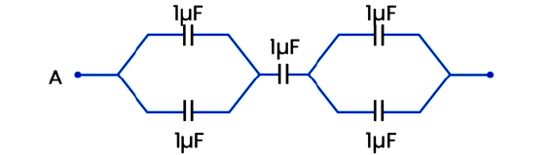
(A) 2μF
(B) 3μF
(C) 5μF
(D) 0.5μF
Correct Answer: (D)

38. The angle between an equipotential surface and an electric line of force is
(A) 0°
(B) 180°
(C) 90°
(D) 270°
Correct Answer: (C)

39. The capacitance between the points A and B in the given circuit will be [Figure: 3μF — (1.5μF || 1.5μF) — 3μF]
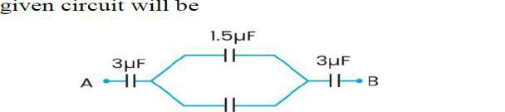
(A) 1μF
(B) 2μF
(C) 3μF
(D) 4μF
Correct Answer: (A)

40. A charge Q is enclosed by a Gaussian spherical surface of radius R. If the radius is doubled, then the outward electric flux will
(A) be doubled
(B) increase four times
(C) be reduced to half
(D) remain the same
Correct Answer: (D)

41. Electric charges of 1 μC, −1 μC and 2 μC are placed in air at the corners A, B and C respectively of an equilateral triangle ABC having each side of length 10 cm. The resultant force on the charge at C is
(A) 0.9 N
(B) 1.8 N
(C) 2.7 N
(D) 3.6 N
Correct Answer: (B)

42. A potential difference of V is applied at the ends of a copper wire of length l and diameter d. On doubling only d, the drift velocity
(A) becomes two times
(B) becomes half
(C) does not change
(D) becomes one fourth
Correct Answer: (C)

43. Which of the following graphs shows the variation of electric field E due to a hollow spherical conductor of radius R as a function of distance from the centre of the sphere?
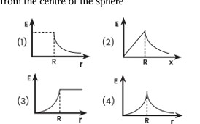
(A) E constant then falls to 0 at R
(B) E = 0 for r<R, peaks at R, falls off as 1/r² beyond R
(C) E rises to a peak exactly at R then drops sharply
(D) E = 0 for r<R, rises gradually, peaks beyond R
Correct Answer: (B)

44. The angle between the dipole moment and the electric field at any point on the equatorial plane is
(A) 90°
(B) 45°
(C) 0°
(D) 180°
Correct Answer: (D)

45. Three equal capacitors, each with capacitance C, are connected as shown in the figure: two in series, in parallel with a third single capacitor directly between A and B. Then the equivalent capacitance between A and B is
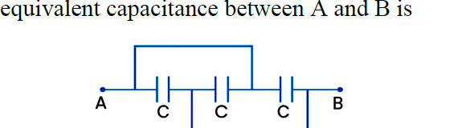
(A) C
(B) 3C
(C) C/3
(D) 3C/2
Correct Answer: (D)

