**Supervised Learning, Unsupervised Learning, and Reinforcement Learning**

**1. Supervised Learning**

Supervised learning is a type of machine learning where the model is trained on a labeled dataset. The dataset consists of input-output pairs, and the goal is for the model to learn the mapping function from inputs to outputs.

**Problem-Solving Techniques:**

* **Classification**: Predicting discrete labels for input data.
  + Example: Email spam detection (Spam or Not Spam).
* **Regression**: Predicting continuous output values.
  + Example: Predicting house prices based on features like size, location, and number of rooms.

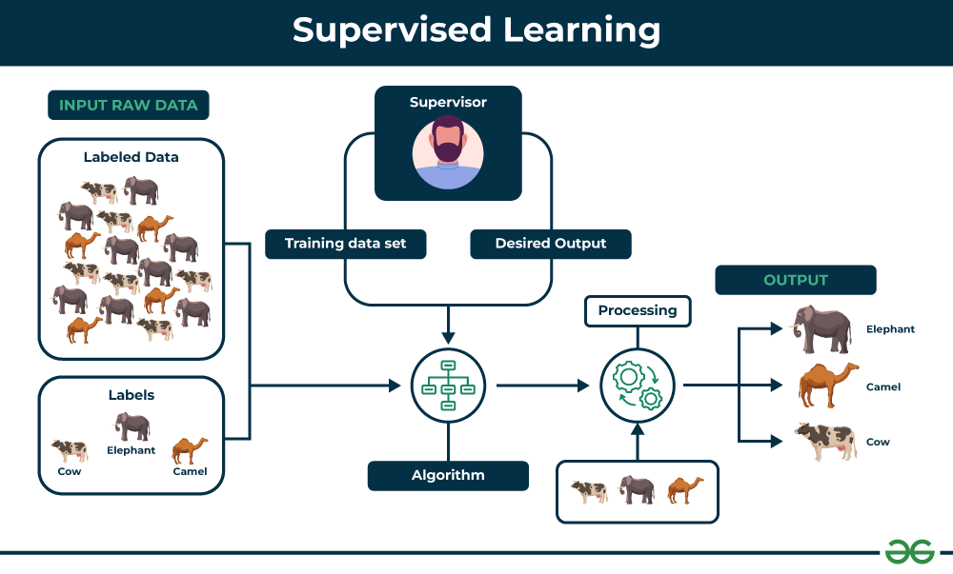

**Key Components of Supervised Learning**

1. **Labeled Dataset:**
   * **Input Data:** The features or attributes that the algorithm uses to make predictions.
   * **Output Labels:** The corresponding values or categories that the algorithm aims to predict.
2. **Learning Algorithm:**
   * The specific method used to learn the mapping between the input data and the output labels.
   * Examples include:
     + **Regression:** Predicting continuous values (e.g., stock prices, house prices).
     + **Classification:** Categorizing data into discrete classes (e.g., spam detection, image recognition).
3. **Training Process:**
   * The algorithm is fed the labeled dataset and iteratively adjusts its internal parameters to minimize the difference between its predicted outputs and the actual labels.
4. **Evaluation:**
   * The trained model is evaluated on a separate set of labeled data (test set) to assess its performance and generalization ability.

**Common Supervised Learning Algorithms:**

**1. Linear Regression**

* **Use case**: Predicting continuous variables (e.g., house prices, stock prices).
* **Concept**: Fits a linear equation to model the relationship between the input (features) and the output (target).

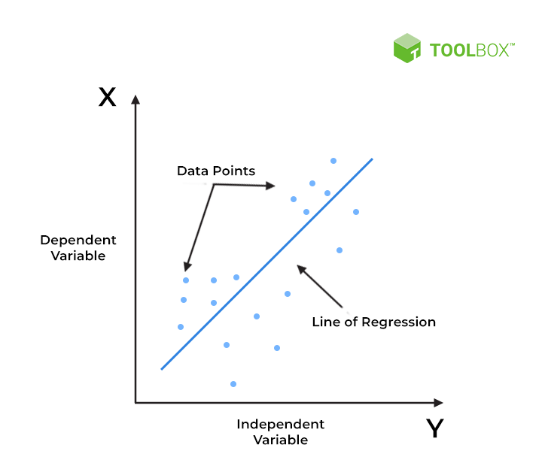

**2. Logistic Regression**

* **Use case**: Binary classification tasks (e.g., spam detection, disease prediction).
* **Concept**: Predicts probabilities and maps them to binary outcomes using the sigmoid function.

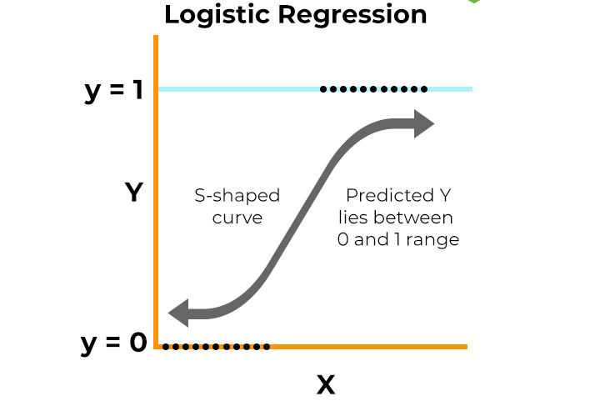

**3. Decision Trees**

* **Use case**: Classification and regression tasks (e.g., customer segmentation, sales forecasting).
* **Concept**: Splits data into branches based on feature values, creating a tree-like structure.

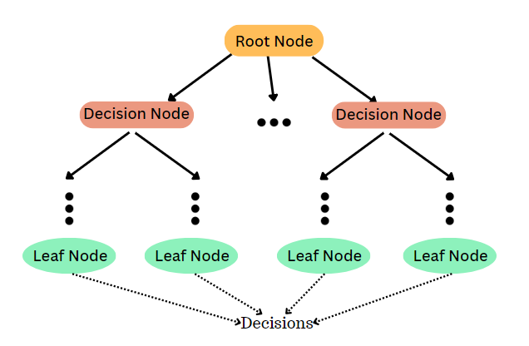

**4. Random Forest**

* **Use case**: Handling overfitting in decision trees, both classification and regression.
* **Concept**: An ensemble of decision trees where each tree votes for the final prediction, improving accuracy and robustnes.

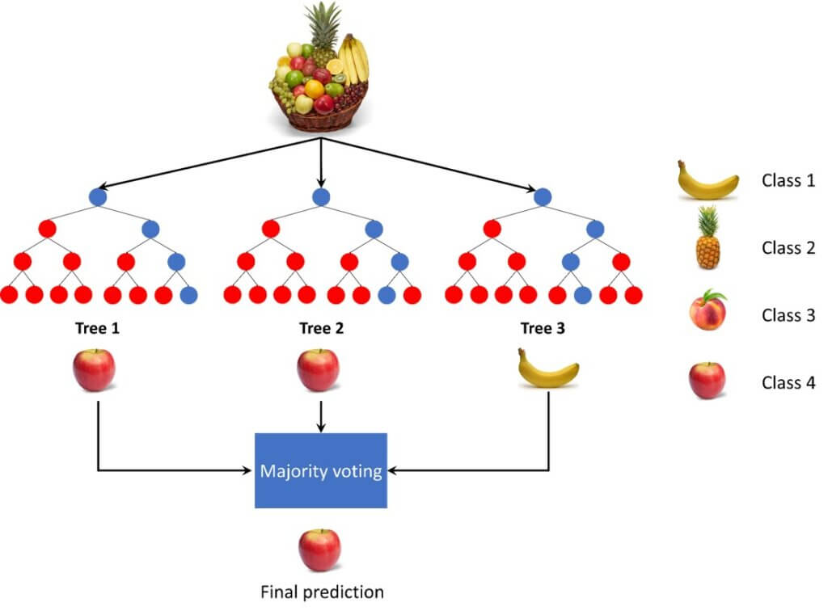

**5. Support Vector Machines (SVM)**

* **Use case**: Classification tasks with high-dimensional data (e.g., image classification).
* **Concept**: Finds the hyperplane that best separates data points of different classes.

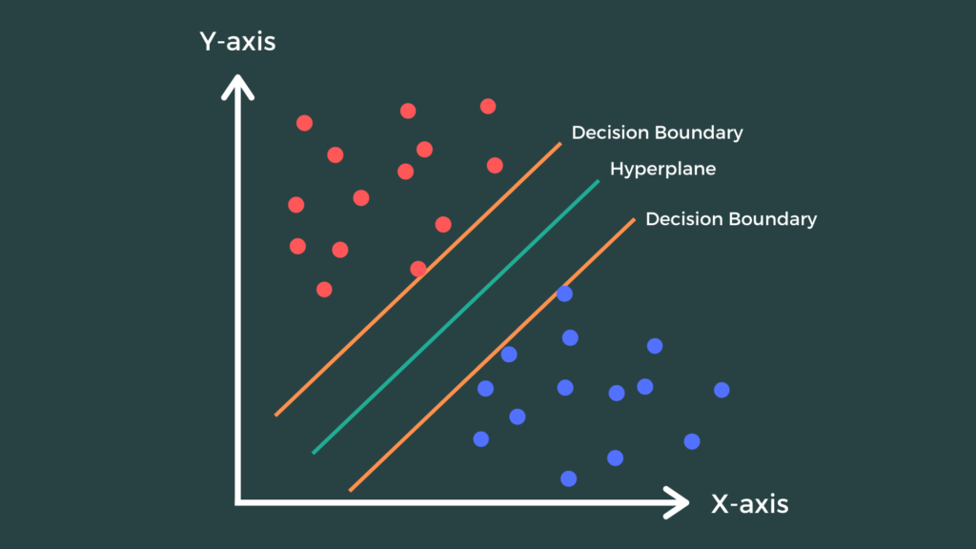

**6. K-Nearest Neighbors (KNN)**

* **Use case**: Simple classification and regression tasks.
* **Concept**: Predicts the target by analyzing the closest kkk neighbors in the feature space.

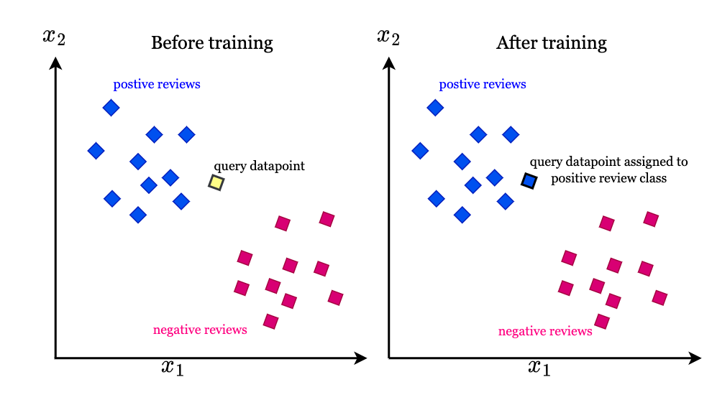

**7. Naive Bayes**

* **Use case**: Text classification, spam filtering, sentiment analysis.
* **Concept**: Based on Bayes’ theorem, assumes independence among predictors.

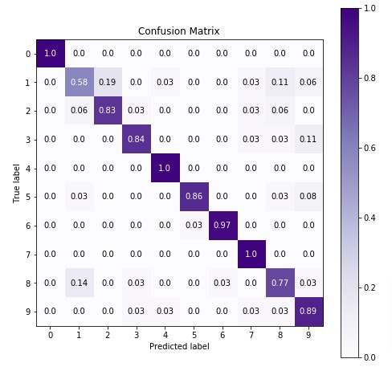

**8. Gradient Boosting Machines (e.g., XGBoost, LightGBM, CatBoost)**

* **Use case**: Highly competitive in Kaggle competitions, used for tabular data.
* **Concept**: Builds models sequentially, where each model corrects errors of the previous one.

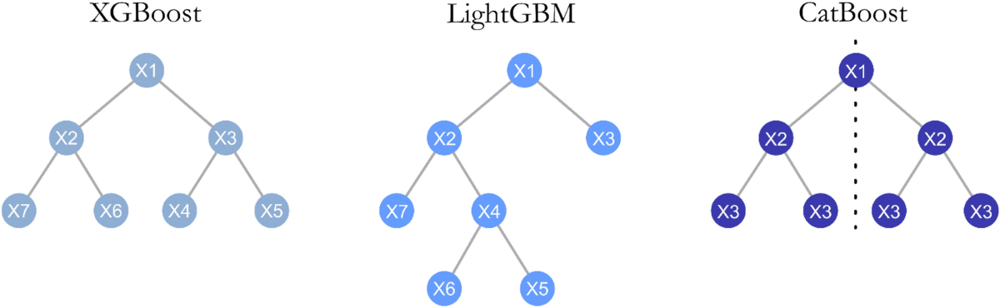

**9. Artificial Neural Networks (ANNs)**

* **Use case**: Complex tasks (e.g., image recognition, speech recognition).
* **Concept**: Inspired by biological neural networks, with multiple layers of interconnected nodes.

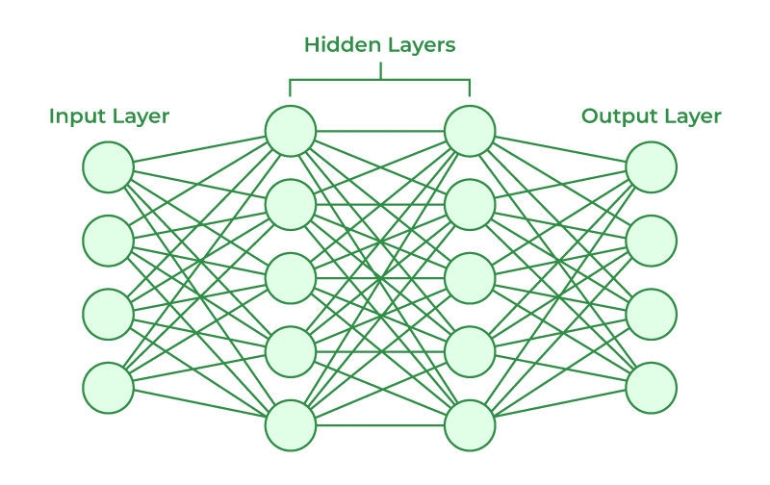

**10. Linear Discriminant Analysis (LDA)**

* **Use case**: Classification tasks, dimensionality reduction.
* **Concept**: Projects data into a space that maximizes class separability.

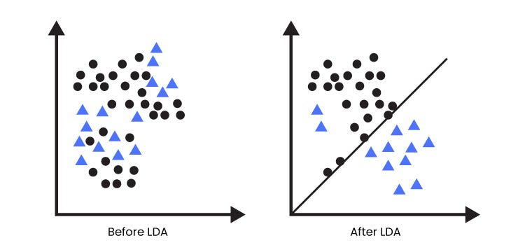

**11. Ridge Regression and Lasso Regression**

* **Use case**: Preventing overfitting in regression models.
* **Concept**: Adds regularization terms to the cost function to shrink coefficients (Ridge uses L2 regularization, Lasso uses L1 regularization).

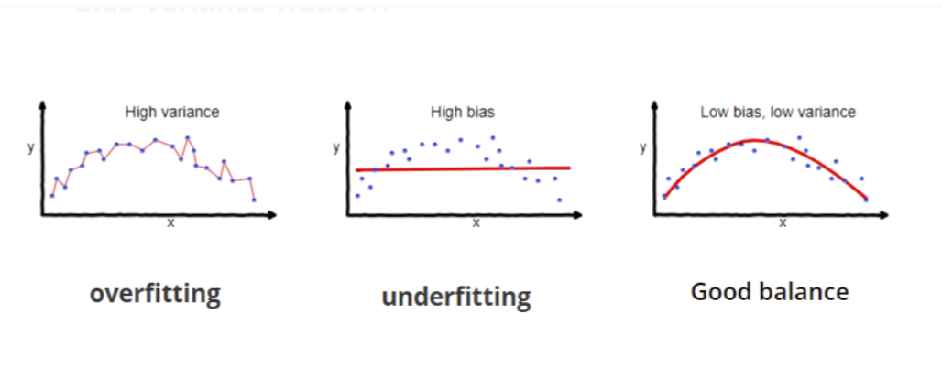

**Applications of Supervised Learning**

* Spam Detection: Classifying emails as spam or not spam.
* Image Recognition: Identifying objects or faces in images.
* Fraud Detection: Detecting fraudulent transactions in financial systems.
* Medical Diagnosis: Predicting the likelihood of a disease based on patient data.
* Customer Churn Prediction: Predicting which customers are likely to leave a service.

**Advantages of Supervised Learning**

* **Predictive Power:** Can make accurate predictions for new data.
* **Versatility:** Applicable to a wide range of problems.
* **Interpretability:** Some models, like decision trees, can be easily interpreted.

**Disadvantages of Supervised Learning**

* **Requires Labeled Data:** Obtaining large, high-quality labeled datasets can be time-consuming and expensive.
* **Overfitting:** Models may overfit the training data, leading to poor performance on unseen data.
* **Bias:** If the training data is biased, the model will also be biased.

**2. Unsupervised Learning**

Unsupervised learning is used on datasets without labeled outputs. The model tries to learn patterns, structures, or distributions from the input data.

**Problem-Solving Techniques:**

* **Clustering**: Grouping data points into clusters based on similarity.
  + Example: Customer segmentation in marketing.
* **Dimensionality Reduction**: Reducing the number of features while retaining the essential information.
  + Example: Visualizing high-dimensional data using Principal Component Analysis (PCA).

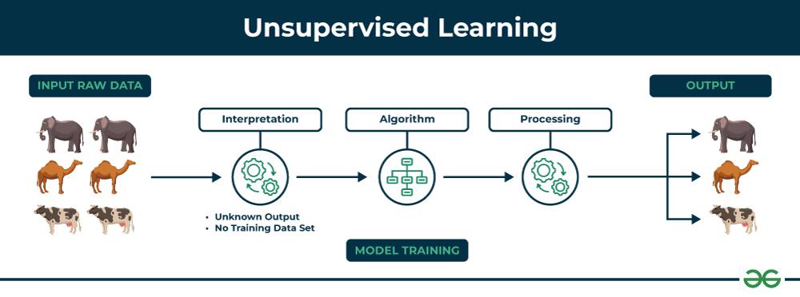

### Key Components of Unsupervised Learning

1. **Unlabeled Dataset:**
   * The data points do not have any associated labels or categories.
2. **Learning Algorithm:**
   * The specific method used to discover patterns and relationships in the unlabeled data.
   * Common examples include:
     + **Clustering:** Grouping similar data points together.
     + **Dimensionality Reduction:** Reducing the number of features in the data while preserving important information.
     + **Anomaly Detection:** Identifying unusual or abnormal data points.
3. **Training Process:**
   * The algorithm analyzes the unlabeled data to identify patterns and structures.
4. **Evaluation:**
   * Evaluating the results of unsupervised learning can be more challenging than supervised learning, as there are no predefined labels to compare against. Techniques like silhouette analysis and domain expertise are often used to assess the quality of the results.

### Common Unsupervised Learning Algorithms

1. **K-Means Clustering:**
   * Partitions data into k clusters, where each data point belongs to the cluster with the nearest mean.
   * **Use Case:** Grouping customers by purchasing behavior.

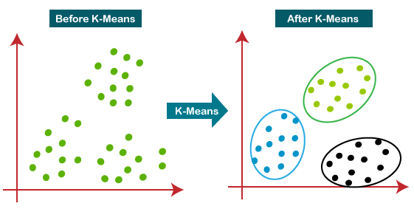

1. **Hierarchical Clustering:**
   * Creates a hierarchical tree-like structure of clusters, where data points are grouped based on their similarity.
   * **Use Case:** Organizing species based on genetic similarity.

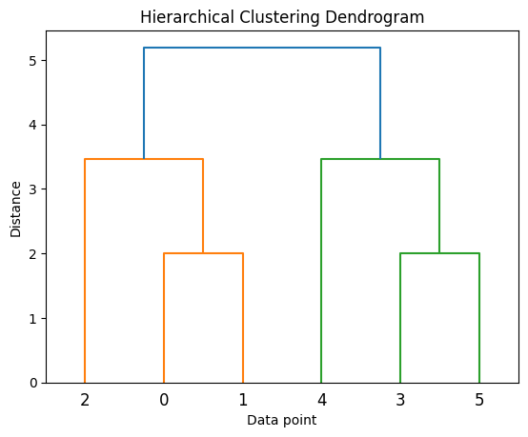

1. **Principal Component Analysis (PCA):**
   * Reduces the dimensionality of data by finding the principal components, which are linear combinations of the original features that capture the most variance.
   * **Use Case:** Simplifying high-dimensional gene expression data for visualization.

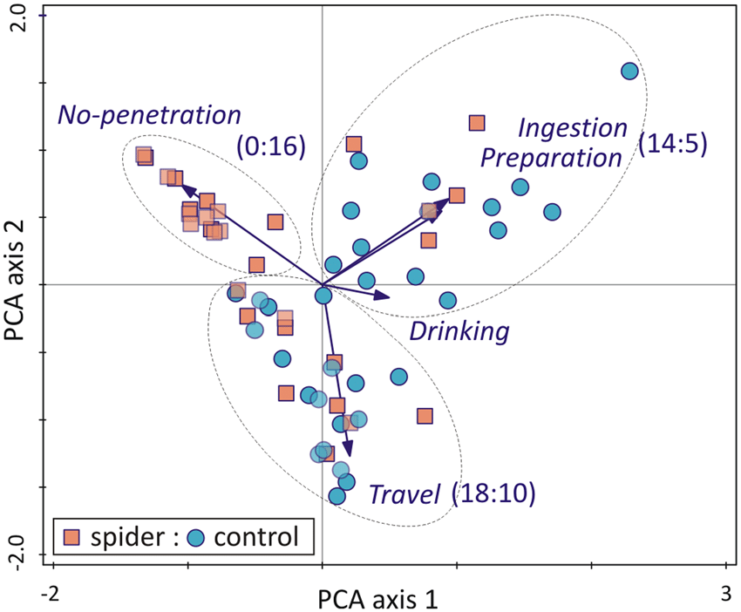

1. **Anomaly Detection:**
   * Identifies unusual or abnormal data points that deviate significantly from the norm.
   * **Use Case:** Detecting fraudulent transactions in financial systems.

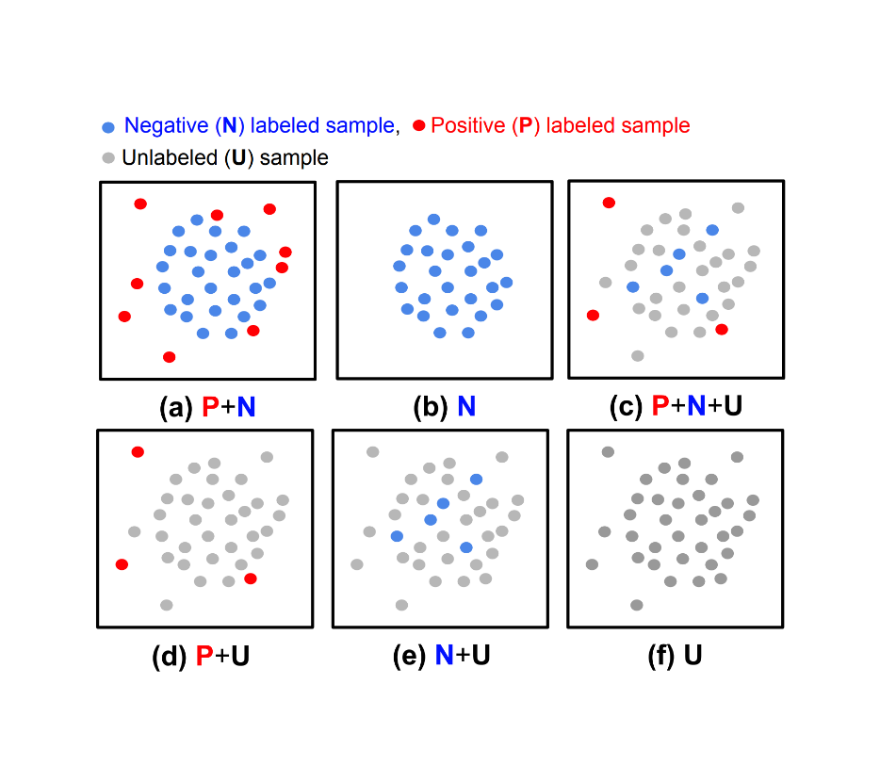

**5. DBSCAN (Density-Based Spatial Clustering of Applications with Noise)**

* **Use case**: Spatial data clustering, anomaly detection.
* **Concept**: Groups data points based on density, identifying clusters of varying shapes and outliers.

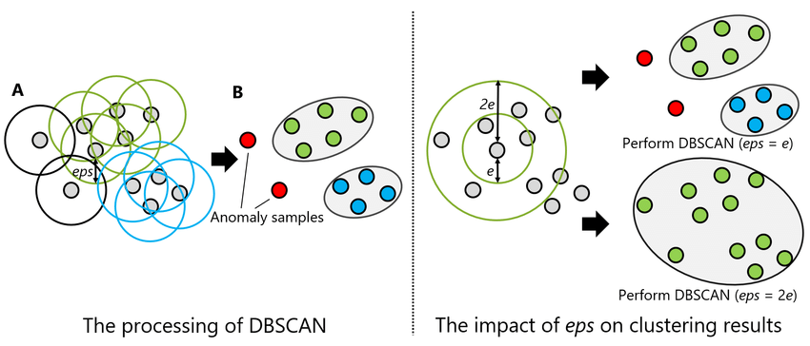

### Applications of Unsupervised Learning

* **Customer Segmentation:** Grouping customers into different segments based on their purchasing behavior.
* **Image Compression:** Reducing the size of images by identifying and removing redundant information.
* **Anomaly Detection in Fraud:** Identifying fraudulent transactions in financial systems.
* **Topic Modeling:** Discovering underlying topics in a collection of documents.
* **Recommendation Systems:** Recommending products or services to users based on their past behavior.

### Advantages of Unsupervised Learning

* **Discover Hidden Patterns:** Can uncover hidden patterns and relationships in data that may not be apparent to human analysts.
* **No Need for Labeled Data:** Eliminates the need for time-consuming and expensive data labeling.
* **Versatility:** Applicable to a wide range of problems, including exploratory data analysis and feature engineering.

### Disadvantages of Unsupervised Learning

* **Evaluation Challenges:** Evaluating the results can be more difficult than supervised learning due to the lack of ground truth labels.
* **Interpretation Challenges:** Understanding the patterns and structures discovered by unsupervised learning algorithms can sometimes be challenging.

**3. Reinforcement Learning**

Reinforcement learning (RL) involves an agent that interacts with an environment to learn a policy for achieving a specific goal. The agent receives rewards or penalties based on its actions and learns to maximize cumulative rewards over time.

**Problem-Solving Techniques:**

* **Markov Decision Processes (MDPs)**: Framework for decision-making in RL.
* **Policy Optimization**: Finding the best action policy directly.
* **Value-Based Methods**: Estimating the value of each action in a given state.

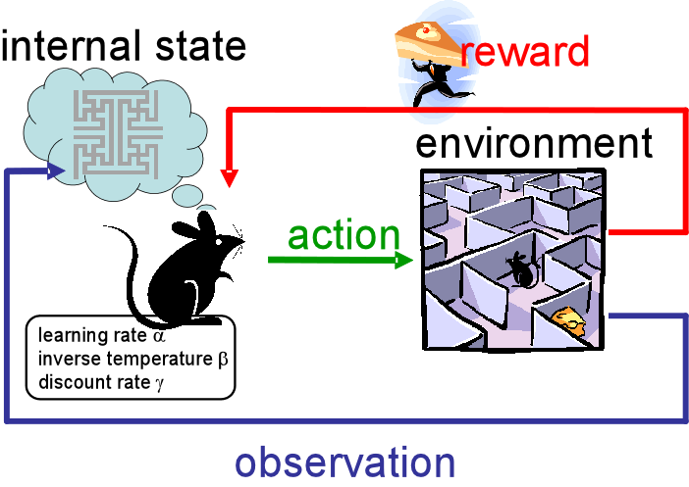

**Key Components of Reinforcement Learning**

1. **Agent:**
   * The decision-making entity that interacts with the environment.
   * It learns a policy to map states to actions.
2. **Environment:**
   * The external world with which the agent interacts.
   * It provides the agent with states and rewards.
3. **State:**
   * A representation of the current situation or condition of the environment.
4. **Action:**
   * A choice made by the agent to interact with the environment.
5. **Reward:**
   * A scalar value that indicates the immediate outcome of an action.
   * Positive rewards encourage actions that lead to desired goals, while negative rewards discourage undesirable actions.
6. **Policy:**
   * A rule or strategy that determines the agent's actions based on the current state.
7. **Value Function:**
   * An estimate of the expected future reward that can be obtained from a given state or state-action pair.

**The Reinforcement Learning Process**

1. **Initialization:** The agent starts in an initial state.
2. **Action Selection:** The agent selects an action based on its current policy.
3. **Environment Transition:** The environment transitions to a new state based on the agent's action.
4. **Reward Signal:** The environment provides a reward signal to the agent based on the action and the new state.
5. **Policy Update:** The agent updates its policy based on the received reward and the observed state-action-reward transitions.

**Common Reinforcement Learning Algorithms**

1. **Q-learning:**
   * Learns an action-value function (Q-value) that estimates the expected future reward for taking a specific action in a given state.

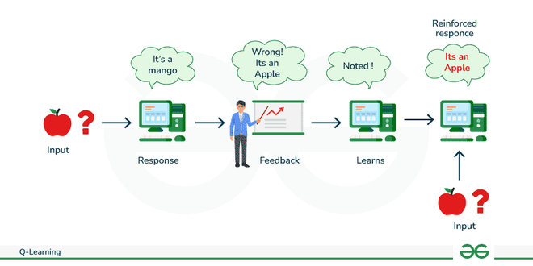

1. **Deep Q-Networks (DQN):**
   * Combines Q-learning with deep neural networks to handle high-dimensional state spaces.

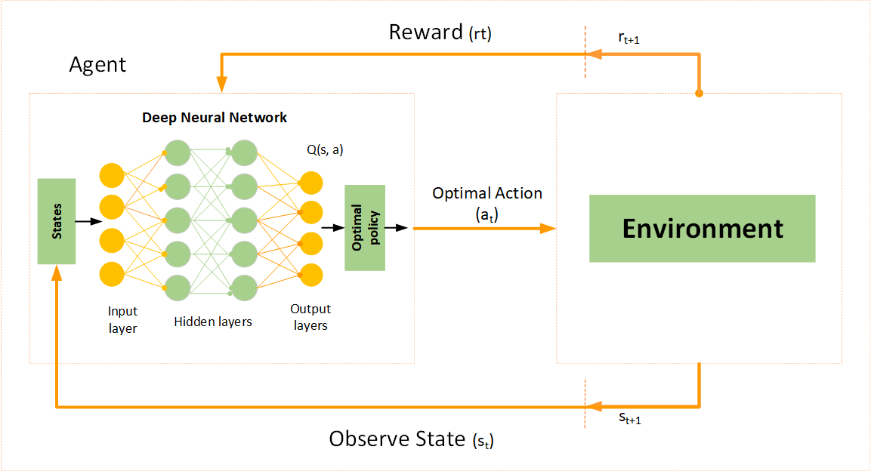

1. **Policy Gradient Methods:**
   * Directly learn a policy function that maps states to actions, often using gradient descent.

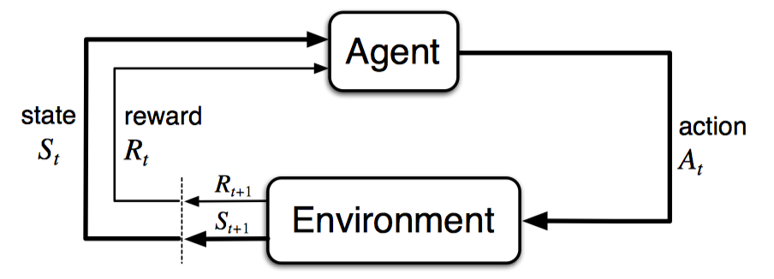

1. **Actor-Critic Methods:**
   * Combine value-based methods (critic) with policy-based methods (actor) to improve learning efficiency.

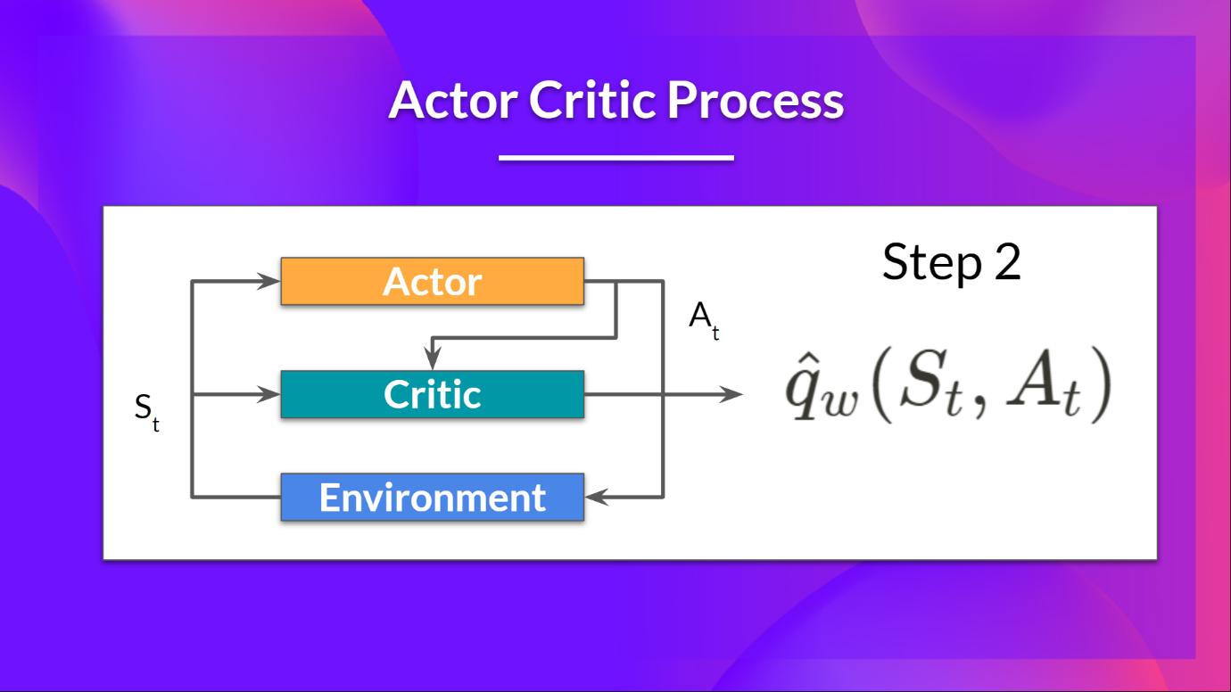

**Applications of Reinforcement Learning**

* **Game Playing:** Training agents to play games like Go, chess, and video games.
* **Robotics:** Controlling robots to perform tasks such as grasping objects, navigating environments, and manipulating objects.
* **Autonomous Driving:** Training self-driving cars to make safe and efficient driving decisions.
* **Recommendation Systems:** Personalizing recommendations for users based on their preferences and past behavior.
* **Finance:** Developing trading algorithms to make optimal investment decisions.

**Advantages of Reinforcement Learning**

* **Goal-Oriented:** Learns to achieve specific goals by maximizing rewards.
* **Adaptable:** Can adapt to changing environments and learn new behaviors.
* **Powerful:** Can solve complex tasks that are difficult to solve with other machine learning methods.

**Disadvantages of Reinforcement Learning**

* **Sample Inefficiency:** Can require a large number of interactions with the environment to learn effectively.
* **Exploration-Exploitation Dilemma:** Balancing exploration of new actions with exploitation of known good actions.
* **Reward Design:** Designing appropriate reward functions can be challenging.