UNT Research and Projects Portal User Guide

**Logging in** **1**

**Logging out** **1**

**Adding a project** **1**

**Editing projects** **3**

**Deleting projects** **5**

**Viewing projects** **5**

**Searching projects** **9**

Search bar 9

Status filters 10

Tag filters 12

**Admin dashboard** **15**

Approve or deny projects 15

Manage users 17

Add or remove admin 18

Editing projects as Admin 19

Search for a project 20

Edit one project 20

Edit multiple projects 22

Import projects 23

Export projects 26

# Pre-requisites:

# User should download “cisco VPN connect” and connect to “UNT VPN” with his/her UNT credentials.

# Graphical user interface, application Description automatically generated Logging in

To access the Login page, click “Login” on the navigation bar.



Upon accessing the Login page, enter your UNT EUID and UNT password. Click

“Submit.”

# Logging out

To log out of the Research and Projects Portal, click the “Logout” button on the navigation bar.

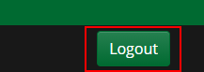

You will be logged out of your account and directed back to the Login page.

# Adding a project

To add a project or a proposal to the website, click “Add Project” on the navigation bar.



Upon accessing the Add Project page, you can fill out a form with your project or proposal’s information. The “Owner Name” and “Contact Information” fields are filled in for you automatically with your UNT credentials. Feel free to change these to suit your project!

An example of a completed form is shown below:

Click “Submit” to submit your project or proposal for review. You will receive a pop-up message for successful submission and your submission will be reviewed by a website administrator (unless you don’t have admin privileges) before it is visible on the website.

# Editing projects

To edit your own project, first click “Profile” on the navigation bar.

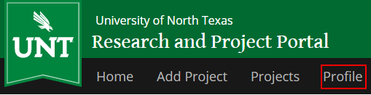

Upon accessing your profile page, identify the project you want to edit. Then, click the “Edit” button on the project card.

You now have access to the Edit Project page. From here, you can edit your project’s information.

Once you’ve made your changes, click “Submit.” Your changes will be reflected on the website.

# Deleting projects

To delete your own project, first click “Profile” on the navigation bar.



Upon accessing your profile page, identify the project you want to edit. Then, click the “Remove” button on the project card. Here I deleted Datetest from the previous image.

Your project will be removed from the website. This change is reflected immediately.

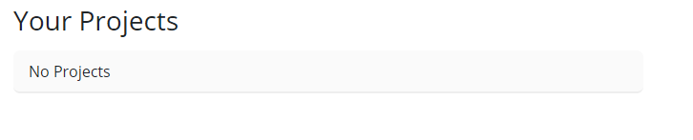

# Viewing projects

To view the projects you’ve submitted, click “Profile” on the navigation bar.



Upon accessing the profile page, you will see all projects that you have submitted.

To view all of the projects on the website, click “Projects” on the navigation bar.

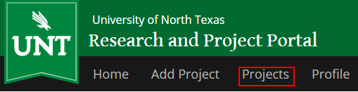

Upon accessing the Projects page, you can see all projects and proposals that have been submitted by users.

To view details about a project, click “More Details” on a project card.

You will be redirected to a page dedicated to that project, which contains that project’s details and the owner’s contact information.

To return to the list of all projects, click “Return to Project List.”

You will be directed back to the Projects page.

# Searching projects

The Projects page offers multiple ways to search for specific projects.

## Search bar

Use the search bar to find a project that has a keyword in its title or description. You can also use the search bar to find projects made by a specific person.

Type in your keyword:

Then press “Go!” to get the search results:

## Status filters

Use status filters to search for projects that are at a specific state of development. You can use multiple status filters to narrow down your search.

Check the boxes that correspond to the kinds of projects you want to see:

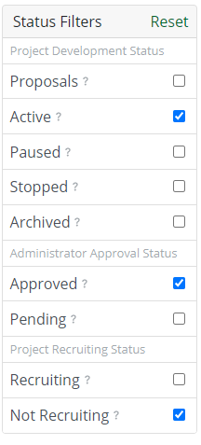

Then search results will appear automatically:

If you wish to set the filters back to their original state, click “Reset.”

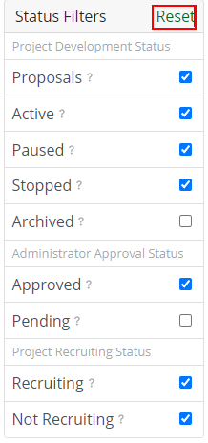

## Tag filters

Use tag filters to search for projects by their tags. You can search for projects that include a tag. You can further narrow the results by specifying tags you do not want to include in your search.

To search for projects with a specific tag, enter the keyword into the first Tag Filters box. Press enter or click the “+” button to add it to your search:

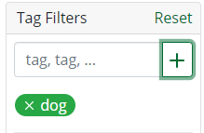

The results will appear automatically:

To exclude a tag from your search results, enter the keyword into the second Tag Filters box. Press enter or click the “-” button to narrow down your search:

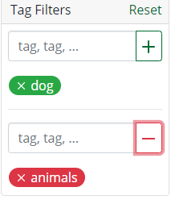

The results will appear automatically (in this case, there are no projects that include the tag “#dog” that **don’t** include the tag “#animal”):



To remove your tag filters, click “Reset.”

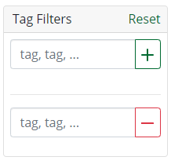

# Admin dashboard

As an administrator, you have access to a suite of tools that will help you manage the Research and Projects Portal.

To access the dashboard, click “Admin” on the navigation bar.

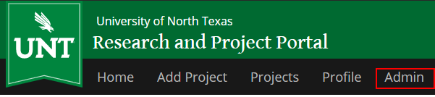

You will be redirected to the Admin Navigation page.

## Approve or deny projects

Use the Pending Projects dashboard to approve or deny potential projects and proposals.

To access this dashboard, click “Pending Projects” on the left sidebar.

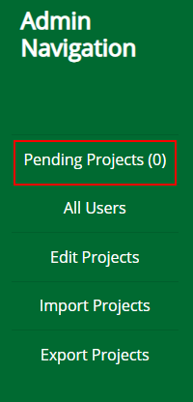

The dashboard shows a queue of projects that need to be reviewed by an admin. The number of projects to be reviewed is indicated on the left sidebar.

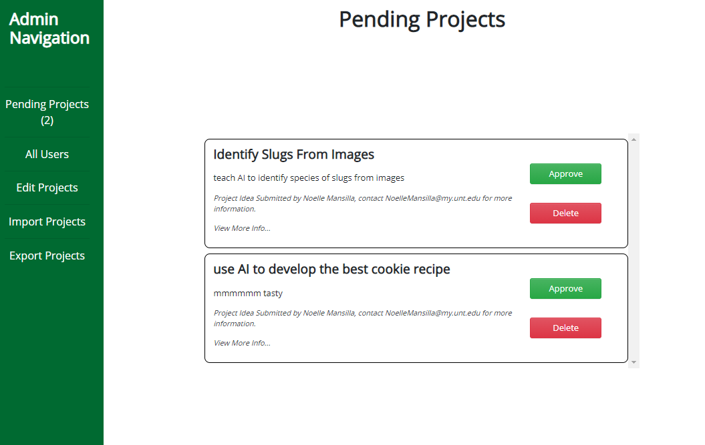

To approve a project, click the “Approve” button.

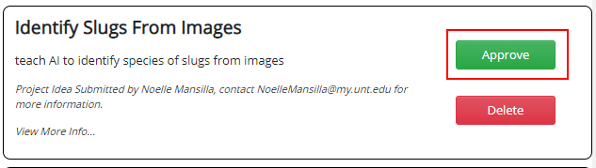

Upon approval, the project will be added to the website and all users will be able to view it from the Projects page.

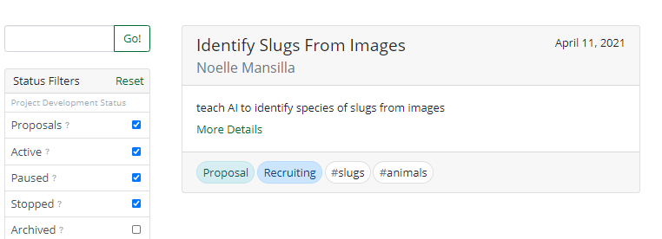

To deny a project, click the “Delete” button.

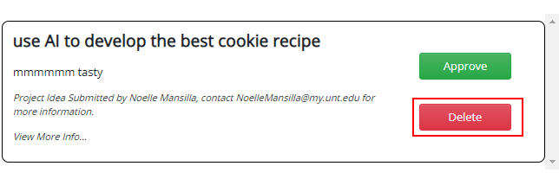

The project will be removed from the dashboard and will not be displayed on the website.

## Manage users

To access the list of all website users, click “All Users” on the left sidebar.

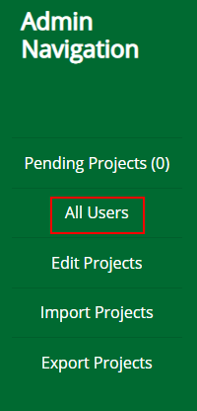

You will see a list of users’ names, EUIDs, and emails.

### Add or remove admin

From the Users page, you can promote or demote a user’s Admin status.

To make a user an admin, identify the user and click “Make Admin” next to their name.

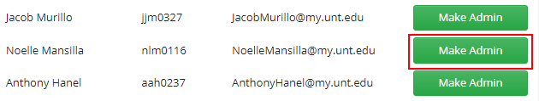

The promoted user will now have access to all Admin functions.

To demote a user from admin status, identify the user and click “Remove Admin” next to their name.

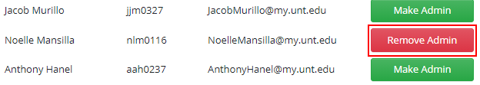

The demoted user will no longer have access to Admin functions.

## Editing projects as Admin

To edit projects as Admin, click “Edit Projects” on the left sidebar.

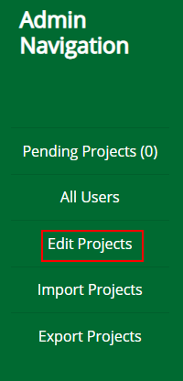

You will see a list of all projects on the website.

The Edit Projects page on the Admin Dashboard offers multiple functions to help you find and edit projects.

### Search for a project

Use the search bar to search for the project(s) you want to edit. You can search by title, owner(s), and tags.

Enter a keyword into the search bar:

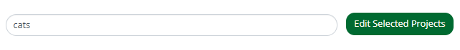

Then the results will appear immediately:

### Edit one project

Identify the project you wish to edit in the list of projects. Click on the project. It will be highlighted in dark grey.

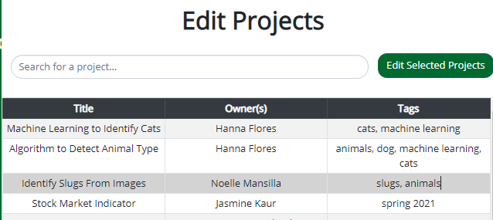

Then, click “Edit Selected Projects.”

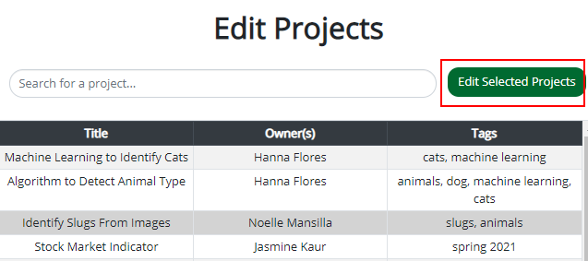

You will then see a window that offers different editing options. From here you can add or remove tags, change the project status, or delete the project.

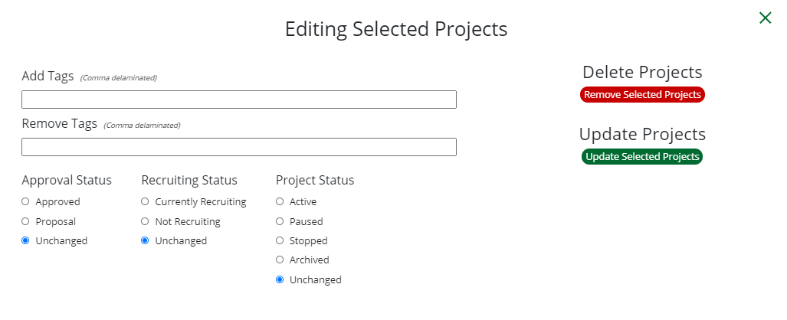

Below is an example of the edit form filled out:

Upon making your changes, click “Update Selected Projects” to submit your edits to the database.

These changes are immediately reflected on the website.



### Edit multiple projects

To batch edit projects, identify the projects you wish to edit. Click each one. Notice that they are highlighted in dark grey.

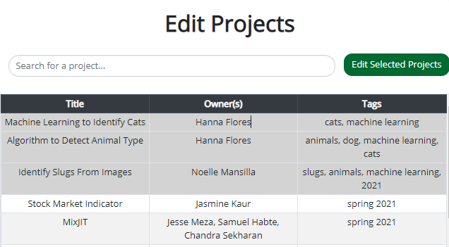

Then, click “Edit Selected Projects.”



You will then see a window that offers different editing options. From here you can add or remove tags, change the projects’ status, or delete the projects.

Refer to the section on editing one project for specifics on editing.

## Import projects

Use the Import Projects tool to add a list of projects to the database.

To access this tool, click “Import Projects” on the left sidebar.

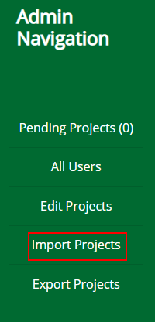

You will be redirected to the Import Projects page.

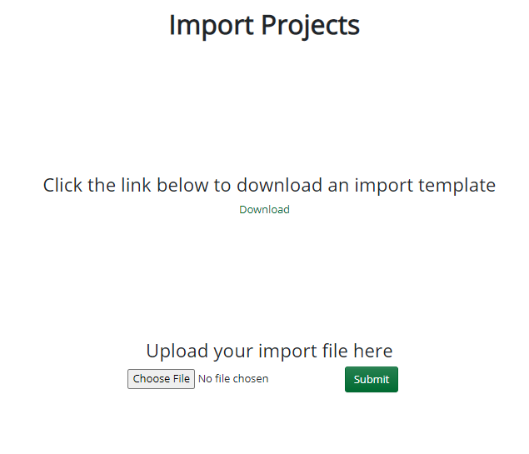

From here, you can download an Excel template. Fill out this template with the projects you wish to import into the website. Below is an example of a filled template.



Save the file. Click “Choose File,” then upload the filled-out template.

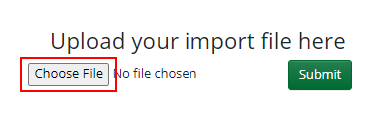

Then click “Submit” to import the projects into the database.

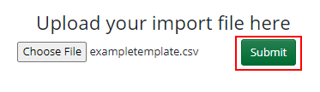

The projects will be added to the website immediately.

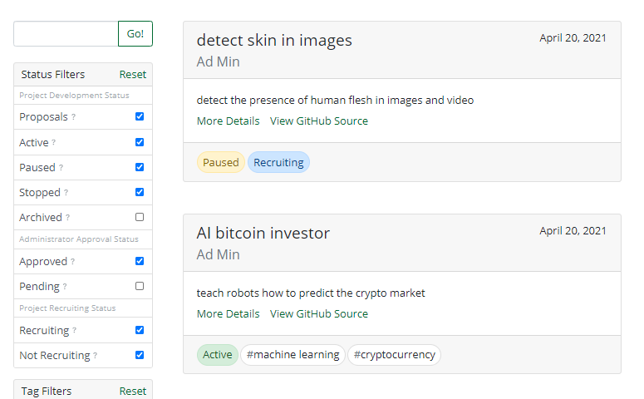

## Export projects

Use the Export Projects tool to export all projects on the website into an Excel spreadsheet.

To access this tool, click “Export Projects” on the left sidebar.

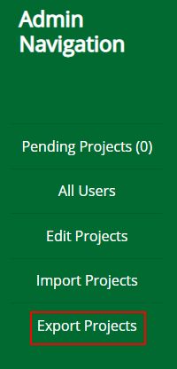

From here, you can download all projects as a .csv spreadsheet. Click “Download.”

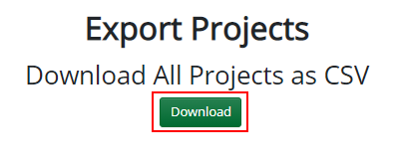

A spreadsheet is downloaded containing every project in the database:

