Mini Project Report on Crime Data Geospatial Analysis
Aim:
To analyze crime data using geospatial techniques and visualize the distribution of crimes across different locations using maps and charts in R.
Scenario / Background:
In recent years, analyzing crime patterns has become important for improving public safety. Police departments collect large amounts of crime data that include location, type of crime, time, and other details.
By using geospatial analysis, we can understand:
- Which areas have higher crime rates
- What types of crimes occur more frequently
- How crime is distributed across locations
This analysis helps authorities in better planning, resource allocation, and crime prevention strategies.
Sample Dataset:
Crime ID | Location | Latitude | Longitude | Crime Type | Time | Victim Age
C101 | Area A | 13.0827 | 80.2707 | Theft | Night | 25
C102 | Area B | 13.0674 | 80.2376 | Assault | Evening | 30
C103 | Area C | 13.0500 | 80.2824 | Robbery | Night | 40
C104 | Area A | 13.0827 | 80.2707 | Theft | Morning | 22
C105 | Area B | 13.0674 | 80.2376 | Burglary | Night | 35

R Program (with line-by-line comments):
Graph: Crime Locations Map
Graph: Victim Age Distribution
Graph: Crime Type Distribution
# ============================================
# Experiment: Crime Data Geospatial Analysis
# ============================================
install.packages(c("ggplot2", "dplyr"))
library(ggplot2)
library(dplyr)
crime_data <- data.frame(
Location = c("Area A","Area B","Area C","Area A","Area B"),
Latitude = c(13.0827,13.0674,13.0500,13.0827,13.0674),
Longitude = c(80.2707,80.2376,80.2824,80.2707,80.2376),
Crime_Type = c("Theft","Assault","Robbery","Theft","Burglary"),
Time = c("Night","Evening","Night","Morning","Night"),
Victim_Age = c(25,30,40,22,35)
)
print(crime_data)
crime_count <- crime_data %>%
group_by(Crime_Type) %>%
summarise(Count = n())
ggplot(crime_count, aes(x = Crime_Type, y = Count, fill = Crime_Type)) +
geom_bar(stat = "identity") +
ggtitle("Crime Type Distribution")
ggplot(crime_data, aes(x = Victim_Age)) +
geom_histogram(binwidth = 5, fill = "blue") +
ggtitle("Victim Age Distribution")
ggplot(crime_data, aes(x = Longitude, y = Latitude, color = Crime_Type)) +
geom_point(size = 3) +
ggtitle("Crime Locations Map")
Output / Observation:
- Theft cases are more frequent compared to other crimes.
- Most victims fall in the age group of 20–40.
- Crimes are concentrated in Areas A and B.
Overall Insight:
Crime is not evenly distributed across locations. Certain areas show higher crime density. Geospatial visualization helps in identifying hotspots.

Graphs Representation :
Geospatial plot :
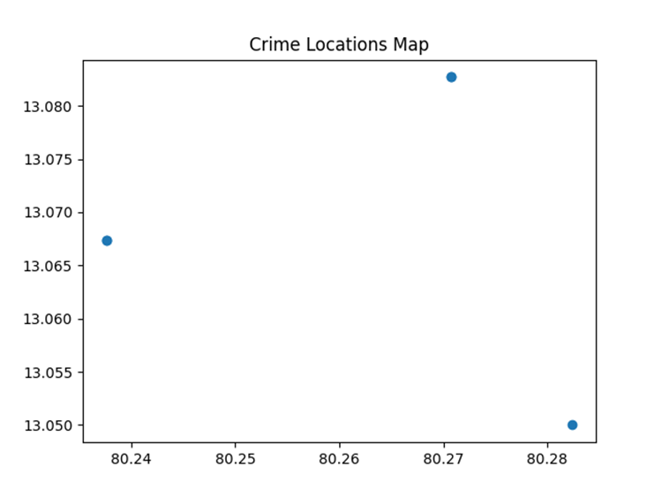

Bar plot:
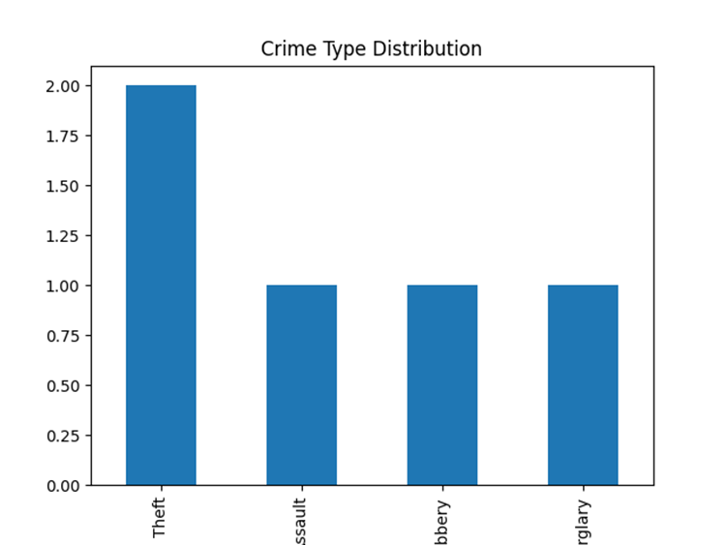
Histograph:

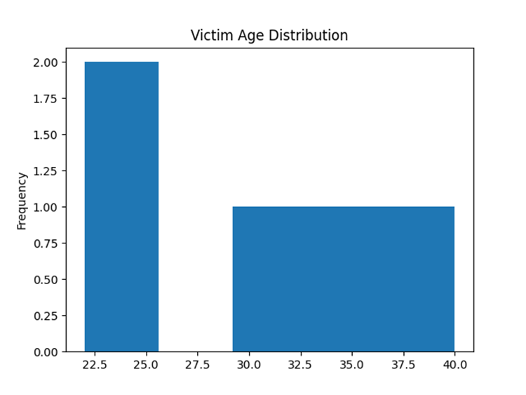
Submitted by:
E.V.S.AKHILA
Reg no: 11249A096
CSE, II Year, IV Semester

