EWB CLOUD NETWORKING | AWS PROJECT CASE STUDY
AWS VPC Peering — Secure Private Communication Between Two Virtual Private Clouds
End-to-End AWS Networking Implementation Using Amazon VPC, EC2, Route Tables, Security Groups, Bastion Host, and VPC Peering
Detail | Information
Name | Eswar Challa
Academic Program | B.Tech — Computer Science and Engineering
Institution | NRI Institute of Technology
Project Program | EWB Cloud Networking
Project Category | AWS Cloud Networking / Cloud Infrastructure
AWS Region | US East (N. Virginia), us-east-1
Project Completion | October 2026
Academic Year / Batch | 1

View Project on GitHub    Scan to open the repository  https://github.com/eswarc440-lgtm/EWB-AWS-VPC-Peering | Watch Project Demonstration    Scan to Watch Project Demo  https://drive.google.com/file/d/1TDjHjTIXCKX _4DxXvPcJrpXFTR3WL7ZD/view?usp=sharing | View pictures    Scan to open the images  https://drive.google.com/drive/folders/1Ih4VyG17SVpJH2dWBdrWzZ9wNR8CEJrR?usp=drive_link
Project overview. I built two isolated AWS networks (VPC A, 10.10.0.0/16, and VPC B, 10.20.0.0/16) and connected them with a VPC peering connection so that private EC2 servers can exchange traffic without using the public internet. A public Bastion Host in VPC A is the only administrative entry point. I verified SSH and ICMP connectivity and used a security-group change to show that access can be blocked and restored.
Table of Contents
About Me 3
1. Project Introduction 3
1.1 Cloud networking and Amazon VPC 3
1.2 AWS VPC Peering and why it is needed 3
1.3 Why routing, isolation and controlled administration matter 3
2. Project Objectives 4
3. Project Architecture 4
3.1 Reading the diagram 5
4. AWS Resource Inventory 5
5. Complete Step-by-Step Project Implementation 6
Step 1 — Select AWS Region and Prepare Environment 6
Step 2 — Create VPC A 7
Step 3 — Create VPC B 7
Step 4 — Create Public and Private Subnets 8
Step 5 — Create and Attach Internet Gateway 9
Step 6 — Configure Route Tables 9
Step 7 — Configure Security Groups 10
Step 8 — Create EC2 Key Pair 11
Step 9 — Launch Three EC2 Instances 12
Step 10 — Configure Bastion-Based SSH Connectivity 13
Step 11 — Test Connectivity Before Peering 14
Step 12 — Create and Accept VPC Peering Connection 15
Step 13 — Configure Peering Routes 15
Step 14 — Test Cross-VPC SSH 17
Step 15 — Test Bidirectional Ping 17
Step 16 — Perform Security Group Restriction Test 18
Step 17 — Troubleshooting and Resolution 20
6. Test Results and Validation 20
7. Security Architecture 21
8. Project Outcomes and Skills Learned 21
9. Conclusion 21

About Me
I am Eshwar, a B.Tech Computer Science and Engineering student at NRI Institute of Technology with an interest in cloud computing, AWS, DevOps and infrastructure automation. I learn best by building real infrastructure rather than relying only on theory, so I treat each lab as a small version of work done in real cloud teams.
In this EWB Cloud Networking project I designed and built two AWS Virtual Private Clouds, connected them with VPC peering, and managed private servers through a Bastion Host. Doing it by hand taught me how route tables, security groups and key-based SSH depend on one another, and how to find the cause of a failure when a connection times out or a login is refused.
This document records what I actually built.

1. Project Introduction

1.1 Cloud networking and Amazon VPC
Cloud networking is the design of addressing, routing and access control for workloads that run on a provider's shared infrastructure. Amazon Virtual Private Cloud (VPC) provides a logically isolated network in which I choose the IPv4 range, divide it into subnets, and decide through route tables, gateways and security groups what may enter or leave.

1.2 AWS VPC Peering and why it is needed
Two VPCs are isolated from each other by default. Application servers in different VPCs, for example in separate teams, environments or accounts, often still need to exchange data. Sending that traffic across the public internet would require public IP addresses, internet gateways and exposed ports for what are really private services.
A VPC peering connection is a private networking link between two VPCs. Traffic uses private IPv4 addresses and stays on the AWS network. It works only when the CIDR blocks do not overlap, and each side must add a route to the other's CIDR. Peering is one-to-one and non-transitive: VPC B cannot reach the internet through VPC A's Internet Gateway.

1.3 Why routing, isolation and controlled administration matter
- Routing decides whether a packet has a path; without both forward and return routes, replies are lost.
- Isolation limits the blast radius: private subnets have no public IPv4 address and no internet route.
- Security groups allow only named sources and ports, for example SSH from a single Bastion address.
- Controlled administration through one Bastion Host gives a single, auditable entry point.
This pattern (public jump host, private application tiers, private links between networks) is widely used for connecting environments such as shared services and application networks, and it is the pattern I practised here.

2. Project Objectives
# | Objective | What it means in this project
1 | Design two non-overlapping VPCs | 10.10.0.0/16 and 10.20.0.0/16 so that peering and routing are unambiguous.
2 | Create public and private subnets | One public and one private subnet in VPC A; one private subnet in VPC B.
3 | Configure an Internet Gateway | Attached to VPC A only, to give the Bastion controlled public access.
4 | Create custom route tables | Three tables with explicit subnet associations.
5 | Configure restrictive security groups | SSH and ICMP allowed only from specific /32 sources.
6 | Launch three Amazon Linux 2023 instances | Bastion, App-A and App-B with fixed private IPs.
7 | Configure the Bastion Host | Public SSH entry point for administration.
8 | Establish VPC peering | Requester VPC A, accepter VPC B.
9 | Configure forward and return routes | 10.20.0.0/16 and 10.10.0.0/16 toward the peering connection.
10 | Verify SSH and private IPv4 communication | Through the Bastion and across the peering link.
11 | Test bidirectional ICMP | App-A ↔ App-B.
12 | Demonstrate security-group enforcement | Block, then restore, ICMP.

3. Project Architecture
Figure 1 shows the implemented topology. It is the architecture diagram I prepared from my verified addressing; it contains no NAT Gateway, VPN or Transit Gateway, and no Internet Gateway in VPC B.
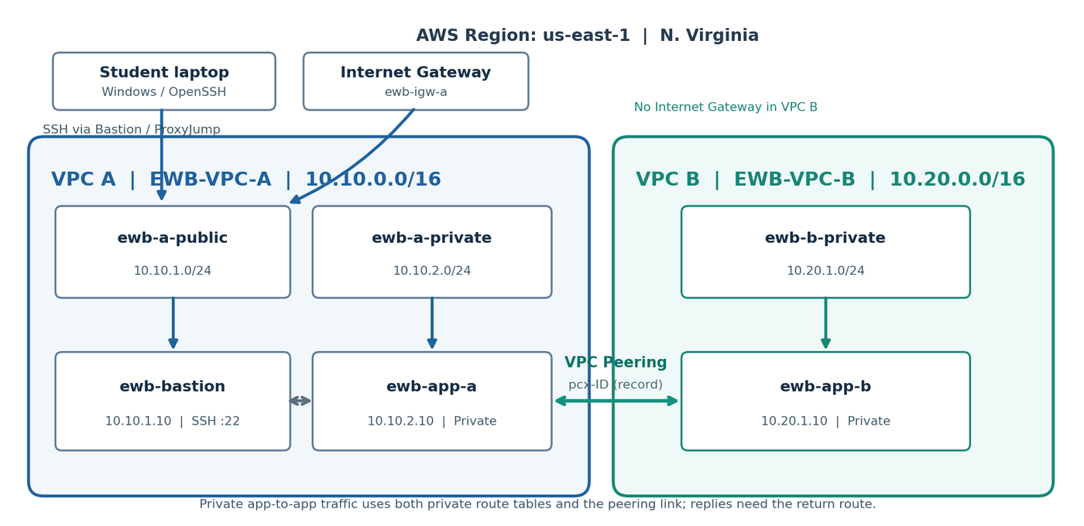
Figure 1 — Implemented architecture: VPC A, VPC B and the peering connection.

3.1 Reading the diagram
Path | Route / protocol | Explanation
Internet access | Laptop → Internet Gateway → Bastion (10.10.1.10) | Only the Bastion has a public IPv4 address. SSH TCP 22 is allowed from my IP /32.
Administrative SSH | Windows OpenSSH → Bastion → ProxyJump → App-A / App-B | Private servers are reached only through the Bastion.
Private subnet routing | 10.10.2.0/24 and 10.20.1.0/24 use local and peering routes only | No internet route exists in the private tables.
VPC peering traffic | 10.10.0.0/16 ⇄ 10.20.0.0/16 via pcx-030bd25f0281f630b | App-A ⇄ App-B and Bastion → App-B use private IPs over the peering link.

The Bastion reaches App-A over the local VPC route. It reaches App-B because its public-subnet route table also points 10.20.0.0/16 to the peering connection. App-A reaches App-B through the private route table, and App-B answers through the return route 10.10.0.0/16 in its own table.

4. AWS Resource Inventory
IDs come from my resource ID checklist; the Bastion ID and VPC A ID also appear in the earlier screenshots shown in Steps 2 and 9. Name tags use the capitalization in my checklist. Because I do not have a final console screenshot of every Name tag, the Name tags are recorded rather than independently verified. The tags column reflects the Project and Student tags I reported applying and also needs console confirmation.
Resource Type | Name Tag | AWS Resource ID | CIDR / Private IP / Rules | Purpose
VPC | EWB-VPC-A | vpc-025f1e8a60245f7f7 | 10.10.0.0/16 | VPC A: bastion and App-A network
VPC | EWB-VPC-B | vpc-0a67933e51932d54a | 10.20.0.0/16 | VPC B: App-B network
Subnet | EWB-A-Public | subnet-08884a98bf6d425c0 | 10.10.1.0/24 | Public subnet, hosts Bastion
Subnet | EWB-A-Private | subnet-0f9840d1e555172f5 | 10.10.2.0/24 | Private subnet, hosts App-A
Subnet | EWB-B-Private | subnet-0d7e793714dc6b0e9 | 10.20.1.0/24 | Private subnet, hosts App-B
Internet Gateway | EWB-IGW-A | igw-0138ee3d13148271e | Attached to VPC A | Public access for Bastion
Route table | EWB-RT-A-Public | rtb-079e496611e46fc49 | Local; 0.0.0.0/0 → IGW; 10.20.0.0/16 → pcx | Public subnet routing
Route table | EWB-RT-A-Private | rtb-08121b2fad18adf64 | Local; 10.20.0.0/16 → pcx | Private A routing
Route table | EWB-RT-B-Private | rtb-0a943aa779c4ea10a | Local; 10.10.0.0/16 → pcx | Private B routing (return route)
Security group | EWB-SG-Bastion | sg-0be7a9a02cef375f9 | SSH from operator /32 | Bastion firewall
Security group | EWB-SG-App-A | sg-0f2fecf03335ea921 | SSH 10.10.1.10/32; ICMP 10.20.1.10/32 | App-A firewall
Security group | EWB-SG-App-B | sg-05a15b1a1dc2b5792 | SSH 10.10.1.10/32; ICMP 10.10.2.10/32 | App-B firewall
EC2 instance | EWB-Bastion | i-08bc2aed2f29417f8 | 10.10.1.10 (public 44.198.160.108 at test time) | Public SSH entry point
EC2 instance | EWB-App-A | i-063a73f819567ff3b | 10.10.2.10 | Private application server A
EC2 instance | EWB-App-B | i-0b82dbab3f422fb5d | 10.20.1.10 | Private application server B
VPC peering | EWB-A-B-Peer | pcx-030bd25f0281f630b | 10.10.0.0/16 ⇄ 10.20.0.0/16 | Private VPC-to-VPC link

5. Complete Step-by-Step Project Implementation
Each step follows the same structure: objective, AWS service, procedure, configuration, internal behaviour, necessity, evidence and result. Evidence is labelled honestly: real screenshots, transcribed terminal text, or a placeholder where I have not yet inserted the capture.

Step 1 — Select AWS Region and Prepare Environment
Objective: I wanted a single, consistent AWS Region in which to build and test all resources.
AWS Service Used: AWS Management Console — Region selector; Amazon EC2 and Amazon VPC service consoles.
Implementation Procedure: I signed in to the AWS Management Console, switched the Region selector to US East (N. Virginia) and confirmed that the VPC and EC2 consoles both showed us-east-1 before creating anything. Earlier in the project an EC2 launch/availability problem in another Region led me to rebuild the environment here (see Step 17).
Configuration Details: Region: us-east-1. Prerequisites: AWS account access, a local Windows machine with OpenSSH, and a planned address scheme (10.10.0.0/16 and 10.20.0.0/16). My first draft diagram used 28.x.x.x ranges; I replaced these with RFC 1918 private ranges.
What Happens Internally: Every VPC, subnet and instance is a Regional or Availability-Zone resource. A VPC peering connection between VPCs in the same Region and account is the simplest form of peering, so staying in one Region keeps the design simple.
Why This Step Is Necessary: Resources created in different Regions are invisible to each other in the console and cannot be mixed into one VPC. A single Region also keeps cost and cleanup manageable: running instances, EBS volumes and public IPv4 addresses are billable, so I planned to delete everything after evidence was captured.
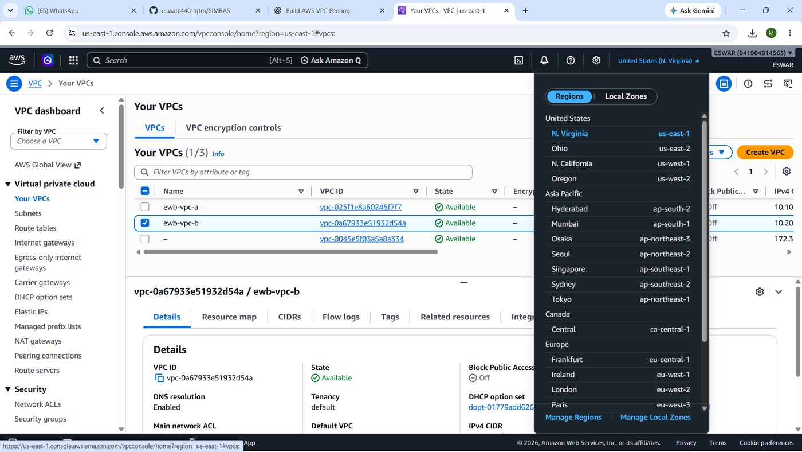
Figure 2 — Region selector set to US East (N. Virginia).
Result / Verification: Region fixed as us-east-1 for all later steps. Evidence of the Region setting appears in the console header of later screenshots once supplied; none is currently available.

Step 2 — Create VPC A
Objective: Create the first isolated network that holds the Bastion Host and the private App-A server.
AWS Service Used: Amazon VPC — Your VPCs → Create VPC.
Implementation Procedure: In the VPC console I chose Create VPC, selected "VPC only", entered the Name tag and the IPv4 CIDR block, left IPv6 disabled and default tenancy, and created it.
Configuration Details: Name tag: EWB-VPC-A (shown as Project-VPC-A in the original screenshot, before renaming). IPv4 CIDR: 10.10.0.0/16. VPC ID: vpc-025f1e8a60245f7f7. Tenancy: default. DNS resolution: enabled.
What Happens Internally: AWS provisions a logically isolated virtual network with a main route table containing one local route for 10.10.0.0/16, a default network ACL and a default security group. Nothing outside the VPC can reach it until gateways and routes are added.
Why This Step Is Necessary: VPC A is the administrative side of the lab: it hosts the only public entry point (the Bastion) and one private workload.
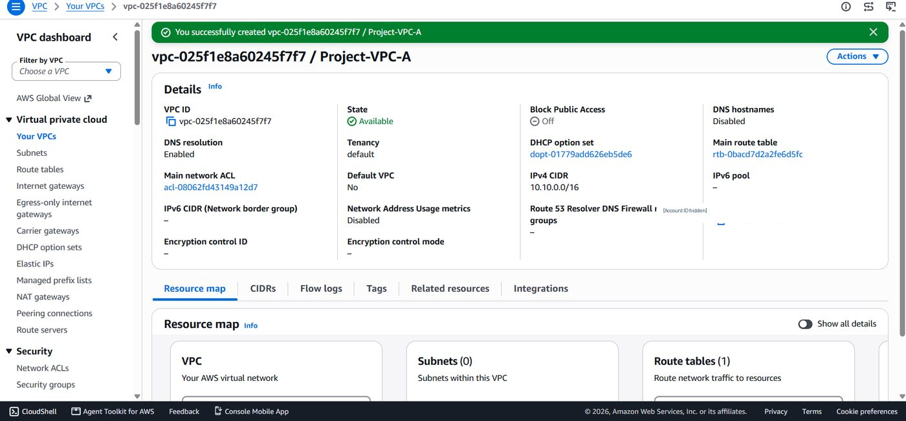
Figure 3 — VPC A creation confirmation: vpc-025f1e8a60245f7f7, State Available, IPv4 CIDR 10.10.0.0/16. This is historical evidence captured before renaming, so the Name tag reads Project-VPC-A; the current tag is recorded as EWB-VPC-A.
Result / Verification: VPC A was created and reached the Available state with CIDR 10.10.0.0/16, verified in the screenshot above. The VPC ID matches the ID I recorded earlier.

Step 3 — Create VPC B
Objective: Create a second, separate network for the remote private workload.
AWS Service Used: Amazon VPC — Your VPCs → Create VPC.
Implementation Procedure: I repeated the VPC creation using a different CIDR block so that the two networks would not overlap.
Configuration Details: Name tag: EWB-VPC-B. IPv4 CIDR: 10.20.0.0/16. VPC ID: vpc-0a67933e51932d54a (from the resource ID checklist).
What Happens Internally: VPC B receives its own local route (10.20.0.0/16) and its own default security group and network ACL. 10.10.0.0/16 and 10.20.0.0/16 share no addresses, so a route for one range can never be confused with the other.
Why This Step Is Necessary: AWS rejects peering between VPCs whose CIDR blocks overlap, and routing would be ambiguous. Planning non-overlapping ranges before building is a core cloud-networking habit.
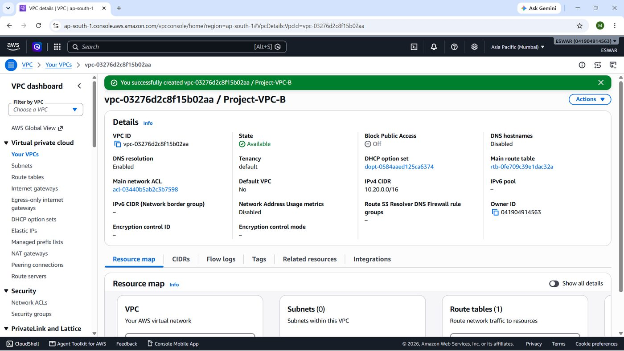
Figure 4 — VPC B details.
Result / Verification: VPC B created with 10.20.0.0/16. The ID is taken from my resource checklist; a console screenshot is still required as direct proof.

Step 4 — Create Public and Private Subnets
Objective: Divide the VPCs into one public and one private subnet in VPC A, and one private subnet in VPC B.
AWS Service Used: Amazon VPC — Subnets → Create subnet.
Implementation Procedure: For each subnet I chose the parent VPC, a Name tag and an IPv4 CIDR block inside the VPC range. I did not enable auto-assignment of public IPv4 addresses on the two private subnets.
Configuration Details: EWB-A-Public — subnet-08884a98bf6d425c0 — 10.10.1.0/24 (VPC A). EWB-A-Private — subnet-0f9840d1e555172f5 — 10.10.2.0/24 (VPC A). EWB-B-Private — subnet-0d7e793714dc6b0e9 — 10.20.1.0/24 (VPC B).
What Happens Internally: A subnet is a slice of a VPC's address space placed in one Availability Zone. AWS reserves five addresses in each subnet, so I used fixed host addresses (.10) for the instances. A subnet is "public" only because of the route table associated with it (Step 6).
Why This Step Is Necessary: Splitting public and private tiers lets me expose only the Bastion and keep application servers unreachable from the internet.
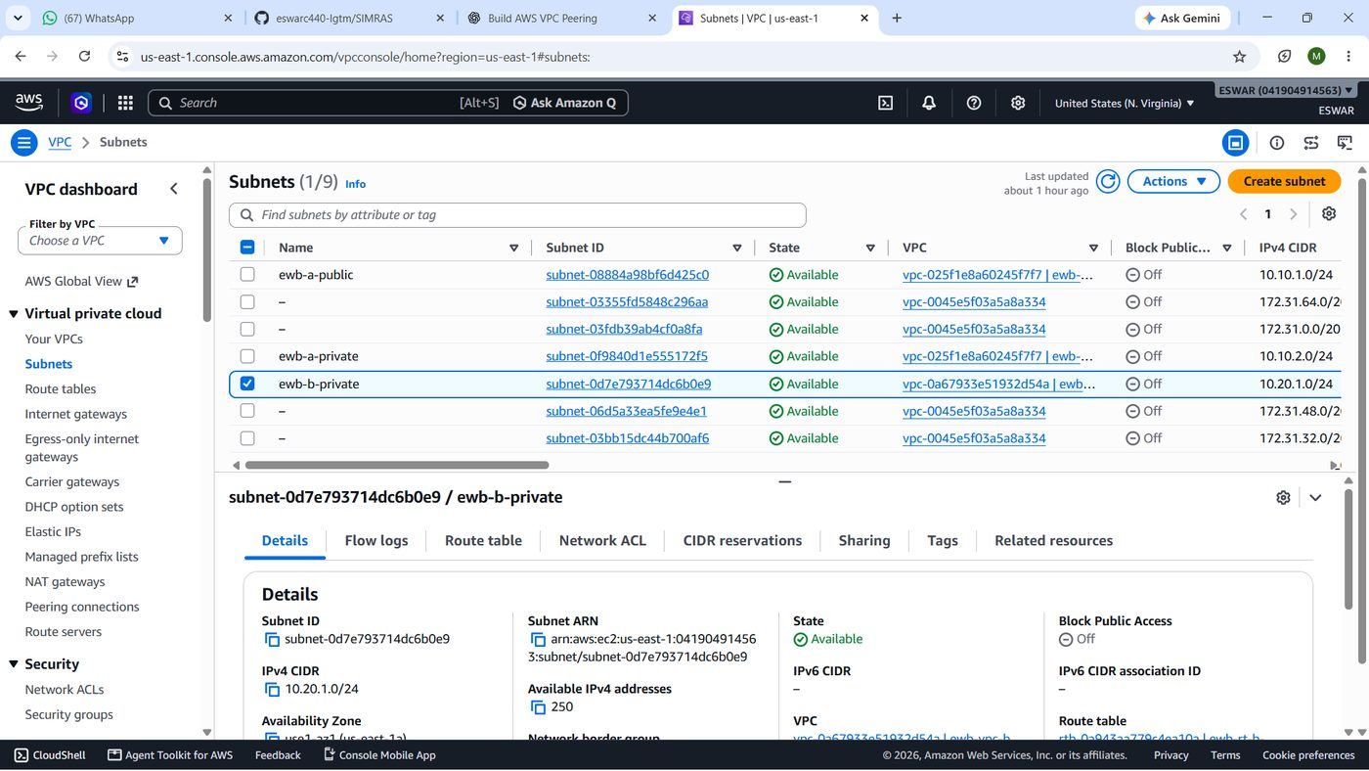
Figure 5 — Subnet list: EWB-A-Public, EWB-A-Private, EWB-B-Private.
Result / Verification: Three subnets recorded with the IDs and CIDRs above (source: resource ID checklist and diagram).

Step 5 — Create and Attach Internet Gateway
Objective: Give VPC A a controlled path to the internet so I can SSH to the Bastion.
AWS Service Used: Amazon VPC — Internet gateways → Create internet gateway → Attach to VPC.
Implementation Procedure: I created an Internet Gateway, then used Actions → Attach to VPC and selected VPC A only.
Configuration Details: Name tag: EWB-IGW-A. ID: igw-0138ee3d13148271e. Attached to: EWB-VPC-A. No Internet Gateway, NAT Gateway, VPN or Transit Gateway exists in VPC B in my evidence.
What Happens Internally: The IGW performs one-to-one NAT between a public IPv4 address and an instance's private address. It only carries traffic when a subnet route points to it and the instance has a public address.
Why This Step Is Necessary: Without the IGW the Bastion would be unreachable from my laptop. Leaving it out of VPC B keeps VPC B private.
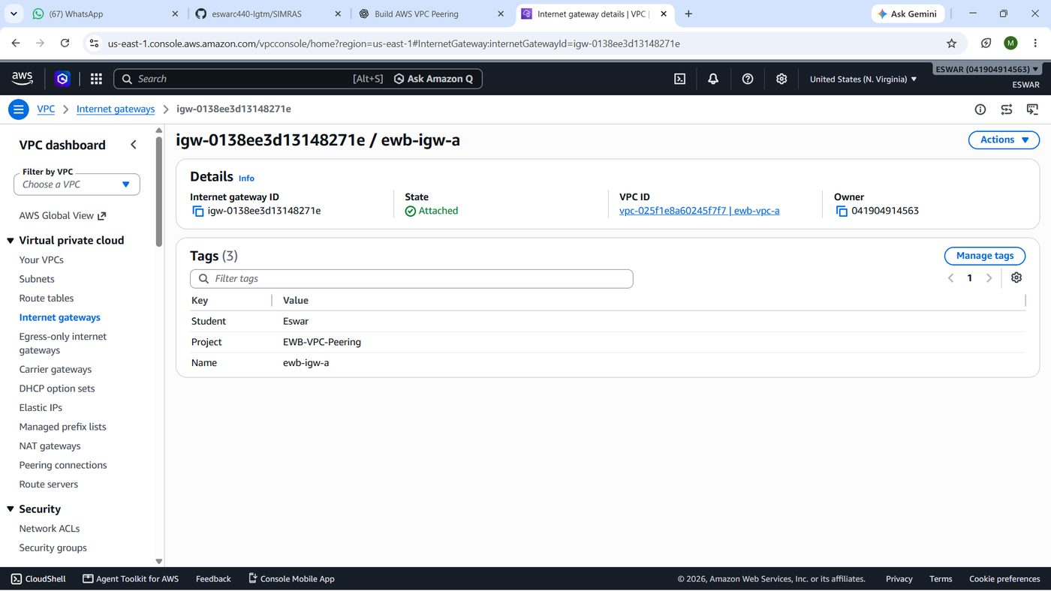
Figure 6 — Internet Gateway attached to VPC A.
Result / Verification: IGW igw-0138ee3d13148271e recorded as attached to VPC A.

Step 6 — Configure Route Tables
Objective: Control where traffic from each subnet is sent.
AWS Service Used: Amazon VPC — Route tables → Create route table, Edit routes, Edit subnet associations.
Implementation Procedure: I created three custom route tables, explicitly associated each with its subnet, and added a default route to the Internet Gateway in the public table. Peering routes were added later in Step 13.
Configuration Details: EWB-RT-A-Public (rtb-079e496611e46fc49) → EWB-A-Public: local 10.10.0.0/16; 0.0.0.0/0 → igw-0138ee3d13148271e. EWB-RT-A-Private (rtb-08121b2fad18adf64) → EWB-A-Private: local only at this stage. EWB-RT-B-Private (rtb-0a943aa779c4ea10a) → EWB-B-Private: local 10.20.0.0/16 only at this stage.
What Happens Internally: Each VPC route table always has an implicit local route. Longest-prefix match decides the next hop: local traffic stays inside the VPC, 0.0.0.0/0 sends everything else to the IGW. The private tables have no default route, so those subnets have no internet path.
Why This Step Is Necessary: Routing, not the subnet name, defines public versus private. The private tables must stay free of an IGW route.
Figure 7 — Route table subnet associations. (No screenshot supplied.)
Result / Verification: Three custom route tables and their associations are recorded in the checklist and diagram. The route entries themselves are evidenced after peering in Step 13 (screenshots pending).

Step 7 — Configure Security Groups
Objective: Allow only the specific SSH and ICMP flows the lab needs.
AWS Service Used: Amazon EC2 — Security Groups → Create security group; Edit inbound rules.
Implementation Procedure: I created one security group per instance role in the correct VPC and added narrow inbound rules. I left the default outbound allow-all rule in place.
Configuration Details: EWB-SG-Bastion (sg-0be7a9a02cef375f9): SSH TCP 22 from my current public IPv4 /32 only. EWB-SG-App-A (sg-0f2fecf03335ea921): SSH 22 from 10.10.1.10/32; ICMP Echo Request (type 8, code 0) from 10.20.1.10/32. EWB-SG-App-B (sg-05a15b1a1dc2b5792): SSH 22 from 10.10.1.10/32; ICMP Echo Request from 10.10.2.10/32. An EC2 Instance Connect prefix-list rule was added temporarily to the Bastion during troubleshooting and should be removed.
What Happens Internally: Security groups are stateful allow-lists attached to network interfaces: a reply to an allowed request is permitted automatically. Because sources are single /32 addresses, App-B accepts SSH only from the Bastion and ping only from App-A.
Why This Step Is Necessary: Opening SSH to 0.0.0.0/0 would expose the Bastion to internet-wide scanning, so I restricted it to my own address. Narrow ICMP rules also made the later block/restore test meaningful.
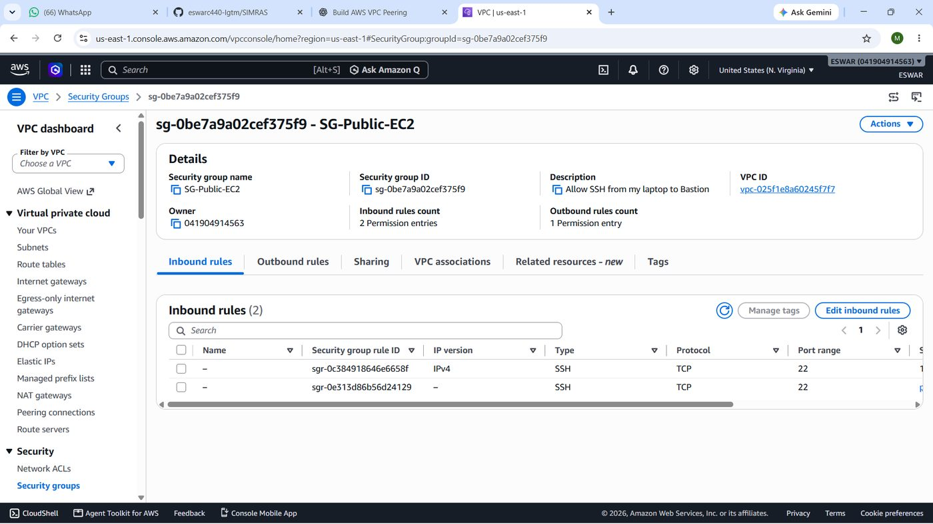
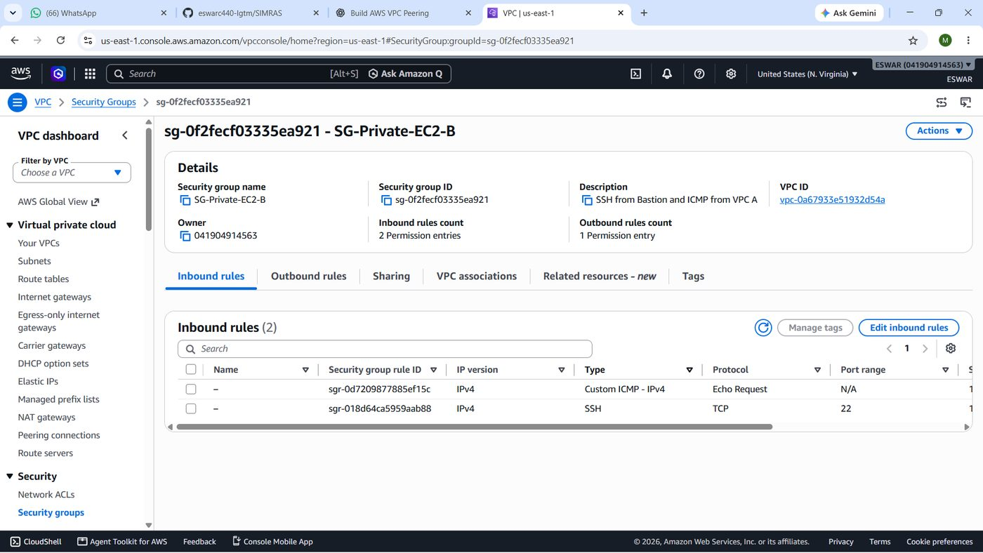
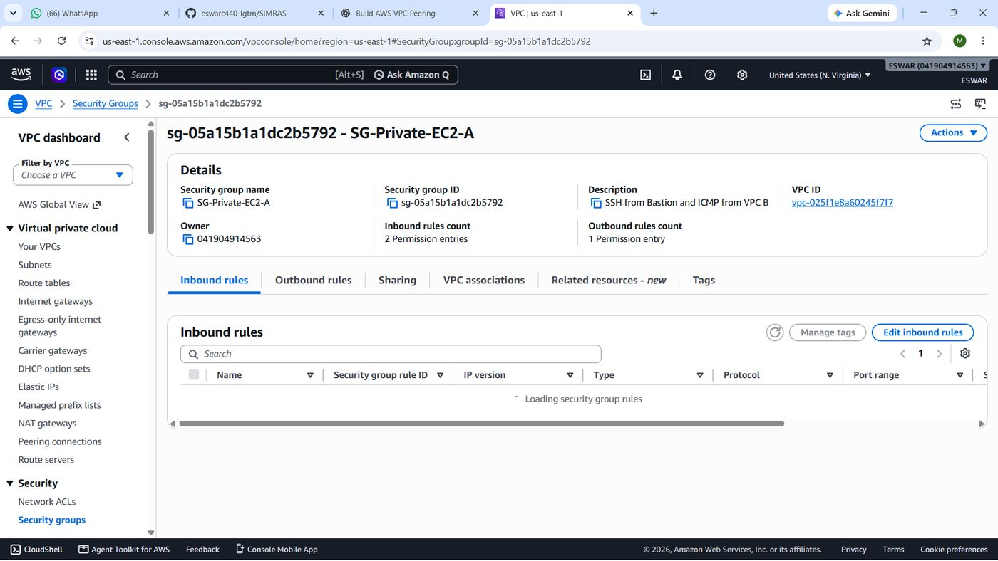
Figure 8 — Security group inbound rules (Bastion, App-A and App-B). Screenshot pending.
Result / Verification: Security groups and rules recorded as above. Console screenshots are needed to prove the exact rule sources.

Step 8 — Create EC2 Key Pair
Objective: Establish key-based SSH authentication instead of passwords.
AWS Service Used: Amazon EC2 — Key Pairs.
Implementation Procedure: I created an RSA key pair and saved the private key locally as vpc-peering-lab.pem with restricted permissions. Later, to fix an authentication mismatch, I imported the matching public key into AWS as vpc-peering-recovered.
Configuration Details: Local private key: vpc-peering-lab.pem (kept only on my workstation; contents never shown in this document). AWS key pair name: vpc-peering-recovered. Key pair ID: [AWS ID NOT YET VERIFIED].
What Happens Internally: AWS stores only the public key and places it in each instance's authorized_keys at first boot. The private key never leaves my machine, and SSH proves possession of it by signing a challenge.
Why This Step Is Necessary: A leaked private key would give access to every instance that trusts it, so it must not appear in reports or repositories.
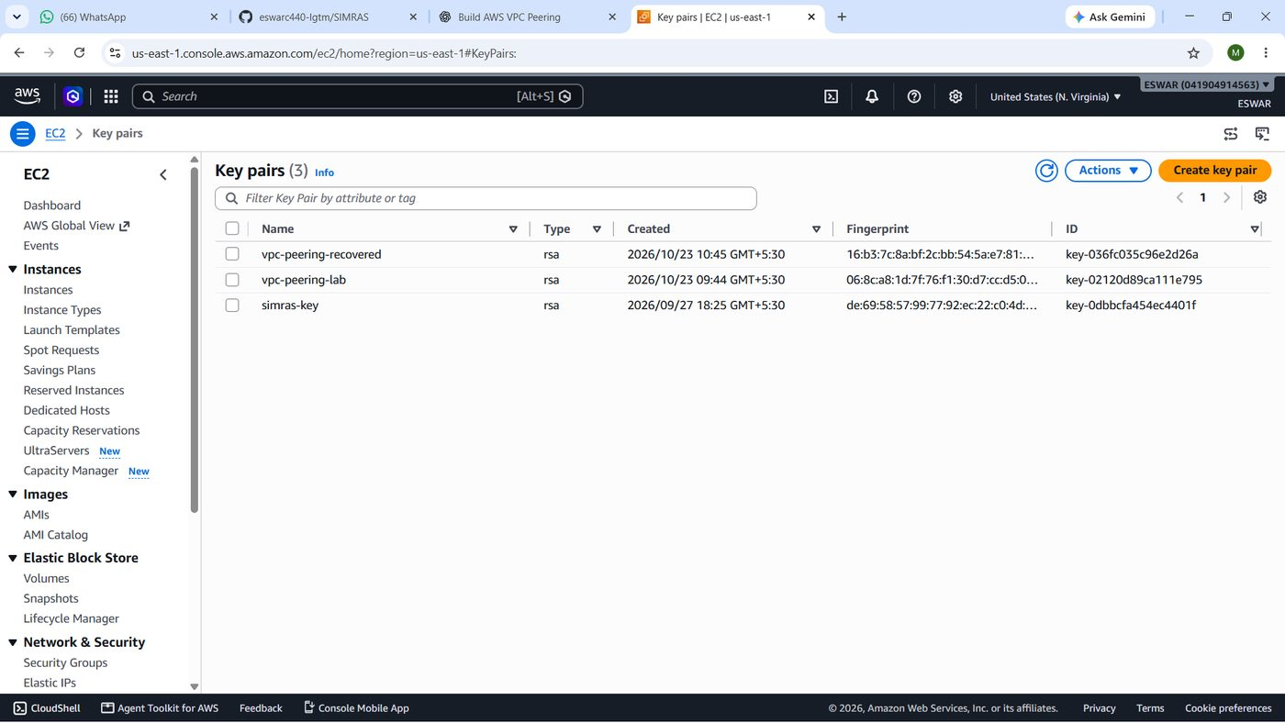
Figure 9 — Key pair list. Screenshot pending.
Result / Verification: Key-pair handling documented; key-pair ID not verified.

Step 9 — Launch Three EC2 Instances
Objective: Deploy one Bastion and two private application servers with fixed private IPs.
AWS Service Used: Amazon EC2 — Instances → Launch instances (Amazon Linux 2023).
Implementation Procedure: For each instance I selected Amazon Linux 2023, chose the VPC and subnet, typed the primary private IPv4 address, attached the matching security group and key pair, and enabled public IPv4 assignment for the Bastion only.
Configuration Details: EWB-Bastion i-08bc2aed2f29417f8, 10.10.1.10, EWB-A-Public, EWB-SG-Bastion, public IPv4 44.198.160.108 at test time. EWB-App-A i-063a73f819567ff3b, 10.10.2.10, EWB-A-Private, EWB-SG-App-A, no public IP. EWB-App-B i-0b82dbab3f422fb5d, 10.20.1.10, EWB-B-Private, EWB-SG-App-B, no public IP. The source report does not confirm an instance relaunch; the key issue was fixed by importing a key (Step 17).
What Happens Internally: EC2 creates an elastic network interface in each subnet with the requested private address. Only the Bastion receives an auto-assigned public address, which can change if it is stopped and started.
Why This Step Is Necessary: These three hosts are the endpoints for every test: the Bastion for administration, App-A and App-B for the cross-VPC traffic.
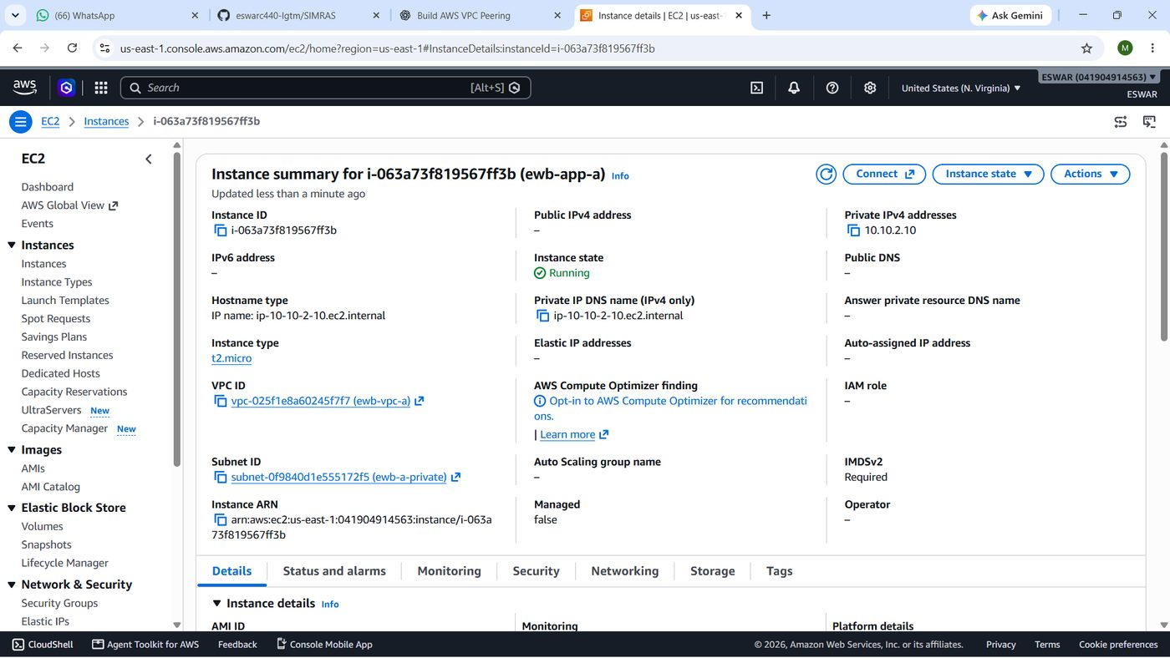
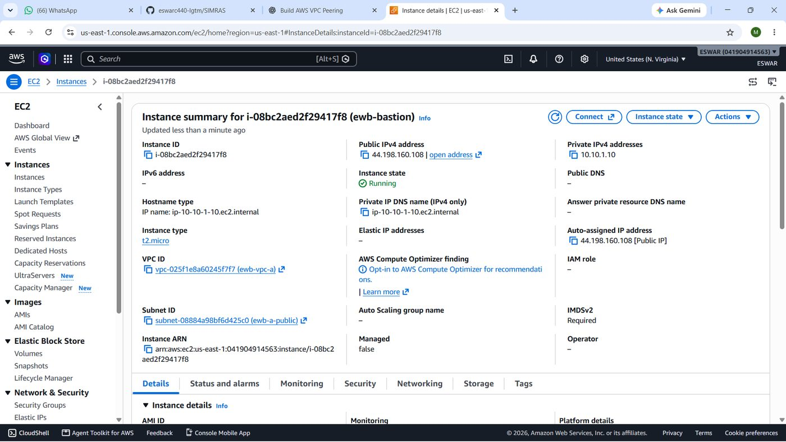
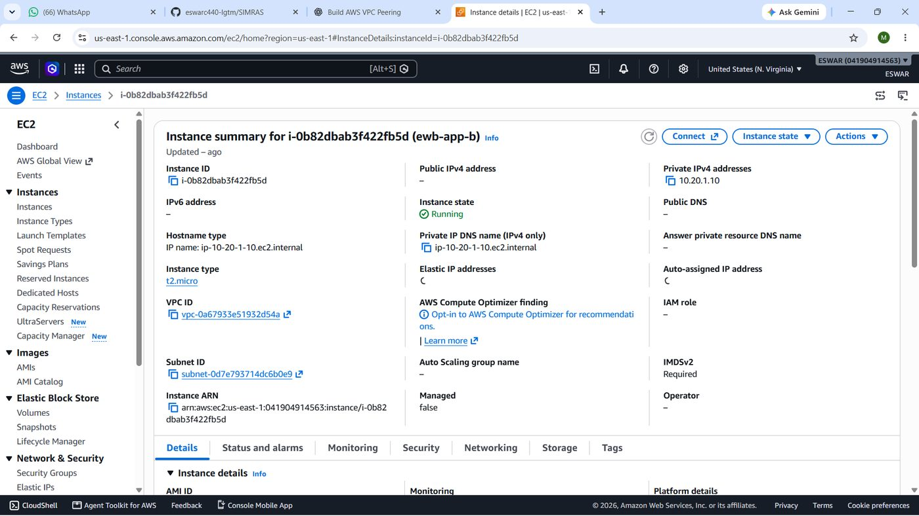
Figure 10 — Three running instances (App-A, Bastion and App-B).
Result / Verification: The Bastion is directly evidenced; its ID matches the earlier record. App-A and App-B IDs come from the resource checklist and need console screenshots.

Step 10 — Configure Bastion-Based SSH Connectivity
Objective: Reach the private servers from Windows through the Bastion without giving them public IPs.
AWS Service Used: OpenSSH on Windows PowerShell; EC2 Instance Connect (recovery only).
Implementation Procedure: I wrote a Windows SSH config with one alias for the Bastion and two aliases that use ProxyJump through it, then connected with ssh vpc-bastion, ssh vpc-app-a and ssh vpc-app-b.
Configuration Details: See configuration block below. Key file path is shown; key contents are not.
Host vpc-bastion
HostName 44.198.160.108
User ec2-user
IdentityFile ~/.ssh/vpc-peering-lab.pem
IdentitiesOnly yes

Host vpc-app-a
HostName 10.10.2.10
User ec2-user
IdentityFile ~/.ssh/vpc-peering-lab.pem
ProxyJump vpc-bastion

Host vpc-app-b
HostName 10.20.1.10
User ec2-user
IdentityFile ~/.ssh/vpc-peering-lab.pem
ProxyJump vpc-bastion

What Happens Internally: ProxyJump opens an SSH session to the Bastion, then tunnels a second SSH connection from the Bastion to the private address. The private servers see the Bastion's private IP (10.10.1.10) as the source, which matches their security-group rule.
Why This Step Is Necessary: This keeps one hardened entry point and avoids public IPs on workloads.
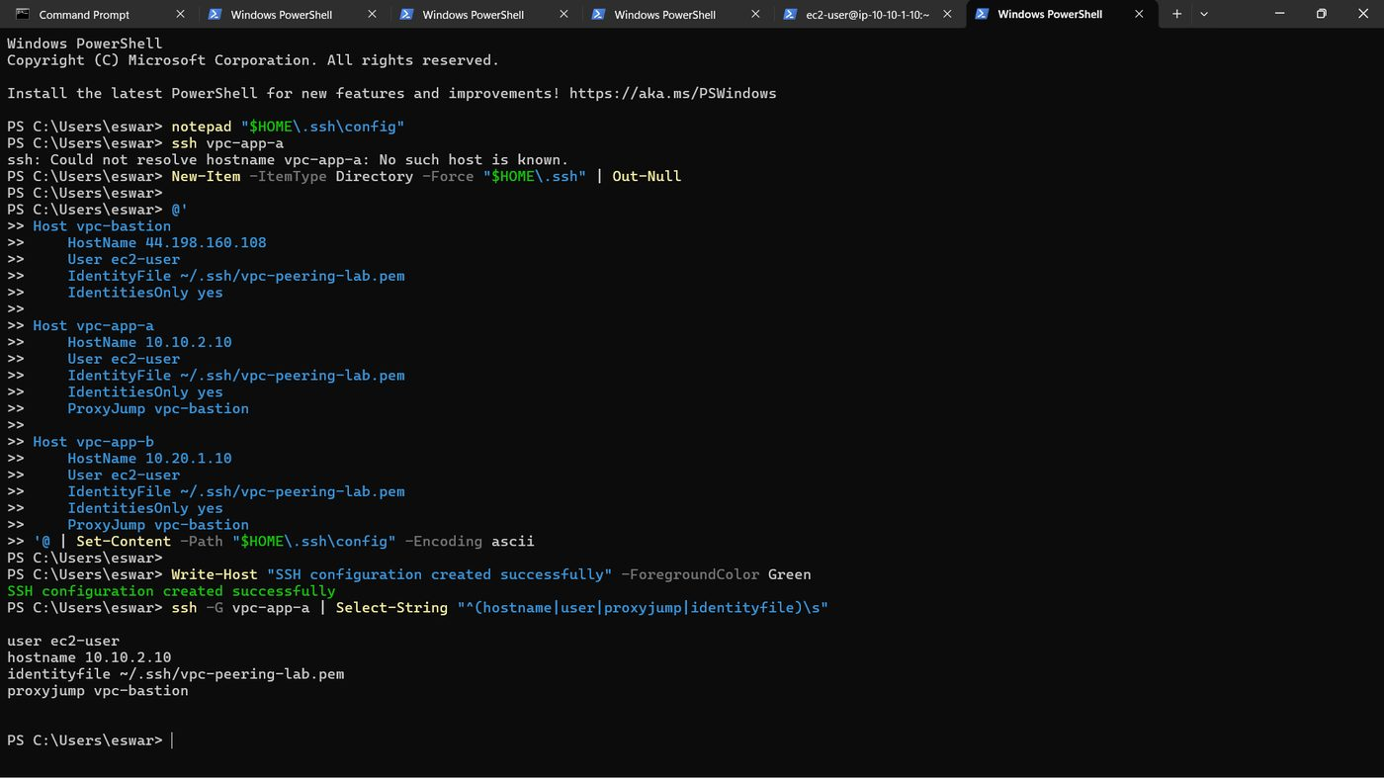
Figure 11 — Bastion and App-A SSH sessions.
Result / Verification: SSH to the Bastion and App-A succeeded according to my project notes; screenshots are pending.

Step 11 — Test Connectivity Before Peering
Objective: Establish a baseline showing the VPCs cannot talk to each other before peering.
AWS Service Used: Linux ping and ssh from App-A / the Bastion.
Implementation Procedure: The plan was to ping or SSH from VPC A to 10.20.1.10 before creating the peering connection.
Configuration Details: Source 10.10.2.10 → destination 10.20.1.10.
What Happens Internally: With no peering connection and no route for 10.20.0.0/16, packets from VPC A have no next hop for that range and are not delivered.
Why This Step Is Necessary: A before/after comparison proves that peering plus routing, not something else, enabled connectivity.
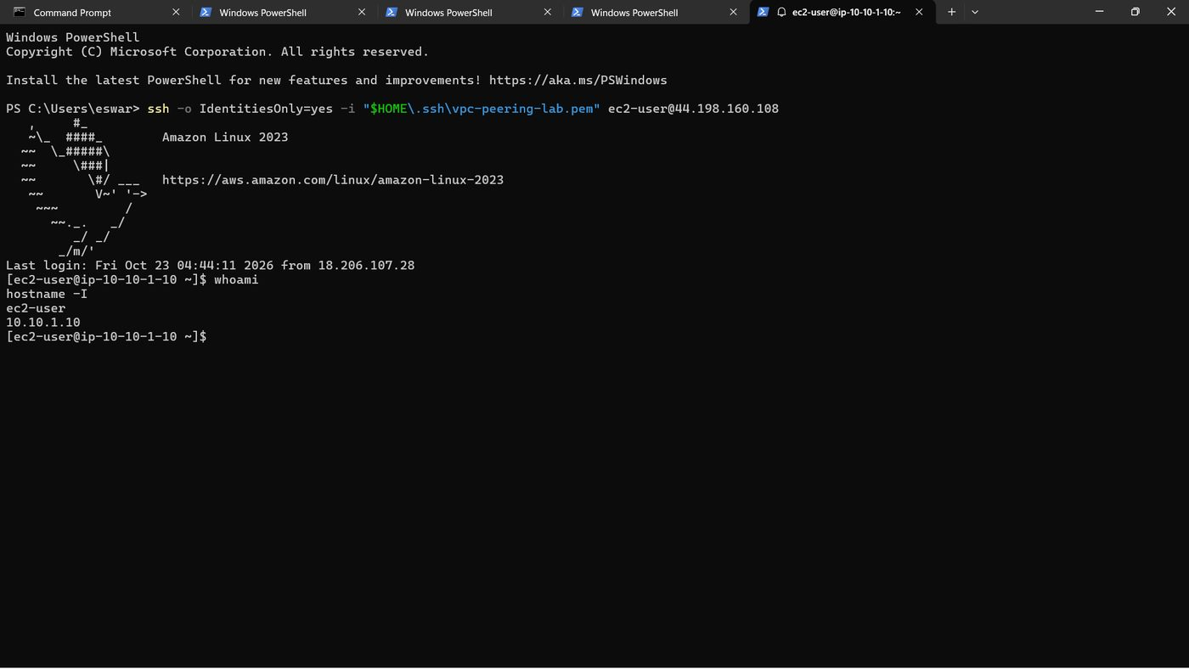
Figure 12 — Pre-peering baseline.
Result / Verification: Failure was expected for this configuration, but I have no captured output from before peering, so no baseline result is claimed here.

Step 12 — Create and Accept VPC Peering Connection
Objective: Create the private link between VPC A and VPC B.
AWS Service Used: Amazon VPC — Peering connections → Create peering connection → Actions → Accept request.
Implementation Procedure: I chose EWB-VPC-A as requester and EWB-VPC-B as accepter (same account, same Region), created the request, then accepted it from the pending state.
Configuration Details: Name tag: EWB-A-B-Peer. Peering ID: pcx-030bd25f0281f630b. Requester CIDR 10.10.0.0/16; accepter CIDR 10.20.0.0/16. Target status: Active.
What Happens Internally: The request creates a one-to-one relationship; traffic stays on the AWS network using private IPs. Peering does not add any routes by itself, and it is not transitive.
Why This Step Is Necessary: It is the resource that routes in Step 13 point at.
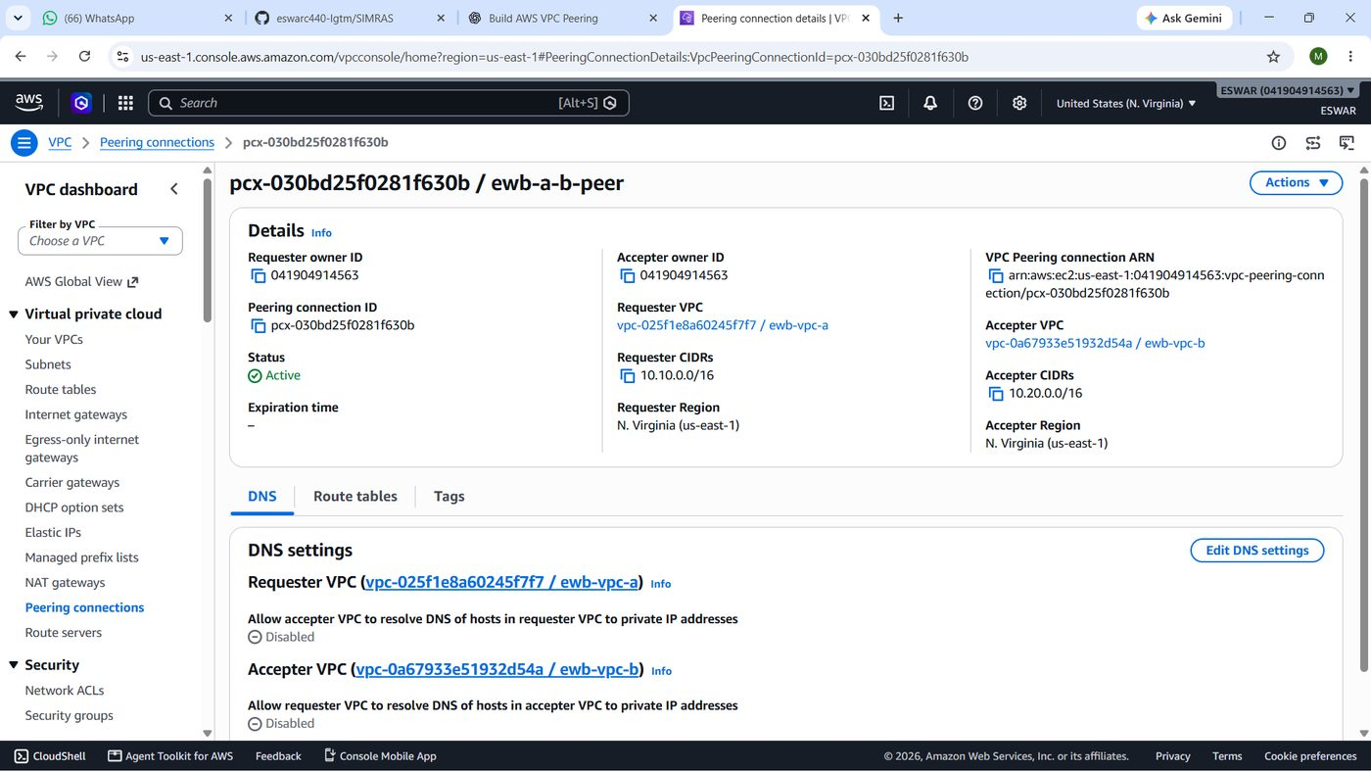
Figure 13 — Peering connection in Active state. Screenshot pending.
Result / Verification: Peering ID recorded in the checklist; Active status was reported but is not shown in a supplied screenshot.

Step 13 — Configure Peering Routes
Objective: Add the forward and return routes so packets can travel in both directions.
AWS Service Used: Amazon VPC — Route tables → Edit routes (target: Peering Connection).
Implementation Procedure: In each of the three custom route tables I added a route to the other VPC's CIDR and chose the peering connection as target. One route entry initially showed only "pcx-" as its target, and the complete accepted peering ID was needed to finish it.
Configuration Details: EWB-RT-A-Public: 10.20.0.0/16 → pcx-030bd25f0281f630b. EWB-RT-A-Private: 10.20.0.0/16 → pcx-030bd25f0281f630b. EWB-RT-B-Private: 10.10.0.0/16 → pcx-030bd25f0281f630b.
What Happens Internally: The forward routes (VPC A tables) send requests; the return route in VPC B's table sends replies. The public-subnet route is needed because the Bastion opens the SSH connection to App-B. Without the return route, replies from App-B would be dropped.
Why This Step Is Necessary: Peering is only a link; routes decide whether packets use it. Missing routes explain the earlier SSH timeout (Step 17).
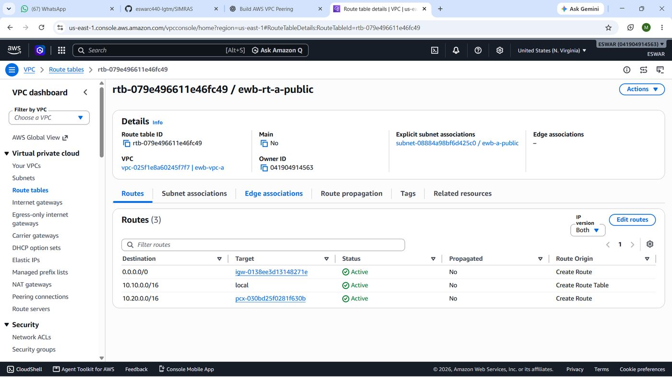
Figure 14 — Public VPC A route table. Screenshot pending.
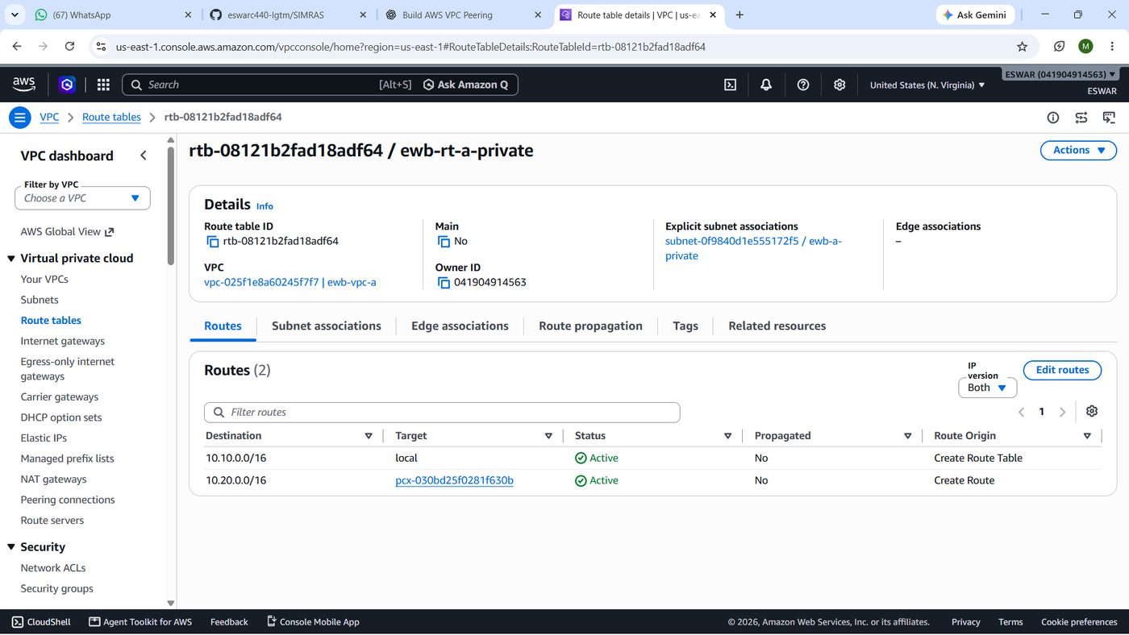
Figure 15 — Private VPC A route table.
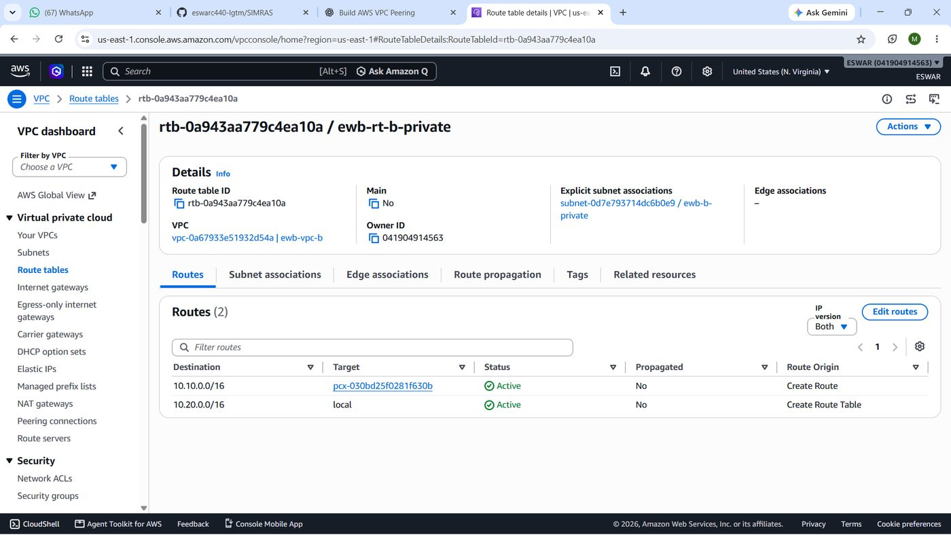
Figure 16 — Private VPC B route table (return route).
Result / Verification: Routes are documented from the project notes; screenshots are required to prove them.

Step 14 — Test Cross-VPC SSH
Objective: Confirm administrative access to App-B across the peering link.
AWS Service Used: OpenSSH ProxyJump; VPC peering.
Implementation Procedure: From Windows PowerShell I ran ssh vpc-app-b, which connected via the Bastion to 10.20.1.10.
Configuration Details: Windows → 44.198.160.108:22 (Bastion) → 10.20.1.10:22 (App-B). Source as seen by App-B: 10.10.1.10.
What Happens Internally: The Bastion's subnet route sends 10.20.0.0/16 to the peering connection, App-B's SG accepts SSH from 10.10.1.10/32, and replies return via the VPC B route.
Why This Step Is Necessary: It proves the routing, peering and security-group rules work together.
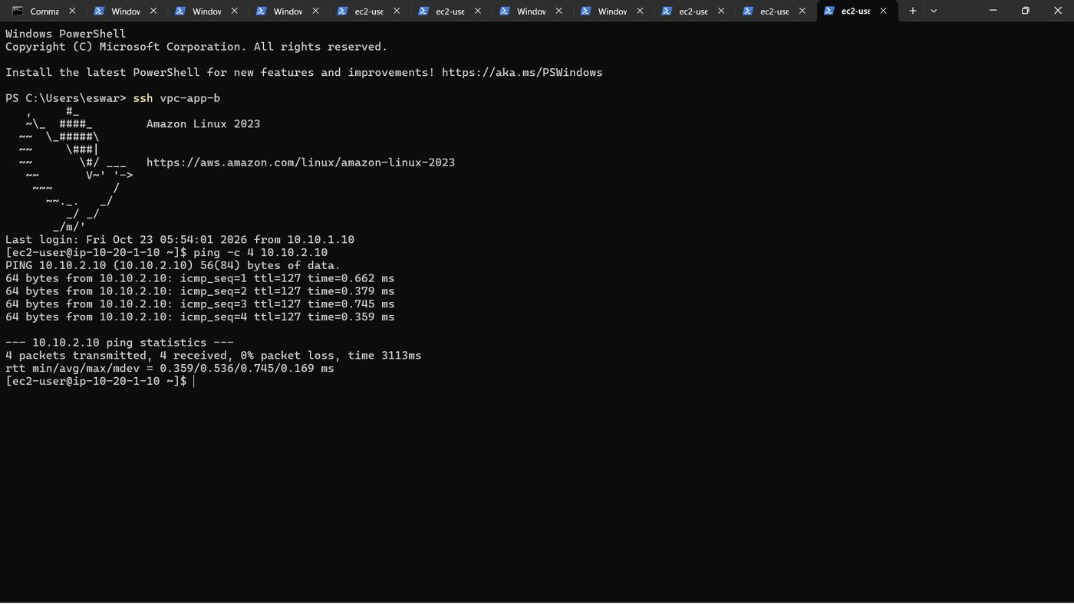
Figure 17 — Cross-VPC SSH session on App-B.
Result / Verification: My notes record an Amazon Linux 2023 shell on ip-10-20-1-10. The screenshot is pending.

Step 15 — Test Bidirectional Ping
Objective: Verify private ICMP connectivity in both directions between the application servers.
AWS Service Used: Linux ping (ICMP) across VPC peering.
Implementation Procedure: I connected to App-A and ran ping -c 4 10.20.1.10; then connected to App-B and ran ping -c 4 10.10.2.10.
Configuration Details: Forward: 10.10.2.10 → 10.20.1.10. Reverse: 10.20.1.10 → 10.10.2.10. Both SGs allow ICMP Echo Request from the other host's /32.
[ec2-user@ip-10-10-2-10 ~]$ ping -c 4 10.20.1.10
64 bytes from 10.20.1.10: icmp_seq=1 ttl=127 time=0.756 ms
64 bytes from 10.20.1.10: icmp_seq=2 ttl=127 time=0.572 ms
64 bytes from 10.20.1.10: icmp_seq=3 ttl=127 time=1.32 ms
64 bytes from 10.20.1.10: icmp_seq=4 ttl=127 time=0.374 ms
4 packets transmitted, 4 received, 0% packet loss, time 3093ms
rtt min/avg/max/mdev = 0.374/0.754/1.316/0.351 ms

Figure 18 — App-A → App-B ping output transcribed from the terminal text I recorded on 23 October 2026 (text transcription, not a screenshot). Average RTT 0.754 ms applies to this test only.
What Happens Internally: Echo requests follow the private route tables over the peering connection; the TTL of 127 is consistent with the packet crossing a hop on the AWS network. Replies return statefully.
Why This Step Is Necessary: ICMP is a simple, clear proof of two-way private reachability.
Figure 19 — App-B → App-A ping. Screenshot pending.
Result / Verification: Forward test: 4 sent, 4 received, 0% loss, average 0.754 ms. Reverse test: I recorded PASS, but have no output or screenshot, so I do not state packet counts or timing.

Step 16 — Perform Security Group Restriction Test
Objective: Show that the security group, not just routing, controls ICMP.
AWS Service Used: Amazon EC2 — Security Groups (EWB-SG-App-B inbound rules).
Implementation Procedure: With ping working, I deleted only the ICMP Echo Request rule (source 10.10.2.10/32) from EWB-SG-App-B, repeated the ping from App-A, then re-added the identical rule and tested again.
Configuration Details: Rule removed/restored: ICMP IPv4 type 8 code 0 from 10.10.2.10/32. SSH rule left untouched.
[ec2-user@ip-10-10-2-10 ~]$ ping -c 4 -W 2 10.20.1.10
PING 10.20.1.10 (10.20.1.10) 56(84) bytes of data.

--- 10.20.1.10 ping statistics ---
4 packets transmitted, 0 received, 100% packet loss, time 3103ms

Figure 20 — Blocked ping with the ICMP rule removed (text transcription of recorded output, not a screenshot).
What Happens Internally: The security group drops unmatched inbound packets silently, so App-A gets no replies even though routes and peering are unchanged. Restoring the rule re-allows the flow immediately.
Why This Step Is Necessary: It separates routing problems from filtering problems and demonstrates least-privilege enforcement.
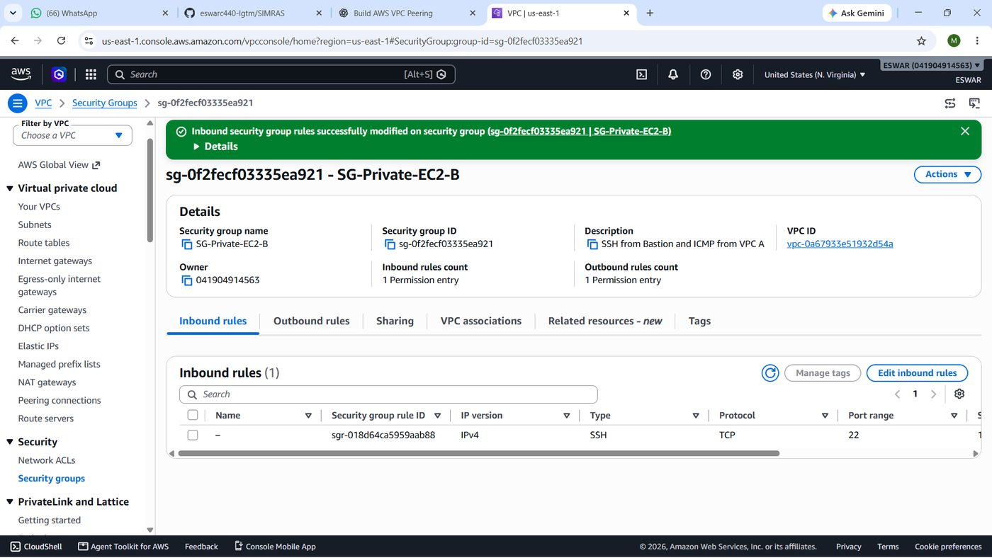
Figure 21 — Rule removed.
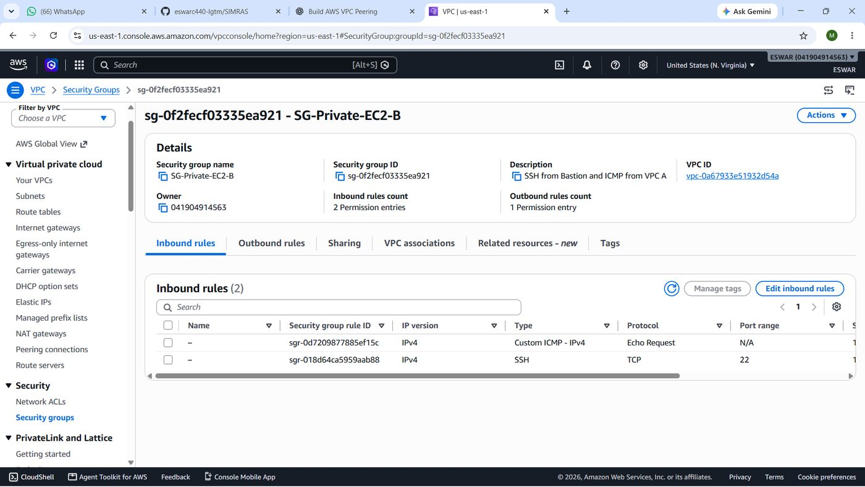
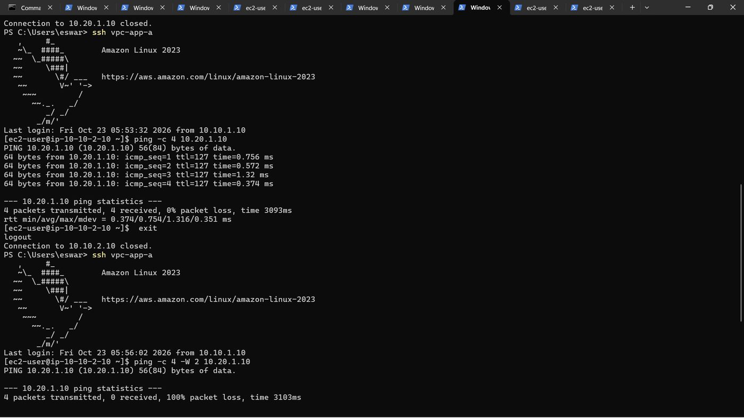
Figure 22 — Rule restored and ping recovered. Screenshot pending.
Result / Verification: Blocked state: 100% loss (recorded output above). Restored state: reported PASS, but no output or screenshot was supplied, so this remains unverified.

Step 17 — Troubleshooting and Resolution
These are the problems I met, based on my project notes. "Confirmed" means the cause was established; "Hypothesis" means it was my working explanation without final proof.
Issue | Observed | Cause | Action and outcome
Region / launch problem | An early Region had instance launch or availability problems. | Hypothesis: Regional capacity or restrictions; not established. | I rebuilt the project in us-east-1 and the instances launched.
Bastion SSH denied | Public-key authentication initially failed. | Confirmed: key on the instance did not match my local key. | I used EC2 Instance Connect to repair authorized_keys; SSH worked.
App-A authentication mismatch | Private host rejected the local key. | Confirmed: key mismatch between local key and instance. | I recovered the public key and imported it into AWS as vpc-peering-recovered; login worked.
App-B SSH timeout | SSH banner timeout through ProxyJump. | Hypothesis at the time (peering, routes or SG); later linked to incomplete routing. | I checked peering status, routes and the App-B SSH rule.
Incomplete peering route | A route target displayed only "pcx-". | Confirmed: the complete peering ID was required. | I selected the full peering ID and completed all three routes; verification succeeded.
Windows alias used in Linux shell | ssh vpc-app-b failed inside a Linux session. | Confirmed: aliases exist only in the Windows SSH config. | I typed exit to return to PowerShell and re-ran the command.

After the route and security fixes, I verified SSH to App-B and the forward ping. The temporary EC2 Instance Connect rule on the Bastion should be removed once it is no longer needed.

6. Test Results and Validation
The table separates what I have captured output for from what I only recorded as PASS in my notes. I do not present an unavailable screenshot as proof.
Test | Source → Destination | Command | Recorded output | Result
SSH to Bastion | Windows → 44.198.160.108 | ssh vpc-bastion | Login reported | PASS
SSH to App-A | Windows → 10.10.2.10 via Bastion | ssh vpc-app-a | Login and private IP reported | PASS
SSH to App-B | Windows → 10.20.1.10 via Bastion + peering | ssh vpc-app-b | Prompt ec2-user@ip-10-20-1-10 | PASS
App-A → App-B ping | 10.10.2.10 → 10.20.1.10 | ping -c 4 10.20.1.10 | 4/4 received, 0% loss, avg 0.754 ms | PASS
App-B → App-A ping | 10.20.1.10 → 10.10.2.10 | ping -c 4 10.10.2.10 | Not supplied | PASS (reported)
ICMP blocked | 10.10.2.10 → 10.20.1.10 | ping -c 4 -W 2 10.20.1.10 | 4 sent, 0 received, 100% loss | PASS
ICMP restored | 10.10.2.10 → 10.20.1.10 | ping after rule re-added | Not supplied | PASS (reported)

Interpretation. The 4/4 reply result shows that private traffic travelled between the VPCs in at least one direction at that moment. The 100% loss after removing one security-group rule is consistent with that rule being the controlling factor, because routes and peering were unchanged. These tests do not demonstrate every port, high availability, or production readiness.

7. Security Architecture
- No public IPs on workloads. App-A and App-B have no public IPv4 addresses, so they cannot be reached directly from the internet.
- Bastion as the single entry point. Administrative SSH goes through one host protected by a /32 source rule.
- Key-based authentication. The private key stays on my workstation and is not published.
- Narrow inbound rules. SSH to private hosts from 10.10.1.10/32 only; ICMP from one host only.
- Stateful security groups. Return traffic for allowed requests is permitted automatically; unmatched inbound traffic is dropped.
- Private peering traffic. Cross-VPC traffic uses private IPs and does not need an Internet Gateway.
- Non-transitive peering. VPC B cannot use VPC A's IGW; private connectivity does not give VPC B internet access.
Limitations: the lab uses default allow-all outbound rules and default network ACLs, a temporary Instance Connect rule was added during troubleshooting, and I did not perform a full security audit. Real environments add monitoring, tighter egress controls and automated infrastructure management, but the layered approach is the same.

8. Project Outcomes and Skills Learned
Skill | What I did in this project
VPC architecture | Designed two VPCs with public and private subnets.
CIDR planning | Chose non-overlapping /16 VPCs and /24 subnets.
Route tables | Built three tables, added IGW and peering routes, understood local routes.
EC2 provisioning | Launched three Amazon Linux 2023 instances with fixed private IPs.
Bastion SSH / ProxyJump | Configured Windows OpenSSH aliases to reach private hosts.
VPC peering | Requested, accepted and routed a peering connection.
Security groups | Wrote source-specific SSH and ICMP rules and tested enforcement.
Connectivity diagnostics | Used ping, SSH timeouts and route inspection to isolate faults.
Troubleshooting | Resolved key mismatches, an incomplete route target and a Region change.
Tagging and documentation | Applied Project/Student tags and recorded IDs and evidence.

9. Conclusion
This project connected two isolated AWS networks, VPC A (10.10.0.0/16) and VPC B (10.20.0.0/16), through a VPC peering connection and showed that private servers can communicate over private IPv4 addresses without any public internet path. A single Bastion Host in VPC A served as the controlled administrative entry point, and security groups limited SSH and ICMP to specific /32 sources.
The recorded tests confirmed SSH to the Bastion and both private servers, a successful App-A to App-B ping (4/4 replies, average 0.754 ms), and a security-group test in which removing a single ICMP rule produced 100% packet loss. Troubleshooting key mismatches, an incomplete peering route and a Region change showed how routing, security groups and authentication each have to be correct for a connection to work.
Several items are still marked pending in this document, including screenshots for some steps, the video demonstration link and the removal of the temporary Instance Connect rule. Completing these would make the evidence for the project complete.

