Step 1

**Install Kubectl and HELM**

* Kubectl : <https://kubernetes.io/docs/tasks/tools/install-kubectl/>
* HELM: <https://github.com/helm/helm/#install> . Please use helm version 3.

# Amazon EKS

## Step 1: Create a Kubernetes cluster

### 1) Install aws-iam-authenticator for Amazon EKS

Choco install aws-iam-authenticator

aws-iam-authenticator help

Step 2

**Install AWS CLI**

To install the aws cli, check the user guide: <https://docs.aws.amazon.com/cli/latest/userguide/cli-chap-install.html>

Once installed, check your AWS CLI version with the following command:

aws –version

Example output:

aws-cli/1.16.87 Python/3.7.2 Darwin/18.2.0 botocore/1.12.77



aws configure

AWS Access Key ID [None]: <your-access-key-ID>

AWS Secret Access Key [None]:<your-secet-access-key>

Default region name [None]: <your-region>

Default output format [None]: json

**Step 3**

**Create an EKS cluster**

To simplify the creation of our cluster on EKS, we are using a simple CLI tool named eksctl available here: <https://github.com/weaveworks/eksctl>.

To create a basic EKS cluster with a given name and region, run:

eksctl create cluster --name=<name> --region=<region>

A cluster will be created with default parameters:

* exciting auto-generated name, e.g. "fabulous-mushroom-1527688624"
* 2x m5.large nodes (this instance type suits most common use-cases, and is good value for money)
* use official AWS EKS AMI
* us-west-2 region
* dedicated VPC (check your quotas)
* using static AMI resolver

**Configure Kubectl for Amazon EKS**

Use the AWS CLI update-kubeconfig command to create or update your kubeconfig for your cluster.

aws eks update-kubeconfig --name <cluster_name>

Test your configuration:

kubectl version

Client Version: version.Info{Major:"1", Minor:"23", GitVersion:"v1.23.6", GitCommit:"ad3338546da947756e8a88aa6822e9c11e7eac22", GitTreeState:"clean", BuildDate:"2022-04-14T08:49:13Z", GoVersion:"go1.17.9", Compiler:"gc", Platform:"windows/amd64"}

Server Version: version.Info{Major:"1", Minor:"27+", GitVersion:"v1.27.8-eks-8cb36c9", GitCommit:"fca3a8722c88c4dba573a903712a6feaf3c40a51", GitTreeState:"clean", BuildDate:"2023-11-22T21:52:13Z", GoVersion:"go1.20.11", Compiler:"gc", Platform:"linux/amd64"}

WARNING: version difference between client (1.23) and server (1.27) exceeds the supported minor version skew of +/-1

Kubectl svc

Step 4

## **Step 2: Configure HELM and install NGINX Ingress**

Let's now configure HELM to work in the Cluster. We first need to give HELM permissions to deploy things into the cluster. Download the file below:

helm-service-account-role.yaml

helm-service-account-role.yaml

Run the following commands in your terminal:

kubectl apply -f helm-service-account-role.yaml

Step 5

kubectl apply -f https://raw.githubusercontent.com/kubernetes/ingress-nginx/controller-v1.3.0/deploy/static/provider/cloud/deploy.yaml

kubectl get pods --namespace ingress-nginx

kubectl get service ingress-nginx-controller --namespace=ingress-nginx

Step 6: Deploy Activiti Cloud Full Example

helm install example activiti-cloud-helm-charts/activiti-cloud-full-example --version 8.1.0 --set global.gateway.domain=REPLACEME --set global.keycloak.clientSecret=$(uuidgen) --set global.gateway.http=false

Go to temp folder

Download the application

(Default installation must be deleted)

Helm delete example

Customized activiti Installation

1. Go to values.yaml and search StorageClass. Assign the name either gp2 or gp3

1. Install storage class driver

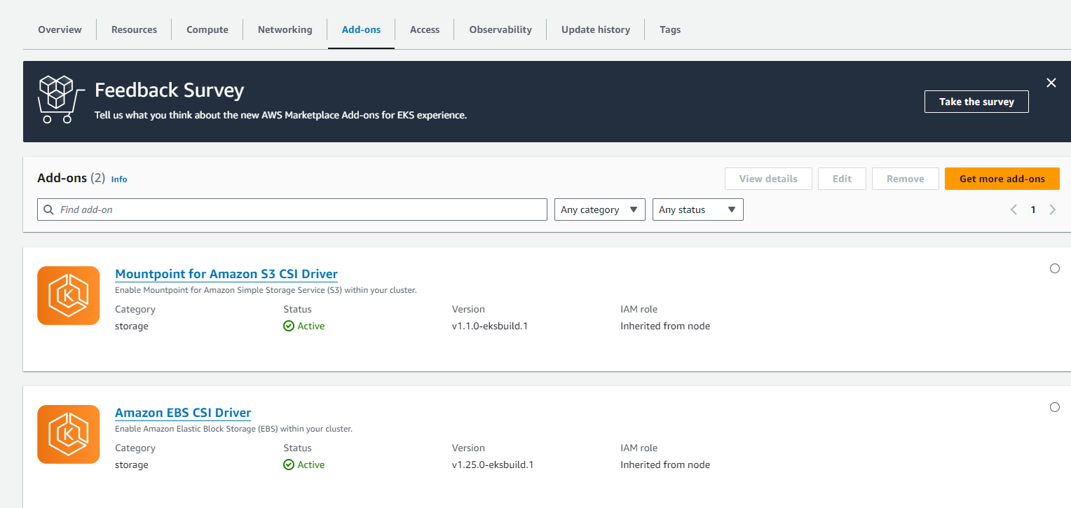

1. Ensure user created

1. Create policy and then edit the policy

EBS Policy

{

"Version": "2012-10-17",

"Statement": [{

"Sid": "VisualEditor0",

"Effect": "Allow",

"Action": [

"ec2:CreateVolume",

"ec2:DeleteVolume",

"ec2:DetachVolume",

"ec2:AttachVolume",

"ec2:DescribeInstances",

"ec2:CreateTags",

"ec2:DeleteTags",

"ec2:DescribeTags",

"ec2:DescribeVolumes"

],

"Resource": "*"

}]

}

1. Associate policy and role

search for arn

kubectl -n kube-system describe configmap aws-auth



aws iam attach-role-policy --role-name eksctl-rpscluster2023-nodegroup-ng-NodeInstanceRole-9UaOhArN4Eeo --policy-arn arn:aws:iam::683059350352:policy/ebspolicy

1. Route 53

Create Hosted Domain

Register Domain

Create record for the domain



Test the route53 address

Ipfconfig/flushdns

Ping anyname.domainname

Ping abc.vhebconsulting.com

Helm install activiti from local machine

helm install example ./activiti-cloud-helm-charts/activiti-cloud-full-example --version 8.1.0 --set global.gateway.domain=abc.vhebconsulting.com --set global.keycloak.clientSecret=$(uuidgen) --set global.gateway.http=false

