GCP PostgreSQL 18 Patroni HA Lab Manual
Three Node High Availability Cluster Using Private GCP VMs

Windows gcloud administration | Ubuntu 24.04 | PostgreSQL 18 | Patroni | etcd

Document purpose | Value
Audience | PostgreSQL DBAs, cloud engineers, DevOps engineers and trainers
Outcome | A working three-node Patroni cluster with automatic failover and controlled switchover
GCP project | postgresql-admin-lab-2026
Primary region | asia-south1
Security model | Private VMs, SSH through IAP, outbound access through Cloud NAT

This manual replaces the earlier PDF commands that were truncated during conversion. Commands are separated by execution environment so Windows commands are not accidentally run inside Linux and vice versa.

Lab Overview
The lab builds one PostgreSQL leader and two streaming replicas. Patroni manages initialization, leader election, promotion, demotion and replica recovery. A three-member etcd cluster stores the distributed cluster state. One etcd member is colocated with each PostgreSQL node for training efficiency.
Node | Zone | Private IP | Installed services
pg-node-1 | asia-south1-a | 10.10.0.11 | PostgreSQL, Patroni, etcd
pg-node-2 | asia-south1-b | 10.10.0.12 | PostgreSQL, Patroni, etcd
pg-node-3 | asia-south1-c | 10.10.0.13 | PostgreSQL, Patroni, etcd

Ports
Port | Purpose | Allowed source
22 | SSH through Identity Aware Proxy | 35.235.240.0/20
5432 | PostgreSQL client and replication traffic | 10.10.0.0/24
8008 | Patroni REST API | 10.10.0.0/24
2379 | etcd client traffic | 10.10.0.0/24
2380 | etcd peer traffic | 10.10.0.0/24

Execution Environments
Label | Run commands in
Windows CMD | Local Windows Command Prompt with Google Cloud CLI installed
Ubuntu all nodes | Run separately on pg-node-1, pg-node-2 and pg-node-3
Ubuntu named node | Run only on the specified VM

Before You Start
- The GCP project exists and billing is enabled.
- Your Google account can create networks, routers, firewall rules and Compute Engine VMs.
- The monthly budget alert is configured.
- Google Cloud CLI is installed on Windows and gcloud auth login has completed.
- The project is an isolated training environment. Do not reuse passwords shown in this manual for production.

Phase 1 Verify the Local gcloud Configuration

Step 1 Select and verify the project
gcloud config set project postgresql-admin-lab-2026
gcloud config get-value project
The second command must return postgresql-admin-lab-2026. Stop if it returns another project.
gcloud auth application-default set-quota-project postgresql-admin-lab-2026

Step 2 Set the location
gcloud config set compute/region asia-south1
gcloud config set compute/zone asia-south1-a
gcloud config list

Step 3 Confirm billing
gcloud billing projects describe postgresql-admin-lab-2026
Continue only when the output contains billingEnabled: true.

Step 4 Enable APIs
gcloud services enable compute.googleapis.com iap.googleapis.com logging.googleapis.com monitoring.googleapis.com

Phase 2 Build the Private Network

Step 5 Create the VPC and subnet
gcloud compute networks create postgres-lab-vpc --subnet-mode=custom
gcloud compute networks subnets create postgres-lab-subnet --network=postgres-lab-vpc --region=asia-south1 --range=10.10.0.0/24 --enable-private-ip-google-access

Step 6 Create firewall rules
gcloud compute firewall-rules create patroni-cluster-internal --network=postgres-lab-vpc --direction=INGRESS --action=ALLOW --rules=tcp:5432,tcp:8008,tcp:2379,tcp:2380,icmp --source-ranges=10.10.0.0/24 --target-tags=patroni-node
gcloud compute firewall-rules create patroni-iap-ssh --network=postgres-lab-vpc --direction=INGRESS --action=ALLOW --rules=tcp:22 --source-ranges=35.235.240.0/20 --target-tags=patroni-node
Never allow PostgreSQL, Patroni or etcd ports from 0.0.0.0/0.

Step 7 Create Cloud NAT
The VMs have no public IP addresses. Cloud NAT supplies outbound internet access for Ubuntu, PGDG and PyPI downloads without permitting unsolicited inbound connections.
gcloud compute routers create postgres-lab-router --network=postgres-lab-vpc --region=asia-south1
gcloud compute routers nats create postgres-lab-nat --router=postgres-lab-router --region=asia-south1 --auto-allocate-nat-external-ips --nat-all-subnet-ip-ranges
gcloud compute routers nats describe postgres-lab-nat --router=postgres-lab-router --region=asia-south1

Phase 3 Create Three Private VMs
Run each command as one line in Windows CMD. The VMs use fixed private IP addresses and no external IP address.

Step 8 Create pg-node-1
gcloud compute instances create pg-node-1 --zone=asia-south1-a --machine-type=e2-standard-2 --network=postgres-lab-vpc --subnet=postgres-lab-subnet --private-network-ip=10.10.0.11 --no-address --tags=patroni-node --image-family=ubuntu-2404-lts-amd64 --image-project=ubuntu-os-cloud --boot-disk-size=30GB --boot-disk-type=pd-balanced

Step 9 Create pg-node-2
gcloud compute instances create pg-node-2 --zone=asia-south1-b --machine-type=e2-standard-2 --network=postgres-lab-vpc --subnet=postgres-lab-subnet --private-network-ip=10.10.0.12 --no-address --tags=patroni-node --image-family=ubuntu-2404-lts-amd64 --image-project=ubuntu-os-cloud --boot-disk-size=30GB --boot-disk-type=pd-balanced

Step 10 Create pg-node-3
gcloud compute instances create pg-node-3 --zone=asia-south1-c --machine-type=e2-standard-2 --network=postgres-lab-vpc --subnet=postgres-lab-subnet --private-network-ip=10.10.0.13 --no-address --tags=patroni-node --image-family=ubuntu-2404-lts-amd64 --image-project=ubuntu-os-cloud --boot-disk-size=30GB --boot-disk-type=pd-balanced
gcloud compute instances list

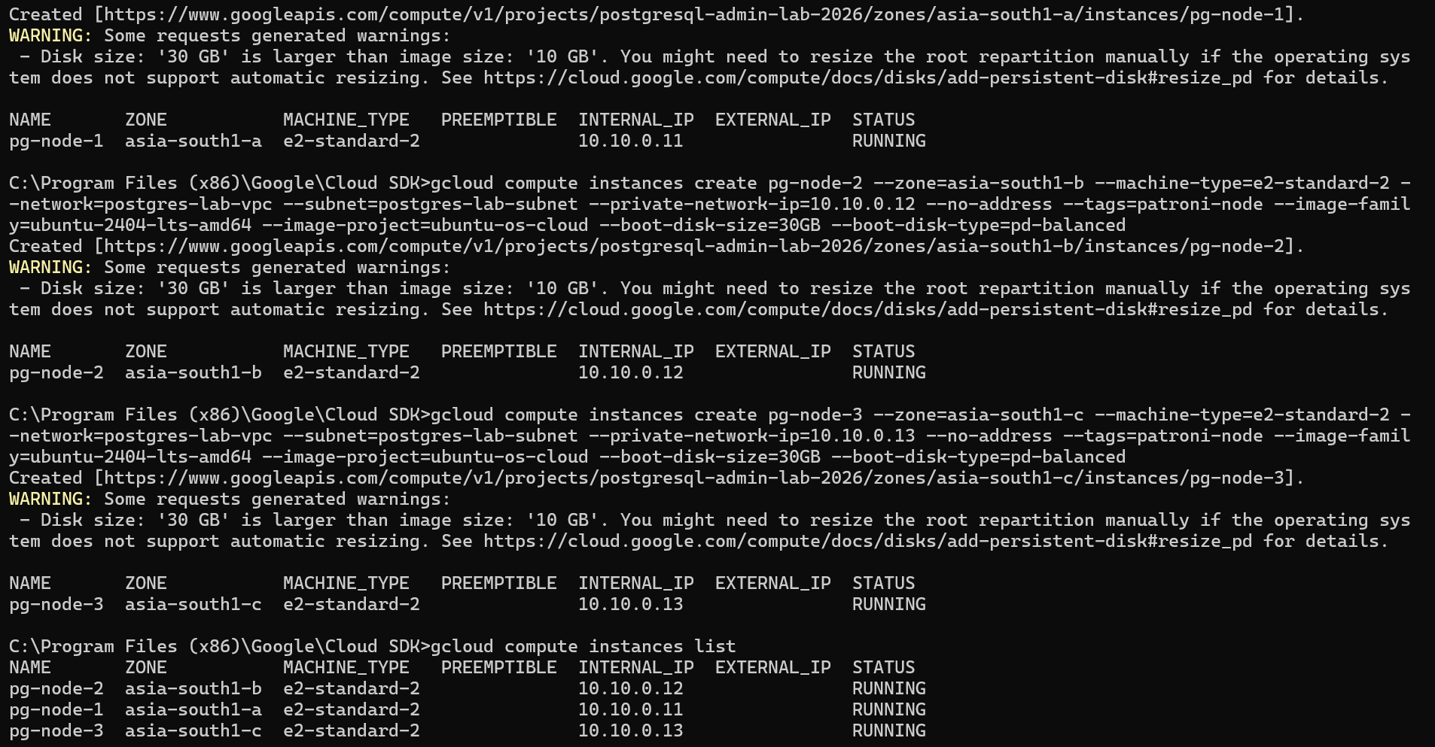

Enable os login
gcloud auth list --filter=status:ACTIVE --format="value(account)"
gcloud projects add-iam-policy-binding postgresql-admin-lab-2026 --member="user:eswaribala70@gmail.com" --role="roles/compute.osAdminLogin"
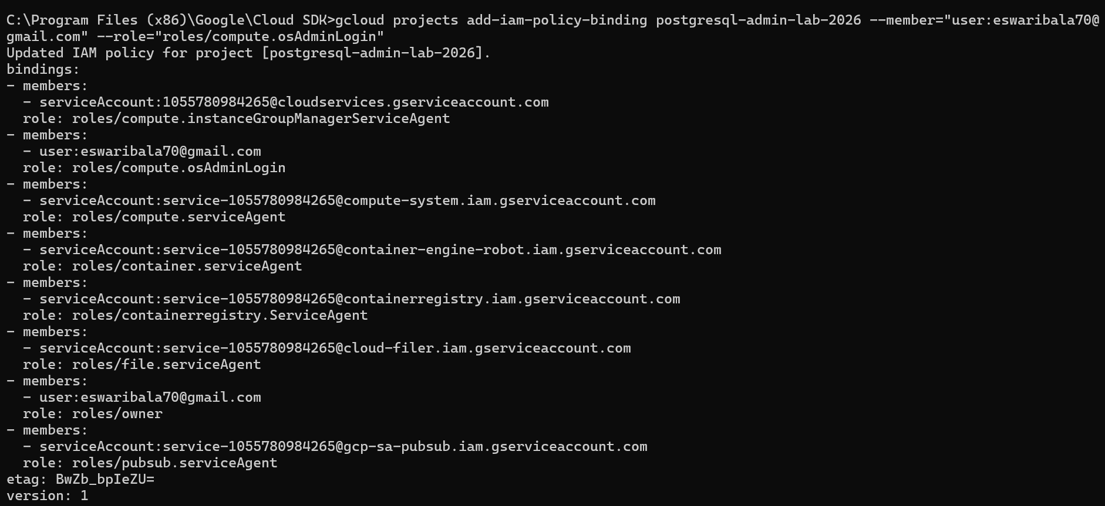
Confirm the IAP role is also assigned:
gcloud projects add-iam-policy-binding postgresql-admin-lab-2026 --member="user:eswaribala70@gmail.com" --role="roles/iap.tunnelResourceAccessor"
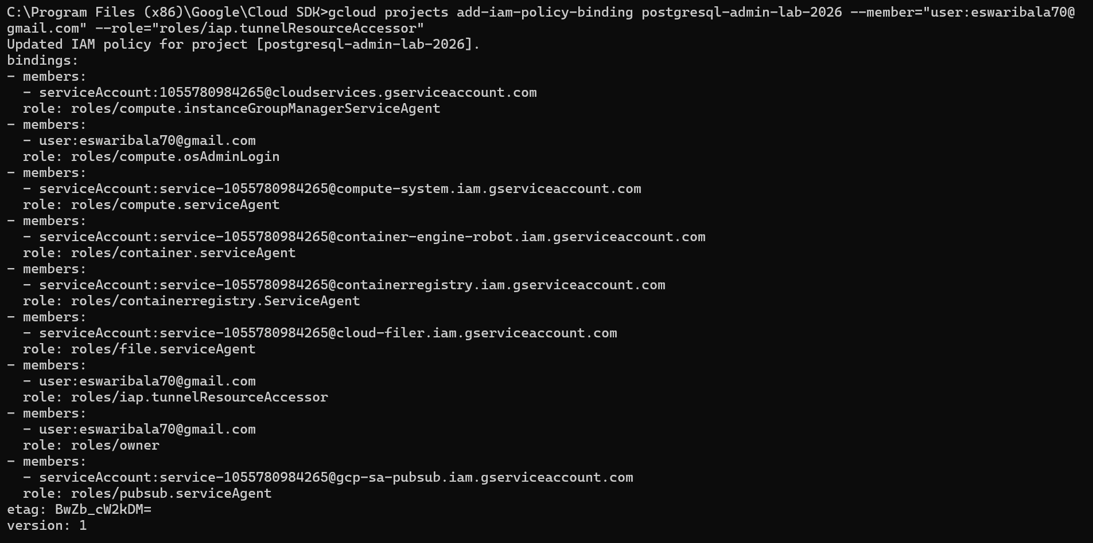

Enable OS Login at project level
gcloud compute project-info add-metadata --project=postgresql-admin-lab-2026 --metadata=enable-oslogin=TRUE
Verify
gcloud compute project-info describe --project=postgresql-admin-lab-2026 --format="yaml(commonInstanceMetadata.items)"
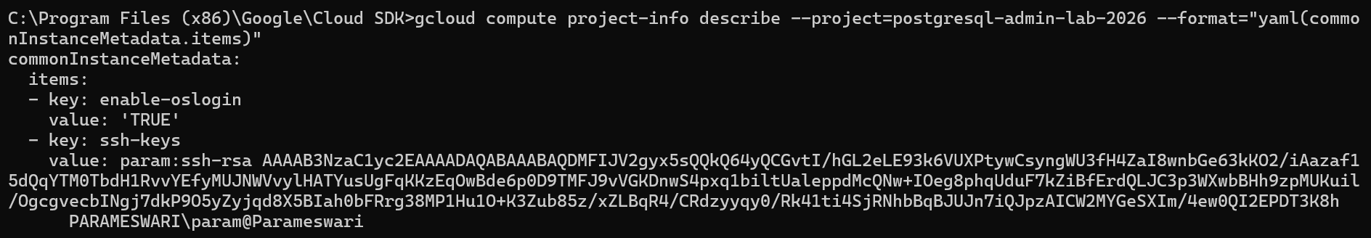
gcloud projects get-iam-policy postgresql-admin-lab-2026 --flatten="bindings[].members" --filter="bindings.members:user:eswaribala70@gmail.com" --format="table(bindings.role)"
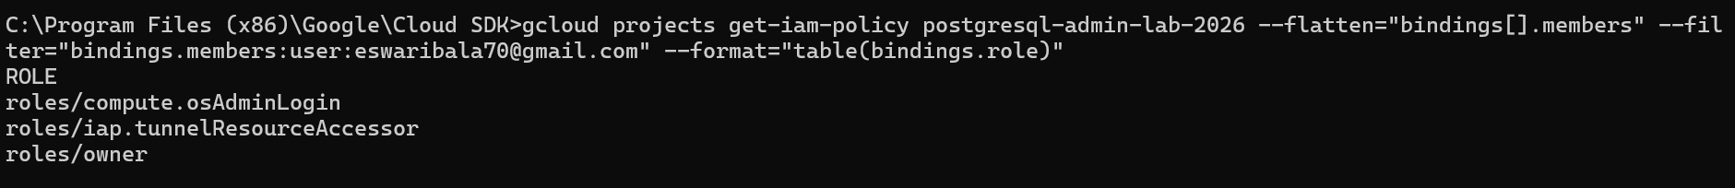
gcloud compute instances reset pg-node-1 --zone=asia-south1-a --project=postgresql-admin-lab-2026
gcloud compute instances describe pg-node-1 --zone=asia-south1-a --format="get(status)"

Phase 4 Connect Through IAP
Use browser SSH.
Go to IAM instances open ssh
/*
Local ssh not needed
Open three Windows CMD windows and keep one session connected to each node.
gcloud compute ssh pg-node-1 --zone=asia-south1-a --tunnel-through-iap
gcloud compute ssh pg-node-2 --zone=asia-south1-b --tunnel-through-iap
gcloud compute ssh pg-node-3 --zone=asia-south1-c --tunnel-through-iap
If access is denied, the user requires roles/iap.tunnelResourceAccessor and suitable Compute Engine or OS Login permissions.
*/

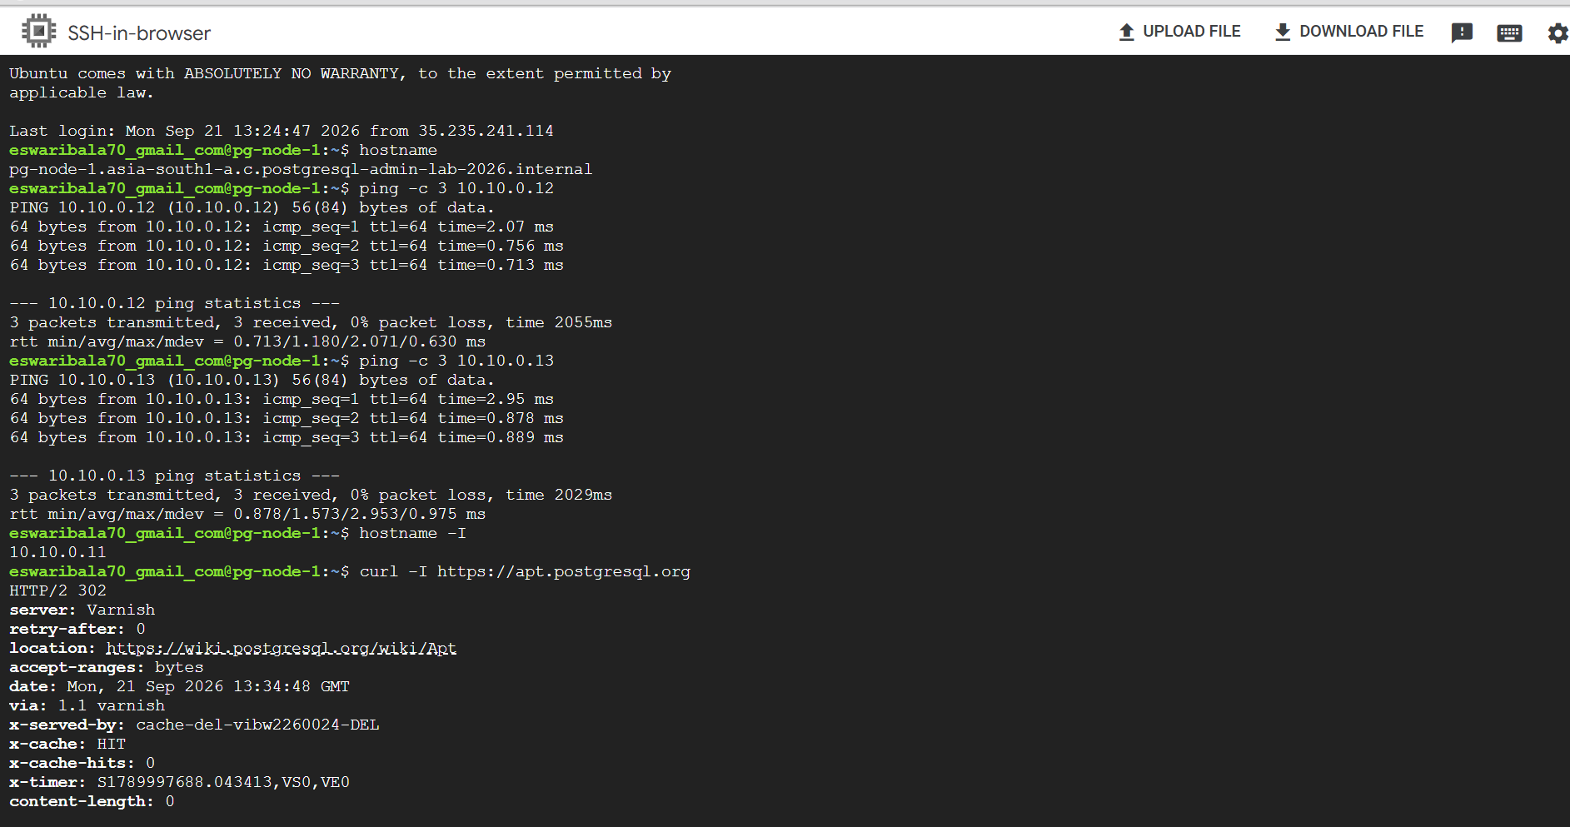

From node 1, test the other nodes:

ping -c 3 10.10.0.12

ping -c 3 10.10.0.13

Step 11 Verify each VM
hostname
hostname -I
curl -I https://apt.postgresql.org
Expected private addresses are 10.10.0.11, 10.10.0.12 and 10.10.0.13. The curl test confirms outbound access through Cloud NAT.

Phase 5 Install PostgreSQL 18 and Patroni
Run this phase on all three Ubuntu nodes.

Step 12 Install prerequisites
sudo apt update
sudo apt install -y curl ca-certificates postgresql-common python3-venv python3-dev libpq-dev gcc etcd-server etcd-client

Step 13 Install PostgreSQL 18 from PGDG
sudo /usr/share/postgresql-common/pgdg/apt.postgresql.org.sh
sudo apt update
sudo apt install -y postgresql-18 postgresql-client-18 postgresql-contrib-18
/usr/lib/postgresql/18/bin/postgres --version

Step 14 Remove the package-created cluster
Patroni must initialize and own the cluster. This operation is valid only for the new empty 18/main cluster.
sudo pg_lsclusters
sudo pg_dropcluster --stop 18 main
sudo pg_lsclusters

Step 15 Create directories
sudo install -d -o postgres -g postgres -m 700 /var/lib/postgresql/18/patroni
sudo install -d -o postgres -g postgres -m 2775 /var/run/postgresql

Step 16 Install Patroni
sudo python3 -m venv /opt/patroni
sudo /opt/patroni/bin/pip install --upgrade pip
sudo /opt/patroni/bin/pip install "patroni[etcd3]" "psycopg[binary]"
/opt/patroni/bin/patroni --version
/opt/patroni/bin/patronictl version
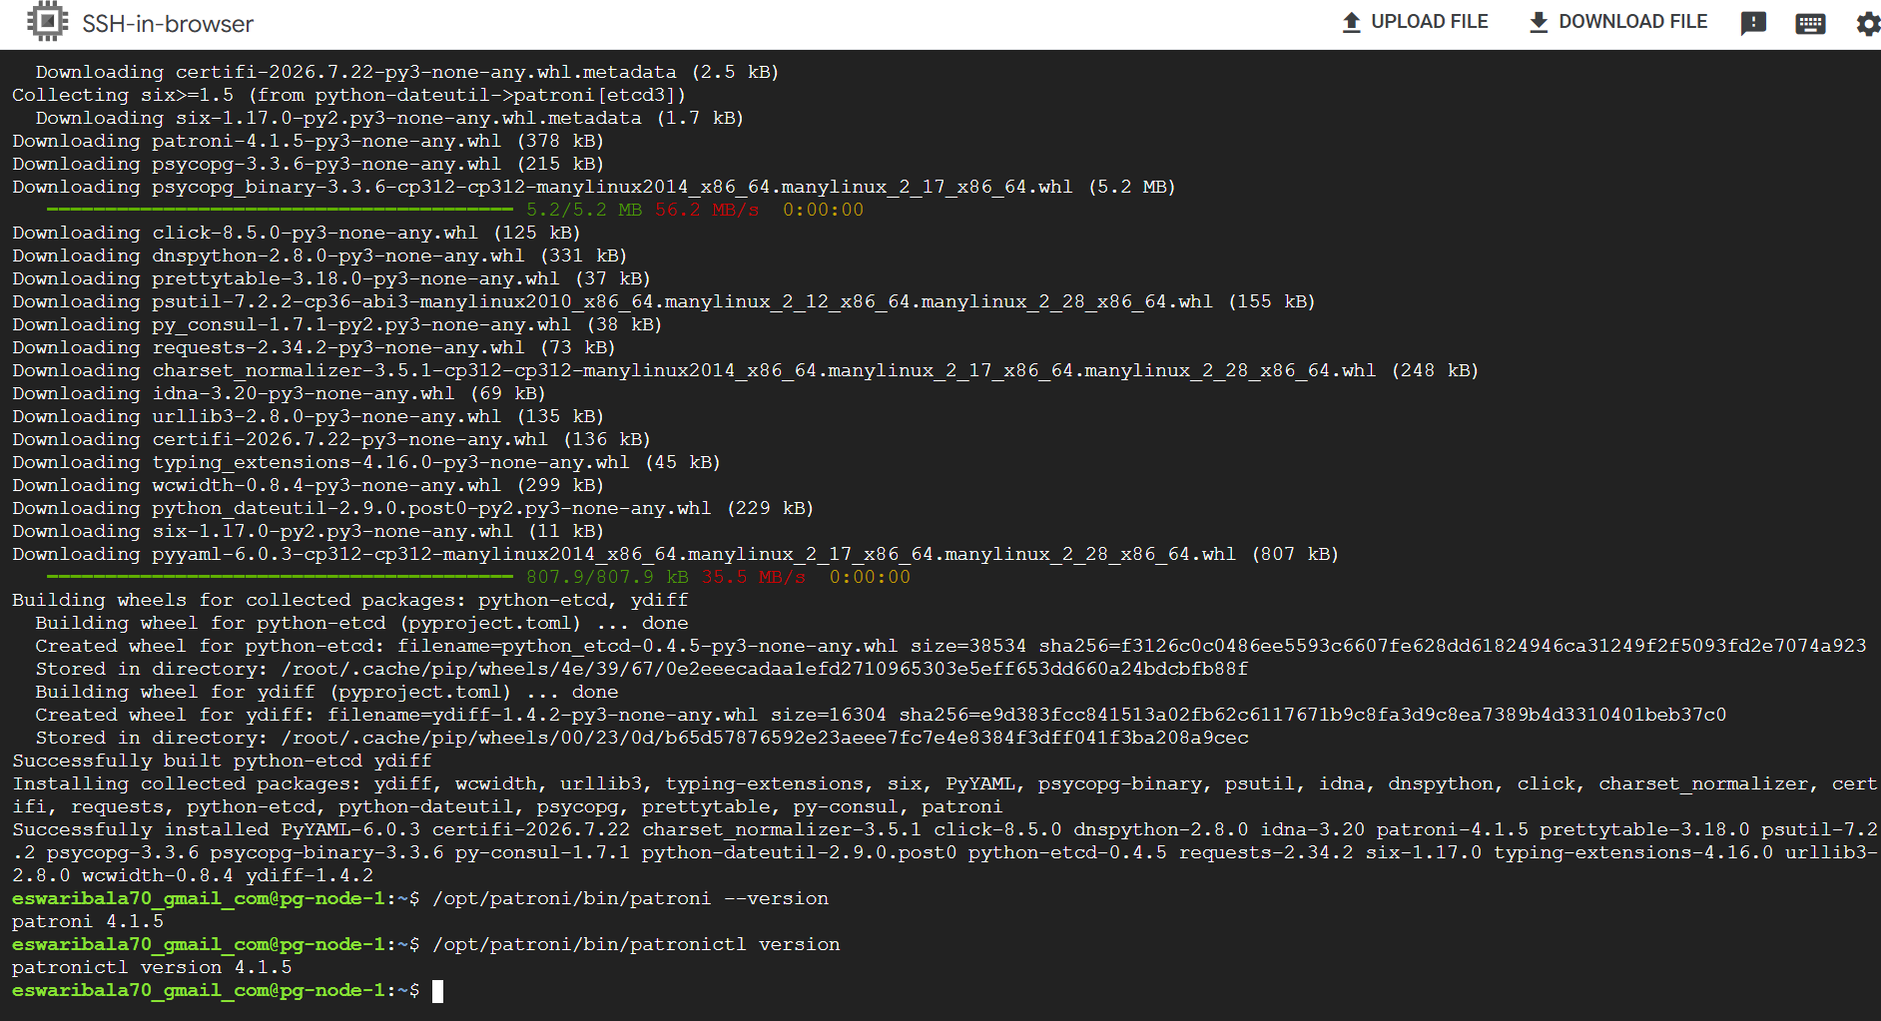

Phase 6 Configure the Three Member etcd Cluster
Patroni needs a Distributed Configuration Store (DCS). In this lab, etcd provides that service.
etcd does not store PostgreSQL table data. It stores small but critical HA coordination information, including:
- Which PostgreSQL node is currently the leader
- Patroni cluster configuration
- Leader-election lock
- Member status
- Failover and switchover state
- Initialization state

Run the stop command on all nodes before editing. Delete the data directory contents only because these are new lab nodes with no existing etcd data.
sudo systemctl stop etcd
sudo find /var/lib/etcd -mindepth 1 -delete
sudo find /var/lib/etcd -mindepth 1 -print

Step 17 Configure pg-node-1
sudo nano /etc/default/etcd
ETCD_NAME="etcd1"
ETCD_DATA_DIR="/var/lib/etcd"
ETCD_LISTEN_PEER_URLS="http://10.10.0.11:2380"
ETCD_INITIAL_ADVERTISE_PEER_URLS="http://10.10.0.11:2380"
ETCD_LISTEN_CLIENT_URLS="http://127.0.0.1:2379,http://10.10.0.11:2379"
ETCD_ADVERTISE_CLIENT_URLS="http://10.10.0.11:2379"
ETCD_INITIAL_CLUSTER="etcd1=http://10.10.0.11:2380,etcd2=http://10.10.0.12:2380,etcd3=http://10.10.0.13:2380"
ETCD_INITIAL_CLUSTER_TOKEN="patroni-etcd-cluster"
ETCD_INITIAL_CLUSTER_STATE="new"

Step 18 Configure pg-node-2
sudo nano /etc/default/etcd
ETCD_NAME="etcd2"
ETCD_DATA_DIR="/var/lib/etcd"
ETCD_LISTEN_PEER_URLS="http://10.10.0.12:2380"
ETCD_INITIAL_ADVERTISE_PEER_URLS="http://10.10.0.12:2380"
ETCD_LISTEN_CLIENT_URLS="http://127.0.0.1:2379,http://10.10.0.12:2379"
ETCD_ADVERTISE_CLIENT_URLS="http://10.10.0.12:2379"
ETCD_INITIAL_CLUSTER="etcd1=http://10.10.0.11:2380,etcd2=http://10.10.0.12:2380,etcd3=http://10.10.0.13:2380"
ETCD_INITIAL_CLUSTER_TOKEN="patroni-etcd-cluster"
ETCD_INITIAL_CLUSTER_STATE="new"

Step 19 Configure pg-node-3
sudo nano /etc/default/etcd
ETCD_NAME="etcd3"
ETCD_DATA_DIR="/var/lib/etcd"
ETCD_LISTEN_PEER_URLS="http://10.10.0.13:2380"
ETCD_INITIAL_ADVERTISE_PEER_URLS="http://10.10.0.13:2380"
ETCD_LISTEN_CLIENT_URLS="http://127.0.0.1:2379,http://10.10.0.13:2379"
ETCD_ADVERTISE_CLIENT_URLS="http://10.10.0.13:2379"
ETCD_INITIAL_CLUSTER="etcd1=http://10.10.0.11:2380,etcd2=http://10.10.0.12:2380,etcd3=http://10.10.0.13:2380"
ETCD_INITIAL_CLUSTER_TOKEN="patroni-etcd-cluster"
ETCD_INITIAL_CLUSTER_STATE="new"

sudo grep '^ETCD_' /etc/default/etcd

final clean up
sudo systemctl stop etcd
sudo systemctl reset-failed etcd
sudo find /var/lib/etcd -mindepth 1 -delete
sudo chown etcd:etcd /var/lib/etcd
sudo chmod 700 /var/lib/etcd
sudo find /var/lib/etcd -mindepth 1 -print

Step 20 Start and verify etcd
Start etcd on all three nodes, then verify from any node.
sudo systemctl start --no-block etcd
after 10 seconds
sudo systemctl enable --now etcd
sudo systemctl status etcd --no-pager

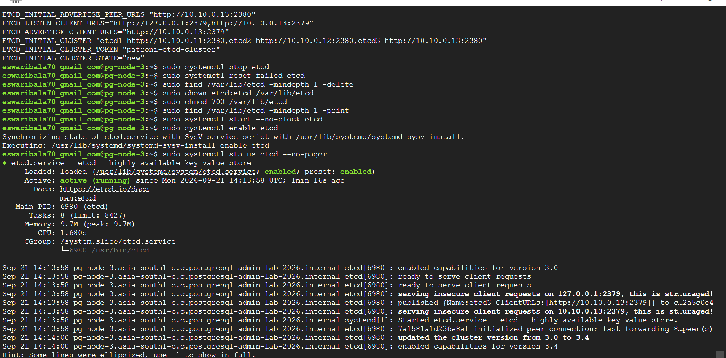
export ETCDCTL_API=3
etcdctl --endpoints=http://10.10.0.11:2379,http://10.10.0.12:2379,http://10.10.0.13:2379 endpoint health
etcdctl --endpoints=http://10.10.0.11:2379 member list --write-out=table

Phase 7 Configure Patroni
Use the same scope, etcd endpoints and passwords on all nodes. Change only the node name and node-specific listen addresses. Replace the example passwords before starting the cluster.

Step 21 Create the node 1 configuration
sudo install -d -o postgres -g postgres -m 750 /etc/patroni
sudo nano /etc/patroni/patroni.yml
scope: postgres-ha
namespace: /service/
name: pg-node-1
restapi:
listen: 10.10.0.11:8008
connect_address: 10.10.0.11:8008
etcd3:
hosts: 10.10.0.11:2379,10.10.0.12:2379,10.10.0.13:2379
bootstrap:
dcs:
ttl: 30
loop_wait: 10
retry_timeout: 10
maximum_lag_on_failover: 1048576
postgresql:
use_pg_rewind: true
use_slots: true
parameters:
wal_level: replica
hot_standby: "on"
max_wal_senders: 10
max_replication_slots: 10
wal_keep_size: 256MB
password_encryption: scram-sha-256
initdb:
- encoding: UTF8
- data-checksums
- auth-local: peer
- auth-host: scram-sha-256
pg_hba:
- local all all peer
- host replication replicator 10.10.0.0/24 scram-sha-256
- host all all 10.10.0.0/24 scram-sha-256
users:
training_admin:
password: "TrainingAdmin-ChangeMe-2026"
options:
- createrole
- createdb
postgresql:
listen: 10.10.0.11:5432
connect_address: 10.10.0.11:5432
data_dir: /var/lib/postgresql/18/patroni
bin_dir: /usr/lib/postgresql/18/bin
pgpass: /var/lib/postgresql/.pgpass
authentication:
superuser:
username: postgres
password: "Postgres-ChangeMe-2026"
replication:
username: replicator
password: "Replication-ChangeMe-2026"
rewind:
username: rewind_user
password: "Rewind-ChangeMe-2026"
parameters:
unix_socket_directories: /var/run/postgresql
create_replica_methods:
- basebackup
basebackup:
checkpoint: fast
tags:
nofailover: false
noloadbalance: false
clonefrom: false
nosync: false

Step 22 Adapt the file for pg-node-2
Use the complete node 1 file and replace only these values:
name: pg-node-2
restapi.listen: 10.10.0.12:8008
restapi.connect_address: 10.10.0.12:8008
postgresql.listen: 10.10.0.12:5432
postgresql.connect_address: 10.10.0.12:5432

Step 23 Adapt the file for pg-node-3
name: pg-node-3
restapi.listen: 10.10.0.13:8008
restapi.connect_address: 10.10.0.13:8008
postgresql.listen: 10.10.0.13:5432
postgresql.connect_address: 10.10.0.13:5432

Step 24 Secure and validate the YAML
sudo chown -R postgres:postgres /etc/patroni
sudo chmod 750 /etc/patroni
sudo chmod 600 /etc/patroni/patroni.yml
sudo -u postgres /opt/patroni/bin/patroni --validate-config /etc/patroni/patroni.yml

Phase 8 Create the Patroni Service
Run on all three nodes.
sudo nano /etc/systemd/system/patroni.service
[Unit]
Description=Patroni PostgreSQL High Availability
After=network-online.target etcd.service
Wants=network-online.target
Requires=etcd.service
[Service]
Type=simple
User=postgres
Group=postgres
ExecStart=/opt/patroni/bin/patroni /etc/patroni/patroni.yml
ExecReload=/bin/kill -HUP $MAINPID
KillMode=process
TimeoutStopSec=30
Restart=on-failure
RestartSec=5
[Install]
WantedBy=multi-user.target
sudo systemctl daemon-reload
sudo systemctl enable patroni

Phase 9 Bootstrap the Cluster

Step 25 Start node 1 first
sudo systemctl start patroni
sudo journalctl -u patroni -n 100 --no-pager
sudo -u postgres /opt/patroni/bin/patronictl -c /etc/patroni/patroni.yml list
Node 1 should initially appear as Leader. Resolve errors before proceeding.

Step 26 Start node 2
sudo systemctl start patroni
sudo -u postgres /opt/patroni/bin/patronictl -c /etc/patroni/patroni.yml list

Step 27 Start node 3
sudo systemctl start patroni
sudo -u postgres /opt/patroni/bin/patronictl -c /etc/patroni/patroni.yml list
Expected result: one Leader and two streaming Replicas.
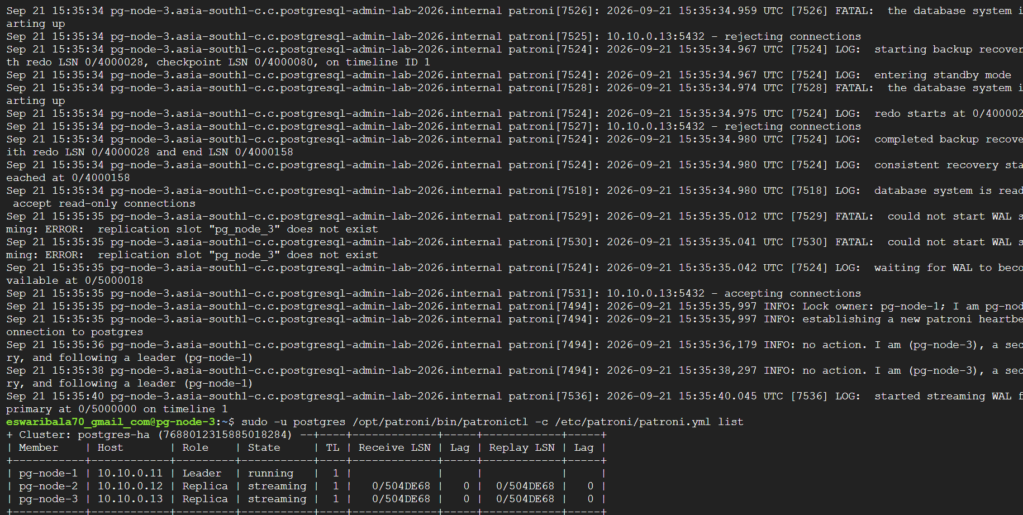

Phase 10 Validate Replication

Step 28 Create data on the leader
sudo -u postgres psql -c "CREATE DATABASE banking;"
sudo -u postgres psql -d banking -c "CREATE TABLE accounts(account_id bigint PRIMARY KEY, customer_name text NOT NULL, balance numeric(12,2) NOT NULL); INSERT INTO accounts VALUES (1001,'Anita',50000.00),(1002,'Bala',35000.00); SELECT * FROM accounts;"

Step 29 Verify a replica
sudo -u postgres psql -d banking -c "SELECT * FROM accounts;"
sudo -u postgres psql -c "SELECT pg_is_in_recovery();"
pg_is_in_recovery() returns t on a replica and f on the leader.
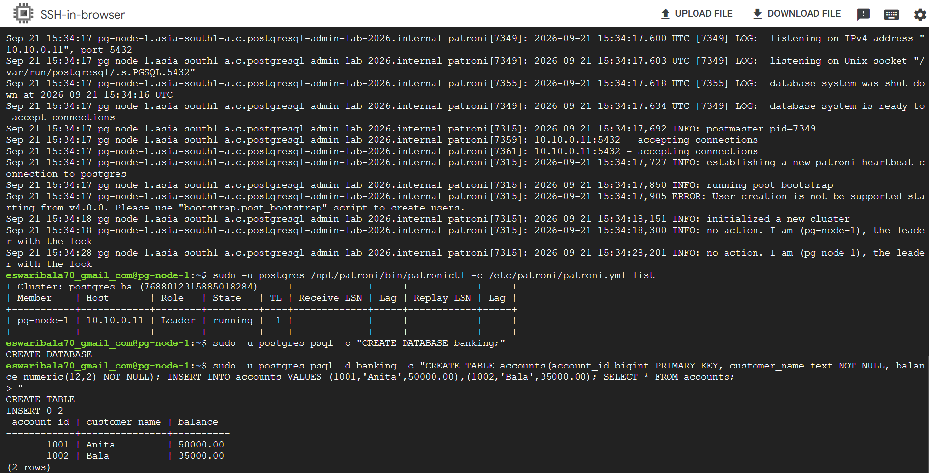

Step 30 Inspect replication from the leader
sudo -u postgres psql -x -c "SELECT application_name, client_addr, state, sync_state, sent_lsn, write_lsn, flush_lsn, replay_lsn FROM pg_stat_replication;"

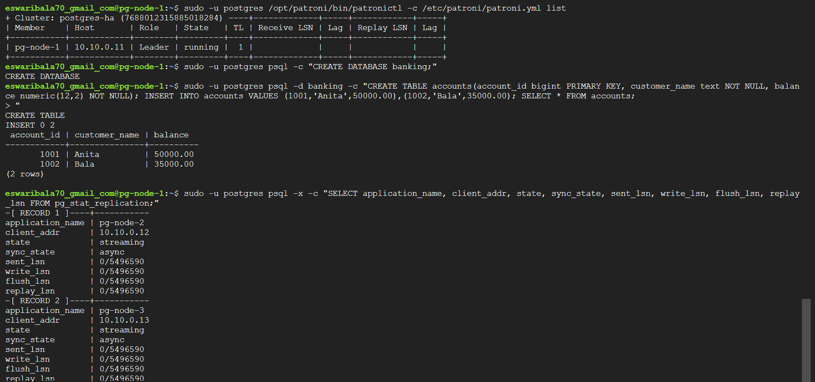

Before closing, optionally verify:

sudo systemctl is-active patroni

sudo systemctl is-active etcd

Expected:

active

active
Later, reconnect to any node and check:
sudo -u postgres /opt/patroni/bin/patronictl \
-c /etc/patroni/patroni.yml list
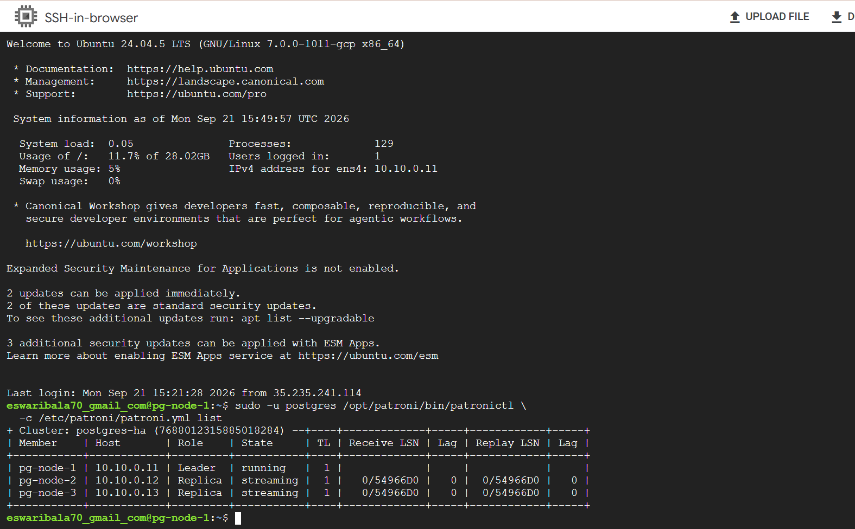

Phase 11 Test Automatic Failover
- Identify the current leader with patronictl list.
- On the leader, stop only Patroni: sudo systemctl stop patroni
- On a surviving node, repeat patronictl list until a new leader is elected.
- Insert a new row on the new leader.
- Restart Patroni on the old leader and confirm that it rejoins as a replica.
sudo -u postgres /opt/patroni/bin/patronictl -c /etc/patroni/patroni.yml list
sudo systemctl stop patroni
sudo -u postgres psql -d banking -c "INSERT INTO accounts VALUES (1003,'Chitra',42000.00); SELECT * FROM accounts;"
sudo systemctl start patroni
sudo -u postgres /opt/patroni/bin/patronictl -c /etc/patroni/patroni.yml list

Phase 12 Test Controlled Switchover
A switchover is planned movement of leadership to a healthy replica. Run from any healthy node:
sudo -u postgres /opt/patroni/bin/patronictl -c /etc/patroni/patroni.yml switchover
Choose the current leader, the candidate replica and now. Verify the new roles with patronictl list.

Client Connectivity
Patroni does not provide a single stable application endpoint. During this lab, connect to the current leader private IP. A later exercise should add HAProxy or another Patroni-aware proxy. PgBouncer can then provide connection pooling behind or alongside that routing layer.

Troubleshooting Reference
Check | Command
Patroni service | sudo systemctl status patroni --no-pager
Patroni logs | sudo journalctl -u patroni -n 100 --no-pager
etcd service | sudo systemctl status etcd --no-pager
etcd logs | sudo journalctl -u etcd -n 100 --no-pager
PostgreSQL processes | ps -ef | grep '[p]ostgres'
Listening ports | sudo ss -ltnp | grep -E ':5432|:8008|:2379|:2380'
Patroni state | curl http://10.10.0.11:8008/patroni
Leader endpoint | curl -i http://10.10.0.11:8008/primary
Database readiness | /usr/lib/postgresql/18/bin/pg_isready -h 127.0.0.1 -p 5432

Stop and Cleanup

Stop VMs and retain disks
gcloud compute instances stop pg-node-1 --zone=asia-south1-a
gcloud compute instances stop pg-node-2 --zone=asia-south1-b
gcloud compute instances stop pg-node-3 --zone=asia-south1-c
Stopped VMs do not incur vCPU and memory charges, but persistent disks and other retained resources can continue to incur charges.

Permanent deletion order
Use these commands only when the lab is no longer required.
gcloud compute instances delete pg-node-1 --zone=asia-south1-a
gcloud compute instances delete pg-node-2 --zone=asia-south1-b
gcloud compute instances delete pg-node-3 --zone=asia-south1-c
gcloud compute routers nats delete postgres-lab-nat --router=postgres-lab-router --region=asia-south1
gcloud compute routers delete postgres-lab-router --region=asia-south1
gcloud compute firewall-rules delete patroni-cluster-internal patroni-iap-ssh
gcloud compute networks subnets delete postgres-lab-subnet --region=asia-south1
gcloud compute networks delete postgres-lab-vpc

Completion Checklist
- [ ] Correct GCP project selected and billing enabled
- [ ] Budget alerts configured
- [ ] VPC, subnet, IAP firewall rule and internal firewall rule created
- [ ] Cloud NAT verified
- [ ] Three private VMs reachable through IAP
- [ ] Three healthy etcd members
- [ ] One Patroni leader and two streaming replicas
- [ ] Replication verified with test data
- [ ] Automatic failover completed
- [ ] Controlled switchover completed
- [ ] Resources stopped or deleted after the lab

