Patroni Cluster Hands-on Lab Manual
Leader Management, Configuration, PgBouncer and pgBadger
PostgreSQL 18 High Availability Administration
3-Node Patroni Cluster
Environment convention: All patronictl commands in this manual use the command that works in this environment: sudo -u postgres /opt/patroni/bin/patronictl -c /etc/patroni/patroni.yml ...

Prepared as an instructor-led practical lab manual

Contents
1. Lab environment and architecture
2. Verify the existing Patroni cluster
3. Understand patroni.yml
4. Local vs dynamic configuration
5. Change cluster configuration safely
6. Leader discovery using Patroni REST API
7. Build banking test workload
8. Verify streaming replication
9. Planned leader switchover
10. Automatic failover and recovery
11. Install and configure PgBouncer
12. PgBouncer monitoring and pooling
13. Add HAProxy for leader-aware routing
14. Configure PostgreSQL logging for pgBadger
15. Generate workload, slow queries and lock waits
16. Generate pgBadger reports
17. Integrated HA exercise
18. Troubleshooting quick reference
19. Lab completion checklist

1. Lab Environment and Architecture

Course objective
At the end of this lab, participants will be able to inspect and administer a three-node Patroni PostgreSQL cluster, understand leader election and cluster configuration, perform planned switchover and automatic failover exercises, use PgBouncer for connection pooling, route connections to the active leader using HAProxy, and analyze PostgreSQL logs using pgBadger.

Prerequisites
- Ubuntu/Linux access with sudo privileges on all PostgreSQL nodes.
- Existing three-node Patroni cluster with PostgreSQL 18 and etcd/DCS already operational.
- Patroni installed under /opt/patroni and configuration file at /etc/patroni/patroni.yml.
- Network connectivity between nodes on PostgreSQL 5432, Patroni REST 8008, and etcd 2379/2380 as applicable.
- psql client available.
- For later labs: apt repository access for PgBouncer, HAProxy and pgBadger.

Reference topology
Application / psql
|
v
PgBouncer :6432
|
v
HAProxy :5000
|
+---- checks Patroni /primary on :8008
|
v
+-------------+ +-------------+ +-------------+
| pg-node-1 | | pg-node-2 | | pg-node-3 |
| PostgreSQL | | PostgreSQL | | PostgreSQL |
| Patroni | | Patroni | | Patroni |
+-------------+ +-------------+ +-------------+
\ | /
+-------------+-------------+
|
etcd
PostgreSQL logs on each node --> pgBadger --> HTML report
Important: Replace sample IP addresses such as 10.10.0.11/12/13 with the actual private IP addresses of your three nodes before running commands.

Lab 1 - Verify the Existing Patroni Cluster
Objective | Confirm cluster membership, leader, replicas and PostgreSQL recovery state.
Suggested duration | 20 minutes

1. Log in to any Patroni node.
2. Run patronictl using the full installation path and postgres OS user.
sudo -u postgres /opt/patroni/bin/patronictl \
-c /etc/patroni/patroni.yml list
Expected result: One member should show Role=Leader and the other members should show Role=Replica. All healthy members should be running/streaming with minimal replication lag.

Verify the Patroni service
sudo systemctl status patroni --no-pager

Verify the PostgreSQL role
sudo -iu postgres psql -c "SELECT inet_server_addr(), pg_is_in_recovery();"
Interpretation: pg_is_in_recovery() = false means the node is primary/leader. true means the node is a standby/replica.

Verify PostgreSQL processes
ps -ef | grep '[p]ostgres'
Verification: Record the current leader and both replicas in the lab worksheet before continuing.

Lab 2 - Understand patroni.yml
Objective | Identify node-specific configuration and understand the purpose of each major section.
Suggested duration | 25 minutes

sudo cat /etc/patroni/patroni.yml
- scope - logical Patroni cluster name; it should be common across all members.
- name - unique Patroni member name on each server.
- restapi - Patroni REST endpoint used for health and role checks.
- etcd3 / etcd - DCS endpoints used for leader lock and dynamic configuration.
- postgresql.listen - PostgreSQL network bind address and port.
- postgresql.connect_address - address advertised to other cluster members.
- postgresql.data_dir - managed PostgreSQL data directory.
- authentication - credentials Patroni uses for replication and superuser operations.

Compare identity-sensitive values
grep -E '^(scope:|name:)|connect_address:|data_dir:' /etc/patroni/patroni.yml
Instructor discussion: scope remains the same across the cluster. name and node IP addresses must be unique. Bootstrap settings are especially important only during initial cluster creation.

Lab 3 - Understand Local vs Dynamic Configuration
Objective | Differentiate the local YAML file from cluster-wide configuration stored in the DCS.
Suggested duration | 25 minutes

Display dynamic configuration
sudo -u postgres /opt/patroni/bin/patronictl \
-c /etc/patroni/patroni.yml show-config
- Local configuration: /etc/patroni/patroni.yml; mainly node-specific values and local settings.
- Dynamic configuration: cluster-wide values stored in the DCS and managed by Patroni.
- Bootstrap configuration: initial values used when the cluster is created; editing bootstrap.dcs later does not normally reconfigure an already-running cluster.

Observe common HA timing settings
sudo -u postgres /opt/patroni/bin/patronictl -c /etc/patroni/patroni.yml show-config | grep -E "ttl|loop_wait|retry_timeout|maximum_lag_on_failover"
Concept: loop_wait controls the Patroni control-loop interval. ttl defines how long the leader lock can remain valid without renewal. retry_timeout controls retry behavior. maximum_lag_on_failover can prevent a significantly lagging replica from being promoted.

Lab 4 - Change Cluster Configuration Safely
Objective | Use patronictl edit-config to make a cluster-wide PostgreSQL logging change.
Suggested duration | 25 minutes

sudo -u postgres /opt/patroni/bin/patronictl \
-c /etc/patroni/patroni.yml edit-config
Add or modify the following under postgresql.parameters, preserving the rest of the existing configuration:
postgresql:
parameters:
log_min_duration_statement: 500

Verify the DCS configuration
sudo -u postgres /opt/patroni/bin/patronictl \
-c /etc/patroni/patroni.yml show-config

Verify the effective PostgreSQL setting
sudo -iu postgres psql -c "SHOW log_min_duration_statement;"
Expected result: The value should be 500ms after Patroni has applied/reloaded the configuration where applicable.
Administration rule: For Patroni-managed PostgreSQL parameters, prefer Patroni dynamic configuration rather than independently editing PostgreSQL configuration on each node. This reduces configuration drift.

Lab 5 - Leader Discovery with Patroni REST API
Objective | Use Patroni REST endpoints to identify primary and replica roles.
Suggested duration | 20 minutes

Example addresses used below: pg-node-1=10.10.0.11, pg-node-2=10.10.0.12, pg-node-3=10.10.0.13.
curl -s -o /dev/null -w "%{http_code}\n" http://10.10.0.11:8008/primary
curl -s -o /dev/null -w "%{http_code}\n" http://10.10.0.12:8008/primary
curl -s -o /dev/null -w "%{http_code}\n" http://10.10.0.13:8008/primary
Expected result: The current leader should return HTTP 200 for /primary. Replicas should not return 200 for that endpoint.

Inspect detailed Patroni state
curl -s http://10.10.0.11:8008/patroni

Check a replica endpoint
curl -s -o /dev/null -w "%{http_code}\n" http://10.10.0.12:8008/replica
Why this matters: HAProxy can use the /primary health check to send write traffic only to the active Patroni leader.

Lab 6 - Create a Banking Test Workload
Objective | Create sample data used for replication, switchover, PgBouncer and pgBadger exercises.
Suggested duration | 25 minutes

sudo -iu postgres psql
CREATE DATABASE banking;
sudo -iu postgres psql banking
CREATE TABLE accounts (
account_id integer PRIMARY KEY,
customer_name varchar(100),
balance numeric(12,2)
);
INSERT INTO accounts VALUES
(101,'Customer-A',50000),
(102,'Customer-B',40000),
(103,'Customer-C',70000);
SELECT * FROM accounts;
Expected result: Three rows should be visible in the accounts table.

Lab 7 - Verify Streaming Replication
Objective | Confirm the leader sees the replicas and the replicas contain the test data.
Suggested duration | 20 minutes

On the current leader
sudo -iu postgres psql -c "SELECT application_name, client_addr, state, sync_state FROM pg_stat_replication;"
Expected result: Two replica connections should normally be visible in a healthy three-node cluster.

On each replica
sudo -iu postgres psql -d banking -c "SELECT pg_is_in_recovery(); SELECT * FROM accounts ORDER BY account_id;"
Expected result: pg_is_in_recovery() should be true and the same three account rows should be visible.

Lab 8 - Planned Leader Switchover
Objective | Move the leader role cleanly to another healthy replica.
Suggested duration | 30 minutes

Safety: Use switchover for a planned role change when the cluster is healthy. Record the current leader first.

sudo -u postgres /opt/patroni/bin/patronictl \
-c /etc/patroni/patroni.yml list

Run an interactive switchover
sudo -u postgres /opt/patroni/bin/patronictl \
-c /etc/patroni/patroni.yml switchover
Choose the current leader and a healthy replica candidate when prompted. Then verify:
sudo -u postgres /opt/patroni/bin/patronictl \
-c /etc/patroni/patroni.yml list
Verification: The selected candidate is now Leader, the previous leader is Replica, and all nodes are healthy.

Confirm write capability on the new leader
sudo -iu postgres psql banking -c "SELECT pg_is_in_recovery(); INSERT INTO accounts VALUES (104,'Customer-D',45000); SELECT * FROM accounts ORDER BY account_id;"
Expected result: The new leader reports false for pg_is_in_recovery() and accepts the INSERT.

Lab 9 - Automatic Failover and Recovery
Objective | Simulate loss of the active Patroni member and observe leader election and rejoin behavior.
Suggested duration | 35 minutes

Safety: Perform this only in the training environment. Stop Patroni on the current leader, not the entire VM at first, so the behavior is easier to observe.

sudo -u postgres /opt/patroni/bin/patronictl -c /etc/patroni/patroni.yml list
On the current leader:
sudo systemctl stop patroni
On another node, observe the cluster:
watch -n 2 'sudo -u postgres /opt/patroni/bin/patronictl -c /etc/patroni/patroni.yml list'
Expected result: After the leader lock expires and election completes, an eligible replica should become the new leader.
Restart Patroni on the stopped node:
sudo systemctl start patroni
sudo systemctl status patroni --no-pager
Verification: The old leader should normally rejoin as a replica. Confirm with patronictl list and pg_is_in_recovery().

Lab 10 - Install and Configure PgBouncer
Objective | Create an application role and route client connections through PgBouncer.
Suggested duration | 40 minutes

Install
sudo apt update
sudo apt install -y pgbouncer
pgbouncer --version

Create application role on the current leader
sudo -iu postgres psql -c "CREATE ROLE bankapp LOGIN PASSWORD 'BankApp@2026'; GRANT CONNECT ON DATABASE banking TO bankapp;"
sudo -iu postgres psql banking -c "GRANT USAGE ON SCHEMA public TO bankapp; GRANT SELECT,INSERT,UPDATE,DELETE ON ALL TABLES IN SCHEMA public TO bankapp;"

Initial PgBouncer configuration
sudo nano /etc/pgbouncer/pgbouncer.ini
[databases]
banking = host=10.10.0.11 port=5432 dbname=banking
[pgbouncer]
listen_addr = 0.0.0.0
listen_port = 6432
auth_type = scram-sha-256
auth_file = /etc/pgbouncer/userlist.txt
pool_mode = transaction
max_client_conn = 200
default_pool_size = 20
admin_users = postgres
stats_users = postgres
Important: For the first learning exercise, the backend may temporarily point directly to the current leader. In the final HA design, replace the leader IP with an HAProxy/VIP endpoint so failover does not require editing PgBouncer.

Restart and verify
sudo systemctl restart pgbouncer
sudo systemctl status pgbouncer --no-pager
ss -ltnp | grep 6432

Lab 11 - PgBouncer Monitoring and Pooling
Objective | Observe clients, servers, pools and statistics.
Suggested duration | 25 minutes

Application connection through PgBouncer
psql -h 10.10.0.11 -p 5432 -U bank_app -d banking
SELECT * FROM accounts ORDER BY account_id;

Connect to PgBouncer admin database

sudo -iu postgres psql -Atc \ "SELECT '\"' || rolname || '\" \"' || rolpassword || '\"' FROM pg_authid WHERE rolname IN ('postgres','bank_app') AND rolpassword IS NOT NULL;" \ | sudo tee /etc/pgbouncer/userlist.txt
sudo cat /etc/pgbouncer/userlist.txt
Change only the bank_app line to:
"bank_app" "BankApp@2026"
On the node shown as Leader, set a known password for PostgreSQL postgres:
sudo -iu postgres psql
Then:
ALTER ROLE postgres PASSWORD 'Postgres@2026';
\q
Now on the node running PgBouncer, edit:
sudo nano /etc/pgbouncer/userlist.txt
For this lab, make the entries simple:
"postgres" "Postgres@2026"
"bank_app" "BankApp@2026"
sudo chown postgres:postgres /etc/pgbouncer/userlist.txt
sudo chmod 640 /etc/pgbouncer/userlist.txt
sudo systemctl restart pgbouncer
sudo systemctl status pgbouncer --no-pager
psql -h 127.0.0.1 -p 6432 -U postgres -d pgbouncer

SHOW POOLS;
SHOW CLIENTS;
SHOW SERVERS;
SHOW STATS;
SHOW DATABASES;
SHOW CONFIG;
Pool mode: In transaction pooling, a server connection is returned to the pool when the transaction completes. Applications that depend heavily on session-level state should be tested carefully before using transaction pooling.

Lab 12 - Add HAProxy for Leader-Aware Routing
Objective | Provide a stable write endpoint that always routes to the Patroni leader.
Suggested duration | 40 minutes

sudo apt update
sudo apt install -y haproxy
Edit the HAProxy configuration and add a write listener. Adjust IP addresses to your nodes:
frontend postgres_write
bind *:5000
default_backend patroni_primary
backend patroni_primary
option httpchk GET /primary
http-check expect status 200
server pg1 10.10.0.11:5432 check port 8008
server pg2 10.10.0.12:5432 check port 8008
server pg3 10.10.0.13:5432 check port 8008
sudo haproxy -c -f /etc/haproxy/haproxy.cfg
sudo systemctl restart haproxy
sudo systemctl status haproxy --no-pager
ss -ltnp | grep 5000

Point PgBouncer to HAProxy
Change the banking database entry to:
banking = host=127.0.0.1 port=5000 dbname=banking
sudo systemctl restart pgbouncer
Verification: Connect to port 6432, execute a write, perform a Patroni switchover, reconnect and confirm writes reach the new leader without changing the PgBouncer backend IP.

Lab 13 - Configure PostgreSQL Logging for pgBadger
Objective | Enable useful workload logging through Patroni dynamic configuration.
Suggested duration | 30 minutes

Verify existing logging
sudo -iu postgres psql -c "SHOW logging_collector; SHOW log_directory; SHOW log_filename; SHOW log_line_prefix; SHOW log_min_duration_statement;"

Edit Patroni dynamic configuration
sudo -u postgres /opt/patroni/bin/patronictl \
-c /etc/patroni/patroni.yml edit-config
Merge the following settings into the existing postgresql.parameters section:
postgresql:
parameters:
log_min_duration_statement: 500
log_connections: "on"
log_disconnections: "on"
log_lock_waits: "on"
log_checkpoints: "on"
log_temp_files: 0
Caution: Do not replace the entire existing postgresql.parameters map with only these values. Preserve current HA and PostgreSQL parameters.

Verify
sudo -iu postgres psql -c "SHOW log_min_duration_statement; SHOW log_connections; SHOW log_lock_waits;"

Lab 14 - Install pgBadger
Objective | Install the analyzer and identify PostgreSQL log files.
Suggested duration | 20 minutes

Check patroni
sudo -u postgres /opt/patroni/bin/patronictl \
-c /etc/patroni/patroni.yml list

sudo apt update
sudo apt install -y pgbadger
pgbadger --version

Find the current PostgreSQL log
sudo -iu postgres psql -Atc "SELECT pg_current_logfile();"
Scope: pgBadger analyzes PostgreSQL logs. Patroni service logs are useful for HA/election troubleshooting but are a separate log stream.

Lab 15 - Generate Slow Queries and Lock Waits
Objective | Create log events that make the pgBadger report useful.
Suggested duration | 30 minutes

Generate slow statements
sudo -iu postgres psql banking -c "SELECT pg_sleep(1); SELECT pg_sleep(2); SELECT pg_sleep(3);"

Generate normal workload
sudo -iu postgres psql banking -c "SELECT * FROM accounts; UPDATE accounts SET balance=balance+100 WHERE account_id=101; SELECT * FROM accounts ORDER BY balance DESC;"

Generate a lock wait
Session 1:
sudo -iu postgres psql banking
BEGIN;
UPDATE accounts SET balance=balance-1000 WHERE account_id=1001;
-- Keep the transaction open
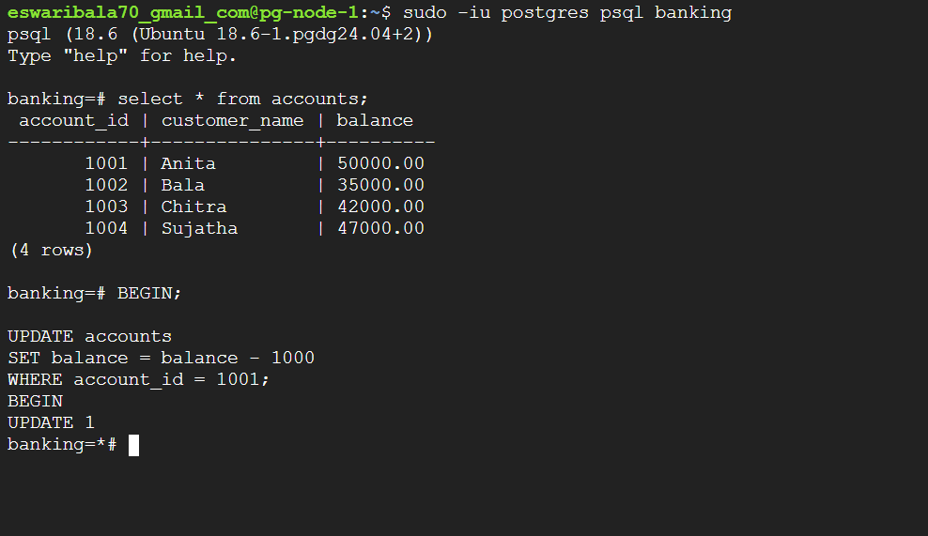

Session 2:
sudo -iu postgres psql banking
UPDATE accounts SET balance=balance+500 WHERE account_id=1001;
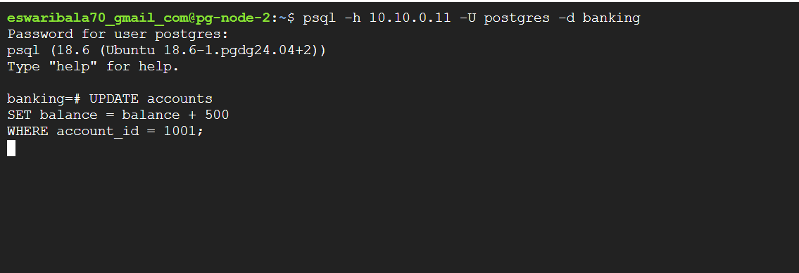
Return to Session 1 and release the lock:
COMMIT;
Verification: Session 2 completes after Session 1 commits. PostgreSQL logs should contain enough data for slow-query and lock-wait analysis depending on configured logging.

Lab 16 - Generate pgBadger Reports
Objective | Build an HTML report from PostgreSQL logs.
Suggested duration | 25 minutes

Setting log config for all three nodes
sudo nano /etc/patroni/patroni.yml
Under:
postgresql:
parameters:
add or update:
postgresql:
parameters:
logging_collector: 'on'
log_directory: 'log'
log_filename: 'postgresql-%Y-%m-%d_%H%M%S.log'
log_min_duration_statement: 0
Restart Patroni on this node:
sudo systemctl restart patroni
Then verify:
sudo -u postgres psql -p 5432 -d postgres -c \
"SHOW logging_collector; SHOW log_directory; SHOW log_min_duration_statement;"
Check log
sudo ls -lh /var/lib/postgresql/18/patroni/log/
expected
total 100K
-rw------- 1 postgres postgres 94K Sep 23 13:28 postgresql-2026-09-23_132227.log

Single-node report
sudo pgbadger /var/lib/postgresql/18/patroni/log/postgresql-2026-09-23_132227.log -o /tmp/pgbadger-report.html
Expected result: An HTML report is created at /tmp/pgbadger-report.html.
How to view the report
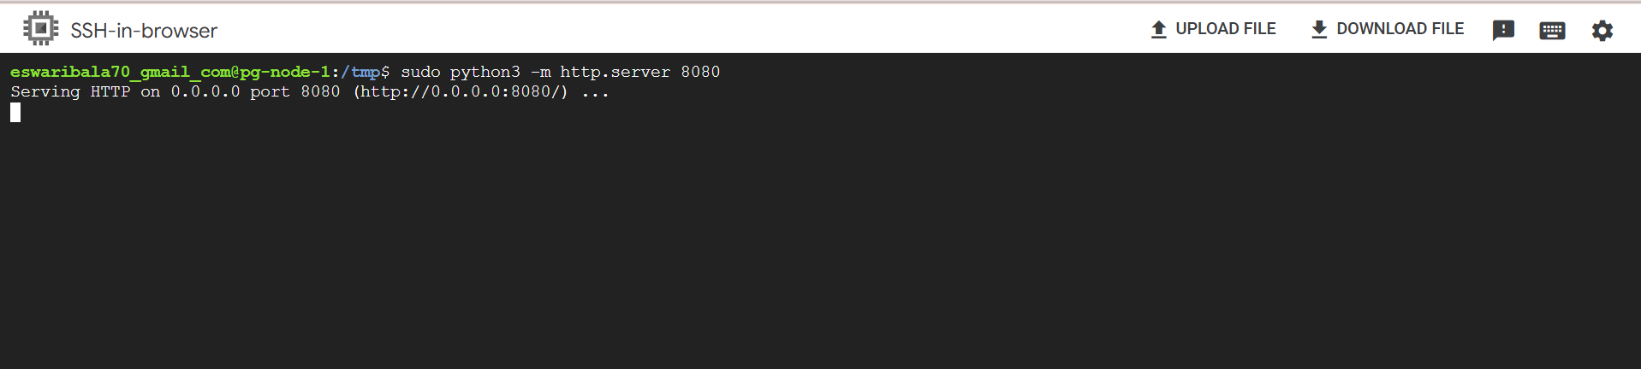
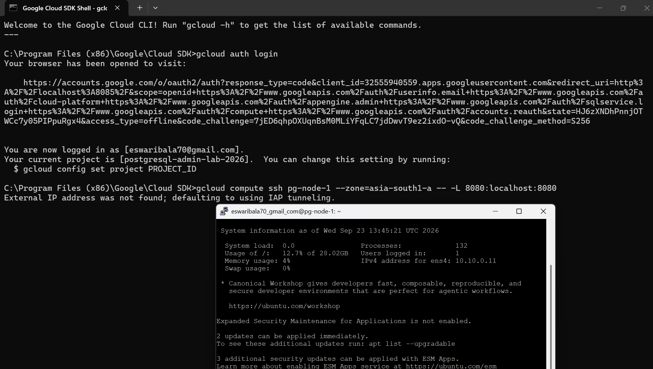

http://localhost:8080/pgbadger-report.html?utm_source=chatgpt.com
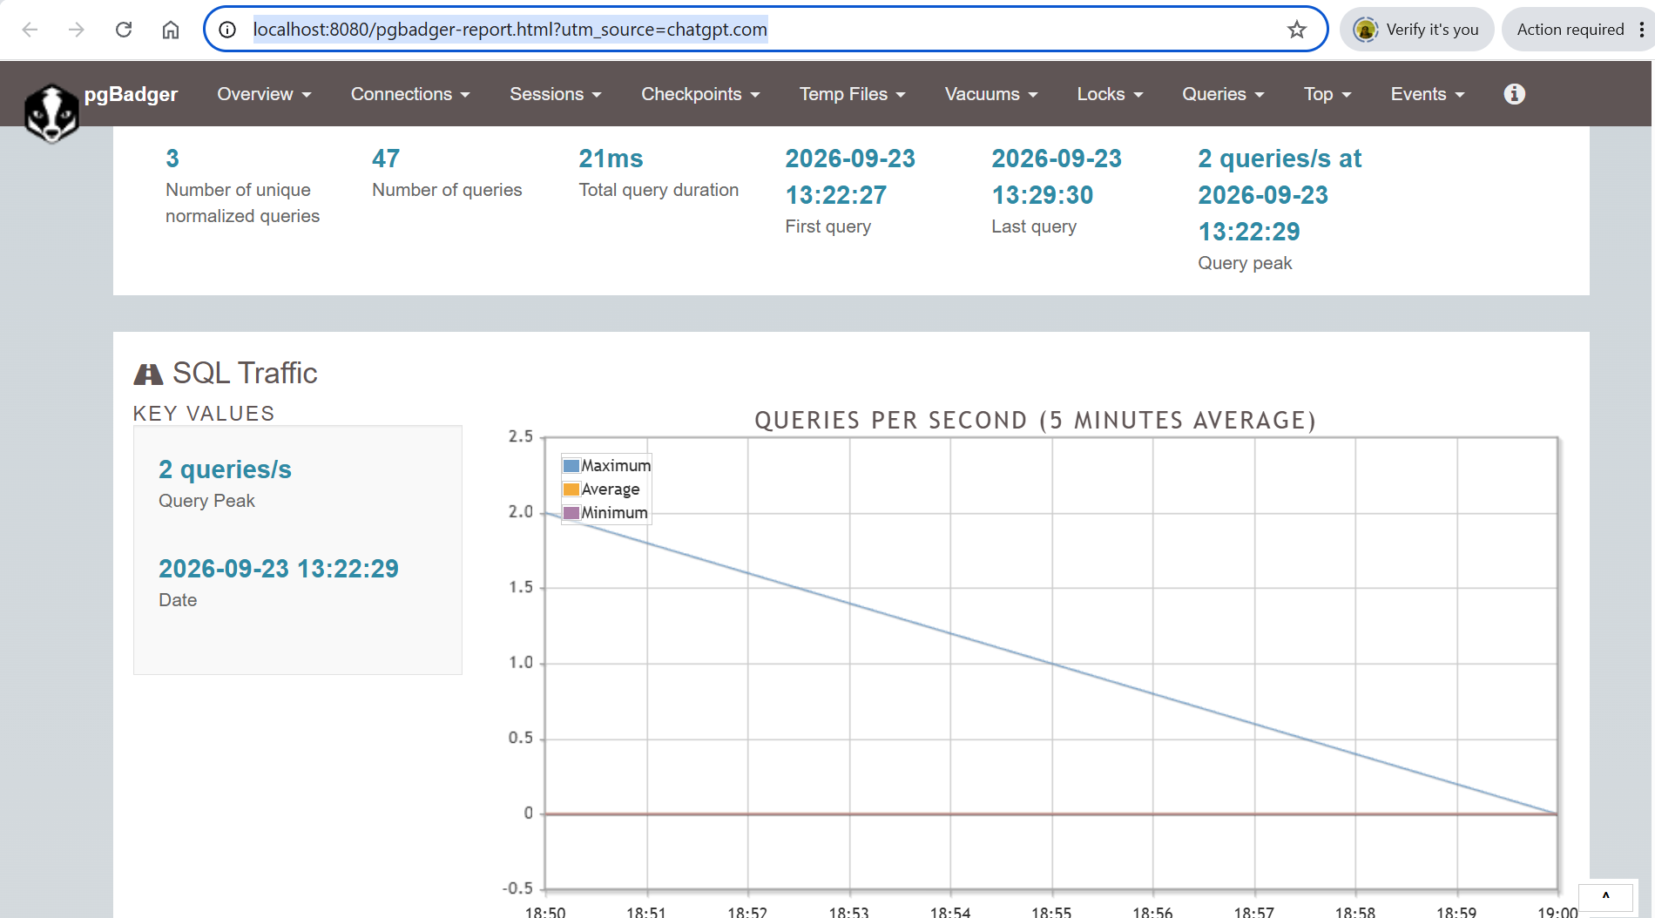

Cluster-level reporting concept
Copy or centrally collect PostgreSQL logs from all three nodes and process them together. This is useful because the leader role can move between nodes.
pgbadger pg-node-1*.log pg-node-2*.log pg-node-3*.log \
-o patroni-cluster-report.html
- Review slowest queries and most time-consuming queries.
- Review connection/session activity.
- Review errors and warnings.
- Review lock-related activity and temporary file activity where logging is enabled.
- Correlate report time ranges with Patroni switchovers/failovers.

Create a central collection directory on pg-node-1:
sudo mkdir -p /var/log/pg-cluster/{node1,node2,node3}
sudo chown -R $USER:$USER /var/log/pg-cluster
Copy the local node-1 logs:
sudo bash -c 'cp /var/lib/postgresql/18/patroni/log/postgresql-*.log /var/log/pg-cluster/node1/'
sudo chown $USER:$USER /var/log/pg-cluster/node1/*

first run on pg-node-2:
Ensure patroni.yml has log configuration
sudo mkdir -p /tmp/pgbadger-node2
sudo bash -c 'cp /var/lib/postgresql/18/patroni/log/postgresql-*.log /tmp/pgbadger-node2/'
sudo chown -R $USER:$USER /tmp/pgbadger-node2
ls -lh /tmp/pgbadger-node2/
mkdir E:\Postgres\logs
mkdir E:\Postgres\logs\node2
mkdir E:\Postgres\logs\node3
download collected log from node 2 and repeat for node 3
gcloud compute scp --recurse pg-node-2:/tmp/pgbadger-node2 E:\Postgres\logs\node2 --zone=asia-south1-b --tunnel-through-iap

upload to node 1
gcloud compute scp --recurse E:\Postgres\logs\node2\pgbadger-node2 pg-node-1:/tmp/ --zone=asia-south1-a --tunnel-through-iap

copy the files from node1
sudo cp /tmp/pgbadger-node2/*.log /var/log/pg-cluster/node2/
sudo find /var/log/pg-cluster -type f -name "*.log" -ls

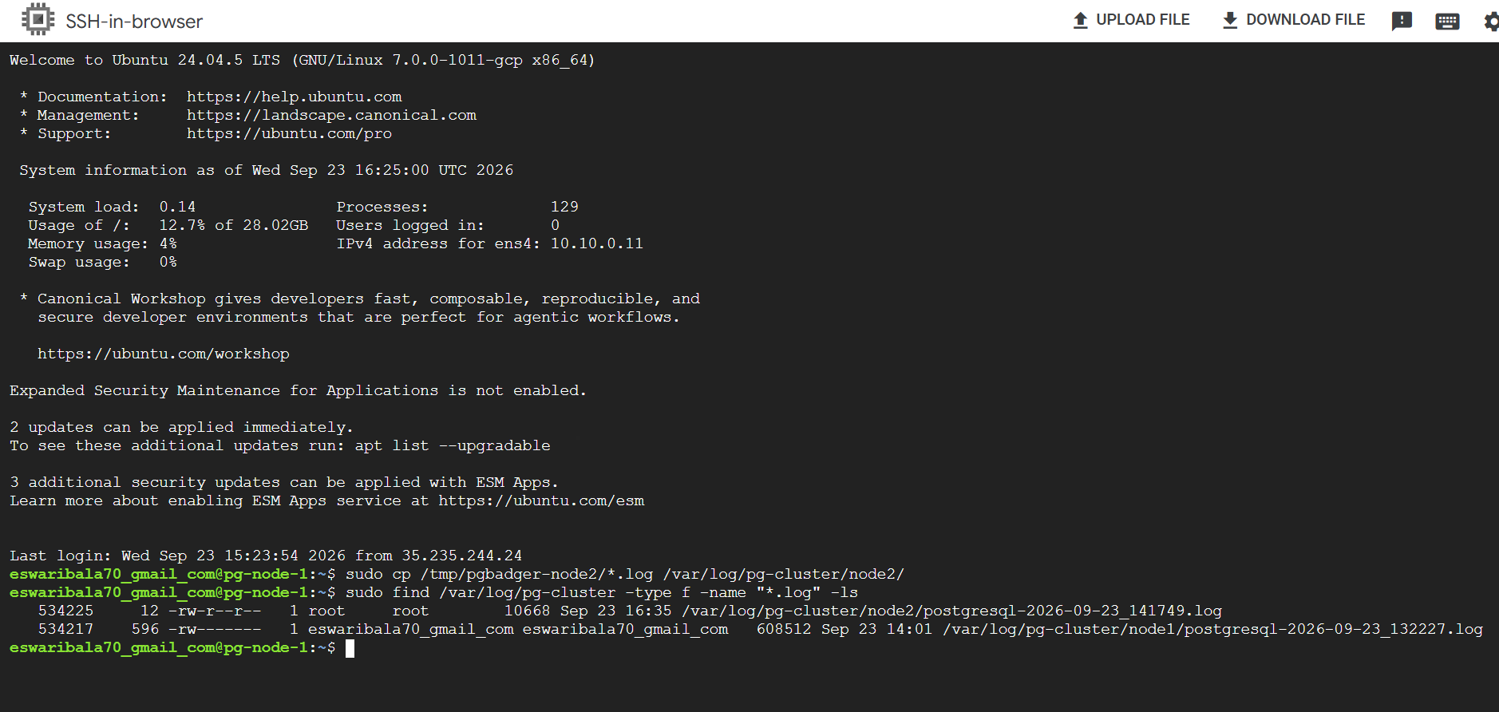

Create patroni report from both the nodes
sudo bash -c 'pgbadger /var/log/pg-cluster/node1/*.log /var/log/pg-cluster/node2/*.log -o /tmp/patroni-cluster-report.html'
- Open the cluster report
- You already used Python successfully for the single-node report:
cd /tmp
sudo python3 -m http.server 8080
gcloud compute ssh pg-node-1 --zone=asia-south1-a --tunnel-through-iap -- -L 8080:localhost:8080

http://localhost:8080/patroni-cluster-report.html?utm_source=chatgpt.com

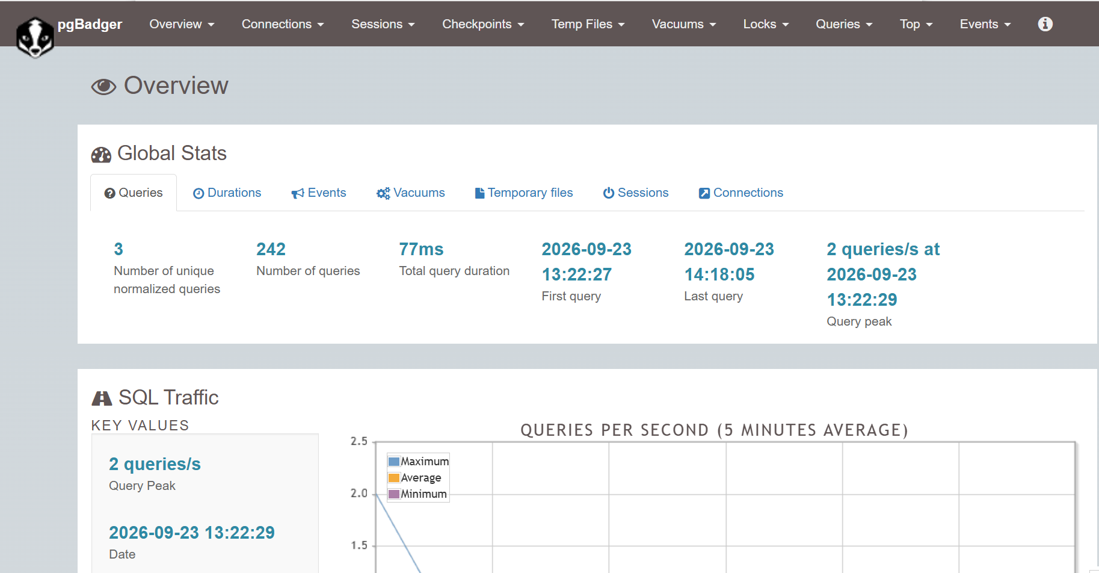

Lab 17 - Integrated HA Exercise
Objective | Validate the complete client path during a Patroni leader change and then analyze the workload.
Suggested duration | 45 minutes

Create a transaction log table
sudo -iu postgres psql banking -c "CREATE TABLE IF NOT EXISTS transaction_log(id bigserial PRIMARY KEY, event_time timestamptz DEFAULT now(), description text); GRANT SELECT,INSERT ON transaction_log TO bankapp; GRANT USAGE,SELECT ON SEQUENCE transaction_log_id_seq TO bankapp;"

Start a continuous client through PgBouncer
while true
do
PGPASSWORD='BankApp@2026' psql \
-h 127.0.0.1 -p 6432 -U bankapp -d banking \
-c "INSERT INTO transaction_log(description) VALUES ('Patroni HA test');"
sleep 2
done
Observation: Keep this terminal visible. During the role transition, one or more client attempts may fail depending on connection lifetime and timing. The important result is that the stable routing path recovers and subsequent writes go to the new leader.

Perform a planned switchover
sudo -u postgres /opt/patroni/bin/patronictl \
-c /etc/patroni/patroni.yml switchover

Verify the new leader
sudo -u postgres /opt/patroni/bin/patronictl -c /etc/patroni/patroni.yml list

Verify data after the change
sudo -iu postgres psql banking -c "SELECT count(*), min(event_time), max(event_time) FROM transaction_log;"

Inspect PgBouncer
psql -h 127.0.0.1 -p 6432 -U postgres pgbouncer
SHOW POOLS;
SHOW SERVERS;
SHOW STATS;

Generate a final pgBadger report
pgbadger postgresql-*.log -o patroni-ha-test.html
Expected result: You have demonstrated the full path: client -> PgBouncer -> HAProxy -> Patroni-selected leader, followed by workload analysis using pgBadger.

18. Troubleshooting Quick Reference
Symptom | Likely cause | Checks / corrective action
sudo patronictl: command not found | /opt/patroni/bin is not in sudo/root PATH | Use sudo -u postgres /opt/patroni/bin/patronictl -c /etc/patroni/patroni.yml ...
patronictl cannot read config | Permissions on /etc/patroni/patroni.yml | sudo -u postgres test -r /etc/patroni/patroni.yml && echo readable
No leader shown | DCS connectivity, expired leader lock, PostgreSQL/Patroni failure | Check systemctl status patroni, journalctl -u patroni, etcd health and patronictl list.
Replica not streaming | Replication connection, pg_hba.conf, credentials or WAL issue | Check pg_stat_replication on leader and Patroni/PostgreSQL logs.
PgBouncer connects to old primary | Backend hard-coded to former leader | Use HAProxy/VIP/service-discovery endpoint instead of a fixed database node IP.
PgBouncer authentication fails | userlist/auth_type mismatch or PostgreSQL credential issue | Check auth_file, SCRAM credential handling, pg_hba.conf and application password.
HAProxy returns connection failure | No backend passes /primary check | curl each node :8008/primary; validate HAProxy config and Patroni REST reachability.
pgBadger report is nearly empty | Insufficient PostgreSQL logging | Check logging_collector, log_min_duration_statement, log_line_prefix and actual log path.
PostgreSQL setting did not change | Restart/reload requirement or wrong config layer | Check patronictl show-config and PostgreSQL pg_settings pending_restart.

19. Lab Completion Checklist
☐ Patroni cluster lists one leader and two healthy replicas.
☐ pg_is_in_recovery() was used to independently confirm roles.
☐ patroni.yml local settings and dynamic DCS configuration were compared.
☐ A safe Patroni dynamic configuration change was performed and verified.
☐ Patroni /primary and /replica REST checks were tested.
☐ Banking sample data was created and verified on replicas.
☐ A planned switchover was completed successfully.
☐ An automatic failover was observed and the old leader rejoined as a replica.
☐ PgBouncer was installed, configured and monitored using SHOW commands.
☐ HAProxy was configured to route to the current Patroni leader.
☐ PostgreSQL logging was configured for useful pgBadger analysis.
☐ Slow queries and a lock wait were generated.
☐ A pgBadger HTML report was produced.
☐ The final integrated PgBouncer -> HAProxy -> Patroni leader exercise was completed.

Command Convention - Quick Copy
# Cluster status
sudo -u postgres /opt/patroni/bin/patronictl \
-c /etc/patroni/patroni.yml list
# Dynamic config
sudo -u postgres /opt/patroni/bin/patronictl \
-c /etc/patroni/patroni.yml show-config
# Edit dynamic config
sudo -u postgres /opt/patroni/bin/patronictl \
-c /etc/patroni/patroni.yml edit-config
# Planned switchover
sudo -u postgres /opt/patroni/bin/patronictl \
-c /etc/patroni/patroni.yml switchover
Training standard: Use the full /opt/patroni/bin/patronictl command throughout this manual. This matches the Patroni virtual-environment installation and avoids sudo PATH differences.

