CORRECTED HANDS-ON LAB MANUAL

PostgreSQL 18 HA with Patroni and PgBouncer on Kubernetes
Zalando Postgres Operator • 3 database instances • Patroni HA • PgBouncer pooler

Item | Lab configuration
Platform | Kubernetes with kubectl
PostgreSQL | 18
HA manager | Patroni, managed through Zalando Postgres Operator
Database instances | 3
Connection pooler | PgBouncer, 2 instances
Operator release used in commands | v2.0.2
Cluster CR name | acid-postgres-ha
Namespace | postgres-ha
Pooler service | acid-postgres-ha-pooler
Estimated duration | 3–4 hours

1. Why This Manual Replaces the Earlier Raw StatefulSet Lab
The earlier training manifest launched the Spilo image directly in a hand-written StatefulSet. In the live test, all three pods became independent Patroni/PostgreSQL primaries with scope 'dummy' and different PostgreSQL database system identifiers. That is not a three-member HA cluster.
Observed pattern from the failed lab:

postgres-0 -> scope=dummy -> role=primary -> system ID A
postgres-1 -> scope=dummy -> role=primary -> system ID B
postgres-2 -> scope=dummy -> role=primary -> system ID C
This corrected lab lets the Zalando Postgres Operator create and manage the StatefulSet, Patroni configuration, services, secrets, bootstrap, replica cloning, and PgBouncer integration.
Note: Do not reuse the PVCs or database data from the failed three-independent-primary deployment.

2. Learning Objectives
- Install the Zalando Postgres Operator on Kubernetes.
- Create one PostgreSQL 18 cluster containing three Patroni-managed instances.
- Verify exactly one primary and two replicas.
- Verify that all members belong to the same PostgreSQL database system.
- Enable an operator-managed PgBouncer connection pooler with two instances.
- Connect a banking application/client through the PgBouncer service.
- Create test data and verify read/write access.
- Perform a controlled Patroni switchover and verify service continuity.
- Understand the difference between Patroni HA, Kubernetes Services, and PgBouncer pooling.

3. Target Architecture
Kubernetes API
|
Zalando Postgres Operator
|
v
Patroni HA Cluster
acid-postgres-ha
|
+--------------+--------------+
| | |
v v v
PostgreSQL-0 PostgreSQL-1 PostgreSQL-2
Primary/Replica Replica/Primary Replica/Primary
| ^ ^
+------- streaming replication -------+
|
Master/Primary Service
|
PgBouncer Service
|
+-------+-------+
| |
v v
PgBouncer-1 PgBouncer-2
\ /
+------v------+
|
Application
Patroni determines the writable primary. The operator maintains Kubernetes resources around the cluster. PgBouncer pools application connections; it does not perform Patroni leader election.

4. Prerequisites
- A working Kubernetes cluster.
- kubectl configured for the target cluster.
- Git installed on the Windows workstation.
- Internet/container-registry access from the cluster.
- A default Kubernetes StorageClass capable of provisioning ReadWriteOnce volumes.
- Permission to create cluster-scoped operator resources and namespace resources.
- At least enough cluster resources for three PostgreSQL pods plus the operator and two PgBouncer pods.

5. Lab 0 - Remove the Incorrect Previous Deployment
Because the previous lab produced three independent PostgreSQL primaries, remove that fresh lab deployment before starting the corrected exercise.
kubectl delete namespace postgres-ha
kubectl get namespace postgres-ha
Expected result: After deletion completes, postgres-ha is no longer listed.
Check persistent volumes:
kubectl get pv
Note: If old lab PVs remain because of the StorageClass reclaim policy, do not intentionally bind the corrected cluster to those old data volumes.

6. Lab 1 - Verify Kubernetes and Storage
kubectl version --client
kubectl cluster-info
kubectl get nodes -o wide
kubectl get storageclass
Expected result: The Kubernetes API is reachable, nodes are Ready, and at least one suitable StorageClass is available.

7. Lab 2 - Download the Postgres Operator
From Windows Command Prompt or PowerShell, change to your working directory and clone the operator repository at the release used for this lab:
cd /d E:\Docker\postgresdeployment
git clone --branch v2.0.2 --depth 1 https://github.com/zalando/postgres-operator.git
cd postgres-operator
Verify the repository:
git describe --tags --always
dir manifests
Expected result: The repository is available locally and the manifests directory is present.

8. Lab 3 - Install the Postgres Operator
The official operator quickstart supports deploying the supplied manifests with Kustomize. From the postgres-operator repository:
kubectl apply -k manifests
Watch the operator:
kubectl get pods -l name=postgres-operator -w
Press Ctrl+C when the operator is Running, then verify:
kubectl get pods -l name=postgres-operator
kubectl get deployment postgres-operator
kubectl get crd | findstr /I postgresql
Expected result: The postgres-operator pod is Running and the PostgreSQL custom resource definition is registered.
If the operator does not become Running:
kubectl get pods -l name=postgres-operator
kubectl describe deployment postgres-operator
kubectl logs deployment/postgres-operator --tail=200

9. Lab 4 - Create the PostgreSQL Namespace
kubectl create namespace postgres-ha
kubectl get namespace postgres-ha
Expected result: postgres-ha is Active.

10. Lab 5 - Create the 3-Instance PostgreSQL 18 Cluster with PgBouncer
Create a file named:
notepad E:\Docker\postgresdeployment\patroni\postgres-ha-operator.yaml
Paste:
apiVersion: "acid.zalan.do/v1"
kind: postgresql
metadata:
name: acid-postgres-ha
namespace: postgres-ha
spec:
teamId: "acid"

volume:
size: 5Gi

numberOfInstances: 3

users:
bank_app: []

databases:
banking: bank_app

postgresql:
version: "18"

enableConnectionPooler: true

connectionPooler:
numberOfInstances: 2
mode: "transaction"
schema: "pooler"
user: "pooler"
resources:
requests:
cpu: 100m
memory: 100Mi
limits:
cpu: "1"
memory: 100Mi
Apply it:
cd /d E:\Docker\postgresdeployment\patroni
kubectl apply -f postgres-ha-operator.yaml
Expected result: Kubernetes accepts the postgresql custom resource.

11. Lab 6 - Watch the Operator Build the Cluster
kubectl get postgresql -n postgres-ha
kubectl get pods -n postgres-ha -w
The operator creates the StatefulSet and initializes one PostgreSQL member first. Remaining members are then created/cloned as replicas. PgBouncer pods are also created.
After the pods stabilize:
kubectl get pods -n postgres-ha -o wide
kubectl get pods -n postgres-ha -l application=spilo -L spilo-role
kubectl get svc -n postgres-ha
kubectl get pvc -n postgres-ha
Expected result: Three Spilo/PostgreSQL pods are Running, one is the master/primary role, two are replicas, and PgBouncer pooler pods are Running.

12. Lab 7 - Identify the Actual Pod and Service Names
Operator-created names differ from the earlier hand-written StatefulSet. Record them instead of assuming postgres-0/postgres-1/postgres-2.
kubectl get pods -n postgres-ha
kubectl get svc -n postgres-ha
kubectl get deployment -n postgres-ha
Typical resources include the cluster service, replica service, and a pooler service named similar to:
acid-postgres-ha
acid-postgres-ha-repl
acid-postgres-ha-pooler
Note: Use the names shown by your own kubectl output if they differ.

13. Lab 8 - Verify Patroni Roles
First list the database pods with their role label:
kubectl get pods -n postgres-ha -l application=spilo -L spilo-role
Expected result: Exactly one database pod is the primary/master and the other two are replicas.
Get one database pod name in Windows CMD:
kubectl get pods -n postgres-ha -l application=spilo
Then run patronictl inside a database pod, replacing POD_NAME:
kubectl exec -it -n postgres-ha POD_NAME -- patronictl list
If patronictl needs the generated configuration path in the image, inspect its help and process/configuration rather than supplying an invented scope option:
kubectl exec -it -n postgres-ha POD_NAME -- patronictl --help
kubectl exec -n postgres-ha POD_NAME -- curl -s http://localhost:8008/
Expected result: Patroni reports one leader/primary and two replicas in one cluster.

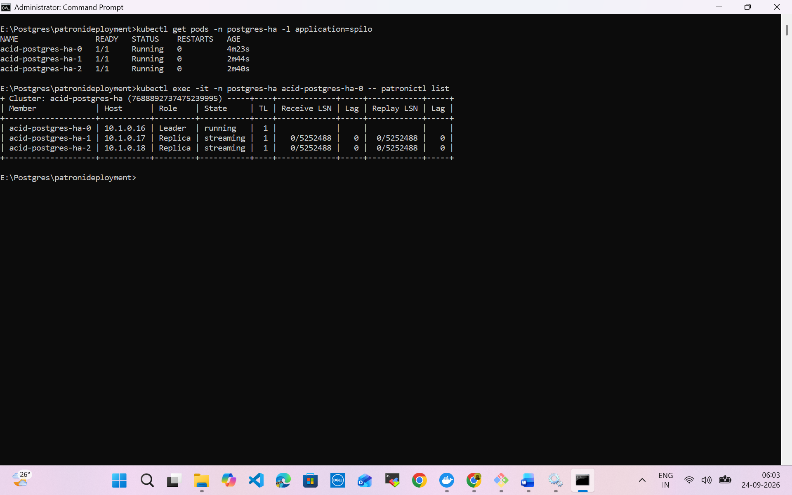

14. Lab 9 - Prove All Three Members Belong to One PostgreSQL Cluster
For each database pod, query the Patroni REST API:
kubectl exec -n postgres-ha POD_0 -- curl -s http://localhost:8008/
kubectl exec -n postgres-ha POD_1 -- curl -s http://localhost:8008/
kubectl exec -n postgres-ha POD_2 -- curl -s http://localhost:8008/
Compare the results.
Property | Correct HA cluster
Patroni scope | Same cluster scope on all members
Role | One primary; two replicas
State | Running/healthy
database_system_identifier | Same identifier on all three members
Patroni member name | Different member name per pod
This is the key validation that was missing from the failed raw StatefulSet lab.

15. Lab 10 - Inspect Operator-Created Credentials
The operator generates a Kubernetes Secret for manifest users. List the secrets:
kubectl get secrets -n postgres-ha
Look for a secret for bank_app whose name follows the operator credential-secret naming pattern. Inspect the secret metadata:
kubectl describe secret -n postgres-ha bank_app.acid-postgres-ha.credentials.postgresql.acid.zalan.do
To display the generated username and password using kubectl templates:
kubectl get secret -n postgres-ha bank_app.acid-postgres-ha.credentials.postgresql.acid.zalan.do -o jsonpath="{.data.username}"
kubectl get secret -n postgres-ha bank_app.acid-postgres-ha.credentials.postgresql.acid.zalan.do -o jsonpath="{.data.password}"
Note: Those values are base64 encoded. For a training environment, you can decode them with a local base64-capable tool or PowerShell. Avoid printing production credentials into shared terminals or screenshots.

16. Lab 11 - Verify PgBouncer
kubectl get deployment -n postgres-ha
kubectl get pods -n postgres-ha -l application=db-connection-pooler
kubectl get svc -n postgres-ha | findstr pooler
Expected result: The master connection pooler has two PgBouncer pods and a pooler Service.
Inspect pooler logs:
kubectl logs -n postgres-ha deployment/acid-postgres-ha-pooler --tail=100
Note: If your deployment name differs, substitute the name returned by kubectl get deployment -n postgres-ha.

17. Lab 12 - Connect Through PgBouncer
Create a temporary PostgreSQL client pod:
kubectl run pg-client --rm -it --restart=Never -n postgres-ha --image=postgres:18 -- bash
Inside the temporary client container, set the generated bank_app password and connect to the pooler:
export PGPASSWORD='GENERATED_BANK_APP_PASSWORD'

psql -h acid-postgres-ha-pooler -p 5432 -U bank_app -d banking
Inside psql:
SELECT current_database();
SELECT current_user;
SELECT pg_is_in_recovery();
SELECT inet_server_addr();
Expected result: The connection succeeds through PgBouncer and pg_is_in_recovery() is false because the master pooler targets the writable service.

18. Lab 13 - Banking Data Test
Inside the banking database:
CREATE TABLE accounts (
account_id integer PRIMARY KEY,
customer_name varchar(100) NOT NULL,
balance numeric(12,2) NOT NULL
);

INSERT INTO accounts VALUES
(101, 'Customer A', 10000.00),
(102, 'Customer B', 15000.00),
(103, 'Customer C', 20000.00);

SELECT * FROM accounts ORDER BY account_id;

UPDATE accounts
SET balance = balance - 500
WHERE account_id = 101;

SELECT * FROM accounts WHERE account_id = 101;
Expected result: DDL and DML complete successfully through PgBouncer.

19. Lab 14 - Verify Streaming Replication
Find the primary pod:
kubectl get pods -n postgres-ha -l application=spilo -L spilo-role
On the primary, query replication status. Replace PRIMARY_POD:
kubectl exec -it -n postgres-ha PRIMARY_POD -- psql -U postgres -d postgres -c "SELECT application_name, client_addr, state, sync_state FROM pg_stat_replication;"
Expected result: Replica connections are visible and their state is streaming.

20. Lab 15 - Controlled Patroni Switchover
Record the current roles before changing anything:
kubectl get pods -n postgres-ha -l application=spilo -L spilo-role
kubectl exec -n postgres-ha PRIMARY_POD -- curl -s http://localhost:8008/
Open Patroni's CLI in one database pod:
kubectl exec -it -n postgres-ha PRIMARY_POD -- patronictl
Use the patronictl help for the installed Patroni version and execute a controlled switchover interactively:
patronictl switchover --help
Note: The exact prompts/options can vary by Patroni version. Use the installed version's help rather than copying an option from another Patroni release.
After the switchover:
kubectl get pods -n postgres-ha -l application=spilo -L spilo-role
kubectl get svc -n postgres-ha
Expected result: A different member holds the primary/master role while the cluster remains healthy.

21. Lab 16 - Test PgBouncer After Switchover
Reconnect through the same PgBouncer service:
psql -h acid-postgres-ha-pooler -p 5432 -U bank_app -d banking
Then:
SELECT pg_is_in_recovery(), inet_server_addr();

UPDATE accounts
SET balance = balance + 100
WHERE account_id = 102;

SELECT * FROM accounts WHERE account_id = 102;
Expected result: The client can reconnect through the unchanged pooler endpoint and writes are routed to the current writable primary.
Note: Existing connections can be interrupted during failover. Real applications should implement appropriate reconnect/retry behavior.

22. Lab 17 - Pod Recovery Test
Choose a replica pod, not the current primary, and delete it:
kubectl delete pod -n postgres-ha REPLICA_POD
kubectl get pods -n postgres-ha -w
Expected result: Kubernetes/operator recreates the member and Patroni returns it to the cluster as a replica.
Verify again:
kubectl get pods -n postgres-ha -l application=spilo -L spilo-role
kubectl get pvc -n postgres-ha

23. Troubleshooting
Symptom | Commands | Interpretation / next area
Operator not Running | kubectl logs deployment/postgres-operator --tail=200 | Check RBAC, image pull, CRD/operator configuration.
PostgreSQL CR not progressing | kubectl describe postgresql acid-postgres-ha -n postgres-ha | Check operator events and validation errors.
Database pod Pending | kubectl describe pod POD -n postgres-ha; kubectl get pvc -n postgres-ha | Usually storage or scheduling.
Database pod CrashLoopBackOff | kubectl logs POD -n postgres-ha --previous | Inspect bootstrap/Patroni/PostgreSQL errors.
Three primaries again | curl localhost:8008 on each DB pod | Stop. Verify they are operator-created members of the same CR; compare system identifiers.
No pooler pods | kubectl get postgresql acid-postgres-ha -n postgres-ha -o yaml | Confirm enableConnectionPooler and connectionPooler configuration.
Pooler authentication failure | kubectl logs deployment/acid-postgres-ha-pooler -n postgres-ha | Use operator-generated application credentials and verify database/user.
Write is read-only | SELECT pg_is_in_recovery(); inspect target service | Client may be reaching a replica endpoint instead of the master pooler.

24. Production Considerations
- Pin and validate operator, Spilo/PostgreSQL, and PgBouncer versions before production rollout.
- Use appropriate StorageClasses, encryption, snapshots, backup/PITR, and tested restore procedures.
- Replication is not a substitute for backup.
- Apply resource requests/limits, topology spread or anti-affinity, and PodDisruptionBudgets suitable for the platform.
- Use TLS, NetworkPolicies, and secure secret-handling practices.
- Monitor Patroni role changes, replication lag, PostgreSQL health, PgBouncer saturation, storage and Kubernetes events.
- Test failover and application retry behavior under realistic load.
- Review operator upgrades and PostgreSQL major-version upgrades as separate controlled lifecycle activities.

25. Cleanup
Delete only the lab database cluster:
kubectl delete -f postgres-ha-operator.yaml
kubectl get pods -n postgres-ha
kubectl get pvc -n postgres-ha
Delete the lab namespace when no longer needed:
kubectl delete namespace postgres-ha
Remove the operator only if it is no longer needed by any PostgreSQL clusters:
cd /d E:\Docker\postgresdeployment\postgres-operator
kubectl delete -k manifests
Note: Do not remove a shared operator while other operator-managed PostgreSQL clusters still depend on it.

26. Final Validation Checklist
☐ Postgres Operator is Running.
☐ acid-postgres-ha custom resource exists.
☐ Three PostgreSQL/Spilo pods are Running.
☐ Exactly one member is primary/master and two are replicas.
☐ All three Patroni REST responses represent the same cluster.
☐ All three members share the same database_system_identifier.
☐ Two PgBouncer pooler pods are Running.
☐ bank_app can connect to banking through acid-postgres-ha-pooler.
☐ CREATE/INSERT/UPDATE succeeds through PgBouncer.
☐ pg_stat_replication shows streaming replicas.
☐ A controlled switchover changes the primary.
☐ The PgBouncer service name remains unchanged after switchover.
☐ A deleted replica is recreated and rejoins the cluster.

27. Key Concepts Recap
Component | Responsibility
PostgreSQL | Stores and processes database data.
Patroni | Leader election, PostgreSQL HA orchestration and failover coordination.
Zalando Postgres Operator | Creates/manages Kubernetes resources and PostgreSQL cluster lifecycle.
Kubernetes Service | Provides stable network endpoints despite pod changes.
PgBouncer | Pools client connections and reduces PostgreSQL connection overhead.
PersistentVolume/PVC | Provides durable database storage beyond pod lifetime.

28. References Used to Correct This Lab
This manual was corrected against the current Zalando Postgres Operator documentation/repository. The operator quickstart documents Kustomize installation and the operator-created PostgreSQL resources; the user/manifest documentation describes numberOfInstances, PostgreSQL version, generated user secrets, and enableConnectionPooler/connectionPooler configuration. The v2.0.2 repository compatibility table lists PostgreSQL 14–18 support.
- Zalando Postgres Operator - Quickstart
- Zalando Postgres Operator - User Guide
- Zalando Postgres Operator - Cluster Manifest Reference
- Zalando Postgres Operator - GitHub repository / release compatibility

