NIIT TRAINING DIVISION | LTM - iRUN Full Stack Engineering
TRAINING LAB GUIDE
LAB EXERCISE - 1
Kafka Architecture — Start a KRaft Cluster and Create Topics
Start a 3-Broker Cluster · Inspect the KRaft Controller Quorum · Create Topics · Find Partitions on Disk

Module Series | Apache Kafka Operations & Streaming Platforms — Day 4
Lab Type | Guided Hands-On SOP — Kafka Platform Operations
Duration | 48 minutes (5 min setup + 25 min tasks + 10 min validation + 8 min debrief)
Difficulty | ⭐⭐ Beginner — Fully Guided with Conceptual Depth
Platform | Linux lab VM with Docker Engine + Compose v2; Apache Kafka 4.3.1 (apache/kafka image), 3-node KRaft cluster
Document Version | v1.0 │ IT Training Division │ 2026
Learner Name | _______________________________________
Date & Batch | _______________________________________
Prerequisite Lab Completed | ☐ Day 1 Lab 3 (Streaming Platforms — Batch vs Real-Time) — signed off
Instructor Sign-Off | _______________________________________

1. LAB OVERVIEW

1.1 Why This Lab Exists
On Day 1 you simulated a topic with a file and offsets with a JSON file. Apache Kafka is the production system behind that idea: a cluster of brokers that store topics as replicated, partitioned, append-only logs, coordinated by a controller quorum (KRaft — Kafka 4.x no longer uses ZooKeeper). Every Kafka operations task — capacity, failover, lag, skew — starts with knowing which component holds what. In this lab you start a real three-broker cluster, inspect its controller quorum, create topics with different partition and replication settings, and find the partition logs on disk.

🎯 NIIT iRUN Alignment
INCIDENT OWNERSHIP: A producer team reports "Kafka is down". You own the first triage step: which brokers are up, which node leads the controller quorum, and are the topic's partitions online?
TROUBLESHOOTING EXCELLENCE: You will read kafka-metadata-quorum and kafka-topics output to locate every partition's leader and replicas, instead of treating the cluster as a black box.
OPERATIONAL READINESS: Topics are created explicitly with chosen partitions, replication factor and min.insync.replicas — never by accident with defaults.

1.2 Lab Scenario

📢 Incident Briefing — Stand Up RetailCo's Event Backbone
TIME: 09:30 │ PRIORITY: MEDIUM │ ASSIGNED TO: You
REQUEST RECEIVED: "RetailCo is replacing nightly file transfers with Kafka. Build a three-broker development cluster that matches production's architecture, and create the first topics for orders, payments and audit events."
CONTEXT: Your lab VM has Docker. The starter files in /labfiles/day4 contain a docker-compose.yml for three Kafka 4.3.1 nodes, each acting as broker AND controller (KRaft combined mode), and a helper script ./k.
YOUR MISSION: Start the cluster, prove all three nodes are healthy, create three topics with deliberate settings, and locate their partitions on disk. You have 25 minutes for the core tasks.
Figure: Lab 1 — Starting Environment: Docker Installed, Starter Files Present, No Kafka Containers Running

1.3 Conceptual Foundation
Kafka has a small number of components. Learn each one's job — every Day 4 lab exercises all of them.
Figure: Kafka Architecture — Producers → Brokers (Topics → Partitions → Replicas) → Consumers (Groups), Coordinated by the KRaft Controller Quorum
Component | Role | In This Lab | How You Inspect It
Broker | Stores partition replicas; serves producers and consumers | kafka-1, kafka-2, kafka-3 | docker compose ps; kafka-topics --describe
Controller (KRaft) | Manages cluster metadata: topics, leaders, ISR; one active leader of the quorum | Same 3 nodes (combined mode) | kafka-metadata-quorum describe --status
Topic / Partition | Named stream split into ordered, append-only logs | orders, payments, audit-log | kafka-topics --describe
Replica / Leader / ISR | Copies of a partition; one leader serves traffic; ISR = replicas in sync | Replication factor 3 or 1 | Leader:, Replicas:, Isr: columns
Figure: Where Data Lives: Each Partition Replica Is a Folder of Segment Files (.log, .index, .timeindex) on a Broker

1.4 Learning Objectives
- Describe Kafka's components: brokers, KRaft controllers, topics, partitions, replicas, producers and consumers
- Start a three-node KRaft cluster with Docker Compose and confirm every node is healthy
- Inspect the controller quorum: cluster ID, active controller and voters
- Create topics with explicit partition count, replication factor and min.insync.replicas
- Read topic descriptions: partition leaders, replica lists and in-sync replicas (ISR)
- Locate partition logs and segment files on a broker's disk

1.5 What You Will NOT Do

🚫 Hard Stops — Absolute Prohibitions for This Lab
✗ NEVER edit docker-compose.yml in /labfiles — work in your own copy in ~/day4
✗ NEVER delete files inside a broker's log directory — Kafka owns them
✗ NEVER run docker compose down -v during the day — it deletes every topic (only at end-of-day clean-up)
✗ NEVER create production-style topics with replication factor 1 — audit-log is the deliberate exception for comparison
✗ NEVER proceed past Task 2 until the quorum shows three voters and a leader

2. PREREQUISITES & SETUP

2.1 Knowledge Prerequisites

Prerequisite | Where Covered | Verified?
Topics, partitions, offsets, consumer groups (concepts) | Day 1 Lab 3 | ☐
Linux terminal and Docker basics | Foundation Module 1 | ☐
Kafka architecture and components | Day 4 Theory — Session 1 | ☐
Brokers & replication | Day 4 Theory — Session 1 | ☐
KRaft (no ZooKeeper) | Day 4 Theory — Session 1 | ☐

2.2 Tools & Access Required

⌨ Pre-Lab — Verify tool versions and lab files
# Update package list and install system dependencies
sudo apt-get update
sudo apt-get install -y ca-certificates curl gnupg lsb-release

# Add Docker's official GPG key
sudo install -m 0755 -d /etc/apt/keyrings
curl -fsSL https://download.docker.com/linux/ubuntu/gpg | sudo gpg --dearmor -o /etc/apt/keyrings/docker.gpg
sudo chmod a+r /etc/apt/keyrings/docker.gpg

# Set up the Docker repository
echo \
"deb [arch=$(dpkg --print-architecture) signed-by=/etc/apt/keyrings/docker.gpg] https://download.docker.com/linux/ubuntu \
$(lsb_release -cs) stable" | sudo tee /etc/apt/sources.list.d/docker.list > /dev/null

# Install Docker Engine, CLI, and Docker Compose Plugin
sudo apt-get update
sudo apt-get install -y docker-ce docker-ce-cli containerd.io docker-buildx-plugin docker-compose-plugin

# Configure user permissions (run docker without sudo)
sudo usermod -aG docker $USER
newgrp docker

# Pre-pull Apache Kafka 4.3.1 Docker image
docker pull apache/kafka:4.3.1

# Create lab workspace directory
mkdir -p ~/day4 && cd ~/day4
# Verify Docker and Compose v2
docker --version
docker compose version
# Verify the pre-pulled image
docker image ls apache/kafka

2.3 Pre-Lab Environment State Verification

Run all checks below and confirm the output matches expectations before starting the timed tasks:

⌨ Pre-Lab — Copy files and set the bootstrap variable
# 1. Confirm no Kafka containers are running yet
docker ps --filter name=kafka
# Expected: only the header line
# 2. Set the bootstrap list used by every command (container-internal addresses)
export BS=kafka-1:19092,kafka-2:19092,kafka-3:19092
echo $BS
# Remember: run 'export BS=...' again in every NEW terminal you open today
PRE-LAB: Record your Docker and Compose versions and the apache/kafka image tag on your VM. Answer: ______________________________________________________________________________________________________________

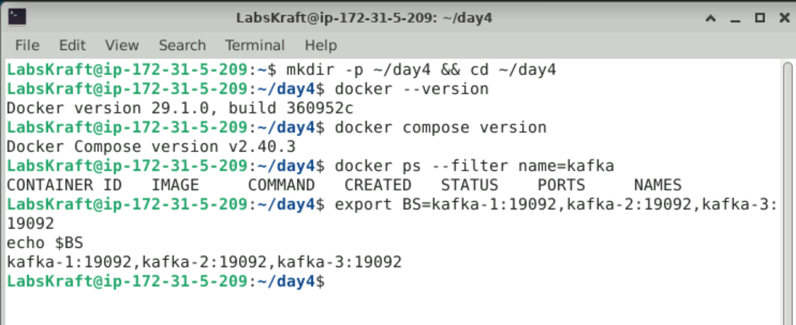

3. CONCEPT DEEP-DIVE BEFORE STARTING

3.1 KRaft — The Controller Quorum

Kafka 4.x stores cluster metadata in an internal Raft log (__cluster_metadata) replicated across the controller nodes. One controller is the active leader; the others are voters ready to take over. A majority of voters must be available for metadata changes (creating topics, electing partition leaders). With three voters, the cluster tolerates the loss of one.

💡 Why This Matters Operationally
Brokers keep serving existing partitions as long as each partition has a leader, but changes such as leader elections and topic creation need the controller quorum. Losing two of three controllers freezes metadata — that is why production clusters use three or five controllers.
To confirm quorum health: kafka-metadata-quorum describe --status shows LeaderId, CurrentVoters and follower lag.

3.2 The Critical Distinction: Container Running vs Broker Ready

⚠️ Most Common Mistake When Starting Kafka
docker compose up returns as soon as the containers are created. Engineers immediately run commands and get timeouts or "node not available" errors, then assume the configuration is wrong.
REASON: Each node must start, join the controller quorum and register as a broker — this takes several seconds after the container starts.
YOU MUST confirm readiness from the broker logs ("Kafka Server started") and the quorum status before creating topics.

3.3 Topic Settings — Where Verification Differs

Setting | Decides | Can It Change Later? | Check Command
Partitions / Replication factor | Parallelism and key distribution / number of copies (fault tolerance) | Partitions: increase only / RF: only by reassignment | kafka-topics --describe (PartitionCount, ReplicationFactor)
min.insync.replicas | How many in-sync copies an acks=all write needs | Yes (topic config) | kafka-topics --describe (Configs:)

📝 How to Choose Partitions and Replication Factor
Ask two questions: "How many consumers must read this topic in parallel?" → at least that many partitions. "How many broker failures must it survive without losing data?" → replication factor 3 with min.insync.replicas = 2 is the common production default (survives one failure while still accepting acks=all writes).

4. LAB TASKS

Figure: Lab 1 — Four-Task Workflow: Start Cluster → Inspect Quorum → Create Topics → Find Partitions on Disk
Figure: Expected Result — 3 Healthy Nodes, Quorum With 3 Voters, Topics orders/payments/audit-log, Segment Files Located

TASK 1 — START: Launch the Three-Node KRaft Cluster

1 | Start the Cluster and Confirm Every Node Is Ready  Kafka Ops SOP — Day 4 Lab 1 | ⏱ 5–6 min
Docker Compose starts three containers. Each runs Kafka in combined mode (broker + controller). You will wait for all three to report that the Kafka server has started.

⌨ Task 1 — Start and verify
# Step 1: start the cluster in the background
docker compose up -d
# Step 2: container status
docker compose ps
# Step 3: readiness - repeat after 10-20 seconds until all three nodes print the line
docker compose logs | grep "Kafka Server started"
# Step 4: the helper runs Kafka tools inside kafka-1 - list topics (none yet)
./k kafka-topics.sh --bootstrap-server $BS --list
📟 Expected Result
Step 2: kafka-1, kafka-2, kafka-3 STATUS Up PORTS 29092 / 39092 / 49092 -> 9092
Step 3: kafka-1 | ... [KafkaRaftServer nodeId=1] Kafka Server started (and the same for nodeId=2 and nodeId=3)
Step 4: empty output (no user topics yet)
1.A Record the status and host port of each container, and how long it took until all three logged Kafka Server started. Answer:
Status: All three containers (kafka-1, kafka-2, kafka-3) are Up.
Host Ports:
- kafka-1: 0.0.0.0:29092->9092/tcp
- kafka-2: 0.0.0.0:39092->9092/tcp
- kafka-3: 0.0.0.0:49092->9092/tcp
Startup Time: Approximately 8 seconds after running docker compose up -d for all three nodes to successfully log Kafka Server started.
1.B ./k runs tools INSIDE kafka-1, using addresses like kafka-2:19092. Why would those addresses not work from your VM's own shell? Answer:
Addresses like kafka-2:19092 rely on Docker's internal user-defined bridge network (day4_default), where container names are resolvable as hostnames exclusively within that network. Your VM's host shell sits outside this Docker network and does not have visibility into Docker's internal DNS resolution service, meaning the host shell cannot resolve the hostname kafka-2.

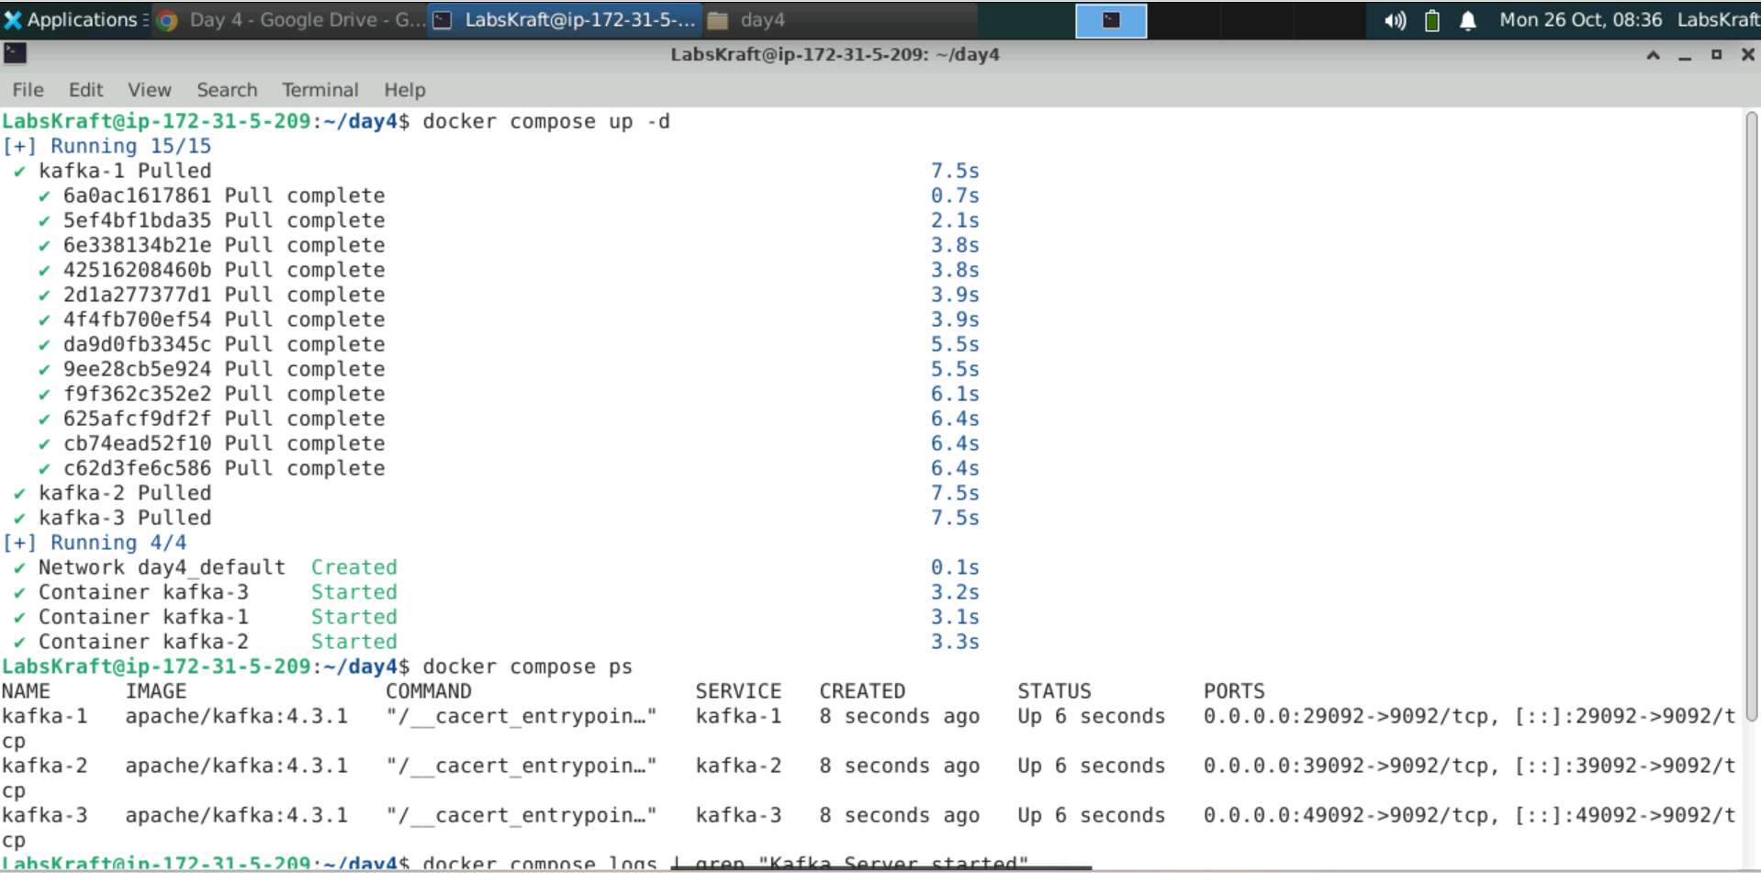

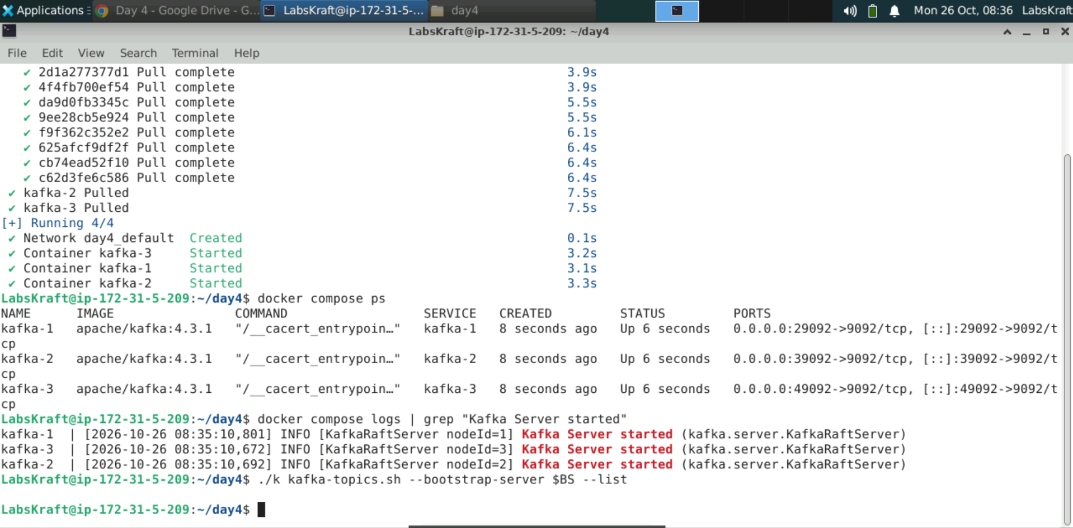

TASK 2 — QUORUM: Inspect the KRaft Controller Quorum

2 | Read the Cluster ID, Active Controller and Voters  Kafka Ops SOP — Day 4 Lab 1 | ⏱ 5 min
The metadata quorum tool shows which node is the active controller and how far behind the others are.

⌨ Task 2 — Quorum status and replication
./k kafka-metadata-quorum.sh --bootstrap-server $BS describe --status
./k kafka-metadata-quorum.sh --bootstrap-server $BS describe --replication
📟 Expected Result
--status: ClusterId: 4L6g3nShT-eMCtK--X86sw | LeaderId: 1, 2 or 3 | LeaderEpoch | HighWatermark
MaxFollowerLag: 0 (or very small) | CurrentVoters: ids 1, 2, 3 | CurrentObservers: none
--replication: one row per node: NodeId, LogEndOffset, Lag, LastFetchTimestamp, Status (Leader / Follower)
2.A Record the ClusterId, LeaderId and the list of CurrentVoters. Answer:
ClusterId: 4L6g3nShT-eMCtK--X86sw
LeaderId: 1
CurrentVoters: ids 1, 2, 3
2.B How many controller nodes could fail before metadata changes stop? Explain using the word majority. Answer:
One controller node can fail. In a 3-node KRaft quorum, a majority (at least 2 out of 3 active voters) is strictly required to achieve consensus and commit metadata changes. If two controller nodes fail, the cluster loses its majority quorum, meaning metadata operations (such as creating topics or electing partition leaders) will freeze.

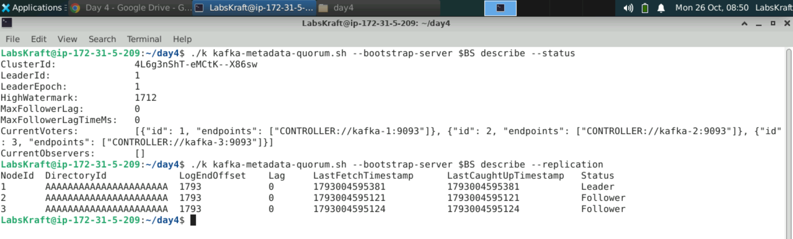

⚠️ STOP CHECK — Confirm Quorum Health, Not Assumption
Before moving to Task 3, confirm CurrentVoters lists three nodes and a LeaderId is present — do not create topics on a cluster whose quorum you have not checked.
If in doubt — show your instructor the --status output before proceeding to Task 3.

TASK 3 — TOPICS: Create Topics With Deliberate Settings

3 | Create orders, payments and audit-log and Read Their Layout  Kafka Ops SOP — Day 4 Lab 1 | ⏱ 8 min
Three topics, three different designs: orders needs parallelism, payments needs durability guarantees, and audit-log is a deliberately fragile single-copy topic for comparison in Lab 3.

⌨ Task 3 — Create, try an impossible topic, list and describe
# Step 1: create the three topics
./k kafka-topics.sh --bootstrap-server $BS --create --topic orders --partitions 6 --replication-factor 3
./k kafka-topics.sh --bootstrap-server $BS --create --topic payments --partitions 3 --replication-factor 3 \
--config min.insync.replicas=2
./k kafka-topics.sh --bootstrap-server $BS --create --topic audit-log --partitions 1 --replication-factor 1
# Step 2: try a replication factor larger than the number of brokers (must FAIL)
./k kafka-topics.sh --bootstrap-server $BS --create --topic too-many-copies --partitions 1 --replication-factor 4
# Step 3: list and describe
./k kafka-topics.sh --bootstrap-server $BS --list
./k kafka-topics.sh --bootstrap-server $BS --describe --topic orders
./k kafka-topics.sh --bootstrap-server $BS --describe --topic payments
📟 Expected Output
Step 1: Created topic orders. / Created topic payments. / Created topic audit-log.
Step 2: Error ... InvalidReplicationFactorException: replication factor 4 cannot be reached - only 3 brokers registered
Step 3: audit-log, orders, payments
orders: PartitionCount: 6 ReplicationFactor: 3 then 6 rows: Partition: 0..5 Leader: n Replicas: a,b,c Isr: a,b,c
payments: PartitionCount: 3 ReplicationFactor: 3 Configs: min.insync.replicas=2
Leaders are spread across brokers 1, 2 and 3; every Isr lists all three replicas
3.A For orders, record the leader of each partition 0–5 and how many partitions each broker leads. Answer:
Partition Leaders:
- Partition 0: Leader 3
- Partition 1: Leader 1
- Partition 2: Leader 2
- Partition 3: Leader 1
- Partition 4: Leader 3
- Partition 5: Leader 2
Partitions Led Per Broker:
- Broker 1: Leads 2 partitions (Partitions 1 and 3)
- Broker 2: Leads 2 partitions (Partitions 2 and 5)
- Broker 3: Leads 2 partitions (Partitions 0 and 4)
3.B Why did Kafka spread the partition leaders across all three brokers instead of putting them on one? Answer:
Kafka spreads partition leaders evenly across all available brokers to balance the client read/write load across the cluster. If all leaders were on a single broker, that node would become a severe performance bottleneck and a single point of failure for active client traffic, while the other brokers would sit idle.

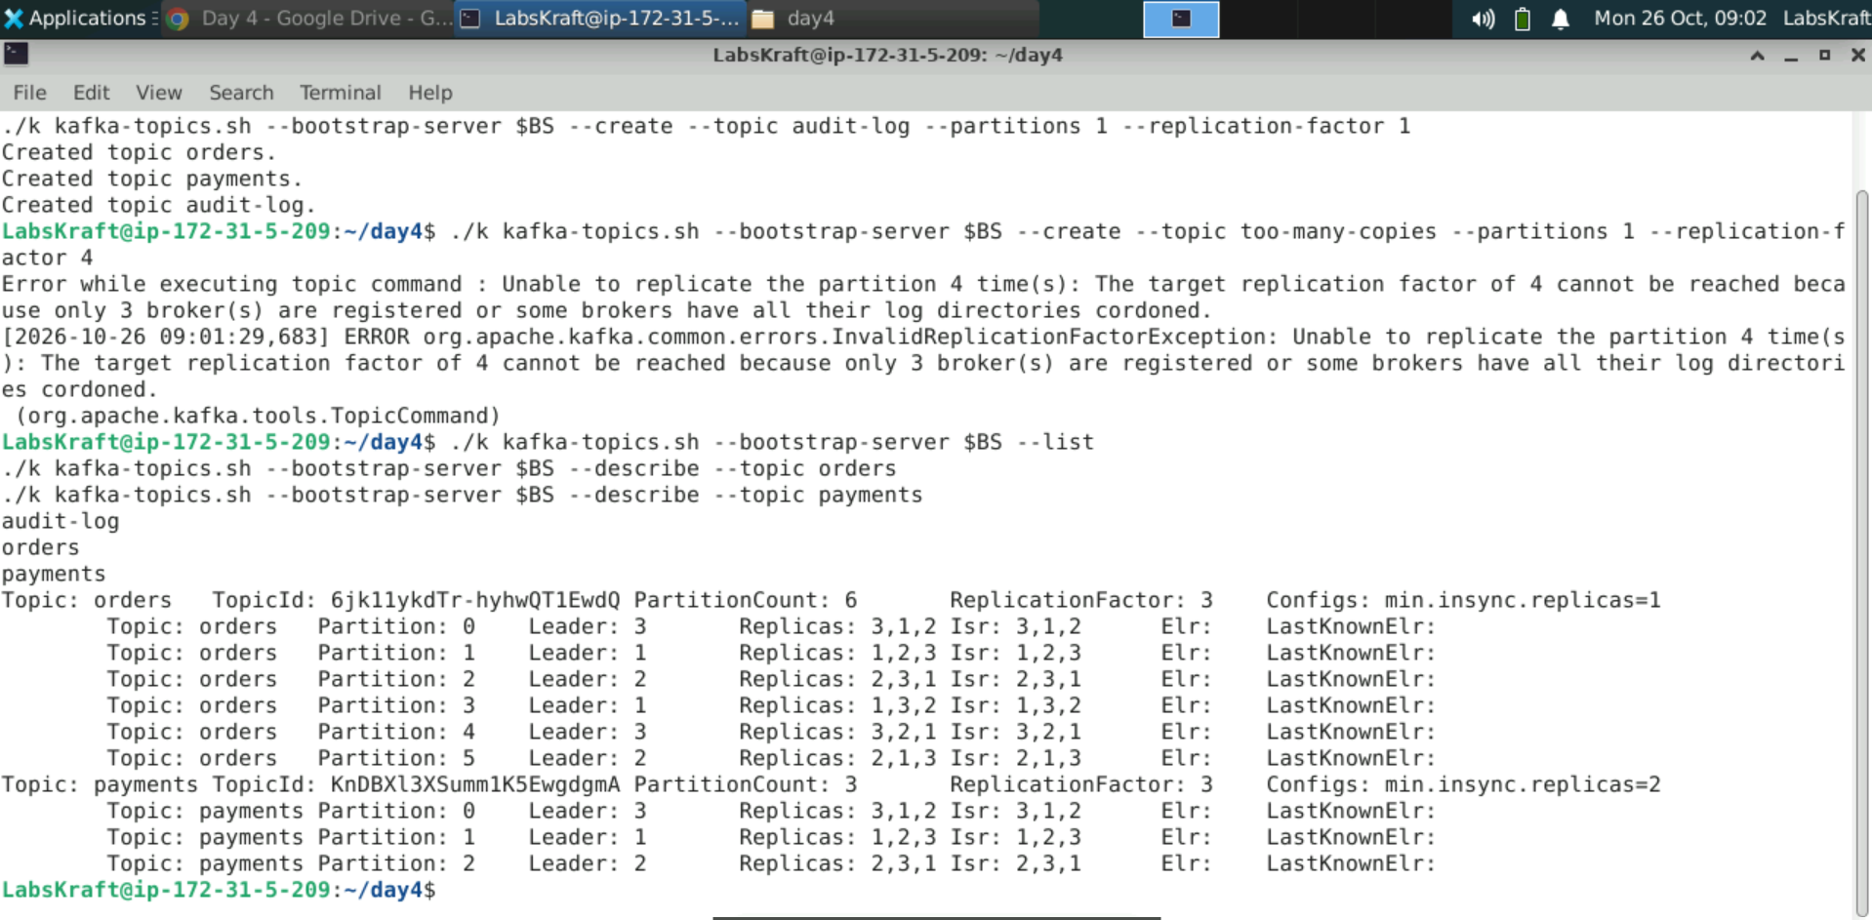

TASK 4 — STORAGE: Find Partitions and Segments on Disk

4 | Locate Partition Folders and Segment Files on a Broker  Kafka Ops SOP — Day 4 Lab 1 | ⏱ 5 min
A partition replica is simply a folder on a broker's disk. Inside it, data is written to segment files with matching index files. You will compare what kafka-1 and kafka-2 store.

⌨ Task 4 — Look inside the brokers' log directories
# Step 1: which partition folders does each broker hold?
docker exec kafka-1 ls /tmp/kraft-combined-logs
docker exec kafka-2 ls /tmp/kraft-combined-logs
# Step 2: inside one partition folder
docker exec kafka-1 ls /tmp/kraft-combined-logs/orders-0
# Step 3: sizes per partition replica, reported by Kafka itself
./k kafka-log-dirs.sh --bootstrap-server $BS --describe --topic-list orders
📟 Expected Output
Step 1: each broker shows __cluster_metadata-0, orders-0 … orders-5, payments-0 … payments-2, meta.properties ...
audit-log-0 appears on ONE broker only (replication factor 1)
Step 2: 00000000000000000000.log 00000000000000000000.index 00000000000000000000.timeindex
leader-epoch-checkpoint partition.metadata
Step 3: JSON listing each broker's log dir with partition sizes (0 bytes — nothing produced yet)
4.A Which broker holds audit-log-0? How many orders-* folders does each broker hold, and why that number? Answer:
audit-log-0 Location: It is held on kafka-2 (as seen in the directory listing output where audit-log-0 appears under kafka-2's log directories).
orders-* Folders Per Broker: Each broker holds all 6 partition folders (orders-0 through orders-5).
Reason: The orders topic was created with a replication factor of 3 in a 3-broker cluster, which means a full replica of every single partition (0 to 5) is stored across every available broker for high availability.
4.B What does the long number 00000000000000000000 in the segment file name represent? Answer:
It represents the base offset (the starting message offset) of the first message stored in that log segment file, padded with leading zeros to 20 digits.

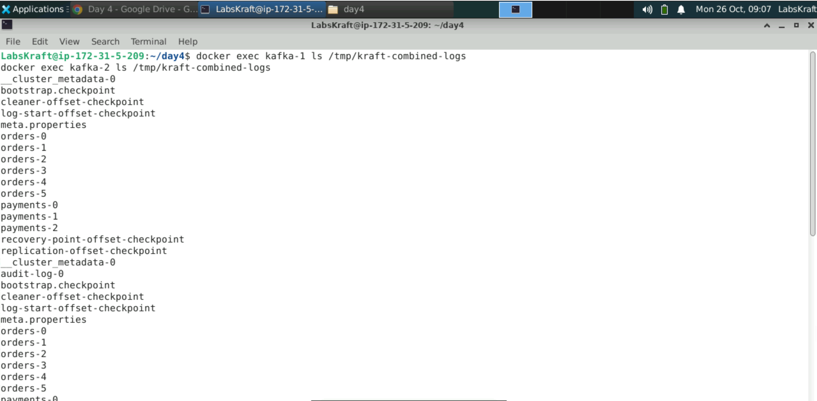

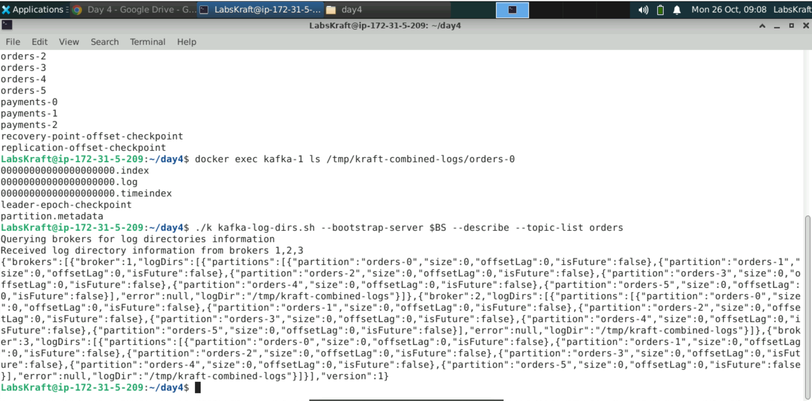

5. VALIDATION — CONFIRM FULL READINESS

Do not close the incident or call for instructor sign-off until ALL 8 validation steps below are completed and recorded.
Figure: Lab 1 — Kafka Architecture Validation Checklist

5.1 Validation Task Set

Validation Check 1 — Three nodes running
⌨ Validation 1
docker compose ps
# PASS criterion: kafka-1, kafka-2, kafka-3 all Up
V1: Are all three containers up? Answer:
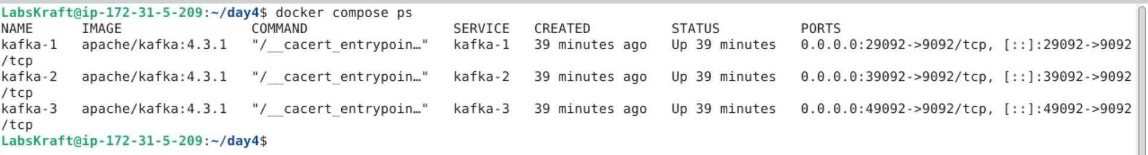
Validation Check 2 — Quorum healthy
⌨ Validation 2
./k kafka-metadata-quorum.sh --bootstrap-server $BS describe --status
# PASS criterion: a LeaderId and three CurrentVoters
V2: Does the quorum show a leader and three voters? Answer:
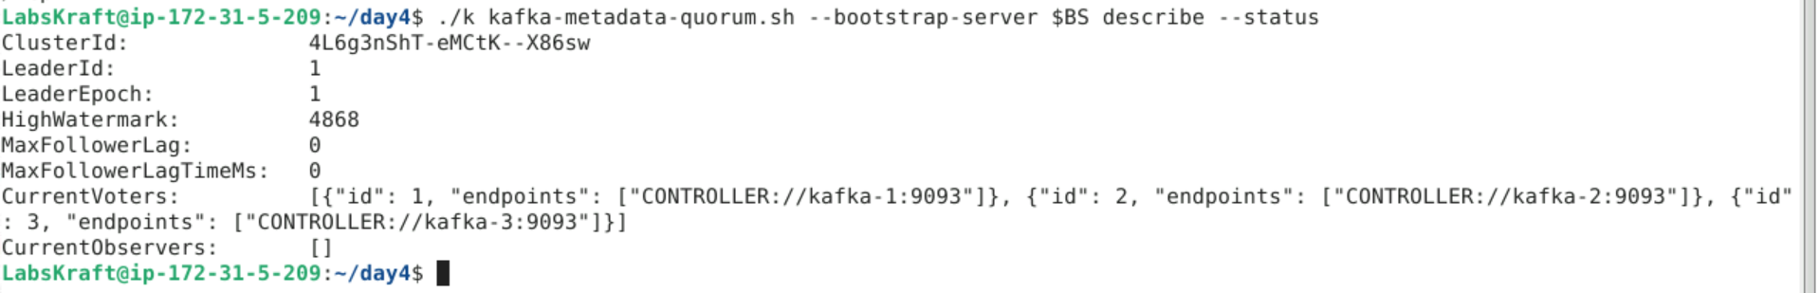
Validation Check 3 — Topics created
⌨ Validation 3
./k kafka-topics.sh --bootstrap-server $BS --list
# PASS criterion: audit-log, orders, payments (too-many-copies absent)
V3: Do exactly the three intended topics exist? Answer:
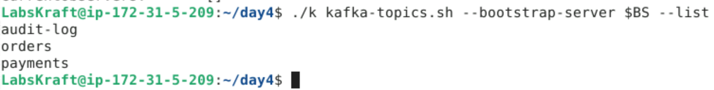
Validation Check 4 — orders layout correct
⌨ Validation 4
./k kafka-topics.sh --bootstrap-server $BS --describe --topic orders | head -1
# PASS criterion: PartitionCount: 6 and ReplicationFactor: 3
V4: Does orders have 6 partitions and RF 3? Answer:
Validation Check 5 — payments durability setting
⌨ Validation 5
./k kafka-topics.sh --bootstrap-server $BS --describe --topic payments | head -1
# PASS criterion: Configs: min.insync.replicas=2
V5: Is min.insync.replicas=2 set on payments? Answer:
Validation Check 6 — All replicas in sync
⌨ Validation 6
./k kafka-topics.sh --bootstrap-server $BS --describe --under-replicated-partitions
# PASS criterion: no output - nothing is under-replicated
V6: Is the under-replicated list empty? Answer:
Validation Check 7 — Partition replicas on disk
⌨ Validation 7
docker exec kafka-3 ls /tmp/kraft-combined-logs | grep -c '^orders-'
# PASS criterion: 6 - every broker holds a replica of every orders partition (RF 3 on 3 brokers)
V7: Does kafka-3 hold all 6 orders replicas? Answer:
Validation Check 8 — Full lab record complete
⌨ Validation 8 — Final completeness check
# Confirm every answer box (PRE-LAB, 1.A through 4.B) is completed
# Leave the cluster RUNNING - Labs 2-5 use it
# PASS criterion: every answer box holds real output (IDs, leaders, folder names)
V8: Confirm all answer boxes and evidence are complete and ready to show your instructor. Answer: ______________________________________________________________________________________________________________

✅ STOP HERE — Show your completed validation record to your instructor before proceeding to Section 7.

6. TROUBLESHOOTING — COMMON ISSUES & FIXES

Issue / Error | Cause | Diagnosis | Fix
permission denied while trying to connect to the Docker daemon | Your user is not in the docker group | groups | grep docker | Ask the instructor to add you to the docker group (then log out and in)
Bind for 0.0.0.0:29092 failed: port is already allocated | Another Kafka or old container uses the port | docker ps -a | Stop/remove the old container, then docker compose up -d
Timed out waiting for a node assignment / connection refused | Commands run before the brokers finished starting | docker compose logs | grep 'Kafka Server started' shows fewer than 3 lines | Wait 20 seconds and retry
--bootstrap-server requires a value / Missing required argument | BS is not set in this terminal | echo $BS prints nothing | export BS=kafka-1:19092,kafka-2:19092,kafka-3:19092
Error: No such container: kafka-1 | Cluster not started, or started from another folder | docker compose ps from ~/day4 | cd ~/day4 && docker compose up -d

7. INSTRUCTOR DEBRIEF — 8 MINUTES

7.1 Discussion Questions

Discussion 1 — Kafka Components
Without looking at notes: draw producers, brokers, partitions with leader and followers, consumers, and the controller quorum.
Which component would you check first if no topic could be created? And if one partition could not be read?
Key answer to explore: topic creation needs the controller quorum; reading a partition needs that partition's leader broker.
Discussion 2 — KRaft vs ZooKeeper
Kafka 4.x removed ZooKeeper. What did that remove from an operator's checklist?
Why do the three nodes in this lab act as both brokers and controllers, and why might production separate them?
Key insight: one system to operate; isolated controllers protect metadata from broker load in large clusters.
Discussion 3 — Partitions and Replication
orders has 6 partitions and RF 3. How many partition replicas exist in total, and how many leaders?
What does audit-log risk with replication factor 1?
Key answer: 18 replicas, 6 leaders; RF 1 means one broker failure makes the topic unavailable and can lose data.
Discussion 4 — Production Considerations
Why should automatic topic creation be disabled in production, and topics created through reviewed scripts instead?
Answer: auto-created topics use default partitions and replication, which rarely match the workload or durability needs.

7.2 Common Mistakes — Learn From These

Mistake | Why It Happens | Consequence | Prevention
Running commands before brokers are ready | Containers look Up immediately | Timeouts mistaken for config errors | Wait for Kafka Server started on every node
Replication factor 1 for important data | Fewer brokers in development | Data loss or unavailability on one failure | RF 3 + min.insync.replicas 2
Too few partitions | Default of 1 partition | Only one consumer can read in parallel | Size partitions for consumer parallelism
Deleting files in log directories | Disk looks full | Corrupted partitions | Use retention settings and kafka tools
Forgetting the bootstrap variable in a new terminal | Environment variables are per shell | Confusing missing-argument errors | export BS=... in every terminal

8. EXTENSION TASKS (Advanced Learners)

Extension A — Topic Configuration
Run ./k kafka-configs.sh --bootstrap-server $BS --describe --entity-type topics --entity-name orders --all and find retention.ms and segment.bytes.
Change retention on audit-log: --alter --add-config retention.ms=3600000, then describe it again.
Key question: what happens to old segments when retention.ms expires?
Extension B — Connect From the Host
From your VM's shell (not ./k), explain why clients there must use localhost:29092 instead of kafka-1:19092.
Find the PLAINTEXT_HOST listener in docker-compose.yml and the advertised listener for each node.
Research: what goes wrong when advertised.listeners is set incorrectly?
Extension C — Isolated Controllers
Research Kafka's isolated mode (separate controller nodes and broker nodes).
Sketch how docker-compose.yml would change for 3 controllers and 3 brokers.
Explain when an organisation should choose isolated over combined mode.

9. LAB COMPLETION & SIGN-OFF

9.1 Submission Checklist

✓ | Completion Criterion | Status
☐ | Three-node KRaft cluster started; readiness confirmed in logs | ☐ Pass / ☐ Fail
☐ | Controller quorum inspected: cluster ID, leader and three voters recorded | ☐ Pass / ☐ Fail
☐ | orders (6×RF3), payments (3×RF3, min ISR 2) and audit-log (1×RF1) created and described | ☐ Pass / ☐ Fail
☐ | Partition folders and segment files located on brokers | ☐ Pass / ☐ Fail
☐ | All 8 validation checks completed and recorded | ☐ Pass / ☐ Fail
☐ | All observation/answer boxes in this guide completed | ☐ Pass / ☐ Fail

9.2 Grading Criteria

Assessment Area | Criteria | Marks | Weight
Task 1 — Start Cluster | Cluster started; readiness evidenced | 15 | 15%
Task 2 — Quorum | Quorum read correctly; fault tolerance explained | 20 | 20%
Task 3 — Topics | Topics created as specified; leaders and ISR interpreted | 30 | 30%
Task 4 — Storage | Partition folders and segments located and explained | 25 | 25%
Validation & Documentation | All 8 validation checks completed; answers complete and accurate | 10 | 10%
TOTAL |  | 100 | 100%

9.3 Instructor Sign-Off

Field | Value
Lab Result | ☐ PASS ☐ PARTIAL ☐ REPEAT REQUIRED │ Score: _______ / 100
Instructor Name | ___________________________________
Instructor Signature & Date | ___________________________________
Remarks / Feedback | ___________________________________ ___________________________________
Completion Date & Time | ___________________________________

10. QUICK REFERENCE — KAFKA CLUSTER & TOPIC COMMAND CARD

Bookmark this page. Every command you need in SOP order.

Category | Command | Purpose
Setup | cp -r /labfiles/day4 ~/day4 && cd ~/day4 | Your own working copy
Setup | export BS=kafka-1:19092,kafka-2:19092,kafka-3:19092 | Bootstrap list (every new terminal)
Cluster | docker compose up -d / docker compose ps | Start and check the cluster
Cluster | docker compose logs | grep "Kafka Server started" | Readiness of each node
Quorum | ./k kafka-metadata-quorum.sh --bootstrap-server $BS describe --status | Controller leader and voters
Topics | ./k kafka-topics.sh --bootstrap-server $BS --create --topic t --partitions p --replication-factor r | Create a topic
Topics | ./k kafka-topics.sh --bootstrap-server $BS --list | List topics
Topics | ./k kafka-topics.sh --bootstrap-server $BS --describe --topic t | Leaders, replicas, ISR, configs
Health | ./k kafka-topics.sh --bootstrap-server $BS --describe --under-replicated-partitions | Partitions missing replicas
Storage | docker exec kafka-1 ls /tmp/kraft-combined-logs | Partition folders on a broker
Storage | ./k kafka-log-dirs.sh --bootstrap-server $BS --describe --topic-list t | Replica sizes per broker

Official Lab Guide — Day 4 Lab 1: Kafka Architecture — Start a KRaft Cluster and Create Topics │ IT Training Division │ NIIT iRUN Framework │ Version 1.0 │ Classification: Internal Training

IT Training Division | NIIT iRUN Framework | Confidential — For Training Use Only | Do Not Distribute

