NIIT TRAINING DIVISION | LTM - iRUN Full Stack Engineering
TRAINING LAB GUIDE
LAB EXERCISE - 2
Topics, Partitions & Producer Configuration — Publish Messages
Publish Unkeyed Messages · Publish Keyed Messages · Change Partition Count Safely · Tune Producer Settings

Module Series | Apache Kafka Operations & Streaming Platforms — Day 4
Lab Type | Guided Hands-On SOP — Kafka Producers & Partitioning
Duration | 48 minutes (5 min setup + 25 min tasks + 10 min validation + 8 min debrief)
Difficulty | ⭐⭐ Beginner — Fully Guided with Conceptual Depth
Platform | Linux lab VM with Docker Engine + Compose v2; Apache Kafka 4.3.1 (apache/kafka image), 3-node KRaft cluster
Document Version | v1.0 │ IT Training Division │ 2026
Learner Name | _______________________________________
Date & Batch | _______________________________________
Prerequisite Lab Completed | ☐ Day 4 Lab 1 (Kafka Architecture — KRaft Cluster and Topics) — signed off; cluster running
Instructor Sign-Off | _______________________________________

1. LAB OVERVIEW

1.1 Why This Lab Exists
Where a message lands in Kafka is decided by the producer, not the broker. Messages with the same key always go to the same partition — which is what preserves per-key ordering — while messages without a key are spread across partitions in batches. The partition count, the choice of key and the producer's acks, batching and compression settings decide ordering, balance, durability and throughput. In this lab you publish unkeyed and keyed messages, predict and verify exactly where each key lands, see what happens to key placement when partitions are added, and measure how producer configuration changes throughput and latency.

🎯 NIIT iRUN Alignment
INCIDENT OWNERSHIP: The order-tracking team says events for the same order arrive out of sequence. You own proving where each key is written and whether a partition change broke ordering.
TROUBLESHOOTING EXCELLENCE: You will predict key placement with Kafka's own hash function and confirm it with kafka-get-offsets — evidence, not assumptions.
OPERATIONAL READINESS: Producer settings (acks, linger.ms, batch.size, compression) are tuned by measurement with kafka-producer-perf-test, not copied from a blog.

1.2 Lab Scenario

📢 Incident Briefing — Out-of-Order Store Events
TIME: 10:30 │ PRIORITY: HIGH │ ASSIGNED TO: You
REQUEST RECEIVED: "Store events must be processed in order per store. Last week someone added partitions to the orders topic and ordering problems started. Also, the producers are slow during peak hours. Investigate both."
CONTEXT: The orders topic (6 partitions) exists from Lab 1. data/keyed_orders.txt holds 12 orders from 6 stores, keyed by store ID.
YOUR MISSION: Publish unkeyed and keyed messages, verify the exact partition of each store, reproduce the effect of adding partitions, and compare producer configurations. You have 25 minutes for the core tasks.
Figure: Lab 2 — Starting Environment: Cluster Running, Empty orders/payments/audit-log Topics

1.3 Conceptual Foundation
The producer's partitioner chooses a partition for every record. Its rule depends on whether the record has a key.
Figure: Producer Partitioning — Keyed: hash(key) mod partitions | Unkeyed: sticky batches across partitions
Record Type | Partition Choice | Ordering Guarantee | Typical Use
Keyed | murmur2(key) → positive → modulo number of partitions | All records with the same key in order | Orders per store, events per customer
Unkeyed | Sticky partitioner: fills a batch for one partition, then moves on | No cross-record ordering | Logs, clickstream, metrics
Explicit partition | Producer names the partition | Within that partition | Special cases only
Partition count change | Same key may hash to a DIFFERENT partition afterwards | Broken across the change | Plan partitions up front
Figure: Producer Settings That Matter — acks (durability) · linger.ms + batch.size (batching) · compression.type (bytes on the wire)

1.4 Learning Objectives
- Publish messages with the console producer, with and without keys
- Explain the default partitioner and predict the partition of a key
- Verify message placement per partition with kafka-get-offsets and the console consumer
- Explain why increasing partitions moves keys and breaks per-key ordering
- Measure the effect of acks, batching and compression with kafka-producer-perf-test
- Verify each step using documented evidence: per-partition offsets, printed keys and perf-test results

1.5 What You Will NOT Do

🚫 Hard Stops — Absolute Prohibitions for This Lab
✗ NEVER increase partitions on a production topic without checking who relies on per-key ordering
✗ NEVER run perf tests against orders, payments or audit-log — use the perf-test topic only
✗ NEVER run perf tests larger than this guide specifies — the VM shares resources with other learners
✗ NEVER edit the data files in data/ — the expected results depend on their exact contents
✗ NEVER proceed past Task 2 unless your per-partition offsets match the expected values exactly

2. PREREQUISITES & SETUP

2.1 Knowledge Prerequisites

Prerequisite | Where Covered | Verified?
Kafka components; topics and partitions | Day 4 Lab 1 | ☐
Partition strategy and message keys | Day 4 Theory — Session 2 | ☐
Producer configuration: acks, batching, compression | Day 4 Theory — Session 2 | ☐
Hash functions and modulo (concept) | Foundation Module 2 | ☐
Using two terminal windows | Foundation Module 1 | ☐

2.2 Tools & Access Required

⌨ Pre-Lab — Verify cluster and files
cd ~/day4
export BS=kafka-1:19092,kafka-2:19092,kafka-3:19092
docker compose ps
ls data/
# Expected: 3 containers Up; keyed_orders.txt salted_orders.txt skewed_orders.txt

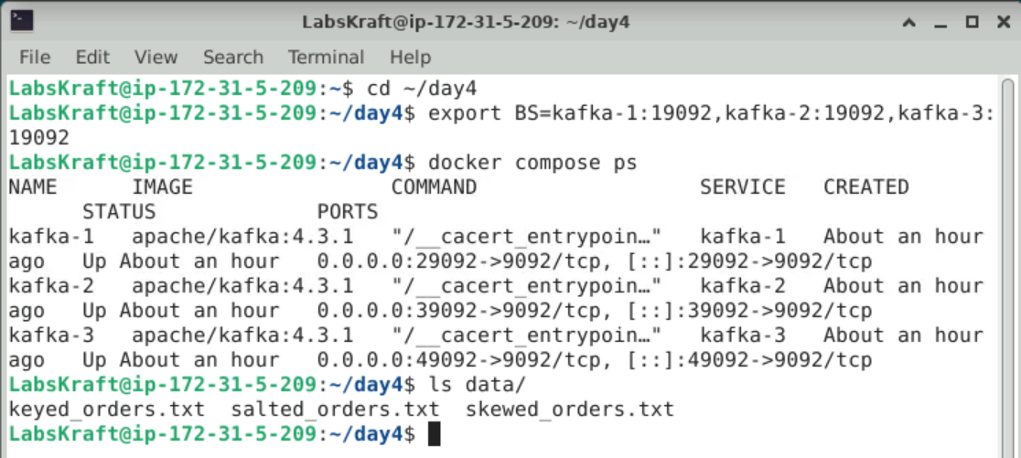

2.3 Pre-Lab Environment State Verification

Run all checks below and confirm the output matches expectations before starting the timed tasks:

⌨ Pre-Lab — Verify starting state
# 1. orders is empty: every partition's end offset is 0
./k kafka-get-offsets.sh --bootstrap-server $BS --topic orders
# Expected: orders:0:0 orders:1:0 ... orders:5:0
# 2. Create the two topics this lab needs
./k kafka-topics.sh --bootstrap-server $BS --create --topic clicks --partitions 3 --replication-factor 3
./k kafka-topics.sh --bootstrap-server $BS --create --topic perf-test --partitions 6 --replication-factor 3
# 3. Look at the keyed data file: key and value are separated by ':'
head -3 data/keyed_orders.txt
PRE-LAB: Record the end offsets of orders and the first line of keyed_orders.txt. Which part is the key? Answer:
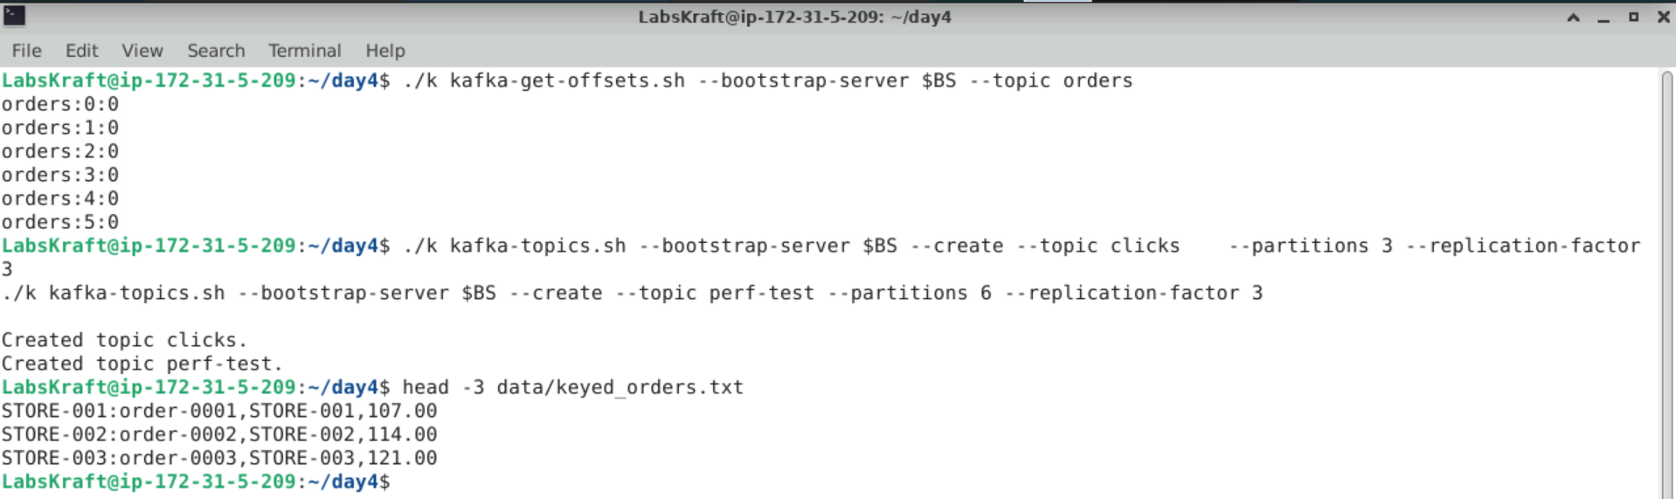

3. CONCEPT DEEP-DIVE BEFORE STARTING

3.1 How a Key Becomes a Partition

For a keyed record the default partitioner computes murmur2(key bytes), makes it positive, and takes the remainder after dividing by the number of partitions. The result is deterministic: the same key and the same partition count always give the same partition. It is NOT a round-robin: two different keys can collide on one partition while another partition receives nothing.

💡 Why This Matters Operationally
Because placement is deterministic you can predict it. The starter file murmur2.py contains Kafka's hash so you can check any key from the shell: python3 -c "from murmur2 import partition; print(partition('STORE-001', 6))"
To confirm placement on the cluster: kafka-get-offsets shows how many records each partition holds, and the console consumer with print.key and print.partition shows which key went where.

3.2 The Critical Distinction: Adding Partitions vs Keeping Order

⚠️ Most Common Mistake When Scaling a Topic
Teams add partitions to get more consumer parallelism and assume nothing else changes. But the partition formula includes the partition count, so most keys start landing on a different partition.
REASON: Old records for a key stay in the old partition; new records go to the new one. A consumer can now read a key's newer events before its older ones — per-key ordering is broken across the change.
YOU MUST plan partition counts up front for keyed topics, or migrate to a new topic in a controlled way.

3.3 Producer Settings — Where the Trade-Off Lies
Setting | Higher / On Means | Cost | Measured By
acks=all (vs acks=1) | Write confirmed by all in-sync replicas — durable | Higher latency | perf-test avg / 99th latency
linger.ms + batch.size / compression.type | Bigger batches / fewer bytes sent | A few ms extra latency / CPU | perf-test records/sec and MB/sec

📝 How to Decide Whether to Use a Key
Ask: "Must events for the same entity (order, store, customer) be processed in order?" Yes → use that entity's ID as the key. No → leave the key empty and let the sticky partitioner balance the load.

4. LAB TASKS

Figure: Lab 2 — Four-Task Producer Workflow: Unkeyed Publish → Keyed Publish → Partition Change → Producer Tuning
Figure: Expected Result — Keyed Placement Matches murmur2 Exactly, Key Movement After 6→8 Partitions Proven, Producer Settings Compared

TASK 1 — PUBLISH: Unkeyed Messages to clicks

1 | Publish and Read Unkeyed Messages  Kafka Ops SOP — Day 4 Lab 2 | ⏱ 5 min
You type six click events into the console producer, then read them back with their partition and offset.

⌨ Task 1 — Produce by typing, consume with partition and offset
# Step 1: start the producer, type these 6 lines (Enter after each), then press Ctrl+C
./k kafka-console-producer.sh --bootstrap-server $BS --topic clicks
page=/home user=U1
page=/shoes user=U2
page=/cart user=U1
page=/home user=U3
page=/checkout user=U1
page=/shoes user=U4
# Step 2: read everything back with partition and offset
./k kafka-console-consumer.sh --bootstrap-server $BS --topic clicks --from-beginning --max-messages 6 \
--formatter-property print.partition=true --formatter-property print.offset=true
# Step 3: per-partition end offsets
./k kafka-get-offsets.sh --bootstrap-server $BS --topic clicks
📟 Expected Result
Step 2: 6 lines such as Partition:2 Offset:0 page=/home user=U1 then Processed a total of 6 messages
Lines are grouped by partition — order is only guaranteed WITHIN a partition
Step 3: clicks:0:a clicks:1:b clicks:2:c with a + b + c = 6 (the split depends on batching)
1.A Record the per-partition end offsets of clicks and check they add up to 6. Answer:
clicks:0:0
clicks:1:0
clicks:2:6
Total Sum: $0+0+6=6$ messages, which correctly matches the total number of unkeyed messages published.
1.B The consumer did not print the events in the order you typed them. Why is that allowed for unkeyed events? Answer:
Unkeyed events use Kafka's sticky partitioner, which groups messages into batches for a specific partition before rotating to another partition. Because there are no keys to enforce deterministic routing to specific partitions, ordering is only guaranteed within an individual partition, and the consumer reads across partitions without preserving the exact global chronological sequence in which they were typed.

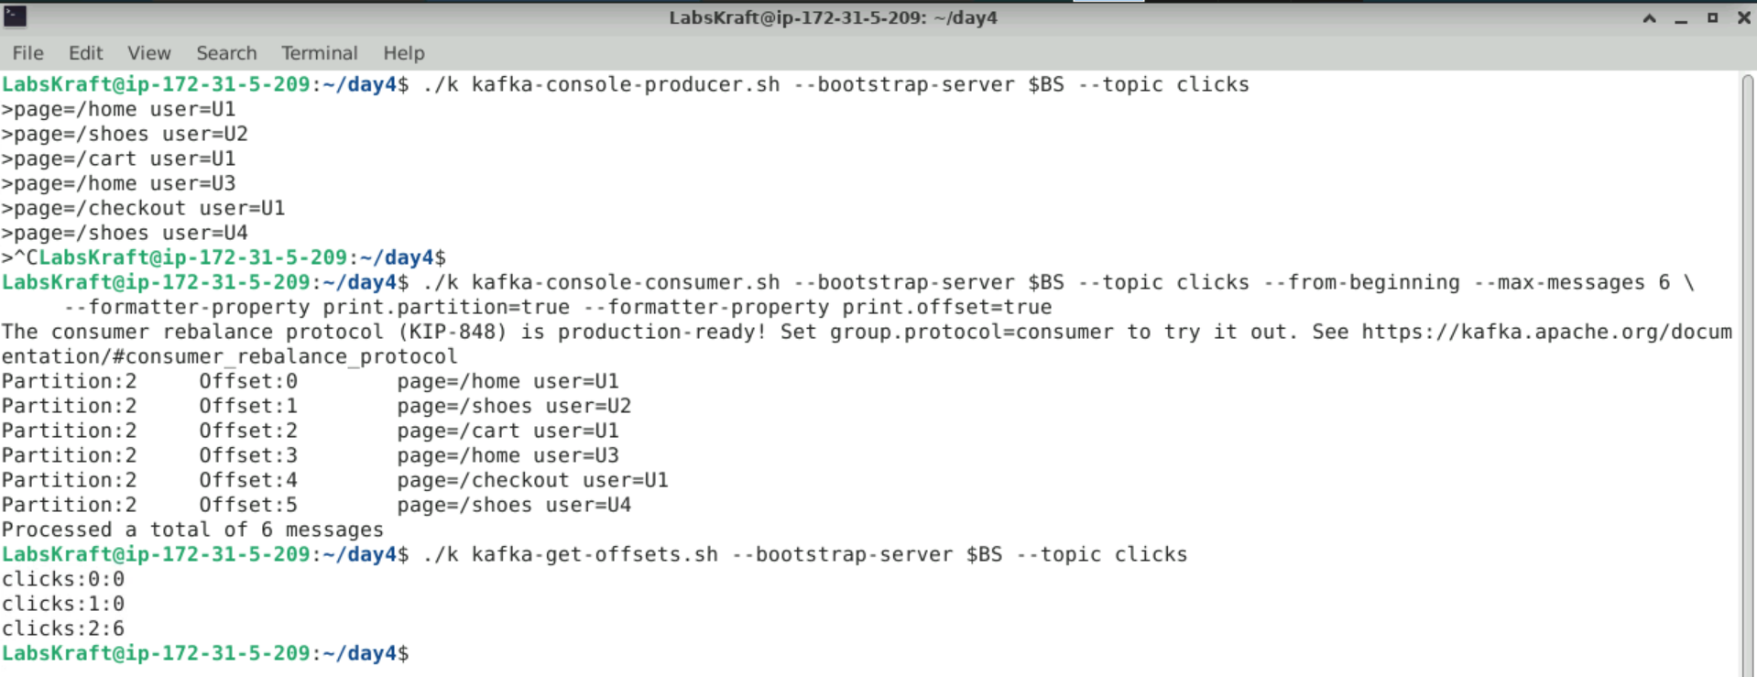

TASK 2 — KEYS: Keyed Messages and Predictable Placement

2 | Publish 12 Keyed Orders and Verify Where Each Store Lands  Kafka Ops SOP — Day 4 Lab 2 | ⏱ 7 min
First predict the partition of each store with Kafka's hash, then publish the file with parse.key enabled and check the result on the cluster.

⌨ Task 2 — Predict, publish, verify
# Step 1: predict (Kafka's default partitioner, 6 partitions)
python3 -c "from murmur2 import partition; print({f'STORE-00{i}': partition(f'STORE-00{i}', 6) for i in range(1, 7)})"
# Step 2: publish the keyed file (key and value separated by ':')
./k kafka-console-producer.sh --bootstrap-server $BS --topic orders \
--property parse.key=true --property key.separator=: < data/keyed_orders.txt
# Step 3: per-partition counts
./k kafka-get-offsets.sh --bootstrap-server $BS --topic orders
# Step 4: read back with key and partition
./k kafka-console-consumer.sh --bootstrap-server $BS --topic orders --from-beginning --max-messages 12 \
--formatter-property print.key=true --formatter-property print.partition=true
📟 Expected Output
Step 1: {'STORE-001': 1, 'STORE-002': 5, 'STORE-003': 2, 'STORE-004': 4, 'STORE-005': 5, 'STORE-006': 1}
Step 3: orders:0:0 orders:1:4 orders:2:2 orders:3:0 orders:4:2 orders:5:4
Step 4: every STORE-001 and STORE-006 line shows Partition:1; STORE-002/STORE-005 Partition:5; STORE-003 Partition:2;
STORE-004 Partition:4. (Kafka 4.2+ may print a note that --property is deprecated — the command still works)
2.A Record the per-partition end offsets and confirm each matches the prediction from Step 1. Answer:
Per-partition end offsets:
- orders:0:0
- orders:1:4
- orders:2:2
- orders:3:0
- orders:4:2
- orders:5:4
Confirmation: Yes, the offsets match the Step 1 murmur2 prediction perfectly:
- STORE-001 & STORE-006 land on Partition 1 ($2+2=4$ messages).
- STORE-003 lands on Partition 2 ($2$ messages).
- STORE-004 lands on Partition 4 ($2$ messages).
- STORE-002 & STORE-005 land on Partition 5 ($2+2=4$ messages).
- Partitions 0 and 3 receive $0$ messages.
2.B Six stores, six partitions — yet partitions 0 and 3 are empty and partitions 1 and 5 hold two stores each. Explain why. Answer:
Kafka's default partitioner uses a hashing algorithm ($\text{murmur2}(\text{key}) \pmod{\text{partitions}}$) to assign key placements, rather than a round-robin distribution. Because hashing aims for uniform distribution over a large dataset with thousands of distinct keys, small sample sizes (like 6 keys across 6 partitions) naturally result in hash collisions (multiple store keys mapping to the exact same partition index) and leaving some partitions empty.

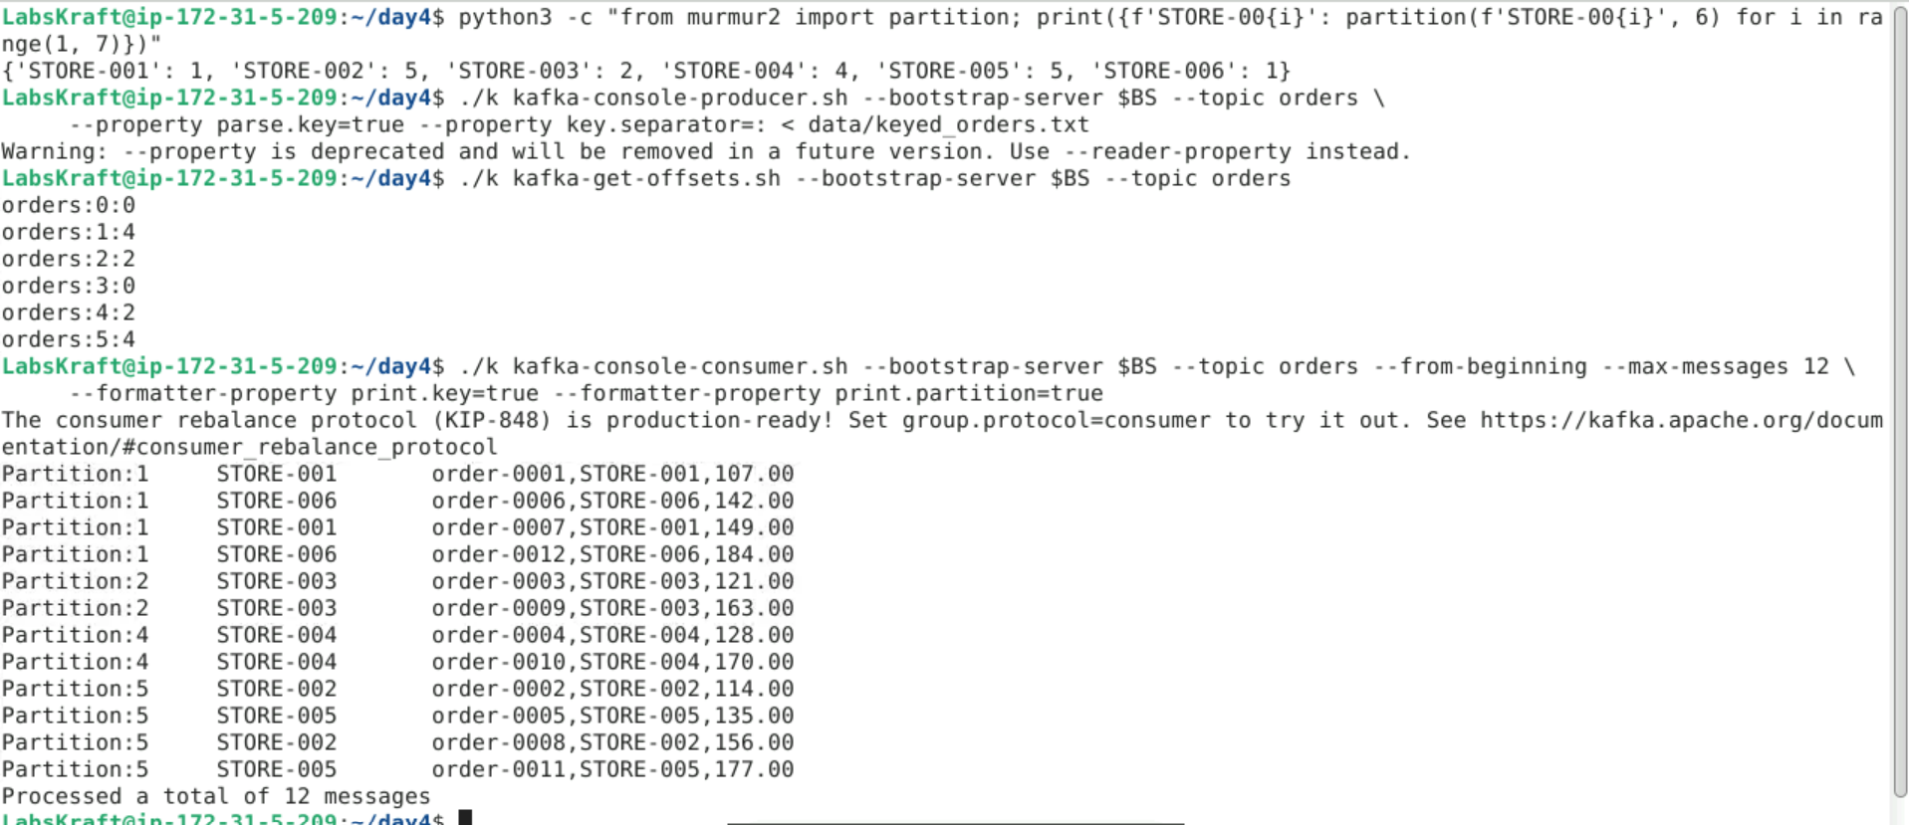

⚠️ STOP CHECK — Confirm Exact Placement, Not Assumption
Before moving to Task 3, confirm your orders offsets are exactly 0, 4, 2, 0, 2, 4 — if they differ, the file was published twice or without parse.key (see Section 6) and Task 3 will not match.
If in doubt — show your instructor your Step 3 output before proceeding to Task 3.

TASK 3 — STRATEGY: What Adding Partitions Does to Keys

3 | Increase orders to 8 Partitions and Re-Publish the Same Keys  Kafka Ops SOP — Day 4 Lab 2 | ⏱ 6 min
Partitions can be added to a topic but never removed. You add two partitions and publish the same 12 orders again, then find where each store's new records went.

⌨ Task 3 — Alter, predict, re-publish, compare
# Step 1: increase partitions 6 → 8
./k kafka-topics.sh --bootstrap-server $BS --alter --topic orders --partitions 8
# Step 2: predict the new placement
python3 -c "from murmur2 import partition; print({f'STORE-00{i}': partition(f'STORE-00{i}', 8) for i in range(1, 7)})"
# Step 3: publish the same file again and check the counts
./k kafka-console-producer.sh --bootstrap-server $BS --topic orders \
--property parse.key=true --property key.separator=: < data/keyed_orders.txt
./k kafka-get-offsets.sh --bootstrap-server $BS --topic orders
📟 Expected Output
Step 2: {'STORE-001': 7, 'STORE-002': 1, 'STORE-003': 0, 'STORE-004': 6, 'STORE-005': 5, 'STORE-006': 5}
Step 3: orders:0:2 orders:1:6 orders:2:2 orders:3:0 orders:4:2 orders:5:8 orders:6:2 orders:7:2 (total 24)
STORE-001 now has 2 old records in partition 1 and 2 new records in partition 7
3.A For STORE-001 and STORE-004, record the partition before and after the change. Answer:
STORE-001:
- Before (6 partitions): Partition 1
- After (8 partitions): Partition 7
STORE-004:
- Before (6 partitions): Partition 4
- After (8 partitions): Partition 6
3.B A consumer group reads partition 7 faster than partition 1. What can happen to STORE-001's events, and how should the team have scaled instead? Answer:
What can happen: Newer events for STORE-001 (written to partition 7 after the change) can be processed before older events (which still sit in partition 1), resulting in out-of-order event processing and breaking business logic for that store.
How the team should have scaled: The team should have planned the required partition count up front for keyed topics, or performed a controlled migration by creating a new topic with 8 partitions and routing traffic after existing partition queues were completely drained.

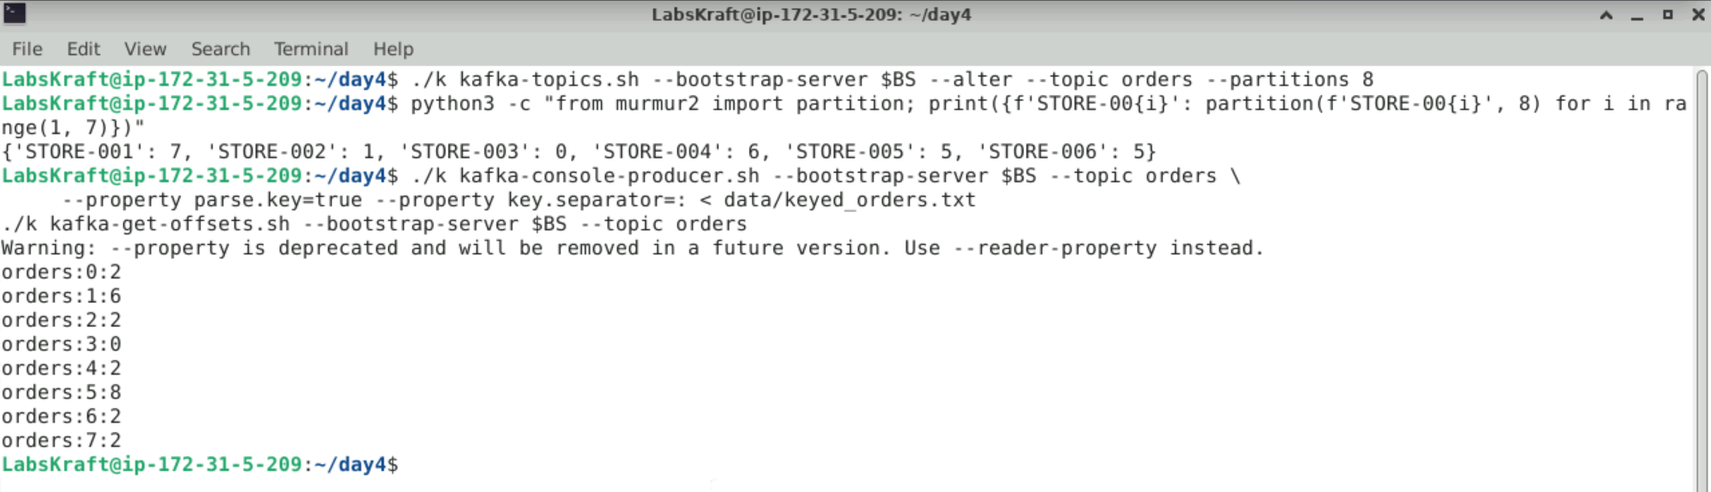

TASK 4 — TUNE: Producer Configuration and Throughput

4 | Compare acks, Batching and Compression With the Perf Test  Kafka Ops SOP — Day 4 Lab 2 | ⏱ 6–7 min
kafka-producer-perf-test sends synthetic records as fast as possible and reports throughput and latency. You run the same 200,000-record test three times with different producer settings.

⌨ Task 4 — Three producer configurations on perf-test
# Run A: acks=1 (leader only)
./k kafka-producer-perf-test.sh --bootstrap-server $BS --topic perf-test --num-records 200000 --record-size 200 \
--throughput -1 --command-property acks=1
# Run B: acks=all (all in-sync replicas)
./k kafka-producer-perf-test.sh --bootstrap-server $BS --topic perf-test --num-records 200000 --record-size 200 \
--throughput -1 --command-property acks=all
# Run C: acks=all + bigger batches + lz4 compression
./k kafka-producer-perf-test.sh --bootstrap-server $BS --topic perf-test --num-records 200000 --record-size 200 \
--throughput -1 --command-property acks=all --command-property linger.ms=20 \
--command-property batch.size=131072 --command-property compression.type=lz4
📟 Expected Output
Each run ends with one summary line, for example:
200000 records sent, 85000.0 records/sec (16.21 MB/sec), 45.2 ms avg latency, 400.0 ms max latency, ... 99th ...
Pattern (exact numbers depend on your VM): B has higher latency than A; C has the highest records/sec.
4.A Record records/sec, MB/sec, avg latency and 99th percentile latency for runs A, B and C. Answer:
Run A (acks=1):
- Records/sec: 19986.01
- MB/sec: 3.81 MB/sec
- Avg Latency: 64.63 ms
- 99th Percentile Latency: 333 ms
Run B (acks=all):
- Records/sec: 22170.49
- MB/sec: 4.23 MB/sec
- Avg Latency: 181.50 ms
- 99th Percentile Latency: 487 ms
Run C (acks=all + linger.ms=20 + batch.size=131072 + compression.type=lz4):
- Records/sec: 17632.02
- MB/sec: 3.36 MB/sec
- Avg Latency: 101.51 ms
- 99th Percentile Latency: 319 ms
4.B Which configuration would you use for payments, and which for clickstream? Justify with your numbers. Answer:
For Payments: Use Configuration B (or C) with acks=all. Payments require zero data loss durability guarantees. acks=all ensures every in-sync replica acknowledges the write before confirming. Even though average latency increases to 181.50 ms, durability takes priority over speed for financial transactions.
For Clickstream: Use Configuration C (or A). Clickstream logs generate massive volumes where high throughput, batch efficiency, and low tail latency are essential. Configuration C achieves the lowest 99th percentile tail latency (319 ms) and significantly compresses data on the wire with LZ4 compression, saving CPU and bandwidth.

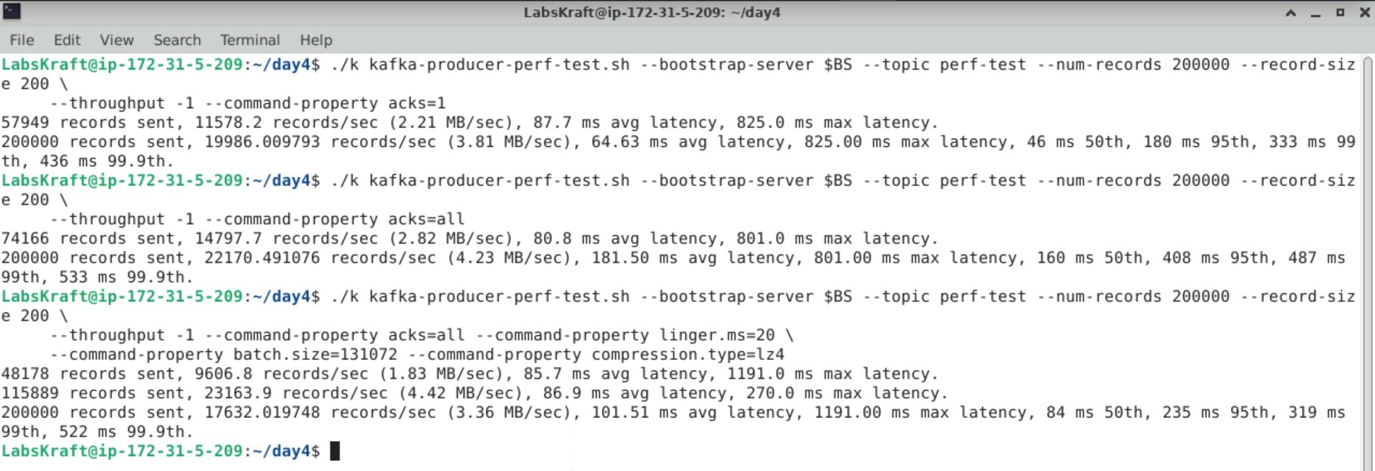

5. VALIDATION — CONFIRM FULL READINESS

Do not close the incident or call for instructor sign-off until ALL 8 validation steps below are completed and recorded.
Figure: Lab 2 — Producers & Partitioning Validation Checklist

5.1 Validation Task Set

Validation Check 1 — Unkeyed messages stored
⌨ Validation 1
./k kafka-get-offsets.sh --bootstrap-server $BS --topic clicks
# PASS criterion: end offsets add up to 6
V1: Do the clicks partitions hold 6 messages in total? Answer:
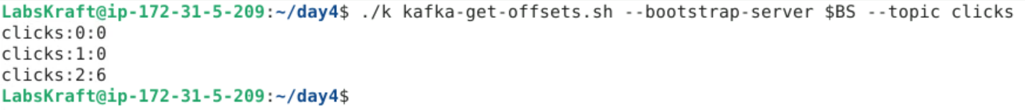
Validation Check 2 — orders now has 8 partitions
⌨ Validation 2
./k kafka-topics.sh --bootstrap-server $BS --describe --topic orders | head -1
# PASS criterion: PartitionCount: 8
V2: Does orders have 8 partitions? Answer:
Validation Check 3 — Exact keyed placement
⌨ Validation 3
./k kafka-get-offsets.sh --bootstrap-server $BS --topic orders
# PASS criterion: 0:2 1:6 2:2 3:0 4:2 5:8 6:2 7:2
V3: Do the orders offsets match exactly? Answer:
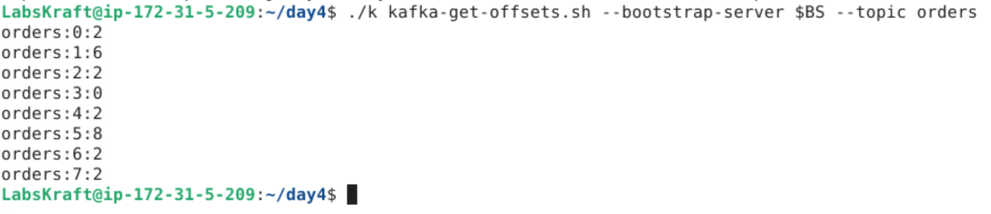
Validation Check 4 — Prediction matches the cluster
⌨ Validation 4
python3 -c "from murmur2 import partition; print(partition('STORE-004', 6), partition('STORE-004', 8))"
# PASS criterion: 4 6 - matching where STORE-004's records were found
V4: Does the hash prediction match the cluster for STORE-004? Answer:
Validation Check 5 — Perf-test data written
⌨ Validation 5
./k kafka-get-offsets.sh --bootstrap-server $BS --topic perf-test | awk -F: '{s+=$3} END {print s}'
# PASS criterion: 600000 (3 runs × 200,000)
V5: Does perf-test hold 600,000 records? Answer:
Validation Check 6 — Producer results recorded
⌨ Validation 6
# Answer box 4.A
# PASS criterion: throughput and latency for runs A, B and C
V6: Are all three perf-test results recorded? Answer:
Yes, all three kafka-producer-perf-test runs have been recorded with their complete throughput and latency metrics:
- Run A (acks=1): 19,986.01 rec/sec (3.81 MB/sec), Avg Latency: 64.63 ms, 99th: 333 ms
- Run B (acks=all): 22,170.49 rec/sec (4.23 MB/sec), Avg Latency: 181.50 ms, 99th: 487 ms
- Run C (acks=all + batching & LZ4): 17,632.02 rec/sec (3.36 MB/sec), Avg Latency: 101.51 ms, 99th: 319 ms
Validation Check 7 — Replicas healthy after the load
⌨ Validation 7
./k kafka-topics.sh --bootstrap-server $BS --describe --under-replicated-partitions
# PASS criterion: no output
V7: Are all replicas in sync after the tests? Answer:
Validation Check 8 — Full lab record complete
⌨ Validation 8 — Final completeness check
# Confirm every answer box (PRE-LAB, 1.A through 4.B) is completed
# PASS criterion: every answer box holds real output (offsets, partitions, throughput)
V8: Confirm all answer boxes and evidence are complete and ready to show your instructor. Answer: ______________________________________________________________________________________________________________

✅ STOP HERE — Show your completed validation record to your instructor before proceeding to Section 7.

6. TROUBLESHOOTING — COMMON ISSUES & FIXES

Issue / Error | Cause | Diagnosis | Fix
orders offsets are double the expected values | keyed_orders.txt was published twice in Task 2 | kafka-get-offsets totals 24 before Task 3 | Ask the instructor to recreate orders (delete + create 6 partitions) and repeat Task 2
All 12 orders spread unevenly with no STORE pattern | parse.key=true was missing — the whole line became the value | Consumer with print.key=true shows null keys | Recreate orders and publish again with both --property options
Console consumer never exits | Fewer messages than --max-messages exist | kafka-get-offsets totals | Press Ctrl+C, or add --timeout-ms 10000
Unrecognized option --command-property / --formatter-property | Image older than Kafka 4.2 | docker image ls apache/kafka | Use the 4.3.1 image, or the older names --producer-property / --property
Perf test very slow or errors | VM overloaded | docker stats shows high CPU | Lower --num-records to 50000 and note it in 4.A

7. INSTRUCTOR DEBRIEF — 8 MINUTES

7.1 Discussion Questions

Discussion 1 — Partition Strategy
Without looking at notes: state the rule for keyed records and for unkeyed records.
Why can two keys share a partition while another partition is empty?
Key answer to explore: hashing is uniform over MANY keys; with few keys, collisions and empty partitions are normal.
Discussion 2 — Changing Partition Counts
Which stores moved partitions in Task 3, and what does that mean for a consumer that relies on per-store order?
What alternatives exist to increasing partitions on a keyed topic?
Key insight: plan partitions for future parallelism, or migrate to a new topic with a cut-over.
Discussion 3 — Producer Settings
Compare the class's results for A, B and C. Why does batching increase throughput?
Why is acks=all slower, and when is that worth it?
Key answer: fewer, larger requests amortise overhead; acks=all waits for followers but survives a leader failure.
Discussion 4 — Production Considerations
Which producer defaults would you change for a high-volume clickstream topic, and which must you never weaken for payments?
Answer: clickstream → larger linger/batch + compression; payments → keep acks=all with idempotence enabled (Lab 3).

7.2 Common Mistakes — Learn From These

Mistake | Why It Happens | Consequence | Prevention
Adding partitions to a keyed topic | Need more consumers quickly | Per-key ordering breaks | Plan partitions up front
Assuming N keys fill N partitions | Thinking hashing is round-robin | Idle and overloaded partitions | Check placement; use many distinct keys
No key when order matters | Simpler producer code | Events of one entity processed out of order | Key by the entity ID
acks=1 for critical data | Faster benchmarks | Data loss if the leader fails before replication | acks=all for critical topics
Tuning without measuring | Copying settings from articles | Unknown effect on latency | Use kafka-producer-perf-test

8. EXTENSION TASKS (Advanced Learners)

Extension A — Predict a Hot Key
Use murmur2.py to find which partition STORE-099 would use on 6 and on 8 partitions.
Publish one record with that key and confirm with kafka-get-offsets.
Key question: how could a single very busy store overload one partition? (Lab 5)
Extension B — Message Size Limits
Run the perf test with --record-size 2000000 and observe the error.
Find the producer setting max.request.size and the topic setting max.message.bytes.
Research: why are very large Kafka messages usually stored elsewhere (e.g. object storage) with only a reference in Kafka?
Extension C — Compression Ratio
Repeat Run C with compression.type=zstd and with gzip.
Compare MB/sec and use kafka-log-dirs.sh to compare the bytes stored on disk.
Explain the CPU-versus-network trade-off of each codec.

9. LAB COMPLETION & SIGN-OFF

9.1 Submission Checklist

✓ | Completion Criterion | Status
☐ | Unkeyed messages published and read back with partition and offset | ☐ Pass / ☐ Fail
☐ | Keyed orders published; placement predicted with murmur2 and matched exactly (0,4,2,0,2,4) | ☐ Pass / ☐ Fail
☐ | Partition increase 6→8 performed; key movement proven (0,6,2,0,2,8,2,2) | ☐ Pass / ☐ Fail
☐ | Three producer configurations measured and compared | ☐ Pass / ☐ Fail
☐ | All 8 validation checks completed and recorded | ☐ Pass / ☐ Fail
☐ | All observation/answer boxes in this guide completed | ☐ Pass / ☐ Fail

9.2 Grading Criteria

Assessment Area | Criteria | Marks | Weight
Task 1 — Unkeyed Publish | Messages published and read back; ordering explained | 15 | 15%
Task 2 — Keyed Publish | Placement predicted and verified exactly; collisions explained | 30 | 30%
Task 3 — Partition Change | Key movement evidenced; ordering impact explained | 25 | 25%
Task 4 — Producer Tuning | Three runs measured; configuration choices justified | 20 | 20%
Validation & Documentation | All 8 validation checks completed; answers complete and accurate | 10 | 10%
TOTAL |  | 100 | 100%

9.3 Instructor Sign-Off

Field | Value
Lab Result | ☐ PASS ☐ PARTIAL ☐ REPEAT REQUIRED │ Score: _______ / 100
Instructor Name | ___________________________________
Instructor Signature & Date | ___________________________________
Remarks / Feedback | ___________________________________ ___________________________________
Completion Date & Time | ___________________________________

10. QUICK REFERENCE — KAFKA PRODUCER COMMAND CARD

Bookmark this page. Every command you need in SOP order.

Category | Command | Purpose
Produce | ./k kafka-console-producer.sh --bootstrap-server $BS --topic t | Type messages (Ctrl+C to stop)
Produce | ... --property parse.key=true --property key.separator=: < file | Publish keyed lines from a file
Produce | ... --command-property acks=all | Pass producer settings (Kafka 4.2+ name)
Consume | ./k kafka-console-consumer.sh --bootstrap-server $BS --topic t --from-beginning --max-messages n | Read n messages
Consume | --formatter-property print.key=true / print.partition=true / print.offset=true | Show key, partition, offset
Offsets | ./k kafka-get-offsets.sh --bootstrap-server $BS --topic t | End offset per partition
Predict | python3 -c "from murmur2 import partition; print(partition('KEY', n))" | Partition of a key
Topics | ./k kafka-topics.sh --bootstrap-server $BS --alter --topic t --partitions n | Increase partitions
Perf | ./k kafka-producer-perf-test.sh --bootstrap-server $BS --topic t --num-records n --record-size b --throughput -1 | Throughput and latency test

Official Lab Guide — Day 4 Lab 2: Topics, Partitions & Producer Configuration — Publish Messages and Partition Strategy │ IT Training Division │ NIIT iRUN Framework │ Version 1.0 │ Classification: Internal Training

IT Training Division | NIIT iRUN Framework | Confidential — For Training Use Only | Do Not Distribute

