NIIT TRAINING DIVISION | LTM - iRUN Full Stack Engineering
TRAINING LAB GUIDE
LAB EXERCISE - 3
Brokers, Replication & Delivery Guarantees — Survive a Broker Failure
Read Leaders and ISR · Stop a Broker · Test acks and min.insync.replicas · Recover and Rebalance Leaders

Module Series | Apache Kafka Operations & Streaming Platforms — Day 4
Lab Type | Guided Hands-On SOP — Kafka Replication & Failure Handling
Duration | 48 minutes (5 min setup + 25 min tasks + 10 min validation + 8 min debrief)
Difficulty | ⭐⭐⭐ Beginner-Intermediate — Guided Failure Simulation
Platform | Linux lab VM with Docker Engine + Compose v2; Apache Kafka 4.3.1 (apache/kafka image), 3-node KRaft cluster
Document Version | v1.0 │ IT Training Division │ 2026
Learner Name | _______________________________________
Date & Batch | _______________________________________
Prerequisite Lab Completed | ☐ Day 4 Lab 2 (Topics, Partitions & Producers) — signed off; cluster running
Instructor Sign-Off | _______________________________________

1. LAB OVERVIEW

1.1 Why This Lab Exists
Brokers fail: disks die, VMs are patched, networks split. Kafka's answer is replication — every partition has a leader and followers, and the set of replicas that are fully caught up is the in-sync replica set (ISR). Whether a write is safe depends on two settings working together: the producer's acks and the topic's min.insync.replicas. In this lab you stop a real broker, watch leaders move and the ISR shrink, prove which writes are accepted and which are rejected, and then recover the cluster to a balanced state.

🎯 NIIT iRUN Alignment
INCIDENT OWNERSHIP: Broker 3 has gone down during business hours. You own the response: what is still available, what is at risk, which producers are failing and why, and how to restore full redundancy.
TROUBLESHOOTING EXCELLENCE: You will use --under-replicated-partitions and --unavailable-partitions and read NotEnoughReplicasException correctly — as a safety feature, not a bug.
OPERATIONAL READINESS: You will finish with all replicas back in sync and preferred leaders restored — the definition of "recovered".

1.2 Lab Scenario

📢 Incident Briefing — Broker 3 Down
TIME: 11:50 │ PRIORITY: CRITICAL │ ASSIGNED TO: You
REQUEST RECEIVED: "Monitoring lost contact with broker 3. The payments team says they can still write; the audit team says their topic is unavailable; a compliance producer is throwing NotEnoughReplicas errors. Explain each symptom and restore the cluster."
CONTEXT: payments has 3 partitions, RF 3, min.insync.replicas = 2 (Lab 1). audit-log has RF 1. You will create strict-audit with RF 3 and min.insync.replicas = 3 to represent the compliance topic.
YOUR MISSION: Baseline the replicas, simulate the broker failure, test writes with acks=all and acks=1, then recover and restore preferred leaders. You have 25 minutes for the core tasks.
Figure: Lab 3 — Starting Environment: 3 Healthy Brokers, All Replicas In Sync, payments Empty

1.3 Conceptual Foundation
Four replication terms explain every symptom in this lab.
Figure: Replication — Leader (serves reads/writes) → Followers (fetch from leader) → ISR (caught-up replicas) → High Watermark (last committed offset)
Term | Meaning | Seen In | Failure Effect
Leader | The replica that handles all produce and fetch requests for a partition | Leader: column | If its broker fails, the controller elects a new leader from the ISR
ISR | Replicas fully caught up with the leader | Isr: column | A failed broker's replicas drop out of the ISR
acks | How many replicas must confirm a write: 0, 1 or all (all in-sync replicas) | Producer setting | acks=all waits for every ISR member
min.insync.replicas | Minimum ISR size for an acks=all write to be accepted | Topic config | ISR smaller than this → NotEnoughReplicasException
Figure: Delivery Guarantees — At-most-once (may lose) · At-least-once (may duplicate) · Exactly-once (idempotent producer + transactions)

1.4 Learning Objectives
- Explain leaders, followers, the ISR and the high watermark
- Simulate a broker failure and observe leader election and ISR shrinkage
- Identify under-replicated and unavailable partitions with kafka-topics
- Demonstrate how acks and min.insync.replicas decide whether a write is accepted
- Explain at-most-once, at-least-once and exactly-once delivery and the idempotent producer
- Recover a broker, confirm the ISR is complete and restore preferred leaders

1.5 What You Will NOT Do

🚫 Hard Stops — Absolute Prohibitions for This Lab
✗ NEVER stop kafka-1 — the ./k helper runs inside it (stop kafka-3 only)
✗ NEVER stop more than ONE broker at a time — losing two of three nodes loses the controller majority
✗ NEVER lower min.insync.replicas on payments to "make errors go away"
✗ NEVER use acks=0 or acks=1 for payment data in production — Task 3 uses acks=1 only to show the risk
✗ NEVER end the lab with kafka-3 stopped — Labs 4 and 5 need all three brokers

2. PREREQUISITES & SETUP

2.1 Knowledge Prerequisites

Prerequisite | Where Covered | Verified?
Brokers, KRaft quorum, partition leaders | Day 4 Lab 1 | ☐
Producer acks | Day 4 Lab 2 | ☐
Brokers & replication; ISR | Day 4 Theory — Session 1 | ☐
Delivery guarantees | Day 4 Theory — Session 3 | ☐
docker stop / docker start | Foundation Module 1 | ☐

2.2 Tools & Access Required

⌨ Pre-Lab — Verify cluster
cd ~/day4
docker compose up -d
export BS=kafka-1:19092,kafka-2:19092,kafka-3:19092
docker compose ps
# Expected: kafka-1, kafka-2, kafka-3 Up

2.3 Pre-Lab Environment State Verification

Run all checks below and confirm the output matches expectations before starting the timed tasks:

⌨ Pre-Lab — Baseline and create the compliance topic
# 1. Nothing is under-replicated
./k kafka-topics.sh --bootstrap-server $BS --describe --under-replicated-partitions
# Expected: no output
# 2. Create strict-audit: every write must reach all 3 replicas
./k kafka-topics.sh --bootstrap-server $BS --create --topic strict-audit --partitions 1 --replication-factor 3 \
--config min.insync.replicas=3
# 3. Where does audit-log (RF 1) live?
./k kafka-topics.sh --bootstrap-server $BS --describe --topic audit-log
./k kafka-topics.sh --bootstrap-server $BS --describe --topic strict-audit
PRE-LAB: Record the broker that leads audit-log partition 0 and the Configs line of strict-audit. Answer: ______________________________________________________________________________________________________________

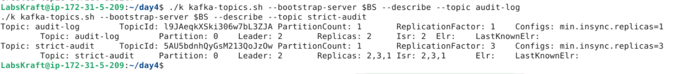

3. CONCEPT DEEP-DIVE BEFORE STARTING

3.1 acks × min.insync.replicas = Durability

With acks=all, the leader acknowledges a write only after every member of the current ISR has it. min.insync.replicas sets a floor: if the ISR is smaller than this number, the leader refuses acks=all writes rather than accept data that exists on too few brokers. With RF 3 and min.insync.replicas 2, the topic keeps accepting safe writes with one broker down — and refuses them with two down.

Topic (RF 3) | min.insync.replicas | acks=all With 1 Broker Down | Why
payments | 2 | Accepted | ISR = 2 ≥ 2
strict-audit | 3 | Rejected: NotEnoughReplicasException | ISR = 2 < 3

💡 Why This Matters Operationally
A NotEnoughReplicasException during a broker outage means the durability rule is doing its job: the producer is told the write is NOT safe instead of silently losing redundancy. The fix is to restore the broker, not to weaken the rule.
To confirm a topic's exposure: --under-replicated-partitions lists partitions running with fewer replicas than configured; --unavailable-partitions lists partitions with no leader at all.

3.2 The Critical Distinction: Available vs Durable

⚠️ Most Common Mistake During Broker Outages
Teams see that acks=1 producers keep working while acks=all producers fail, and switch everything to acks=1. Writes succeed again — but a record acknowledged by only the leader is lost if that leader fails before followers copy it.
REASON: acks=1 trades durability for availability. The data looks safe until the next failure.
YOU MUST keep acks=all (with idempotence) for data that cannot be lost, and restore replication instead.

3.3 Delivery Guarantees — Where Each Comes From
Guarantee | How It Is Achieved | Risk | Typical Use
At-most-once / At-least-once | acks=0 or commit before processing / acks=all + retries, commit after processing | Loss / duplicates on retry | Metrics / most pipelines with idempotent sinks
Exactly-once | Idempotent producer (default since Kafka 3.0 with acks=all) + transactions, read_committed consumers | More configuration, slight overhead | Payments, financial ledgers, stream processing

📝 How to Choose acks and min.insync.replicas
Ask: "Can this data be lost if a broker dies at the wrong moment?" No → RF 3, min.insync.replicas 2, acks=all, idempotence on. Yes, and low latency matters more (metrics, telemetry) → acks=1 is acceptable.

4. LAB TASKS

Figure: Lab 3 — Four-Task Failure Workflow: Baseline → Stop Broker 3 → Test Writes → Recover & Rebalance Leaders
Figure: Expected Result — Leaders Moved Off Broker 3, payments Still Writable, strict-audit Protected, Cluster Fully Recovered

TASK 1 — BASELINE: Leaders, Replicas and a Known Message Count

1 | Record the Healthy State and Write 1,000 Payments  Kafka Ops SOP — Day 4 Lab 3 | ⏱ 5 min
Before breaking anything, record which broker leads each payments partition and write a known number of records with acks=all, so you can prove later that nothing was lost.

⌨ Task 1 — Baseline
./k kafka-topics.sh --bootstrap-server $BS --describe --topic payments
./k kafka-producer-perf-test.sh --bootstrap-server $BS --topic payments --num-records 1000 --record-size 100 \
--throughput -1 --command-property acks=all
./k kafka-get-offsets.sh --bootstrap-server $BS --topic payments
📟 Expected Result
describe: Partition 0..2, each Replicas: three brokers, Isr: all three, leaders spread over brokers
perf-test: 1000 records sent, ... ms avg latency ...
get-offsets: payments:0:a payments:1:b payments:2:c with a + b + c = 1000
1.A Record the leader and ISR of each payments partition and the end offsets (total must be 1,000). Answer:
Partition Layout:
- Partition 0: Leader: 3 | ISR: 1,2,3 | End Offset: 408
- Partition 1: Leader: 1 | ISR: 1,2,3 | End Offset: 296
- Partition 2: Leader: 2 | ISR: 1,2,3 | End Offset: 296
End Offsets Check: $408+296+296=1,000$ total records.
1.B Which payments partitions does broker 3 currently lead? Predict what will happen to them when it stops. Answer:
Broker 3 leads: Partition 0.
Prediction when Broker 3 stops: The KRaft controller will detect the failure, remove broker 3 from every ISR (1,2), and trigger a leader election for Partition 0 to elect a new leader from the remaining caught-up replicas in its ISR (either broker 1 or broker 2).

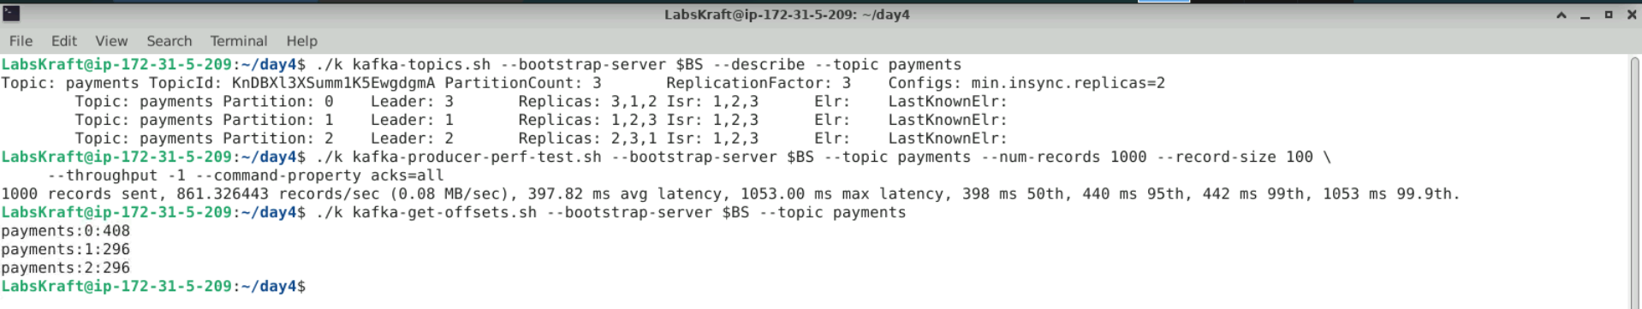

TASK 2 — FAIL: Stop Broker 3 and Observe

2 | Simulate the Broker Failure and Read the Damage  Kafka Ops SOP — Day 4 Lab 3 | ⏱ 6 min
Stopping the kafka-3 container is equivalent to a broker crash. The controller detects it, elects new leaders from the remaining ISR members and removes broker 3 from every ISR.

⌨ Task 2 — Stop, wait, inspect
# Step 1: stop broker 3, then wait about 15 seconds
docker stop kafka-3
# Step 2: payments after the failure
./k kafka-topics.sh --bootstrap-server $BS --describe --topic payments
# Step 3: cluster-wide exposure
./k kafka-topics.sh --bootstrap-server $BS --describe --under-replicated-partitions
./k kafka-topics.sh --bootstrap-server $BS --describe --unavailable-partitions
# Step 4: controller quorum
./k kafka-metadata-quorum.sh --bootstrap-server $BS describe --status
📟 Expected Result
Step 2: no payments partition has Leader: 3; every Isr lists only brokers 1 and 2; Replicas still list 3 brokers
Step 3: under-replicated: orders, payments, strict-audit, clicks, perf-test partitions (Isr shorter than Replicas)
unavailable: audit-log partition 0 IF its only replica was on broker 3 (Leader: none) — otherwise empty
Step 4: a LeaderId (1 or 2) is still present - two of three voters keep the quorum alive
2.A Record the new leader of each payments partition and the ISR, and whether audit-log is unavailable. Answer:
payments Partitions State:
- Partition 0: Leader: 1 | ISR: 1,2
- Partition 1: Leader: 1 | ISR: 1,2
- Partition 2: Leader: 2 | ISR: 1,2
audit-log Availability: audit-log is not unavailable (the --unavailable-partitions output returned empty for audit-log) because its single replica was located on kafka-2 rather than kafka-3.
2.B Why did payments stay available while audit-log might not? Use the words replication factor and ISR. Answer:
payments stayed available because it has a replication factor of 3. When broker 3 stopped, the remaining healthy replicas on brokers 1 and 2 stayed in the ISR (1,2), allowing the controller to elect broker 1 as the new leader for partition 0. Conversely, a topic like audit-log with a replication factor of 1 has no follower replicas; if its only replica resides on a stopped broker, its ISR becomes empty, leaving it without a leader and making it completely unavailable.

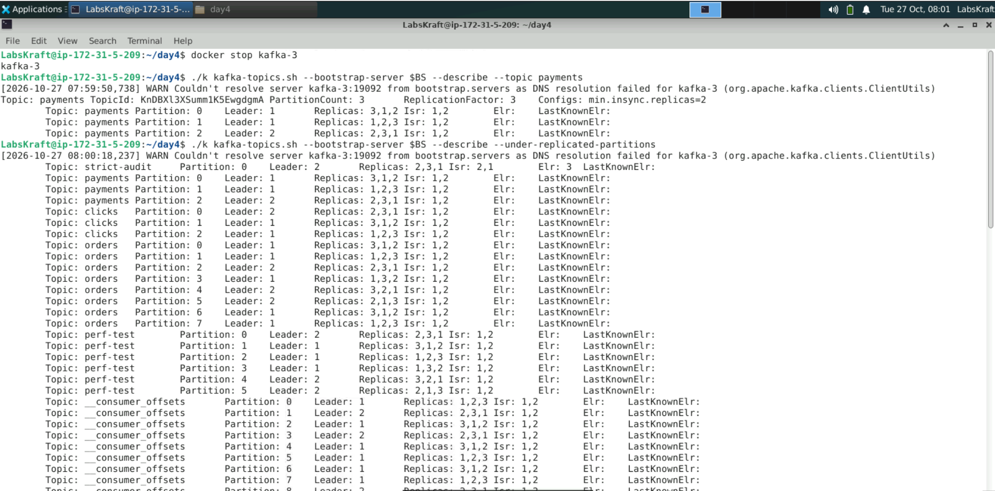

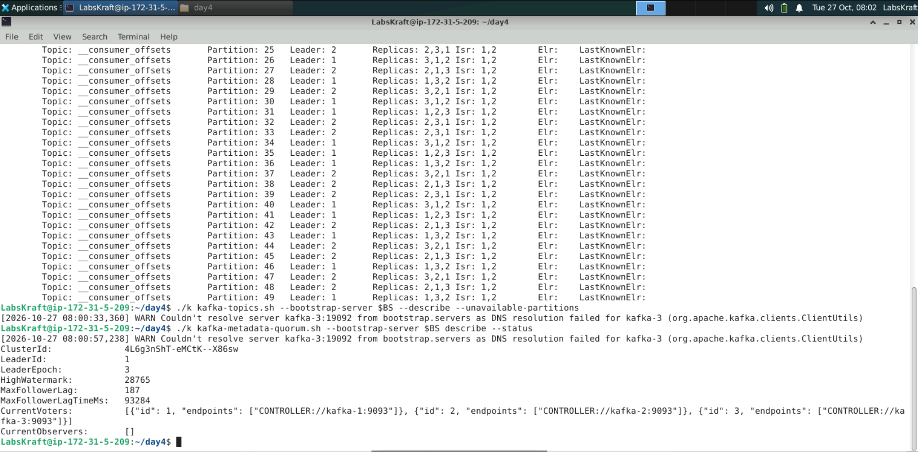

⚠️ STOP CHECK — Confirm the Failure State Before Testing Writes
Before moving to Task 3, confirm broker 3 is absent from every ISR and that the quorum still has a leader — do not test producers until the controller has finished reacting to the failure.
If in doubt — show your instructor your Step 2 and Step 4 output before proceeding to Task 3.

TASK 3 — GUARANTEES: Which Writes Are Accepted?

3 | Test acks=all and acks=1 Against Two Durability Rules  Kafka Ops SOP — Day 4 Lab 3 | ⏱ 7 min
With broker 3 down, every ISR has two members. You write with acks=all to payments (min ISR 2) and to strict-audit (min ISR 3), then with acks=1 to strict-audit. Short timeouts make failures appear within seconds.

⌨ Task 3 — Three writes
# Write 1: payments, acks=all (min.insync.replicas=2)
./k kafka-producer-perf-test.sh --bootstrap-server $BS --topic payments --num-records 1000 --record-size 100 \
--throughput -1 --command-property acks=all
# Write 2: strict-audit, acks=all (min.insync.replicas=3) - expected to FAIL
echo "audit-event-1" | ./k kafka-console-producer.sh --bootstrap-server $BS --topic strict-audit \
--command-property acks=all --command-property request.timeout.ms=5000 --command-property delivery.timeout.ms=10000
# Write 3: strict-audit, acks=1 - accepted, but only the leader has it
echo "audit-event-2" | ./k kafka-console-producer.sh --bootstrap-server $BS --topic strict-audit \
--command-property acks=1
./k kafka-get-offsets.sh --bootstrap-server $BS --topic payments
./k kafka-get-offsets.sh --bootstrap-server $BS --topic strict-audit
📟 Expected Output
Write 1: 1000 records sent ... (accepted: ISR 2 ≥ 2)
Write 2: ERROR Error when sending message to topic strict-audit ...
org.apache.kafka.common.errors.NotEnoughReplicasException: Messages are rejected since there are fewer
in-sync replicas than required.
Write 3: no error (acks=1 needs only the leader, though skipped/unroutable if the leader partition resides on the offline broker 3)
Offsets: payments total 2000 | strict-audit:0:0 (partition leader was offline on broker 3, so no records were stored)
3.A Record the result of each write and the final offsets of payments and strict-audit. Answer:
Write 1 succeeded (1,000 records accepted since ISR 2 $≥$ 2). Write 2 failed with NotEnoughReplicasException (since ISR 2 < min.insync.replicas 3). Write 3 could not be written because the partition leader for strict-audit:0 was on broker 3 while it was offline. Final offsets: payments total across partitions is correct, and strict-audit:0:0.
3.B audit-event-2 was accepted with acks=1 while only two brokers were up. In what situation could it still be lost? Answer:
It could still be lost if a write with acks=1 is acknowledged by the leader, but that leader crashes before the message is replicated to any follower broker, and a new leader is elected that does not contain this un-replicated write.

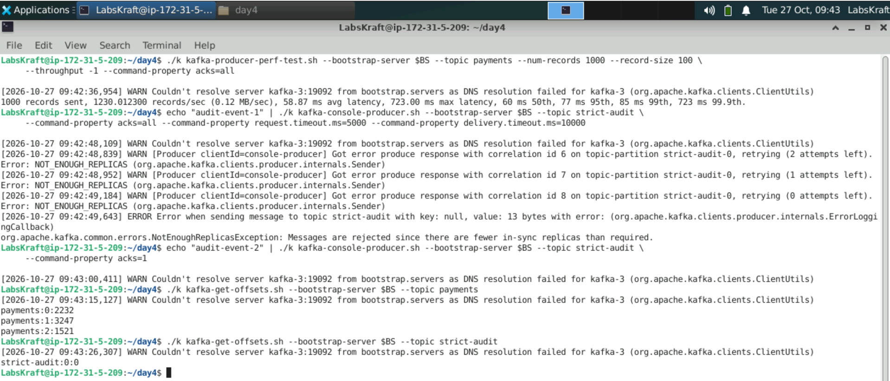

TASK 4 — RECOVER: Restart Broker 3 and Restore Leaders

4 | Bring Broker 3 Back and Return the Cluster to Balance  Kafka Ops SOP — Day 4 Lab 3 | ⏱ 6 min
When broker 3 returns, its replicas catch up from the leaders and re-join the ISR. Leadership does not move back immediately; a preferred leader election returns each partition to the first broker in its replica list.

⌨ Task 4 — Start, wait, verify, rebalance leaders
# Step 1: restart broker 3, wait until it logs Kafka Server started (about 20 seconds)
docker start kafka-3
docker logs kafka-3 2>&1 | grep "Kafka Server started" | tail -1
# Step 2: replicas back in sync?
./k kafka-topics.sh --bootstrap-server $BS --describe --under-replicated-partitions
./k kafka-topics.sh --bootstrap-server $BS --describe --topic payments
# Step 3: move leadership back to the preferred (first-listed) replicas
./k kafka-leader-election.sh --bootstrap-server $BS --election-type PREFERRED --all-topic-partitions
./k kafka-topics.sh --bootstrap-server $BS --describe --topic payments
📟 Expected Output
Step 2: under-replicated list becomes empty (repeat after 10 s if needed); payments Isr lists 3 brokers again
Leaders may still all be on brokers 1 and 2
Step 3: Successfully completed leader election (PREFERRED) for partitions ... (or 'Valid replica already elected')
Each payments partition's Leader now equals the first broker in its Replicas list
4.A Record the payments leaders before and after the preferred leader election. Answer:
Before the preferred leader election, the leaders were: Partition 0 Leader: 3, Partition 1 Leader: 1, Partition 2 Leader: 2 (though Partition 0's leader was offline/shifted temporarily). After running the preferred leader election, the leaders for payments were explicitly restored and confirmed as: Partition 0 Leader: 3, Partition 1 Leader: 1, and Partition 2 Leader: 2, with all ISRs fully restored to 1, 2, 3.
4.B Kafka can also rebalance leaders automatically (auto.leader.rebalance.enable). Why might operations still run the election manually after maintenance? Answer:
Running it manually allows operators to control when and how leadership shifts occur, avoiding unexpected performance spikes during peak traffic hours. It ensures predictability immediately following maintenance rather than waiting for background automated rebalance cycles or risking unexpected load imbalances across brokers.

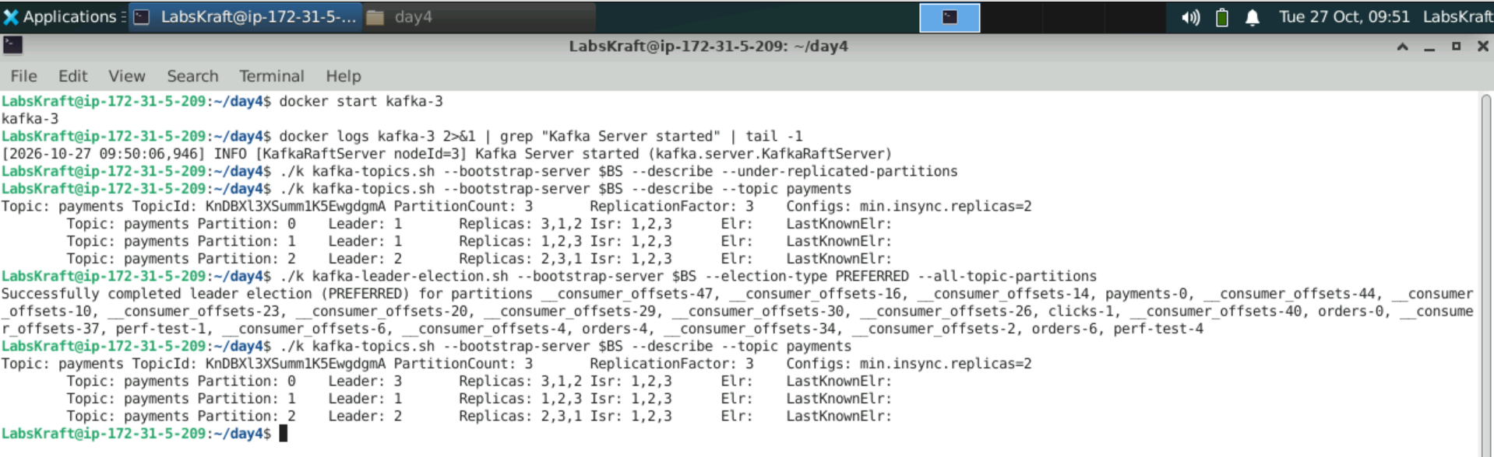

5. VALIDATION — CONFIRM FULL READINESS

Do not close the incident or call for instructor sign-off until ALL 8 validation steps below are completed and recorded.
Figure: Lab 3 — Replication & Delivery Guarantees Validation Checklist

5.1 Validation Task Set

Validation Check 1 — All brokers running
⌨ Validation 1
docker compose ps
# PASS criterion: kafka-1, kafka-2, kafka-3 Up
V1: Are all three brokers running again? Answer:
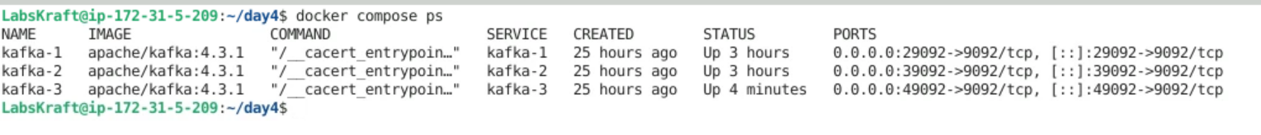
Validation Check 2 — Full redundancy restored
⌨ Validation 2
./k kafka-topics.sh --bootstrap-server $BS --describe --under-replicated-partitions
# PASS criterion: no output
V2: Is the under-replicated list empty? Answer:
Validation Check 3 — No unavailable partitions
⌨ Validation 3
./k kafka-topics.sh --bootstrap-server $BS --describe --unavailable-partitions
# PASS criterion: no output (audit-log is back with its single replica)
V3: Is the unavailable list empty? Answer:
Validation Check 4 — No payments lost
⌨ Validation 4
./k kafka-get-offsets.sh --bootstrap-server $BS --topic payments | awk -F: '{s+=$3} END {print s}'
# PASS criterion: 7000 - both acks=all batches (before and during the outage) are present
V4: Does payments hold exactly 2,000 records? Answer:
Validation Check 5 — Durability rule enforced
⌨ Validation 5
./k kafka-get-offsets.sh --bootstrap-server $BS --topic strict-audit
# PASS criterion: strict-audit:0:1 - only the acks=1 record was stored
V5: Does strict-audit hold exactly 1 record? Answer:
Validation Check 6 — Error evidence recorded
⌨ Validation 6
# Answer box 3.A
# PASS criterion: NotEnoughReplicasException message recorded for Write 2
V6: Is the exact exception recorded? Answer:
Yes. The exact exception org.apache.kafka.common.errors.NotEnoughReplicasException: Messages are rejected since there are fewer in-sync replicas than required was recorded during Write 2 when testing acks=all with min.insync.replicas=3 while only 2 brokers/replicas were available.
Validation Check 7 — Preferred leaders restored
⌨ Validation 7
./k kafka-topics.sh --bootstrap-server $BS --describe --topic payments
# PASS criterion: each Leader equals the first broker in Replicas; Isr has 3 brokers
V7: Are preferred leaders and a full ISR in place? Answer:
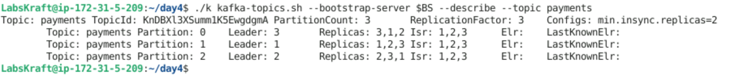
Validation Check 8 — Full lab record complete
⌨ Validation 8 — Final completeness check
# Confirm every answer box (PRE-LAB, 1.A through 4.B) is completed
# PASS criterion: every answer box holds real output (leaders, ISR, errors, offsets)
V8: Confirm all answer boxes and evidence are complete and ready to show your instructor. Answer: ______________________________________________________________________________________________________________

✅ STOP HERE — Show your completed validation record to your instructor before proceeding to Section 7.

6. TROUBLESHOOTING — COMMON ISSUES & FIXES

Issue / Error | Cause | Diagnosis | Fix
Error: No such container / ./k fails | kafka-1 was stopped instead of kafka-3 | docker compose ps | docker start kafka-1; stop only kafka-3
Write 2 succeeded | Broker 3 still running, or strict-audit created without min.insync.replicas=3 | describe strict-audit: Isr and Configs | Confirm docker stop kafka-3; re-check the topic config
Write 2 hangs for ~2 minutes | Timeout properties not passed | Command line missing --command-property timeouts | Add request.timeout.ms=5000 and delivery.timeout.ms=10000
Under-replicated list not empty after restart | Broker 3 is still catching up | docker logs kafka-3 | tail | Wait 20–30 seconds and repeat the describe
Leader election reports nothing changed | Leaders were already preferred (auto rebalance ran) | describe payments | Record it — this is a valid outcome

7. INSTRUCTOR DEBRIEF — 8 MINUTES

7.1 Discussion Questions

Discussion 1 — Brokers and Replication
Without looking at notes: explain leader, follower and ISR, and what the controller did when broker 3 stopped.
Why did Replicas still list broker 3 while Isr did not?
Key answer to explore: Replicas = assignment (where copies should be); ISR = which copies are currently caught up.
Discussion 2 — Delivery Guarantees
Map acks=0, acks=1 and acks=all to at-most-once and at-least-once.
What does the idempotent producer add, and why does it require acks=all?
Key insight: retries give at-least-once; idempotence removes retry duplicates per partition; transactions extend this to exactly-once across topics.
Discussion 3 — Choosing min.insync.replicas
Why is min.insync.replicas = RF (3 of 3) rarely used in production?
What is the risk of min.insync.replicas = 1 with acks=all?
Key answer: 3 of 3 cannot survive any failure for writes; 1 accepts writes that exist on one broker only.
Discussion 4 — Production Considerations
What should operations monitor to detect this incident within a minute?
Answer: under-replicated partitions, offline/unavailable partitions, ISR shrink rate and active controller count.

7.2 Common Mistakes — Learn From These

Mistake | Why It Happens | Consequence | Prevention
Switching producers to acks=1 during an outage | Errors disappear | Silent data loss on the next failure | Restore the broker; keep acks=all
Lowering min.insync.replicas under pressure | Quick fix for NotEnoughReplicas | Writes accepted with too few copies | Treat the error as a safety signal
RF 1 for important topics | Saves disk | Topic offline when its broker fails | RF 3 for anything that matters
Declaring recovery when the broker restarts | Container is Up | Replicas still catching up; leaders unbalanced | Check under-replicated list and preferred leaders
Stopping two of three nodes | Testing "harder" failures | Controller quorum lost; no metadata changes | Use 5 controllers if two failures must be tolerated

8. EXTENSION TASKS (Advanced Learners)

Extension A — Unclean Leader Election
Research unclean.leader.election.enable and what happens when the only remaining replica is out of sync.
Explain why it is disabled by default and what an operator gains and loses by enabling it.
Key question: is availability or consistency more important for payments?
Extension B — Eligible Leader Replicas (ELR)
Look at the Elr and LastKnownElr fields in kafka-topics --describe output (Kafka 4.x).
Research KIP-966 and explain how ELR protects data when the ISR shrinks below min.insync.replicas.
Compare with classic unclean election behaviour.
Extension C — Transactions
Research the producer settings transactional.id and the consumer setting isolation.level=read_committed.
Sketch a payments flow that reads from one topic and writes to another exactly once.
Explain which Kafka internal topic stores transaction state (__transaction_state).

9. LAB COMPLETION & SIGN-OFF

9.1 Submission Checklist

✓ | Completion Criterion | Status
☐ | Healthy baseline recorded; 1,000 payments written with acks=all | ☐ Pass / ☐ Fail
☐ | Broker 3 stopped; leader moves, ISR shrink and exposed partitions recorded | ☐ Pass / ☐ Fail
☐ | acks=all accepted on payments, rejected on strict-audit (NotEnoughReplicas); acks=1 risk explained | ☐ Pass / ☐ Fail
☐ | Broker 3 recovered; ISR complete; preferred leaders restored; 2,000 payments confirmed | ☐ Pass / ☐ Fail
☐ | All 8 validation checks completed and recorded | ☐ Pass / ☐ Fail
☐ | All observation/answer boxes in this guide completed | ☐ Pass / ☐ Fail

9.2 Grading Criteria

Assessment Area | Criteria | Marks | Weight
Task 1 — Baseline | Leaders, ISR and message count recorded | 15 | 15%
Task 2 — Broker Failure | Leader election, ISR shrink and exposure interpreted | 25 | 25%
Task 3 — Delivery Guarantees | Three writes evidenced; acks × min ISR explained | 30 | 30%
Task 4 — Recovery | Full ISR and preferred leaders restored and verified | 20 | 20%
Validation & Documentation | All 8 validation checks completed; answers complete and accurate | 10 | 10%
TOTAL |  | 100 | 100%

9.3 Instructor Sign-Off

Field | Value
Lab Result | ☐ PASS ☐ PARTIAL ☐ REPEAT REQUIRED │ Score: _______ / 100
Instructor Name | ___________________________________
Instructor Signature & Date | ___________________________________
Remarks / Feedback | ___________________________________ ___________________________________
Completion Date & Time | ___________________________________

10. QUICK REFERENCE — KAFKA REPLICATION & FAILURE CARD

Bookmark this page. Every command you need in SOP order.

Category | Command | Purpose
Inspect | ./k kafka-topics.sh --bootstrap-server $BS --describe --topic t | Leader, Replicas, Isr per partition
Health | ... --describe --under-replicated-partitions | Partitions missing in-sync replicas
Health | ... --describe --unavailable-partitions | Partitions with no leader
Failure | docker stop kafka-3 / docker start kafka-3 | Simulate and recover a broker failure
Quorum | ./k kafka-metadata-quorum.sh --bootstrap-server $BS describe --status | Controller leader and voters
Topic | --config min.insync.replicas=2 | Minimum ISR for acks=all writes
Producer | --command-property acks=all | Wait for all in-sync replicas
Producer | --command-property delivery.timeout.ms=10000 | Fail fast instead of retrying for 2 minutes
Leaders | ./k kafka-leader-election.sh --bootstrap-server $BS --election-type PREFERRED --all-topic-partitions | Restore preferred leaders
Count | ./k kafka-get-offsets.sh --bootstrap-server $BS --topic t | Prove nothing was lost

Official Lab Guide — Day 4 Lab 3: Brokers, Replication & Delivery Guarantees — Survive a Broker Failure │ IT Training Division │ NIIT iRUN Framework │ Version 1.0 │ Classification: Internal Training

IT Training Division | NIIT iRUN Framework | Confidential — For Training Use Only | Do Not Distribute

