Day 2 — Solution Guide
Instructor-only | Databricks Operations & Job Troubleshooting

Purpose: provide a complete reference for execution, real-time validation, troubleshooting, recovery and cleanup. Use the completed Day2_Operations_Evidence_Solutions.xlsx alongside this guide. Capture actual runtime outputs; do not hardcode environment-dependent metrics or claim performance improvements without evidence.

1. Readiness gate
- Dedicated non-production workspace, training catalog, participant schema, and shared input Volume are ready.
- Users uploads all three CSVs once to the Volume; participants import their own notebook copies and update SCHEMA.
- Provider preflight confirms 1,000 base rows, 100 update rows and 100 product records.
- D2-2 test Job has demonstrated both the intentional failure and successful recovery.
- Participant workbook is blank; completed reference workbook and this guide are kept in 03_INSTRUCTOR_ONLY.

Scenario D2-1 — Delta Pipeline Quality, MERGE and History
Ticket: D2-INC-1042
Priority: P1
Notebook: 04_Artifacts/Notebooks/D2_1_Delta_Retail_Pipeline.py

Execution Steps and Evidence Capture

Step 1 — Verify Configuration and Volume Access
Execution
- Open the D2-1 notebook.
- Set CATALOG = "databricks_operations_training".
- Replace YOUR_USERNAME in SCHEMA with your assigned Databricks username.
- Verify that BASE points to /Volumes/databricks_operations_training/YOUR_USERNAME/day2_data.
- Run the configuration and preflight cell.
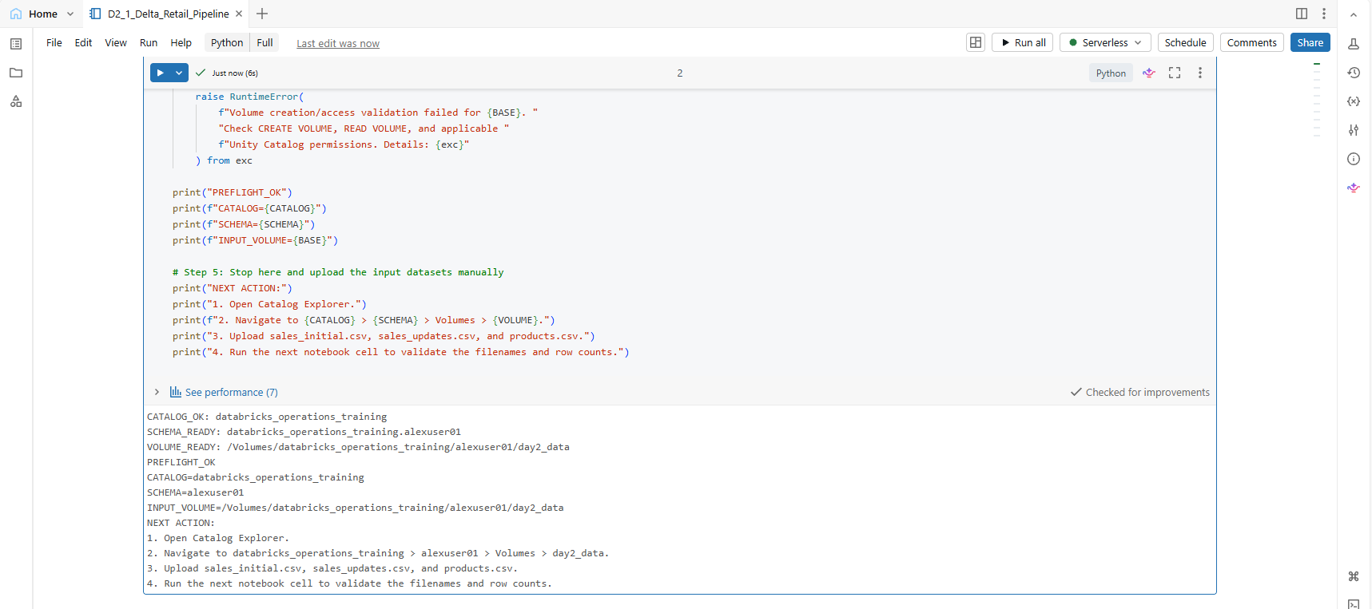Expected Result: The catalog, participant schema, and Volume are accessible. No preflight error is raised.
Evidence to Capture: Successful preflight output showing the catalog, schema, and Volume path.

Step 2 — Upload and Validate Input Datasets
Execution
- After the preflight cell succeeds, open Catalog Explorer.
- Navigate to databricks_operations_training → your schema → Volumes → day2_data.
- Upload sales_initial.csv, sales_updates.csv, and products.csv from the supplied 04_Artifacts/Data folder.
- Confirm that all three files appear directly inside the Volume.
- Return to the notebook and run the input-file validation cell.
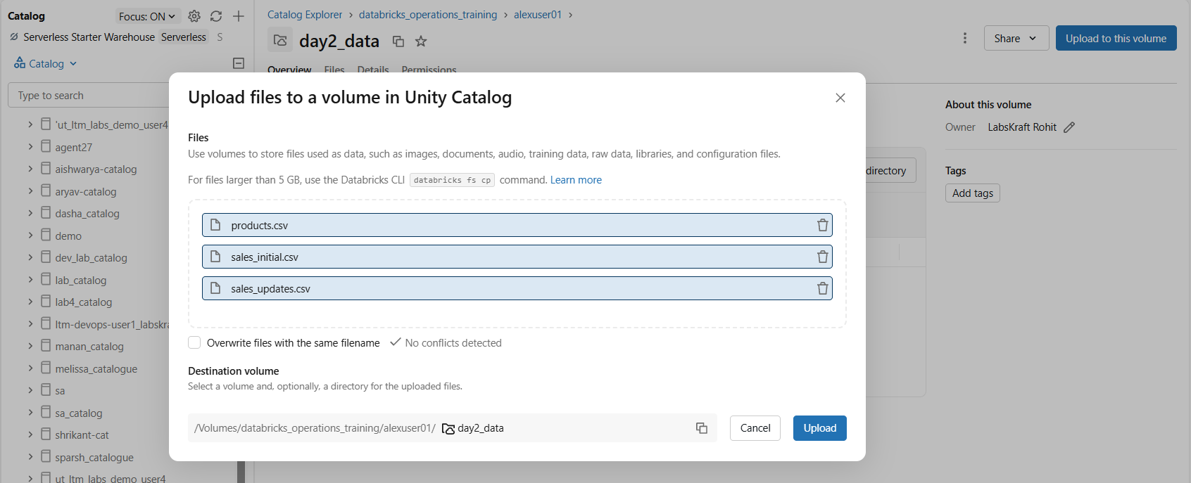
- Run the dataset-read cell.
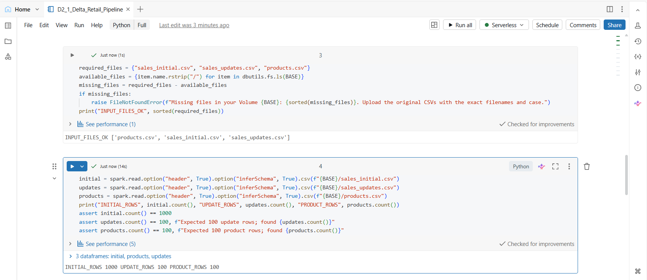Expected Result:
- sales_initial.csv — 1,000 rows.
- sales_updates.csv — 100 rows.
- products.csv — 100 rows.
If the counts differ, check the uploaded files, filenames, capitalization, and Volume path before continuing.

Step 3 — Capture the Initial Data-Quality Profile
Execution
- Run the data-quality profile cell before making changes to the data.
- Review the total row count, distinct order IDs, null customer IDs, blank region values, and minimum/maximum order dates.
- Record the actual values in the validation evidence.
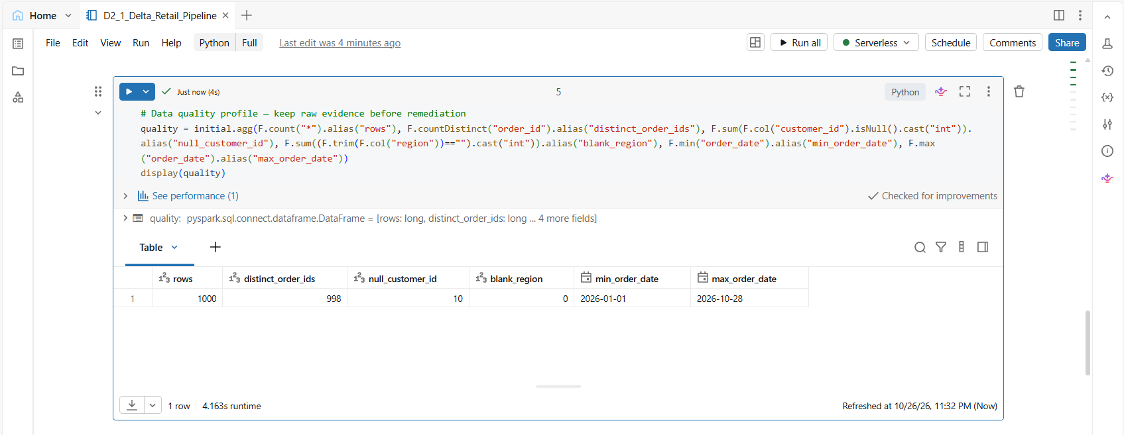Expected Result: The quality profile displays the initial dataset metrics before remediation.

Step 4 — Create the Initial Delta Target
Execution
- Run the cell that writes the initial sales dataset to the sales_orders Delta table.
- Confirm that the fully qualified table name uses your assigned training schema.
- Review the target row count.
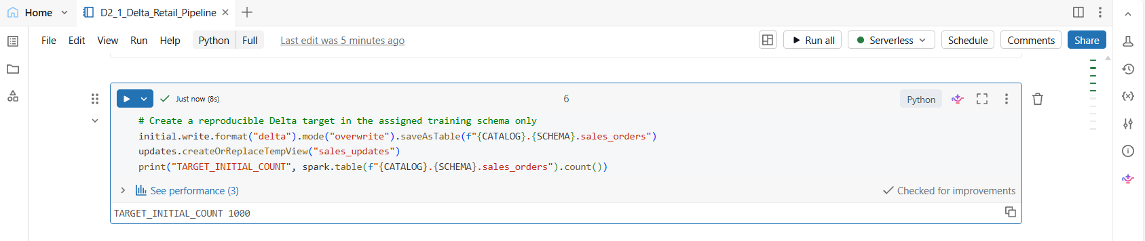Expected Result: The Delta target is created and contains 1,000 initial rows.

Step 5 — Deduplicate Updates and Execute MERGE
Execution
- Run the source-deduplication cell.
- Confirm that the latest source_updated_at record is retained for each order_id.
- Run the MERGE cell to update matched orders and insert unmatched orders.
- Review the execution result.
Expected Result: MERGE completes without duplicate source-key errors.
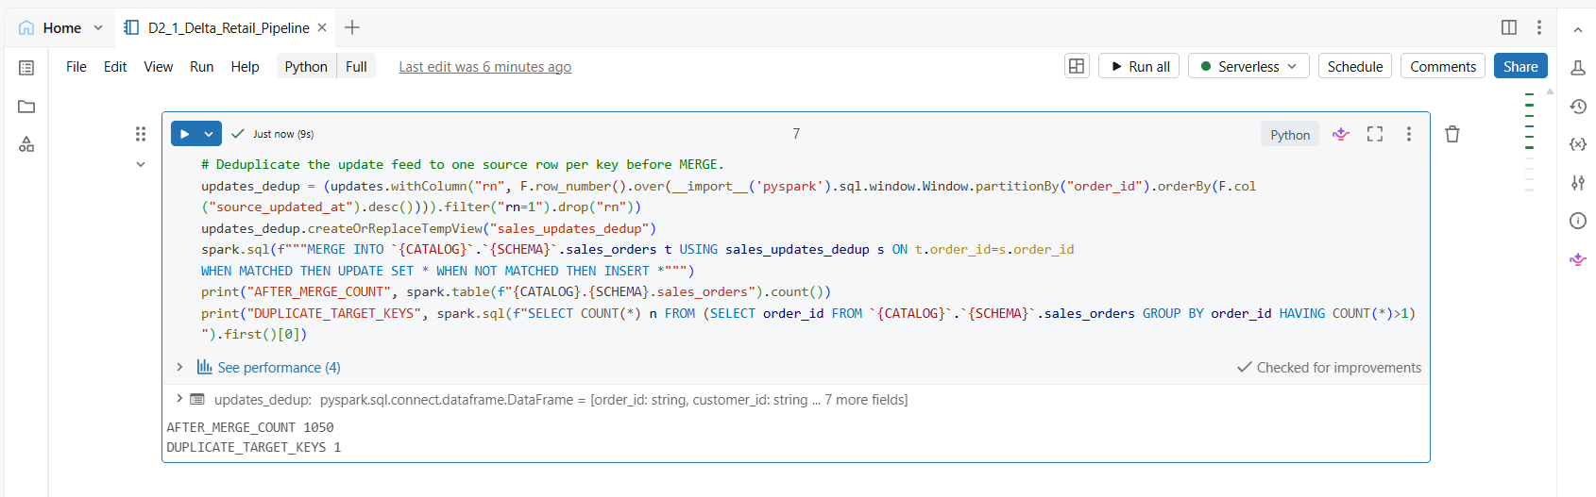

Step 6 — Validate Target Keys and Final Row Count
Execution
- Run the target duplicate-key validation query.
- Review the final target row count.
- Record both values.
Pass Criteria:
- DUPLICATE_TARGET_KEYS = 1.
- The final row count is consistent with the actual matching and insertion behavior of the MERGE.
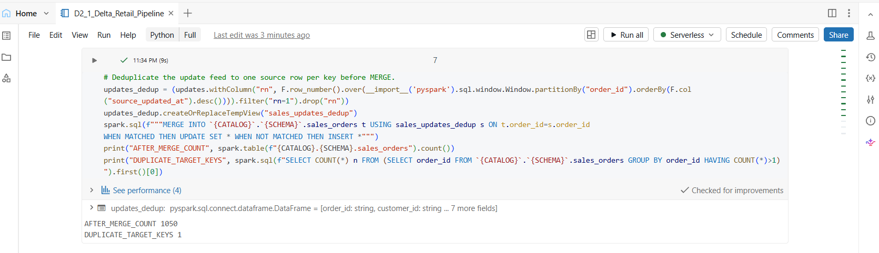Do not assume the final count is 1000 , matching updates and deduplicated source keys affect the resulting count.
Evidence to Capture: Duplicate-key result and final target count.

Step 7 — Investigate the Duplicate-Key Incident

Execution

Run the duplicate-key investigation cell after the MERGE.

Identify the order ID reported more than once in sales_orders.

Check the initial dataset for the same duplicate key.

Inspect the source records and compare their source_updated_at timestamps.

Observed Result: Order O0000150 appears three times in the initial dataset and the target table.

Root Cause: The initial dataset contains duplicate order IDs. Deduplicating the incoming update feed alone does not remove duplicates already present in the target.

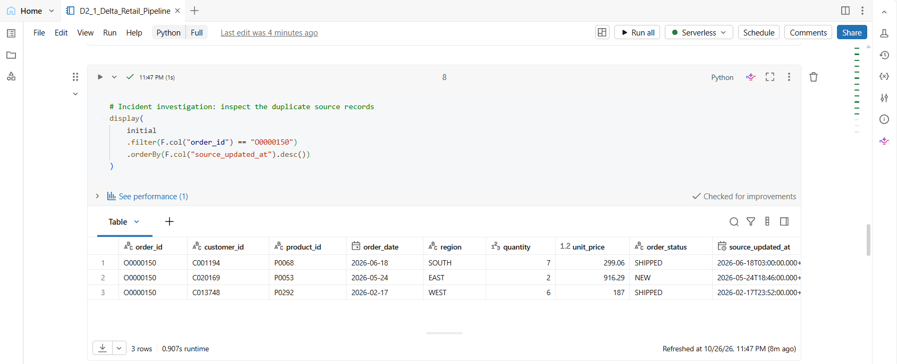

Step 8 — Repair the Initial Data and Validate MERGE Recovery

Execution

Run the recovery cell to retain one record per order ID using the latest source_updated_at.

Confirm the initial dataset decreases from 1,000 to 998 rows and contains zero duplicate keys.

Run the target rebuild cell and confirm REBUILT_TARGET_COUNT = 998.

Rerun the existing source-deduplication and MERGE cell.

Confirm DUPLICATE_TARGET_KEYS = 0.

Observed Result:

Repaired initial dataset: 998 rows.

Rebuilt target: 998 rows.

Target after MERGE: 1,048 rows.

Duplicate target keys after MERGE: 0.

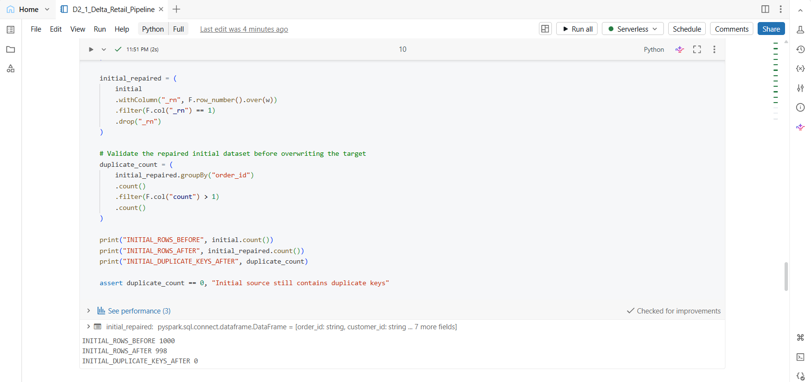Resolution: The duplicate-key incident is resolved. The initial data is deduplicated before loading, and the incoming updates are deduplicated before MERGE.

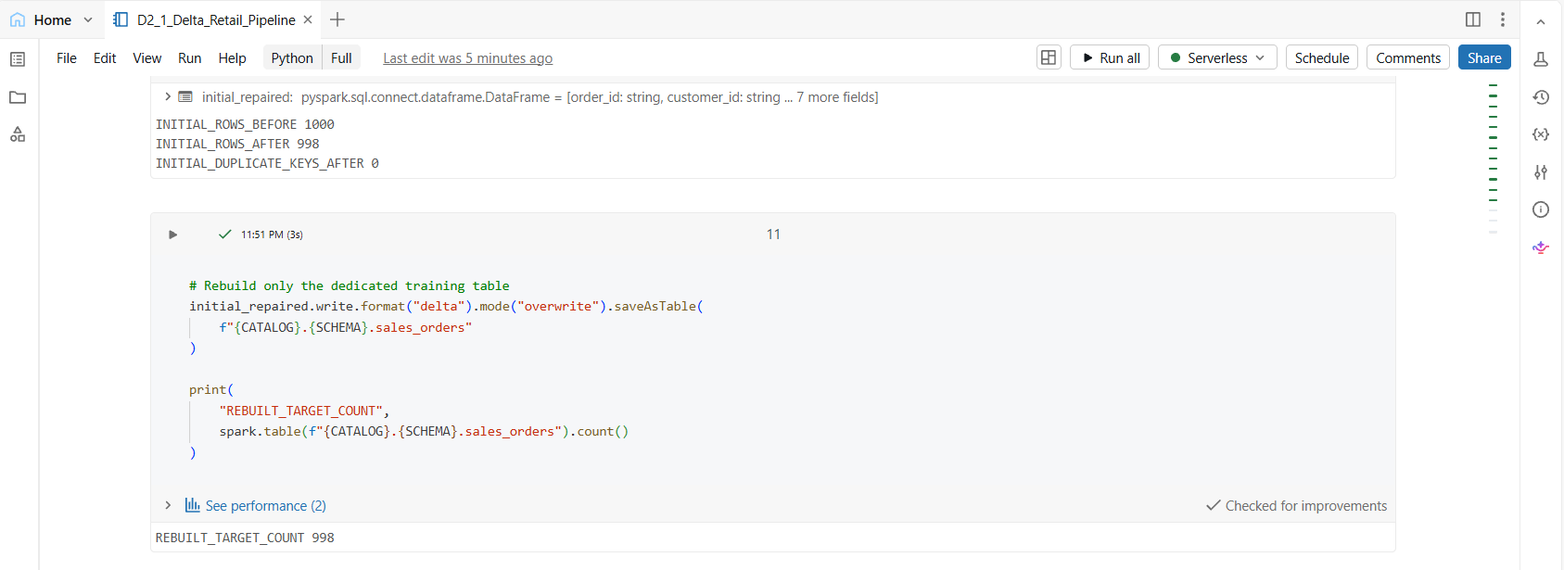Note: The recovery rebuild creates a new Delta table history. Capture the history evidence only after recovery is complete.

Step 9 — Validate Delta History and Time Travel
Execution
- Record the latest Delta table version before the controlled update.
- Update order O0000001 to status REVIEW.
- Record the new Delta version.
- Query the current record and the record at the pre-update version.
Expected Result: The Delta history advances after the update. The current status is REVIEW, while the historical status reflects the state before the update.
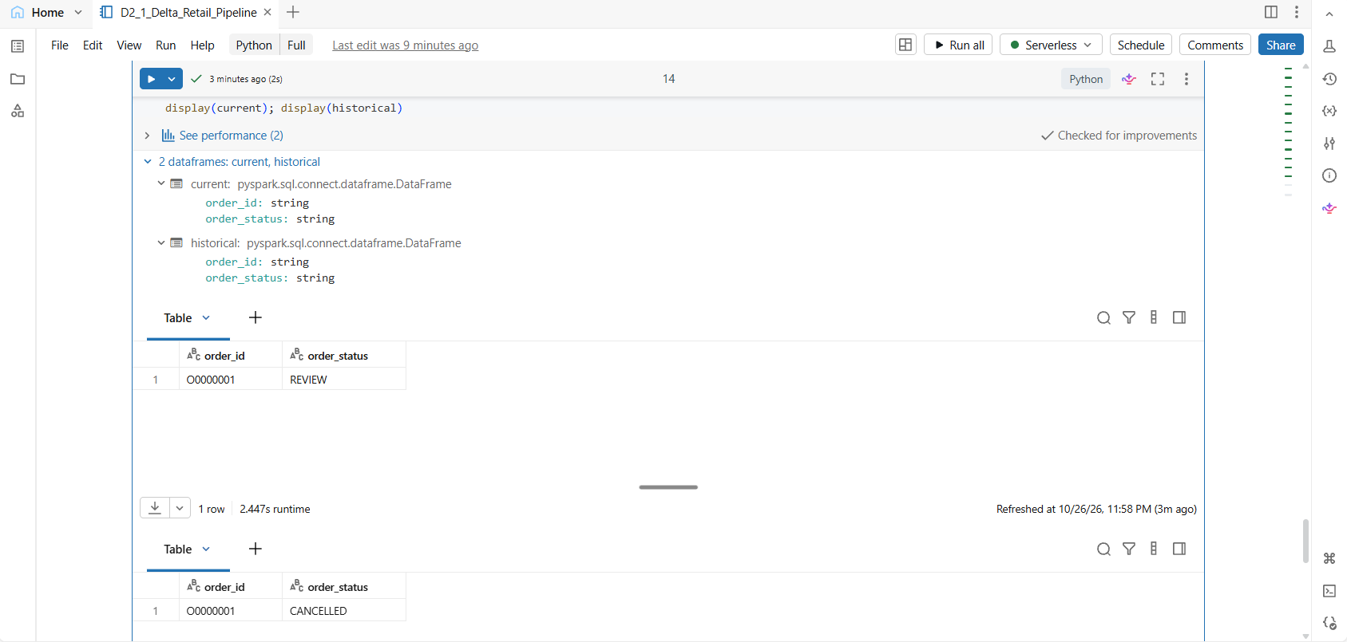Evidence to Capture: Before/after version numbers and current-versus-historical record values.

Step 10 — Compare Join Execution Plans
Execution
- Confirm that products_ref exists in your training schema.
- Run the formatted execution plan for the normal join.
- Run the formatted execution plan for the broadcast-hinted join.
- Compare the physical operators displayed by Databricks.
Expected Result: Both plans are displayed for comparison.
Do not claim that broadcast improves performance unless repeatable measurements support that conclusion. Results can vary with table size, memory, skew, adaptive query execution, and runtime decisions.
Evidence to Capture: Both formatted physical plans and a brief observation of the operators.

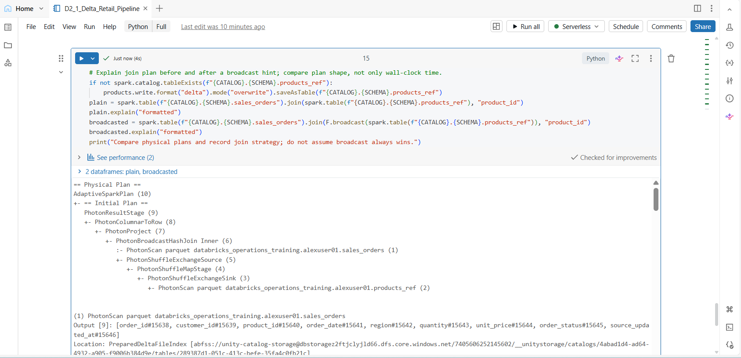Step 11 — Execute Delta Maintenance
Execution
- Run OPTIMIZE only against your dedicated training table, if supported and permitted.
- Capture the completion output or the exact error returned.
- Review the maintenance result and record any limitation.
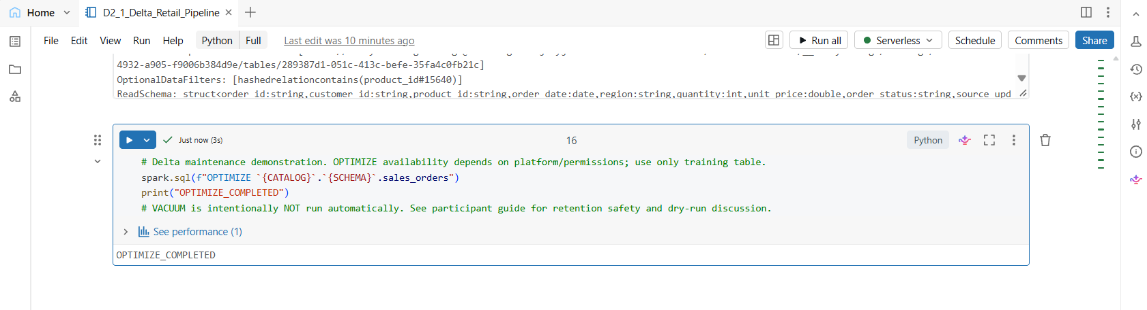Expected Result: The maintenance operation completes successfully, or its failure/limitation is documented accurately.
Safety Note: Do not run VACUUM as part of this exercise.
Evidence to Capture: Actual OPTIMIZE output or error message.

Pass Criteria
- All three input datasets have the expected row counts.
- The initial data-quality profile is captured before remediation.
- The Delta target is created in the participant's dedicated schema.
- Source updates are deduplicated and MERGE completes.
- Target duplicate-key count is zero.
- Delta history advances and current/historical values are compared.
- Both join plans are captured and conclusions are evidence-based.
- OPTIMIZE completion or limitation is documented.
- VACUUM is not run.

Troubleshooting D2-1
Symptom | Check | Corrective action
PATH_NOT_FOUND / missing file | BASE path, Volume path, case-sensitive filename, upload completion and read permission | Correct the BASE path or re-upload the missing CSV; rerun input-read cells.
Initial row count is not 1,000 | CSV upload completeness, wrong file, accidental file modification | Restore the provided source file and verify row count before proceeding.
MERGE ambiguity or multiple source matches | Duplicate order_id values in update feed; matching column names and types | Deduplicate to latest source_updated_at per order_id; verify source/target schema and rerun safely.
Duplicate target keys after MERGE | Target was not freshly created, non-deduplicated source, or notebook rerun against an unintended table | Stop; verify the dedicated schema and table name, recreate only the approved training target, deduplicate source and rerun.
Time Travel values do not differ | Recorded version timing, chosen key, UPDATE result, table version history | Confirm O0000001 exists, record version before UPDATE, check UPDATE affected a row and use that exact versionAsOf.
OPTIMIZE denied or unsupported | Runtime, object type, compute, privilege and exact error | Record the limitation; do not switch to admin or claim success.

Scenario D2-2 — Production Job Failure,

Evidence, Repair and Retry
Ticket: D2-INC-1043
Priority: P1
Notebook: D2_2_Job_Failure_Repair
Job: D2-2_Production_Job_Failure_Repair

Objective
Investigate a failed Databricks Job, identify the cause from the run output, correct the failure condition, rerun the job, and validate successful output in a Delta table.

Step 1 — Validate the notebook configuration
- Open D2_2_Job_Failure_Repair.
- Verify the catalog, assigned schema, and input Volume path.
- Confirm that the notebook can access the required input location.
- Review Cell 2 and verify SIMULATE_FAILURE = True.
Expected result: Preflight validation passes and the notebook is configured to simulate an intentional failure.

Step 2 — Generate the incident records
- Run Cell 2.
- Verify that three incident records are displayed.
- Confirm the incident IDs, severity, symptoms, and affected-row values.
Expected result: Three incident records are generated and the failure simulation flag is True.

Step 3 — Trigger the failure
- Run Cell 3.
- Review the exception returned by the validation gate.
- Confirm that the error contains TRAINING_INJECTED_FAILURE.
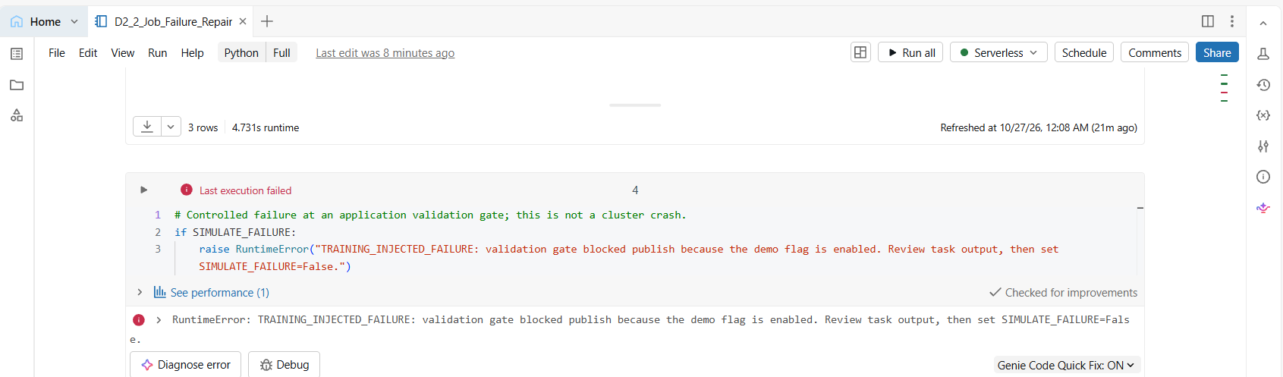Expected result: The cell fails intentionally because the demonstration failure flag is enabled.
This is a controlled application-level exception, not a cluster crash.

Step 4 — Create and execute the Databricks Job
- Navigate to Jobs & Pipelines.
- Create the job D2-2_Production_Job_Failure_Repair.
- Add a notebook task named Job_Execution.
- Select the D2_2_Job_Failure_Repair notebook.
- Select the supported compute configuration.
- Leave job parameters empty because the current notebook initializes the failure flag directly in Cell 2.
- Save the job and click Run now.
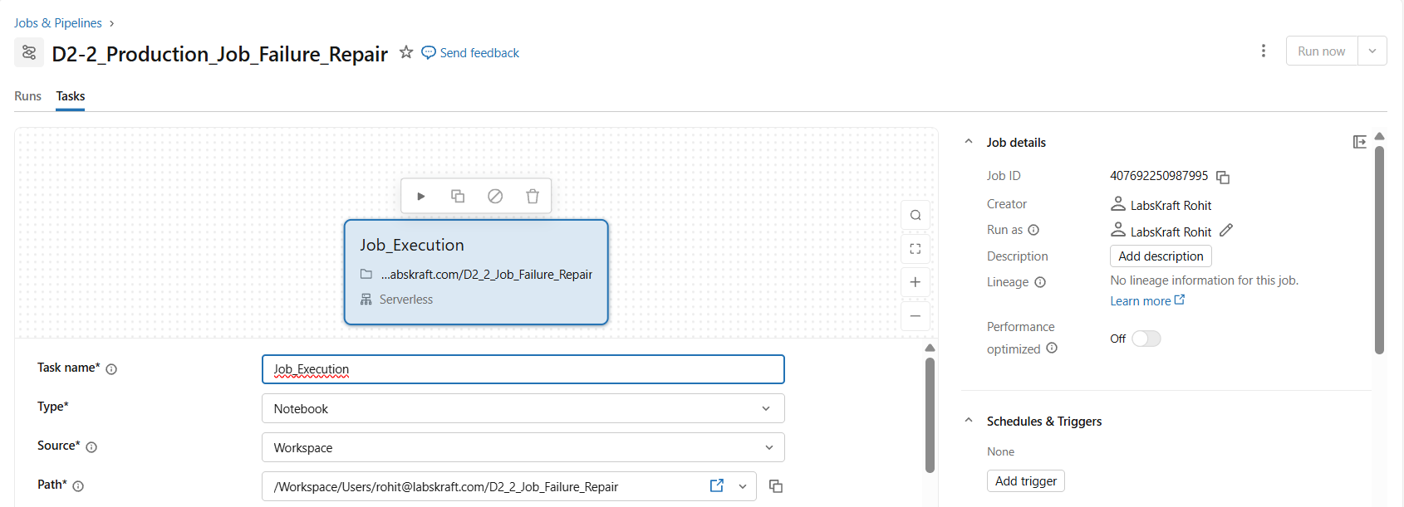Expected result: The first job run fails with the intentional validation exception.

Step 5 — Investigate and repair the failure
- Open the failed Job run.
- Inspect the failed task and its error output.
- Identify the cause: SIMULATE_FAILURE = True deliberately raises the validation exception.
- Return to the notebook and change the setting to SIMULATE_FAILURE = False.
- Save the notebook.
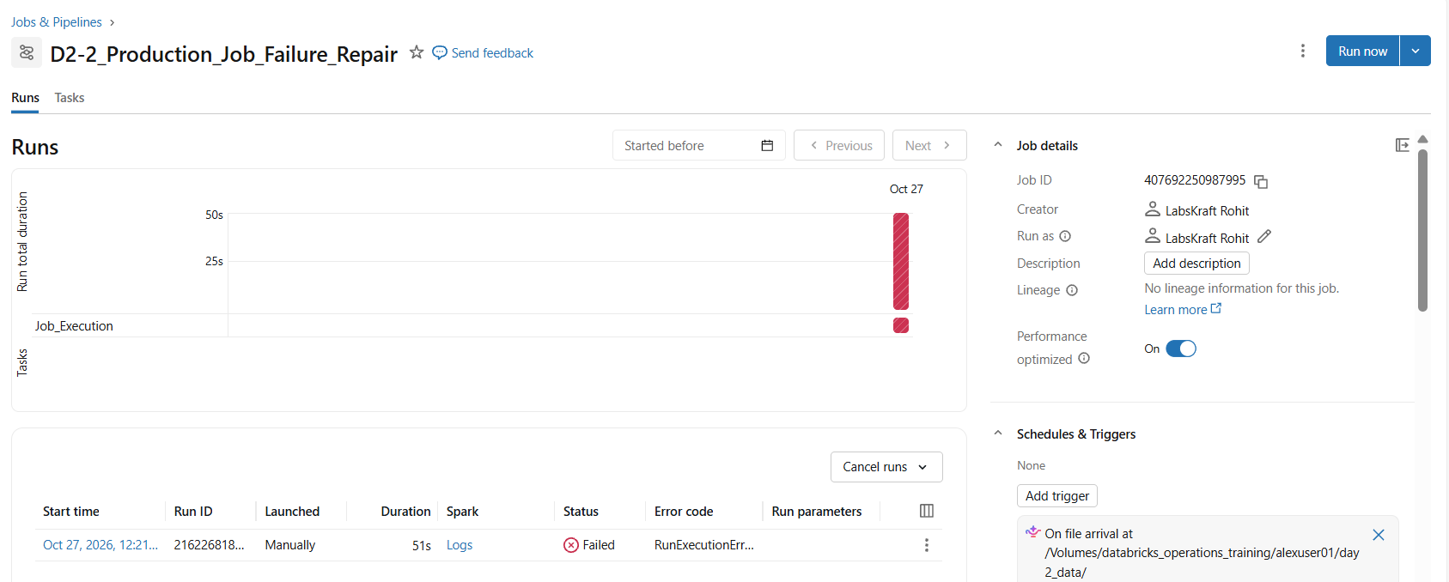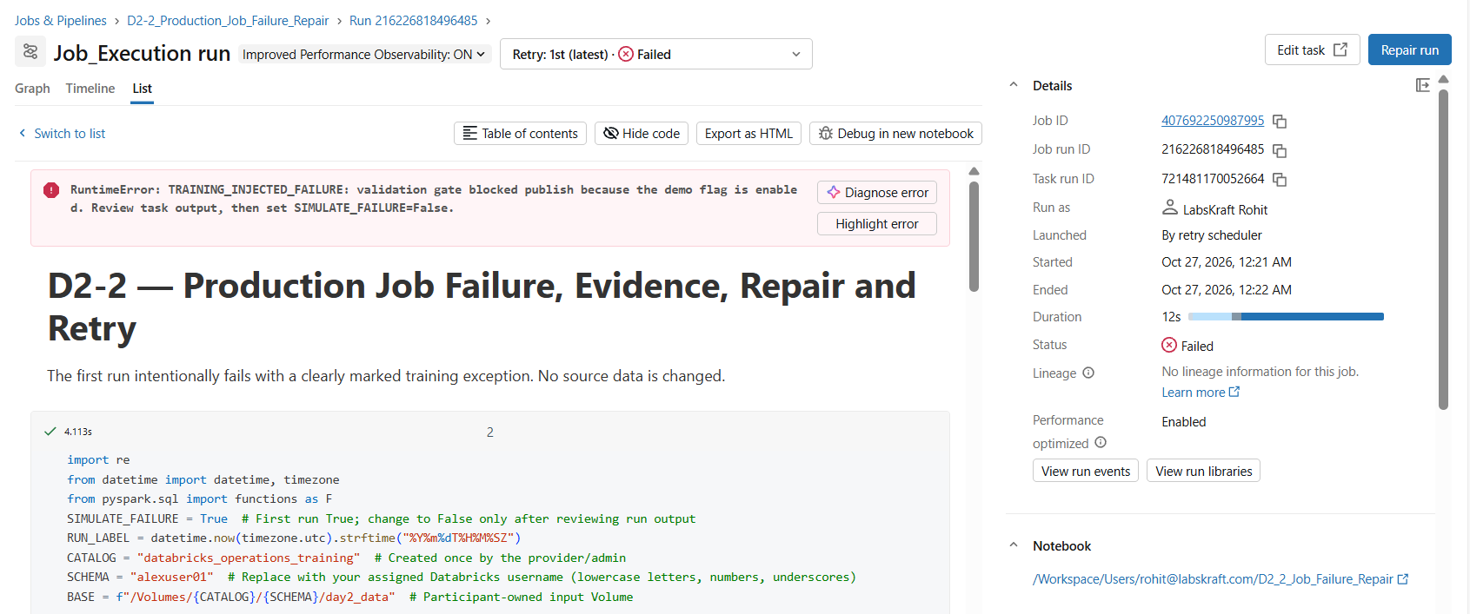Expected result: The failure condition is corrected so that the notebook can pass the validation gate.

Step 6 — Rerun the repaired Job
- Return to Jobs & Pipelines.
- Open D2-2_Production_Job_Failure_Repair.
- Click Run now.
- Wait for the task to finish.
- Verify that the latest run status is Succeeded.
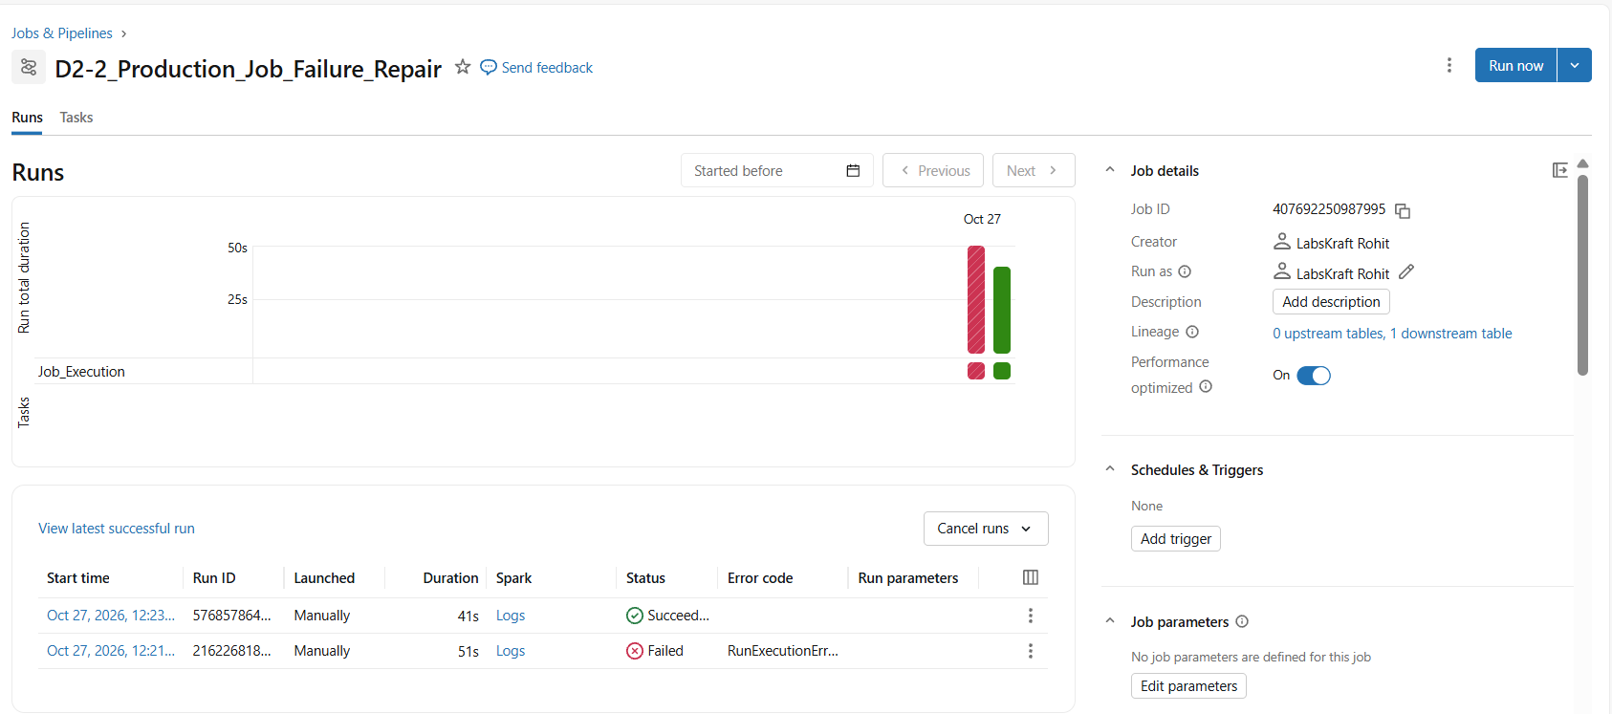
Expected result: The first run remains failed in the run history, while the subsequent run succeeds.
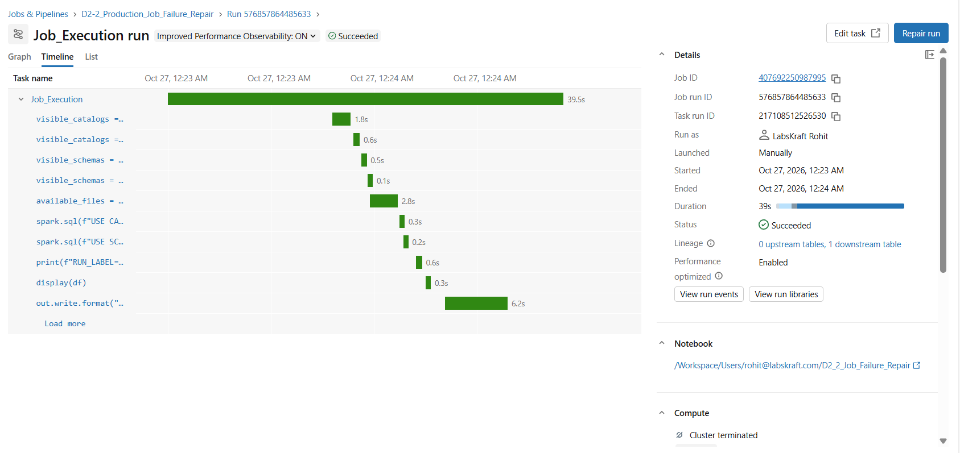

Step 7 — Validate the recovery output
- Open Catalog Explorer.
- Navigate to databricks_operations_training → your assigned schema.
- Open the day2_job_output table.
- When compute is available, inspect the Sample Data tab.
- Verify that three incident records are present.
Expected result: The notebook reports RECOVERY_SUCCESS and ROWS=3. The output table contains the three expected incident records.
Evidence: Insert Screenshot 7 — Notebook recovery output. Add a separate Sample Data screenshot when available.

Pass Criteria
- The notebook generates three incident records.
- The validation gate fails intentionally when the failure flag is enabled.
- The actual Databricks Job records a failed run.
- The failure cause is identified from the notebook code and run output.
- The configuration is corrected and the notebook is saved.
- A subsequent Job run succeeds.
- The recovery output reports three records and the Delta table is verified.

Troubleshooting D2-2
- If the first run fails with another exception, inspect task output, notebook path, compute state, permissions, policy/quota and catalog/schema constants. Do not label it as expected failure.
- If recovery fails with TRAINING_INJECTED_FAILURE, confirm SIMULATE_FAILURE=False was saved in the notebook revision used by the Job.
- If Repair run is not available, use a new run after saving the fix and note the workspace/job UI limitation.
- If output table count is not 3, verify successful task run, catalog/schema, table name and write permission. Do not overwrite non-training data.

PQ 3 — Operations Triage and Query Plans

Objective: Diagnose a table-resolution failure, investigate table accessibility, recover by correcting the table reference, and compare Spark query execution plans.
Notebook: D2_3_Operations_Triage_and_Query_Plans
Environment:
- Catalog: databricks_operations_training
- Schema: alexuser01
- Target table: sales_orders
- Expected row count: 1048

Step 1 — Validate the Workspace and Data Objects
Run Cell 1 to validate the catalog, participant schema, input Volume, and availability of the sales_orders table.
Expected evidence: PREFLIGHT_OK and successful catalog/schema/table inspection.
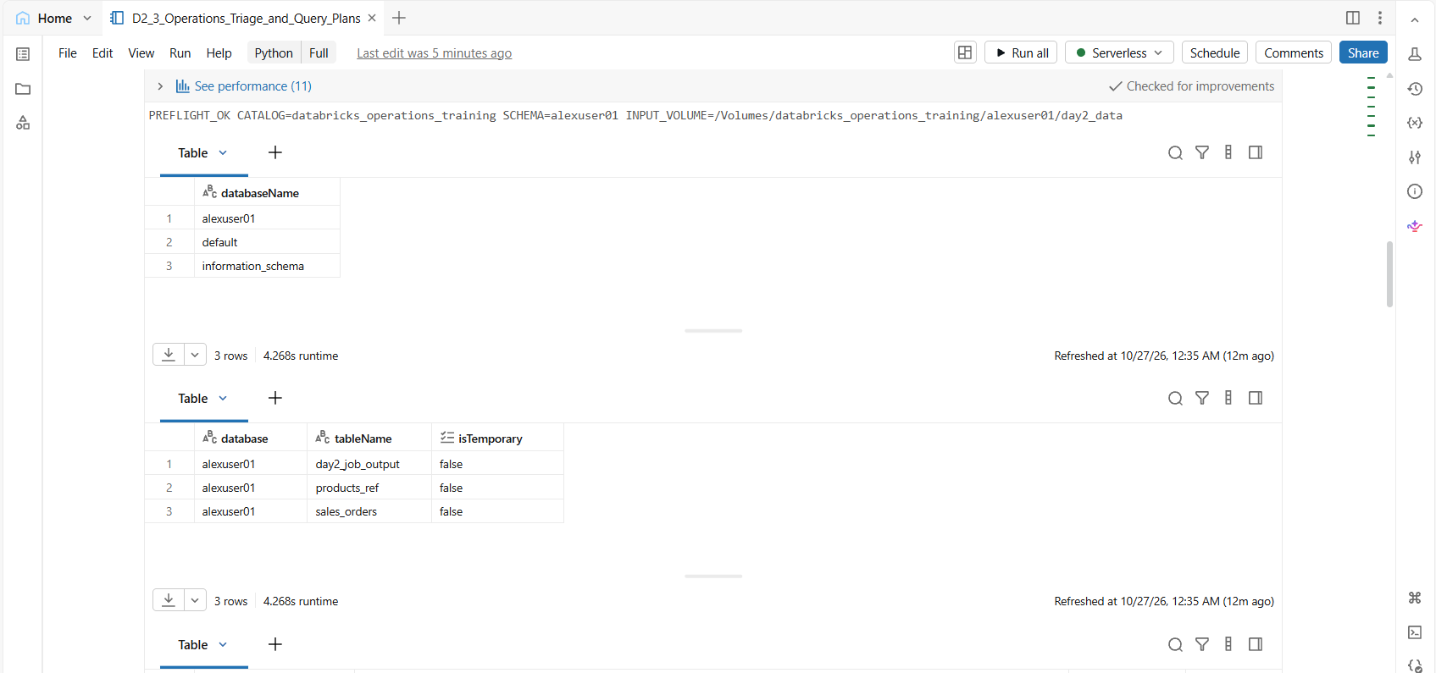

Step 2 — Review the Table's Current State
Run Cell 4 to retrieve the total row count and group orders by order_status.
Validated output:
Order status | Rows
PAID | 357
SHIPPED | 256
NEW | 236
CANCELLED | 105
REVIEW | 94
Total | 1,048
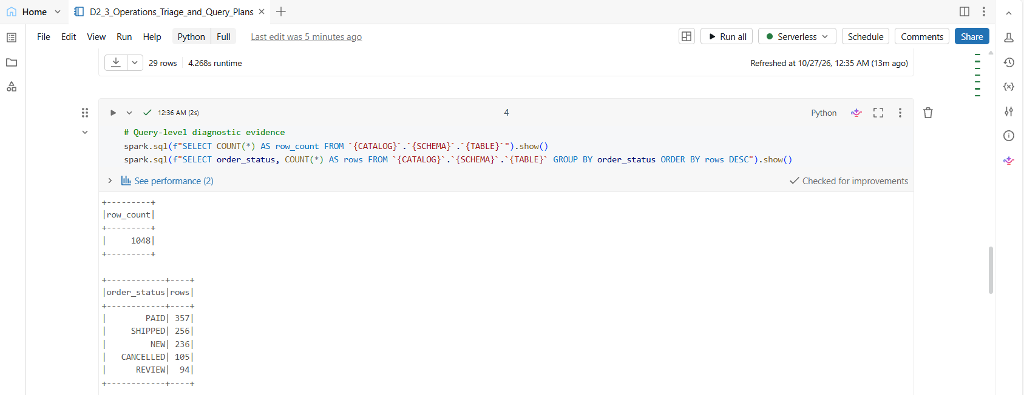

Step 3 — Review the Operations Triage Checklist
Run Cell 5 to display the recommended troubleshooting sequence:
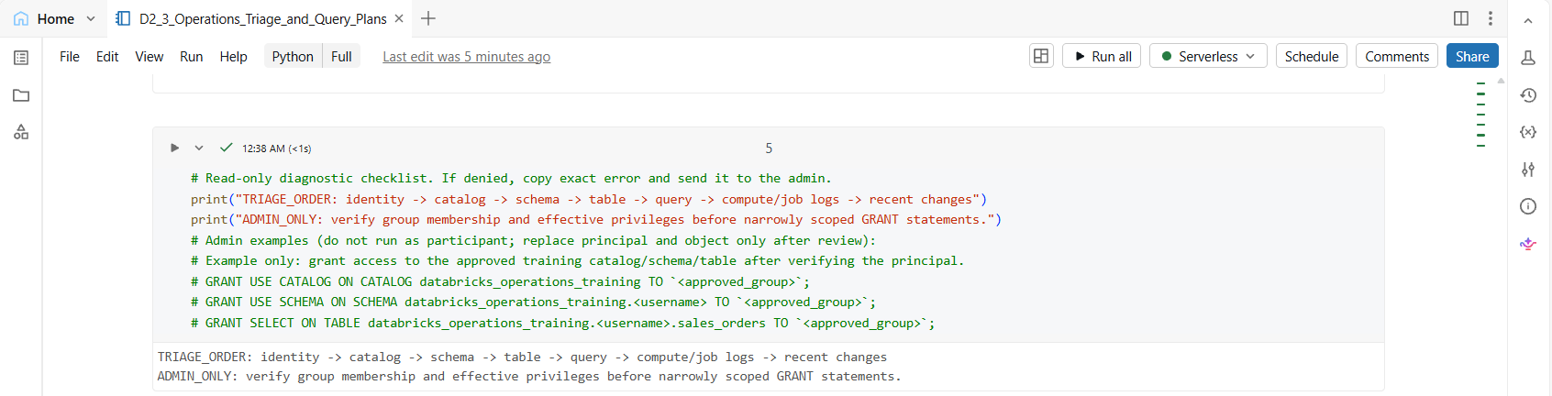Identity → Catalog → Schema → Table → Query → Compute/Job Logs → Recent Changes.
The cell also explains that administrators must verify group membership and effective privileges before applying narrowly scoped GRANT statements. The privileged examples remain commented out.

Step 4 — Compare Query Execution Plans
Run Cell 6 to compare the physical execution plan for a standard join with a broadcast-hinted join.
Inspect the physical operators and record the plans displayed by Databricks. The observed plan includes PhotonBroadcastHashJoin Inner.
Expected evidence: Both plans are displayed for comparison. Do not assume the broadcast hint guarantees better performance.
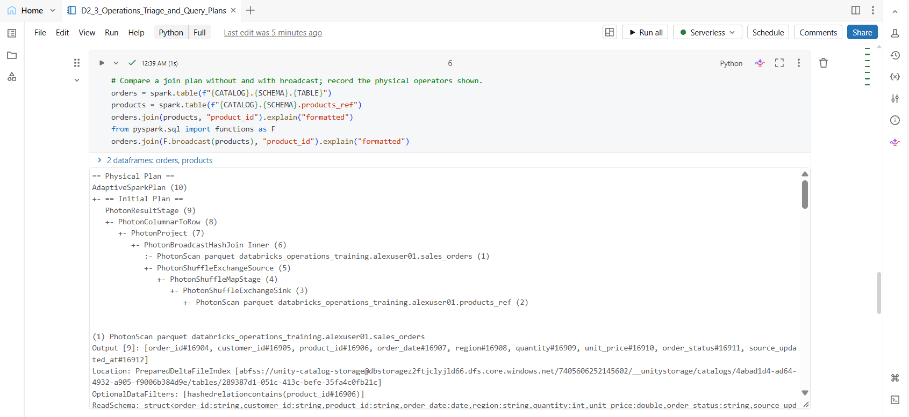

Step 5 — Reproduce a Table-Resolution Failure
Run the controlled failure cell using the intentionally invalid reference:
databricks_operations_training.alexuser01.sales_orders_invalid
The query returns an AnalysisException because the referenced table does not exist. The error output identifies the unresolved table and prints INCIDENT_REPRODUCED.
Root cause: Incorrect table name, not an authorization failure.
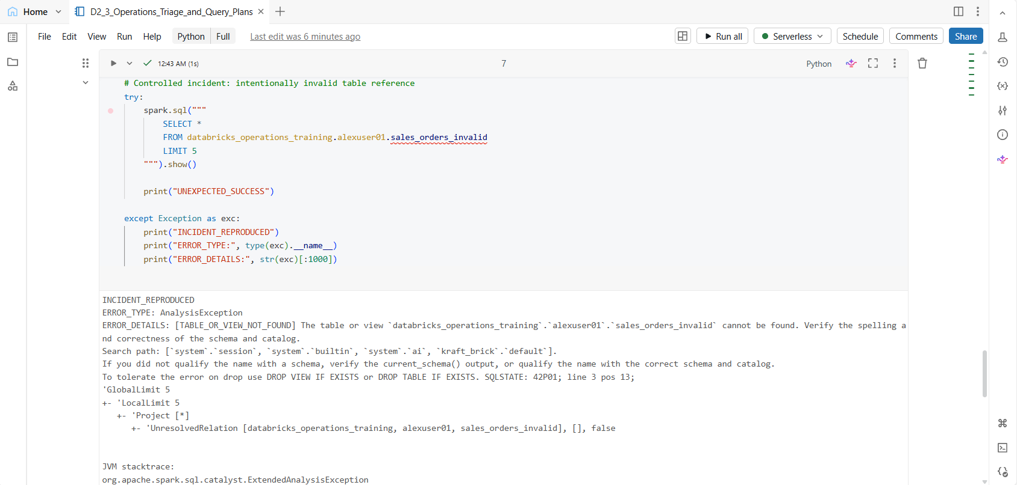

Step 6 — Correct the Table Reference and Validate Recovery
Run the recovery cell using the correct table:
databricks_operations_training.alexuser01.sales_orders
The cell executes a COUNT(*) query and displays the result.
Validated output:
- row_count: 1048
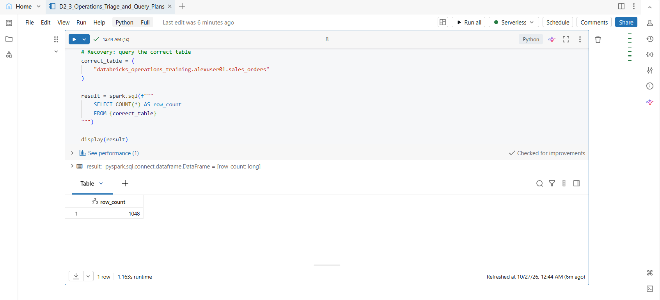This confirms that the corrected reference resolves successfully and the target table remains accessible.

Final Validation Criteria
- Catalog, schema, and input Volume preflight succeeded.
- Order-status diagnostics returned 1,048 total rows.
- Operations triage checklist executed successfully.
- Query-plan inspection executed.
- System-table read succeeded in the current environment.
- Invalid table reference reproduced an AnalysisException.
- Corrected table reference returned 1,048 rows.

Cleanup
No cleanup is required. The scenario uses read-only queries and an intentionally invalid table reference. It does not modify the source table or change permissions.

Troubleshooting D2-3
- PERMISSION_DENIED: record current_user(), exact object and full error; ask the admin to inspect group membership and effective grants.
- Catalog/schema/table absent: confirm constants, object location, workspace/catalog binding and privileges before concluding the object does not exist.
- Lineage unavailable: check Unity Catalog object type, access, workspace feature support and recorded lineage operations; mark N/A with reason if unsupported.
- Query plan differs from expectation: record the actual operators. AQE, data size, statistics, runtime and hints can change the physical plan.
- Slow query: do not recommend a restart from elapsed time alone. Check compute state, task/job logs, query plan, data volume, skew and recent changes.

5. Real-time instructor scoring
Area | Meets standard when… | Status
Delta reliability | Quality profile captured, MERGE is deduplicated/idempotent, zero duplicate target keys, history evidence saved | Pass / Needs revision
Job recovery | Expected first failure identified from logs, recovery action recorded, successful run and 3-row output verified | Pass / Needs revision
Access triage | Identity and exact error captured; root cause isolated; only authorized least-privilege grants applied if needed | Pass / Needs revision
Query and operations evidence | Actual plans and lineage availability recorded; no unsupported performance claims; cleanup is safe | Pass / Needs revision
Completion standard: all four areas meet standard, evidence workbook is saved, no production/shared objects were changed, and compute cleanup is confirmed.

6. Cleanup and reset
- Export or save participant evidence before deleting any Job or table.
- Confirm the catalog/schema is dedicated to this training and no participant work must be retained.
- With instructor approval, drop only the named training objects: <catalog>.<schema>.day2_job_output, <catalog>.<schema>.products_ref, and <catalog>.<schema>.sales_orders. Replace placeholders with the exact approved names; do not run a broad cleanup.
- Delete the training Job only after evidence is saved. Keep the CSVs and notebooks if reusing the workspace.
- Reset SIMULATE_FAILURE=True for the next cohort.
- Stop personal compute or verify auto-termination.
- Do not run VACUUM as routine cleanup and never shorten retention on shared/production tables.

7. Final validation checklist
- All three tickets have a completed evidence row and actual results.
- Required counts (1,000 / 100 / 100) and 3-row recovery output are verified.
- Duplicate target key count is zero after MERGE.
- Delta history, Time Travel, query plan and lineage are recorded with limitations as applicable.
- Failure/recovery run IDs, permission actions and owners are documented.
- Blank participant workbook and completed instructor workbook share the same two-tab structure.
- Only dedicated training resources are cleaned up; compute is stopped or auto-terminated.
Shared input Volume: `/Volumes/databricks_operations_training/shared_data/day2_data`. Provider creates the `shared_data` schema and `day2_data` Volume once, uploads all three CSVs once, and grants READ VOLUME. Participant schemas are separate; do not create a Volume per participant.

Cell-by-Cell Execution Guide — Quick Overview
Run one cell at a time during the initial validation. Review the output before proceeding, and capture screenshots at the relevant steps.

D2-1 — Retail Delta Pipeline
- Configuration and Preflight: Validate the catalog, participant schema, and input Volume.
- Input Files and Counts: Verify the three CSV files and their expected row counts.
- Data Quality: Review the initial quality profile and identify duplicate order IDs.
- Duplicate Remediation: Inspect duplicate records, retain the latest valid record, rebuild the target with 998 unique rows, and rerun MERGE.
- Delta History: Compare the table versions and current versus historical order status.
- Query Plans: Compare normal and broadcast-hinted joins.
- Maintenance: Run OPTIMIZE on the training table. Do not run VACUUM.

D2-2 — Production Job Failure, Repair and Retry
- Configuration and Preflight: Validate the participant environment and set SIMULATE_FAILURE = True.
- Incident Input: Generate three synthetic incident records.
- Controlled Failure: Run the job and capture the intentional validation error.
- Repair and Retry: Set SIMULATE_FAILURE = False, save the notebook, and rerun the job.
- Recovery Validation: Confirm the job succeeds and day2_job_output contains three records.

D2-3 — Operations Triage and Query Plans
- Preflight and Table Inspection: Validate the environment and inspect the sales_orders table.
- Query Diagnostics: Confirm the total row count of 1,048 and review the order-status distribution.
- Triage Checklist: Follow the identity-to-catalog-to-schema-to-table-to-query-to-compute/logs sequence. Keep GRANT examples for administrator reference only.
- System-Table Access: Query system.access.assistant_events. The validated query succeeded and returned five records.
- Controlled Failure: Query the intentionally invalid table sales_orders_invalid and capture the AnalysisException.
- Recovery: Correct the table reference and verify that sales_orders returns 1,048 rows.
- Query Plans: Compare the normal and broadcast-hinted join plans; do not assume broadcast is always faster.

Manual Job UI Evidence — D2-2
- Open the designated Databricks Job or create one if the exercise requires it.
- Run with SIMULATE_FAILURE = True and capture the failed run.
- Change the flag to False and rerun the job.
- Capture the successful run and validate the three-row output.
If the curriculum requires notebook execution only, do not create a Job unnecessarily.
Validation note: The guide describes the expected workflow. Mark a step as passed only after checking the actual output in the target environment.

