**Java 9 Module – Create and use modules in Eclipse IDE**

We will create a class in one module and use that class in another module.

**1. Creating a Java Project**

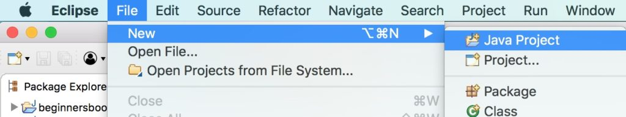

We are creating a java project in Eclipse IDE. The project name we are using is “beginnersbook.demo”.

**2. Create module-info.java file**

Once the project is created, **right click on the project name**, go to the “**Configure**” option and click “**create module-info.java**” option as shown in the following screenshot. Give the module name same as project name “**beginnersbook.demo**“.  
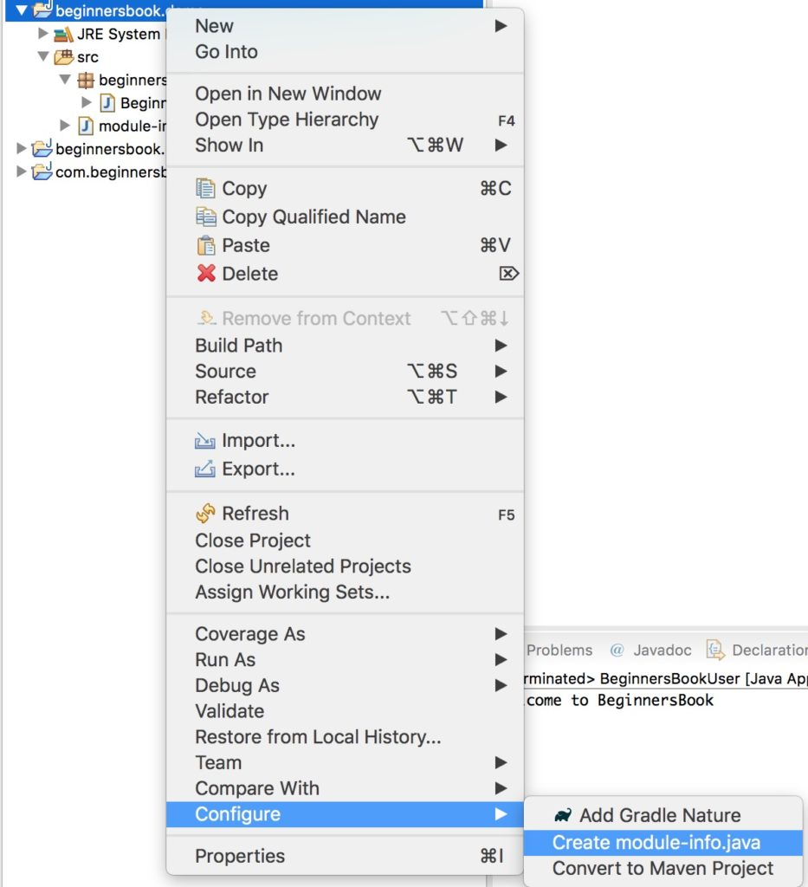

For now leave the file empty. We will come to it later.

**3. Create a package and a class**

We are creating a class in this module and we will use this class in another module. We are creating a class “**BeginnersBook**” in the package “**beginnersbook.demo**“.

Source code of the class BeginnersBook:

package beginnersbook.demo;

public class BeginnersBook {

public String welcomeMessage() {

return "Welcome to BeginnersBook";

}

}

**4. Export the package that we have created**

Since we are planning to use the class “BeginnersBook” in another module, lets make this package exported so that it can be used outside of the module. To do this, write this code in **module-info.java** file –  
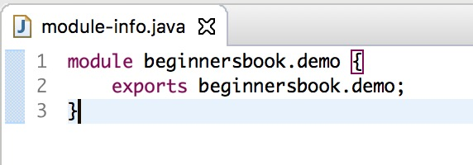

module beginnersbook.demo {

exports beginnersbook.demo;

}

**Final Structure of project beginnersbook.demo looks like this:**  
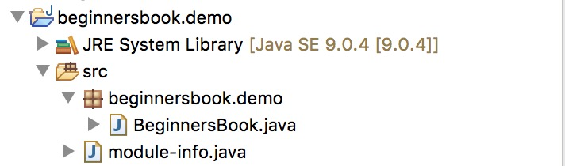

**5. Lets create another module**

Lets create a new java project, name it as “**beginnersbook.user**” and create the **module-info.java** file the same way that we have created above and name it as “beginnersbook.user”. The module-info.java file of this project has this code:

//module-info.java file

module beginnersbook.user {

exports beginnersbook.user;

requires beginnersbook.demo;

}

Since we are planning to use the beginnersbook.demo package, we mention the package name after requires keyword as shown in the above code.

Note: You will most likely get an error message saying that the package name is not resolved, this is because the other module is not in the build path. To resolve this error, right click on the project beginnersbook.user, go to Build Path -> Configure Build Path as shown in the following screenshot:  
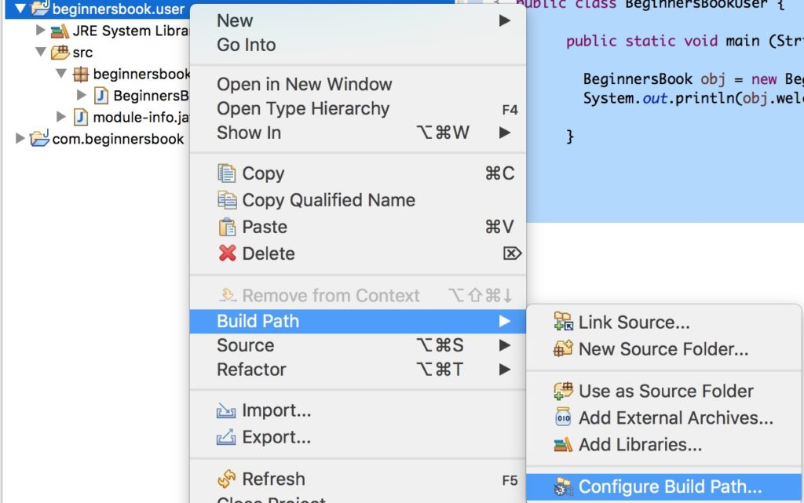

Go to **Projects** tab, click on **Modulepath** then click on “Add” button on the right side and add the previous java project “beginnersbook.demo” that we have created. Your final screen should look like this:  
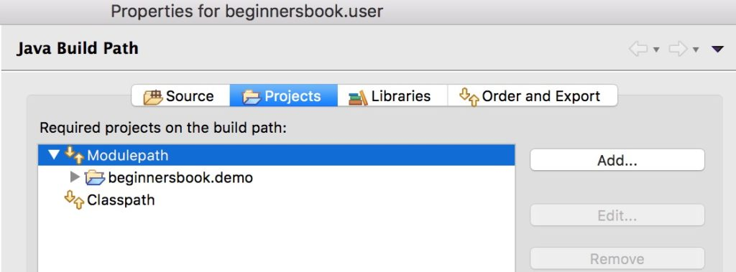

Your error should be resolved now.

**6. Lets create a class in second module**

Create a class “**BeginnersBookUser**” in this project under package “**beginnersbook.user**“.

Source code of the class BeginnersBookUser:

package beginnersbook.user;

import beginnersbook.demo.BeginnersBook;

public class BeginnersBookUser {

public static void main (String arg[]) {

BeginnersBook obj = new BeginnersBook();

System.out.println(obj.welcomeMessage());

}

}

**Final Structure of both projects looks like this:**  
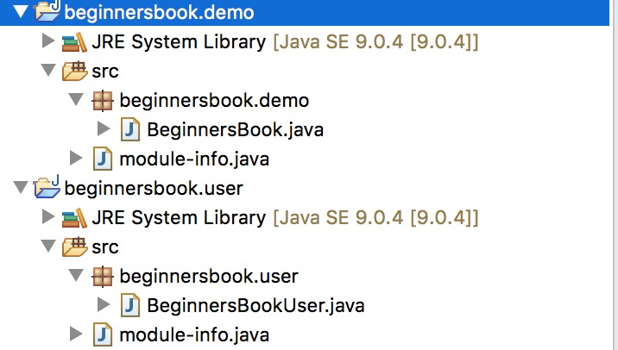

**7. Final Step**

Lets run the BeginnersBookUser class, you should get the following output:

Welcome to BeginnersBook

Thats it guys. To give a brief, we have created a class in a module and exported the package so that the class can be used outside the module.  
To test it, we have created another class in a different module and used the exported package and finally used that class that we have created first.