oc new-app -e MYSQL_USER=demo_user, MYSQL_PASSWORD=demo_pass,MYSQL_DATABASE=virtusacustomerdb,MYSQL_ROOT_PASSWORD=password registry.access.redhat.com/openshift3/mysql-55-rhel7

oc new-app -e MYSQL_USER=demo_user, MYSQL_PASSWORD=demo_pass,MYSQL_DATABASE=virtusacustomerdb,MYSQL_ROOT_PASSWORD=password registry.access.redhat.com/rhscl/mysql-80-rhel7

oc new-app -e MYSQL_USER=demo_user, MYSQL_PASSWORD=demo_pass,MYSQL_DATABASE=datamaticsclaimdb,MYSQL_ROOT_PASSWORD=password --docker-image="mysql:latest"

oc new-app -e MYSQL_USER=demo_user MYSQL_PASSWORD=demo_pass MYSQL_DATABASE= boacamundadb MYSQL_ROOT_PASSWORD=password --docker-image="mysql:latest"

oc new-app -e MYSQL_USER=demo_user MYSQL_PASSWORD=demo_pass MYSQL_DATABASE= virtusacustomerdb MYSQL_ROOT_PASSWORD=password --docker-image="mysql:latest"

oc new-app -e MYSQL_USER=demo_user MYSQL_PASSWORD=demo_pass MYSQL_DATABASE= virtusausappointmentdb MYSQL_ROOT_PASSWORD=password --docker-image="mysql:latest"

mysql

172.30.61.73

oc new-app -e H2_USER=sa, H2_PASSWORD=sa,H2_DATABASE= camunda-db, --docker-image=" oscarfonts/h2:latest"

to transfer files like license to pod

oc rsync /path/to/license_dir your_pod_name:/tmp/license_dir

mysql --host=localhost --user=your_username --password=your_password -e "filename.sql"

oc new-app -e \

MYSQL_USER=<username>,MYSQL_PASSWORD=<password>,MYSQL_DATABASE=<database_name> \

registry.access.redhat.com/openshift3/mysql-55-rhel7

oc new-app hekonsek/h2

<http://10.128.16.217:81>

jdbc:h2:tcp://<remote ip>//tmp/myapp

To view pods

Oc get pods

oc expose svc/mysql

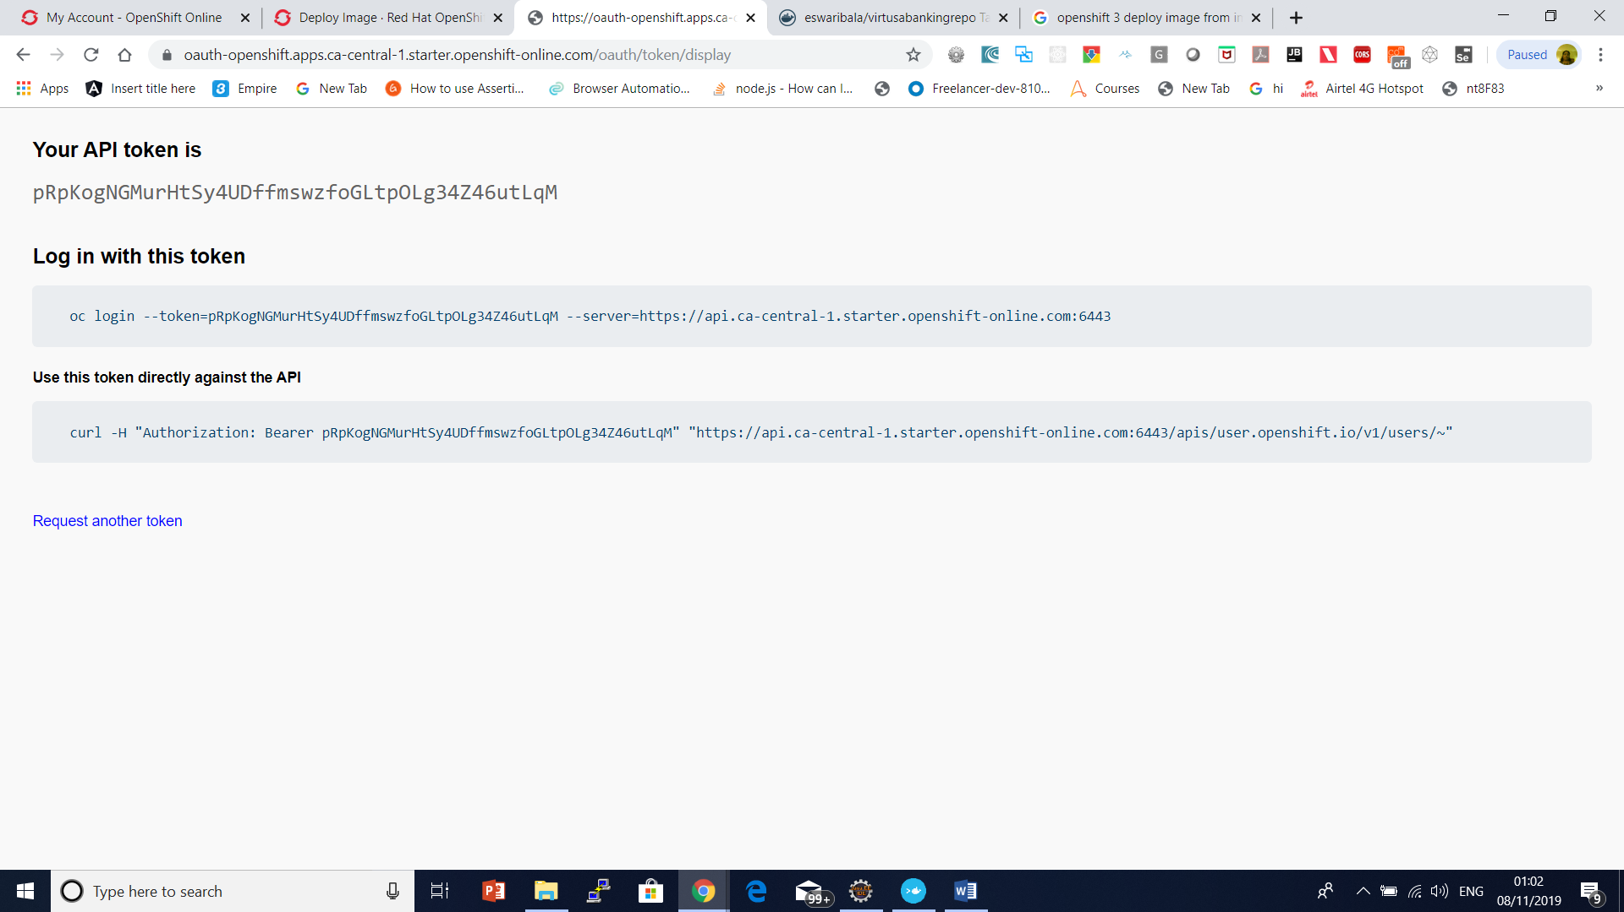

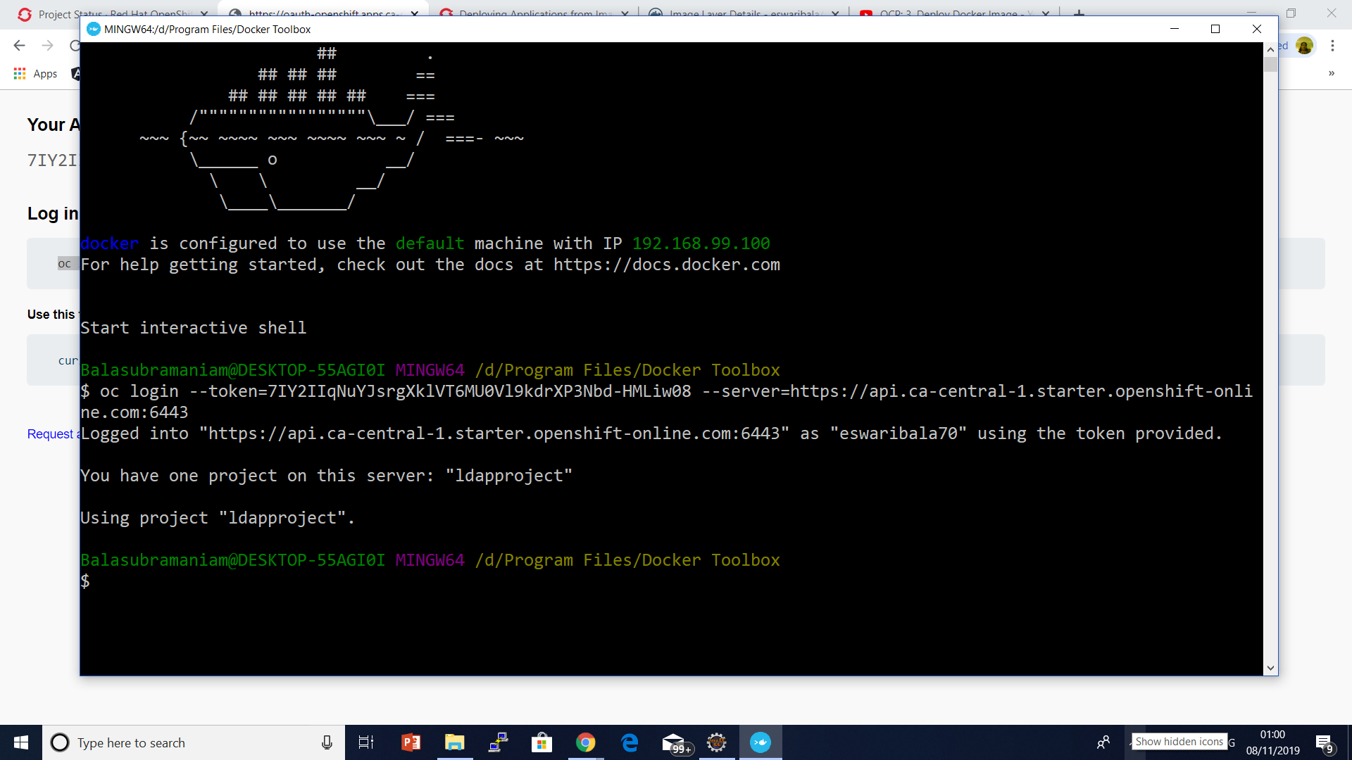

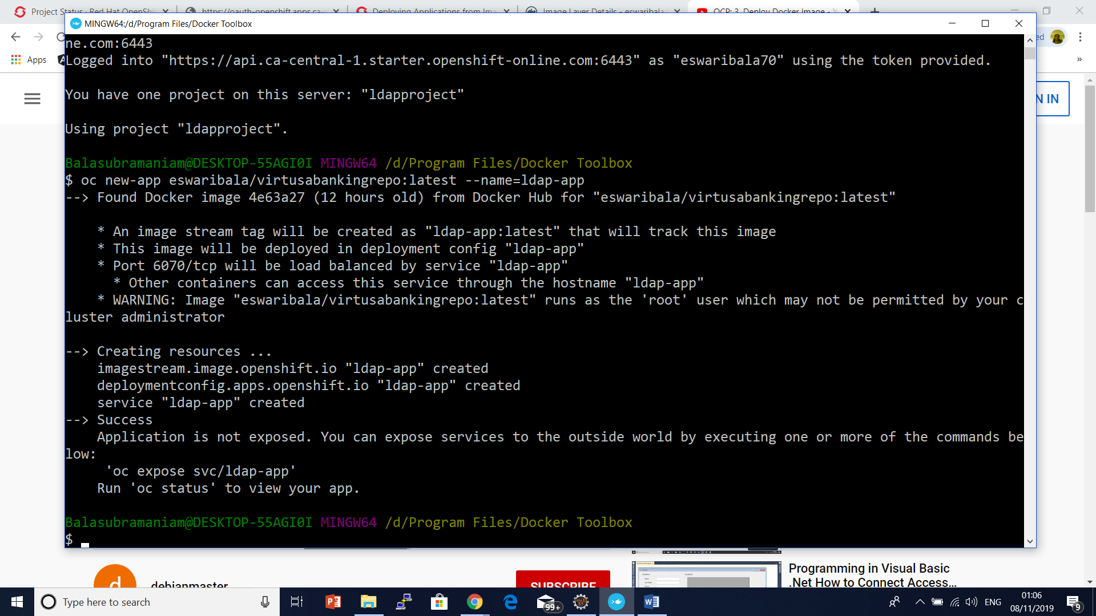

To expose service

oc expose dc/visaapp2020 --port=7070

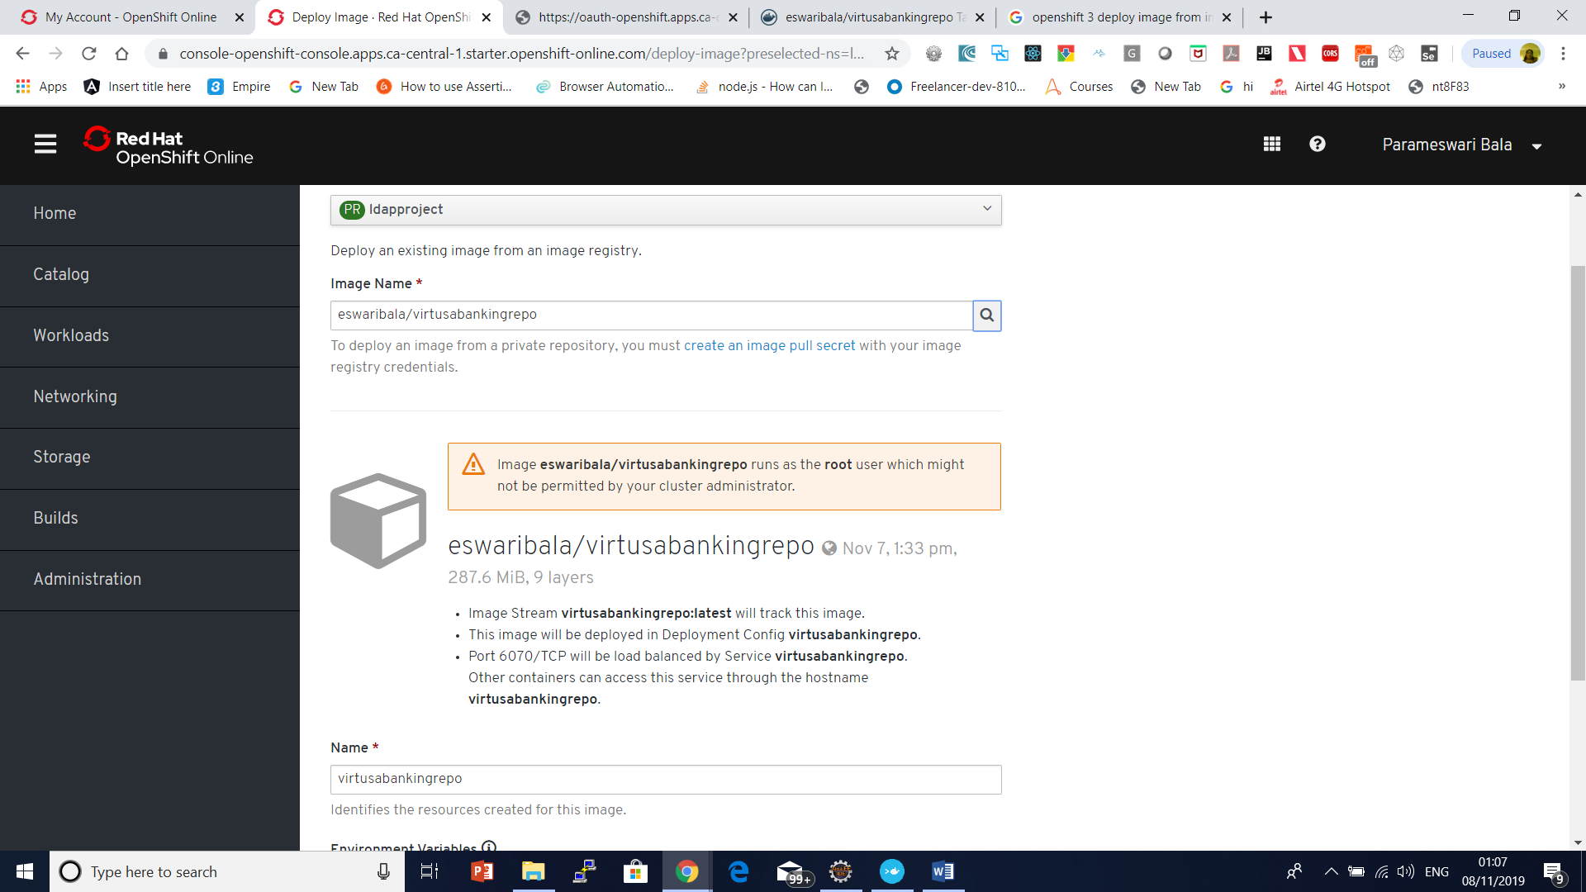

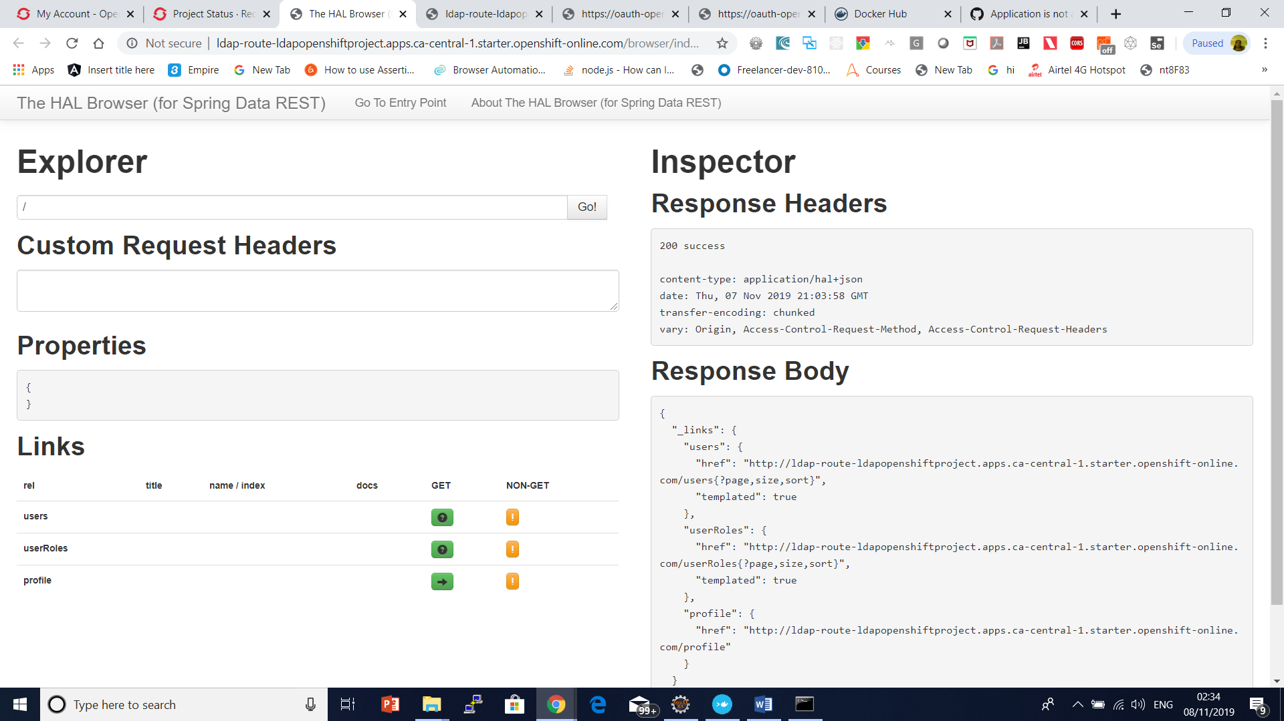

oc create secret docker-registry docker-hub-secret --docker-server=docker.io --docker-username=your-dockerhub-username --docker-password=your-dockerhub-password --docker-email=your-dockerhub-email