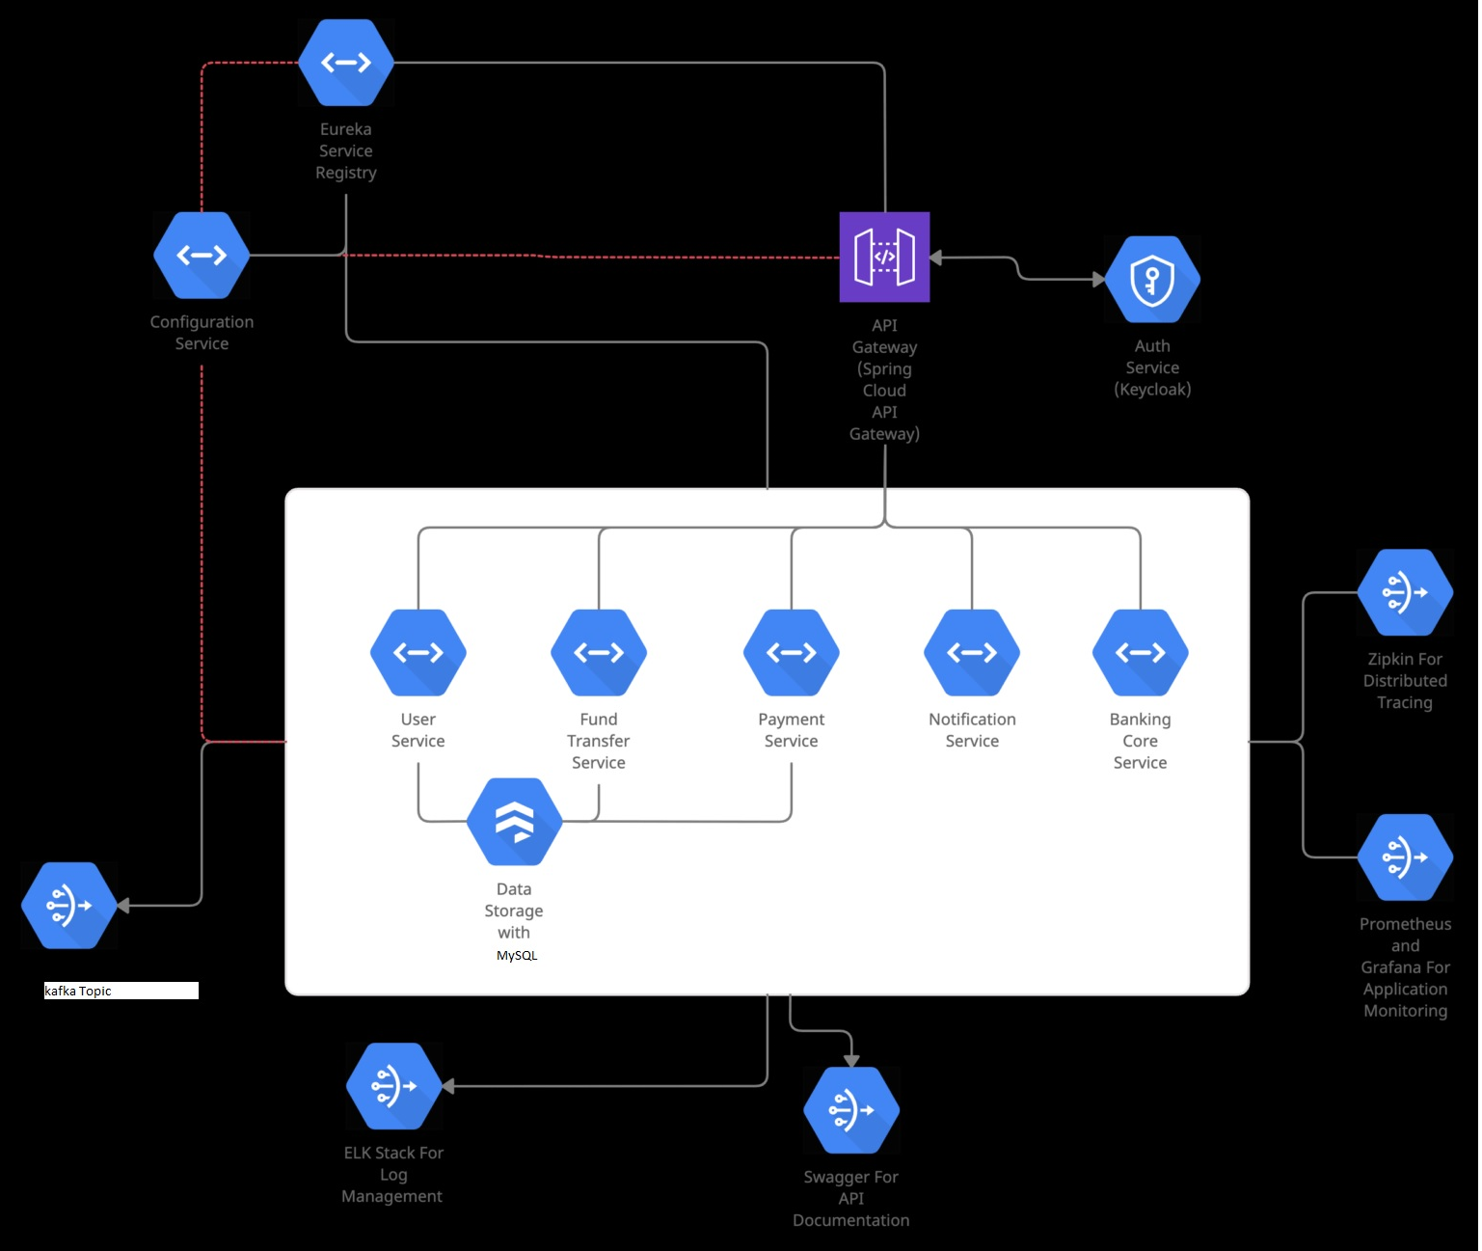

Deploy One of the components in Kubernetes